Introduction to Scrum



Introduction to Scrum

Student Guide



Introduction to Agile Methods by Evan Leybourn is licensed under a Creative Commons **Attribution-ShareAlike** 3.0 Australia License <<http://creativecommons.org/licenses/by-sa/3.0/au/>>

Evan Leybourn

[evan@theagiledirector.com](mailto:evan@theagiledirector.com)

Twitter: @eleybourn

Introduction to Scrum (cc)-by-sa – Evan Leybourn Page 1 of 84

Introduction to Scrum

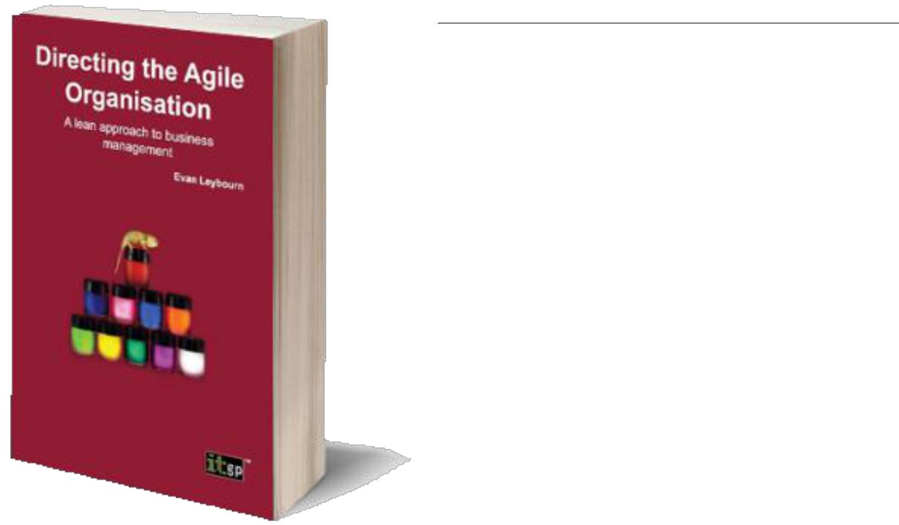

**OTHER WORKS BY**

**EVAN LEYBOURN**



**DIRECTING THE AGILE ORGANISATION – BY EVAN LEYBOURN**

[**http://theagiledirector.com/book**](http://theagiledirector.com/book)

• Embrace change and steal a march on your competitors

• Discover the exciting adaptive approach to management

• Become the Agile champion for your

organisation

Business systems do not always end up the way that we first plan them. Requirements can change to accommodate a new strategy, a new target or a new competitor. In these circumstances, conventional business management methods often struggle and a different approach is required.

Agile business management is a series of concepts and processes for the day-to-day management of an organisation. As an Agile manager, you need to understand, embody and encourage these concepts. By embracing and shaping change within your organisation you can take advantage of new opportunities and outperform your competition.

Using a combination of first-hand research and in-depth case studies, Directing the Agile Organisation offers a fresh approach to business management, applying Agile processes pioneered In the IT and manufacturing industries.

Introduction to Scrum (cc)-by-sa – Evan Leybourn Page 2 of 84

Introduction to Scrum



**TABLE OF CONTENTS**



Other Works by Evan Leybourn 2

Directing the Agile Organisation – by Evan Leybourn 2

Table of Contents 3

What Does Agile Mean? 5

The Agile Manifesto 6

Agile Methods 7

Key Points 7

Understanding Waste 8

Critical Success Factors 9

Common Misconceptions 10

Scrum Overview 11

Project Roles 14

Project Team 15

Interested and Committed 15

Primary Roles 16

Project Initiation **Error! Bookmark not defined.**

Specifications in Agile? 19

Beginning the Process 19

Outcomes 19

Backlog 20

Accuracy 22

Estimating Effort 23

How? 23

Estimating Time 25

Cost / Time / Scope 26

Introduction to Scrum (cc)-by-sa – Evan Leybourn Page 3 of 84

Introduction to Scrum

Starting an Sprint 28

Sprint Planning Meeting 30

During an Sprint 34

Daily Lifecycle 35

Task Lifecycle 36

Development Hints 38

Test Driven Development 39

Continuous Integration 40

Scrum Meeting (aka Daily Stand-up) 43

Inspection 44

Burndown & Burnup Charts 45

Progress Problems 46

Finishing an Sprint 49

Sprint Review 50

Kaizen and the Sprint Retrospective 51

References 52

Books & Links 53

Tools 53

Introduction to Scrum (cc)-by-sa – Evan Leybourn Page 4 of 84

Introduction to Scrum



# WHAT DOES AGILE MEAN?



*‘On two occasions I have been asked, “Pray, Mr Babbage, if you put into the machine wrong figures, will the right answers come out?” [...] I am not able rightly to apprehend the kind of confusion of ideas that could provoke such a question.’*

*Charles Babbage, 1864*

Notes:

Introduction to Scrum (cc)-by-sa – Evan Leybourn Page 5 of 84

Introduction to Scrum

## THE AGILE MANIFESTO

The “Agile Software Development Manifesto” was developed in February 2001, by representatives from many of the fledgling “agile” processes such as Scrum, DSDM, and XP. The manifesto is a set of 4 values and 12 principles that describe “What is meant by Agile".

**THE AGILE VALUES**

1. Individuals and interactions over processes and tools
2. Working software over comprehensive documentation
3. Customer collaboration over contract negotiation
4. Responding to change over following a plan

**THE AGILE PRINCIPLES**

1. Our highest priority is to satisfy the customer through early and continuous delivery of valuable software.
2. Welcome changing requirements, even late in development. Agile processes harness change for the customer's competitive advantage.
3. Deliver working software frequently, from a couple of weeks to a couple of months, with a preference to the shorter time-scale.
4. Business people and developers must work together daily throughout the project.
5. Build projects around motivated individuals. Give them the environment and support they need, and trust them to get the job done.
6. The most efficient and effective method of conveying information to and within a development team is face-to-face conversation.
7. Working software is the primary measure of progress.
8. Agile processes promote sustainable development. The sponsors, developers, and users should be able to maintain a constant pace indefinitely.
9. Continuous attention to technical excellence and good design enhances agility.
10. Simplicity – the art of maximising the amount of work not done – is essential.
11. The best architectures, requirements, and designs emerge from self-organising teams.
12. At regular intervals, the team reflects on how to become more effective, then tunes and adjusts its behaviour accordingly.

Notes:

Introduction to Scrum (cc)-by-sa – Evan Leybourn Page 6 of 84

Introduction to Scrum

## AGILE METHODS

The term Agile actually refers to a concept, not a specific methodology. There are many, and sometimes conflicting, methods that can be used under the Agile umbrella. These include;

* Agile Unified Process,
* Behaviour Driven Development (BDD),
* Crystal Clear,
* Dynamic Systems Development Method (DSDM),
* Extreme Programming (XP)
* Feature Driven Development (FDD),
* Kanban
* Lean Development,
* Rapid Application Development (RAD),
* IBM - Rational Unified Process (RUP),
* Scrum,
* Test Driven Development (TDD),

**KEY POINTS**

All of the above methods have four key points in common.

1. Iterative design process
2. Continuous stakeholder engagement
3. Aims for quality and reliable software
4. Short development cycles (up to a month) allows to regular delivery of software

This shows that an Agile approach is appropriate in contexts where the outcomes are not known (or can’t be known) in advance and where the delivery of the outcomes cannot be fully controlled.

Notes:

Introduction to Scrum (cc)-by-sa – Evan Leybourn Page 7 of 84

Introduction to Scrum

The following figures1 are an excellent example of the differences between traditional (or phased) software development vs. the Agile approach of iterative development.

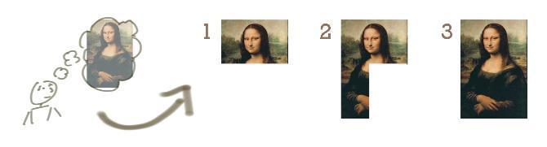

FIGURE 1: THE TRADITIONAL APPROACH (PHASED DELIVERY OF KNOWN OUTPUTS)

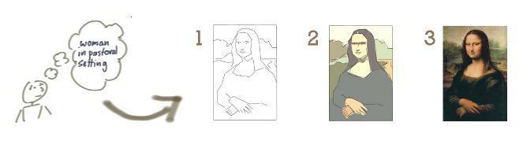

FIGURE 2: THE AGILE APPROACH (ITERATIVE DELIVERY TO MEET CHANGING EXPECTATIONS )

## UNDERSTANDING WASTE

The techniques and frameworks within Agile aim to increase development efficiency, by eliminating all ‘wasteful’ processes. Drawing on the successful concepts from the Lean manufacturing frameworks, we can define 3 major forms of waste.

* **Mura (Unevenness):** Mura exists where there is a variation in workflow, leading tounbalanced situations, most commonly where workflow steps are inconsistent, unbalanced, or without standard procedures.

1. Images with thanks from Jeff Patton: http://www.agileproductdesign.com/

Notes:

Introduction to Scrum (cc)-by-sa – Evan Leybourn Page 8 of 84

Introduction to Scrum

* **Muri (Overburden):** Muri exists where management expects unreasonable effortfrom personnel, material or equipment, most commonly resulting from unrealistic expectations and poor planning.
* **Muda (Waste):** Muda is any step in the production workflow that does not adddirect value to the Customer. The original seven wastes, as defined by the Toyota Production System (TPS), were:
  1. Transport,
  2. Inventory,
  3. Motion (moving more than is required),
  4. Waiting,
  5. Overproduction,
  6. Over Processing (from poor design), and
  7. Defects (the effort involved in inspecting for, and fixing, defects).

## CRITICAL SUCCESS FACTORS

The successful application of an agile methodology depends on the relative maturity of an organisation in relation to Customer Engagement, Staff Resources, Technology, and Processes. These measures are defined as follows:

* Customer Engagement – Product owners involved in teams daily activities, defines requirements, drives the prioritisation of requirements, and has decision making delegation of authority.
* Staff – have experience in an agile method, are skilled in the Standard Operating Environment (SOE) toolsets, have an understanding of the underlying data and technical infrastructure, and are conversant in the development, testing, and configuration and release procedures.
* Technology – a stable and well documented technology stack, with clearly defined ownership and service levels, providing discreet development, testing and release environments that are sized and supported for the delivery of projects, and controlled through rigorous configuration and release management.
* Processes – business processes exist for all domains, with cross stream interdependencies defined and service levels agreed, and clear business ownership and delegations of authority identified.

Notes:

Introduction to Scrum (cc)-by-sa – Evan Leybourn Page 9 of 84

Introduction to Scrum

## COMMON MISCONCEPTIONS

Being a generic term, Agile means different things to different people. Therefore, before we go much further, I should clarify some of the more common misconceptions surrounding Agile.

* **Agile is ad hoc, with no process control:** First of all, Agile isn’t a lack of process.

Agile provides a range of formal processes, and methods, to inform work processes, customer engagement and management models. Conversely, Agile isn’t about blindly following the prescribed ‘agile’ methods and processes. Agile is about using your common sense to apply processes, as determined by the current situation, and shaped by the agile philosophy.

* **Agile is faster and/or cheaper:** Agile isn’t significantly faster, or cheaper, thanalternative frameworks. Put another way, in most cases you can’t get significantly more effort out of your Teams by moving to an agile approach. While there is an overall efficiency gain when utilising agile methods, well-managed Agile and non-Agile Teams will deliver products and services in approximately the same time and effort.
* **Agile teams do not plan their work or write documentation:** Agile is not anexcuse to avoid appropriate planning or writing documentation. It is an on-demand, or Just-In-Time, approach that encourages continuous planning and documentation, but only when needed for specific Customer Requirements. This allows Customers and Teams to determine if the planning, or document, adds value to the process or product. It creates an opportunity to emphasise valuable documents, and eliminate anything that isn’t useful.
* **An Agile project never ends:** While this may be true in some situations, the benefitof Agile is that work will continue while the Customer continues to gain business value, and that value is worth more than the cost of developing it. Most projects, in any industry, have a point of diminishing returns. This is the ideal time for an agile project to end.
* **Agile only works for small organisations:** Agile works for projects, teams andorganisations of any size, not just small projects. That is not to say that it will work for all organisations, but size is rarely a factor. Large and complex projects and organisations are often excellent candidates for Agile transformation, where it is difficult, or impossible, to know all your Customer’s Requirements in advance.

Notes:

Introduction to Scrum (cc)-by-sa – Evan Leybourn Page 10 of 84

Introduction to Scrum

* **Without upfront planning, Agile is wasteful:** This assumes that your Customerknows the detail of all of their Requirements in advance. If this is true, then by all means, undertake comprehensive upfront planning. However, in reality this is rare, and usually leads to the greater ‘waste’ of having undertaken design and development work that was ultimately unnecessary. Agile Business Management encourages minimal upfront planning, ensuring everyone is working towards the same goal, and reduces the risk of miscommunication.
* Finally, **Agile is not the solution to all your problems.** It is a change in approach and culture that comes with its own set of benefits and issues.

## SCRUM OVERVIEW

Scrum is described as a ‘framework within which you can employ various processes and techniques’, rather than a process, or a technique, for building products. The Scrum framework is primarily team based, and defines associated roles, events, artefacts and rules. The three primary roles within the Scrum framework are:

1. The product owner who represents the stakeholders,
2. The scrum master who manages the team and the Scrum process
3. The team, about 7 people, who develop the software.

Each project is delivered in a highly flexible and iterative manner where at the end of every sprint of work there is a tangible deliverable to the business. This can be seen in the following diagram.

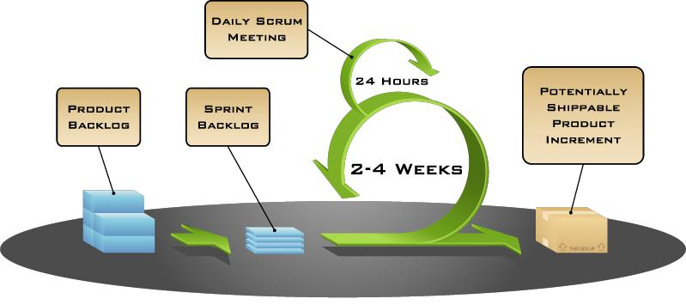

FIGURE 3: SCRUM FRAMEWORK

Notes:

Introduction to Scrum (cc)-by-sa – Evan Leybourn Page 11 of 84

Introduction to Scrum

The requirements that form the basis of the project are collated into what is called a Project Backlog, and is updated regularly. The features that are associated with these requirements are termed User Stories. This relationship is illustrated in the following diagram:

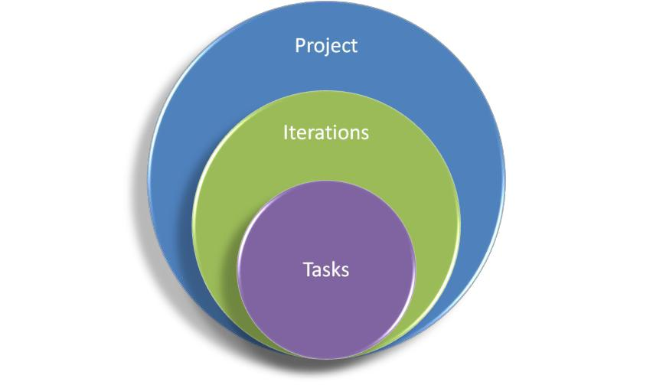

FIGURE 4: SCRUM PROJECT STRUCTURE

The work is time-boxed into a series of 1 to 4 week cycles where the business and project team estimate which User Stories in descending priority order are achievable each cycle, or Iteration. This subset of User Stories from the Project Backlog form the basis of the Iteration Backlog planned for delivery over that two week period.

Under Scrum, there are 3 timeboxed (or fixed duration) meetings held during an Iteration plus a daily stand-up meeting for the team, scrum master and (ideally) the product owner. At the beginning of a sprint, features to be developed during the sprint are decided during the sprint planning meeting. At the end of the Iteration are another 2 meetings, the Iteration review and Iteration retrospective where the team reviews the product and demonstrates the use of the software, as well as reflect on, and improve, the Iteration process itself.

After the sprint is complete, the next set of User Stories is selected from the Project Backlog and the process begins again. Burn rate is monitored to determine when funding will be exhausted.

Notes:

Introduction to Scrum (cc)-by-sa – Evan Leybourn Page 12 of 84

Introduction to Scrum

TABLE 1: KEY SCRUM CONCEPTS

|  |  |
| --- | --- |
| **Concept** | **Description** |
| **Project** | Discreet set of end user requirements that |
|  | have been grouped, prioritised and funded. |
| **Requirement** | The end user statement that outlines their |
|  | information need. |
| **Sprint** | A sprint is a 1 to 4 week time-boxed event |
|  | focused on the delivery of a subset of User |
|  | Stories taken from the Project Backlog. |
| **Project Backlog** | The Project Backlog is the current list of |
|  | User Stories for the Project. User Stories can |
|  | be added, modified or removed from the |
|  | Backlog during the Project. |
| **Sprint Backlog** | Subset of User Stories from the Project |
|  | Backlog that are planned to be delivered as |
|  | part of a Sprint. |
| **User Stories** | The User Story is a one or two line |
|  | description of the business need, usually |
|  | described in terms of features. |
| **Tasks** | Tasks are the activities performed to deliver |
|  | a User Story. |
| **Technical Debt** | This refers to items that were either: |
|  | • missing from the Planning meeting; |
|  | or |
|  | • deferred in favor of early delivery. |

Notes:

Introduction to Scrum (cc)-by-sa – Evan Leybourn Page 13 of 84

Introduction to Scrum



# PROJECT ROLES



*‘So Mr Edison, how did it feel to fail 10,000 times?’*

*‘Young man, I didn’t fail, I found 9,999 ways that didn’t work’*

*Thomas Edison, anecdotal (on his invention of the incandescent light)*

Notes:

Introduction to Scrum (cc)-by-sa – Evan Leybourn Page 14 of 84

Introduction to Scrum

## PROJECT TEAM

The project team is a self governing group capable of independently delivering to a customer’s requirements. As a result the team requires cross functional representation of skills and knowledge in the data, tools and infrastructure domains.

A typical project team can be comprised of the following:

* Product Owner
* Scrum Master
* Architects / Analysts
* Designers
* Developers

The project team characteristics and responsibilities are as follows:

* 7 ± 2 (5 to 9) resources who are allocated full-time to an Sprint
* Cross functional in nature across skills, applications, data and organisational knowledge
* Self empowered
* Responsible for delivering the product
* Determine the tasks required to deliver each feature
* Estimate the effort for each task
* Develop the features
* Resolve issues

Ideally the project team, including the product owner are co-located.

## INTERESTED AND COMMITTED

Interested roles are individuals who have an “interest” in the software development. Whilst they should be kept informed of progress, they do not have the same level of responsibility and input into the development as committed roles. Interested parties include the Users, the Customers and the Product Owner.

Committed roles are responsible for the software development, and are the people who “do” the work. Committed parties include the Scrum Master, the Team and Testers.

Notes:

Introduction to Scrum (cc)-by-sa – Evan Leybourn Page 15 of 84

Introduction to Scrum

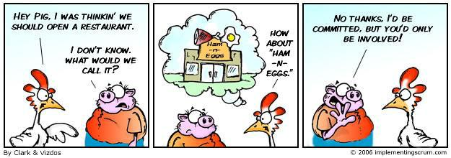

FIGURE 5: PIGS AND CHICKENS

## PRIMARY ROLES

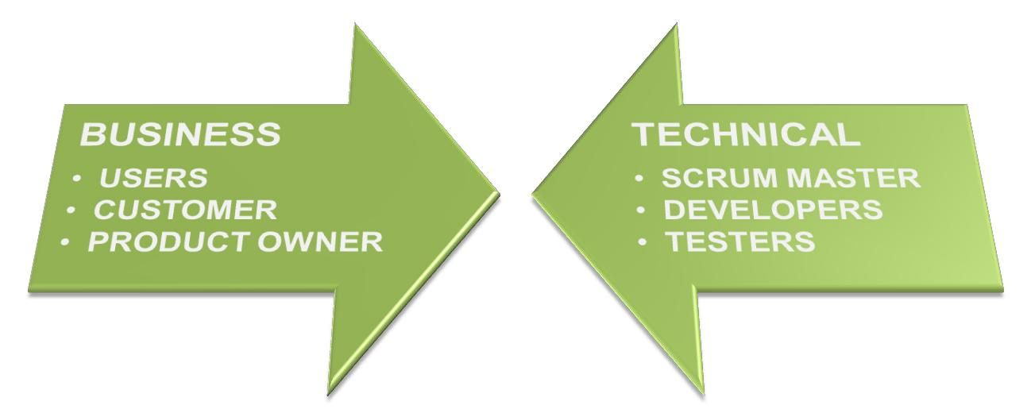

FIGURE 6: BUSINESS VS TECHNICAL ROLES

Notes:

Introduction to Scrum (cc)-by-sa – Evan Leybourn Page 16 of 84

Introduction to Scrum

TABLE 2: PRIMARY SCRUM ROLES

|  |  |  |  |  |  |  |  |  |  |  |
| --- | --- | --- | --- | --- | --- | --- | --- | --- | --- | --- |
|  | **Role** |  | **Primary Responsibility** | |  | **Typical** | | **Does Not** | |  |
|  | **Users** |  | • | Use the software |  | • | There are no typical | • | Set Scope |  |
|  | *Interested Role* |  | • | Identify issues & |  |  | users. | • | Test Work |  |
|  |  |  | • | Provide feedback |  |  |  |  |  |  |
|  |  |  |  |  |  |  |  |  |
| **Customers** | |  | • | Define, start and end |  | • | Internal managers | • | Direct Work |  |
| *Interested Role* | |  |  | the project |  | • | External Clients |  |  |  |
|  | **Product** |  | • | Manage the product |  | • | Project Manager | • | Manage the |  |
|  | **Owner** |  |  | backlog |  | • | Product manager |  | Team |  |
|  | *Interested Role* |  | • | Set the scope |  | • | Customer |  |  |  |
|  |  |  |  |  |  |
|  |  |  | • | Approve Releases |  |  |  |  |  |  |
| **Scrum Master** | |  | • | Manage the Agile |  | • | Project manager | • | Prioritise |  |
| *Committed* | |  |  | process |  | • | Team Leader |  | features |  |
| *Role* | |  | • | Report on progress |  | • | Team member |  |  |  |
|  | **Developers** |  | • | Develop features |  | *cross functional* | | • | Prioritise |  |
|  | *Committed* |  | • | Resolve issues |  | • | Developer |  | features |  |
|  | *Role* |  |  |  |  | • | Designers |  |  |  |
|  |  |  |  |  |  |  |  |
|  |  |  |  |  |  | • | Writers |  |  |  |
|  |  |  |  |  |  | • | Administrators |  |  |  |
| **Testers** | |  | • | Test |  | • | Existing developers | • | Test their own |  |
| *Committed* | |  | • | Approve or reject |  | • | Dedicated testers |  | code |  |
| *Role* | |  |  | features for release |  |  |  |  |  |  |

Notes:

Introduction to Scrum (cc)-by-sa – Evan Leybourn Page 17 of 84

Introduction to Scrum



# SPRINT 0 – Project Initiation



aka Feasibility

aka Project Initiation

aka Sprint 0 (XP)

*‘It is always wise to look ahead, but difficult to look further than you can see.’ Winston Churchill, ~1960*

Notes:

Introduction to Scrum (cc)-by-sa – Evan Leybourn Page 18 of 84

Introduction to Scrum

## SPECIFICATIONS IN AGILE?

Contrary to common opinion, it is very important to have a good specification before starting an agile project. By building this specification (or backlog in agile terminology) a project will;

* Reduce Risk & Uncertainty
* Improve Decision Making and integrate With Long term Goals
* Improved cost planning (including Staff Hiring)
* Prioritise research and information Gathering

## BEGINNING THE PROCESS

Unlike traditional waterfall methods, the specification phase of an agile project is very short; usually no more than 1 or 2 days, and the full team should be available at inception. During the period the customer should be made fully aware of their role. The design should contain the following;

* Problem statement that needs to be addressed
* Desired business objectives, outcomes and benefits for this project
* Identified key stakeholders
* High Level Business Requirements
* Architectural and technical scope
* Testing requirements

## OUTCOMES

The outcomes from Project Initiation, or Sprint 0, are:

* The team should be identified and brought together
* If not part of the team, identify and train the product owner
* Create the product backlog in low detail. Allow customers to slowly build the product requirements throughout the process.
* Estimate the product backlog.
* Plan length of the sprint, anywhere from 1 day to 4 weeks. Each sprint should accomplish something releasable. Short sprints short can reduce overtime.
* Add any team training to the backlog as tasks.

Notes:

Introduction to Scrum (cc)-by-sa – Evan Leybourn Page 19 of 84

Introduction to Scrum

## BACKLOG

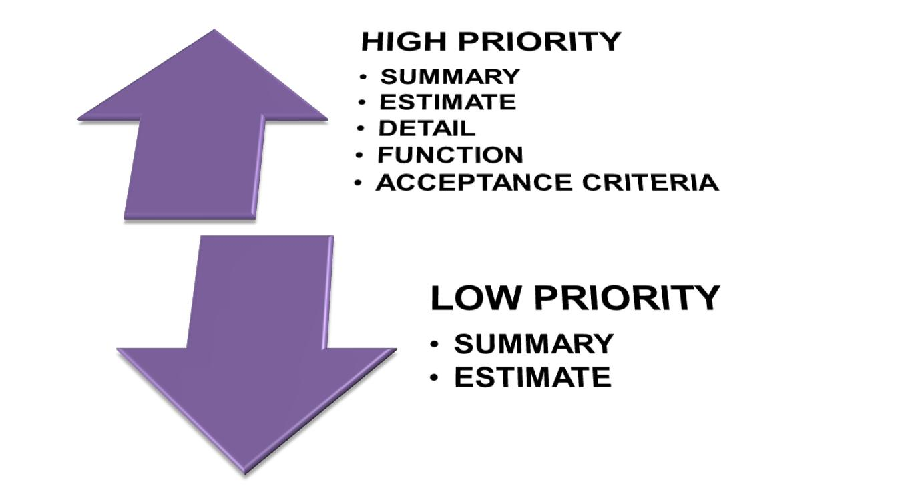

FIGURE 7: PRODUCT BACKLOG

The backlog contains all the User Stories (features) for the product. The Product Owner is responsible for defining the User Stories, and assigning each with a priority for delivery. The order may also be influenced by Story dependencies or business value e.g. a lower priority Story may need to be done first before a higher priority Story can be started.

The User Stories describe the set of features that will satisfy each Information requirement. The high priority User Stories that are candidates for the next Sprint require sufficient detail for the team to solution, and should be sized to fit within two weeks.

Each User Story should meet the INVEST characteristics, as defined by Bill Wake.

* Independent: Each Requirement should be as self-contained as possible, with minimal dependencies on any other Requirement. This allows for easy reordering or removal, as Customer Requirement’s change.

Notes:

Introduction to Scrum (cc)-by-sa – Evan Leybourn Page 20 of 84

Introduction to Scrum

* Negotiable: The Customer can change a Requirement at any time, up to the point it

enters the Sprint Backlog (see Chapter 4: Work, the Agile Way).

* Valuable: Each Requirement should deliver a tangible, and measurable, benefit to the Customer.
* Estimatable: The definition of each Requirement is such that the Team can estimate it.
* Small: The estimate, and delivery, of a Requirement, should be within a few days, or a single Sprint.
* Testable: Each Requirement should have appropriate quality control and quality assurance metrics, so the Customer can validate their Deliverables against the original Requirement.

Each feature should contain, at a minimum, the function, priority, an estimate of the effort to develop and the estimate risk (0 - 100%) based on how accurate the team feels the estimate is.

In can be helpful to structure each User Story in the following format.

*As a [role]*

*I want a [goal/desire]*

*So that [benefit]*

The [role] is the expected end-user of the User Story, who is usually different from the Customer. The [goal/desire] of each User Story describes what should be delivered, and the [benefit] provides the context, or the Why.

Notes:

Introduction to Scrum (cc)-by-sa – Evan Leybourn Page 21 of 84

Introduction to Scrum

## ACCURACY

### 

FIGURE 8: ESTIMATE ACCURACY OVER TIME

It is important to note that to increase the accuracy of any estimate, the effort involved increases exponentially. In Agile, we are only interested in the initial estimation.

By keeping Sprints short, we can better review and respond to deviations in the estimate quickly. See the Burndown chart chapter for more information.

Notes:

Introduction to Scrum (cc)-by-sa – Evan Leybourn Page 22 of 84

Introduction to Scrum

## ESTIMATING EFFORT

### STORY ESTIMATION

A Story Point is single number intended to represent all of the work required for the whole team to build the final product. As a result, to perform estimation based on Story Points it requires cross functional representation of all the requisite skills and knowledge in the Business Intelligence Platform data, tools and infrastructure during the Sprint Planning meeting.

Story Points are used for the high level estimation of User Stories. They are usually based on the delivery of similar User Stories in previous Sprints. This assumes that the project team, data and infrastructure are relatively constant between one project and the next. The size of a Story Point for a given project team will eventually normalise over time.

All Stories should be assigned as estimated effort, or cost, to implement. We use a modified Fibonacci series, such as 1, 2, 3, 5, 8, 13, 20, 40, and 100, to represent effort. This encourages features to be split into the smallest task possible, and provides a more realistic estimate range.

### TASK ESTIMATION

Task estimation is performed at the Sprint level. During the Sprint Planning session the team breaks the User Stories into their composite tasks to determine how they will be delivered. The process of solution decomposition may reveal additional tasks, or more complex tasks that were not apparent during the high level Story Point based estimation that impact what was planned to be delivered. The scope of the Sprint can be renegotiated with the product owner if this is the case. Unlike Story Points, these estimates are an indicative idea of how much time they will take in an ideal world.

**HOW?**

Tasks can be estimated in 4 ways.

1. **Expert opinion:** The team member with specific understanding, or who is mostlikely to develop the task, can provide a more accurate estimate of effort.

E.g. A database administrator can better estimate effort for database tasks.

Notes:

Introduction to Scrum (cc)-by-sa – Evan Leybourn Page 23 of 84

Introduction to Scrum

1. **Comparison:** Comparing a task to another, already estimated, task.e.g. "Task A is about twice the effort of Task B"
2. **Components:** If a task is too large to accurately estimate, break it into small sub-tasks.

e.g. User management can be broken into interface, login, ACL, etc.

1. **Planning poker:** If using Planning Poker, estimates must not be mentioned at allduring discussion to avoid anchoring. A timer may be used to ensure that discussion is structured; any person may turn over the timer and when it runs out all discussion must cease and a round of poker is played.

Each person lays a card face down representing their estimate of the task, and then simultaneously turns their cards over.

People with high estimates and low estimates are given an opportunity to discuss their estimate before anyone else can speak.

Repeat the estimation process until a consensus is reached.

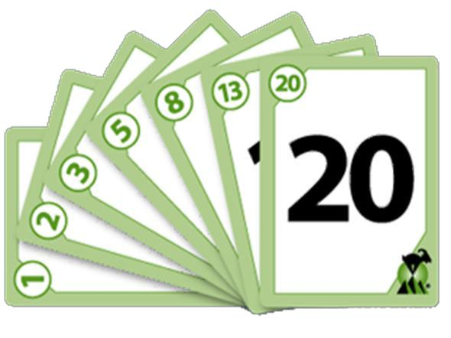

FIGURE 9: PLANNING POKER CARDS

Notes:

Introduction to Scrum (cc)-by-sa – Evan Leybourn Page 24 of 84

Introduction to Scrum

## ESTIMATING TIME

Converting an estimated cost into estimated time is very simple. There are 2 primary modifiers that we use. Staff overhead and estimate accuracy (or risk).

**STAFF OVERHEAD**

This is a percentage modifier for staff availability to work on specific project tasks. It allows you to take into account factors such as estimated leave, illness, breaks, scrum meetings etc. The industry standard modifier is 25%-40%, though you should modify this as required. To calculate staff overhead use the following process;

*working hours = (hours per day * days per sprint * staff) – planned leave project hours = sum of actual (from last sprint) staff overhead = (working hours/project hours) – 1*

**CALCULATION**

*Story Cost x (Staff Overhead + 1) x (Estimate Risk + 1)*

*e.g.*

*4 x (25%+1) x (50%+1)*

* *4 x 1.25 x 1.5*
* *5 to 7.25 hours*

Notes:

Introduction to Scrum (cc)-by-sa – Evan Leybourn Page 25 of 84

Introduction to Scrum

## COST / TIME / SCOPE

*“How much is this going to cost?” - “As much as you're willing to spend.” “How long is this going to take?” - “As long as it necessary.” “What am I going to get?” - “Whatever you tell us you want.”*

**FIXED COST**

Where a customer asks for a fixed price quote prior to agreeing to project commencement, but is flexible on what is delivered and how long it takes.

* Work in absolute customer priority order – reducing the time spent on technical helper tasks will help meet short-term budget constraints (at the cost of long term, post-project, efficiency)
* Release in short (1-2 week) sprints – similar to longer waterfall projects, longer sprints have a tendency to cost overruns to deliver on time
* Monitor velocity and burn rate – this is your key indicator of cost

**FIXED TIME**

Where a customer asks for delivery by a certain date, but is flexible in scope and cost.

* Work in absolute business value order – increases the number of user stories complete in a given sprint (high business value = simple, moderate-high priority)
* Enforce sprint duration – Your project will be defined by a fixed number of sprints, and extending an sprint will push out your final date

**FIXED SCOPE**

Where a customer asks for a fixed set of deliverables, but is flexible in the time it takes to deliver and the cost of delivery. This is sometimes known as “heavy agile”.

* Focus on backlog definition and estimation during Sprint 0 to ensure accurate scope definition

Notes:

Introduction to Scrum (cc)-by-sa – Evan Leybourn Page 26 of 84

Introduction to Scrum

**FIXED COST AND SCOPE**

Where the customer asks for a fixed price quote for a fixed set of deliverables. In this situation, the final date for delivery is flexible. As well as the points in fixed cost and fixed scope;

* Increase the estimate risk during Sprint 0 – to ensure your quote for the project allows for unexpected delays (which would impact on your cost to deliver)
* Update delivery date as required

**FIXED COST AND TIME**

Where the customer asks for a fixed price quote by a fixed time. In this situation, the exact set of features (or scope) for delivery is flexible. As well as the points in fixed cost and fixed time;

* Calculate total cost as cost per sprint – which makes your quote to the customer very simple.

**FIXED TIME AND SCOPE**

Where the customer asks for a fixed set of deliverables by a fixed time. In this situation, the total cost to the customer is flexible. As well as the points in fixed time and fixed scope;

* Pre-assign work to sprints during Sprint 0 – which will define the scope delivery timetable.
* Pad schedule with extra sprints – to cater to unexpected defects or technical debt
* Increase the size of the team 3-4 sprints prior to the end of the project if required – to ensure the set of features are completed in time.

**FIXED COST, TIME AND SCOPE**

Where the customer gives no flexibility in the project.

Cancel the project – this is not an agile project. This should be run using a waterfall methodology such as PRINCE2 (and even they are likely to fail without some flexibility)

Notes:

Introduction to Scrum (cc)-by-sa – Evan Leybourn Page 27 of 84

Introduction to Scrum



# STARTING AN SPRINT



*‘Make everything as simple as possible, but not simpler.’ Albert Einstein (paraphrased), 1933*

Notes:

Introduction to Scrum (cc)-by-sa – Evan Leybourn Page 28 of 84

Introduction to Scrum

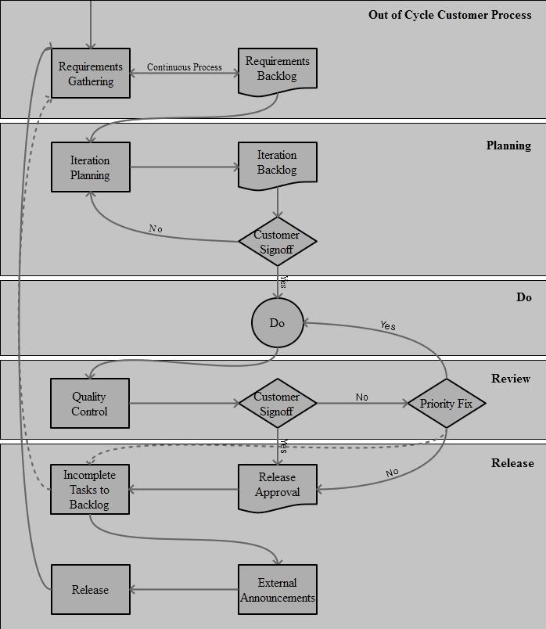

FIGURE 10: EXAMPLE BUSINESS PROCESS FLOWCHART

Notes:

Introduction to Scrum (cc)-by-sa – Evan Leybourn Page 29 of 84

Introduction to Scrum

## SPRINT PLANNING MEETING

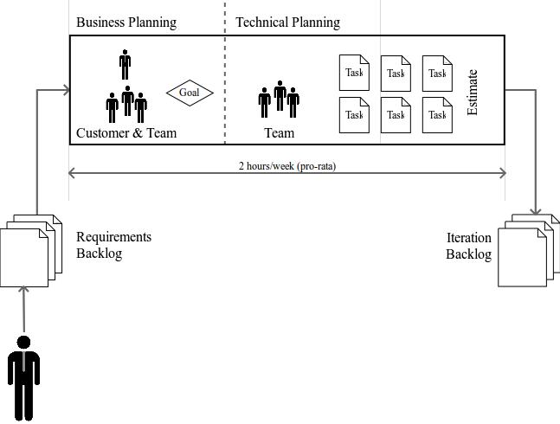

FIGURE 11: SPRINT PLANNING

The Sprint Planning Meeting is run before the start of each Sprint, and allows the customer and developers to discuss the requirements and work required for the next release. This step in the Scrum process focuses on determining the target scope of delivery for a Sprint, and defines the sprint backlog. The Sprint Planning Meeting should be no more than 8 hours long (4 weeks pro rata).

The Product Owner and Scrum Master are responsible for updating the Project Backlog in preparation for the Sprint Planning meeting. This includes clarification, prioritisation and in some cases investigation of the feasibility of the collated User Stories. This activity also needs to take into consideration any technical debt inherited from previous Sprints.

**PART 1 – BUSINESS SPECIFICATIONS**

The first part of the sprint planning meeting aims to convert features from the backlog into a realistic goal for this sprint. The product owner is a part of this process and sets the priority of the tasks. This also provides the Product Owner with the opportunity to communicate the required scope of delivery, provide the business context and priority, and address any questions the project team may have to assist with performing the solution

Notes:

Introduction to Scrum (cc)-by-sa – Evan Leybourn Page 30 of 84

Introduction to Scrum

decomposition and estimation steps. This part of the meeting should take no more than ¼ of the time.

Ensure that a copy of the Project Backlog has been distributed prior to the Sprint Planning meeting to provide the project team with time to consider solution options for discussion during the workshop, and prepare clarification questions for the Product Owner.

The participants for this session are as follows:

* Product Owner
* Scrum Master
* Team
* Testers

**PART 2 – TECHNICAL SPECIFICATIONS**

The second part of the Sprint Planning meeting is technical, and usually without the product owner. This is the solution decomposition and estimating step in the planning process and aims to estimate the effort for all features in the release and (optionally) write the test cases.

The general flow of activity in this step is described in the following diagram:

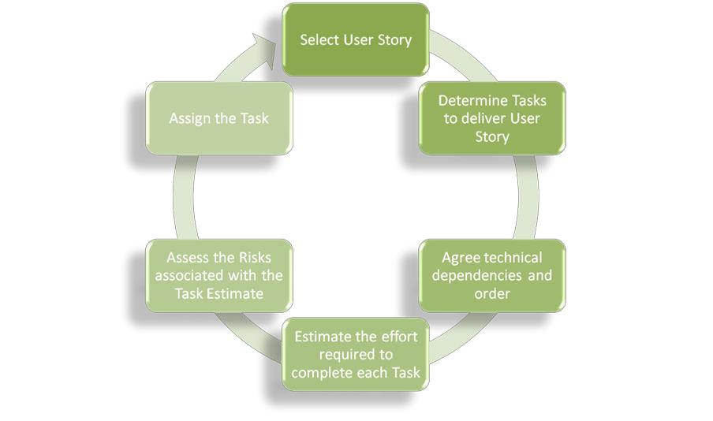

FIGURE 12: DESIGN AND PLANNING WORKFLOW

Notes:

Introduction to Scrum (cc)-by-sa – Evan Leybourn Page 31 of 84

Introduction to Scrum

As a guideline, large tasks should be broken into tasks preferably no longer than 1 day and tasks that involve waiting should be split into separate tasks. Research tasks should have a high estimate risk. This is done to enable accurate tracking and the calculation of velocity.

For complex User Stories or those with a high number of interdependencies it may be necessary to split the task decomposition and estimating activities across 2 days and allow the team members an opportunity to consult with external parties on feasibility and obtain input into the estimating process.

Always remember that tasks can be created, but features can't.

The participants for this session are as follows:

• Scrum Master

• Team

• Testers

TABLE 3: KEY PLANNING ELEMENTS

|  |  |
| --- | --- |
| **Planning Element** | **Description** |
| **User Story** | The User Story is a description of the |
|  | business need, usually expressed as a |
|  | feature. |
| **Story Identifier** | Every User Story will be assigned a unique |
|  | identifier for tracking purposes. |
| **Task** | A task is typically a single activity that can be |
|  | described in one sentence that contributes |
|  | to the delivery of a User Story. |
|  | • Generally a task takes no longer than 4-8 |
|  | hours of effort to complete |
|  | • There may be one or many Tasks per |
|  | User Story |
|  | • The task can only be assigned to and |
|  | owned by one person at a time |
| **Task Identifier** | A Unique identifier will be assigned to track |
|  | each Task, and show which User Story they |
|  | are associated with. |
| **Project Function** | This describes the architectural layer where |
|  | the Task activity will be performed. |

Notes:

Introduction to Scrum (cc)-by-sa – Evan Leybourn Page 32 of 84

Introduction to Scrum

|  |  |  |
| --- | --- | --- |
| **Assignee** | This is the person who will be responsible | |
|  | for delivering the task. This can done at any | |
|  | point in the Sprint. The person assigned to | |
|  | the completion of the Task may also change | |
|  | at any point in the Sprint. | |
| **Estimate** | The estimate in hours is the amount of | |
|  | effort the team agrees is required to | |
|  | complete the specified Task. The estimate | |
|  | includes: | |
|  | • | Analysis |
|  | • | Build |
|  | • | Unit Test |
|  | • Migrate from DEV to TEST | |
|  | • | Integration Testing |
|  | • | Documentation |
| **Estimate Risk Modifier** | This is a measure of the confidence level | |
|  | associated with the estimate provided and | |
|  | represented as a numeric modifier. | |

**NOTES**

* Prepare beforehand.
* This is a creative, problem solving process. Encourage brainstorming.
* Ensure the planning room has plenty of paper, a whiteboard and a computer with Google access.

Notes:

Introduction to Scrum (cc)-by-sa – Evan Leybourn Page 33 of 84

Introduction to Scrum



# DURING AN SPRINT



*‘Treat your men as you would your own beloved sons. And they will follow you into the deepest valley.’*

*Sun Tzu, ~6th Century BCE*

Notes:

Introduction to Scrum (cc)-by-sa – Evan Leybourn Page 34 of 84

Introduction to Scrum

## DAILY LIFECYCLE

The daily lifecycle of team activities is as follows;

1. Team members select the next Task to work on
2. Undertake the task as described
3. Commit and share the completed task with the rest of the team
4. Write and run the tests that will be used to verify they have been completed successfully. Verification, unit testing and documentation need to be completed prior to migrating the deliverable from DEV to SIT.

The assignee for a Task may change at any of these steps. Team members will proactively interact will their colleagues and any internal parties as required to progress the assigned Task to completion, including any quality assurance and review.

The governance of the daily lifecycle is through the daily Scrum Meeting.

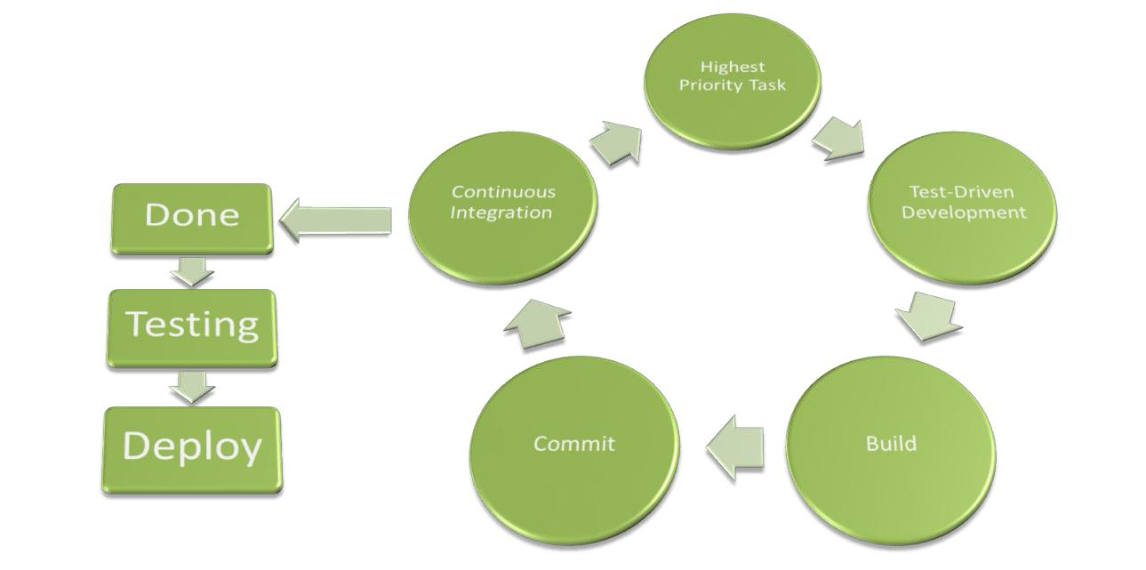

FIGURE 13: WORK LIFECYCLE

Notes:

Introduction to Scrum (cc)-by-sa – Evan Leybourn Page 35 of 84

Introduction to Scrum

## TASK LIFECYCLE

Based on Kanban, a task will progress through a minimum of 4 different states during its lifecycle. Each task and state should be visible to the team, product owner and customer; commonly this is done through a card wall or integrated dashboard.

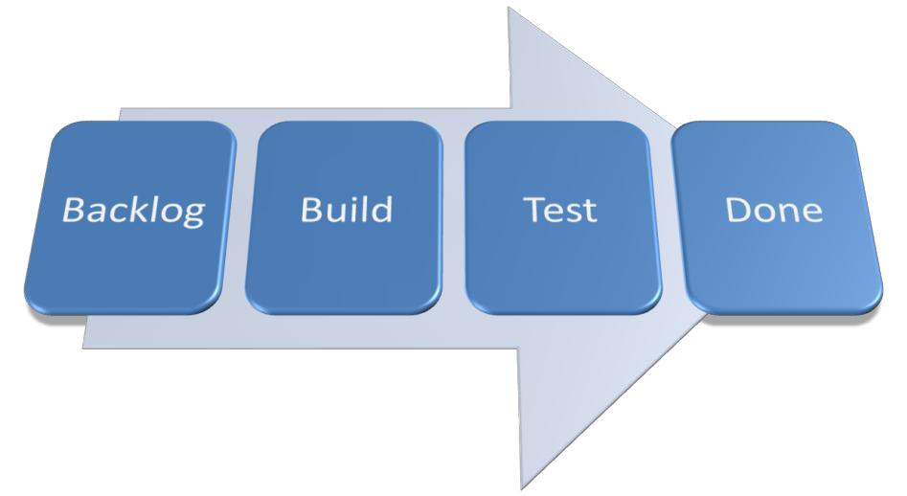

FIGURE 14: BASIC TASK LIFECYCLE

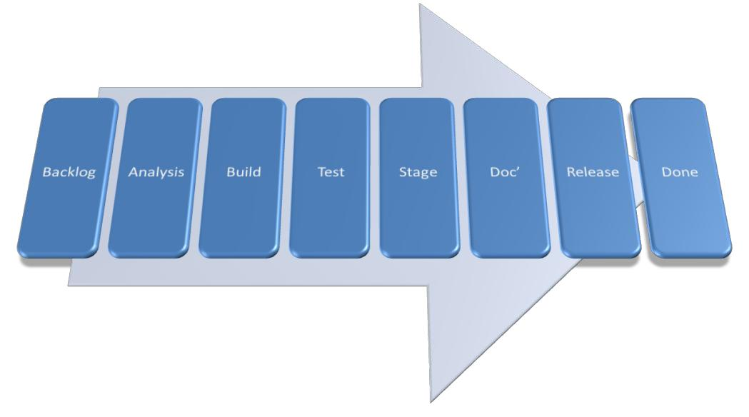

FIGURE 15: COMPLEX TASK LIFECYCLE

Notes:

Introduction to Scrum (cc)-by-sa – Evan Leybourn Page 36 of 84

Introduction to Scrum

## SPRINT BACKLOG

The Sprint Backlog is the subset of User Stories from the Project Backlog that the Product Owner and project team agreed would be delivered for this Sprint.

The User Stories will be broken into tasks which are put into the Sprint Backlog. Based on the logical sequencing of tasks and agreed prioritisation, the project team members select the next task to work on and promote this to the “In Progress” state.

**IN PROGRESS**

In Progress items are Tasks that are actively being worked on. This includes both development and unit testing activities. Once the task has been completed it is promoted to the “Testing” state.

In Progress Tasks include the following types of activity being performed:

* Analysis
* Build
* Unit Test
* Documentation

When a Task has been completed the deliverable will be changed to the “Testing” state. In the case of code based artefacts these will be promoted from the development environment to the test environment.

**BLOCKED**

Blocked items are Stories and or Tasks that have upstream or downstream dependencies external to the project team that are preventing progress. These impediments are moved to this holding state to highlight these issues to the Scrum Master and Product Owner for escalation and resolution.

**TESTING**

Testing, in this context, is performed by the team’s specialist testing resources. Unit testing is expected to be undertaken by the developers.

**DONE**

Tasks are considered “Done” when:

Notes:

Introduction to Scrum (cc)-by-sa – Evan Leybourn Page 37 of 84

Introduction to Scrum

* Code has been produced, meets development standards, and has been checked in and run against current version in source control
* Unit tests written and passed
* System tested and passed
* Quality Assurance reviewed
* Builds without errors for deployment
* Relevant documentation, including diagrams have been produced or updated and communicated

When the Sprint has completed the User Stories selected by the team to be delivered are either “Done” or “Not Done”. The decision over whether a User Story is Done is based on whether all the pre-requisite Tasks associated with this Story have been completed. The completed User Stories are presented to the Product Owner in the Sprint Review for acceptance and sign-off.

**NOT DONE**

Tasks that are “Not Done” are reviewed in the context of the User Stories that they belong to and if this impacts whether the User Story can be considered delivered. The not done tasks may be rolled into a new User Story for the next Sprint, accrued as technical debt, or it may be decided that they are no longer required and are removed.

## DEVELOPMENT HINTS

**FEATURES**

Get the highest priority feature from the Sprint backlog. Allow developers to choose their work, don't assign it. The backlog can be updated mid-sprint if critical changes are required.

**DEVELOP**

Agile also makes some suggestions on improving the development process. These are;

* **Pair Programming:** Two developers working together, the first as a coder and theother as a reviewer. These roles should change regularly, and the pairs themselves should switch pairs each day
* **Code Standards:** A common coding style (Documentation, Names, Whitespace, etc)
* **System Metaphor:** All classes and functions should be named such that theirpurpose is understood.

Notes:

Introduction to Scrum (cc)-by-sa – Evan Leybourn Page 38 of 84

Introduction to Scrum

**COMMIT**

Everyone must commit every day, and should never commit broken code. (Continuous Integration)

**TRANSPARENCY**

Key to Agile is transparency between the product, the team and the customers.

Customers can:

* Attend scrums. However they should not talk. Questions should be directed to the Product Owner or Scrum Master. An alternative is to record the scrums and make the recording available to the customer.
* See the product and sprint backlog in its current state.
* See the state of each task via a card wall or integrated dashboard.
* Access a test version of the software from the development environment.

## TEST DRIVEN DEVELOPMENT

**KEY POINTS**

Tests are written by the Customer and Developer together and are written before the code. Both automated unit tests and user acceptance tests should be written. There is no issue with using standards such as IEEE 829 and IEEE1008 to document and write tests.

By using TDD, the team can prove how well a project is going and how close to completion. This in turn, allows customers and product owner to make informed decisions about the project.

**TEST COVERAGE**

The tests should cover;

* Software functions,
* Boundary cases,
* User interface,
* User experience,
* Non-functional components,
* Performance

Notes:

Introduction to Scrum (cc)-by-sa – Evan Leybourn Page 39 of 84

Introduction to Scrum

**TEST TYPES**

There are 4 types of tests that can be written.

1. Defect
2. Functionality
3. Usability
4. Data

**TDD IN DEVELOPMENT**

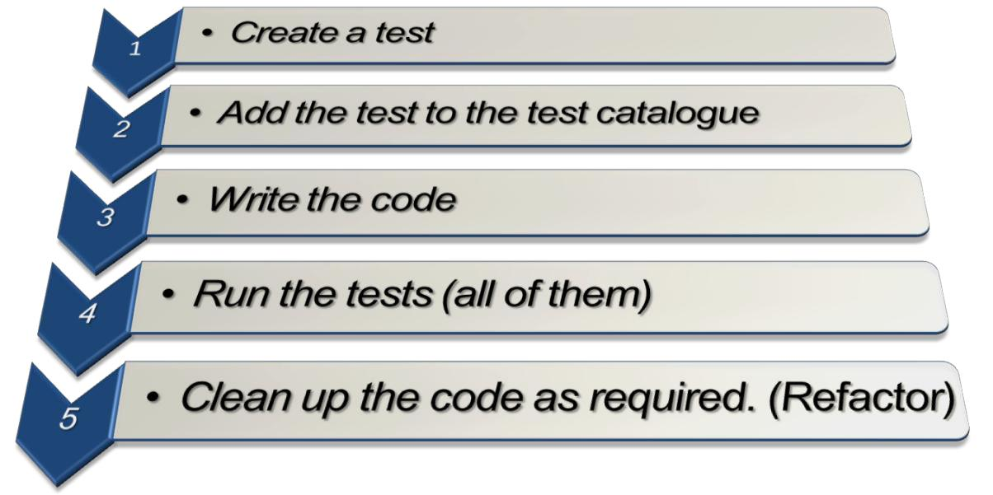

FIGURE 16: TDD WORKFLOW

**CONTINUOUS INTEGRATION**

**UNIT TESTING**

Runs predefined tests to identify software defects

* Create tests for each class and function
* Create tests for all parameter combinations
* Create tests for all edge cases
* Create tests to examine the database for logical errors
* Create tests to detect interface defects (Selenium)
* Tests should be kept in the version control repository
* Test in a clone of the production environment

Notes:

Introduction to Scrum (cc)-by-sa – Evan Leybourn Page 40 of 84

Introduction to Scrum

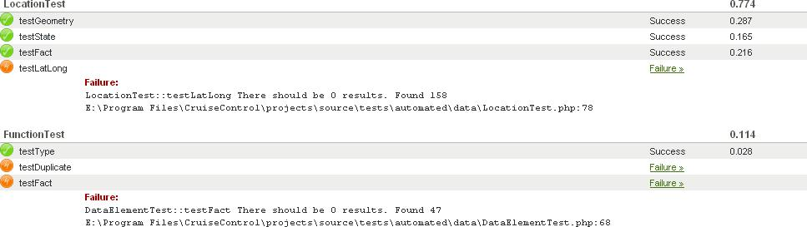

FIGURE 17: UNIT TEST SCREENSHOT

**CODE STANDARDS**

Inspect the developed code for deviations from the internal code standard

* Check for correct inline documentation (docblock)
* Check for correct variable naming conventions
* Check for correct whitespacing conventions
* Check for complex code that may require refactoring
* Check for incomplete or unused functions

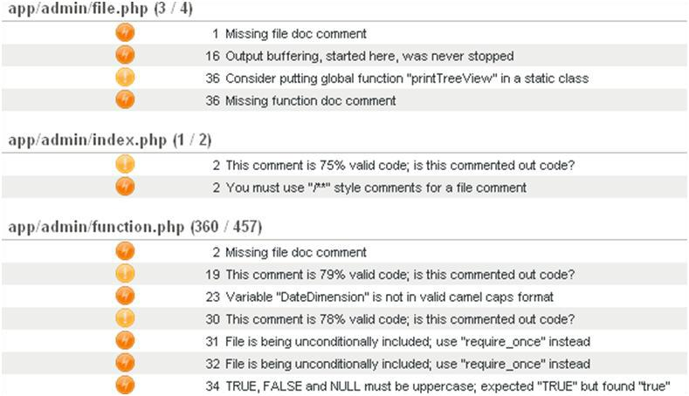

FIGURE 18: CODE STANDARD SCREENSHOT

Notes:

Introduction to Scrum (cc)-by-sa – Evan Leybourn Page 41 of 84

Introduction to Scrum

**DOCUMENTATION**

The following should be commented;

* Files
* Classes
* Functions
* Class Variables
* Complex Structures

Comments should contain;

* Description
* Author
* Usage
* Parameter description
* Return description
* References to other functions
* Copyright (file comments)

**CODE COVERAGE**

Calculate and display how much of the software is covered by unit tests. Aim for 80-90% code coverage.

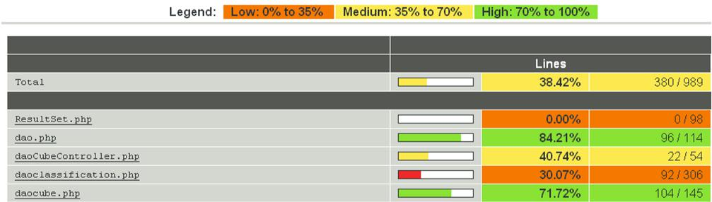

FIGURE 19: CODE COVERAGE SCREENSHOT

**COMPILE**

Run any compile or make scripts. All commits should compile.

Notes:

Introduction to Scrum (cc)-by-sa – Evan Leybourn Page 42 of 84

Introduction to Scrum

## SCRUM MEETING (AKA DAILY STAND-UP)

The purpose of the daily stand-up meeting is to provide a consistent focus on incremental progress and delivery demonstrated to the Product Owner. It is intended to be informative and interactive and align the team’s understanding of what is being worked on, by whom and its current status.

This meeting consists of the Product Owner, Scrum Master, and the project team and is time-boxed to 15 minutes.

All participants should answer the following three questions:

1. What did you achieve yesterday?
2. What will you achieve today?
3. What impediment may prevent you from achieving your goal today?

It is the objective of the Scrum Master to remove any impediment identified by the team.

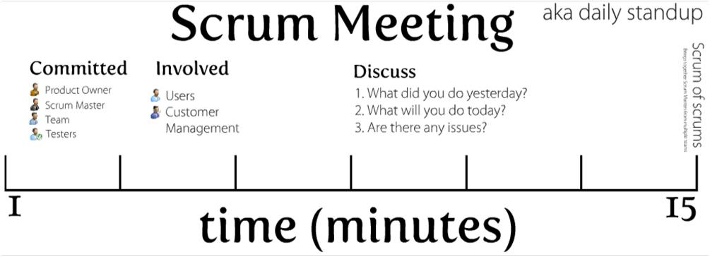

FIGURE 20: DAILY STANDUP WORKFLOW

Projects with multiple teams should hold a scrum of scrums, also timeboxed to 15 minutes, after the initial scrums. This meeting should bring together Scrum Masters from multiple teams to answer the same 3 questions as before, but relating to their teams.

Notes:

Introduction to Scrum (cc)-by-sa – Evan Leybourn Page 43 of 84

Introduction to Scrum

## INSPECTION

## PROJECT VELOCITY

Project Velocity is a measure that determines the capacity and resulting output from the project team over time. In this case it refers to how many User Stories the project team estimate that they can deliver in the project.

The methods available to determine Project Velocity are as follows:

* Use historical values - this assumes similarity between previous User Stories in terms of relative size, data, infrastructure etc
* Run an Sprint – derive the estimate based on observed Velocity over 2-3 Sprints
* Make a forecast – this approach is used where we do not have existing historical values and it is not feasible to run several Sprints to observe the team’s velocity. User Stories are disaggregated and estimated at a Task level.

The scope of the project, any changes to the scope, and the planned and actual delivery of User Stories can be represented in a burndown or burnup chart. This chart can also be used to forecast when the project team will have completed all the User Stories in the Project Backlog.

## SPRINT VELOCITY

Effort based Velocity determines the capacity and resulting output from the project team for a given Sprint i.e. how many User Stories can be delivered over the next two weeks. This velocity can be calculated as an average at the team level, or if there is a significant variation in the working hours as an aggregate of the individuals.

Sprint velocity is measured in terms of Potential and Forecast capacity:

* Potential Sprint Velocity is the sum of allocated working hours for the project team
* Forecast Sprint Velocity is the estimated productive workable hours that can be attributed to Sprint tasks i.e. takes into account Staff Overhead

Notes:

Introduction to Scrum (cc)-by-sa – Evan Leybourn Page 44 of 84

Introduction to Scrum

## BURNDOWN & BURNUP CHARTS

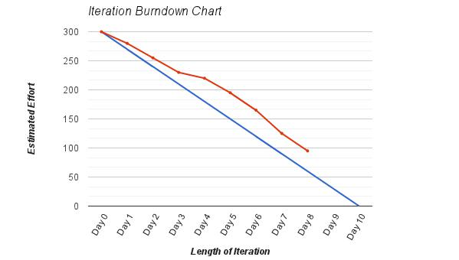

FIGURE 21: EXAMPLE BURNDOWN CHART

Burndown and Burnup charts help managers and customers to view progress against the release, improve future estimates and identify problem trends early. The Burndown (or burnup) chart should be available to everyone involved in the project.

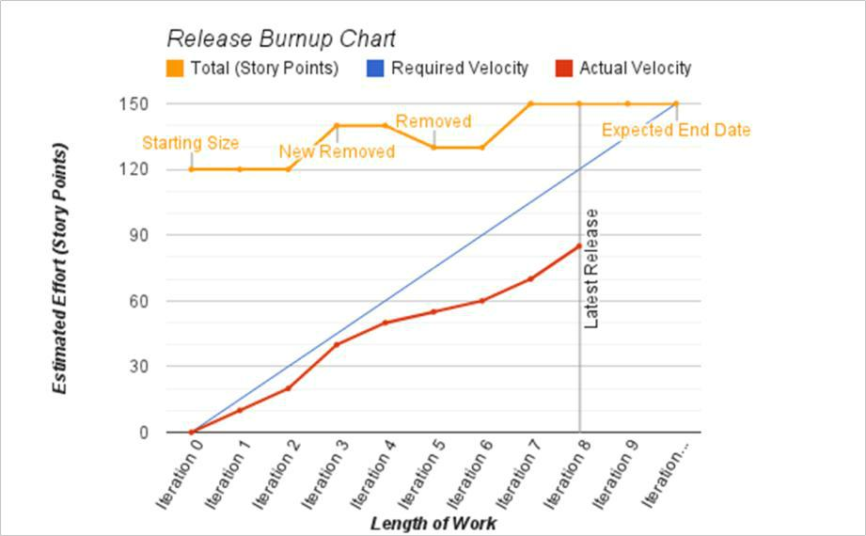

FIGURE 22: EXAMPLE BURNUP CHART

Notes:

Introduction to Scrum (cc)-by-sa – Evan Leybourn Page 45 of 84

Introduction to Scrum

## PROGRESS PROBLEMS

All about risk mitigation

**DISCOVERY**

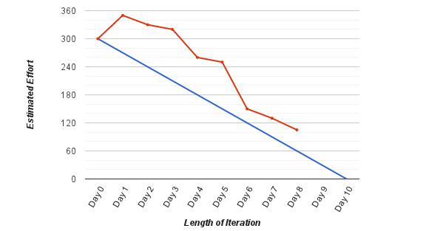

FIGURE 23: PROBLEM BURNDOWN (DISCOVERY)

Issues identified after the sprint begins or refined estimation after the sprint begins. Watch the progress carefully. If necessary review the tasks in the Sprint

## SCOPE CREEP

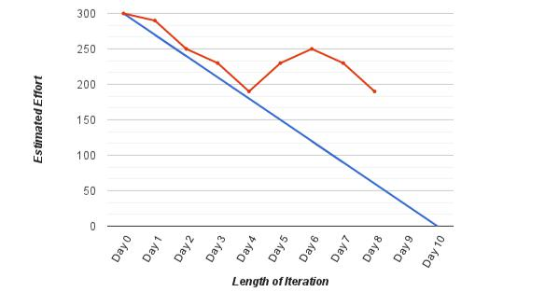

FIGURE 24: PROBLEM BURNDOWN (SCOPE CREEP)

Tasks are being added mid-release. Identify who is adding tasks and stop this behaviour.

Notes:

Introduction to Scrum (cc)-by-sa – Evan Leybourn Page 46 of 84

Introduction to Scrum

## PLATEAU

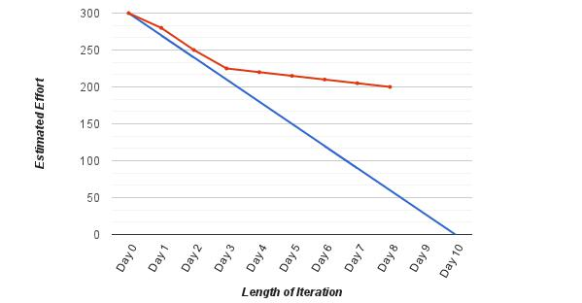

FIGURE 25: PROBLEM BURNDOWN (PLATEAU)

Features are more difficult than estimated or unexpected staffing issues. Review the tasks in the sprint.

## TOO MANY FEATURES

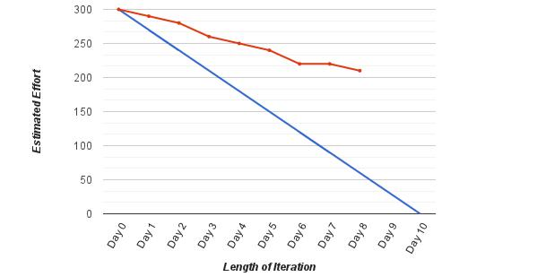

FIGURE 26: PROBLEM BURNDOWN (TOO MANY FEATURES)

Features are more difficult than estimated. Review the estimation process and remove tasks from the sprint.

Notes:

Introduction to Scrum (cc)-by-sa – Evan Leybourn Page 47 of 84

Introduction to Scrum

## TRACKING EPICS

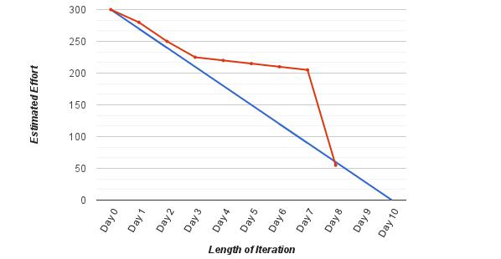

FIGURE 27: PROBLEM BURNDOWN (TRACKING EPICS)

Individual stories are too large and difficult to track. Keep each task under 1 day of work.

Notes:

Introduction to Scrum (cc)-by-sa – Evan Leybourn Page 48 of 84

Introduction to Scrum



# FINISHING AN SPRINT



*‘Fall seven times. Stand up eight.’*

*Old Japanese Proverb*

Notes:

Introduction to Scrum (cc)-by-sa – Evan Leybourn Page 49 of 84

Introduction to Scrum

## SPRINT REVIEW

After the Sprint, the Scrum Master should hold a Sprint Review meeting to demonstrate to the Product Owner and Customer (if different) the completed User Stories for final review for release to production. As the Product Owner should have been involved in the development and verification process on a daily basis this step should be straightforward.

The participants for this session are as follows:

* Product Owner
* Scrum Master
* Project Team

During the meeting the team should:

* Present the completed work to the Product Owner
* Review the work that was completed
* Review the work that was not completed. The User Stories that were not completed may move to the next Sprint.

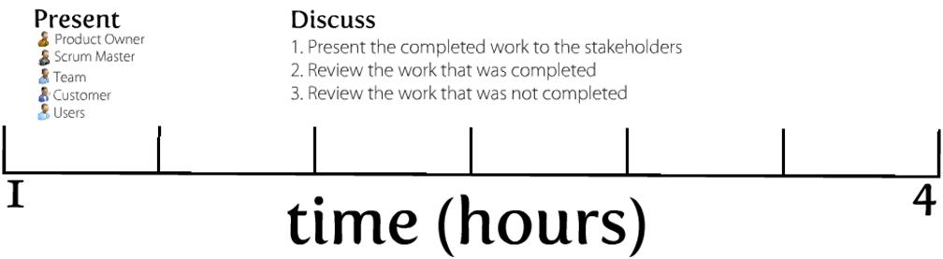

FIGURE 28: SPRINT REVIEW

Notes:

Introduction to Scrum (cc)-by-sa – Evan Leybourn Page 50 of 84

Introduction to Scrum

## KAIZEN AND THE SPRINT RETROSPECTIVE

After the Sprint Review, the Scrum master should hold a Sprint Retrospective meeting to discuss and improve on the Sprint process itself. During this meeting the team should;

1. Reflect on the sprint
2. Make any process improvements
3. Discuss what went well during the sprint
4. What could be improved during the sprint

The Sprint Retrospective provides the team with the opportunity to reflect on the Sprint just completed and drive continuous process improvement out of the learning’s taken from this.

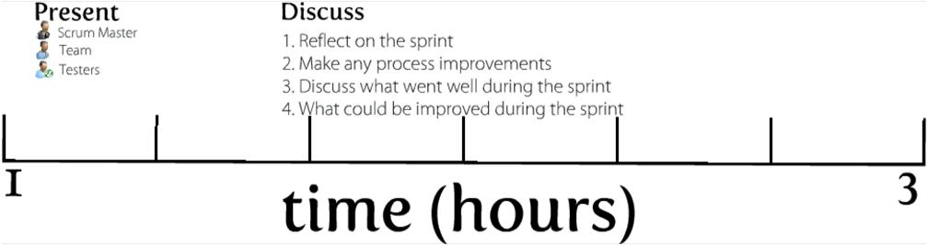

FIGURE 29: SPRINT RETROSPECTIVE

Notes:

Introduction to Scrum (cc)-by-sa – Evan Leybourn Page 51 of 84

Introduction to Scrum



# REFERENCES



Notes:

Introduction to Scrum (cc)-by-sa – Evan Leybourn Page 52 of 84

Introduction to Scrum

**BOOKS & LINKS**

Directing the Agile Organisation – Evan Leybourn

Agile Estimating and Planning - Mike Cohn

Managing Agile Projects - Kevin J. Aguanno

http://en.wikipedia.org/wiki/Agile_software_development

http://agilemanifesto.org/

http://en.wikipedia.org/wiki/Agile_testing

http://en.wikipedia.org/wiki/Scrum_(development)

http://www.ambysoft.com

http://en.wikipedia.org/wiki/Iterative_and_incremental_development

http://en.wikipedia.org/wiki/Agile_software_development

http://www.agileadvice.com/

http://en.wikipedia.org/wiki/IEEE_829

http://www.ddj.com/architect/201202925?pgno=4

http://www.scrumalliance.org

**TOOLS**

http://trac.edgewall.org/

http://watir.com

Notes:

Introduction to Scrum (cc)-by-sa – Evan Leybourn Page 53 of 84

Introduction to Scrum



# SUPPORTING MATERIAL – EXAMPLE RELEASE AND TEST MANAGEMENT PLAN



Notes:

Introduction to Scrum (cc)-by-sa – Evan Leybourn Page 54 of 84

Introduction to Scrum

## SCHEDULE OF ACTIVITIES & DESCRIPTION OF THE APPROVAL PROCESS

This is an example process for a monthly iteration cycle.

|  |  |  |  |  |  |  |  |  |  |  |  |  |
| --- | --- | --- | --- | --- | --- | --- | --- | --- | --- | --- | --- | --- |
|  |  |  |  |  |  |  |  | Requirements | |  |  |  |
| Design Document | | | | | | | | Gathering | |  |  |  |
|  |  |  |  |  |
|  |  |  |  |  |  |  |  | Includes Produce Owner | |  |  |  |
|  |  |  |  |  |  |  |  | discussions during the previous | |  |  |  |
|  |  |  |  |  |  |  |  | release | |  |  |  |
| Design Document | | |  |  |  |  |  |  |  |  |  |  |
|  |  |  |  |  |  |  |  |  |  |
|  | |  | |  | Development | |  |  |  |
| Appendices | |  |  |  |  |  |  |  |  |  |
|  |  | |  | |  | Design Meeting | |  |  |  |
|  |  |  |  |  |  |  |  |  |  |  |
|  |  |  |  |  |  |  |  |  |  |  |  |  |
|  |  |  |  |  |  |  |  |  |  |  |  |  |
|  |  |  |  |  |  |  |  | Release Design | | Release Design | |  |
|  |  |  |  |  |  |  |  | Document | |  |
|  |  |  |  |  |  |  |  | Document | |  |
|  |  |  |  |  |  |  |  |  |  |  |
|  |  |  |  |  |  |  |  | Includes Testing Document | | Appendices | |  |
|  |  |  |  |  |  |  |  |  |  |  |  |  |
|  |  |  |  |  |  |  |  |  |  |  |  |  |
|  |  |  |  |  |  |  |  |  |  |  |  |  |

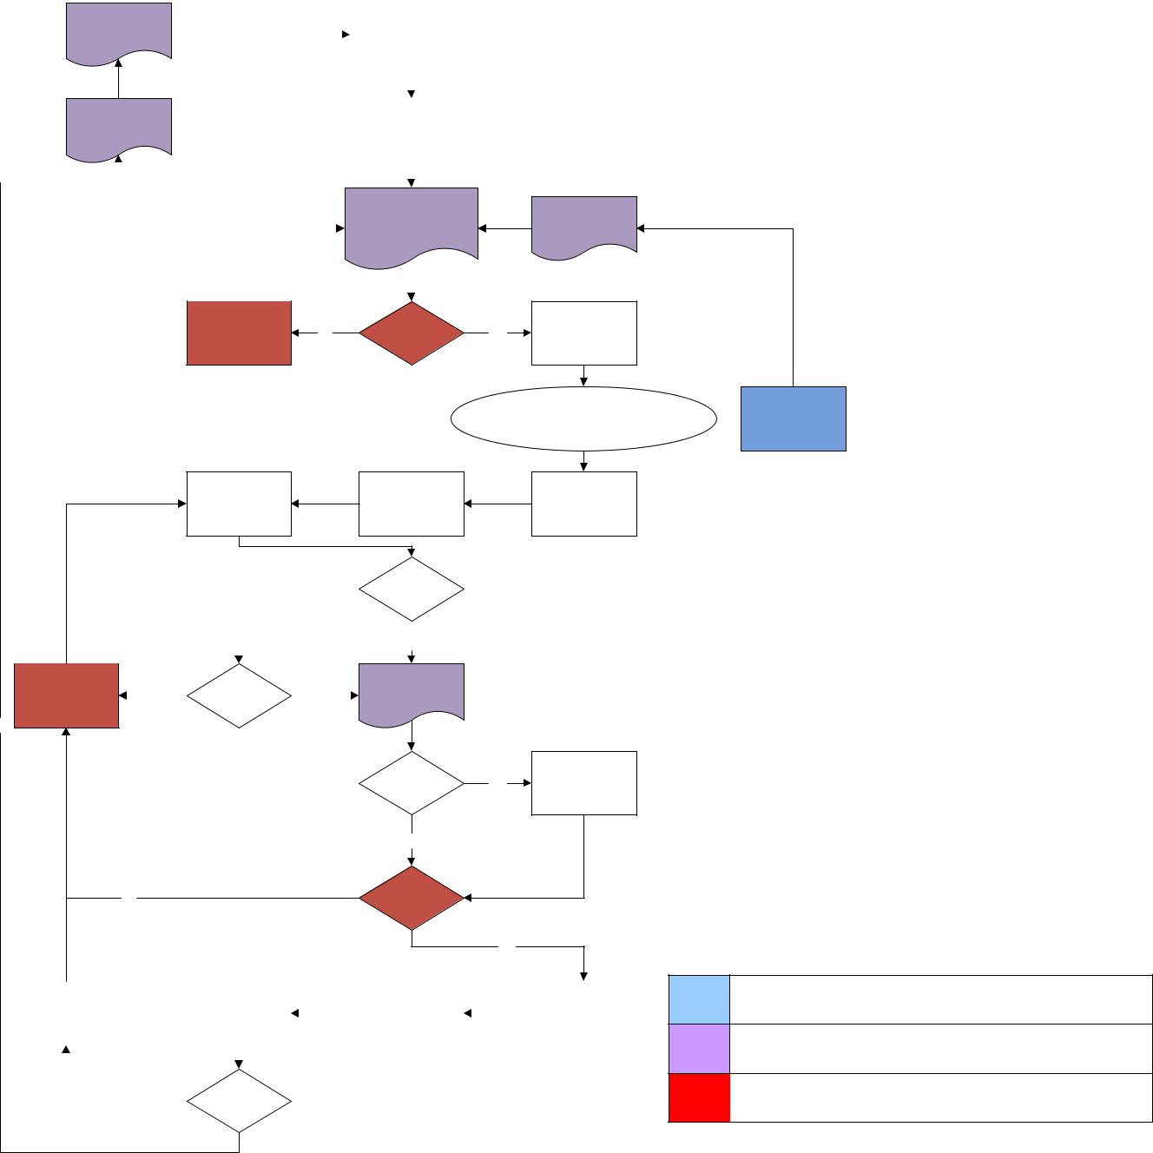

Create Tasks in

Development

No PO Signoff Yes Trac & Assign to

Update Meeting

Developers

Development

Mid-Cycle

Requirement

Includes Daily Scrums & DEV updates

Migrate DEV to

Testing Code Freeze

TEST

|  |  |  |  |  |  |  |  |  |  |  |  |  |  |  |  |  |  |
| --- | --- | --- | --- | --- | --- | --- | --- | --- | --- | --- | --- | --- | --- | --- | --- | --- | --- |
|  |  |  |  |  |  |  | No |  |  |  |  |  | Tests Pass | | | |  |
|  |  |  |  |  |  |  |  |  |  |  |  |  |  |  | |  |  |
|  |  |  |  |  |  |  |  |  |  |  |  |  |  |  |  |  |  |
|  |  |  |  |  |  |  |  |  |  |  |  |  |  | Yes | |  |  |
|  |  |  |  |  |  |  |  |  |  |  |  |  | Release Approval | | | |  |
|  |  |  |  |  |  |  |  |  |  |  |  |  |  |
| Resolve Issues |  |  | Yes |  | Priority Fix | | |  |  | No |  |  | Document | | | |  |
|  |  |  |  |  |
|  |  |  |  |  |  |  |  |  |  |  |  |  |  |  |  |  |  |

Yes

Add Uncompleted

Uncompleted

Yes Tasks to Next

Tasks

Release

No

No PO Signoff

Yes

|  |  |  |  |  |  |  |  |  |  |  |  |  |  |
| --- | --- | --- | --- | --- | --- | --- | --- | --- | --- | --- | --- | --- | --- |
| Rollback | | | |  | Post Production | |  |  | Release to |  |  | External |  |
|  | Testing | |  |  | Production |  |  | Announcements |  |
|  |  |  |  |  |  |  |  |  |  |
|  |  |  |  |  |  |  |  |  |  |  |  |  |  |
|  |  |  |  |  |  |  |  |  |  |  |  |  |  |
|  |  |  |  |  |  | | | |  |  |  |  |  |
|  |  | No |  |  | Tests Pass | | | |  |  |  |  |  |
|  |  |  |  |  |  |  |  |  |
|  |  |  |  |  |  |  |  |  |  |  |  |  |  |

Requirements

Documentation

Product Owner Processes

Notes:

Introduction to Scrum (cc)-by-sa – Evan Leybourn Page 55 of 84

Introduction to Scrum

|  |  |  |  |  |  |  |  |  |  |  |  |  |  |
| --- | --- | --- | --- | --- | --- | --- | --- | --- | --- | --- | --- | --- | --- |
|  | **Process** |  |  | **Description** |  |  | **Timeframe** |  |  | **Responsible** | |  |  |
|  |  |  |  |  |  |  |  |  |
|  |  |  |  |  |  |  |  |  |  |  | |  |  |
|  | Design Document |  |  | The base design document. This outlines all baseline |  |  | Complete |  |  | Technical | |  |  |
|  |  |  |  | features in <Product> when initially released. |  |  |  |  |  | Lead | |  |  |
|  |  |  |  |  |  |  |  |  |  |  |
|  | |  |  |  |  |  |  |  |  |  | |  |  |
|  | Requirements |  |  | Requirements are drawn from user and product owner |  |  | Ongoing |  |  | Technical | |  |  |
|  | Gathering |  |  | feedback during the previous months. The priorities are |  |  |  |  |  | Lead | |  |  |
|  |  |  |  |  |  |  |  |  |  |
|  |  |  |  | set by the product owner which leads to the |  |  |  |  |  |  |  |  |  |
|  |  |  |  | development design meeting. |  |  |  |  |  |  |  |  |  |
|  | |  |  |  |  |  |  |  |  |  | |  |  |
| Development Design | |  |  | A half day meeting of the development team to discuss |  |  | Day 1 |  |  | Development | |  |  |
| Meeting | |  |  | the requirements and to decide on the resources and |  |  |  |  |  | Team | |  |  |
|  |  |  |  | timeframes involved. |  |  |  |  |  |  |  |  |  |
|  | |  |  |  |  |  |  |  |  |  | |  |  |
|  | Release Design |  |  | A formal document outlining the features that will be |  |  | Day 1-2 |  |  | Technical | |  |  |
|  | Document |  |  | developed during the next sprint. Not all requirements |  |  |  |  |  | Lead | |  |  |
|  |  |  |  |  |  |  |  |  |  |
|  |  |  |  | (from step 1) will be part of the release. |  |  |  |  |  |  |  |  |  |
|  | |  |  |  |  |  |  |  |  |  | |  |  |
|  | Product Owner |  |  | Does the product owner approve the design document? |  |  | Day 2 |  |  | Product | |  |  |
|  | Signoff? |  |  |  |  |  |  |  |  | Owner | |  |  |
|  |  |  |  |  |  |  |  |  |  |  |
|  |  |  |  |  |  |  |  |  |  |  | |  |  |
|  | Development Update |  |  | A short meeting of the development team to resolve any |  |  | Day 2 |  |  | Development | |  |  |
|  | Meeting |  |  | design issues raised by the Product Owner and hindering |  |  |  |  |  | Team | |  |  |
|  |  |  |  |  |  |  |  |  |  |
|  |  |  |  | signoff. |  |  |  |  |  |  |  |  |  |
|  | |  |  |  |  |  |  |  |  |  | |  |  |
| Create Tasks in | |  |  | After the design document is complete, the features are |  |  | Day 3 |  |  | Technical | |  |  |
| management system & | |  |  | broken down into short tasks and assigned to developers |  |  |  |  |  | Lead | |  |  |
| Assign to Developers | |  |  | to complete. |  |  |  |  |  |  |  |  |  |
|  | |  |  |  |  |  |  |  |  |  | |  |  |
| Development | |  |  | The development of <product>. Progress is measured |  |  | Approximately |  |  | Development | |  |  |
|  |  |  |  | through daily scrums and review of the tasks. |  |  | 20 days |  |  | Team | |  |  |
|  |  |  |  | Updates to <product> are regularly migrated to the DEV |  |  |  |  |  |  |  |  |  |
|  |  |  |  | server. Issues in newly developed code are added as |  |  |  |  |  |  |  |  |  |
|  |  |  |  | defects. |  |  |  |  |  |  |  |  |  |
|  | |  |  |  |  |  |  |  |  |  | |  |  |
|  | Mid-Cycle |  |  | These are high priority requirements, drawn from user |  |  |  |  |  | Product | |  |  |
|  | Requirement |  |  | and product owner feedback during the development, |  |  |  |  |  | Owner | |  |  |
|  |  |  |  |  |  |  |  |  |  |
|  | Gathering |  |  | and form part of the current release cycle. |  |  |  |  |  |  |  |  |  |
|  |  |  |  |  |  |  |  |  |  |  | |  |  |
|  | Release Design |  |  | Appendices to the formal design document outlining any |  |  |  |  |  | Technical | |  |  |
|  | Document Appendices |  |  | mid-cycle requirements. |  |  |  |  |  | Lead | |  |  |
|  |  |  |  |  |  |  |  |  |  |
|  |  |  |  |  |  |  |  |  |  |  | |  |  |
| Code Freeze | |  |  | No new features can be developed during this release |  |  | Day n-5 |  |  | Technical | |  |  |
|  |  |  |  | cycle. The developers will continue to work on |  |  |  |  |  | Lead | |  |  |
|  |  |  |  | defects/bugs in <product>. Any requirements from the |  |  |  |  |  |  |  |  |  |
|  |  |  |  | design document which are incomplete are moved to the |  |  |  |  |  |  |  |  |  |
|  |  |  |  | next release. |  |  |  |  |  |  |  |  |  |
|  |  |  |  |  |  |  |  |  |  |  |  |  |  |
|  |  |  |  |  |  |  |  |  |  |  |  |  |  |
|  | Notes: |  |  |  |  |  |  |  |  |  |  |  |  |
|  |  |  |  |  |  |  |  |  |  |  |  |  |  |

Introduction to Scrum (cc)-by-sa – Evan Leybourn Page 56 of 84

Introduction to Scrum

|  |  |  |  |  |  |  |  |  |  |  |
| --- | --- | --- | --- | --- | --- | --- | --- | --- | --- | --- |
|  |  |  |  | The product owner can choose to extend the current |  |  |  |  |  |  |
|  |  |  |  | release cycle if the requirements warrant it. |  |  |  |  |  |  |
|  |  |  |  |  |  |  |  |  | |  |
| Migrate DEV to TEST | |  |  | Migrate all changes from the DEV server to the TEST |  | Day n-5 |  | Development | |  |
|  |  |  |  | server for formal testing |  |  |  | Team | |  |
|  |  |  |  |  |  |  |  |  | |  |
| Testing | |  |  | <product> testers run the base test cases and any new |  | Day n-5 |  | Testers | |  |
|  |  |  |  | test cases to identify issues and defects in the current |  |  |  |  |  |  |
|  |  |  |  | release. |  |  |  |  |  |  |
|  |  |  |  |  |  |  |  |  | |  |
| Tests Pass? | |  |  | Were the tests successful? |  | Day n-5 |  | Testers | |  |
|  |  |  |  |  |  |  |  |  | |  |
| Priority Fix? | |  |  | Are the issues raised in testing minor, and can they be |  | Day n-5 |  | Technical | |  |
|  |  |  |  | delayed until the next release? |  |  |  | Lead | |  |
|  | |  |  |  |  |  |  |  | |  |
|  | Resolve Issues |  |  | Any issues or defects for the current release are resolved |  | Day n-3-4 |  | Development | |  |
|  |  |  |  | by the developers, which then get re-tested. |  |  |  | Team | |  |
|  |  |  |  |  |  |
|  | |  |  |  |  |  |  |  | |  |
|  | Release Approval |  |  | A document based on the initial design document which |  | Day n-2 |  | Technical | |  |
|  | Document |  |  | outlines all completed features in the current release. |  |  |  | Lead | |  |
|  |  |  |  |  |  |  |
|  |  |  |  |  |  |  |  |  | |  |
| Uncompleted Tasks? | |  |  | Are there any features from the original design |  | Day n-1 |  | Technical | |  |
|  |  |  |  | document which could not be completed in the current |  |  |  | Lead | |  |
|  |  |  |  | release? |  |  |  |  |  |  |
|  | |  |  |  |  |  |  |  | |  |
| Add Uncompleted | |  |  | To form part of the next design document. |  | Day n-1 |  | Technical | |  |
| Tasks to Next Release | |  |  |  |  |  |  | Lead | |  |
|  | |  |  |  |  |  |  |  | |  |
|  | Product Owner |  |  | Does the product owner approve the current release |  | Day n-1 |  | Product | |  |
|  | Signoff? |  |  |  |  |  |  | Owner | |  |
|  |  |  |  |  |  |  |  |
|  |  |  |  |  |  |  |  |  | |  |
| External | |  |  | Send an email to all <product> users describing the new |  | Day n-1 |  | Technical | |  |
| Announcements | |  |  | changes to <product> with the updated user manual. |  |  |  | Lead | |  |
|  | |  |  |  |  |  |  |  | |  |
| Backup Current | |  |  | Make a manual backup of the current production |  | Day n-1 |  | CIO Division | |  |
| Production | |  |  | release. This is used if the system needs to rollback after |  |  |  |  |  |  |
|  |  |  |  | the release. |  |  |  |  |  |  |
|  | |  |  |  |  |  |  |  | |  |
| Release to Production | |  |  | Migrate the changes from TEST to PROD |  | Day n |  | CIO Division | |  |
|  | |  |  |  |  |  |  |  | |  |
| Post Production | |  |  | Run through a series of tests to ensure the production |  | Day n |  | Testers | |  |
| Testing | |  |  | release was successful. |  |  |  |  |  |  |
|  | |  |  |  |  |  |  |  | |  |
| Test Pass? | |  |  | Were the post production tests successful? |  | Day n |  | Testers | |  |
|  | |  |  |  |  |  |  |  | |  |
| Rollback | |  |  | Revert PROD to previous release. |  | Day n |  | CIO Division | |  |
|  | |  |  |  |  |  |  |  | |  |
|  | Design Document |  |  | Appendices to the base design document outlining the |  | Day n+1 |  | Technical | |  |
|  | Appendices |  |  | changes to <product> that were made in the current |  |  |  | Lead | |  |
|  |  |  |  |  |  |  |
|  |  |  |  | release. |  |  |  |  |  |  |
|  |  |  |  |  |  |  |  |  |  |  |
|  |  |  |  |  |  |  |  |  |  |  |
|  | Notes: |  |  |  |  |  |  |  |  |  |
|  |  |  |  |  |  |  |  |  |  |  |

Introduction to Scrum (cc)-by-sa – Evan Leybourn Page 57 of 84

Introduction to Scrum

## ROLES, RESPONSIBILITIES AND RESOURCE REQUIREMENTS

|  |  |  |
| --- | --- | --- |
| **Name** | **Role** | **Responsibility** |
| <Name> | Product Owner | Final approval for release |
| <Name> | Technical | Sign off of issues / tasks within the scope of the |
|  | Manager | release |
| <Name> | Scrum Manager | Manage the daily scrum and monthly design meeting |
| Testers (Various) | Tester | Follow test cases to identify issues. Can pass/fail cases |
|  |  | at their discretion |
| <Name> | Infrastructure | Maintaining the Development, Test, and Production |
|  | Lead | hardware |
|  |  | Install software onto Production hardware |
|  |  | Run post-release deployment tests to confirm |
|  |  | successful deployment |

Formal testers must have had training in using <product>, but should not be “power users”. That is, highly skilled users often miss the usability issues that a “casual user” can identify. For the same reasons, software developers cannot be testers.

Notes:

Introduction to Scrum (cc)-by-sa – Evan Leybourn Page 58 of 84

Introduction to Scrum

## ROLL BACK STRATEGY

Rollback occurs if the post-production testing identifies any major issues. It is for this reason that post-production testing occurs as soon as possible after the migration from TEST to PROD. The process is as follows;

1. Take a complete backup of the current production application. This includes the application data, and the database.
2. Migrate the new version from the Test server to the Production server.
3. Post-Production testing runs through a series of tests to ensure the production release was successful. These tests include;
   1. Comprehensive tool testing to ensure each tool operates as expected.
   2. Speed testing to ensure that each tool (specifically mapping and charting) are responsive within the allowed times.
   3. Authentication testing to ensure that administrators and normal users can access <product> appropriately.
   4. Data quality testing to ensure that the <product> database was updated correctly.
4. If the tests did not pass, and the issue can’t be resolved quickly in-situ, begin the rollback process;
   1. Obtain permission from the Product Owner to rollback.
   2. Replace the new version of <product> with the recent backup, including application data, the mapping files and the database.
   3. Email all <product> users informing them of an issue and that the expected upgrade will take place at a later time.
   4. Review the issues with the Product Owner and Development Team to identify what caused the issue and why it was not picked up in initial testing.

Notes:

Introduction to Scrum (cc)-by-sa – Evan Leybourn Page 59 of 84

Introduction to Scrum

## TESTING METHODOLOGY

**TEST DRIVEN DESIGN METHODOLOGY**

The <product> testing methodology is based on “Test Driven Design Methodology” (TDD), which is part of the Extreme Programming practices. The core of the methodology is that the basic tests are developed before the software is written.

Yes

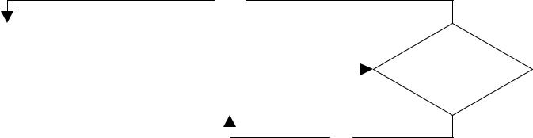

|  |  |  |  |  |  |  |
| --- | --- | --- | --- | --- | --- | --- |
| Write Test Cases |  |  | Write Code |  | Test Passes |  |
|  |  |  |  |
|  |  |  |  |  |  |  |



No

A major part of TDD is “Unit Testing”, a series of automated tests which thoroughly search for logical errors in the software whenever a function is completed. These tests are constantly built on previous tests so if something developed six months ago suddenly breaks under a new update, it is known immediately.

See http://www.developer.com/design/article.php/3622546 for more information

**TESTING DETAILS**

Testing is performed by <who> staff. These are people who are familiar with the system, but are not involved in the development process.

When a release is scheduled all current test cases are loaded into the issue management system by the Technical Lead. These test cases are assigned to the testers on a random basis and each tester is given a short session discussing what changes have been made and what they should expect.

As each test is completed, the tester updates the test case as either “passed” or “failed”. Failed tests are reviewed by the Technical Lead who either accepts the failure or assigns a defect to a developer to resolve the issue. Once resolved the failed test case is reassigned to the original tester to re-test.

Further information can be found under the “Test Report Template” section of this document.

Notes:

Introduction to Scrum (cc)-by-sa – Evan Leybourn Page 60 of 84

Introduction to Scrum

**TEST TYPES**

There are four forms of tests which are run.

1. Defect Testing - Are there any bugs or defects that have been missed?
2. Functionality Testing - Does the release meet the original requirements specification?
3. Usability Testing – Is the release user friendly?
4. Data Testing – Is the data in <product> reasonable and suitable as a policy evidence base?

**MANUAL TESTING**

All tasks in <product> are managed using a test management tool, including test cases. Each test case is linked to a category and a milestone in which to complete it (e.g. May Release). These test cases are then assigned to a tester to run and go through the following workflow;

* New (Test cases are created)
* Assigned (Test cases are assigned to a tester)
* Tested (Test cases have been run and are awaiting review)
  1. Failed test cases go back to assigned once the underlying issue is resolved.
* Closed

**AUTOMATED TESTING (UNIT TESTS)**

The continuous integration environment runs unit tests for every software update and informs the developers if they have introduced a new defect. If a unit test fails, the responsible developer is notified immediately and the update is removed from the current version until is passes.

Notes:

Introduction to Scrum (cc)-by-sa – Evan Leybourn Page 61 of 84

Introduction to Scrum

## MAPPING BETWEEN THE TEST SCRIPTS AND THE REQUIREMENTS

As per the development process, basic test cases are developed during the initial design phase. These test cases are further refined during the development cycle as specific functionality is created. This process ensures a close mapping between the test scripts and the requirements.

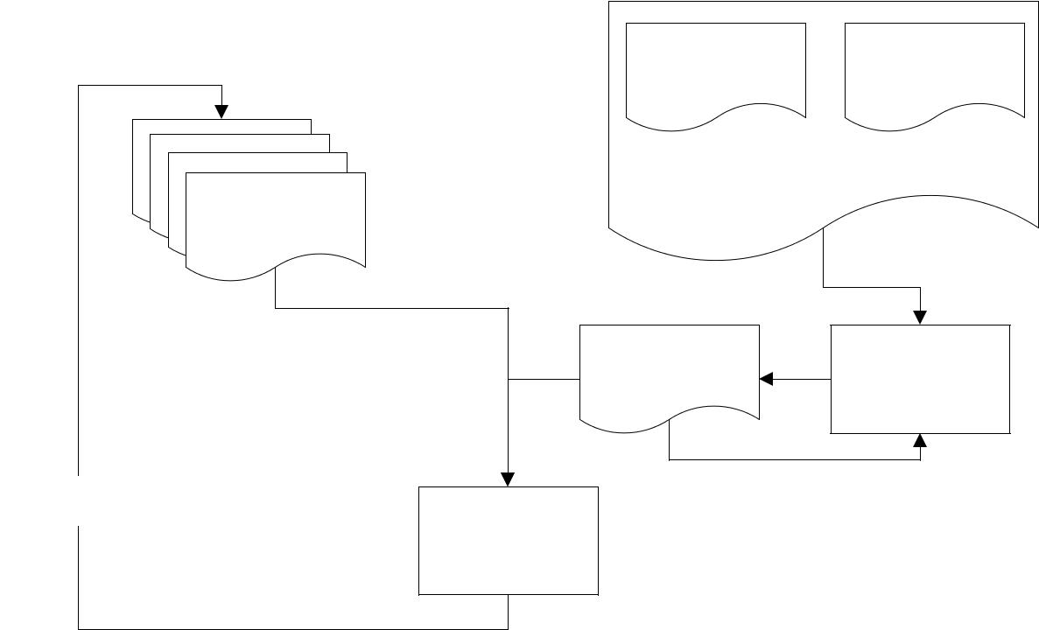

Release Design Release Test

Document Cases

Release Design Document

Test Case

Catalogue

Update Test

Cases Development

Add to Test Case

Catalogue

Release Test Run

There are two exceptions to this process.

1. Tests developed prior to this process. These tests form part of the catalogue to ensure good coverage of the test scripts.
2. Core tests that relate to underlying functionality. Underlying functionality is a product of the design process, and does not map to a design requirement.

Notes:

Introduction to Scrum (cc)-by-sa – Evan Leybourn Page 62 of 84

Introduction to Scrum

## TEST REPORT TEMPLATE

There are 6 details that make up a test case.

1. Reported By: Who is managing the test case? This person is responsible for verifying the result and managing the resolution of any issues arising from failed test cases.
2. Owned By: Who is the test cases assigned to?
3. Priority: How important is this test case?
4. Milestone: Which release is this test case for? Each Milestone in Trac is a monthly release.
5. Component: What part of <product> is the test case for?
6. The description of the test. This is broken into numbered steps. There can be many verifications in a single test, and if any of them fail the entire test fails.

Note that test cases don’t use time estimation.

**SAMPLE TEST CASES**

These testcases are written by the developers and loaded into the tracking system during each testing period.

|  |  |  |
| --- | --- | --- |
| **Summary** | **Test** |  |
| <Test Summary> | 1. | Log in to <product> |
|  | 2. | Select <something> |
|  | 3. | Verify <results> |

Notes:

Introduction to Scrum (cc)-by-sa – Evan Leybourn Page 63 of 84

Introduction to Scrum



# SUPPORTING MATERIAL – EXAMPLE HIGH-LEVEL BUSINESS REQUIREMENTS



Notes:

Introduction to Scrum (cc)-by-sa – Evan Leybourn Page 64 of 84

Introduction to Scrum

**GLOSSARY OF TERMS**



**Term** **Definition**



<Term> <Definition>

**INTRODUCTION**

**OBJECTIVE**

<What Is The Objective Of This Product>

**NEED/PURPOSE**

<What Need Or Purpose Does It Fulfil>

**USAGE**

<Who Is The Target Audience / Who Is Allowed To Access The Product>

**SCOPE OF REQUIREMENTS SPECIFICATION**

**INCLUSIONS**

<What Is Included In The Specification>

**EXCLUSIONS**

<What Is Not Included In The Specification>

Notes:

Introduction to Scrum (cc)-by-sa – Evan Leybourn Page 65 of 84

Introduction to Scrum

## FUNCTIONAL REQUIREMENTS

**GENERAL**

|  |  |  |
| --- | --- | --- |
| **ID** | **Requirement description** | **Essential** |
|  |  | **or** |
|  |  | **Desirable** |
| 1 |  | Essential |
| **REPORT GENERATION & PRINTING (INCLUDING MANAGEMENT INFORMATION)** | |  |
|  |  |  |
| **ID** | **Requirement description** | **Essential** |
|  |  | **or** |
|  |  | **Desirable** |
| 1 |  | Essential |
| **HELP FACILITIES** | |  |
|  |  |  |
| **ID** | **Requirement description** | **Essential** |
|  |  | **or** |
|  |  | **Desirable** |
| 1 | Online help will be available | Essential |
| 2 | Context sensitive help for users | Desirable |
| 3 | Tooltips will appear on mouse-over of objects | Essential |
| 4 |  |  |
| **SYSTEM MANAGEMENT** | |  |
|  |  |  |
| **ID** | **Requirement description** | **Essential** |
|  |  | **or** |
|  |  | **Desirable** |
| 1 |  | Desirable |
| **NON-FUNCTIONAL REQUIREMENTS** | |  |
| **GENERAL** |  |  |
|  |  |  |
| **ID** | **Requirement description** | **Essential** |
|  |  | **or** |
|  |  | **Desirable** |
| 1 |  |  |

Notes:

Introduction to Scrum (cc)-by-sa – Evan Leybourn Page 66 of 84

Introduction to Scrum

**SECURITY**

|  |  |  |
| --- | --- | --- |
| **ID** | **Requirement description** | **Essential** |
|  |  | **or** |
|  |  | **Desirable** |
| 1 | The product will adhere to Open Web Application Security Project | Desirable |
|  | (OWASP) standards and guidelines |  |
| 2 |  |  |
| **AVAILABILITY** |  |  |
|  |  |  |
| **ID** | **Requirement description** | **Essential** |
|  |  | **or** |
|  |  | **Desirable** |
| 1 | Core operating hours 8am to 6pm, Monday to Friday | Essential |
| 2 | 99% availability during core operating hours | Essential |
| 3 | Any planned maintenance is expected to be carried out outside | Essential |
|  | these hours |  |
| 4 | Monthly reports provided on the amount of downtime/uptime | Essential |
| 5 |  |  |
| **USER ACCESS** |  |  |
|  |  |  |
| **ID** | **Requirement description** | **Essential** |
|  |  | **or** |
|  |  | **Desirable** |
| 1 |  |  |
| **ACCESSIBILITY** | |  |
|  |  |  |
| **ID** | **Requirement description** | **Essential** |
|  |  | **or** |
|  |  | **Desirable** |
| 1 | The product will adhere to World Wide Web Consortium (W3C) | Essential |
|  | accessibility standards and guidelines |  |
| 2 |  |  |
| **USABILITY** |  |  |
|  |  |  |
| **ID** | **Requirement description** | **Essential** |
|  |  | **or** |
|  |  | **Desirable** |
| 1 |  | Desirable |

Notes:

Introduction to Scrum (cc)-by-sa – Evan Leybourn Page 67 of 84

Introduction to Scrum

**IT SERVICE CONTINUITY (DISASTER RECOVERY)**

|  |  |  |
| --- | --- | --- |
| **ID** | **Requirement description** | **Essential** |
|  |  | **or** |
|  |  | **Desirable** |
| 1 | A disaster recovery process will be in place. The system will be able | Desirable |
|  | to be recovered and available within 48 hours of a disaster event. |  |
| 2 |  |  |
| **PERFORMANCE** | |  |
|  |  |  |
| **ID** | **Requirement description** | **Essential** |
|  |  | **or** |
|  |  | **Desirable** |
| 1 | Response times for users will be 4 seconds maximum response to | Desirable |
|  | all web pages. |  |
| 2 |  |  |
| **CAPACITY/VOLUME** | |  |
|  |  |  |
| **ID** | **Requirement description** | **Essential** |
|  |  | **or** |
|  |  | **Desirable** |
| 1 |  |  |
| **INTEROPERABILITY** | |  |
|  |  |  |
| **ID** | **Requirement description** | **Essential** |
|  |  | **or** |
|  |  | **Desirable** |
| 1 |  |  |
| **DATA** |  |  |
|  |  |  |
| **ID** | **Requirement description** | **Essential** |
|  |  | **or** |
|  |  | **Desirable** |
| 1 |  |  |

Notes:

Introduction to Scrum (cc)-by-sa – Evan Leybourn Page 68 of 84

Introduction to Scrum

**AUDIT**

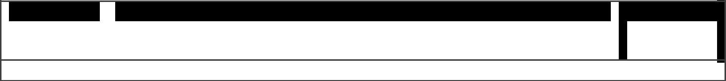

**ID** **Requirement description**  **Essential**

**or**



**Desirable**



1

## REQUIREMENTS IMPOSED BY SPECIFIC LEGISLATION STRATEGIES

**GENERAL**

|  |  |  |
| --- | --- | --- |
| **ID** | **Requirement description** | **Essential** |
|  |  | **or** |
|  |  | **Desirable** |
| 1 |  |  |
| **PRIVACY** |  |  |
|  |  |  |
| **ID** | **Requirement description** | **Essential** |
|  |  | **or** |
|  |  | **Desirable** |
| 1 |  |  |

## CONSTRAINTS

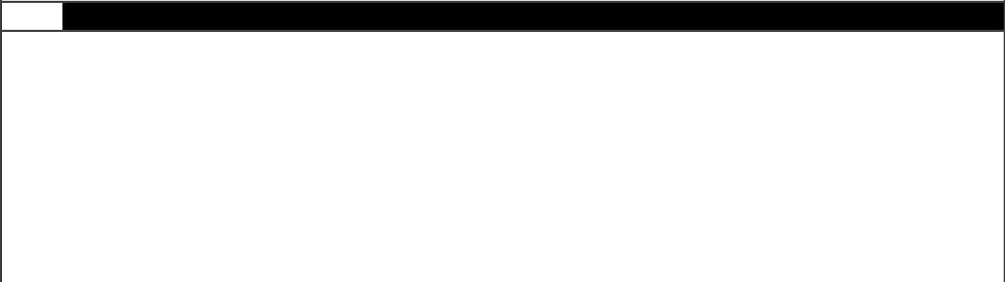

**Id** **Description**



1 Developer resource limits.

1. The product will be a web application and as such the interface needs to be compliant with standard web browsers including but not limited to Internet Explorer 6 & 7 and Mozilla Firefox

3  Compliance with OWASP and W3C standards. This constraint is self-imposed. Refer to  sections 3.2.2 and 3.2.4.



1. Due to web standards and accessibility the interface is constrained to HTML, CSS and JavaScript



5

Notes:

Introduction to Scrum (cc)-by-sa – Evan Leybourn Page 69 of 84

Introduction to Scrum

## ASSUMPTIONS



**Id** **Description**



1

## RISKS



**Id** **Description**



1

Notes:

Introduction to Scrum (cc)-by-sa – Evan Leybourn Page 70 of 84

Introduction to Scrum



# SUPPORTING MATERIAL – EXAMPLE TECHNICAL ARCHITECTURE



Notes:

Introduction to Scrum (cc)-by-sa – Evan Leybourn Page 71 of 84

Introduction to Scrum

## CONCEPTUAL SYSTEM DESIGN SECTION

|  |  |  |  |
| --- | --- | --- | --- |
|  | **Conceptual System Checklist** | | **Responses - Select all that apply** |
|  | |  |  |
|  | Project Type | | □ New System |
|  |  |  | □ Upgrade System |
|  |  |  | □ Other (specify): |
| Development Approach | | | □ Commercial Off The Shelf (COTS ) |
|  |  |  | □ Government Off The Shelf (GOTS ) |
|  |  |  | □ Custom |
|  | Delivery of Functionality | | □ Modular (functionality delivered over time) |
|  |  |  | □ Monolithic (functionality delivered all at once) |
| System Interactions | | | □ Business to Business (B2B) |
|  |  |  | □ Business to Customer (B2C) |
|  | Electronic Commerce | | □ Yes |
|  |  |  | □ No |
| Pilot Prior to Implementation | | | □ Yes |
|  |  |  | □ No |
|  | Security - Regulatory or Privacy | |  |
|  | Requirements | |  |
| [W3C Accessibility](http://www.w3.org/TR/WCAG20/) Compliance | | | □ Yes |
|  |  |  | □ No |
|  | Estimated Total Number of | | Total: |
|  | Customers | | By Audience: |
|  |  |  | Customer: ______ Employee: _____ Business:_____ |
|  |  |  | Other:______ |
| Estimated Total Number of | | | Total: |
| Concurrent Customers | | | By Audience: |
|  |  |  | Customer: ______ Employee: _____ Business:_____ |
|  |  |  | Other:______ |
|  | Average Transaction Response | | Platform: Windows XP Pro, PIV 1.2Ghz, 512MB RAM |
|  | Time Requirements | | Bandwidth: DSL/Cable (1Mb, 50% utilized) |
|  |  |  | Average File Size: ____ |
|  |  |  | Platform: Windows XP Pro, PIV 1.2Ghz, 512MB RAM |
|  |  |  | Bandwidth: LAN (10Mb, 50% utilized) |
|  |  |  | Average File Size: 30Kb |
| Production Hours of Operation | | |  |
|  | | |  |
|  | Production Availability | | Uptime => Downtime/year (i.e. unplanned) |
|  |  |  |  |

Notes:

Introduction to Scrum (cc)-by-sa – Evan Leybourn Page 72 of 84

Introduction to Scrum

|  |  |  |  |
| --- | --- | --- | --- |
| Expectations | 99% (2 Nines) => 003d 15h 36m 00s | |  |
| Application Backup Requirements | Full Backup: | |  |
|  | __ Real Time __ Daily __ Weekly | |  |
|  | Incremental Backup: | |  |
|  | __ Hourly __ Daily __ Weekly | |  |
| Application Recovery Requirements | Recovery Time Objective: | |  |
| Disaster Recovery Requirements | Hot Site: __ hour(s) | |  |
|  | Warm Site: __ days(s) | |  |
|  | Cold Site: __ days(s) | |  |
| Hosting Location |  |  |  |
| Architectural Approach | □ SOA | |  |
|  | □ 3/N Tier | |  |
|  | □ Other (specify): | |  |
| Processing Type | □ OLTP | |  |
|  | □ OLAP | |  |
|  | □ Other (specify): | |  |
| Development Platform | □ J2EE | |  |
|  | □ .NET | |  |
|  | □ PHP | |  |
|  | □ Other (specify): | |  |
| Architectural Framework(s) |  |  |  |
| Architectural Pattern(s) | □ MVC | |  |
|  | □ Factory | |  |
|  | □ Controller | |  |
|  | □ Data Access Object | |  |
|  | □ Other (specify): | |  |
| Software Testing | Test Driven Design Methodology (TDD) - basic tests are | |  |
|  | developed before the software is written. | |  |
|  |  |
|  | Tests include; | |  |
|  | • | Functional |  |
|  | • | Performance |  |
|  | • | Accessibility |  |
|  | • | User Acceptance |  |
| Security Technologies | □ Identity and Access Management | |  |
|  | □ SSL/TLS | |  |
|  | □ Data Encryption | |  |
|  | □ Cookie Encryption | |  |
|  | □ | __ DES __ 3DES __ AES __ Other (specify): |  |
|  | □ Other (specify): | |  |

Notes:

Introduction to Scrum (cc)-by-sa – Evan Leybourn Page 73 of 84

Introduction to Scrum

## CONCEPTUAL SYSTEM DESIGN DIAGRAM

<Insert Physical Architecture Diagram>

<Descript Physical Architecture Diagram>

## DETAIL SYSTEM DESIGN CHECKLIST

|  |  |
| --- | --- |
| **Detail System Checklist** | **Responses – Select all that apply** |
|  |  |
| Client Operating Systems | □ Apple |
|  | □ Microsoft |
|  | □ Linux |
|  | □ Unix |
|  | □ Palm |
|  | □ Microsoft PocketPC |
|  | □ Other (specify): |
| Client Platforms | □ Desktop/Laptop |
|  | □ Tablet |
|  | □ PDA |
|  | □ Smart Phone |
|  | □ Other (specify): |
| Client Footprint by Platform | Specify size of footprint in KB or MB: |
|  | Desktop/Laptop: |
|  | Tablet: |
|  | PDA: |
|  | Smart Phone: |
|  | Other (specify): |
| Client Connection Speed | Specify speed in kbps or mbps: |
|  | Minimum: |
|  | Recommended: |
| Client Richness | □ Browser Based |
|  | □ Rich Client |
|  | □ Rich Internet (AJAX) |
| Browsers and Versions Supported | □ Internet Explorer: |
|  | □ Mozilla Firefox: |
|  | □ Safari: |
|  | □ Opera: |
| Presentation - Client Side | □ HTML |
| Languages | □ DHTML |

Notes:

Introduction to Scrum (cc)-by-sa – Evan Leybourn Page 74 of 84

Introduction to Scrum

|  |  |  |  |
| --- | --- | --- | --- |
|  |  | □ XML |  |
|  |  | □ XHTML |  |
|  |  | □ VB.NET |  |
|  |  | □ C# |  |
|  |  | □ ActiveX Controls |  |
|  |  | □ Java Applets |  |
|  |  | □ Java |  |
|  |  | □ JavaScript |  |
|  |  | □ VBScript |  |
|  |  | □ C++ |  |
|  |  | □ Other (specify): |  |
|  | Application State | □ Cookies (Non-Persistent Cookies, Persistent |  |
|  |  | Cookies) |  |
|  |  | □ Session Ids |  |
|  |  | □ State Stored in Hidden Fields |  |
|  |  | □ Other (specify): |  |
|  | Virtualization | □ Server |  |
|  |  | □ Storage |  |
|  | Web Server Location | □ Public Facing |  |
|  |  | □ Internal Facing |  |
|  | Web Server Operating System | □ Windows |  |
|  |  | □ Linux |  |
|  |  | □ Unix |  |
|  |  | □ Other (specify): |  |
|  |  | □ Specify Version: |  |
|  | Web Server Software | □ Apache |  |
|  |  | □ Microsoft |  |
|  |  | □ Sun |  |
|  |  | □ Oracle |  |
|  |  | □ Other (specify): |  |
|  |  | □ Specify Edition and Version: |  |
|  | Web Server - High Availability | Load Balanced: __ Yes __ No |  |
|  |  | Processor Architecture: __ 64 Bit __ 32 Bit |  |
|  |  | Processor Cores: __ Double __ Single |  |
|  |  | Other (specify): |  |
|  | Web Server - Specifications | Rollout Configuration: |  |
|  |  | Number of Servers: __ CPUs/Server: __ CPU Type: |  |

_________

CPU Speed: _____ Amount of RAM: ____

Maximum Configuration:

Notes:

Introduction to Scrum (cc)-by-sa – Evan Leybourn Page 75 of 84

Introduction to Scrum



|  |  |  |  |  |
| --- | --- | --- | --- | --- |
|  |  |  | Number of Servers: __ CPUs/Server: __ CPU Type: | |
|  |  | __________ | |  |
|  |  |  | CPU Speed: _____ Amount of RAM: ____ | |
|  | Presentation – Server Side |  | □ ASP.NET |  |
|  | Languages |  | □ VB.NET |  |
|  |  |  | □ C# |  |
|  |  |  | □ PHP |  |
|  |  |  | □ JSP |  |
|  |  |  | □ Servlets |  |
|  |  |  | □ Java |  |
|  |  |  | □ Server Side Includes (SSI) |  |
|  |  |  | □ C++ |  |
|  |  |  | □ Other (specify): |  |
|  | Application Server Operating |  | □ Windows | |
|  | System |  | □ Linux | |
|  |  |  | □ Unix | |
|  |  |  | □ Other (specify): | |
|  |  |  | □ Specify Version: | |
|  | Application Server Software |  | □ Microsoft |  |
|  |  |  | □ IBM |  |
|  |  |  | □ Sun |  |
|  |  |  | □ Oracle |  |
|  |  |  | □ BEA |  |
|  |  |  | □ Other (specify): |  |
|  |  |  | □ Specify Edition and Version: |  |
|  | Application Server – High |  | Processor Architecture: __ 64 Bit __ 32 Bit | |
|  | Availability |  | Processor Cores: __ Double __ Single | |
|  |  |  | RAID Supported: __ Yes __ No | |
|  |  |  | SAN Supported: __ Yes __ No | |
|  |  |  | Mirroring Supported: __ Yes __ No | |
|  |  |  | Clustering Supported: __ Yes __ No | |
|  |  |  | Grid/On Demand Supported: __ Yes __ No | |
|  |  |  | Other (specify): | |
|  | Application Server - Specifications |  | Rollout Configuration: | |

Number of Servers: __ CPUs/Server: __ CPU Type:

_________

CPU Speed: _____ Amount of RAM: ____

Maximum Configuration:

Number of Servers: __ CPUs/Server: __ CPU Type:

__________

Notes:

Introduction to Scrum (cc)-by-sa – Evan Leybourn Page 76 of 84

Introduction to Scrum

|  |  |
| --- | --- |
|  | CPU Speed: _____ Amount of RAM: ____ |
| Business Rule – Application | □ VB.NET |
| Languages | □ C# |
|  | □ PHP |
|  | □ Java (J2SE) |
|  | □ Java/EJB (J2EE) |
|  | □ C++ |
|  | □ Other (specify): |
| Database Server Operating System | □ Windows |
|  | □ Linux |
|  | □ Unix |
|  | □ Other (specify): |
|  | □ Specify Version: |
| Database Server Software | □ Microsoft |
|  | □ IBM |
|  | □ Oracle |
|  | □ PostgreSQL |
|  | □ MySQL |
|  | □ Other (specify): |
|  | □ Specify Version: |
| Database Server – High Availability | Processor Architecture: __ 64 Bit __ 32 Bit |
|  | Processor Cores: __ Double __ Single |
|  | RAID Supported: __ Yes __ No |
|  | SAN Supported: __ Yes __ No |
|  | Mirroring Supported: __ Yes __ No |
|  | Clustering Supported: __ Yes __ No |
|  | Grid/On Demand Supported: __ Yes __ No |
|  | Other (specify): |
| Database Server - Specifications | Rollout Configuration: |
|  | Number of Servers: __ CPUs/Server: __ CPU Type: |
|  | _________ |
|  | CPU Speed: _____ Amount of RAM: ____ |
|  | Maximum Configuration: |
|  | Number of Servers: __ CPUs/Server: __ CPU Type: |
|  | __________ |
|  | CPU Speed: _____ Amount of RAM: ____ |
| Data Access – Connectivity | □ ADO.NET |
| Methods | □ ODBC |
|  | □ OLE/DB |
|  | □ JDBC |

Notes:

Introduction to Scrum (cc)-by-sa – Evan Leybourn Page 77 of 84

Introduction to Scrum

|  |  |
| --- | --- |
|  | □ JDO |
|  | □ DB2 Connect |
|  | □ Other (specify): |
| SQL Languages | □ T/SQL |
|  | □ PL/SQL |
|  | □ Other (specify): |
| Stored Procedures Utilization | No |
|  | Yes |
|  | __ Data Access only |
|  | __ Business Rules and Data Access |

## SYSTEM DESIGN DESCRIPTION

<Insert High Detail Physical Architecture Diagram> <Describe High Detail Physical Architecture Diagram>

**BUSINESS CONTINUITY**

<Describe Business Continuity / Disaster Recovery Procedures In Place>

**EXPECTED ISSUES**

<Describe Issues Or Link To Issues Register>

Notes:

Introduction to Scrum (cc)-by-sa – Evan Leybourn Page 78 of 84

Introduction to Scrum



# SUPPORTING MATERIAL – EXAMPLE DESIGN PAGE



Notes:

Introduction to Scrum (cc)-by-sa – Evan Leybourn Page 79 of 84

Introduction to Scrum

Story: ______________________________________________________

|  |  |  |  |  |  |  |  |  |  |  |
| --- | --- | --- | --- | --- | --- | --- | --- | --- | --- | --- |
|  |  | **Estimate** |  |  |  |  | **Priority** |  |  |  |
|  |  | |  |  |  |  |  |  |  |  |
|  |  | **Value** |  |  |  |  | **Risk** |  |  |  |
|  |  | |  |  |  |  | **Test Cases** | |  |  |
|  |  | **Purpose** | |  |  |  |  |  |

|  |  |  |
| --- | --- | --- |
| **Use Cases** |  | **Notes** |

Notes:

Introduction to Scrum (cc)-by-sa – Evan Leybourn Page 80 of 84

Introduction to Scrum



# SUPPORTING MATERIAL – EXAMPLE RELEASE APPROVAL



Notes:

Introduction to Scrum (cc)-by-sa – Evan Leybourn Page 81 of 84

Introduction to Scrum

**RELEASE APPROVAL**

Release Name: ___________________________________

Version: __________________________________________

Date: _____________________________________________

## COMPLIANCE OUTCOME

|  |  |  |
| --- | --- | --- |
| **Requirement** | **Pass/Fail** | **Notes** |
|  |  |  |
|  |  |  |
|  |  |  |
|  |  |  |
|  |  |  |
|  |  |  |
|  |  |  |
|  |  |  |
|  |  |  |
|  |  |  |
|  |  |  |
|  |  |  |
|  |  |  |

## DEFECT TESTING OUTCOME

|  |  |  |
| --- | --- | --- |
| **Name** | **Pass/Fail** | **Notes** |
|  |  |  |
|  |  |  |
|  |  |  |
|  |  |  |
|  |  |  |
|  |  |  |
|  |  |  |
|  |  |  |
|  |  |  |
|  |  |  |

Notes:

Introduction to Scrum (cc)-by-sa – Evan Leybourn Page 82 of 84

Introduction to Scrum

## PERFORMANCE TESTING OUTCOME

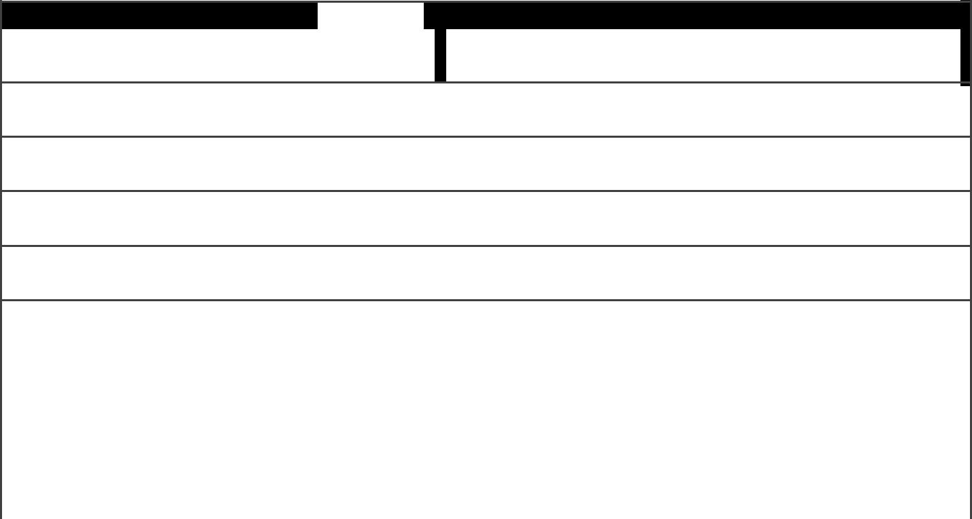

**Name** **Pass/Fail** **Tests**

**(All results are the average of 10 loads at SSC level)**



 Single User

 1000 Users



Single User

1000 Users



 Single User

 1000 Users



Single User

1000 Users



 Single User

 1000 Users



Single User

1000 Users



 Single User

 1000 Users



Single User

1000 Users

## ISSUES TO CARRY OVER TO THE NEXT RELEASE

Notes:

Introduction to Scrum (cc)-by-sa – Evan Leybourn Page 83 of 84

Introduction to Scrum

## SIGN OFF

Technical Program Final

<Name> <Name> <Name>

Notes:

Introduction to Scrum (cc)-by-sa – Evan Leybourn Page 84 of 84