transparent-img-marquee
Free unicode font generator.  Create eye-catching text styles you can copy and paste anywhere. Then bring your style into Adobe Express to design social posts, emails, and handles effortlessly.  Try for free | 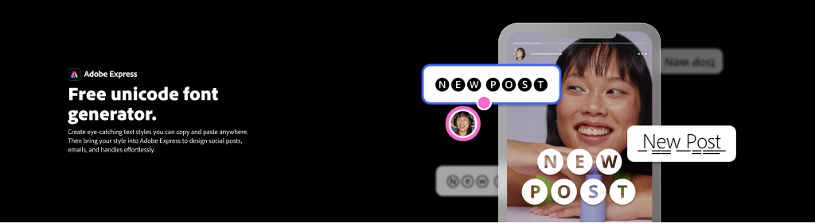

---
font-generator

---
columns
Looking for more fonts?  Browse the complete Adobe Fonts collection with over 30,000+ fonts in Adobe Express. Then start with a template to design anything.  Get Adobe Express Free | 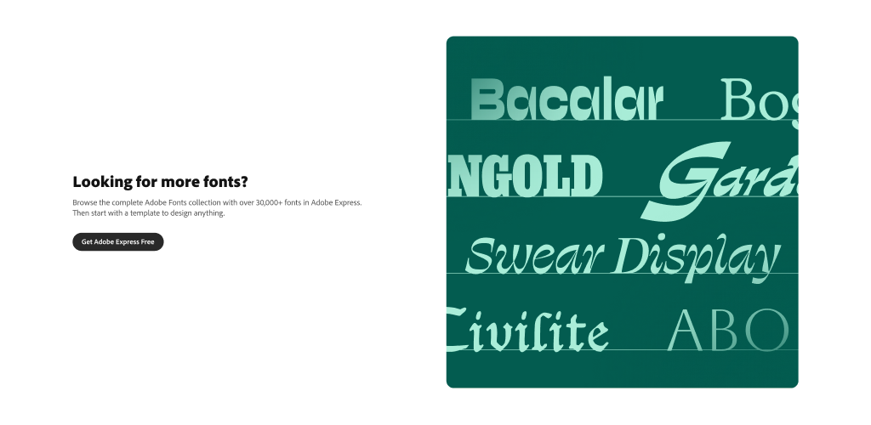

---

How the unicode font generator works.
how-to-v2
https://picsum.photos/seed/fontgen-howto/600/400
Find your unicode font. | Lorem ipsum dolor sit amet consectetur. Diam tortor magna lectus leo maecenas consectetur potenti pretium amet. Semper in blandit ultrices at etiam in facilisis.
Edit and copy text. | Lorem ipsum dolor sit amet consectetur. Diam tortor magna lectus leo maecenas consectetur potenti pretium amet. Semper in blandit ultrices at etiam in facilisis.
Paste anywhere online. | Lorem ipsum dolor sit amet consectetur. Diam tortor magna lectus leo maecenas consectetur potenti pretium amet. Semper in blandit ultrices at etiam in facilisis.
Take your unicode font further in Adobe Express. | Lorem ipsum dolor sit amet consectetur. Diam tortor magna lectus leo maecenas consectetur potenti pretium amet. Semper in blandit ultrices at etiam in facilisis.

---
how-to-cards (summary)

Add your text everywhere Unicode is supported.
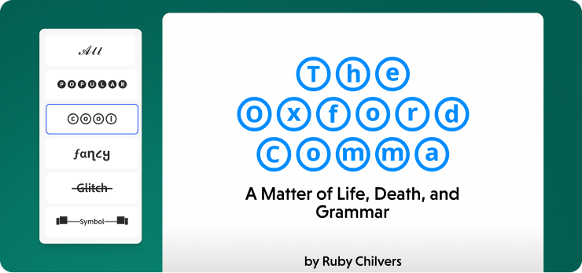

Social media
Instagram, TikTok, Facebook, YouTube, Snapchat, X, LinkedIn, Pinterest, and Threads.


Messaging apps
WhatsApp, Facebook Messenger, Telegram, Google Chat, iMessage, Signal, and SMS.


Gaming platforms
Discord, Roblox, PUBG, Free Fire, Fortnite, Minecraft, and Steam.
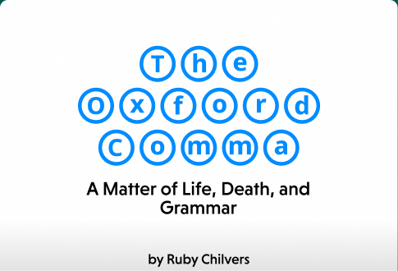

Professional tools
Slack, Microsoft Teams, Google Docs, Google Classroom, Notion, and email signatures.


Forums & communities
Reddit, Quora, Stack Overflow, GitHub, and Twitch.

---
font-bento

See your unicode font in action.
Felis interdum neque enim pretium hendrerit metus ornare vel malesuada. Cras mi dolor aenean risus. Sagittis vel at ipsum non elementum sit eget semper.
Create now
Social media | 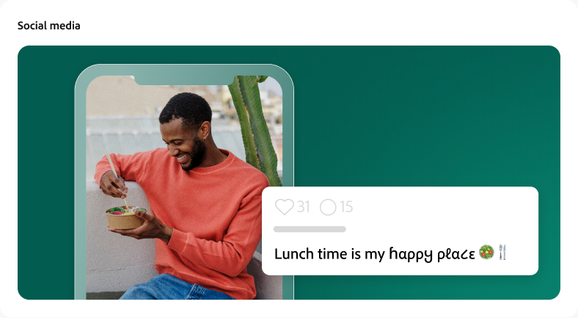
Games | 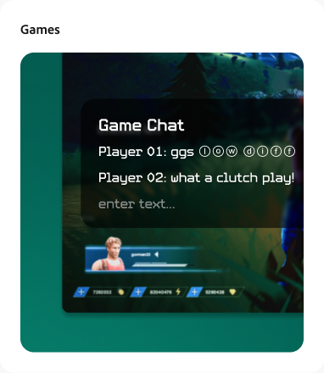
Design | 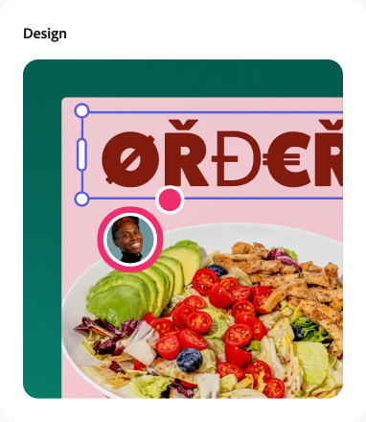
Messaging | 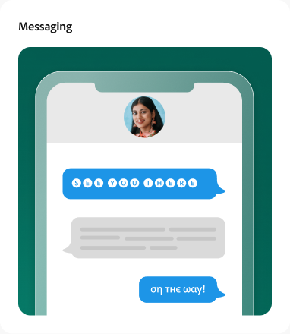
Ads | 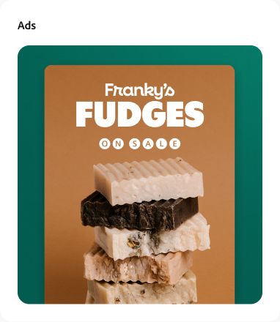
Documents | 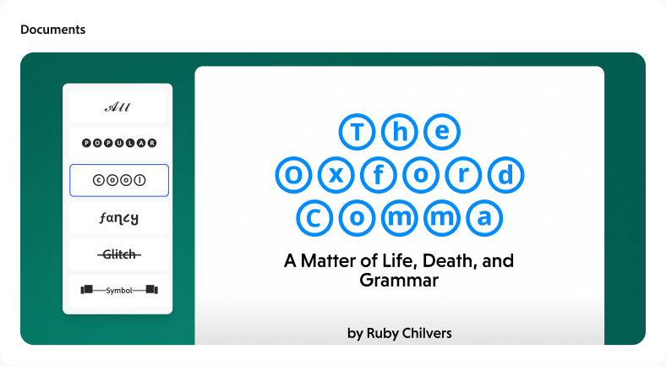

---
quotes (carousel)

See what people are saying about Adobe Express.
Lorem ipsum dolor sit amet consectetur. Proin a dignissim pretium pellentesque ultricies augue nisl. Vitae nunc sed etiam velit dui. Neque diam ut ac non. Sed turpis in rhoncus. |   Jane Doe  Job title
Lorem ipsum dolor sit amet consectetur. Proin a dignissim pretium pellentesque ultricies augue nisl. Vitae nunc sed etiam velit dui. Neque diam ut ac non. Sed turpis in rhoncus. |   Jane Doe  Job title
Lorem ipsum dolor sit amet consectetur. Proin a dignissim pretium pellentesque ultricies augue nisl. Vitae nunc sed etiam velit dui. Neque diam ut ac non. Sed turpis in rhoncus. |   Jane Doe  Job title
Lorem ipsum dolor sit amet consectetur. Proin a dignissim pretium pellentesque ultricies augue nisl. Vitae nunc sed etiam velit dui. Neque diam ut ac non. Sed turpis in rhoncus. |   Jane Doe  Job title
Lorem ipsum dolor sit amet consectetur. Proin a dignissim pretium pellentesque ultricies augue nisl. Vitae nunc sed etiam velit dui. Neque diam ut ac non. Sed turpis in rhoncus. |   Jane Doe  Job title

---
faqv2 (expandable)
Questions? We have answers.
Lorem ipsum dolor sit amet consectetur? | Lorem ipsum dolor sit amet consectetur. Euismod morbi dui vel arcu erat. Enim eu eget pulvinar risus sed tempor gravida leo. Sollicitudin massa habitasse elementum pretium nulla dignissim massa euismod pretium. Fermentum sit elit enim sapien mi libero. Gravida luctus ultrices sit id pellentesque faucibus massa enim. Nunc quis dolor tortor a.
Lorem ipsum dolor sit amet consectetur adipiscing? | Lorem ipsum dolor sit amet consectetur. Euismod morbi dui vel arcu erat. Enim eu eget pulvinar risus sed tempor gravida leo. Sollicitudin massa habitasse elementum pretium nulla dignissim massa euismod pretium.
Lorem ipsum dolor sit amet, how does it work? | Lorem ipsum dolor sit amet consectetur. Euismod morbi dui vel arcu erat. Enim eu eget pulvinar risus sed tempor gravida leo. Sollicitudin massa habitasse elementum pretium.
What platforms support unicode fonts? | Lorem ipsum dolor sit amet consectetur. Euismod morbi dui vel arcu erat. Enim eu eget pulvinar risus sed tempor gravida leo. Sollicitudin massa habitasse elementum pretium nulla dignissim massa euismod pretium. Fermentum sit elit enim sapien mi libero.
Is the unicode font generator free to use? | Lorem ipsum dolor sit amet consectetur. Euismod morbi dui vel arcu erat. Enim eu eget pulvinar risus sed tempor gravida leo. Sollicitudin massa habitasse elementum pretium nulla dignissim massa euismod pretium.
Can I use unicode fonts in social media bios? | Lorem ipsum dolor sit amet consectetur. Euismod morbi dui vel arcu erat. Enim eu eget pulvinar risus sed tempor gravida leo. Sollicitudin massa habitasse elementum pretium nulla dignissim massa euismod pretium. Fermentum sit elit enim sapien mi libero.
How do I use my unicode font in Adobe Express? | Lorem ipsum dolor sit amet consectetur. Euismod morbi dui vel arcu erat. Enim eu eget pulvinar risus sed tempor gravida leo. Sollicitudin massa habitasse elementum pretium nulla dignissim massa euismod pretium.

---
banner-bg (cool-dark-bg)

Looking for more fonts?
Browse the complete Adobe Fonts collection with over 30,000+ fonts in Adobe Express.
Get Adobe Express Free

---
metadata
Title | Free Unicode Font Generator | Adobe Express
Description | Create eye-catching unicode text styles with our free font generator. Copy and paste anywhere — social media, messaging apps, gaming, and more. Powered by Adobe Express.
Short Title | Unicode Font Generator
gnav-source | /express/localnav-express
footer-source | /federal/footer/footer
georouting | on

