columns (fullsize)
Free image compressor.  Easily compress your images in one click using Adobe Express, the quick and easy create-anything app. Use the online photo compressor to instantly change the file size of any image to share across your social channels.  Upload your photo | Upload animation (MP4)

section-metadata
showwith | fqa-non-qualified

— SECTION BREAK —
frictionless-quick-action
Free image compressor.
Easily compress your images in one click using Adobe Express, the quick and easy create-anything app. Use the online photo compressor to instantly change the file size of any image to share across your social channels.
Alternate video source (MP4) | Drag and drop an image  or browse to upload.  Upload your photo  File must be JPEG, JPG, PNG or WebP and less than 40MB  By uploading your image or video, you agree to the Adobe Terms of Use and Privacy Policy
Quick-Action | compress-image

section-metadata
showwith | fqa-qualified-desktop

— SECTION BREAK —
frictionless-quick-action-mobile
Free image compressor.
Easily compress your images in one click using Adobe Express, the quick and easy create-anything app. Use the online photo compressor to instantly change the file size of any image to share across your social channels.
Do more with your image in Adobe Express.
Alternate video source (MP4) | Tap to upload an image.
File must be JPEG, JPG, PNG or WebP and less than 40MB
By uploading your image or video, you agree to the Adobe Terms of Use and Privacy Policy
fallback | https://main--da-express-milo--adobecom.aem.live/express/fragments/mobile-frictionless-qa/fallback-remove-background
Quick-Action | compress-image

section-metadata
showwith | fqa-qualified-mobile

— SECTION BREAK —
How to compress a JPEG.
steps (highlight, image, schema)
 | 1. Select  Upload your image to our image compressor tool.
 | 2. Compress.  Either upload a JPEG from your device or access an image in Adobe Express. Use the slider to compress the JPEG down from 100 percent to 0 percent. The add-on will reflect, in real time, the size of the compressed image.
 | 3. Continue editing.  Click Add to page or Download when you've got a JPEG size that works for your project. Keep editing your image in Adobe Express by applying filters, cropping, and more.

— SECTION BREAK —
columns
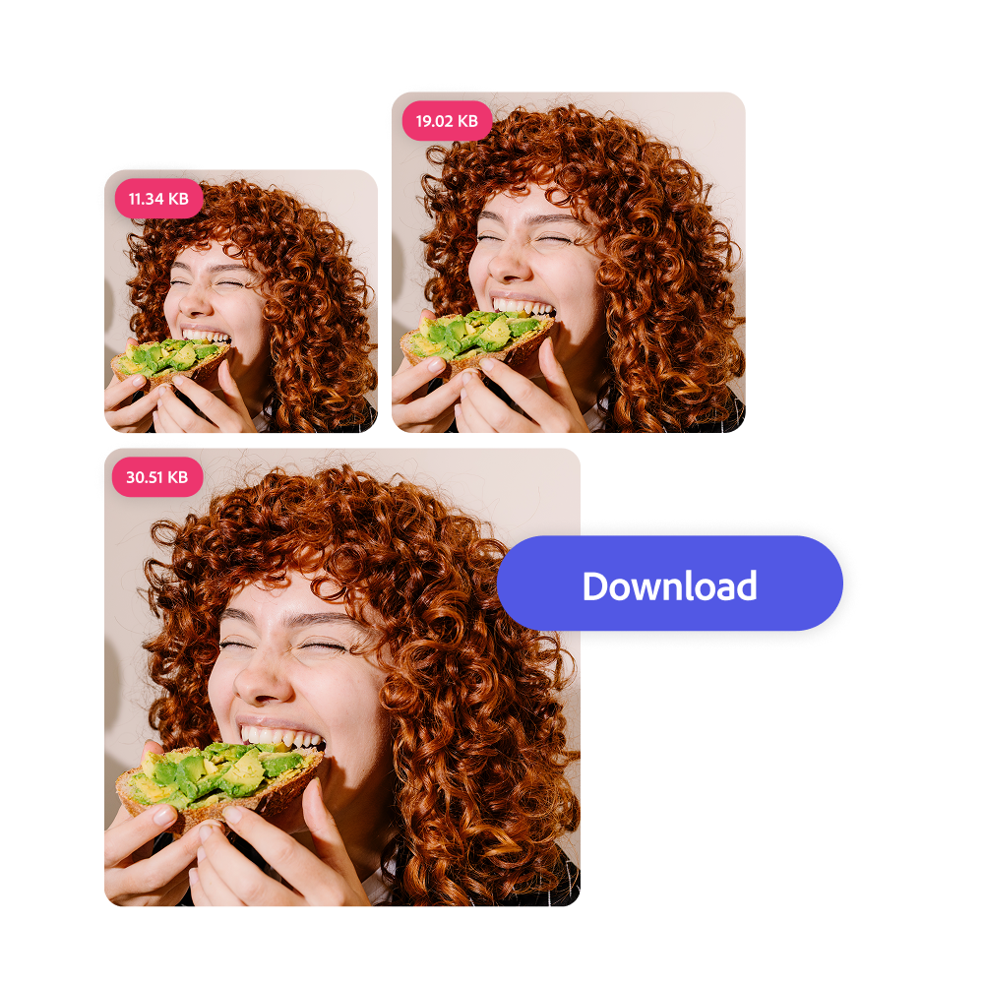 | Quickly compress any image.  If you're compressing an image for the homepage of your blog or so you can text your vacation photos to the friend chat in bulk, you want to be able to use your photos right away. Just upload your image into the image compressor, then use the slider tool to pick the ideal file size.

columns
Strike the ideal balance.  Customize the level of compression you need for your JPEG with the easy-to-use slider. Compress just a little to maintain the highest image quality or a lot if you're looking to save space in your digital storage of choice. | 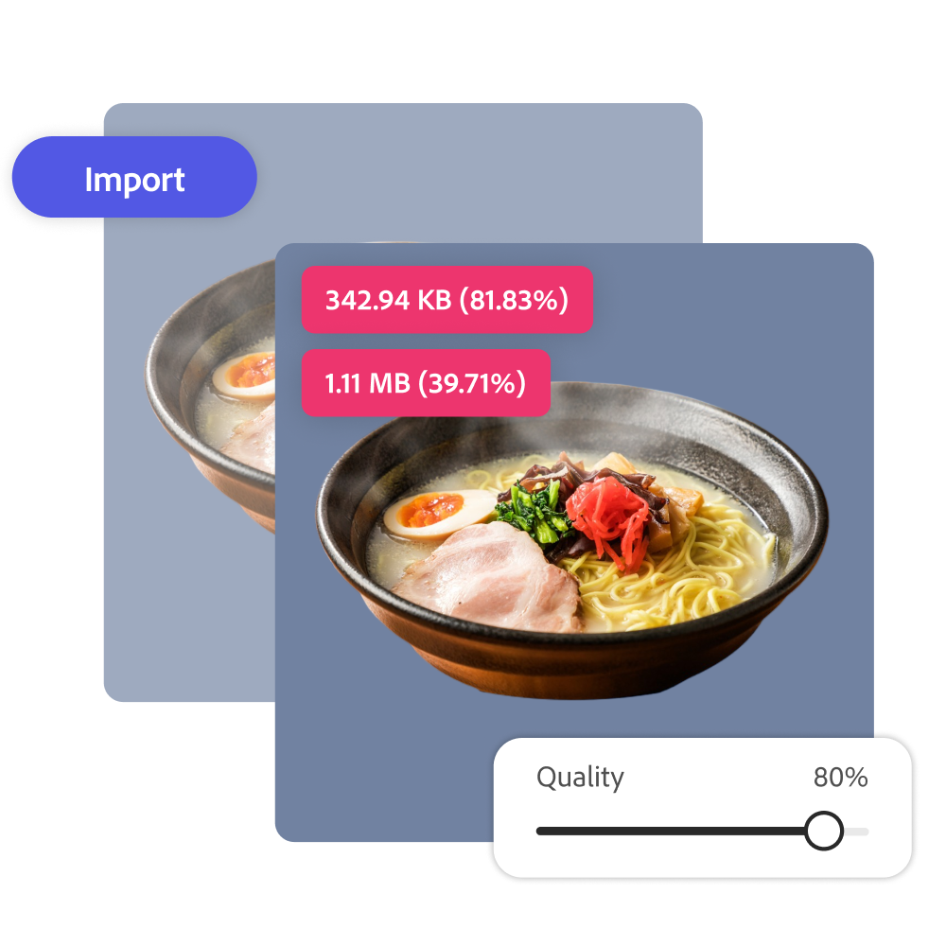

columns
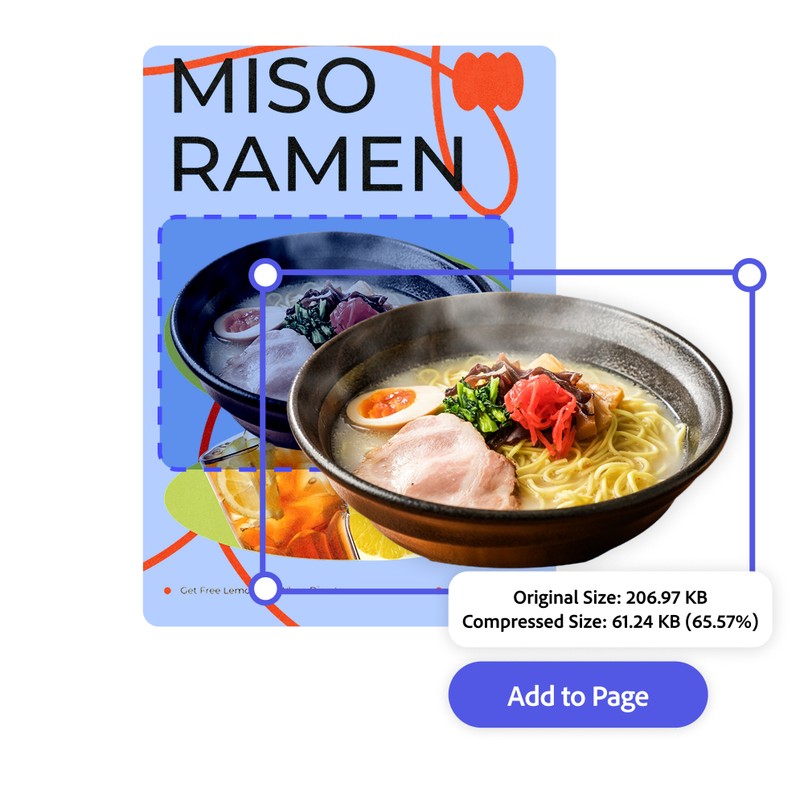 | Streamline your workflow.  Compress your JPEGs in one place in Adobe Express. You can even use images you're working within the Adobe Express editor without needing to download first. Finalize designs faster when you're not switching between programs for different tasks. Click Add to page to keep editing or download the new JPEG.

columns
Customize your photo online with the compression tool, templates, and more.  Adobe Express makes editing and using images easy. Take time to explore the image editing options among an array of others to develop your style. With Adobe Express on your side, all you need to do is open the app to create unique and standout designs that will captivate your audience. | 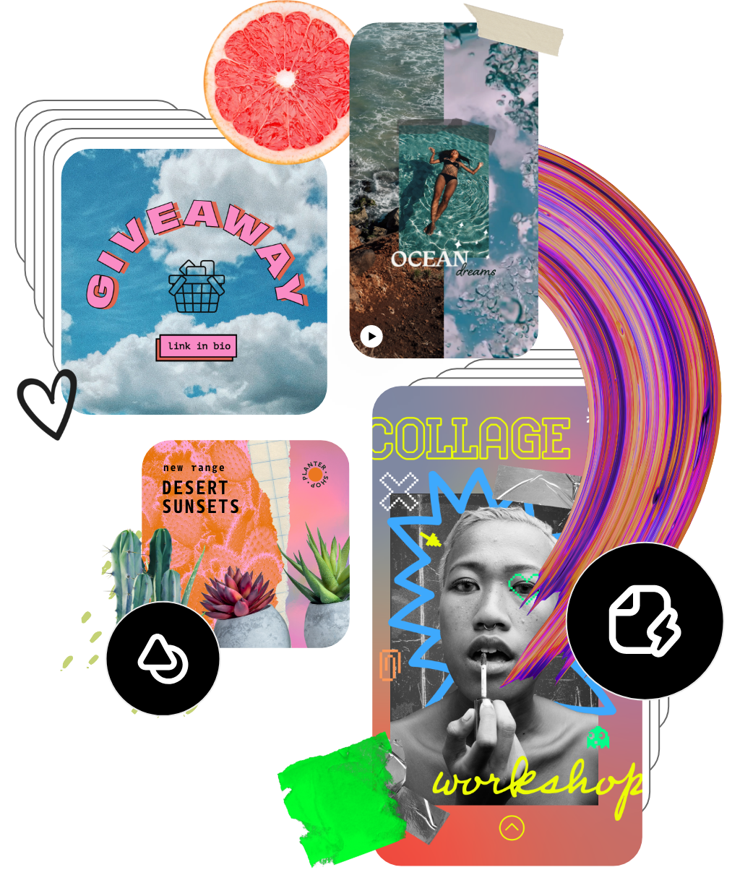

— SECTION BREAK —
link-list
Discover even more.
Remove Background
Blur Background
Convert Image File
Photo Effect
Enhance Image
Video Editor/Maker

— SECTION BREAK —
banner
Easily compress JPEGs with Adobe Express.

— SECTION BREAK —
Frequently asked questions.
faq
How do I compress JPEGs in Adobe Express? | Upload a JPEG, JPG, PNG, or WebP file (up to 40MB) to the image compressor above. Use the slider to choose your compression level, then Download or Open in Adobe Express to keep editing.
What files are supported by the image compressor? | JPEG, JPG, PNG, and WebP images can be compressed with the image compressor. The compressed image will be converted to your chosen format on download. You can also open the compressed image in the Adobe Express editor for more editing options.
Will compressing an image reduce its quality? | Compression may reduce quality, especially at higher compression levels. Use the slider to adjust the compression and find a good balance between file size and visual quality.
Can I get Adobe Express for free? If so, what’s included? | Yes, Adobe Express has a free plan that includes core features like photo editing tools and effects and thousands of free templates. Learn more about our plans and pricing.

— SECTION BREAK —
breadcrumbs
Home
Feature
Image Compressor

— SECTION BREAK —
metadata
Title | Free image compressor | Adobe Express
Description | Easily compress your images in one click using Adobe Express. Use the online photo compressor to instantly change the file size of any image to share across your social channels.
Short Title | Image Compressor
show-floating-cta | yes
desktop-floating-cta | floating-button
mobile-floating-cta | mobile-fork-button-frictionless
frictionless-safari | on
main-cta-link | https://adobesparkpost.app.link/c4bWARQhWAb
fork-cta-1-icon | cc-express
fork-cta-1-icon-text | Adobe Express
fork-cta-1-text | Get free app
fork-cta-1-link | https://adobesparkpost.app.link/5pSIOLrnqTb
fork-cta-2-icon | SX_GlobeGrid_18_N
fork-cta-2-icon-text | Web version
fork-cta-2-text | Continue
fork-cta-2-link | https://adobesparkpost-web.app.link/e/00XSYb7H5Hb
fork-cta-2-link-frictionless | #mobile-fqa-upload
fork-cta-2-text-frictionless | Upload photo
breadcrumbs | n/a
breadcrumbs-from-url | off
breadcrumbs-hidden-entries | image,video,design
quickaction-upload-page | on
theme | No Brand Header
show-free-plan | yes
marquee-inject-logo | yes

