Introduction to functions

Adolfo Alvarez

2020-01-29

## Definition:

A function $f$ assigns to each element $x$ in some set $S$ a unique element in a set $T$

* The set $S$ is called the **domain** of $f$ or $Dom(f)$
* For $x$ in $Dom(f)$, $f(x)$ is called the image of $x$ under $f$
* The set of all images $f(x)$ is a subset of $T$ called the image of $f$, or $Im(f)$

$$Im(f)=f(x):x∈Dom(f)$$

## Some examples

$f_{1}(x)=x^{2}$

$f_{2}(x)=\sqrt{(}x)$

$f_{3}(x)=log(x)$

$f_{4}(x)=sin(x)$

Are you familiar with them?

* x is a variable, or input
* $f(x)$ is the output, which has to be uniquely determined!
* You need to know what values of x are allowed

## Graphs

The graphical representation of the previous functions are:

## Square function

$f(x)=x^{2}$

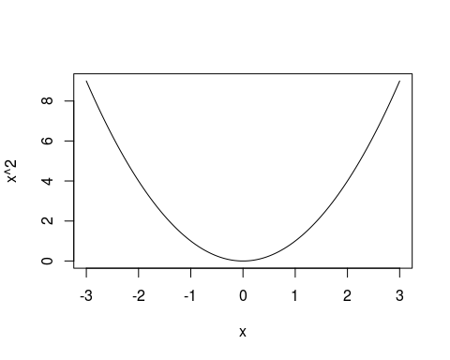

## Square root function

$f_{2}(x)=\sqrt{(}x)$

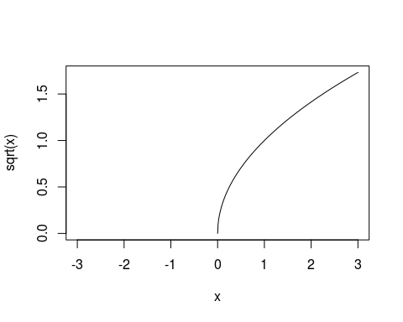

## Logarithmic function

$f_{3}(x)=log(x)$

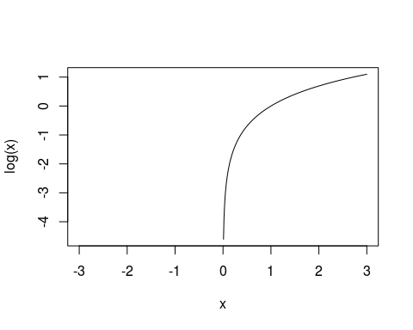

## Exponential function

$f_{4}(x)=exp(x)$

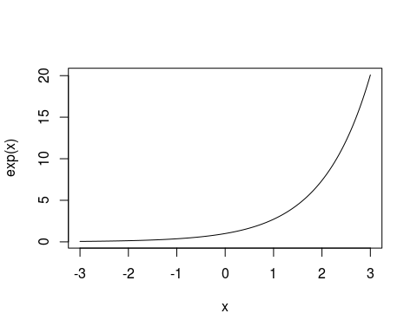

## Sine function

$f_{5}(x)=sin(x)$

