I have my XML file and through the XSL file I have been able to add a button to certain elements of the XML as seen in the image.

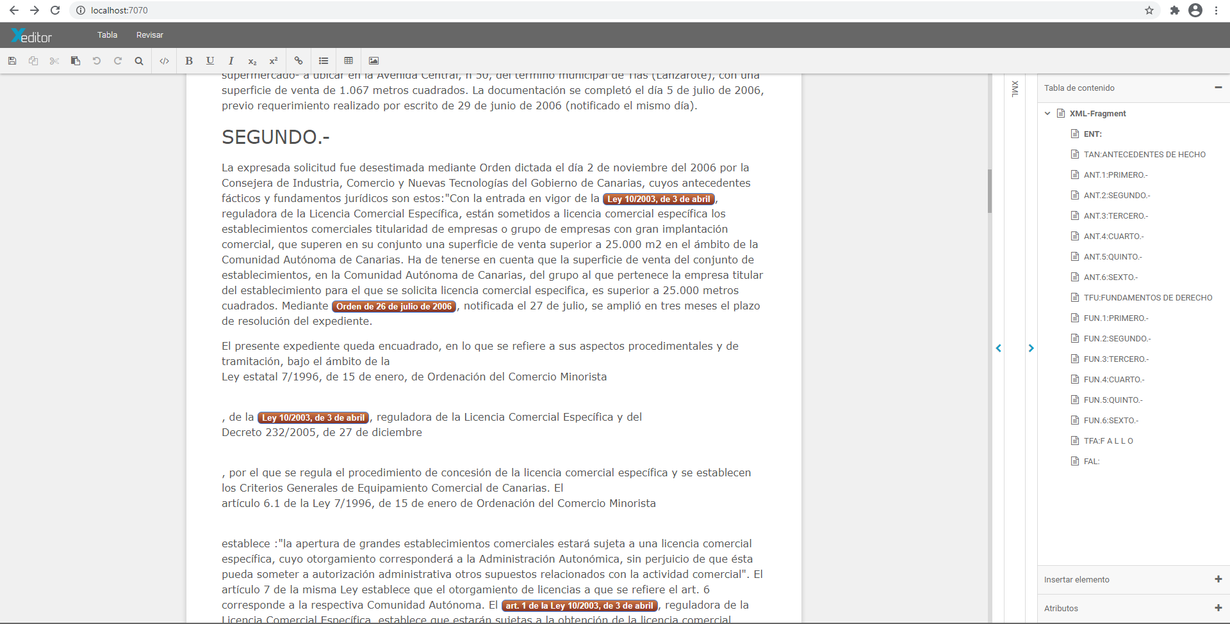

What I need to do is that clicking on the buttons opens a window, but I can't find a way to do it.

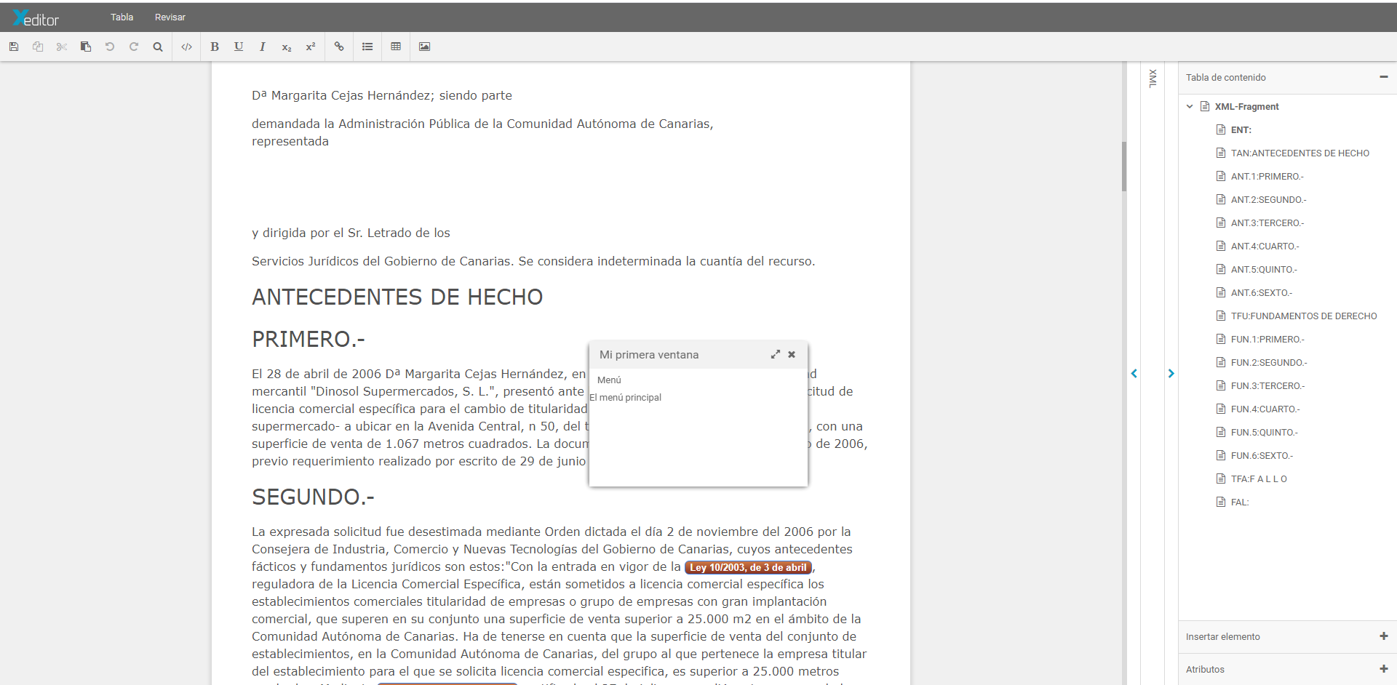

In the XSL definition I have the following code that paints the button for me.

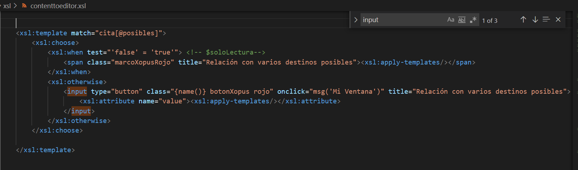

The file that the sale creates for me is the following, for now it is a simple test, because this window will carry a lot of business logic.

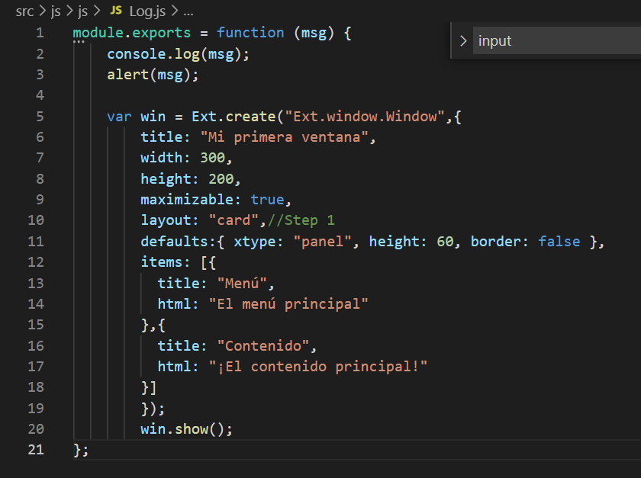

But the problem is that when I press the button, the msg () function does not recognize me.

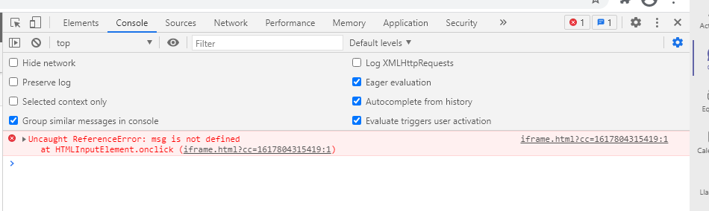

I don't know how to bind the button event with the class that renders the window.

The only thing that I have managed to invoke when loading the page from the index.js file,

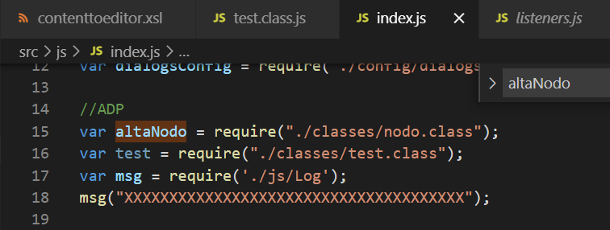

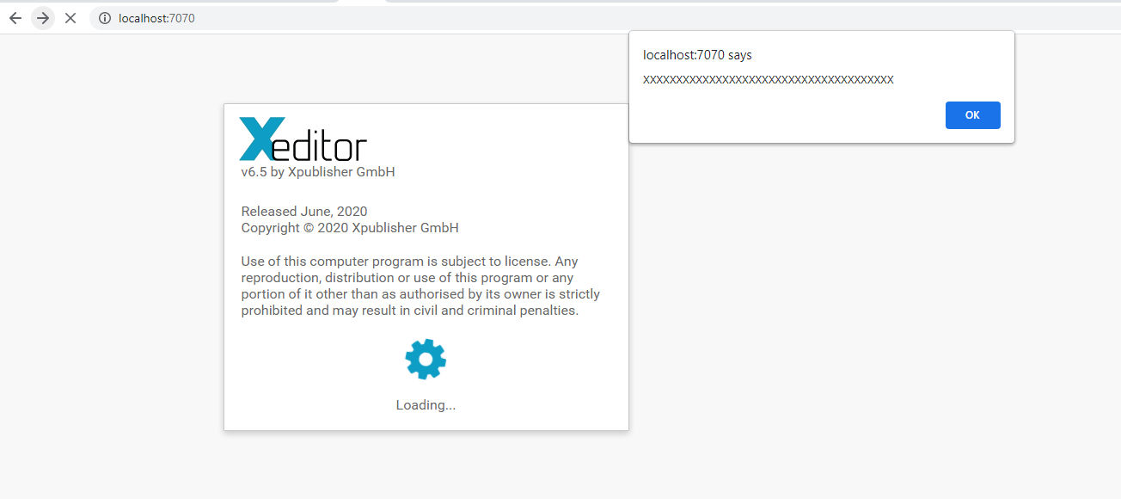

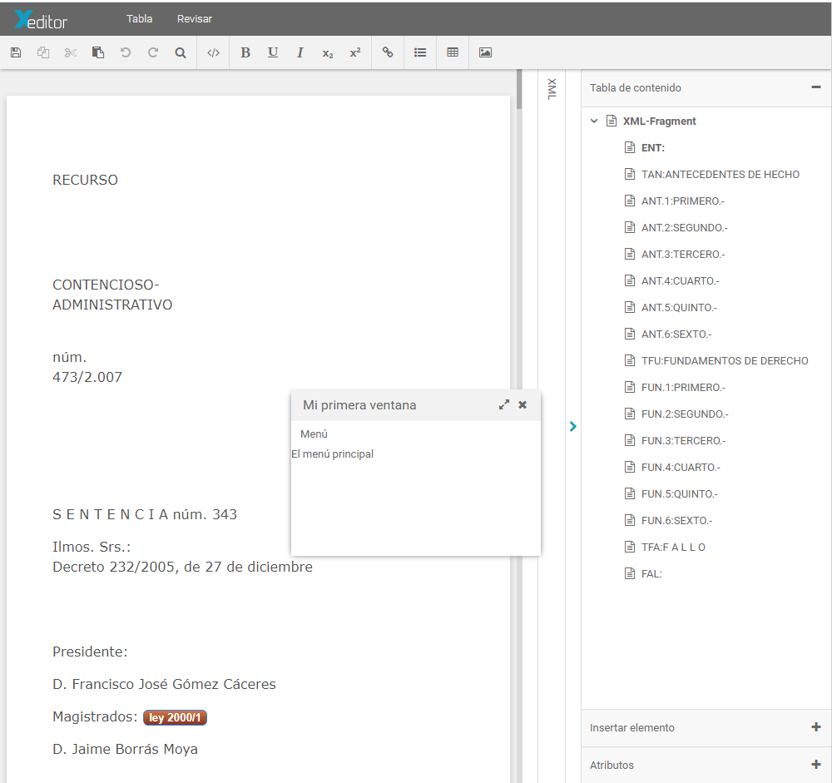

but when trying with the button it no longer recognizes msg ().

You can tell me how I can relate the events defined in the XSL with the classes that I can define within the project and be able to access them according to the event that it invokes.