**Top-level Architecture:**

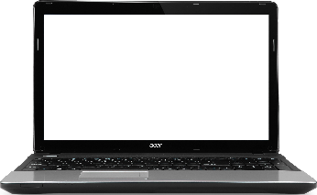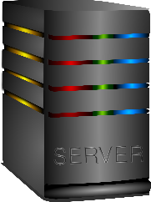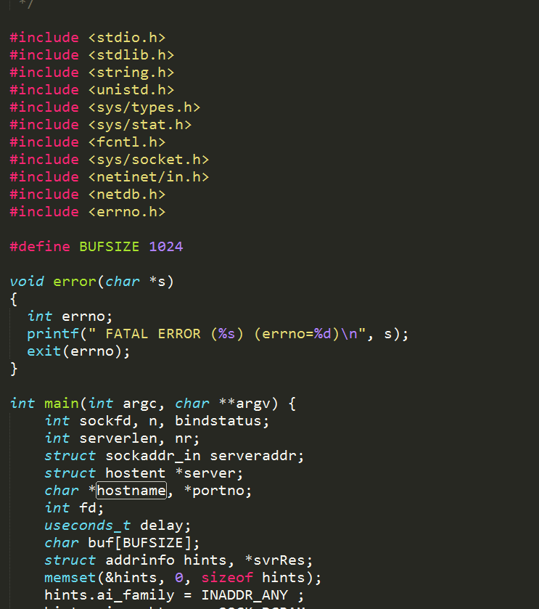

10.200.x.x

UPD: 2345

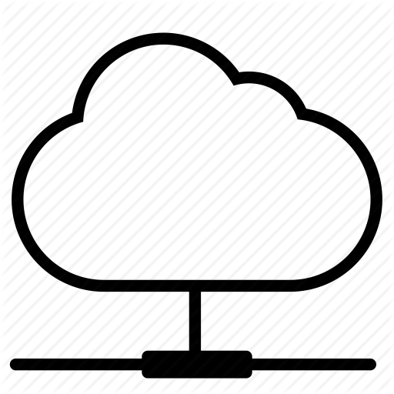

afsaccess4.njit.edu

UDP: 4567

udpradio.c

**Environment:**

On laptop:

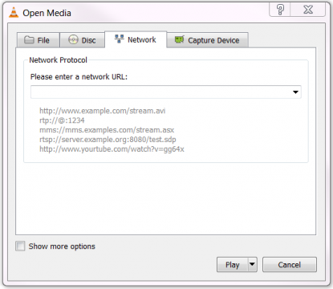

udp://@:0.0.0.0:2345

On Server:



**Steps:**

1. Create a UDP socket and bind on the server
2. Build the host’s internet address (use the cmdline arguments hostname and port)
3. Open file
4. Read file and send the message to server (packet size 1024 bytes and delay from the cmdline argument)