Defect 1

[UI] User is redirected to a page with Error 405 when login is incorrect

Severity: High

Steps to reproduce:

- Go to /Prod/Account/Login page
- Enter incorrect login
- Enter incorrect password

Actual result: User is redirected to 405 error

Expected Result: Error message “The specified username or password is incorrect.” is dispalyed to a user

Important note:

When login is correct and password in incorrect, the message is actually shown. This ups a security risk because username can be guessed.

Defect 2:

[UI] User can access /Prod/Benefits/ page without Login

Severity: Medium

Steps to reproduce:

- Go to /Prod/Account/LogIn page
- Click Paylocity Benefits Dashboard logo at the top right

Or

- Go to /Prod/Benefits directly via URL

Actual result: /Prod/Benefits page is displayed, without any data

Expected result: User is redirected back to Login page

Defect 3:

[UI] No message when session is expired

Severity: Low

Steps to reproduce:

- Go to /Prod/Account/LogIn page
- Login with correct credentials
- Wait for some time, usually about 10 mins

Actual Result: User is still on /Prod/Benefits and can click edit or new Employee, but it will result in no action

Expected result: User is notified when session has expired and redirected to login page

Defect 4:

[UI] No error is displayed when fields for a new employee are incorrect

Severity: Medium

Preconditions: User is logged in

Steps to reproduce:

- Go to /Prod/Benefits/
- Click “Add Employee”
- Enter employee data, but leave First Name empty
- Click “Add”

Actual Result: Employee is not created, but no error message displayed

Expected Result: Error message about First Name being empty is displayed

No message is displayed for other validation errors as well:

- Empty First Name, Last Name or Dependends
- First Name or Last Name being longer than 50 symbols
- Dependents being < 0 or > 32

Defect 5:

[UI] Headers for First Name and Last Name are in a wrong order

Severity: High

Preconditions: User is logged in

Steps to reproduce:

- Go to /Prod/Benefits/
- Wait for table with Employees to be loaded

Actual Result: First Name and Last Name are in a wrong order

Expected Result: First Name should be first header, and Last name should be second

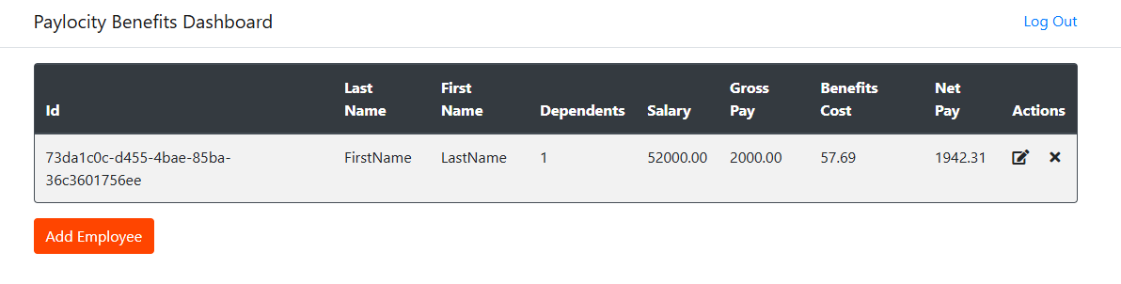

Defect 6:

[UI] Employees table can get out of bounds if First or Last Name is too long

Severity: Low

Preconditions: User is logged in

Steps to reproduce:

- Go to /Prod/Benefits/
- Click “Add Employee”
- Create an employee where First or Last name is 50 symbols

Actual Result: Table is out of bounds

Expected result: Depends on design agreement, table can expand or name can be wrapped

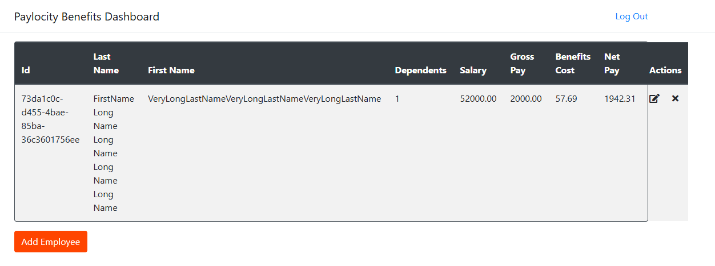

Defect 7:

[UI] Edit window is called Add Employee

Severity: Low

Preconditions: User is logged in, and at least one Employee is present in the table

Steps to reproduce:

- Go to /Prod/Benefits/
- Click Edit icon for any Employee

Actual Result: Modal Window is called Add Employee

Expected Result: Name should be Update Employee

Defect 8:

[API] Username is mandatory in docs but not in practice

Severity: Low

Steps to reproduce:

API docs: https://wmxrwq14uc.execute-api.us-east-1.amazonaws.com/Prod/swagger/v1/swagger.json

- Make POST request to /api/Employees with the following body:

{
"firstName": "John",
"lastName": "Doe",
}

Same issue is present for PUT request

Actual Result: New user is created

Expected result: Update API docs or make the field mandatory, in case docs are correct

Defect 9:

[API] Username cannot be changed

Severity: Medium

Steps to reproduce:

API docs: https://wmxrwq14uc.execute-api.us-east-1.amazonaws.com/Prod/swagger/v1/swagger.json

- Make POST request to /api/Employees with the following body:

{
"Username": "NewUsername"
"firstName": "John",
"lastName": "Doe",
}

Same goes for PUT request

Actual Result: New user is created with username being "NewUsername"

Expected Result: Username is the same as logged in user

This is either a bug, or an API issue. If field cannot be changed, we should remove it from POST and PUT bodies

Defect 10:

[API] API gives more information than needed

Severity: Medium

Steps to reproduce:

Preconditions: at least one Employee is present in the data

Steps to reproduce:

API docs: https://wmxrwq14uc.execute-api.us-east-1.amazonaws.com/Prod/swagger/v1/swagger.json

- Make a valid GET request to /api/Employees to get one user or list of users

Actual Result: As per docs, GET reuqest returns fields partitionKey and sortKey, which are giving out internal data structure and can potentially be used for security attacks

Expected Result: partitionKey and sortKey are omitted from response and docs

Defect 11:

[API] POST and PUT requests cannot edit expiration field

Severity: Blocker

Steps to reproduce:

- Make POST request to /api/Employees with the following body:

{
"firstName": "First2",
"lastName": "User2",
"expiration": "2026-03-13T06:59:46+00:00"
}

- Make GET request to get created user

Same issue for PUT request

This is a blocker issue, as expiration logic cannot be tested without editing it.

Actual Result: Expiration is still one month forward, even when POST response says it has changed

Expected Result: Expiration is updated as stated

Defect 12:

[API] Expiration field is not present in response for POST and PUT if they do not edit it

Severity: Low

Steps to reproduce:

- Make POST request to /api/Employees with the following body:

{
"firstName": "First2",
"lastName": "User2",
}

Same issue for PUT

Actual Result: Expiration field is not present in response

Expected Result: Expiration field should be present in POST and PUT responses

Defect 13:

[API] POST request cannot change salary

Severity: High

Steps to reproduce:

- Make POST request to /api/Employees with the following body:

{
"firstName": "First2",
"lastName": "User2",
"salary": 20000,
}

Actual Result: Salary is set to 20000

Expected Result: Salary is set to default 52000

Defect 14:

[API] PUT request can set salary to negative numbers

Severity: Medium

Preconditions: at least one Employee is present in the data

Steps to reproduce:

- Make PUT request to /api/Employees with the following body:

{
"id": <existing_user_id>,
"firstName": "First2",
"lastName": "User2",
"salary": -500,
}

Actual Result: Salary is set to -500

Expected result: Error message should be shown for negative salary

Defect 15:

[API] POST and PUT requests can set expiration in the past

Severity: High

Steps to reproduce:

- Make POST request to /api/Employees with the following body:

{
"firstName": "First2",
"lastName": "User2",
"expiration": "2023-03-13T06:59:46+00:00"
}

Same issue for PUT request

Actual Result: No error, expiration is in the past

Expected Result: Error message should be displayed about trying to set expiration in the past

