Author: Adomas Vensas

Student’s ID: 2110644

Contacts: [adomasve@gmail.com](mailto:adomasve@gmail.com)

Assignment’s number: 7

Assignment’s purpose:

Create a utility (named “slltool”’ by the creator) for an implementation of a singly linked list. The tool must be universally applicable and highly modular. In addition, two supplementary modules and two showcase programs must be created to prove the capabilities of the tool. First program (“main1”) unit tests and examines the quality of the utility. Second program (“main2”) has both of the supplementary modules: “revlist” and “structlist”. “revlist” extends the capabilities of “slltool” by providing a function to reverse the SLL. “structlist” aggregates future structures that may be used in the file.

“slltool” module is described exhaustively in its documentation “slltool_documentation”.

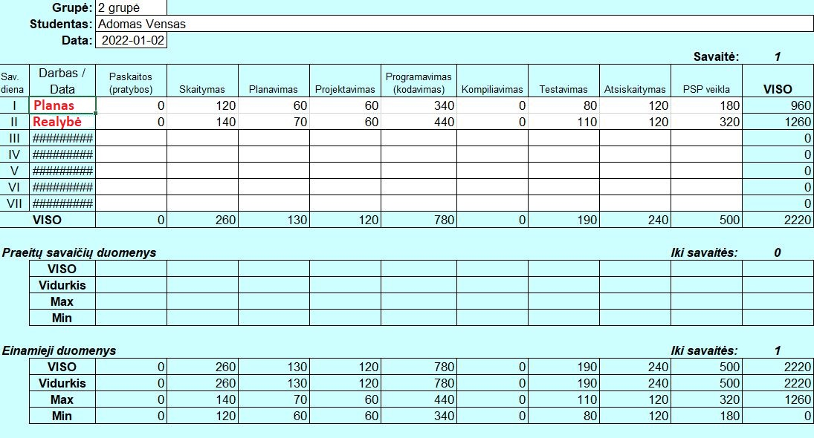I was not expecting to do terrifically well - plenty of experience in this course to know that plans don’t usually go the way I want. I set out a goal to finish in 16 hours – finished in 21. The main reason for this was a misunderstanding of the requirements. I did not understand whether error handling was a must and how to implement a SRP model effectively without “choking” functions with “printf” statements. Because of this inability to organize, I did the error handling and later had to delete all of it which erased all my painstaking hours of work. Deleted, because I wanted to play safe and not break any rules of code. On a more positive note, creating the linked list was relatively easy because I had most of the templates ready from before. However, still no good idea on how to complete these homework exercises at a satisfactory level. I’m a perfectionist but there simply is not enough time to be pedantic. Lastly, I have no idea how the lecturer is going to grade any of them. This element of surprise is unnerving considering the nearing exams. But the ship doesn’t wait, therefore I should not dwell on these things and simply move on.

Paveikslėlis, kuriame yra stalas

Automatiškai sugeneruotas aprašymas

Laiko fiksavimo forma

|  |  |  |  |  |  |  |  |  |  |  |  |
| --- | --- | --- | --- | --- | --- | --- | --- | --- | --- | --- | --- |
| Grupė | | 2 grupė | | | | | Data | | 2022-01-02 | | |
| Studentas | | Adomas Vensas | | | | | | | | | |
|  | | | | | | | | | | | |
| Data | Nuo | | Iki | Trukdžiai | Laikas | Veikla | | Komentarai | | B. | Vnt. |
| 01-02 | 12:20 | | 15:00 | 40, 20 min pertraukos | 20 min | Planavimas | | Suplanavau ar bus error handling ir prisiminiau, kad turiu linked list‘o visas funkcijas | |  |  |
|  |  | |  |  | 30 min | Projektavimas | | Suprojektavau mintyse testus ateities moduliui | |  |  |
|  |  | |  |  | 30 min | Skaitymas | | Pradėjau skaityti apie error handling‘ą C | |  | Neskaičiavau, kiek svetainių skaičiau |
|  |  | |  |  | 20 min | Programavimas | | Copy-paste turimas funkcijas linked list‘o | |  | +143 eilutės |
| 01-03 | 23:00 | | 00:30 |  | 60 min | Skaitymas | | Skaitau apie „generic linked list“ | |  |  |
|  |  | |  |  | 30 min | Programavimas | | Tobulinu copy-paste‘intas funkcijas nes yra klaidų | |  | +40 eilučių |
| 01-04 | 11:20 | | 12:30 |  | 20 min | Skaitymas | | Skaitau apie preprocesoriaus komandas, toliau apie generic linked list‘ą | |  |  |
|  |  | |  |  | 50 min | Planavimas | | Suplanavau funkcijas, kurios daryti funkcijas, kurios tikrina ar galima naudoti kitas funkcijas | |  | +50 eilučių |
|  | 14:00 | | 18:00 |  | 30 min | Skaitymas | | Skyriau researchinimui apie macrosus ir kur storinti error pranešimus ir kaip naudot header failus. | |  |  |
|  |  | |  |  | 180 min | Programavimas | | Funkcijų pertvarkymai, naujų funkcijų kūrimas, pabaigiau funkcijas, kurios tikrina kitas funkcijas | | X  12:30 | +45 eilutės |
|  |  | |  |  | 30 min | Projektavimas | | Pradėjau abejoti naudingumu error handling | |  |  |
| 01-05 | 11:00 | | 12:40 |  | 100 min | PSP veikla | | Parašiau pirmą variantą modulio dokumentacijos | |  | +10 lapų |
|  | 15:00 | | 17:00 |  | 60 min | PSP veikla | | Pabaigiau dokumentaciją | |  |  |
|  |  | |  |  | 30 min | Programavimas | | Sudariau linked list‘ui modulį. Perrašiau header failą kaip reikėjo. | | X  16:30 | +35 eilutes |
|  |  | |  |  | 30 min | Testavimas | | pradėjau daryti testus main1.c | |  | +150 eilučių |
| 01-06 | 11:00 | | 14:00 |  | 60 min | Programavimas | | Pertvarkiau .c failus pagal ansktesnių nd reikalavimus, ištryniau error handling beveik visą. | |  | +64 eilutės |
|  |  | |  |  | 120 min | Programavimas | | Pabaigiau main2.c failą su visais moduliais | | X  15:00 | +100 eilučių |
| 01-07 | 11:00 | | 15:00 |  | 80 min | Testavimas | | Pabaigiau main1.c | | 13:00 | +239 eilutės |
|  |  | |  |  | 80 min | PSP veikla | | Parašiau standartą | | X  14:00 | +6 lapai |
|  |  | |  |  | 80 min | PSP veikla | | Finalizavau ataskaitas | | X  15:00 | +visi ataskaitų lapai |
| 01-09 | 13:40 | | 15:40 |  | 120 min | Atsiskaitymas | | Filmuoju atsiskaitymą | | X  15:00 | +1 vaizdo įrašas |
|  |  | |  |  |  |  | |  | |  |  |
|  |  | |  |  |  |  | |  | |  |  |
|  |  | |  |  |  |  | |  | |  |  |
|  |  | |  |  |  |  | |  | |  |  |
|  |  | |  |  |  |  | |  | |  |  |
|  |  | |  |  |  |  | |  | |  |  |
|  |  | |  |  |  |  | |  | |  |  |
|  |  | |  |  |  |  | |  | |  |  |
|  |  | |  |  |  |  | |  | |  |  |
|  |  | |  |  |  |  | |  | |  |  |
|  |  | |  |  |  |  | |  | |  |  |
|  |  | |  |  |  |  | |  | |  |  |
|  |  | |  |  |  |  | |  | |  |  |
|  |  | |  |  |  |  | |  | |  |  |
|  |  | |  |  |  |  | |  | |  |  |
|  |  | |  |  |  |  | |  | |  |  |