Generating Web Sites from XTM Topic Maps

Problem
You want to capture knowledge about some subject in a Topic Map. You want to do so in a way that facilitates generation of a web site from the Topic Map using XSLT.

Solution
The solution is based on the Cogitative Topic Maps Web Site (CTW) framework introduced to readers in XML Topic Maps edited by Jack Park (Addison Wesley, 2002). This work was initially presented at Extreme Markup Languages 2000..
Readears unfamiliar with Topic Maps may want to read the discussion recipe 11.3 first or refer to the See Also section of 11.3 and this recipe for more resources.
The CTW uses the following mapping from topic map elements to HTML.
Topic Map Element | HTML Rendering
TopicMap | Web Site
Topic | Web Page
Topic Associations | Site map
Topic Occurrences | Images, graphics, text, html fragments, etc.
Topic Names | Page Headers, Titles, Lists, and Hyperlink titles
The Topic Map we will create covers the subject of algorithms and specifically sorting algorithms. The information for this topic map was organized from information gathered from the Internet including descriptions, demonstrations and code examples in several programming languages.
Once the subject and content of the web site were decided, the ontology of the web site subjects and objects followed pretty much straightforwardly. The CTW ontology layer consists of two main parts: classification of topic subjects that the website is about and classification of topic characteristics that provide web pages content.
Both of these classifications play very important role in controlling web site’s look and feel. Topic types control web pages layout and types of topic characteristics control the styling of web page elements and building blocks.
The follwing subsections describe the subjects of the Sorting Algorithms Web Site.

Sorting Algorithms
Quite obviously, the main subjects of our web site are the various subclasses of sorting algorithm.
<topic id="sort">
...
</topic>
<association>
<instanceOf>
<topicRef xlink:href="#_class-subclass"/>
</instanceOf>
<member>
<roleSpec>
<topicRef xlink:href="#_superclass"/>
</roleSpec>
<topicRef xlink:href="#sort"/>
</member>
<member>
<roleSpec>
<topicRef xlink:href="#_subclass"/>
</roleSpec>
<topicRef xlink:href="#simplesort"/>
<topicRef xlink:href="#in-place sort"/>
<topicRef xlink:href="#heapsort"/>
<topicRef xlink:href="#adaptivesort"/>
<topicRef xlink:href="#distributionsort"/>
<topicRef xlink:href="#mergesort"/>
</member>
</association>
The full version of the topic map and XSLT scripts is available online at http://www.cogx.com/ctw. Here we will only provide some fragments to illustrate recipe instructions.
Each of the sorting algorithms may have its own subclasses, for example we counted four variations of in-place-sort, each of which may in turn have its own sub-classes.
<association>
<instanceOf>
<topicRef xlink:href="#_class-subclass"/>
</instanceOf>
<member>
<roleSpec>
<topicRef xlink:href="#_superclass"/>
</roleSpec>
<topicRef xlink:href="#in-place sort"/>
</member>
<member>
<roleSpec>
<topicRef xlink:href="#_subclass"/>
</roleSpec>
<topicRef xlink:href="#quicksort"/>
<topicRef xlink:href="#insertionsort"/>
<topicRef xlink:href="#selsort"/>
<topicRef xlink:href="#dimincrsort"/>
</member>
</association>
There is an excellent web site of algorithms maintained by National Institute of Standards and Technology (NIST) [3] that collects information about various computational algorithms. It maintains a web page devoted to each algorithm. In our topic map we will use URLs of those pages as subject identifiers of algorithms.
<topic id="insertionsort">
<subjectIdentity>
<subjectIndicatorRef xlink:href="http://www.nist.gov/dads/HTML/insertsrt.html"/>
</subjectIdentity>
Besides playing roles in class-subclass associations with other algorithms, sorting algorithms have other topic characteristics such as base names and occurrences.
In our topic map sorting algorithms have names under which they are commonly recognized.
<baseName>
<baseNameString>insertion sort</baseNameString>
</baseName>
Sometimes they also have alternative names represented as base names in the also-known-as scope.
<baseName>
<scope>
<topicRef xlink:href="#also-known-as"/>
</scope>
<baseNameString>linear insertion sort</baseNameString>
</baseName>
Algorithm’s description is represented as a topic occurrence of type description in the scope of the description’s source. The following is a citation from the National Institute of Standards and Technology website (thus specified in the scope of nist topic), which can also read: “In the context of NIST, insertion sort is described as {…}”:

<occurrence>
<instanceOf>
<topicRef xlink:href="#description"/>
</instanceOf>
<scope>
<topicRef xlink:href="#nist"/>
</scope>
<resourceData>Sort by repeatedly taking the next item and inserting it into the final data structure in its proper order with respect to items already inserted. </resourceData>
</occurrence>
Links to algorithm demonstrations such as applets and animations are represented as topic occurrences of type demonstration.
<occurrence>
<instanceOf>
<topicRef xlink:href="#demo"/>
</instanceOf>
<resourceRef xlink:href="http://www.cosc.canterbury.ac.nz/people/mukundan/dsal/ISort.html"/>
</occurrence>
We also record links to sorting algorithms implementations and represent them in our topic map as occurrences of type code sample specified in the scope of a programming language in which they are implemented. Programming languages is the other class of topics represented on our web site constituting an orthogonal navigational dimension.
<occurrence>
<instanceOf>
<topicRef xlink:href="#code"/>
</instanceOf>
<scope>
<topicRef xlink:href="#fortran"/>
</scope>
<resourceRef
xlink:href="http://gams.nist.gov/serve.cgi/Module/TOMS/505/8547"/>
</occurrence>
<occurrence>
<instanceOf>
<topicRef xlink:href="#code"/>
</instanceOf>
<scope>
<topicRef xlink:href="#java"/>
</scope>
<resourceRef xlink:href=
"http://www.cs.ubc.ca/spider/harrison/Java/InsertionSortAlgorithm.java"/>
</occurrence>
</topic>
That is all the information about algorithms that we want to be able to represent. We will use it to build page headers, links to related algorithms, descriptions, links to pages on the web defining that algorithm, links to algorithm demonstrations and code samples with cross links to programming languages in which this samples are implemented.
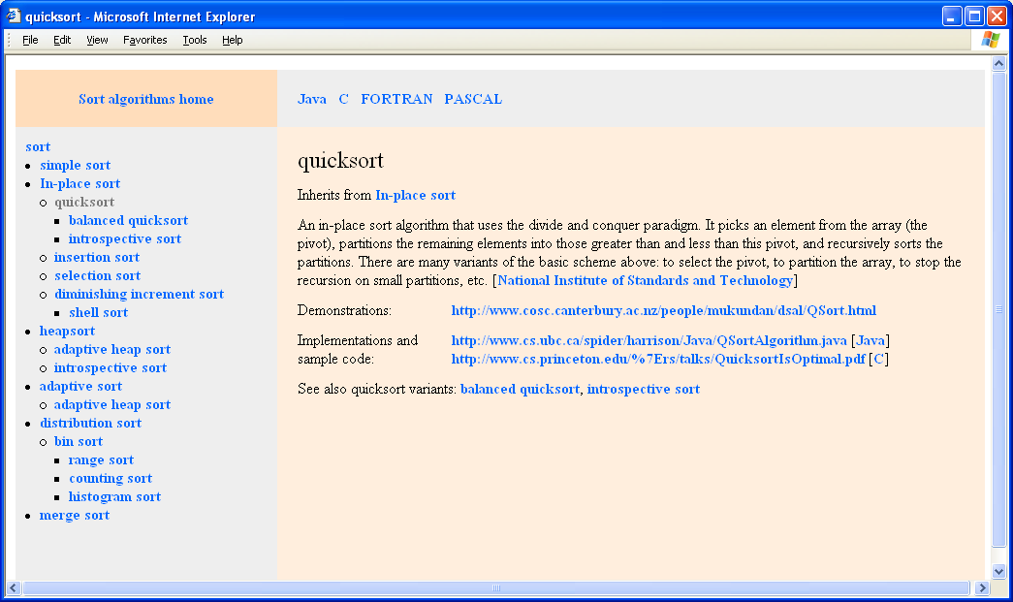

Programming Languages
As far as programming languages are concerned we are only interested in the fact that they are instances of the programming language class, in their names and definitions.
<topic id="java">
<subjectIdentity>
<subjectIndicatorRef xlink:href="http://foldoc.doc.ic.ac.uk/foldoc/foldoc.cgi?query=java"/>
</subjectIdentity>
<instanceOf>
<topicRef xlink:href="#plang"/>
</instanceOf>
<baseName>
<baseNameString>Java</baseNameString>
</baseName>
<occurrence>
<instanceOf>
<topicRef xlink:href="#definition"/>
</instanceOf>
<scope>
<topicRef xlink:href="#???"/>
</scope>
<resourceData>???????? ?????????? ????.</resourceData>
</occurrence>
</topic>
On a programming language page we will gather links to code samples implemented in that language, and cross links to the implemented algorithms.
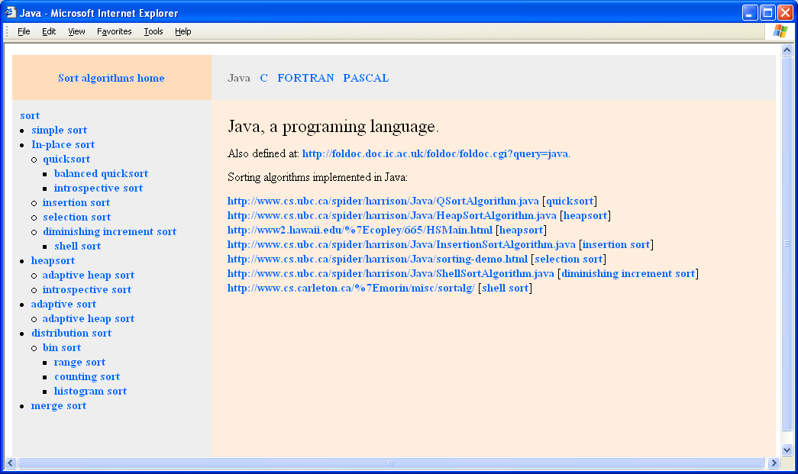

Root topic
And at last there is the root topic. In the CTW framework this is the topic whose subject is indicated by the topic map document itself. In topic map terms root topic reifies the topic map document to which it belongs.
<topic id="default">
<subjectIdentity>
<subjectIndicatorRef xlink:href="#map"/>
</subjectIdentity>
In CTW when topic maps merge this topic is added to the scopes of all topic characteristic assignments. And more importantly for us right now: this topic corresponds to the home or default page of the CTW website.
We will display its hyperlinked name in the upper left corner of all pages on our web site.
<baseName>
<baseNameString>Sort algorithms home</baseNameString>
</baseName>
As far as the topic characteristics go, this is the place to store topic map annotations and assertions about the topic map. In our case we will limit ourselves to the description of this little project and copyright metadata.
<occurrence>
<instanceOf>
<topicRef xlink:href="#definition"/>
</instanceOf>
<resourceData>This web site represents ....</resourceData>
</occurrence>
</topic>
On the root page we will only show project’s description as an introduction to the web site.
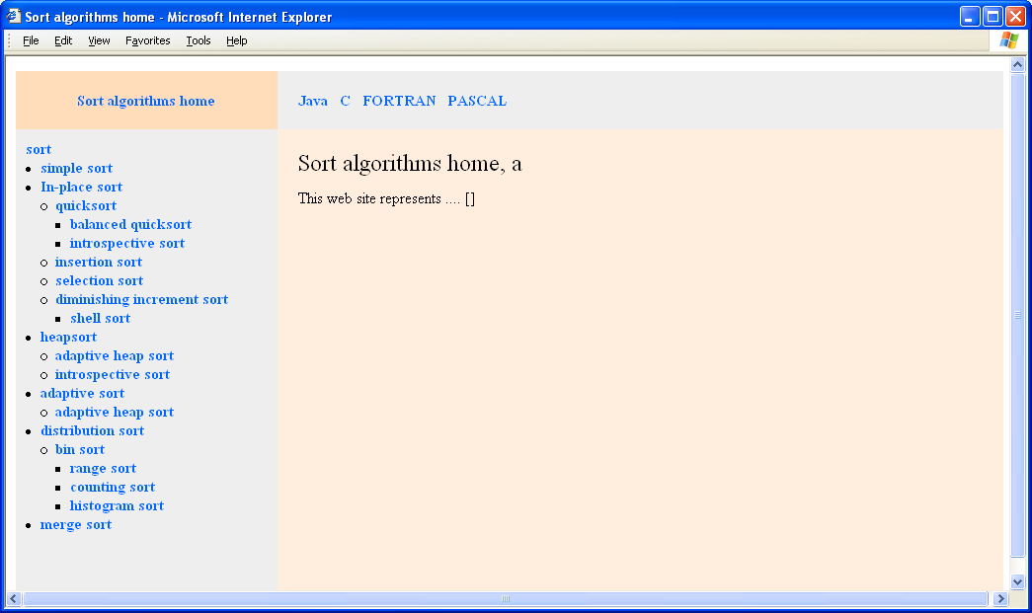

Page elements and layout
First we define root variable that represents the root topic: as described above this is the topic indicated by the containing topic map document.
<xsl:variable name="root"
select="//topic[subjectIdentity/subjectIndicatorRef/@xlink:href
= concat('#',/topicMap/@id)]"/>
Same node could be matched using subjectIndicator key that matches topics using addresses of resources that indicate them.
<xsl:key
name = "subjectIndicator"
match = "topic"
use = "subjectIdentity/subjectIndicatorRef/@xlink:href" />

<xsl:variable name="root"
select="key('subjectIndicator',concat('#',/topicMap/@id))"/>
Lets look at the first template that the XSLT processor will match:
<xsl:template match="/">
First goes instruction to generate the default page by calling root-page layout template for the root topic:
<xsl:call-template name="root-page">
<xsl:with-param name="this" select="$root"/>
</xsl:call-template>
Next follows instruction to generate web pages for every subclass of sorting algorithm. Here we call algorithm-page layout template with basic sorting algorithm as this parameter. Inside the template recursively calls itself to iterate over subclasses of all subclasses.
<xsl:call-template name="algorithm-page">
<xsl:with-param name="this" select="key('topicByID','#sort')"/>
</xsl:call-template>
Instruction to generate pages for every instance of a programming language by calling lang-page layout template:
<xsl:for-each select="key('instanceOf','#plang')">
<xsl:call-template name="plang-page"/>
</xsl:for-each>
</xsl:template>
instanceOf key returns all topic instances of some class based on the hashed ids of the class topic:
<xsl:key
name = "instanceOf"
match = "topic"
use = "instanceOf/topicRef/@xlink:href" />
topicByID key returns all topic elements based on the hashed ids of a given topic:
<xsl:key
name = "instanceOf"
match = "topic"
use = "instanceOf/topicRef/@xlink:href" />
As you might have noticed on screen-shots, all three layout templates have common sub-division into four square areas. This is controlled by the common main page building template that we will consider before looking at the individual layout templates.
Let’s follow the code. First we instruct the processor to create an output file relative to the output folder specified in the $out-dir parameter and create the TITLE header with the base name of the current topic in the unconstrained scope. The latter is achieved by instantiating template matching <topic> element in the label mode.
<xsl:template name="page">
<xsl:param name="this"/>
<xsl:param name="content"/>
<redirect:write select="concat($out-dir,$this/@id,'.html')">
<HTML>
<HEADER>
<TITLE>
<xsl:apply-templates select="$this" mode="label"/>
</TITLE>
</HEADER>
<BODY>
Now we start subdivision of the page into four parts. In the upper right corner we create a hyperlink to the home page whose label is the name of root topic in the unconstraint scope. The topic matching template in the link mode does that.
<table width="1000" height="100%" cellspacing="0" cellpadding="10">
<tr>
<td width="250" height="20" bgcolor="#ffddbb" align="center">
<xsl:apply-templates select="$root" mode="link"/>
</td>
In the upper right part of the page we have a selection of links to programming languages pages. This is done by iterating over all topics, instances of programming language topic.
<td width="750" height="20" valign="top" bgcolor="#eeeeee">
<table cellspacing="10">
<tr>
<xsl:for-each select="key('instanceOf','#plang')">
<td background="grey">
<xsl:apply-templates select="." mode="link"/>
</td>
</xsl:for-each>
</tr>
</table>
</td>
</tr>
In the lower left quarter of the page under the home page link we print the part of the site map corresponding to the classification of the sorting algorithms.
<tr>
<td valign="top" bgcolor="#eeeeee">
<xsl:call-template name="sitemap">
<xsl:with-param name="classRef">#sort</xsl:with-param>
<xsl:with-param name="current" select="$this/@id"/>
</xsl:call-template>
</td>
And finally in the main part of the page in the lower right quarter we output the main page content pertinent to the current topic submitted to the page template as content parameter.
<td valign="top" bgcolor="#ffeedd" ><xsl:copy-of select="$content"/></td>
</tr></table>
</BODY>
</HTML>
</redirect:write>
</xsl:template>
The template above uses baseName matching template in the label mode.
<xsl:template match="topic" mode="label">
<xsl:value-of select="baseName[not(scope)]/baseNameString"/>
</xsl:template>
And the baseName matching template in the link mode creates a hyperlink to the topic’s web page.
<xsl:template match="topic" mode="link">
<a href="{@id}.html">
<xsl:value-of select="baseName[not(scope)]/baseNameString"/>
</a>
</xsl:template>
Latter in the code we will use baseName matching template in the subject-indicator mode. This creates a hyperlink to a resource indicating matched topic.
<xsl:template match="topic" mode="indicator">
<a href="{subjectIdentity/subjectIndicatorRef/@xlink:href}">
<xsl:value-of select="baseName[not(scope)]/baseNameString"/>
</a>
</xsl:template>
sitemap template iterates over all subclasses of the sort topic, creates hyperlinks to pages corresponding to derived algorithms and recursively calls itself to iterate over subclasses of the subclasses, and so on.
<xsl:template name="sitemap">
<xsl:param name="classRef"/>
<xsl:param name="current"/>
<xsl:variable name="topic" select="key('topicByID',$classRef)"/>
<xsl:choose>
<xsl:when test="$topic/@id=$current">
<span class="A"><xsl:apply-templates select="$topic" mode="label"/></span>
</xsl:when>
<xsl:otherwise>
<xsl:apply-templates select="$topic" mode="link"/>
</xsl:otherwise>
</xsl:choose>
<xsl:variable name="aref" select="key('classAssoc',$classRef)"/>
<xsl:if test="$aref">
<ul>
<xsl:for-each select="$aref/member[roleSpec/topicRef/@xlink:href='#_subclass']/topicRef">
<li>
<xsl:call-template name="sitemap">
<xsl:with-param name="classRef" select="@xlink:href"/>
<xsl:with-param name="current" select="$current"/>
</xsl:call-template>
</li>
</xsl:for-each>
</ul>
</xsl:if>
</xsl:template>
classRef key used by the sitemap template uses hashed id of a given topic to match superclass-subclass associations where the topic plays super-class role.
<xsl:key
name = "classAssoc"
match = "association[instanceOf/topicRef/@xlink:href='#_class-subclass']"
use = "member[roleSpec/topicRef/@xlink:href='#_superclass']/topicRef/@xlink:href" />
Latter in the code we will use subClassRef key that also matches superclass-subclass associations but this time using member where the topic plays sub-class role.
<xsl:key
name = "subClassAssoc"
match = "association[instanceOf/topicRef/@xlink:href='#_class-subclass']"
use = "member[roleSpec/topicRef/@xlink:href='#_subclass']/topicRef/@xlink:href" />
Now we are ready to consider three layout templates.
root-page layout template is very simple. We call page template described above and send it HTML code generated for occurrences of type description in the content parameter.
<xsl:template name="root-page">
<xsl:param name="this"/>
<xsl:call-template name="page">
<xsl:with-param name="this" select="$this"/>
<xsl:with-param name="content">
<font size="+1">
<xsl:apply-templates select="$this/occurrence[instanceOf/topicRef/@xlink:href='#description']"/>
</font>
</xsl:with-param>
</xsl:call-template>
</xsl:template>
plang-page layout template has a bit more to it. It has a title composed of the name of the current topic followed by the name of topic’s type.
<xsl:template name="plang-page">
<xsl:param name="this" select="."/>
<xsl:call-template name="page">
<xsl:with-param name="this" select="$this"/>
<xsl:with-param name="content">
<font size="+2"><xsl:apply-templates select="$this" mode="label"/>, a
<xsl:apply-templates mode="label"
select="key('topicByID',$this/instanceOf/topicRef/@xlink:href)" />.
</font>
<br/><br/>
Then there goes a subject identity line pointing to a place elsewhere on the web where the subject of this topic is defined. Following it are topic descriptions, if any.
<xsl:apply-templates select="$this/subjectIdentity"/>
<xsl:apply-templates
select="$this/occurrence[instanceOf/topicRef/@xlink:href='#description']"/>
Then we iterate and output a link for each code occurrence implemented in the current language. In square brackets following the resource we place a link to the sorting algorithm implemented in this resource.
<xsl:variable name="codes"
select="key('plang-codes',concat('#',$this/@id))"/>
<xsl:if test="$codes">
<span>Sorting algorithms implemented in
<xsl:apply-templates select="$this" mode="label"/>:</span>
<ul>
<xsl:for-each select="$codes">
<li>
<a href="{resourceRef/@xlink:href}"><xsl:value-of select="resourceRef/@xlink:href"/></a>
[<xsl:apply-templates select=".." mode="link"/>]<br/>
</li>
</xsl:for-each>
</ul>
<br/><br/>
</xsl:if>
</xsl:with-param>
</xsl:call-template>
</xsl:template>
plang-codes key used above matches all occurrences in the topic map by any of their scope themes..
<xsl:key
name="plang-codes"
match="occurrence"
use="scope/topicRef/@xlink:href"/>
At last algorithm-page layout template. It has a title composed of the name of the current topic followed by also-known-else names in square brackets.

<xsl:template name="algorithm-page">
<xsl:param name="this"/>
<xsl:call-template name="page">
<xsl:with-param name="this" select="$this"/>
<xsl:with-param name="content">
<font size="+2"><xsl:apply-templates select="$this" mode="label"/>
<xsl:if test="$this/baseName[scope/topicRef/@xlink:href='#also-known-as']">
[<xsl:value-of select="$this/baseName
[scope/topicRef/@xlink:href='#also-known-as']
/baseNameString"/>]
</xsl:if>
</font>
<br/><br/>
Subject identity line is followed by the list of super-classes if any from which the current sorting algorithm inherits.
<xsl:apply-templates select="$this/subjectIdentity"/>
<xsl:variable name="superclasses"
select="key('subClassAssoc',concat('#',$this/@id))
member[roleSpec/topicRef/@xlink:href='#_superclass']/topicRef"/>
<xsl:if test="$superclasses">
Inherits from
<xsl:for-each select="$superclasses">
<xsl:apply-templates
select="key('topicByID',@xlink:href)" mode="link"/>
<xsl:if test="position() != last()">, </xsl:if>
</xsl:for-each>
<br/><br/>
</xsl:if>
Then goes one or more sorting algorithm descriptions followed by the list of links to algorithm demonstration occurrences and by the list of code samples with cross links to implementing programming languages in square brackets.
<xsl:apply-templates
select="$this/occurrence[instanceOf/topicRef/@xlink:href='#description']"/>
<xsl:variable name="demos"
select="$this/occurrence[instanceOf/topicRef/@xlink:href='#demo']"/>
<xsl:if test="$demos">
<span>Demonstrations: </span>
<ul>
<xsl:for-each select="$demos">
<li>
<a href="{resourceRef/@xlink:href}"><
xsl:value-of select="resourceRef/@xlink:href"/>
</a><br/>
</li>
</xsl:for-each>
</ul>
<br/>
</xsl:if>
<xsl:variable name="codes"
select="$this/occurrence[instanceOf/topicRef/@xlink:href='#code']"/>
<xsl:if test="$codes">
<span>Implementations and sample code: </span>
<ul>
<xsl:for-each select="$codes">
<li>
<a href="{resourceRef/@xlink:href}">
<xsl:value-of select="resourceRef/@xlink:href"/>
</a>
[<xsl:apply-templates mode="link"
select="key('topicByID',scope/topicRef/@xlink:href)" />]
</li>
</xsl:for-each>
</ul>
<br/>
</xsl:if>
On the bottom of the page we list sub-classes or variations if any of the current sorting algorithm.
<xsl:variable name="subclasses"
select="key('classAssoc',concat('#',$this/@id))
/member[roleSpec/topicRef/@xlink:href='#_subclass']/topicRef"/>
<xsl:if test="$subclasses">
See also
<xsl:value-of select="$this/baseName[not(scope)]/baseNameString"/>
variants:
<xsl:for-each select="$subclasses">
<xsl:apply-templates select="key('topicByID',@xlink:href)" mode="link"/>
<xsl:if test="position() != last()">, </xsl:if>
</xsl:for-each>
</xsl:if>
</xsl:with-param>
</xsl:call-template>
And finally algorithm-page layout template calls itself recursively to outpate pages for subclasses of all its subclasses.
<xsl:variable name="aref" select="key('classAssoc',concat('#',$this/@id))"/>
<xsl:for-each
select="$aref/member[roleSpec/topicRef/@xlink:href='#_subclass']/topicRef">
<xsl:call-template name="algorithm-page">
<xsl:with-param name="this" select="key('topicByID',@xlink:href)"/>
</xsl:call-template>
</xsl:for-each>
</xsl:template>

Discussion
Topic Maps is a technology to accumulate and manage knowledge about real world knowledge domains. In this case, we represented relationships between algorithms and other objects and resources. If we are careful to follow the conventions of CTW, we get the benefit of being able to drive the creation of a web site from the topic map source.
In this solution we had limited ourselves to just a few types of objects and relationships between them. Of curse real life applications are much more complicated. Our main aim was to demonstrate the power and tremendous opportunities provided by the CTW framework and I hope that we succeeded.

In the CTW framework, a single topic map document controls both the content and structure of an entire Web site. Proper CTW topic map architecture provides for robust and intuitive maintenance of links between web pages, web pages content and metadata. Web sites built according to CTW are easily mergeable, and dead link immune. XSLT brings a consistent look and feel as well as platform independence and reusability.
There is a price that we have to pay to get all these benefits: CTW framework requires you to think of your content in terms of topics, topic characteristics and associations. This approach constrains us to creating content only in the limits of the chosen ontology but it helps keep the knowledge represented on the Web site well organized and navigable.
XSLT goes a long way to enabling the CTW because it provides a means to transform and stylize the knoweldge containd in the topic map in a very modular and maintainable fashion.

See Also
XML Topic Maps: Creating and Using Topic Maps for the Web. ISBN 0-201-74960-2 is an excelent book that covers both the theory and application of Topic Maps in a very accessible manner.
The author of this recipe maintains a site at http://www.cogx.com/ctw/
default.html that further discusses Topic Maps and the Cogitative Topic Maps framework. Slides from the Extreme Markup Languages presentation of CTW are available at
http://www.topicmaps.org.

