Autonomous Vehicle Perception Pipeline
Project Documentation

Project: ROS2-based perception stack for autonomous vehicle research
Institution: TH OWL Lemgo
Repository: Link
Document date: June 2026

1. Project Overview
The project develops a modular perception pipeline for autonomous vehicle research. The system processes data from a vehicle-mounted ZED 2i stereo camera and a Robosense 128-line LiDAR (an ARS548 radar is also available on the vehicle but is not consumed by the current pipeline) and produces real-time scene understanding. The outputs include 2D object detection, 3D object detection, distance estimation, road surface classification, weather classification, risk assessment, and 3D object localisation through sensor fusion. The implementation is built on ROS2 Humble and runs on a workstation equipped with an NVIDIA RTX A5000 GPU.

2. Scope
The scope of the project covered the design, implementation, and validation of a complete perception software stack. The stack is organised into five ROS2 packages. Each package addresses a distinct domain: camera-based detection, LiDAR-based detection, environment classification, sensor fusion, and risk assessment. The packages share a common runtime and compose into a single coherent pipeline that can be launched together. The deliverables include the working software stack, model assets, supporting scripts for build and launch orchestration, a public GitHub repository, and a system architecture diagram.

3. Pipeline Architecture
The diagram below shows the complete node and topic graph of the pipeline. It captures every active component and the data flow between them. The supervisor walkthrough is intended to follow this diagram from left to right and top to bottom.
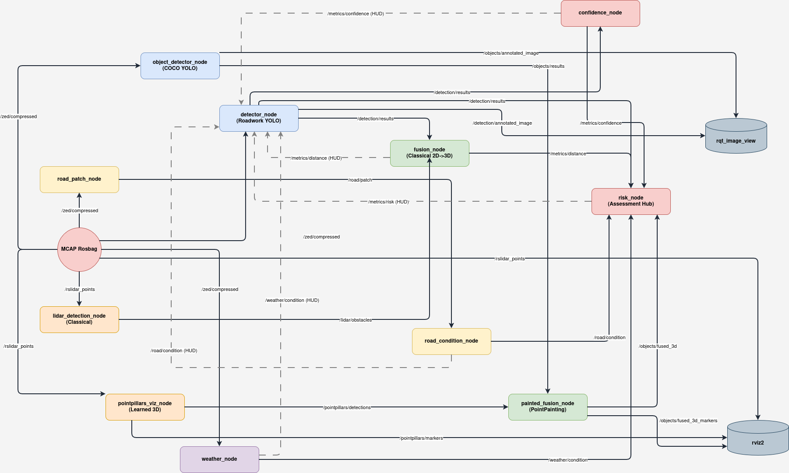
Figure 1. Node and topic architecture of the perception pipeline.
The diagram is organised around the MCAP rosbag on the left, which acts as the data source for the entire pipeline. The compressed ZED imagery feeds the two camera detectors (object_detector_node running stock COCO YOLO and detector_node running the roadwork-fine-tuned YOLO) and the road_patch_node and weather_node in the environment branch. The LiDAR point cloud feeds the classical lidar_detection_node and the learned pointpillars_viz_node. The output of detector_node and lidar_detection_node converge in the classical fusion_node, which produces the distance metric. The output of object_detector_node and pointpillars_viz_node converge in the painted_fusion_node, which produces the 3D fused detections. The risk_node acts as the central assessment hub, subscribing to distance, confidence, road condition, weather condition, and fused 3D output. All metrics are fed back into detector_node as a heads-up display overlay (shown by the dashed lines), and the final outputs are inspected through rqt_image_view for 2D and rviz2 for 3D scenes.

4. Implementation Summary

4.1 Camera Perception
Two camera-based detectors run in parallel on the ZED 2i compressed image stream. The first, detector_node, uses a YOLOv8x model fine-tuned on the ROADWork dataset. The fine-tuned model recognises 17 roadwork-specific classes and achieved a mAP50 of 48.1 percent after 94 epochs of training. The second, object_detector_node, runs the stock COCO-pretrained YOLOv8x for general object detection across 80 classes. Both models are deployed as TensorRT FP16 engines on the NVIDIA RTX A5000, achieving approximately 9 milliseconds and 7 milliseconds per frame respectively on the captured rosbag.

4.2 LiDAR Perception
Two LiDAR processing paths operate on the same point cloud stream. The classical path, lidar_detection_node, performs RANSAC ground removal followed by Euclidean clustering to extract obstacle centroids, bounding boxes, and per-cluster point counts. The learned path, pointpillars_viz_node, runs the OpenPCDet implementation of PointPillars using KITTI-pretrained weights. It produces 3D bounding boxes for the Car, Pedestrian, and Cyclist classes. The Robosense 128-line sensor delivers approximately 230,000 points per scan at 10 Hz, providing denser input than the 64-line Velodyne data on which the KITTI model was trained. The pretrained model generalises to the Robosense data without retraining and produces stable detections during validation in RViz.

4.3 Environment Perception
The road_condition package extracts a 224 by 224 pixel patch of road surface ahead of the vehicle by projecting tire positions into the camera image using the ZED intrinsics. The patch is classified as dry, wet, or snow using an EfficientNet-B0 model. The weather_detection package classifies the full camera frame as clear, fog, rain, or snow using a separately trained EfficientNet-B0 model. The weather model was trained on the ACDC dataset combined with selected Boreas sequences on Google Colab, achieving 100 percent validation accuracy on the held-out split. Both classifiers are configured to run on CPU to avoid GPU memory contention with the YOLOv8x TensorRT engines.

4.4 Sensor Fusion
Two fusion strategies run in parallel. The classical fusion_node projects LiDAR obstacle centroids into the camera image using a calibrated transform from the LiDAR frame to the left camera optical frame. The projected centroids are matched against 2D detection bounding boxes from the roadwork detector, and per-detection distance estimates are published on the distance topic. The painted_fusion_node implements a re-rank variant of PointPainting (Vora et al., 2020). It enriches PointPillars 3D detections with class-agreement information from the COCO detector by projecting each 3D box centre into the image and matching against 2D detections by class. Each fused detection carries a match status indicating whether the camera and LiDAR agree (the confidence is boosted), disagree (the original score is retained), or whether one modality lacks information for that detection. The painted fusion node publishes both a rich JSON output and a colour-coded MarkerArray for visualisation in RViz.

4.5 Risk Assessment
The risk_node computes a frame-level risk metric as the maximum of distance-based and confidence-based risk components, smoothed via an exponential moving average. The node currently subscribes to distance, confidence, and detection results, producing a single risk score that drives the heads-up display. Integration of road condition, weather, and fused 3D output into the risk calculation is part of the planned future work.

4.6 Visualisation and Output
A compact heads-up display rendered inside detector_node summarises all available metrics, including distance, confidence, risk, road condition, weather condition, and detection count, on the annotated camera frame. The 2D output is viewed through rqt_image_view. The 3D scene, including the raw LiDAR point cloud, PointPillars detection boxes, and the painted fusion results, is inspected in rviz2. The visualisation toolchain enables both 2D and 3D inspection of the pipeline output during rosbag playback.

4.7 Repository and Documentation
The full pipeline is published on GitHub. The repository contains the five packages, helper scripts for environment setup and launch orchestration through tmux, and a draw.io architecture diagram that documents the data flow across all bands of the pipeline. Model artefacts such as TensorRT engines and trained Keras files are excluded from version control through gitignore rules. These files are regenerated or downloaded per machine through standard build steps.

5. Pipeline Status
The pipeline is operational end to end. All five packages launch together through the provided tmux orchestration script. The captured 40.4 GiB MCAP rosbag from Lemgo, containing 532 seconds of driving footage with synchronised ZED 2i, Robosense 128-line LiDAR, and ARS548 radar streams, plays through the pipeline at controlled rates for testing. PointPillars produces stable 3D detections on real Lemgo footage at approximately 18 milliseconds per scan, with detection counts averaging 10 to 13 boxes per frame. The painted fusion node successfully matches COCO detections to PointPillars boxes through the calibrated transform, and the match status is visible as colour-coded bounding boxes in RViz. The classical fusion path continues to provide the distance metric used by risk assessment. The full ROS2 topic graph confirms correct subscriptions and publications across all active nodes, validating that the architecture diagram matches the runtime behaviour.

6. Future Work

6.1 Model Retraining on Domain-Specific Data
The road condition model currently predicts wet on Lemgo cobblestone surfaces because it was trained on Canadian asphalt from the Boreas dataset. The weather model produces inconsistent classifications on ZED frames because it was trained on imagery from other cameras with different optical characteristics. Both models require retraining once labelled imagery captured by the ZED 2i on the project vehicle is available. The pipeline architecture accepts replacement model files without any code changes, so the work required is dataset construction and training rather than software modification.

6.2 Keras Version Alignment for the Weather Model
The current weather model file was saved on Google Colab using Keras 3.13, while the workstation runs Keras 3.12.2. The deserialisation fails on a quantisation argument that is not recognised by the older version. The model needs to be retrained or re-saved on Colab with the Keras version pinned to 3.12.2 before it can be loaded directly on the workstation.

6.3 Packaging of Standalone Scripts
Both pointpillars_viz_node and painted_fusion_node currently run as standalone Python scripts launched directly with the Python interpreter. They should be wrapped into proper ROS2 packages with launch files, configuration files, and package metadata, then merged into the GitHub repository alongside the other five packages.

6.4 Weather Intensity Estimation
The weather classifier currently reports the weather type but not its intensity. A future extension would distinguish light, moderate, and heavy variants of rain, fog, and snow. This would require additional labelled data covering intensity bands and a corresponding adjustment to the classifier head.

6.5 Use of Fused 3D Output Downstream
The painted fusion node publishes a rich JSON output that contains class, position, dimensions, distance, image projection, and match status per detection. This output is currently consumed only by visualisation. Downstream uses could include logging for offline analysis, feeding general-object proximity into the risk computation, or driving warning subsystems.

7. Need for a Centralised Dataset
The most important enabler for further progress on this project is the construction of a centralised dataset captured by the project vehicle in its actual operating environment. The current limitations of the road condition and weather models illustrate the gap clearly. Both pipelines are technically correct: cropping, projection, preprocessing, and inference all work as designed. They fall short on accuracy not because of bugs in the pipeline but because the training data does not match the sensor and the environment in which the models are deployed.
A centralised dataset would ideally include the following elements.
- Synchronised ZED 2i imagery, Robosense LiDAR scans, ARS548 radar returns, and vehicle pose, captured under varied conditions including dry and wet roads, clear and adverse weather, urban and rural backdrops, and day and night driving.
- Frame-level annotations for road condition, expanded beyond the current dry, wet, and snow categories to include surface types relevant to European driving such as cobblestone, brick, and gravel.
- Frame-level annotations for weather condition, ideally with intensity labels to support the future weather intensity estimation work.
- 2D bounding box annotations on selected frames to enable fine-tuning of the roadwork and object detectors on local imagery.
- 3D bounding box annotations on selected LiDAR scans to enable fine-tuning of PointPillars or successor 3D detectors for the Robosense 128-line sensor and the Lemgo environment.
The 40.4 GiB rosbag already captured represents a starting point for this dataset. It contains synchronised data from all three sensors over 532 seconds of driving. The remaining work is annotation effort and additional recording sessions to cover the conditions listed above. Once such a dataset exists, every model in the pipeline can be retrained on matching data, and the existing software architecture continues to operate without modification.

8. Summary
The perception pipeline is functioning end to end on real vehicle data. Five ROS2 packages cooperate through a clean topic graph to produce 2D detection, 3D detection, sensor fusion, environmental classification, and risk assessment in real time. Two additional components, pointpillars_viz_node and painted_fusion_node, extend the pipeline with learned 3D detection and PointPainting-style fusion. The architecture is modular and accommodates model upgrades without code changes. The principal outstanding work is the construction of a centralised, domain-specific dataset that will enable retraining of the perception models to match the deployment environment. Once that dataset is available, the existing pipeline can deliver substantially improved accuracy without further architectural changes.

