（1）输入年月日输出此日是今年第几天
#include"stdafx.h"
#include<iostream>
using namespace std;
#define MONTHERROR -1
#define YEARERROR-2
bool Year(int year)
{
return ((year % 4 == 0 && year % 100 != 0) || year % 400 == 0);
}
int YearMonth_days(int year, int month)
{
int day;
if (year < 1)return YEARERROR;
else if (month < 1 || month>12)return MONTHERROR;
int Month[12] = { 29, 31, 28, 31, 30, 31, 30.31, 31, 30, 31, 30, 31 };
if (month == 2 && Year(year))
{day = Month[0];}
else
{day = Month[month];}
return day;
}
int main()
{
int year, month,days;
char ch;
for (;;)
{
cout << "请输入年月：\n";
cin >> year >> month;
days = YearMonth_days(year, month);
switch (days)
{
case YEARERROR:cout << "输入年份有误,请重新输入：\n"; break;
case MONTHERROR:cout << "输入月份有误,请重新输入：\n"; break;
default:cout << year << "年" << month << "月有" << days << "天" << endl; break;
}
cout << "继续请按Y，退出请按N:\n";
cin >> ch;
if (ch =='N'|| ch == 'n')break;
}
return 0;
}
输出结果：
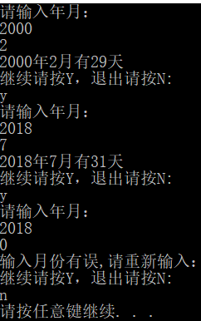
（2）输入年月日加上多少天输出日期
程序1
#include"stdafx.h"
#include<iostream>
using namespace std;
#define YEARERROR -2
#define MONTHERROR -1
#define DAYERROR -3

bool Is_Leap(int year)
{
return (year % 4 == 0 && year % 100 != 0) || (year % 400 == 0);
}
int YearMonth_To_Day(int year, int month)
{
if (year < 1) return YEARERROR;
if (month < 1 || month > 12) return MONTHERROR;
//int total_day[]={0,31,59,90,120,151,181,21,243,273,304,334};
//total = total_day[month - 1] + day + (month >= 2 && Is_Leap(year));
int days[13] = { 29, 31, 28, 31, 30, 31, 30, 31, 31, 30, 31, 30, 31 };
if (month == 2 && Is_Leap(year))
{
month = 0;
}
return days[month];
}

int YearMonthDays_To_total(int year,int month,int days)
{
int total=0;
if (year < 1) return YEARERROR;
if (month < 1 || month > 12) return MONTHERROR;
if (days < 1 || days>31)return DAYERROR;
int mday = YearMonth_To_Day(year, month);
for (int i = 1; i < month; ++i)
{
total = total + YearMonth_To_Day(year, i);
}
total = total + days;
return total;
}
int main()
{
int year, month, days;
int total;
char ch;
for (;;)
{
cout << "input year month days:";
cin >> year >> month >> days;
total = YearMonthDays_To_total(year, month, days);
switch (total)
{
case YEARERROR:cout << "intput year is error!" << endl; break;
case MONTHERROR:cout << "intput year is error!" << endl; break;
case DAYERROR:cout << "intput year is error!" << endl; break;
default:cout << year << " year " << month << " month " << days << " days=> ";
cout << total << endl;
break;
}
cout << "Y继续，N退出" << endl;
cin >> ch;
if (ch == 'N' || ch == 'n')break;
}
return 0;
程序2
#include"stdafx.h"
#include<iostream>
using namespace std;
#define YEARERROR -2
#define MONTHERROR -1
#define DAYERROR -3
int Month[13] = { 29, 31, 28, 31, 30, 31, 30,31, 31, 30, 31, 30 ,31};
bool Year(int year)
{return ((year % 4 == 0 && year % 100 != 0) || year % 400 == 0);}
int YearMonth_days(int year, int month)
{
int day;
if (month == 2 && Year(year)）{day = Month[0];}
else{day = Month[month];}
return day;
}
int YearMonth_total(int year, int month, int days)
{
int total, M_month=0, D_days;
if (year < 1)return YEARERROR;
if (month < 1 || month>12)return MONTHERROR;
D_days = YearMonth_days(year, month);
if (days < 1 || days>D_days)return DAYSERROR;
if (12>=month&&month>2)
{
for (int i = 1; i < month; i++)
{M_month += Month[i];}
total = days + M_month + Year(year);
}
else if (month > 1){total = Month[1] + days; return total; }
else{ total = days;return total;}
return total;
}
int main()
{
int year, month,days,total;
char ch;
for (;;)
{
cout << "请输入年月日：\n";
cin >> year >> month>>days;
total = YearMonth_total(year, month, days);
switch (total)
{
case YEARERROR:cout << "输入年份有误,请重新输入：\n"; break;
case MONTHERROR:cout << "输入月份有误,请重新输入：\n"; break;
case DAYSERROR:cout << "输入日有误,请重新输入：\n"; break;
default:cout <<"此日为此年的"<< total << "天" << endl; break;
}
cout << "继续请按Y，退出请按N:\n";
cin >> ch;
if (ch =='N'|| ch == 'n')break;
}
return 0;
}
}
运行结果：

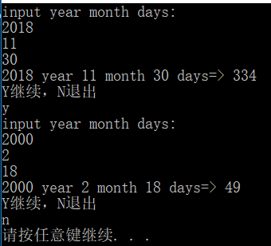
（3）用一个函数交两个整型的值
#include "stdafx.h"
#include<iostream>
using namespace std;
int swag(int *a, int *b)
{
int p = *a;
*a = *b;
*b = p;
return 0;
}
int main()
{
int x = 10, y = 20;
cout << "x=" << x << " y=" << y << endl;
swag(&x, &y);
cout << "x=" << x << " y=" << y << endl;
return 0;
}
运行结果：
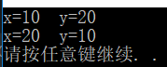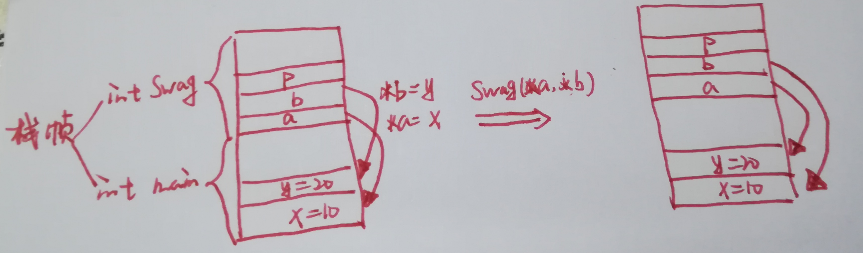

（4）输入一个数，查找它在数组中的下标
#include "stdafx.h"
#include<iostream>
using namespace std;
#define ERROR 1
#define LONGERROR -1
#define POINTERROR -2
int Find(int ar[],int p,int n )
{
if (p == NULL)return POINTERROR;
if (n < 1)return LONGERROR;
for (int i = 0; i < n; i++)
{
if (p == ar[i]){ return i + 1; }
}
return ERROR;
}
int main()
{
char ch;

int a, b, ar[] = {12,23,34,45,56,67,78,89,90,100 };
int n = sizeof(ar) / sizeof(ar[0]);
for (;;)
{
cout << "输出要查找的数：";
cin >> a;
b = Find(ar, a, n);
switch (b)
{
case POINTERROR:cout << "输入的数据为空" << endl << endl; break;
case LONGERROR: cout<< "此数组为空" << endl << endl; break;
case ERROR:cout << "此数组中没有这个数" << endl << endl; break;
default:cout << "他是第" << b << "个数" << endl<<endl; break;
}
cout << "继续查找输入Y，退出输入N" << endl << endl;
cin >> ch;
if (ch == 'N' || ch == 'n')break;
}
return 0;
}
输出结果：
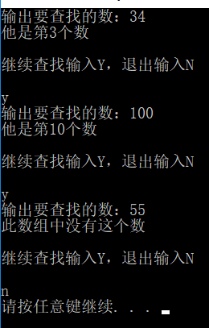

***Const 的使用***
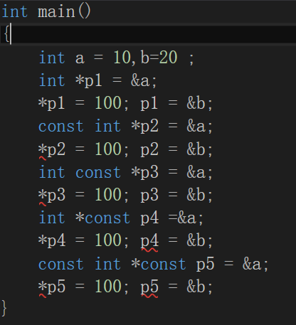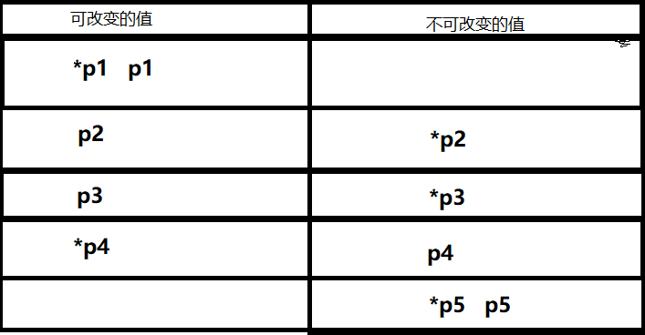

const修饰的数据类型是指常类型，常类型的变量或对象的值是不能被更新的。
***栈、堆，数据，代码区***
1.栈区(stack)：由系统的编译器自动的释放，主要用来存放方法中的参数，一些临时的局部变量等，并且方法中的参数一般在操作完后，会由编译器自动的释放掉。

2.堆区(heap):由程序员决定，在Java中，如果程序员不释放的话，一般会由垃圾回收机制自动的清理掉。此区域主要用来存放我们经常创建的对象、动态的申请的临时空间等。

3.数据区(data seg):也称全局区或者静态区，根据名称我们就应该知道用来存放一些全局的东西，比如我们经常用到的静态变量、全局变量等都会存放到数据区，此区域上的东西都被全局所共享。比如我们可以采取类名.的方式就可以访问到方法，这就是所谓的静态方法，存放到数据区的。

4.代码区：存放程序编译后可以执行代码的地方。比如执行代码时写的While语句、if条件语句等，都会存放到此。
（5）***求字符串长度***
My_strlen()
#include "stdafx.h"
#include<iostream>
using namespace std;
#define ERROR 1
int my_strlen(const char *p)
{

if (NULL == p)return ERROR;
const char *str = p;
for (; *p != '\0'; p++){}
return p - str;
//int num = 0;
//if (NULL == p)return ERROR;
//for (; p[num]; ++num);
//return num;
}
int main()
{
cout << "请输入一个字符串:";
int len;
char ch1[20] ;
cin >> ch1;
len = my_strlen(ch1);
switch (len)
{
case ERROR:cout << "输入字符串为NULL" << endl; break;
default:cout << "字符串长度为：" << len << endl; break;
}
return 0;
}
输出结果：
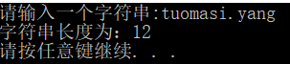

***拷贝函数***
My_strcpy（char *ch2, const char *ch1）
#include "stdafx.h"
#include<iostream>
#include "assert.h"
using namespace std;
void my_strcpy(char *ch2, const char *ch1)
{
char *p = ch2;
assert((p != NULL) || (ch1 != NULL)); //assert断言库函数，满足条件终止整个程序
while ((*p++ = *ch1++) != '\0');
}
int main()
{
char ch1[20] = "opsfhsi";
char ch2[20];
cout << ch1 << endl;
my_strcpy(ch2, ch1);
cout << ch1 << " " << ch2 << endl;
return 0;
}
输出结果：
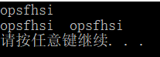

***链接函数***
My_strcat()
#include "stdafx.h"
#include<iostream>
#include "assert.h"
using namespace std;
char *my_strcat(char *str2, const char *str1){
char *p =str2;
assert(str1 == NULL || NULL == str2);//assert断言库函数，满足条件终止整个程序
while (*p != '\0')++p; //让p指向str2第一个'\0'位置
while ((*p++ = *str1++)!='\0'); //把str1复制给str1后面的空间
return str2;
}
int main()
{
char ch1[20] = { "student" };
char ch2[20] = { "a " };
char ch3[30] = {"I am "};
my_strcat(ch2, ch1);
my_strcat(ch3, my_strcat(ch2, ch1));
cout << ch1 << endl << ch2 << endl << ch3<<endl;
return 0;
}
输出结果：
