## Beer sample preparation

We mixed by inversion the content in the beer bottle for at least 5 minutes.

Transfered 50 mL beer into a 50 mL conical tube.

Spin down cells and precipitable material (5000 rpm, 20 min, 4 °C)

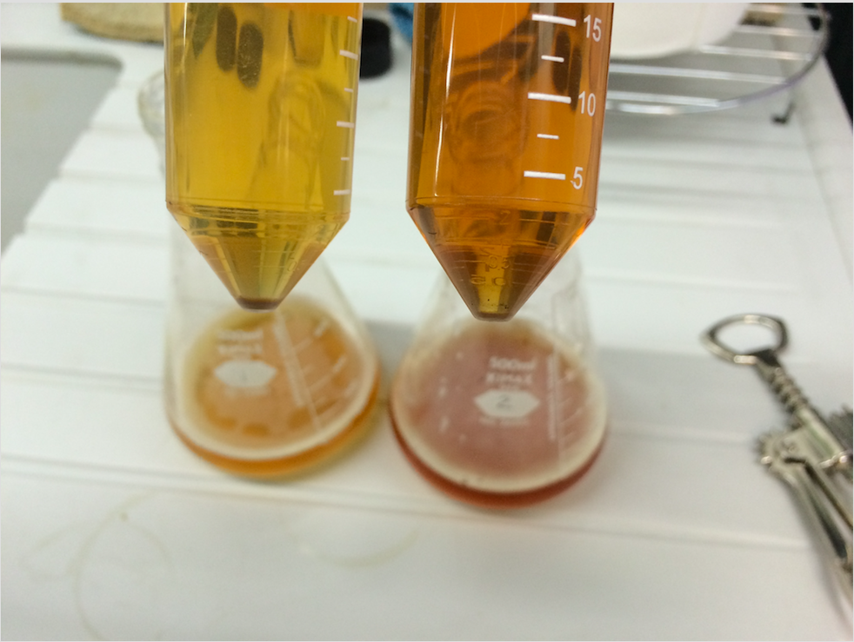Removed supernatant. Attention: we noticed that low fermenting beers (i.e. lager, pilsner) have a unstable pellet compared to high fermenting beers (i.e. ales).

Resuspended the pellet in 1 mL TE (Tris 10 mM, EDTA 1 mM, pH 8.0).

Transferred the resuspension in 1.5 mL tubes.

Spin down cells and precipitable material (10000 rpm, 10 min, 4 °C).

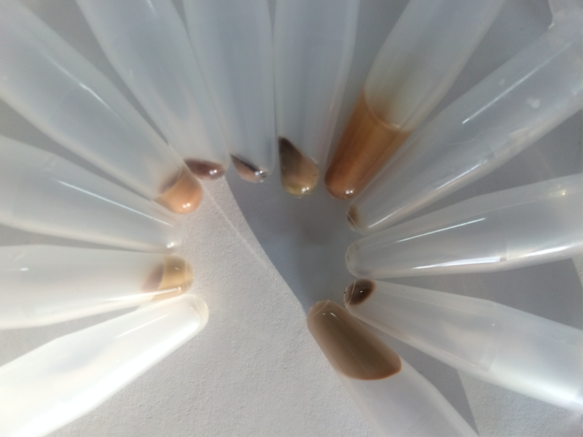

Removed supernatant and store at -20°C for future analyses.

Stored the pellet at -20°C until DNA extraction.

## DNA extraction

We used the ZR Fecal DNA MiniPrep Kit from Zymo Research (Catalog No. D6010) with minor modifications.

Thaw the pellets and resuspend in 750 uL Lysis Solution.

Transfer to ZR BashingBead Lysing Tube.

Secure in a vortex fitted with 2 mL tube holder and process at maximum speed for 5 minutes.

Centrifuge the Lysis Tube (10000 rpm, 1 min, RT)

Transfer 400 uL supernatant to a Zymo-Spin IV Spin Filter (Orange Top) in a Collection Tube and centrifuge (7000 rpm, 1 min, RT)

Add 1200 uL of Fecal DNA Binding Buffer to the filtrate in the Collection Tube.

Transfer 800 μl of the mixture from Step 5 to a Zymo-SpinTM IIC Column4 in a

Collection Tube and centrifuge at 10,000 x g for 1 minute.

Discard the flow through from the Collection Tube and repeat with the filtration with the remaining lysate.

Add 200 μl DNA Pre-Wash Buffer to the Zymo-SpinTM IIC Column in a new Collection Tube and centrifuge at 10,000 x g for 1 minute.

Add 500 μl Fecal DNA Wash Buffer to the Zymo-SpinTM IIC Column and centrifuge at 10,000 x g for 1 minute.

Transfer the Zymo-SpinTM IIC Column to a clean 1.5 ml microcentrifuge tube and add 100 μl (35 μl minimum) DNA Elution Buffer directly to the column matrix. Centrifuge at 10,000 x g for 30 seconds to elute the DNA.

Snap off the base of the Zymo-SpinTM IV-HRC Spin Filter (Green Top) and place into a clean Collection Tube. Centrifuge at 8,000 x g for 3 mins.

Note: If the HRC matrix is dry, add 400-600 μl water prior to prepping the filter.

Transfer the eluted DNA to a prepared Zymo-SpinTM IV-HRC Spin Filter (Green Top) in a clean 1.5 ml microcentrifuge tube and centrifuge at exactly 8,000 x g for 1 minute.

The filtered DNA is now suitable for PCR.

## QC DNA extraction

Ideally one would like to measure the absorbance of the extracted DNA at 230, 260 and 280 nm (i.e. with a nanodrop) to ensure the DNA is free from protein and chemical contaminants.

## PCR1: ITS amplification

Yeast is a fungus. We amplified the fungal hypervariable region ITS1 (internal transcribed spacer 1) as described by Bukolich et al. in [eLife 2015](https://elifesciences.org/content/4/e04634). The primers were BITS (5′–CTACCTGCGGARGGATCA–3′) and B58S3 (5′–GAGATCCRTTGYTRAAAGTT–3′) PCR reactions contained 5–100 ng DNA template, 1× GoTaq Green Master Mix (Promega), 1 mM MgCl2, and 2 pmol of each primer. Reaction conditions consisted of an initial 95 °C for 2 min followed by 40 cycles of 95 °C for 30 s, 55 °C for 30 s, and 72 °C for 60 s, and a final extension of 72 °C for 5 min.

## QC PCR1

We verified the expected amplicon size (500nt) with a fragment analyser.

## PCR1 Clean-Up

We used AMPure XP beads to purify the ITS amplicon away from free primers and primer dimer species. We followed manufacturer’s instructions.

## PCR2: Indexing

We attached dual indices and Illumina sequencing adapters using the Nextera XT Index Kit. We followed manufacturer’s instructions. PCR reactions contained 5 uL purified DNA, 5 uL each of appropriate Nextera XT Index primers, 25 uL 2x KAPA HiFi HotStart Ready Mix, and 10 uL PCR Grade water. Reaction conditions consisted of an initial 95 °C for 3 min followed by 8 cycles of 95 °C for 30 s, 55 °C for 30 s, and 72 °C for 30 s, and a final extension of 72 °C for 5 min.

## PCR2 Clean-Up

See PCR1 Clena-Up.

## MiSeq Sequencing

We followed the MiSeq v3 reagent kit protocol. Briefly, we quantified the amplified DNA with a fluorimetric method that uses dsDNA binding dyes (Qubit). We diluted each DNA sample to 4 nM using 10 mM Tris pH 8.5 and pooled 5 uL of diluted DNA from each library. In preparation for cluster generation and sequencing, 5 uL of the pooled final library was denatured with 5 uL of freshly diluted 0.2 N NaOH, and combined with 30% PhiX control library to serve as an internal control for low-diversity libraries. After loading the samples on the MiSeq, we generated paired 2x 300bp reads that were exported as FASTq files.

## ITS mapping analysis

We downloaded the curated set of ITS sequences from the Refseq database (<https://www.ncbi.nlm.nih.gov/refseq/targetedloci/>). We used these sequences to build an ITS index for the [Burrows-Wheeler Aligner.](http://bio-bwa.sourceforge.net/) We used BWA to map the reads of each beers from the fastq files to our ITS index. Subsequently, we counted the number of ITS per beer and per species and we kept only the species where we found more than 10 reads. We used R statistical software in order to plot the results and to perform the hierarchical clustering analysis with the ape library. Finally, we compared our results with the user friendly pipeline of One Codex using their targeted loci analysis.

EtNa method: full protocol here <http://www.biotechniques.com/multimedia/archive/00249/BTN5803-RP-Frost_Su_249231a.pdf>

In short:

* Spin 50 mL (minimum) beer to obtain a pellet
* Resuspend the pellet in 100 uL TE, transfer to a 1.5 mL tube
* Add 455 uL of EtNa solution (250 mM NaOH, 3 mM EDTA, 75% ethanol solution).
* (EtOH for molecular biology or Migros?)
* Mix to give a final concentration of 200 mM NaOH, 2.4 mM EDTA, >61% ethanol.
* Heat at 80% for 10 min.
* optional: if the PCR does not amplify consider adding 5% Chelex 100 to the Etna solution and decant with a short spin before passing on column.
* Bring at room temperature.
* Load the DNA extraction liquid on DNA purification columns and follow manufacturer's instruction.

Complete Etna article: <http://www.biotechniques.com/BiotechniquesJournal/2015/March/A-single-protocol-for-extraction-of-gDNA-from-bacteria-and-yeast/biotechniques-357170.html>

**Recycling columns**

FW HCl = 36.47; 37% HCl = 370 g/L » 10 M

25% » 6.75 M

Mix 1 vol HCl with 5.75 vol dH2O

Buffer QBT (Equilibration Buffer)

750 mM NaCl, 50 mM MOPS (pH 7.0), 15% ethanol, 0.15% Triton X-100

Dissolve 43.83g NaCl, 10.46g MOPS (free acid) in 800 mL dH2O. Adjust pH to 7.0. Add 150 mL 100% ethanol and 15 mL 10% triton X-100 solution. Adjust volume to 1 liter.

Store at room temperature.

* Soak used columns with 700 uL 1M HCl
* Store with cap closed in airtight container for at least 24 hrs.
* Rinse extensively with dH2O
* Re-equilibrate with 700 uL buffer QBT pH 7.0 at 42 °C.
* Air dry. Place into a plastic bag.

**Open recipe of Qiagen buffers**

<http://openwetware.org/wiki/Qiagen_Buffers>

<http://www.epochlifescience.com/Product/SpinColumn/minispin.aspx>

Instrumentation needed:

Pipettes

Thermoblock

Vacuum manifold / centrifuge.

**DNA extraction protocol 2**

This protocol gives dirty DNA but it can be seen by eye (used during workshops).

* Spin down yeast cells from 50 mL beer (5000 rpm, 15 min) Use non-filtered beers
* Remove surnatant
* Resuspend the cells in 1 mL TE
* Add glass bead slurry
* Vortex the cells to break them.
* Complete to 5 mL TE
* Transfer the lysate without beads in 12 mL tubes
* Pour slowly, on the side, 5 mL of ice-cold isopropanol.

The DNA pops up.

**A "workshop" experiment that always work:**

* Put 1-2 mL fruit puree (i.e. McDonalds Frucht Puree) in a 12 mL tube.
* Add a pinch of salt.
* Add a fraction of a drop of liquid soap.
* Complete to 5 mL with water.
* Shake like making a cocktail. There will be foam.
* Transfer the liquid without foam in a second 12 mL tube.
* Pour slowly, on the side, 5 mL of ice-cold isopropanol.

The DNA pops up immediately.

If avoiding the soap and replacing isopropanol with Bacardi 151 (Rum, 75% alcohol) one can make a DNA cocktail. Cheers!

**Beer DNA on a filter (shipment)**

To 1 vol beer add 1 volume 13% PEG 8000 (w/v) 0.8M NaCl. Sit on ice/fridge 20 min, filter.

**Literature survey**

Yu 2004 has a bead-beating method with buffer recipes

Bing_2014 Made a phylogenetic tree of yeasts constructed from Bayesian analysis of the concatenated sequences of nine protein genes (CCA1, FUN14, FSY1, GDH1, HIS3, MET2, MLS1, PDR10, and RIP1) and three intergenic regions (between APP1 and YPT53; FAR8 and RSF1; and MSL1 and DSN1, respectively) with a total length of 10,657 bp

Kawahata_2007 shows positions of ITS primers in the ITS region

Monerawela_2015 shows lager-specific genes in some commercial beers (Chimay, Sierra Nevada, Coopers Brewery, Hens Tooth, Rauch Bier, Schneider Weisse, Kloster Hell).

Melo_ have developed species-specific primers capable of distinguishing three important yeast species (bayanus, cerevisiae, pastorianus) in alcoholic fermentation.

Nakamura_2013 extracts DNA from liophylized beer (250 mg powder) and develop species specific primes suitable to identify 16 typical malting barley cultivars.

Nakamura_2013 measures foam stability as the time (second) for the decrease in the foam volume (50 mL by the use of a graduated cylinder of 200 mL after the generation of foam by spontaneous pouring 200 mL of sample beer throught the plstic tube, inside diameter 8 mm, at the height differene of 300 mm.

Cheng 2007 measures GMO pcr from Honey.

Hotzel_2009 Compares three methods of DNA extraction starting from 2 mL beer. They measure yeast DNA but not plant DNA. They explain: the failure to detect residual DNA from hop or barley in any of the beer samples shown here can be explained by brewing technology. Since, typically, the wort is boiled for about 2 h while its pH is approximately 4.5, any DNA from barley and hop will be subject to fragmentation.

Hotzel_2009 Uses 2 mL beer DNA extraction from membrane binding. Beer (2 ml) was boiled, cooled to room temperature and passed through a DNA-binding membrane (BioTrace HP 0.45mm, diameter 15 mm; Gelman Sciences, Rossdorf, Germany). This can be shipped, if we precondition the membrane with sodium azide. The membranes were first conditioned by passing 5 ml of prewarmed 0.5% (w/v) Triton X-100 solution through each well using vacuum.

**15.09.15**

MM 2x 84 uL

primer F 3.4 uL

primer R 3.4 uL

H2O 35.3 uL

There is no amplification using 5 uL template, both ITS primers than cloroplast.

Extracted DNA using spin columns does not look good at nanodrop (230 contamination). To 125 uL DNA add 12.5 uL NaAc 2.5M pH 5, 344 uL EtOH precipitation o/n.

**PCR**

for kits/workshops, it is nice to have mastermixes stabilized at room temperature in single tubes. For instance

* 27-9559-01 are 155.18 CHF / 96 single tubes of 0.2 mL. = 1.6 CHF /reaction
* <http://www.gelifesciences.com/webapp/wcs/stores/servlet/catalog/en/GELifeSciences-ch/products/AlternativeProductStructure_17007/27955901>

1.6 CHF = 1.2 GBP --> 15 tubes = 18 Gbp

Service italy, Sentinel 1.93 GBP 30 Gbp