
History for Junior High School 1
Term 1 • Quill Series
Exploring Ghana's Heritage and African Civilizations

Name: ___________ Class: ___________

Table of Contents
Table of Contents

1. Lesson 1 — The meaning and importance of history ........... page 1
2. Lesson 2 — Sources of history: oral, written, material ........... page 8
3. Lesson 3 — Pre-colonial Ghana: kingdoms and states ........... page 15

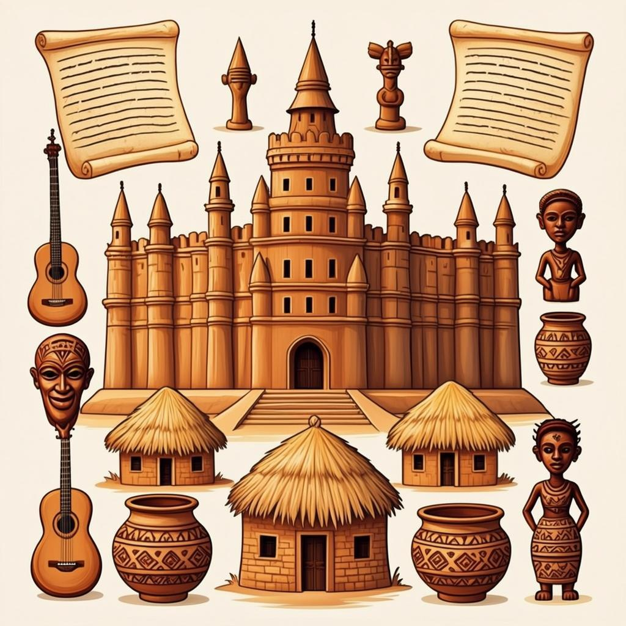

Section 1: The meaning and importance of history & Related Topics
Section 1: The meaning and importance of history & Related Topics
In this section, we will explore the fundamental concepts of history and its significance in understanding our past. We will examine various sources of historical information and discover the rich pre-colonial kingdoms and states that existed in Ghana before European contact.
Lessons in this section:
- Lesson 1: The meaning and importance of history
- Lesson 2: Sources of history: oral, written, material
- Lesson 3: Pre-colonial Ghana: kingdoms and states
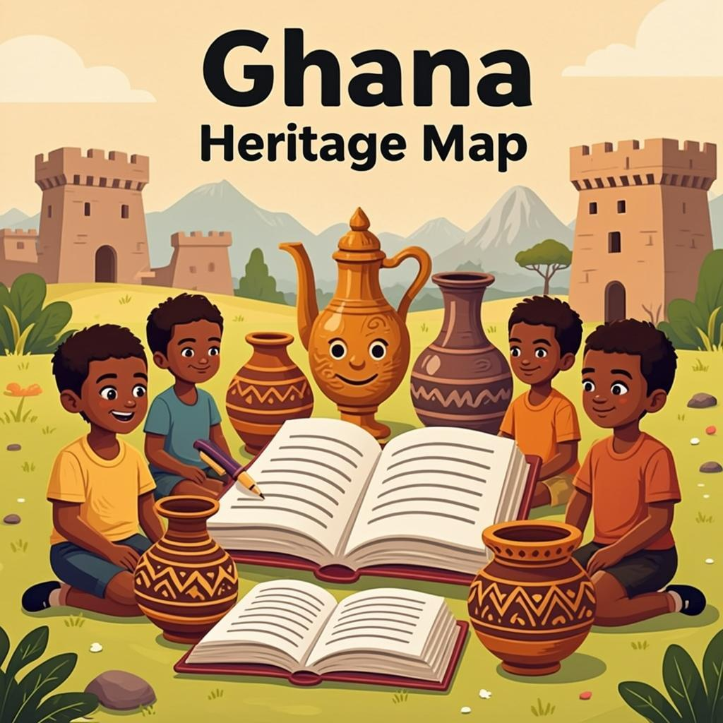

Lesson 1: The meaning and importance of history
Lesson 1: The meaning and importance of history
Learning Objectives
- Define history and explain its meaning
- Identify the importance of studying history
- Differentiate between primary and secondary sources
- Explain how history helps us understand the present
History is the study of past events, particularly human affairs. It helps us understand how societies have developed over time and why things are the way they are today. By studying history, we can learn from the successes and mistakes of the past to make better decisions for the future.
What is History?
History is not just about memorizing dates and events. It is about understanding the causes and effects of past occurrences, the people who shaped events, and the context in which these events happened. History helps us make sense of our world by showing us how we got to where we are today.
In Ghana, history includes the study of our great empires like the Ashanti Empire, the transatlantic slave trade, our struggle for independence, and the development of our nation as a republic. Each of these periods has contributed to shaping the Ghana we know today.
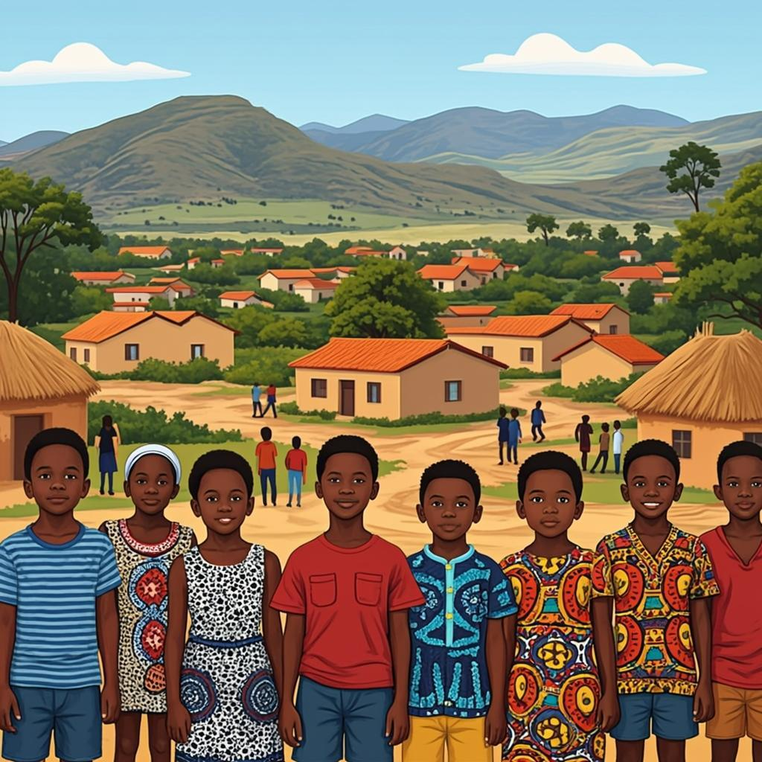
Timeline of Ghana's History
Why Study History?
Studying history is important for several reasons. First, it helps us understand our identity and heritage. By knowing where we come from, we can better understand who we are. Second, history provides valuable lessons that can guide us in making decisions about the future.
Third, history helps us develop critical thinking skills. By analyzing different sources and perspectives, we learn to evaluate information and form our own opinions. Finally, history fosters national pride and unity by connecting us to our shared past.
Importance of History | Examples in Ghanaian Context
Identity and Heritage | Learning about the Ashanti Empire and its traditions
Lessons for the Future | Understanding the causes of past political events
Critical Thinking | Analyzing different accounts of the transatlantic slave trade
National Unity | Celebrating Ghana's independence and cultural festivals

Sources of History
Historians use different types of sources to gather information about the past. These are generally classified as primary and secondary sources. Primary sources are original materials created during the time period being studied, such as letters, diaries, official documents, and artifacts.
Secondary sources are materials created after the time period by someone who did not experience the events firsthand. These include history books, documentaries, and articles that analyze primary sources. In Ghana, examples of primary sources include the writings of Kwame Nkrumah and artifacts from ancient civilizations like the Koma people.
Key Vocabulary
History | The study of past events, particularly human affairs
Primary Source | Original materials created during the time period being studied
Secondary Source | Materials created after the time period by someone who did not experience the events firsthand
Heritage | Valued qualities and traditions that have been passed down from previous generations
Civilization | The society, culture, and way of life of a particular area at a particular time

Teacher's Tip: Encourage students to connect historical events to their own lives. Ask them how learning about Ghana's past helps them understand current events or cultural practices in their communities. This makes history more relevant and engaging.

Exercise: The Meaning and Importance of History
Name: ___________ Date: ___________
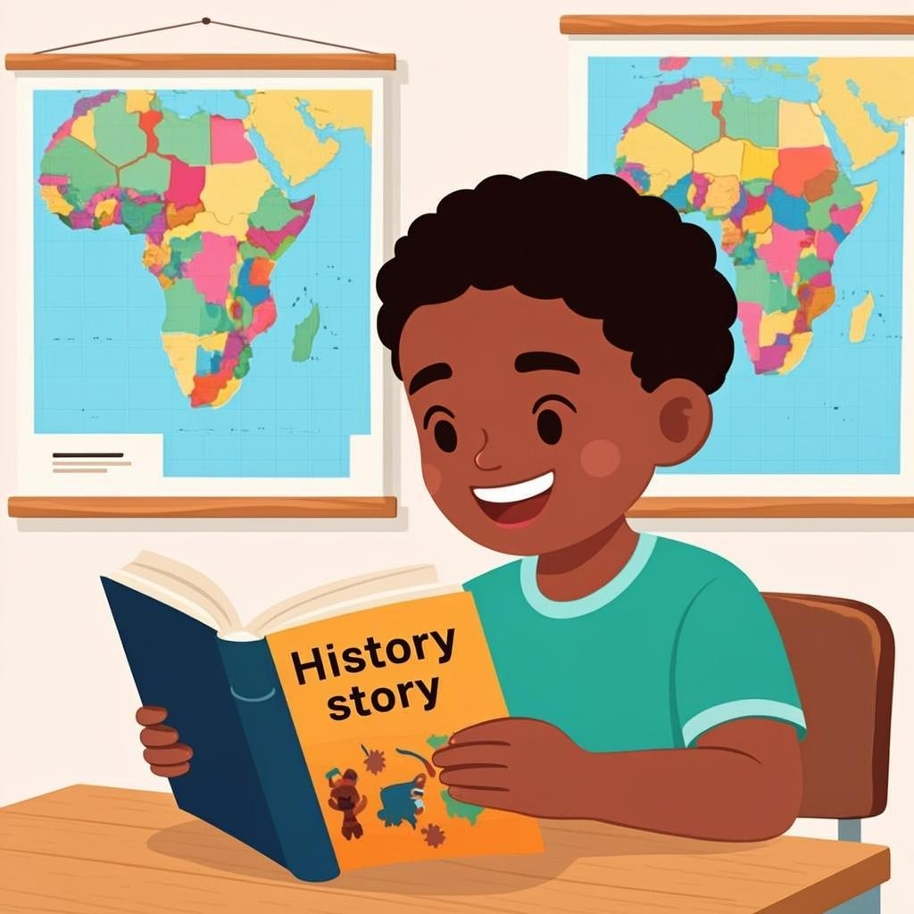
Complete the Sentences
Fill in the blanks using the words from the word bank below.
Word Bank: events | society | documents | histories | Independence
1. History is the study of past ________ and their effects on the present.
2. The study of history helps us understand how ________ developed over time.
3. Primary sources are ________ created during the time period being studied.
4. Secondary sources are ________ that interpret primary sources.
5. In Ghana, we can learn about our past by studying events like the ________ and the transatlantic slave trade.
Multiple Choice Questions
Choose the correct answer for each question.
1. What is the primary purpose of studying history?
A. To memorize dates
B. To understand how past events shape the present
C. To find old artifacts
D. To learn about foreign countries
2. Which of the following is an example of a primary source?
A. A history textbook
B. A diary from the 1800s
C. A documentary film
D. An encyclopedia
3. Why is it important to study Ghanaian history specifically?
A. Because it's easier than world history
B. To understand our national identity and cultural heritage
C. Because it's required by the GES
D. To learn only about famous leaders
4. How does history help in decision-making today?
A. By providing exact solutions for current problems
B. By showing patterns and consequences of past decisions
C. By predicting future events
D. By eliminating the need for research
Match the Terms
Match each historical term with its correct definition.
1. Chronology | A. The arrangement of events in time order
2. Heritage | B. The stage of human social development and organization
3. Archaeology | C. The study of human history through excavation of artifacts
4. Oral Tradition | D. Cultural information, traditions, and history passed down verbally
5. Civilization | E. Valued objects and qualities passed down through generations

Short Answer Questions
Answer the following questions in complete sentences.
1. Explain why history is sometimes described as 'the laboratory of human experience'.
2. Describe one way that studying Ghana's pre-colonial history can help us understand present-day Ghanaian society.
3. If you could interview a historical figure from Ghana's past, who would you choose and what would you ask them?
Study Tip: Remember to check your answers!

Homework — Lesson 1

Name: ___________ Date: ___________
Homework — Lesson 1: The meaning and importance of history
Tasks
Complete the following tasks to reinforce what you have learned about history.
1. Interview an elder in your family and write down one historical event they remember.
2. Write a paragraph explaining why studying history is important for Ghanaian students.
3. List three Ghanaian historical sites and explain their significance.
4. Collect one old photograph from your family album and write a short description of what it shows.
Fill in the Blanks
Complete the sentences below using words from the word bank.
Word Bank: past | identity | history
1. History helps us understand our ___________ and cultural heritage.
2. The study of past events is called ___________.
3. Primary sources are materials that were created during the ___________ being studied.
Multiple Choice
Choose the best answer for each question.
1. Which of the following is NOT a primary source?
A. A diary
B. An ancient coin
C. A history textbook
D. A photograph
2. Why is history important to Ghanaians?
A. It helps us understand our national identity
B. It is only required for exams
C. It has no practical use
D. It is only about ancient events
3. Which Ghanaian landmark is a significant historical site?
A. Kumasi Zoo
B. Cape Coast Castle
C. Lake Volta
D. Mole National Park
Short Answer Questions
Answer the following questions in complete sentences.
1. Explain how the study of history can help us avoid repeating past mistakes.
2. Describe one way in which Ghana's history has influenced its present-day culture.
Remember!: Bring your homework to the next class!

Lesson 2: Sources of History: Oral, Written, Material
Lesson 2: Sources of History: Oral, Written, Material
Learning Objectives
- Identify and explain the three main types of historical sources
- Distinguish between oral, written, and material sources of history
- Evaluate the importance of each source type in understanding Ghana's past
- Apply knowledge of historical sources to analyze historical information
History is built upon evidence from the past. To understand how societies developed, events unfolded, and cultures evolved, historians rely on various sources of information. These sources provide insights into different aspects of life in earlier times. In this lesson, we will explore the three main categories of historical sources: oral traditions, written documents, and material artifacts. Each type offers unique advantages and challenges for historical research.
Oral Sources of History
Oral sources consist of information passed down through generations by word of mouth. These include folktales, proverbs, songs, chants, and spoken traditions. In Ghana, oral traditions have played a crucial role in preserving historical knowledge, especially before the advent of widespread literacy.
One significant example of oral history in Ghana is the tradition of 'griots' or 'storytellers' who memorize and recite detailed accounts of royal lineages, important events, and cultural practices. During festivals like Homowo in the Ga areas or Aboakyir in the Fante communities, historical narratives are shared through performances and ceremonies.
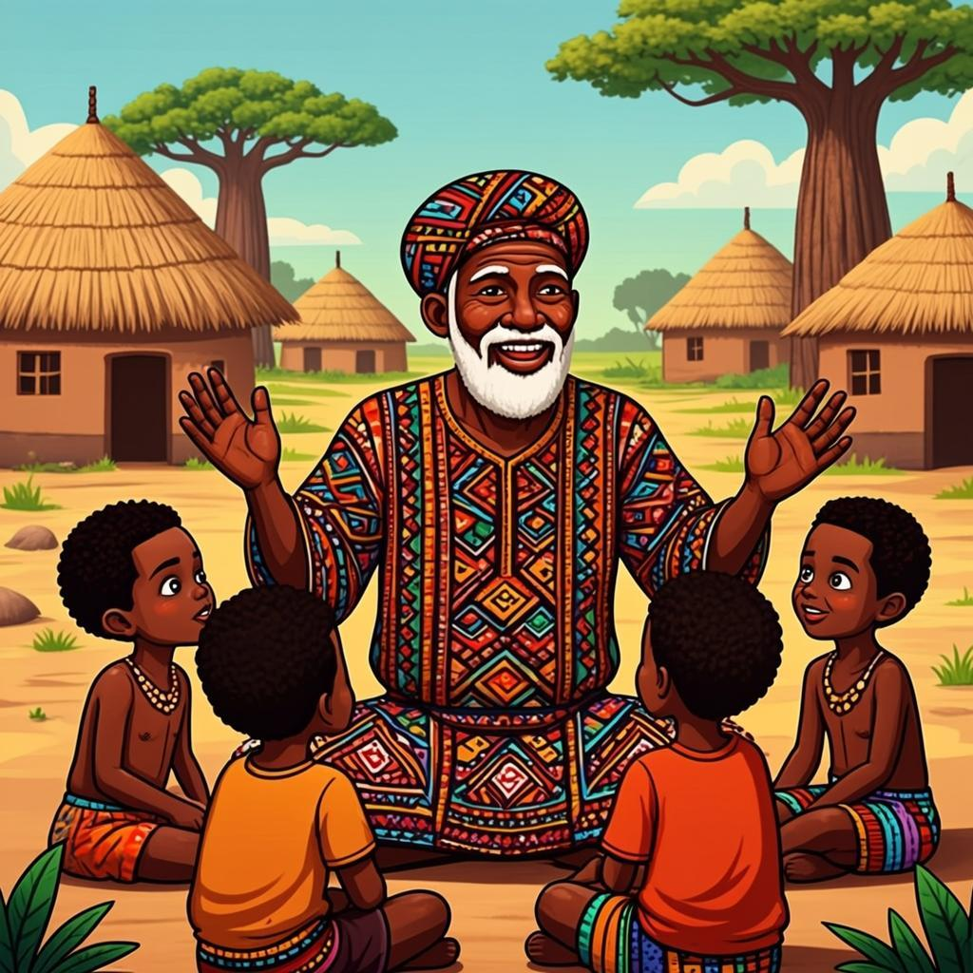
An elder sharing oral traditions with the younger generation
Written Sources of History
Written sources include documents that contain recorded information about the past. These can be official records like treaties, letters, government documents, or personal accounts such as diaries and autobiographies. In Ghana, written sources became more prominent with European contact and the establishment of colonial administration.
Important written sources for Ghanaian history include records from the transatlantic slave trade, colonial government documents, missionary reports, and early newspapers. The Public Records and Archives Administration Department (PRAAD) in Ghana holds many of these valuable documents, which historians use to reconstruct the nation's past.
Type of Written Source | Examples | Historical Value
Official Documents | Colonial records, treaties, government reports | Provide insights into administration and policies
Personal Accounts | Diaries, letters, autobiographies | Offer individual perspectives on historical events
Publications | Newspapers, books, academic journals | Reflect public opinion and intellectual discourse

Material Sources of History
Material sources, also known as archaeological or artifact sources, include physical objects from the past. These can range from everyday items like pottery, tools, and clothing to monumental structures like forts, castles, and traditional buildings. In Ghana, material sources provide tangible evidence of past civilizations and technological achievements.
The Cape Coast Castle and Elmina Castle are significant material sources that bear witness to Ghana's role in the transatlantic slave trade. Archaeological sites like those at Begho and Koma Hill reveal information about pre-colonial societies in Ghana. Artifacts such as gold weights, terracotta heads, and traditional regalia also offer valuable insights into Ghana's rich cultural heritage.
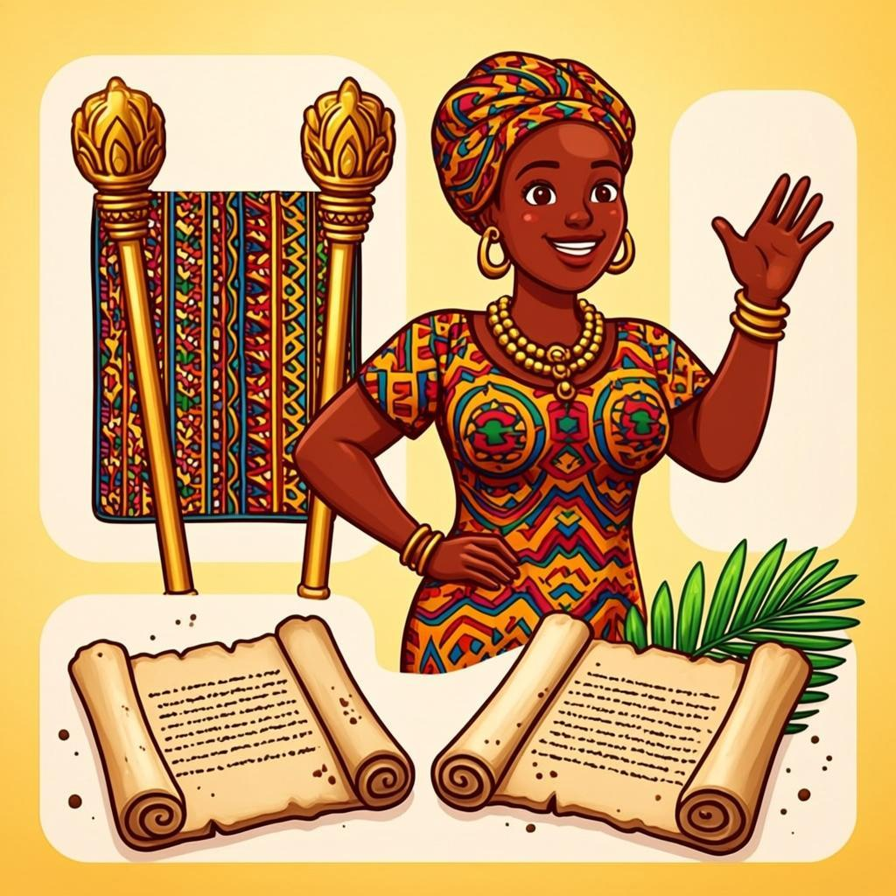
Classification of historical sources with Ghanaian examples
Comparing Sources of History
Each type of historical source has its strengths and limitations. Oral traditions preserve cultural values and perspectives that may not be recorded elsewhere, but they can change over time. Written sources provide precise information and dates but may reflect the biases of their authors. Material sources offer concrete evidence but require interpretation and may lack contextual information.
Historians often use multiple sources to cross-verify information and gain a more complete understanding of the past. For example, while studying the Asante Empire, historians might combine oral traditions about past kings, written accounts from European traders, and material evidence from archaeological excavations to build a comprehensive picture of this powerful West African state.
Key Vocabulary
Oral Tradition | Historical information passed down through speech and storytelling from one generation to another
Primary Source | An original document or object created during the time period being studied
Archaeology | The study of human history through the excavation and analysis of material remains
Ethnohistory | The study of historical cultures using both written records and oral traditions
Artifact | An object made or modified by humans, typically of historical or cultural interest

Teacher's Tip: Encourage students to bring examples of different historical sources from their homes or communities. This could include family photographs (material source), family stories passed down orally (oral source), or old documents like birth certificates (written source). This hands-on approach helps students connect abstract concepts to their own lived experiences.

Exercise: Sources of History

Name: ___________ Date: ___________

Exercise: Sources of History

Fill in the Blanks
Complete the following sentences using the words from the word bank below.
Word Bank: oral | written | material | Homowo | Independence Arch | archaeological | Aboakyir
1. Historians use ________ traditions to learn about the past from stories told by elders.
2. ________ records such as diaries and letters provide first-hand information about historical events.
3. Artifacts like pottery and tools are examples of ________ evidence.
4. The ________ of Cape Coast Castle is an important material source for studying Ghana's transatlantic slave trade.
5. ________ is a festival that provides oral traditions about the history of the Ga people.
Multiple Choice Questions
Choose the best answer for each question.
1. Which of the following is NOT a source of history?
A. Oral traditions
B. Written records
C. Material evidence
D. Future predictions
2. What type of source is a traditional drum used in ceremonies?
A. Written source
B. Material source
C. Oral source
D. Digital source
3. Which Ghanaian market is known for its historical significance as a trading center?
A. West Hills Mall
B. Kumasi Central Market
C. Kejetia Market
D. Makola Market
4. Which source would best help historians understand the daily life of ancient Ghanaians?
A. Modern newspapers
B. Archaeological artifacts
C. Radio broadcasts
D. Television programs
Match the Source with its Description
Match each historical source with its correct description.
1. Oral traditions | A. Documents like books and manuscripts
2. Written records | B. Symbolizes Ghana's independence history
3. Material evidence | C. Provides evidence about pre-colonial Ghana
4. Lake Volta | D. Stories passed down through generations
5. Independence Arch | E. Physical objects from the past

Short Answer Questions
Answer the following questions in complete sentences.
1. Explain why oral traditions are important in Ghanaian history.
2. Describe one written source that could help historians study the transatlantic slave trade in Ghana.
3. How can material evidence like artifacts help historians understand the past better than written sources alone?

Remember: Remember to check your answers!

Homework — Lesson 2

Name: ___________ Date: ___________

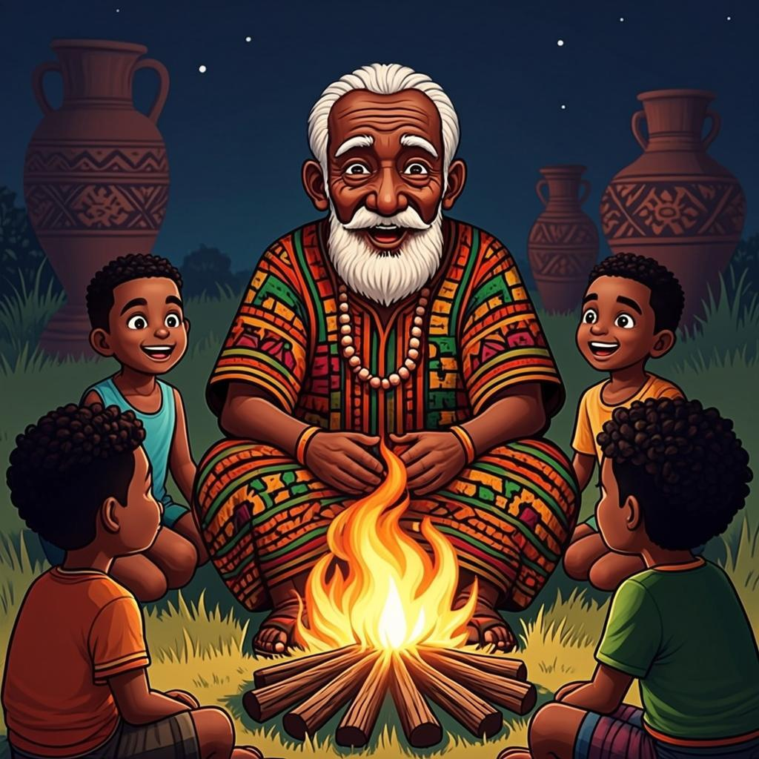
Homework — Lesson 2
Complete the following activities based on our lesson about sources of history.
1. Research one traditional festival in your community and write down one historical fact you learn about it.
2. Interview an elder in your family about a historical event they witnessed and write down three key points.
3. Find one written source (newspaper, book, or document) at home and describe what historical information it provides.
Fill in the Blanks
Complete the sentences below with the correct type of historical source.
Word Bank: oral | written | material | archaeological | traditional
1. Stories passed down from generation to generation are called ________ sources.
2. Letters, diaries, and books are examples of ________ sources of history.
3. Objects like tools, pottery, and buildings are known as ________ evidence.
Multiple Choice
Choose the best answer for each question.
1. Which of the following is NOT a type of historical source?
A. Oral traditions
B. Written documents
C. Future predictions
D. Material objects
2. Which source would be most useful for understanding daily life in pre-colonial Ghana?
A. A modern textbook
B. An oral tradition from that period
C. A newspaper from 2020
D. A tourist brochure
3. What is the main limitation of oral sources of history?
A. They are always accurate
B. They can change with each telling
C. They only contain facts
D. They are never about important events
Short Answer Questions
Answer the following questions in complete sentences.
1. Explain why it is important to use different types of historical sources when studying the past.
2. Give one example of how material evidence can help historians understand a culture that left no written records.
Remember: Bring your homework to the next class!
• • • • • • • • • • • • • • • • • • • •

Lesson 3: Pre-colonial Ghana: kingdoms and states
Lesson 3: Pre-colonial Ghana: kingdoms and states
Learning Objectives
- Identify and describe the major pre-colonial kingdoms and states in Ghana
- Explain the political structures of the Ashanti and Dagomba kingdoms
- Analyze the factors that contributed to the rise and fall of these pre-colonial states
- Compare and contrast the different pre-colonial political systems in Ghana
Before the arrival of European colonizers, the territory now known as Ghana was home to several powerful kingdoms and states. These political entities had well-organized systems of governance, trade networks, and cultural practices that flourished for centuries. Understanding these pre-colonial societies is essential to comprehending Ghana's rich historical heritage and the foundations of its modern nationhood.
Major Pre-colonial Kingdoms and States
Ghana's pre-colonial period featured several significant political entities, each with its unique characteristics and contributions to the region's history. Among these, the Ashanti Empire, Dagomba Kingdom, Gonja Kingdom, and Mole-Dagbani states were particularly influential.
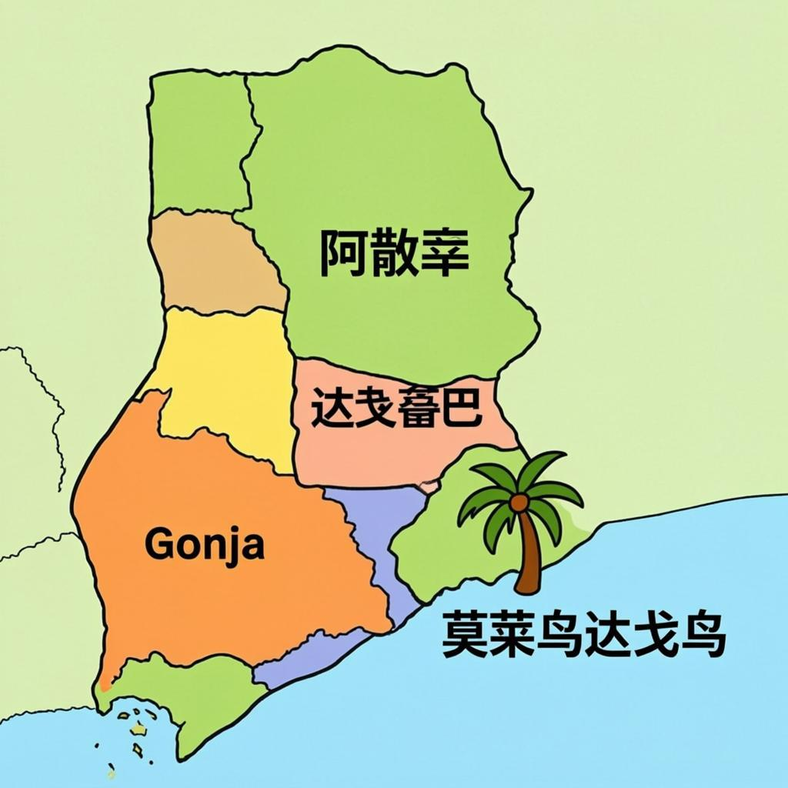
Map of major pre-colonial kingdoms in Ghana
The Ashanti Empire
The Ashanti Empire, established around the 17th century, was one of the most powerful and centralized states in West African history. Located in the forest region of modern-day Ghana, the Ashanti developed a sophisticated political system with a powerful king known as the Asantehene. The empire was renowned for its military strength, gold wealth, and intricate craftsmanship.
The Ashanti Empire was organized into a hierarchical system with the Asantehene at the top, followed by the kingmakers and provincial chiefs. The empire's governance was based on a constitution known as the 'Ashanti Constitution,' which outlined the rights and responsibilities of rulers and citizens. The Ashanti were also skilled traders, exchanging gold, kola nuts, and slaves for European goods through coastal trading posts.
The Dagomba Kingdom
The Dagomba Kingdom emerged in the northern part of present-day Ghana around the 15th century. Unlike the centralized Ashanti Empire, the Dagomba Kingdom was organized as a traditional state with a king known as the Ya Naa. The kingdom was located in the savannah region and was strategically positioned for trans-Saharan trade.
The political structure of the Dagomba Kingdom was based on a system of chieftaincy, with the Ya Naa as the paramount chief. The kingdom was divided into smaller chiefdoms, each ruled by a sub-chief. The Dagomba people were known for their expertise in horse breeding and their distinctive traditional architecture, including the famous mud-brace mosques.
Political Structures and Governance
Kingdom/State | Ruler Title | Political Structure | Capital City
Ashanti Empire | Asantehene | Centralized monarchy with council of chiefs | Kumasi
Dagomba Kingdom | Ya Naa | Decentralized chieftaincy system | Yendi
Gonja Kingdom | Yagbonwura | Centralized monarchy with divisional chiefs | Damango
Mole-Dagbani States | Various | Segmentary lineage system | Various

Key Vocabulary
Asantehene | The ruler of the Ashanti Empire, considered the political and spiritual head of the Ashanti people
Chieftaincy | A system of governance where traditional leaders known as chiefs exercise authority over a defined territory and people
Trans-Saharan Trade | The network of trade routes connecting sub-Saharan Africa with North Africa and the Mediterranean region
Empire | A group of nations or peoples ruled over by a single supreme authority, often an emperor or empress
Kingdom | A territory with a monarchical form of government, ruled by a king or queen

Teacher's Tip: Encourage students to compare and contrast the political systems of the Ashanti and Dagomba kingdoms. Ask them to identify similarities and differences in governance structures, succession processes, and relationships with neighboring states. This critical thinking exercise will help students develop a deeper understanding of diverse political systems in pre-colonial Ghana.

Exercise: Pre-colonial Ghana: Kingdoms and States
Name: ___________ Date: ___________
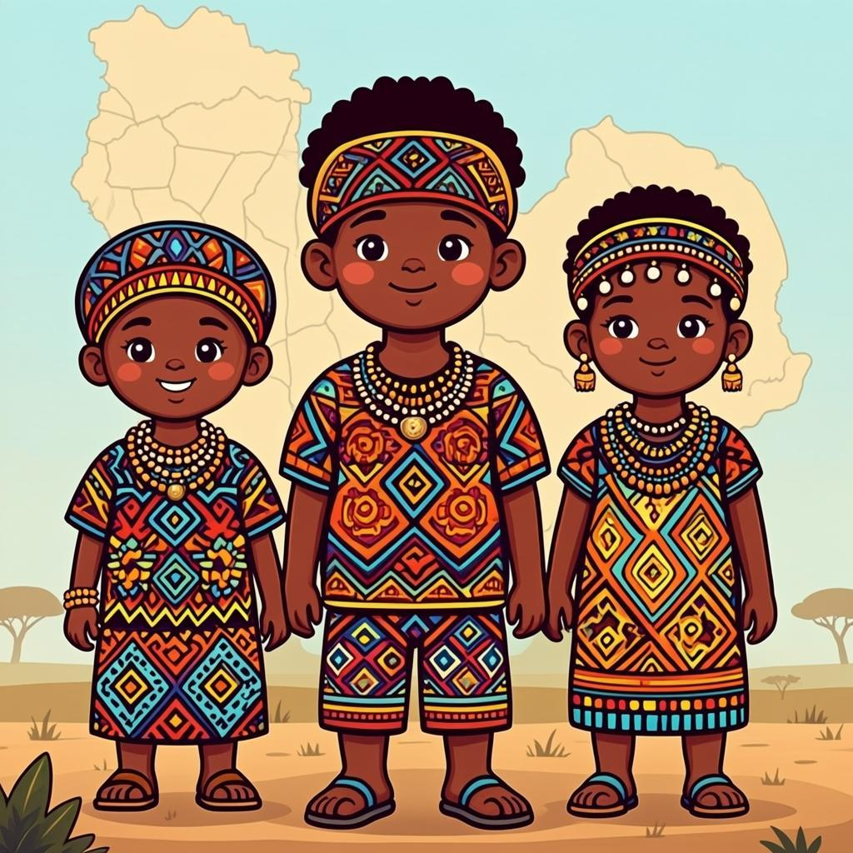
Complete the Sentences
Fill in the blanks using the words from the word bank below.
Word Bank: Ashanti | Dagbon | Gonja | Aboakyir | Akwamu
1. The ___________ Empire was one of the most powerful states in pre-colonial West Africa.
2. The Ashanti Empire was located in the ___________ region of present-day Ghana.
3. The ___________ Festival is celebrated by the people of Ada to commemorate their victory over the Ashantis.
4. The ___________ Kingdom was known for its sophisticated system of governance and justice.
5. The ___________ Empire was located in the northern part of present-day Ghana.
Multiple Choice Questions
Choose the best answer for each question.
1. Which kingdom was known for its gold trade and wealth?
A. Dagbon Kingdom
B. Ashanti Empire
C. Ga State
D. Ewe Kingdom
2. The Ashanti Empire was founded by:
A. Osei Tutu
B. Yaa Asantewaa
C. Prempeh I
D. Kwame Nkrumah
3. Which of these was NOT a pre-colonial Ghanaian kingdom?
A. Ashanti
B. Dagbon
C. Mali
D. Gonja
4. The Golden Stool is a sacred symbol of which kingdom?
A. Dagbon
B. Ashanti
C. Fante
D. Ga
Match Kingdoms with Their Characteristics
Match each kingdom on the left with its correct characteristic on the right.
1. Ashanti Empire | A. Located in northern Ghana, known for its cavalry
2. Dagbon Kingdom | B. Known for the Golden Stool and powerful military
3. Ga State | C. Located in northern Ghana, known for trade in salt and kola nuts
4. Gonja Empire | D. Coastal kingdom centered around Accra
5. Fante Confederacy | E. Coastal alliance that resisted European influence

Short Answer Questions
Answer the following questions in complete sentences.
1. Describe one way the Ashanti Empire maintained its power and unity.
2. Explain the significance of the Golden Stool in Ashanti tradition.
3. Name two pre-colonial Ghanaian kingdoms and describe one characteristic of each.
Remember!: Remember to check your answers!

Homework — Lesson 3

Name: ___________ Date: ___________

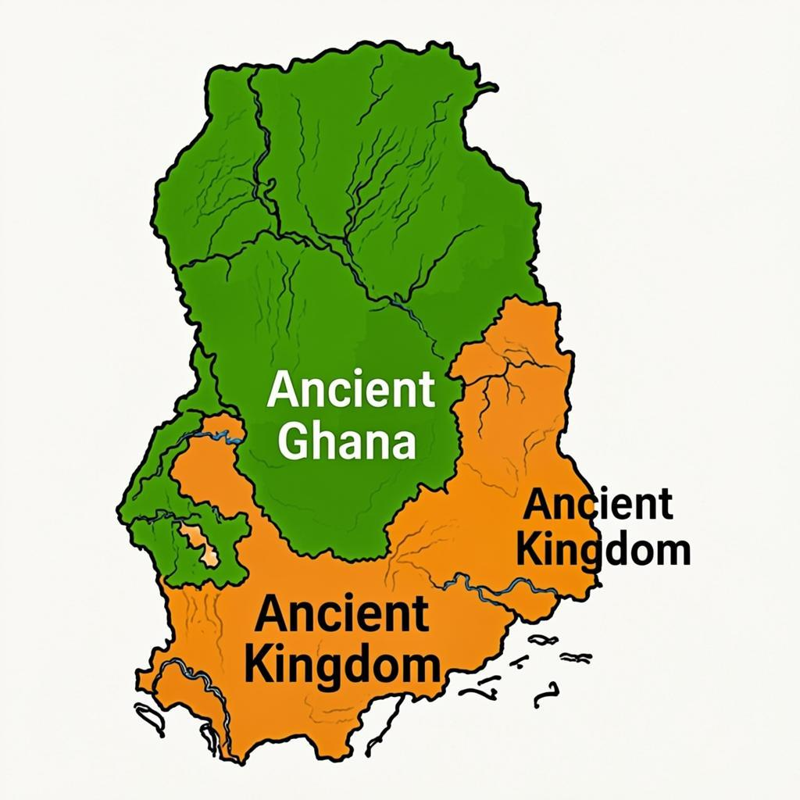

Homework — Lesson 3
Complete the following activities to reinforce your understanding of Pre-colonial Ghana: Kingdoms and States.
1. Research and write a short paragraph about one of the following kingdoms: Ashanti, Dagbon, or Gonja. Include information about its location, founder, and one significant achievement.
2. Draw a simple map showing the location of at least three pre-colonial Ghanaian kingdoms.
3. Interview an elder family member about any traditional stories they know about pre-colonial Ghanaian kingdoms.
Complete the Sentences
Fill in the blanks with the correct terms from your lesson.
Word Bank: Ashanti | Aboakyir | Dagbon | Gonja | Mamprussi
1. The ___________ Empire was one of the most powerful states in pre-colonial West Africa.
2. The ___________ Festival is celebrated by the people of Ada to commemorate their victory over the Ashantis.
3. The ___________ Kingdom was known for its expertise in horse breeding and warfare.
Test Your Knowledge
Choose the best answer for each question.
1. Which pre-colonial kingdom was located in the northern part of present-day Ghana?
A. Ashanti Empire
B. Dagbon Kingdom
C. Fante Confederacy
2. What was the main economic activity of the Ashanti Empire?
A. Fishing
B. Gold mining and trade
C. Cocoa farming
3. The Golden Stool is a sacred symbol of which kingdom?
A. Dagbon
B. Ashanti
C. Gonja
Short Answer Questions
Answer the following questions in complete sentences.
1. Explain the significance of the caste system in the pre-colonial Ashanti Empire.
2. Describe how the trans-Saharan trade influenced the development of pre-colonial Ghanaian kingdoms.
Remember: Bring your homework to the next class!

History Glossary
History Glossary
Trans-Saharan Trade | The network of trade routes across the Sahara Desert that connected West Africa with North Africa and the Mediterranean world.
Ashanti Empire | A powerful West African kingdom located in what is now Ghana, known for its military strength, wealth, and centralized government.
Gold Coast | The name given to Ghana by European traders due to the abundance of gold in the region, which was a major center for the transatlantic slave trade.
Colonialism | The practice of acquiring and maintaining control over another country and exploiting it economically and politically.
Independence | The state of being free from British rule, achieved by Ghana on March 6, 1957, under Kwame Nkrumah's leadership.
Pan-Africanism | A movement that promotes the unity, solidarity, and self-determination of African peoples and African diaspora communities worldwide.
Cape Coast Castle | A historic fort in Cape Coast, Ghana, built by European traders and used as a major hub for the transatlantic slave trade.
Transatlantic Slave Trade | The forced migration of millions of Africans to the Americas between the 16th and 19th centuries to work as enslaved laborers on plantations.
Pre-colonial | Referring to the period in African history before European colonization, characterized by diverse indigenous societies and kingdoms.
Ethnic Groups | Social groups that share common cultural characteristics such as language, traditions, and ancestry, such as the Akan, Ewe, and Ga in Ghana.
Cultural Heritage | The traditions, objects, and practices passed down through generations that help define a community's identity and history.
Nationalism | The ideology that promotes the interests of a particular nation, especially with the aim of gaining and maintaining national sovereignty.
Oral Tradition | The transmission of history, culture, and knowledge through spoken word rather than written texts, which has been crucial in preserving Ghanaian history.
Archaeology | The study of human history and prehistory through the excavation of artifacts, structures, and other physical remains.

Well Done!
Well Done!
Congratulations on completing your first term in Junior High School 1! You have worked hard and learned many important things about our nation's history. Remember that understanding where we come from helps us build a better future for Ghana.
"The future belongs to those who believe in the beauty of their dreams." — Kwame Nkrumah
Remember: Keep practising every day!


