English Language for Kindergarten 1
Term 1 • Quill Series

Learning English through fun activities and pictures

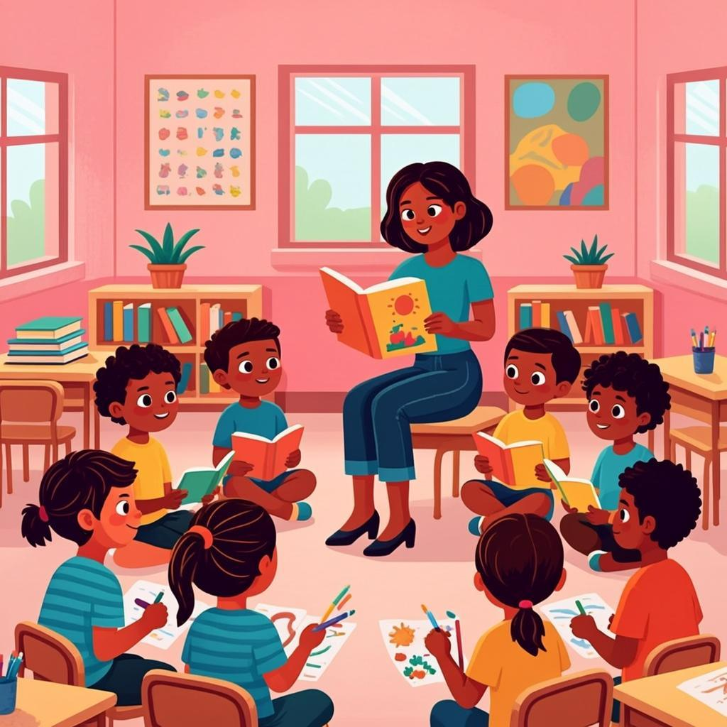

Name: ___________ Class: ___________

Table of Contents
Welcome to English Language for Kindergarten 1! Here is what we will learn:
1. Lesson 1 — Phonics: sounds of the alphabet ........... page 1
2. Lesson 2 — Greetings and self-introduction ........... page 3
3. Lesson 3 — Phonics: sounds of the alphabet ........... page 5
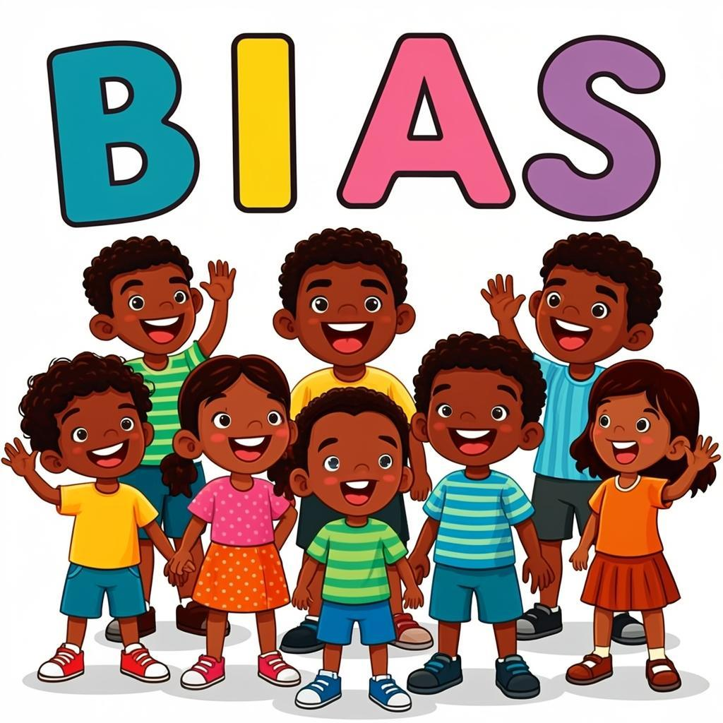
Let's learn English together!

Lesson 1: Phonics: sounds of the alphabet
Lesson 1: Phonics: sounds of the alphabet
Learning Objectives
- Identify letters of the alphabet
- Recognize the sound of each letter
- Match letters to their sounds
- Say the sounds of letters clearly
Hello children! Today we will learn about the sounds of letters. Letters make sounds. When we put sounds together, we can read words!
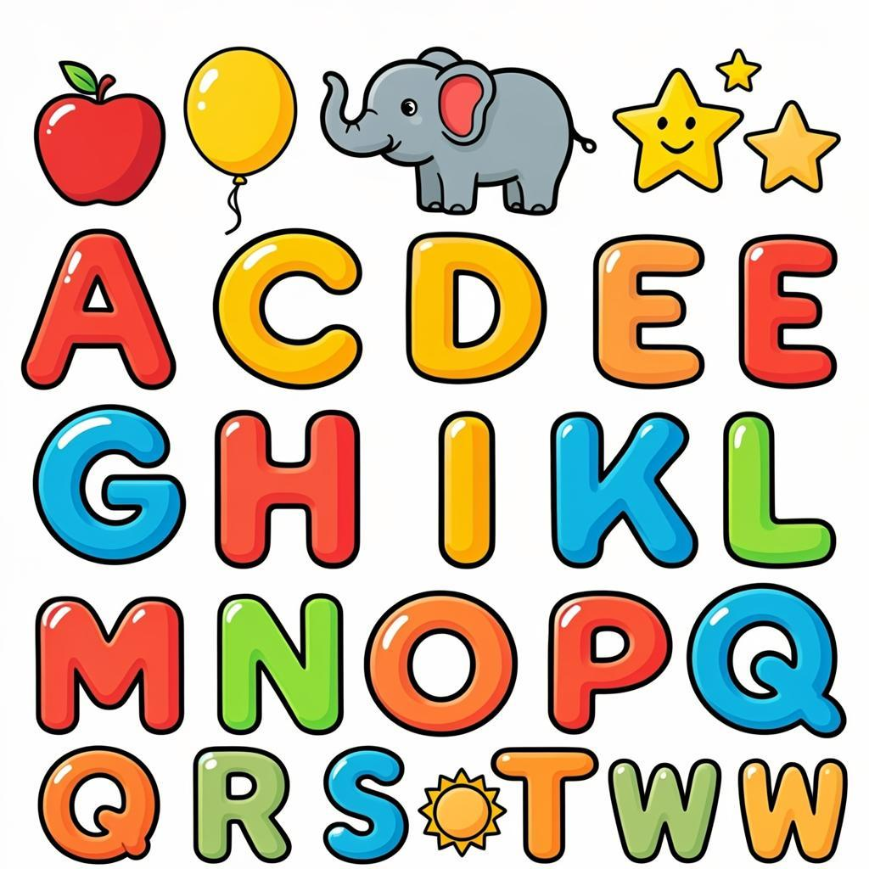
Letter Sounds
Each letter has a special sound. Let us learn some letter sounds:
Letter | Sound | Word Example
A | /a/ | Apple
B | /b/ | Ball
C | /c/ | Cat
D | /d/ | Dog

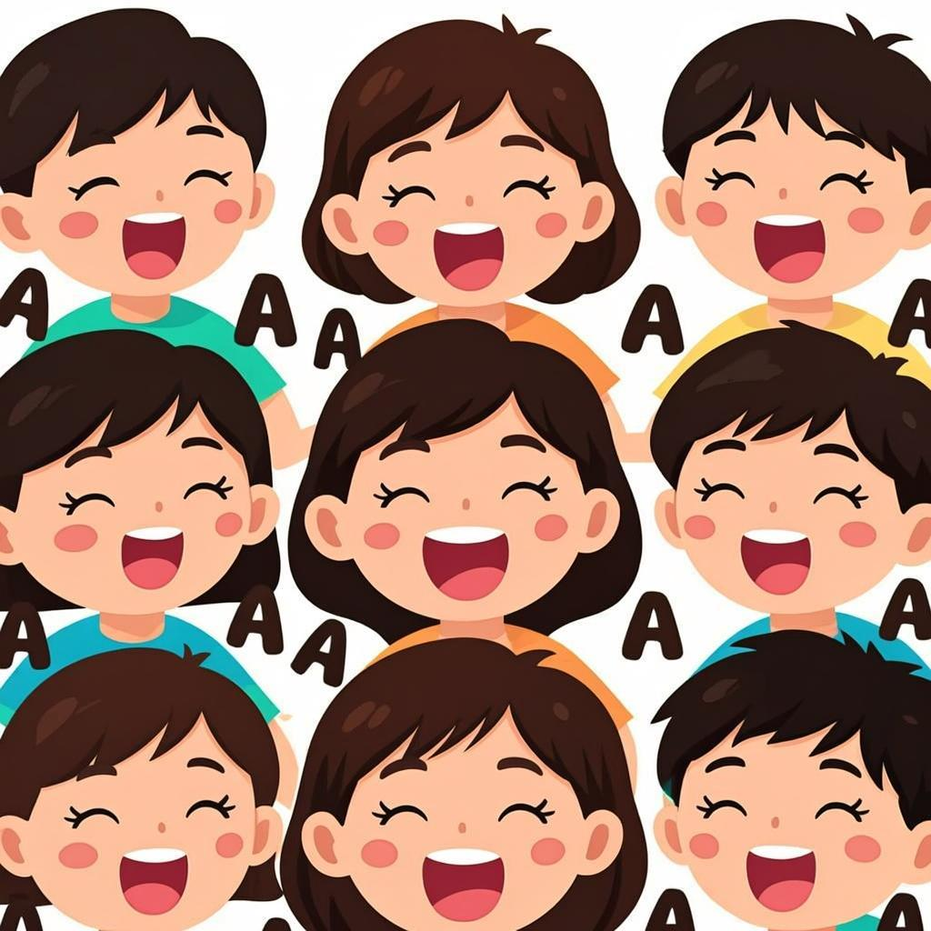
Say the sound with your mouth. Make the sound clearly. Listen to the sound. Practice the sound many times.
Key Vocabulary
Alphabet | The letters A to Z
Phonics | Learning letter sounds
Sound | What letters make when we say them
Letter | A, B, C, D and other symbols in writing

Teacher's Tip: Use hand gestures to help children remember sounds. For example, for 'A', open your mouth wide. For 'B', puff out your cheeks. Encourage children to make the sounds loudly and clearly.

Exercise: Letter Sounds
Name: ___________ Date: ___________

Fill in the blanks with the correct letter
Look at the picture and fill in the blank with the correct letter sound.
Word Bank: a | b | c | d
1. A is for _______. (Apple)
2. B is for _______. (Ball)
3. C is for _______. (Cat)
4. D is for _______. (Dog)
Circle the correct letter
Look at the picture and circle the correct letter that makes the beginning sound.
1. What is the first sound in 'elephant'?
A. a
B. b
C. e
D. f
2. What is the first sound in 'banana'?
A. b
B. a
C. n
D. d
3. What is the first sound in 'igloo'?
A. i
B. g
C. l
D. o
Match the letter with the picture
Draw a line from the letter to the picture that starts with that sound.
1. A | A. Cat
2. B | B. Dog
3. C | C. Fish
4. D | D. Ball
5. E | E. Apple
6. F | F. Elephant

Circle the correct word
Look at each picture and circle the correct word.
1. Circle the word that starts with 'a': apple or banana
2. Circle the word that starts with 'b': ball or cat
3. Circle the word that starts with 'c': dog or cat
4. Circle the word that starts with 'd': dog or egg
Remember!: Remember to check your answers!

Homework — Lesson 1
Name: ___________ Date: ___________

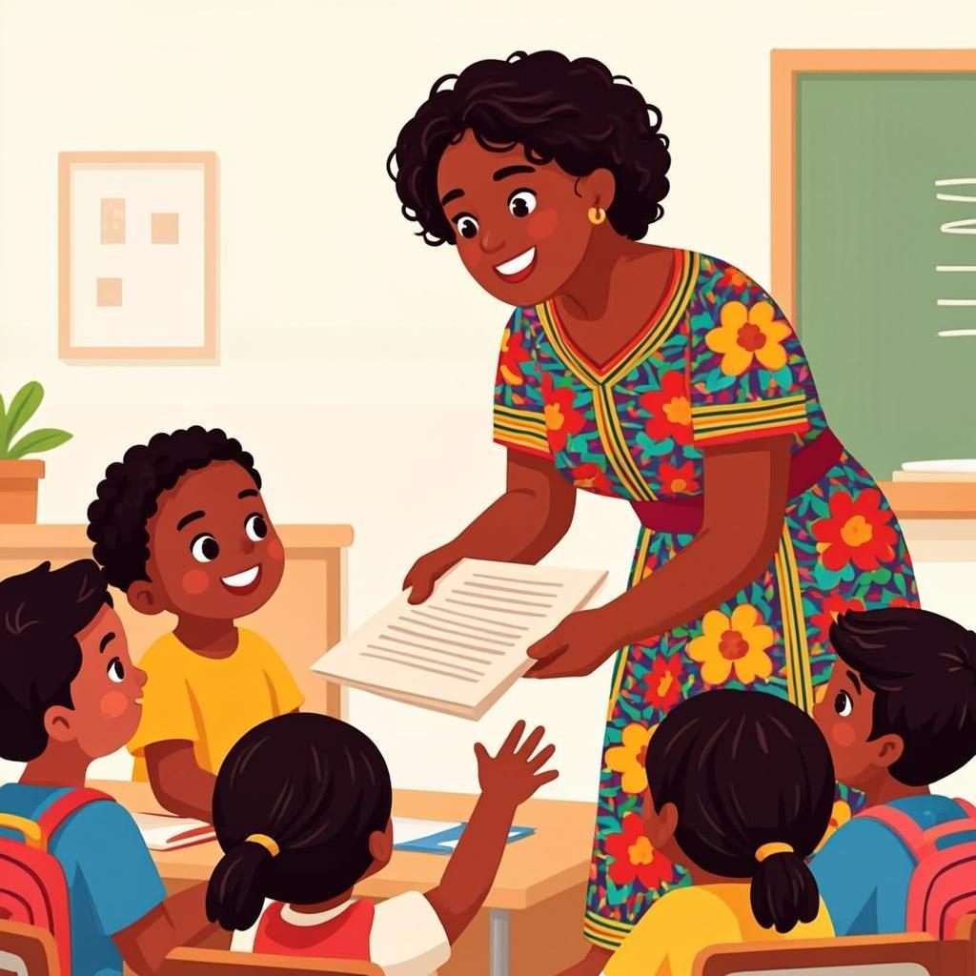

Phonics Practice
Complete the following activities at home with your family.
1. Practice saying the sounds of the letters a, b, c, d, e.
2. Find objects in your home that start with these sounds.
3. Ask your parents to help you write the letters.
Complete the Words
Fill in the blanks with the correct letter from a, b, c, d, e.
Word Bank: a | b | c | d
1. A is for ___________ (apple)
2. B is for ___________ (ball)
3. C is for ___________ (cat)
4. D is for ___________ (dog)
Circle the Correct Letter
Circle the letter that makes the sound you hear.
1. What letter makes the 'ah' sound?
A. b
B. a
C. c
2. What letter makes the 'buh' sound?
A. a
B. d
C. b
3. What letter makes the 'cuh' sound?
A. d
B. e
C. c
Practice Writing
Trace the letters below. Then try writing them on your own.
a
_______________________
b
_______________________
c
_______________________
d
_______________________
e
_______________________
Remember!: Bring your homework to the next class!

Lesson 2: Greetings and self-introduction
Lesson 2: Greetings and self-introduction
Learning Objectives
- Say 'hello' and 'good morning' to friends
- Introduce yourself by saying your name
- Ask a friend their name
- Respond when someone asks your name
Hello, children! Today we will learn how to greet our friends and tell them our names.

Greetings
We can say hello to our friends in different ways.
- Hello
- Good morning
- Good afternoon
- Good day
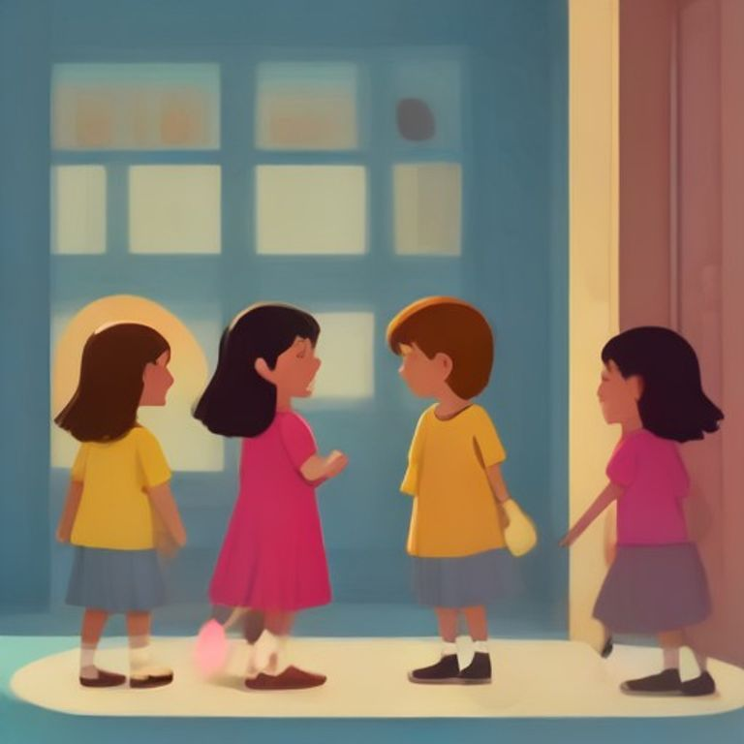
Introducing Yourself
When you meet a new friend, you can tell them your name.
Say: 'My name is Kwame.'
Or: 'I am Ama.'

Asking a Friend's Name
You can ask your friend their name like this:
'What is your name?'
Your friend can answer: 'My name is Esi.'
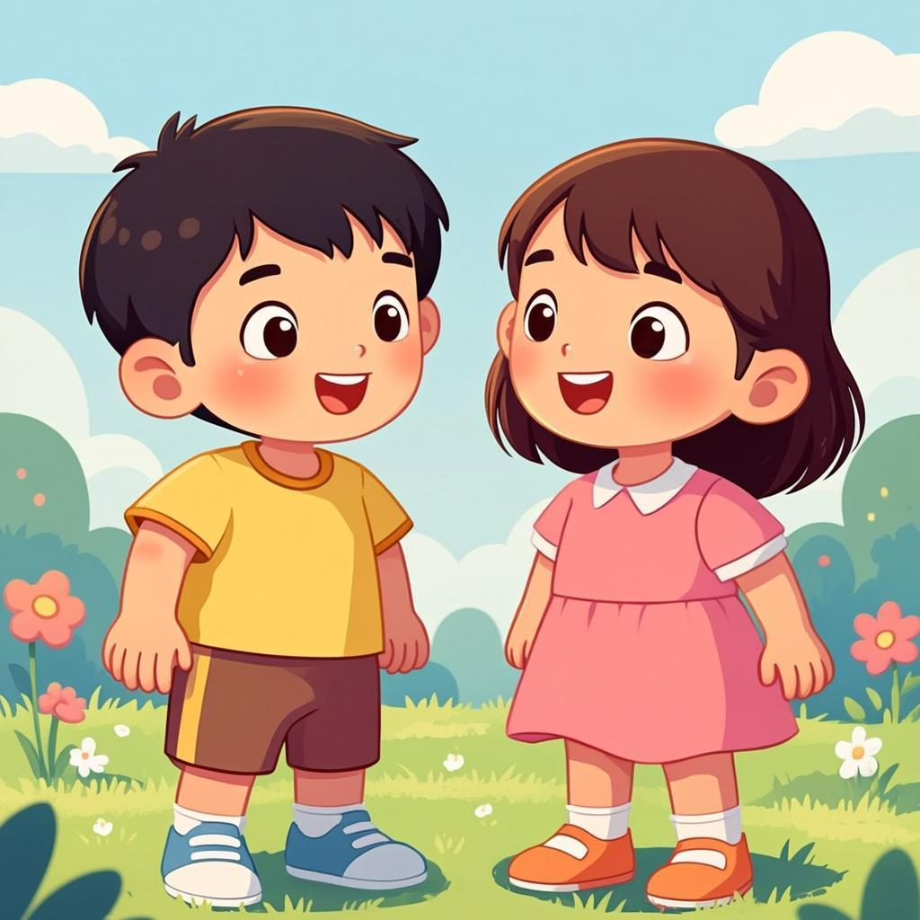
Key Vocabulary
Hello | A friendly way to greet someone
Good morning | A greeting used until about 12 noon
Name | The word people call you
Friend | Someone you like and play with

Teacher's Tip: Practice greetings with the children using different names. Have them stand in a circle and greet each other by name. Use puppets to make role-play more engaging for young learners.

Exercise: Greetings and Self-Introduction

Name: ___________ Date: ___________
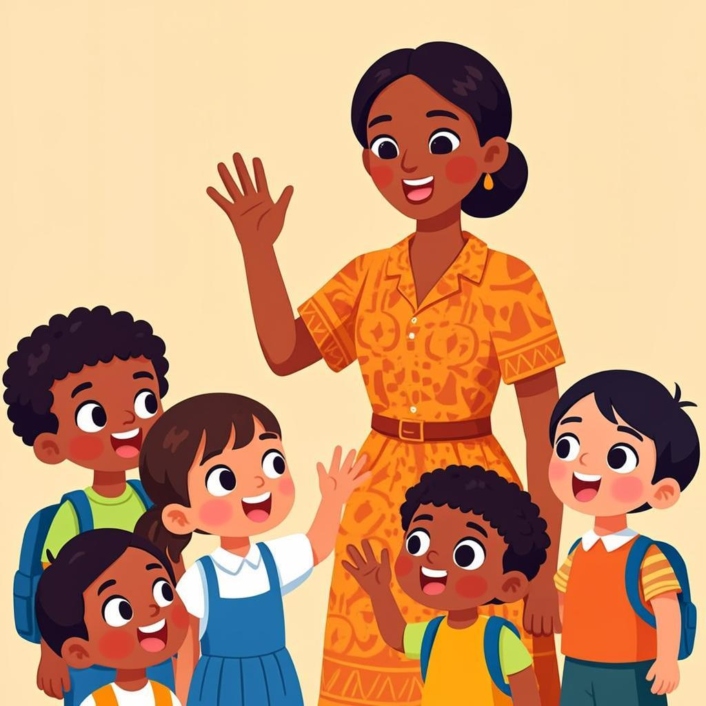
Fill in the blanks
Complete the sentences using the words from the word bank.
Word Bank: Kwame | 5 | Accra | fufu | school
1. Hello, my name is ________.
2. I am ________ years old.
3. I live in ________.
4. I like to eat ________.
5. This is my ________.
Choose the correct answer
Circle the correct option.
1. When you meet your teacher, you say:
A. Goodbye
B. Thank you
C. Good morning
D. Sorry
2. When you leave school, you say:
A. Hello
B. Goodbye
C. Please
D. Excuse me
3. Your teacher asks 'What is your name?' You answer:
A. I am fine
B. My name is Kofi
C. Thank you
D. Goodbye
4. A new friend asks 'How old are you?' You say:
A. I am 4 years old
B. I am happy
C. Good morning
D. Thank you
Match the greetings
Draw a line to match the greetings with the correct responses.
1. Good morning | A. I am fine, thank you
2. How are you? | B. My name is Abena
3. What is your name? | C. Good morning, teacher
4. Goodbye | D. Goodbye, see you tomorrow

Circle the correct word
Look at the picture and circle the correct word.
1. Picture of a child waving. Options: Hello/Goodbye
2. Picture of a child eating kenkey. Options: Food/Book
3. Picture of a child holding a toy car. Options: Toy/Fruit
4. Picture of a child sleeping. Options: Awake/Sleeping
Tip: Remember to check your answers!

Homework — Lesson 2
Name: ___________ Date: ___________

Complete the sentences
Fill in the blanks with the correct greeting word from the word bank.
Word Bank: Good morning | Good afternoon | Good evening
1. Good morning, Teacher.
2. Good afternoon, Ama.
3. Good evening, Mama.
Choose the correct answer
Circle the correct way to introduce yourself.
1. When you meet your friend at school, you say:
A. Good night
B. Good morning
C. Good evening
2. When you meet your teacher, you say:
A. Hello Teacher
B. Goodbye Teacher
C. See you Teacher
3. Your name is Kofi. You say:
A. I am Ama
B. My name is Kofi
C. I am Kofi
Practice your greetings
Draw a picture of yourself greeting someone. Write 'Hello' under your picture.
Remember: Bring your homework to the next class!

Word Bank
Kwame | A common boy's name in Ghana.
Ama | A common girl's name in Ghana.
apple | A round, red or green fruit.
banana | A long, yellow fruit.
book | Something we read with pages.
pencil | A writing tool with a point.
school | A place where we learn.
teacher | A person who teaches us at school.
friend | Someone we like to play with.
red | A bright color like tomatoes.
yellow | A bright color like the sun.
blue | A color like the sky.
big | Something that is large.
small | Something that is tiny.
happy | When you feel good inside.

Well Done!
Well Done!
You have finished your first term of English! You are now a little reader. You have learned new words and can read simple sentences. Good job!
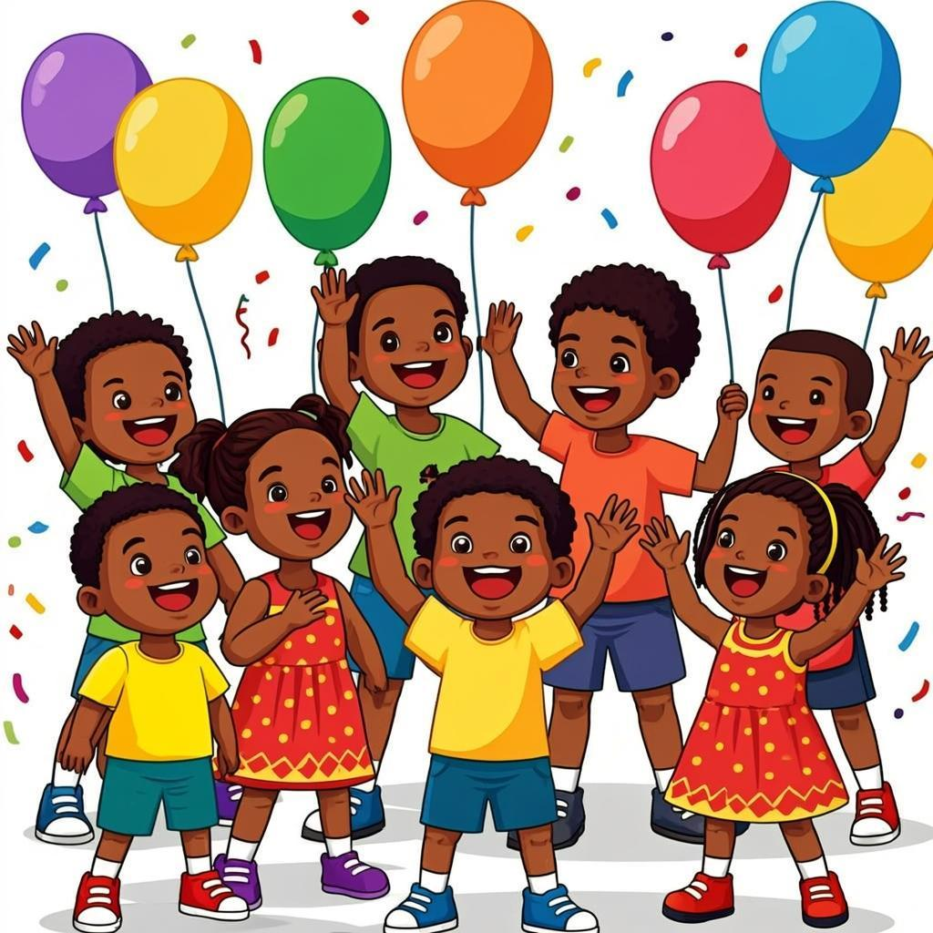
"Knowledge is power. Information is liberating. Education is the premise of progress, in every society, in every family." — Kofi Annan
Remember: Keep practising every day!


