Mathematics for Kindergarten 2
Term 1 • Quill Series
Let's learn numbers, shapes, and counting with fun!
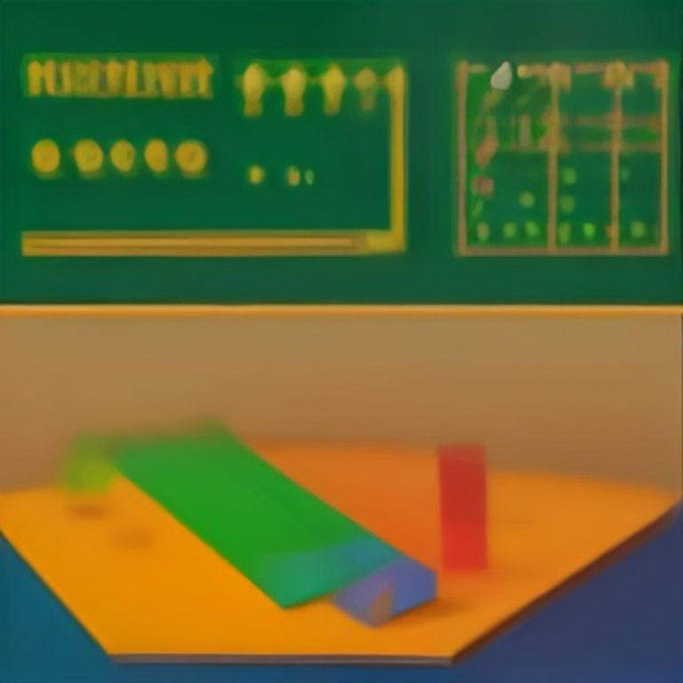

Name: ___________ Class: ___________

Table of Contents
Table of Contents

This book has fun lessons to help you learn numbers.

1. Lesson 1 — Counting with Friends ........... page 2
2. Lesson 2 — Numbers in My World ........... page 4
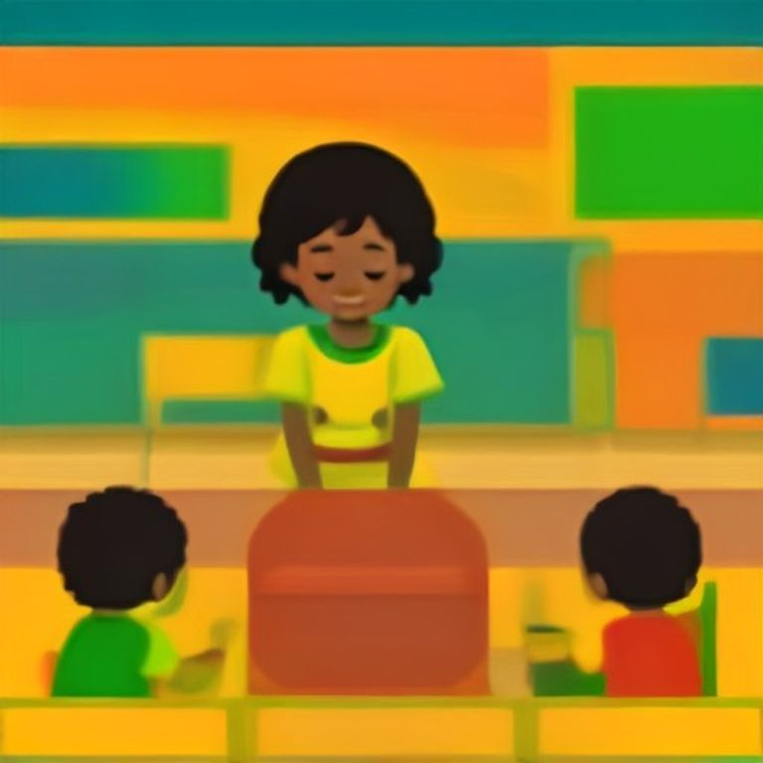
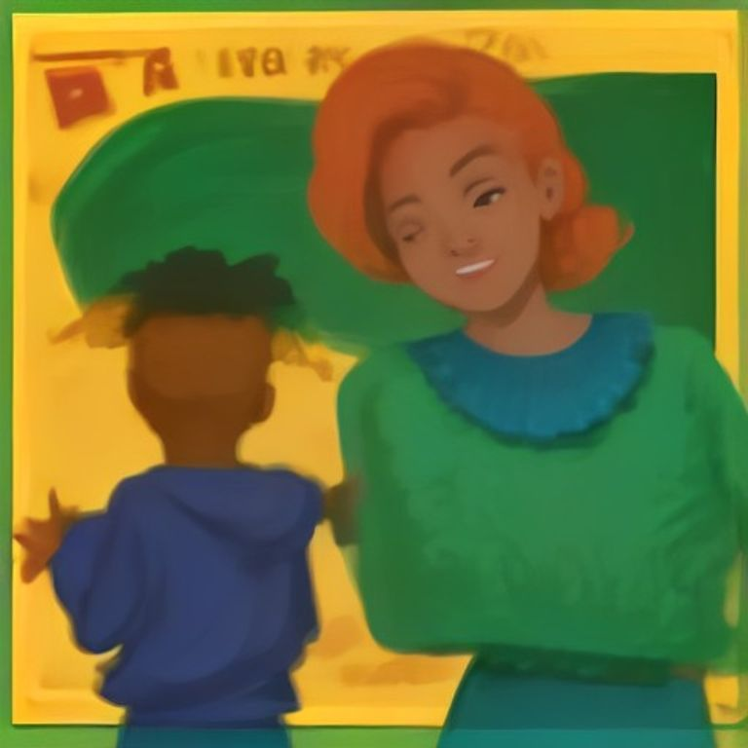
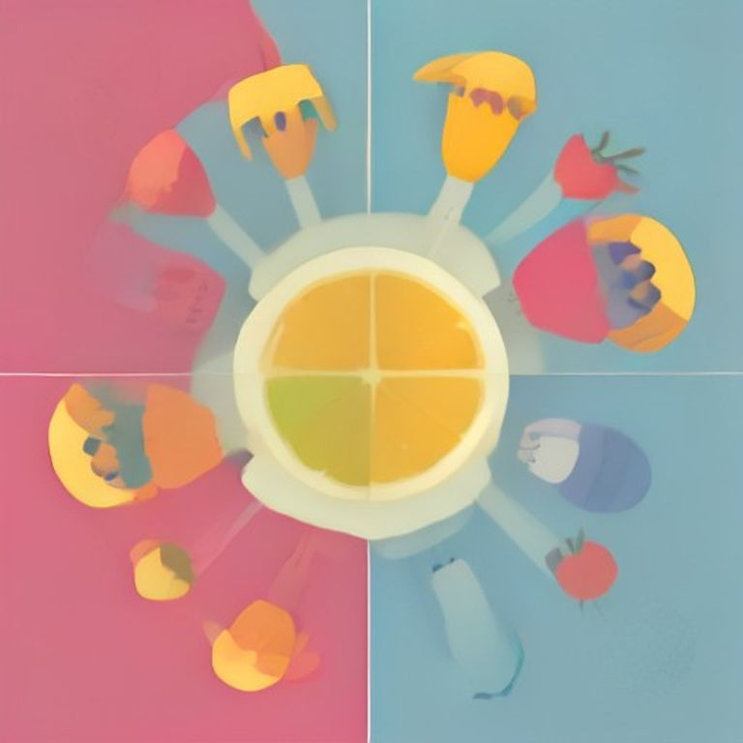
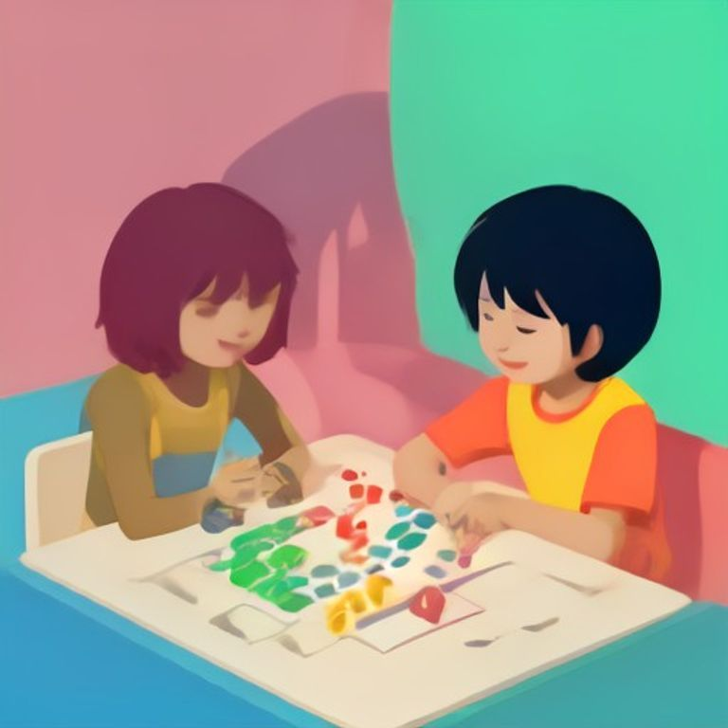

Lesson 1: Numbers 1 – 20: counting and recognition
Lesson 1: Numbers 1 – 20: counting and recognition
Learning Objectives
- Count numbers from 1 to 20
- Recognize numbers 1 to 20
- Match numbers with objects
- Write numbers 1 to 20
Today we will learn about numbers. Numbers help us count things. We will count from 1 to 20.
Counting Objects
Look at the picture. Count the bananas.

There are 15 bananas. Let us count together: 1, 2, 3, 4, 5, 6, 7, 8, 9, 10, 11, 12, 13, 14, 15.
Recognizing Numbers
Each number has a shape. Let us learn to recognize numbers 1 to 20.
Number | Word
1 | one
2 | two
3 | three
4 | four
5 | five

Numbers in Everyday Life
We use numbers every day. We count money. We count our toys. We count our friends.
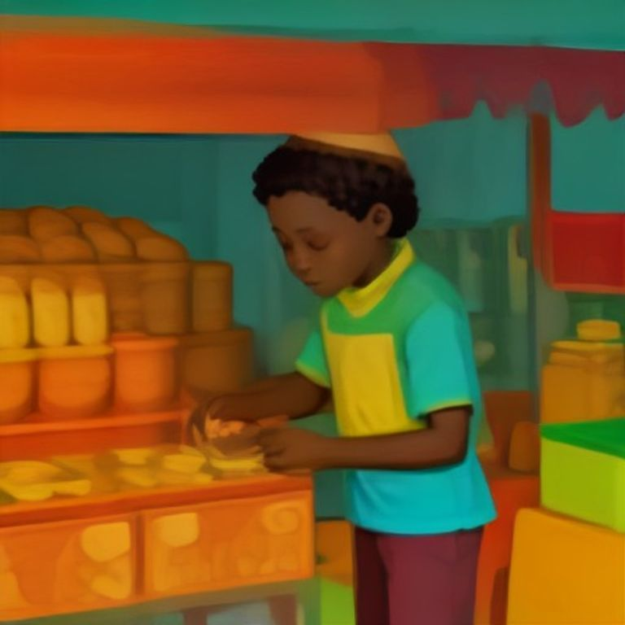
Kwame has 5 cedis. He can buy 5 balls.
Key Vocabulary
Count | Say numbers in order
Number | A symbol or word for how many
Recognize | Know what something is
Object | Things we can see and touch

Teacher's Tip: Use real objects like stones, fruits, or pencils to help children count. Encourage them to touch each object as they count. This helps with number recognition.

Numbers 1-20: Counting and Recognition
Name: ___________ Date: ___________

Fill in the blanks
Use the word bank to fill in the blanks
Word Bank: five | ten | seven | twenty
1. I see ___________ birds in the sky.
2. There are ___________ apples in the basket.
3. Kwame has ___________ pencils.
4. Ama can count to ___________.
Count and choose
Count the objects and choose the correct number
1. How many bananas?
A. 5
B. 6
C. 7
D. 8
2. How many balls?
A. 3
B. 4
C. 5
D. 9
3. How many books?
A. 10
B. 11
C. 12
D. 13
Match the number to the correct group
Draw a line from the number to the correct group of objects
1. 5 | A. 🍎🍎🍎🍎🍎
2. 8 | B. 🚗🚗🚗🚗🚗🚗🚗🚗🚗🚗🚗🚗🚗🚗🚗
3. 12 | C. ⚽⚽⚽⚽⚽⚽⚽⚽⚽⚽⚽⚽
4. 15 | D. 🐶🐶🐶🐶🐶🐶🐶🐶

Circle the correct number
Look at the picture and circle the correct number
1. 🚲🚲🚲 - Three
2. 🌈🌈🌈🌈🌈 - Five
3. 🌟 - One
Remember!: Remember to check your answers!

Homework — Lesson 1

Name: ___________
Date: ___________

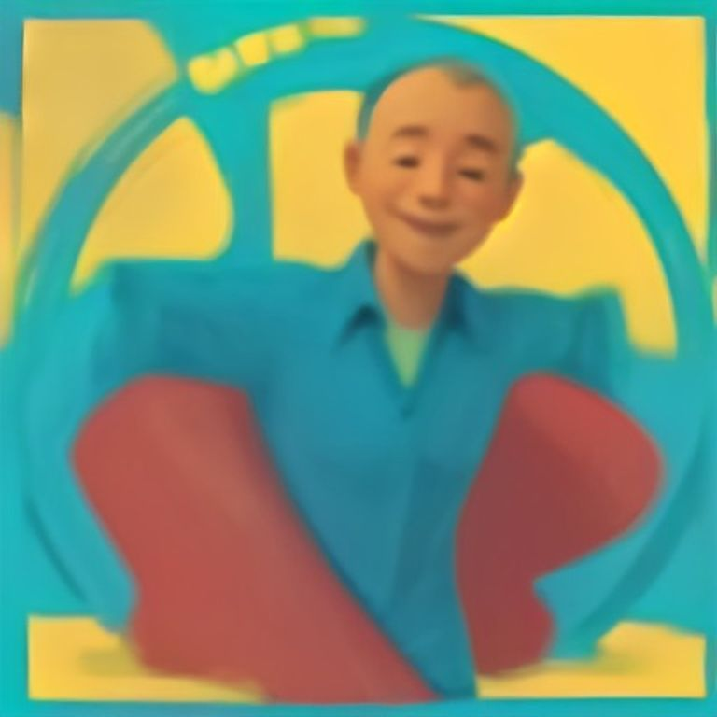

Count and Write
Count the objects and write the number.
Homework — Lesson 1
Complete these activities with your parents.
1. Count how many chairs are in your living room.
2. Count how many spoons are on the dining table.
3. Count how many books are on your shelf.
4. Count how many shoes are at your door.
Fill in the Blanks
Use the word bank to fill in the blanks.
Word Bank: 1 | 2 | 3 | 4 | 5 | 7
1. I have _______ eyes.
2. There are _______ days in a week.
3. A dog has _______ legs.
Choose the Correct Number
Circle the correct number.
1. How many fingers do you have on one hand?
A. 3
B. 5
C. 10
2. How many legs does a spider have?
A. 6
B. 8
C. 10
3. How many wheels does a bicycle have?
A. 1
B. 2
C. 4
Practice Writing Numbers
Trace the numbers below and then write them three times each.
1. 1
2. 2
3. 3
4. 4
5. 5
Remember!: Bring your homework to the next class!

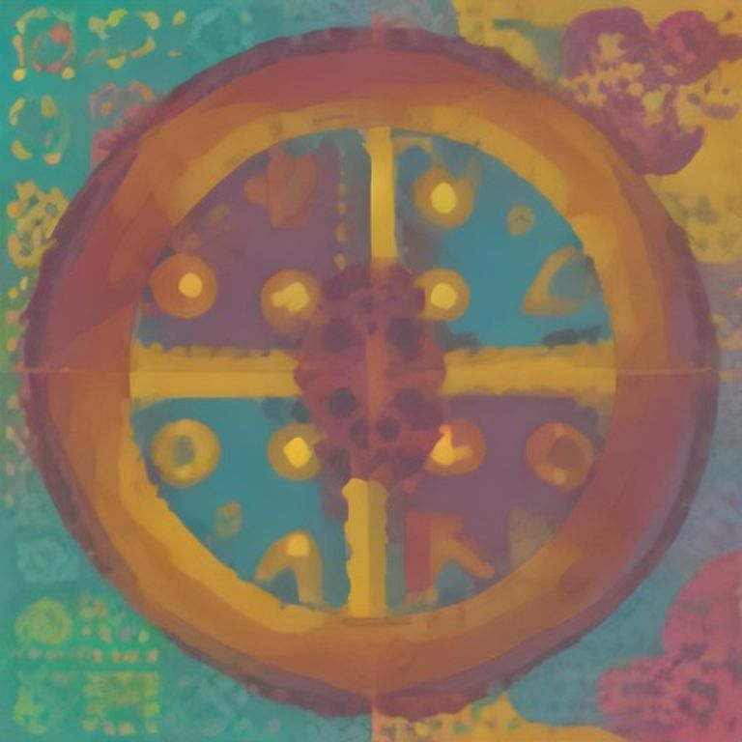

Lesson 2: Tracing and writing numbers
Lesson 2: Tracing and writing numbers
Learning Objectives
- I can trace numbers from 1 to 5.
- I can write numbers from 1 to 5.
- I can count objects and match them to numbers.
- I can recognize numbers in everyday life.
Today we will learn about numbers. Numbers help us count things.
Tracing Numbers
We will trace numbers with our fingers.
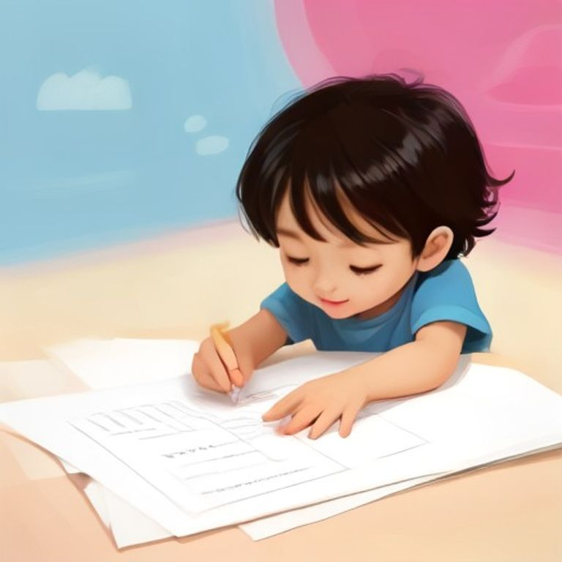
Tracing the number 1
Trace each number slowly. Follow the dotted lines.
Writing Numbers
After tracing, we will write numbers ourselves.

Writing the number 2
Hold your pencil correctly. Start at the dot.
Counting and Matching
Count objects and match them to numbers.

Counting bananas
One banana is number 1. Two bananas are number 2.
Key Vocabulary
Number | A symbol like 1, 2, 3
Trace | Follow with your finger
Count | Say numbers one by one
Match | Pair things that are the same

Teacher's Tip: Use your fingers to count objects in the classroom. Let children touch each object as they count.

Tracing and Writing Numbers
Exercise 2: Tracing and Writing Numbers
Name: ___________ Date: ___________
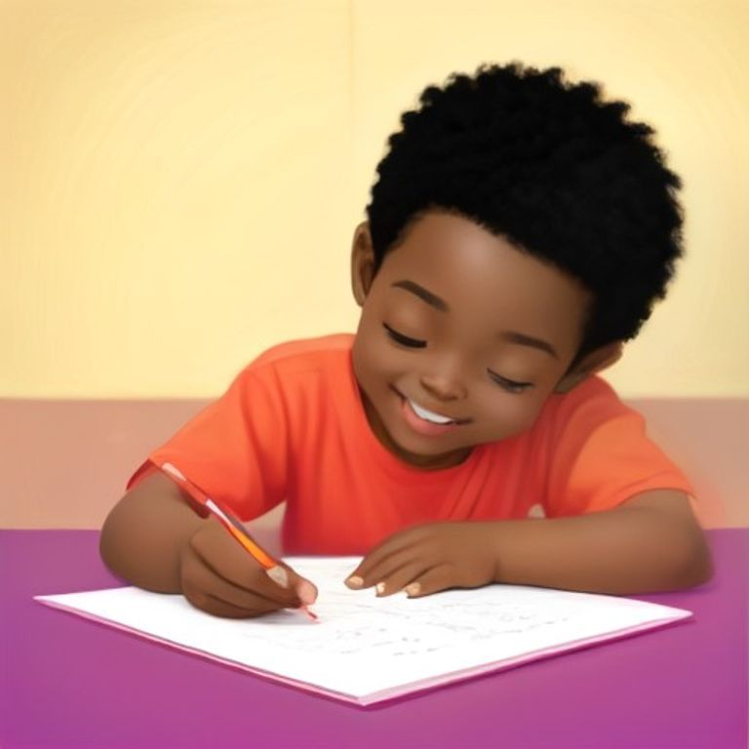
Fill in the Blanks
Use the word bank to fill in the blanks in the sentences below.
Word Bank: two | five | one | seven
1. I have _______ fingers on one hand.
2. There are _______ days in a week.
3. I am _______ years old.
4. We have _______ legs.
Choose the Correct Number
Look at the picture and choose the correct number.
1. How many apples are there?
A. Three
B. Five
C. Four
D. Two
2. How many balls are there?
A. One
B. Two
C. Three
D. Four
3. How many pencils are there?
A. Five
B. Six
C. Seven
D. Eight
4. How many books are there?
A. Three
B. Four
C. Five
D. Six
Match the Numbers
Draw a line from the number to the correct picture.
1. 1 | A. one banana
2. 2 | B. three balls
3. 3 | C. four books
4. 4 | D. two pencils
5. 5 | E. five apples

Colour the Pictures
Colour the pictures that show 3 items.
1. banana
2. pencils
3. balls
4. books
Remember!: Check your answers before you finish!

Homework — Lesson 2
Name: ___________ Date: ___________

Homework — Lesson 2
Do these tasks at home with a grown-up.
1. Trace the numbers from 1 to 10.
2. Count the fingers on your hands and write the number.
3. Draw 3 balls and write the number.
4. Practise writing numbers with sand or water.
Fill the Blanks
Write the correct number in the blank.
Word Bank: 1 | 2 | 3 | 5 | 7 | 10
1. I have ___ fingers on one hand.
2. There are ___ days in a week.
3. A clock has ___ hands.
Choose the Correct Number
Circle the right number.
1. How many eyes do you have?
A. 1
B. 2
C. 3
2. How many legs does a chair have?
A. 2
B. 3
C. 4
Practice Writing Numbers
1
_______________________
2
_______________________
3
_______________________
4
_______________________
5
_______________________
Tip: Bring your homework to the next class!

Math Words
Math Words We Know
Number | A number tells us how many things we have.
One | One is the first number after zero.
Two | Two is one and one together.
Three | Three is one, one, and one.
Four | Four is two and two.
Five | Five fingers on one hand.
Big | Big means something is large.
Small | Small means something is little.
Long | Long means something is not short.
Short | Short means something is not long.
Circle | A circle is round like a plate.
Square | A square has four equal sides.
Add | Add means put together.
Count | Count means say numbers one by one.


We count with numbers!
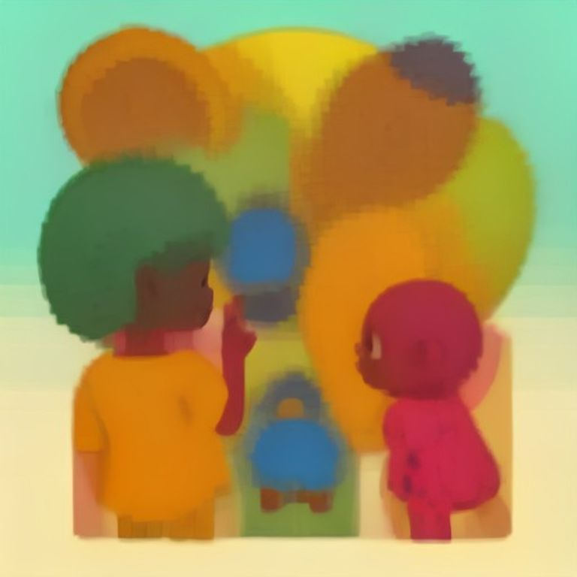
Big and small things around us.

Well Done!
Well Done!
You did great work in Mathematics!
You learned about numbers and shapes.
You are ready for Term 2!
"The future belongs to those who learn more and learn better." — Kofi Annan
Remember: Keep practising every day!
