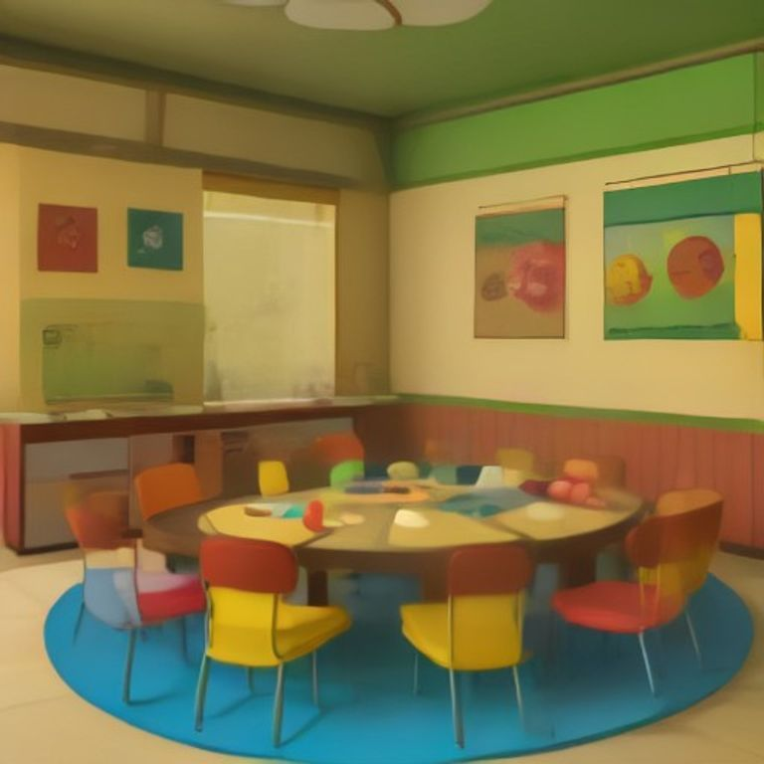
English Language for Kindergarten 1
Term 1 • Quill Series
Learn to read and write with fun activities

Name: ___________ Class: ___________

Table of Contents
Table of Contents

1. Lesson 1 — My Friends ........... page 2
2. Lesson 2 — My Family ........... page 4


Lesson 1: Phonics: sounds of the alphabet
Lesson 1: Phonics: sounds of the alphabet
Learning Objectives
- Identify letters of the alphabet
- Recognize the sounds of letters
- Match letters to their sounds
- Say sounds clearly
Hello children! Today we will learn about the sounds of letters. Letters make different sounds. We will learn to say these sounds. This will help us read later.
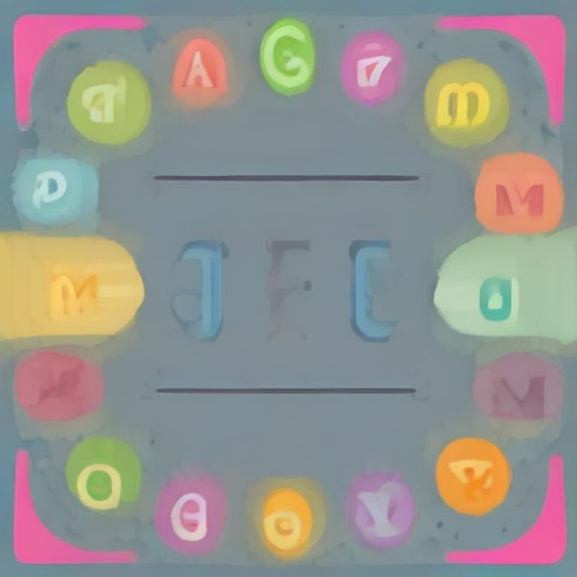
The Alphabet Chart
Letter Sounds
Each letter has a special sound. We say these sounds when we read.
Letter | Sound
A | a as in apple
B | b as in ball
C | c as in cat
D | d as in dog

Let's practice saying these sounds together.
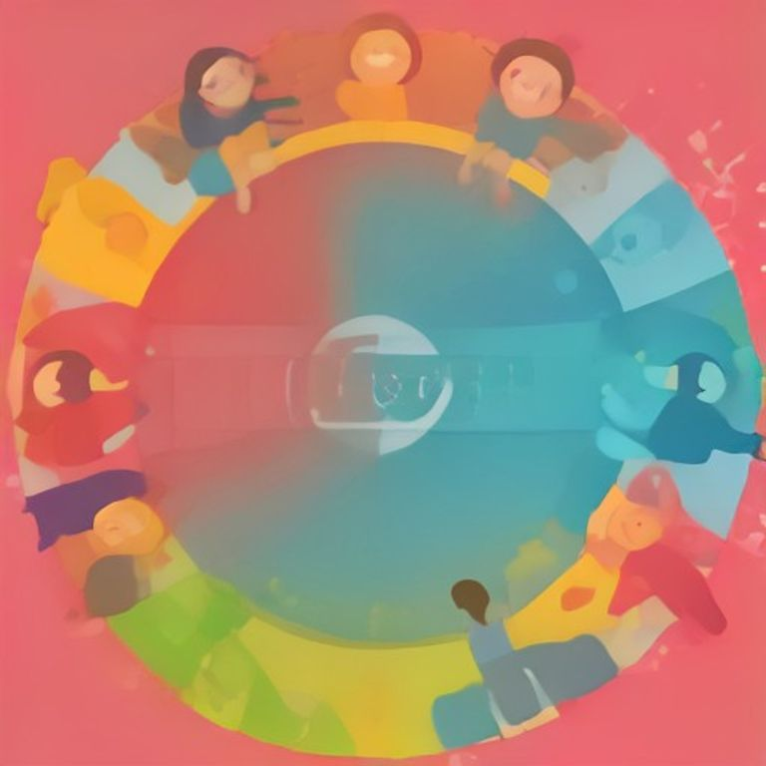
Children practicing sounds
Vowel Sounds
The letters A, E, I, O, U are special letters. They are vowels. They make different sounds.
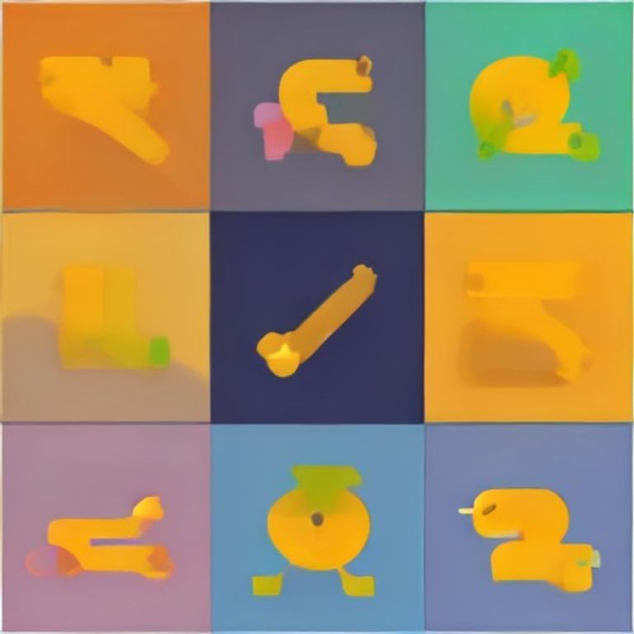
The Vowels
Key Vocabulary
Alphabet | The letters A to Z
Sound | The noise a letter makes
Letter | A written symbol like A, B, C
Vowel | The letters A, E, I, O, U
Phonics | Learning letter sounds

Teacher's Tip: Encourage children to make the sounds with exaggerated mouth movements. Use hand gestures for each sound to help kinesthetic learners. Practice in a fun, lively manner with lots of repetition.

Lesson 1: Phonics Exercise
Lesson 1: Phonics Exercise
Name: ___________ Date: ___________
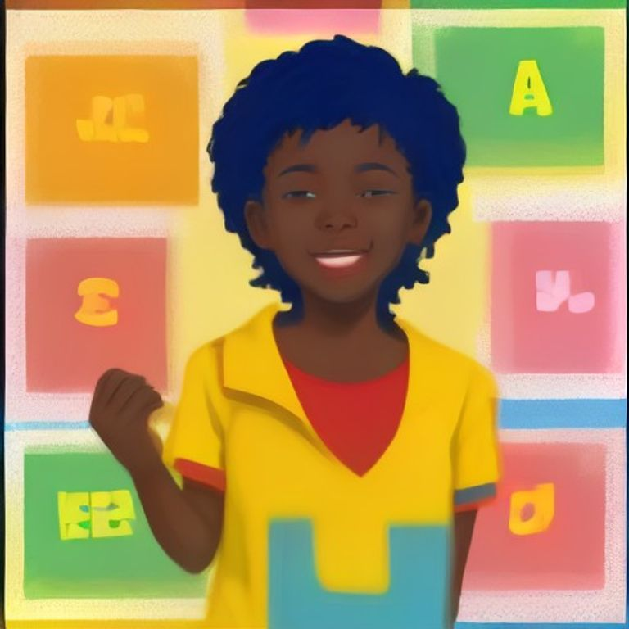
Fill in the Blanks
Look at the pictures and fill in the blanks with the correct letters.
Word Bank: a | b | c | d | e
1. A is for ___________. (apple)
2. B is for ___________. (ball)
3. C is for ___________. (cat)
4. D is for ___________. (dog)
5. E is for ___________. (egg)
Circle the Correct Letter
Look at the picture and circle the correct letter that begins the word.
1. What begins with 'A'?
A. Ball
B. Apple
C. Cat
D. Dog
2. What begins with 'B'?
A. Apple
B. Ball
C. Cat
D. Dog
3. What begins with 'C'?
A. Dog
B. Ball
C. Apple
D. Cat
4. What begins with 'D'?
A. Cat
B. Dog
C. Ball
D. Apple
Match Letters to Pictures
Draw a line from the letter to the matching picture.
1. A | A. Apple
2. B | B. Egg
3. C | C. Dog
4. D | D. Ball
5. E | E. Cat

Circle the Correct Word
Look at each picture and circle the correct word that matches.
1. Apple or Ball
2. Cat or Dog
3. Egg or Ball
4. Dog or Cat
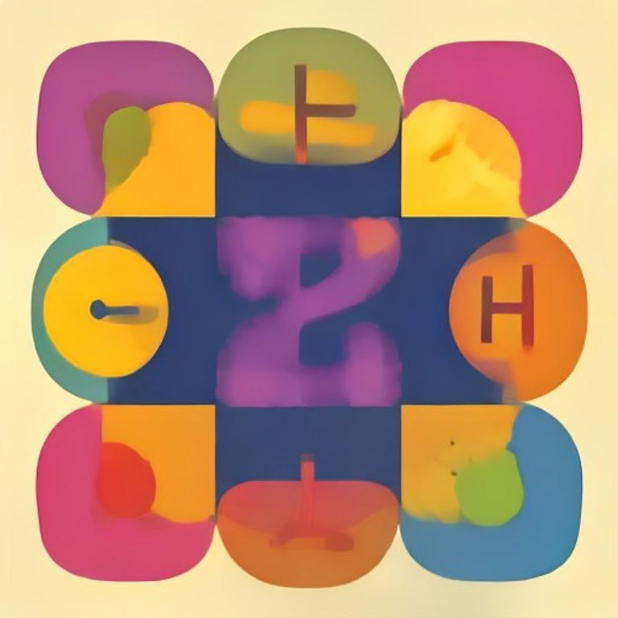
Remember!: Remember to check your answers!

Homework — Lesson 1
Name: ___________ Date: ___________
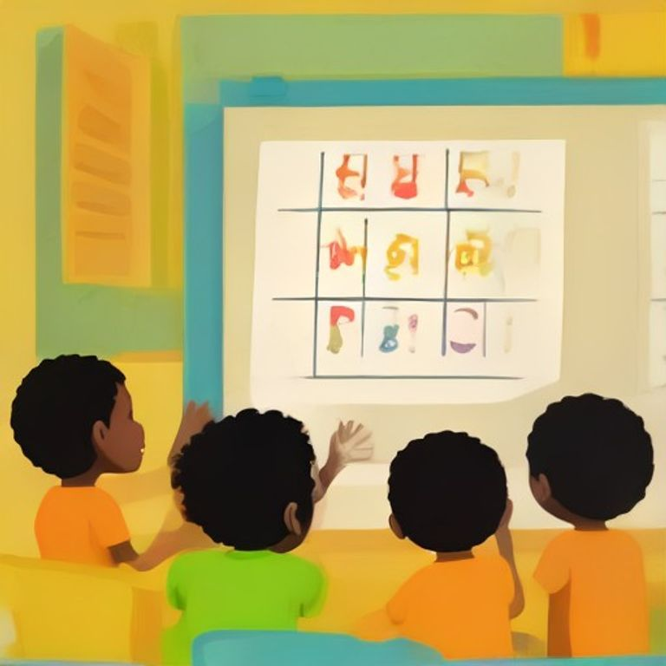
Homework — Lesson 1
Do these activities at home with a grown-up.
1. Ask an adult to help you say each letter sound.
2. Find objects in your home that start with 'a' and 'b'.
3. Practice writing your name.
4. Listen to a story at bedtime.
Fill in the Blanks
Look at the pictures and fill in the missing letters.
Word Bank: apple | ball | cat | dog | egg
1. A is for ___________ (picture of apple)
2. B is for ___________ (picture of ball)
3. C is for ___________ (picture of cat)
Circle the Correct Word
Look at the picture and circle the correct word.
1. What is this? (picture of a book)
A. ball
B. book
C. bag
2. What is this? (picture of a pen)
A. pencil
B. pen
C. pan
3. What is this? (picture of a mango)
A. banana
B. mango
C. orange
Practice Writing
Trace the letters below. Then try to write them on your own.
1. A a
2. B b
3. C c
Remember!: Bring your homework to the next class!

Lesson 2: Greetings and self-introduction
Lesson 2: Greetings and self-introduction
Learning Objectives
- Say hello to friends and teachers
- Introduce yourself by saying your name
- Ask someone their name
- Respond when someone asks your name
Hello, children! In this lesson, we will learn how to greet people and tell them our names. This is important when we meet new friends.
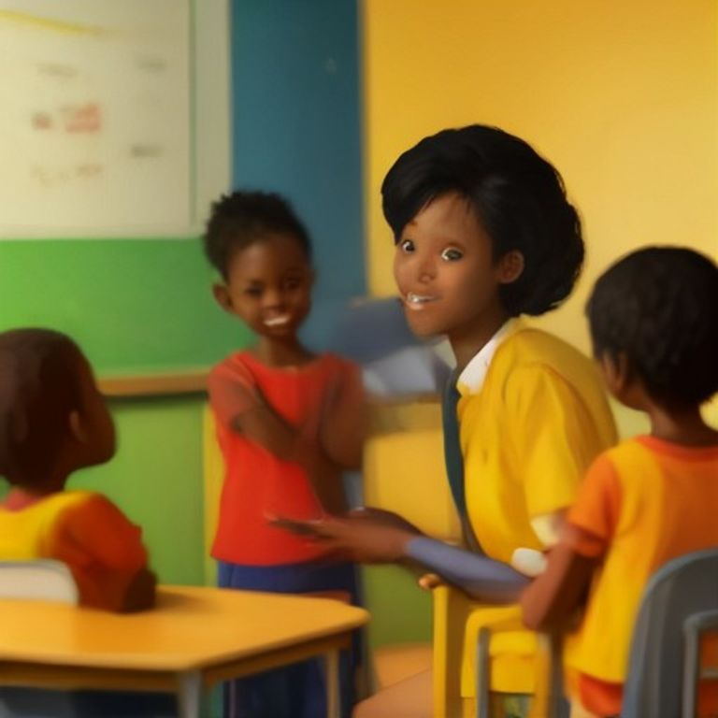
Ways to Greet
When we see someone, we can say hello to them. We can also say good morning, good afternoon, or good evening.
1. Hello
2. Good morning
3. Good afternoon
4. Good evening
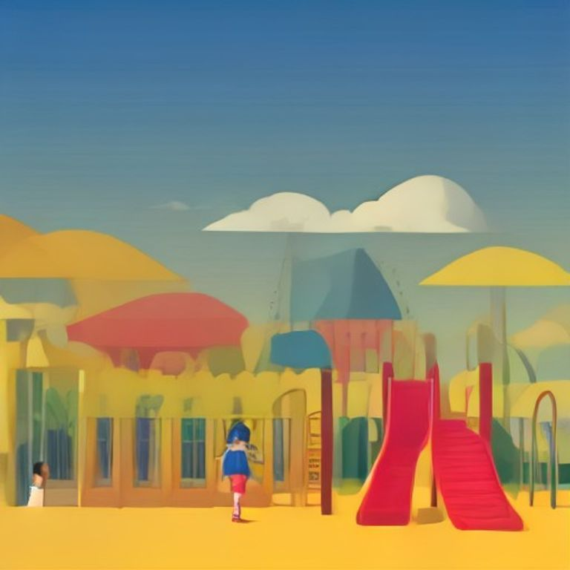
Introducing Yourself
When we meet someone new, we can tell them our name. We say: 'My name is...' and then say our name.
For example:
My name is Kwame.
My name is Ama.
My name is Kofi.

Asking Someone Their Name
We can ask someone their name. We say: 'What is your name?'
When someone asks us our name, we can say: 'My name is...' and then say our name.
Hello | A word we say when we meet someone
Morning | The early part of the day before noon
Afternoon | The middle part of the day from 12 to 6
Name | The special word that is just for you

Teacher's Tip: Encourage children to practice greeting each other and introducing themselves in pairs. Use Ghanaian names like Kwame, Ama, Kofi, and Abena to make it more relatable. Create a song with the greetings to make learning fun!

Exercise: Greetings and Self-Introduction
Name: ___________ Date: ___________
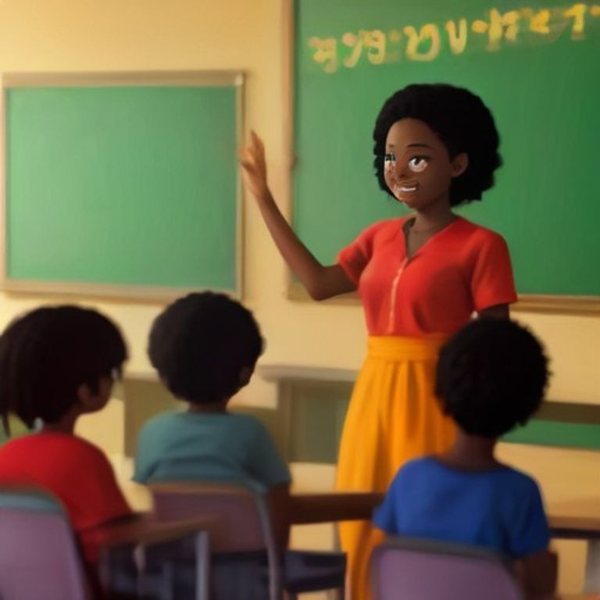
Complete the Sentences
Fill in the blanks using the words in the word bank.
Word Bank: hello | my | name | I | am | are
1. ___________ Kwame.
2. ___________ am fine.
3. ___________ you?
4. ___________ name is Abena.
5. ___________ hello to your friend.
Choose the Right Word
Circle the correct answer.
1. When you meet someone, you say:
A. Goodbye
B. Thank you
C. Hello
D. Sorry
2. The correct response to 'How are you?' is:
A. I am fine
B. Goodbye
C. Thank you
D. Sorry
3. When you introduce yourself, you say:
A. My name is...
B. Goodbye
C. Thank you
D. Sorry
4. When you leave, you say:
A. Hello
B. Goodbye
C. Thank you
D. Good morning
Match the Greetings
Draw a line from the greeting on the left to the correct response on the right.
1. Hello | A. Good morning
2. How are you? | B. My name is Kofi
3. Good morning | C. Goodbye
4. What is your name? | D. See you later
5. Goodbye | E. I am fine

Circle the Correct Word
Look at each picture and circle the correct word that matches the greeting.
1. A picture of a child waving with the words: Hello/Goodbye
2. A picture of a child pointing to themselves with the words: My name is/Your name is
3. A picture of two children shaking hands with the words: Welcome/Goodbye
4. A picture of a child smiling with the words: I am fine/Thank you
Remember!: Remember to check your answers!

Homework — Lesson 2
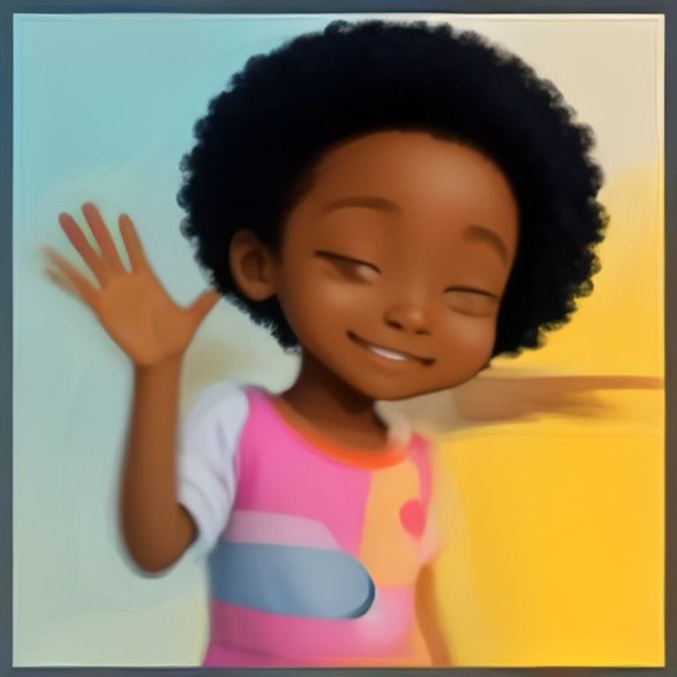
Name: ___________ Date: ___________
Homework — Lesson 2
Complete these tasks with your family.
1. Practise saying 'Hello' and 'Good morning' to your family.
2. Tell your name to someone at home.
3. Ask 'How are you?' to a family member.
4. Wave goodbye when you leave home.
Fill in the blanks
Use these words: Hello, Goodbye, How are you
Word Bank: Hello | Goodbye | How are you
1. ______ my name is Ama.
2. ______, I am fine.
3. ______, see you tomorrow.
Circle the right answer
Look at the questions and circle the best answer.
1. What do you say when you meet someone?
A. Goodbye
B. Hello
C. Thank you
2. What do you say when you leave?
A. Good morning
B. Goodbye
C. I am fine
Practise writing
Trace these words three times.
Hello
_______________________
Goodbye
_______________________
My name is
_______________________
Remember!: Bring your homework to the next class!

Our Words
Word Dictionary
apple | A round, red or green fruit that we can eat.
ball | A round toy that we can roll and catch.
book | A thing with pages that has stories and pictures.
chair | Something we sit on with a back and legs.
dog | A friendly animal that barks and wags its tail.
eye | The part of our face that helps us see.
friend | Someone we like to play with and share with.
house | A building where we live with our family.
jollof | A tasty Ghanaian rice dish with tomato and spices.
kite | A toy that flies in the wind with a string.
moon | A bright circle in the sky at night.
nose | The part of our face we use to smell.
water | A clear liquid that we drink to stay healthy.
yellow | A bright color like a banana or the sun.
zoo | A place where we can see different animals.

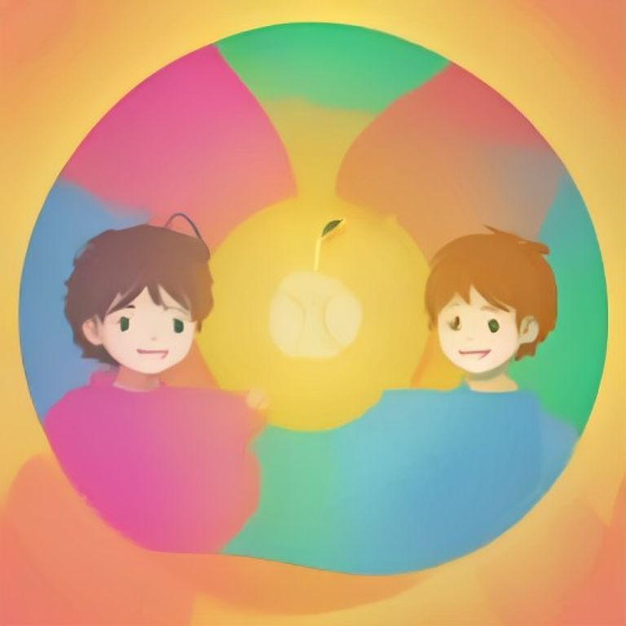

Well Done!
Well Done!
You have finished your first term of school. You are very clever!
"The future belongs to those who believe in the beauty of their dreams." — Kwame Nkrumah
Remember: Keep practising every day!
