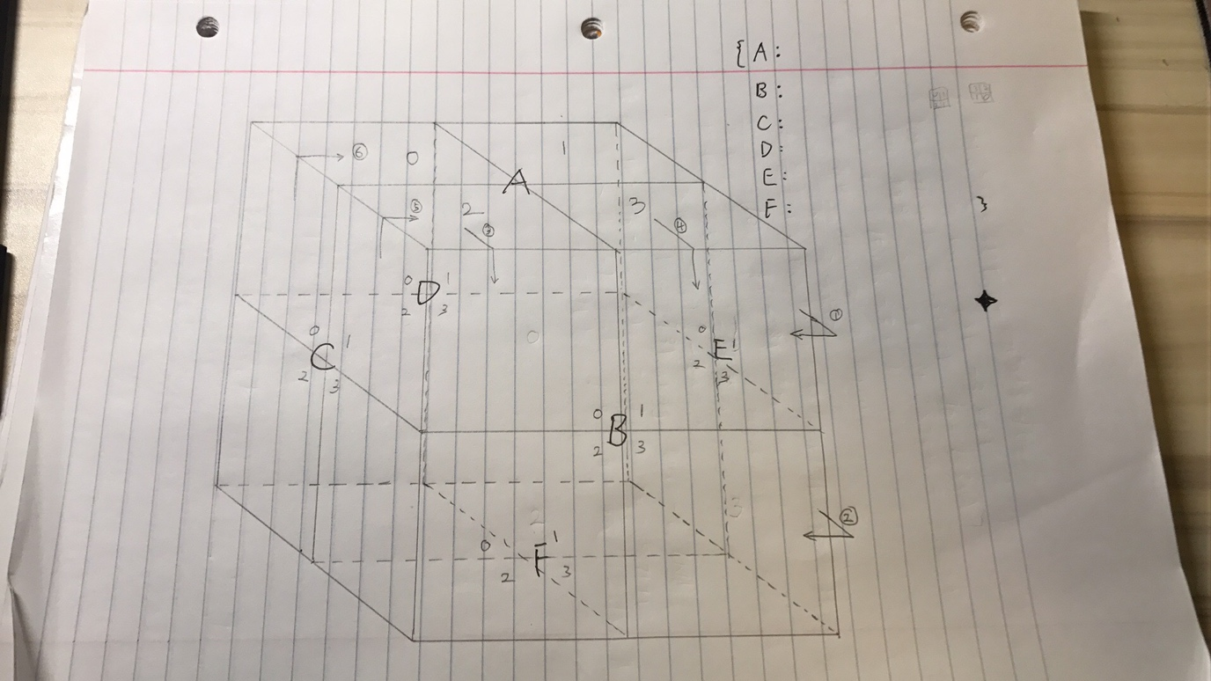

Sean has finished the Q-learning part of the project. Freddie has finished the state formulation and transition, and operators of the project. With default 3 colors, we perform q-learning technique to allow program to explore the goal state and find the shortest path.

So far, each file is working alright. However, we haven’t test files if they work properly together. We will continue working on it this weekend.