ASSIGNMENT 4

Adonis Shareef

07-01-2021

# Markdown Basics

## Favorite Foods

1. Pizza
2. Tacos
3. Pad Thai

## Images

All Cases (Log Plot) 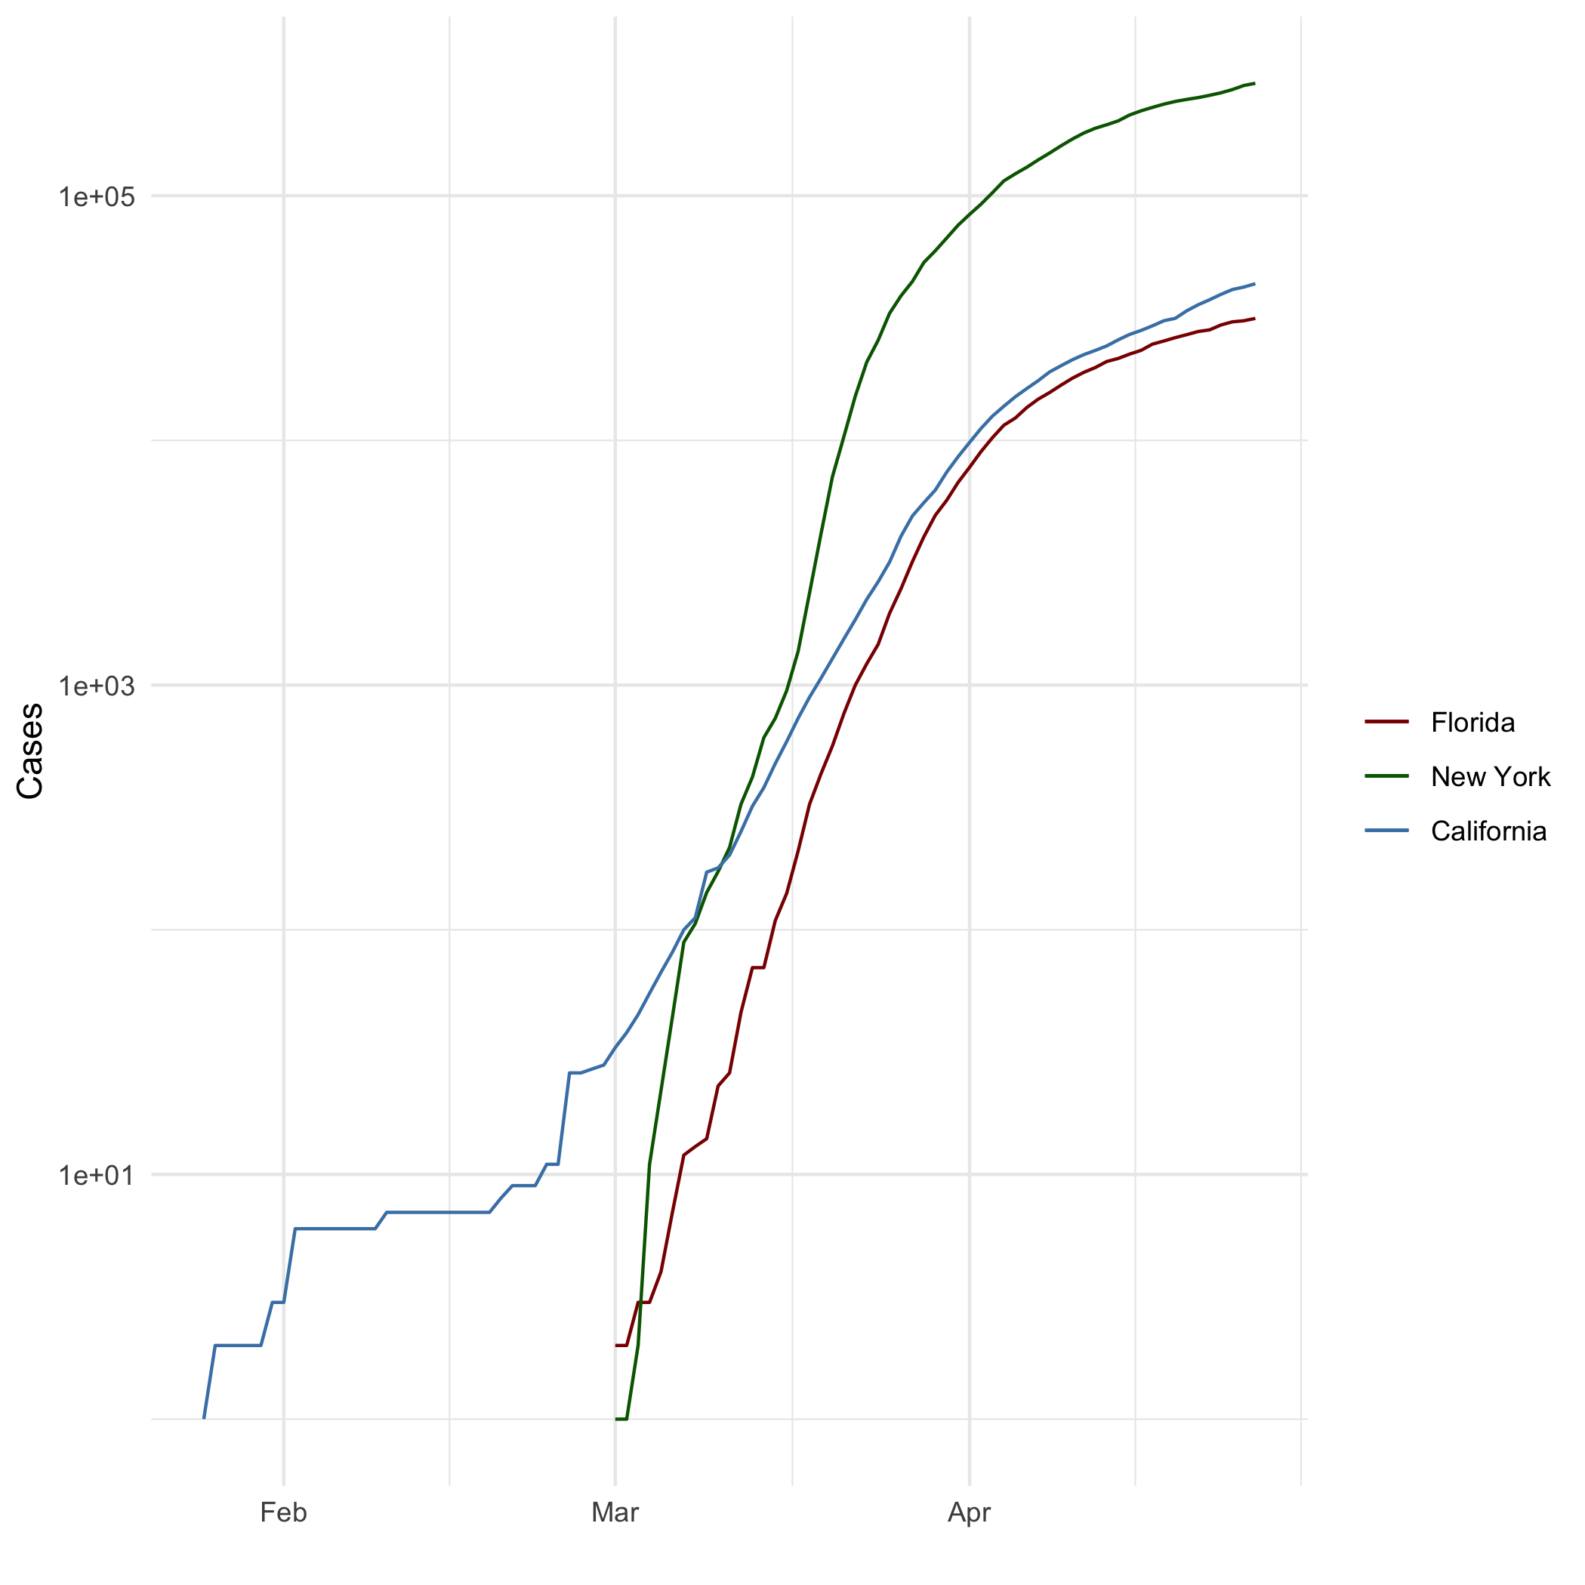 ## Add a Quote

“It’s beauty in the struggle, ugliness in the success.”  
  
 -J.Cole

## Add an Equation

$$P(A|B)=\frac{P(B|A)P(A)}{P(B)}$$

## Add a Footnote

This is a footnote[1]

## Add Citations

* R for Everyone (Lander 2014)
* Discovering Statistics Using R (Field, Miles, and Field 2012)

# Inline Code

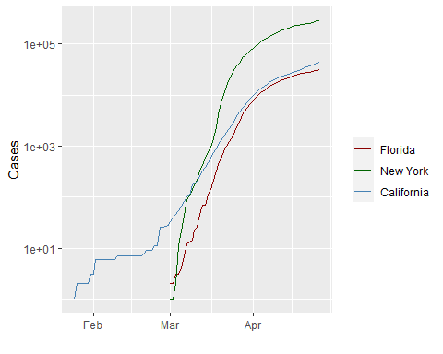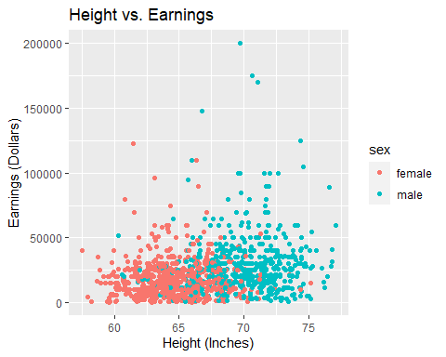

# Tables

Lord of the Rings

|  |  |  |  |  |
| --- | --- | --- | --- | --- |
| name | race | in_fellowship | ring_bearer | age |
| Aragon | Men | TRUE | FALSE | 88 |
| Bilbo | Hobbit | FALSE | TRUE | 129 |
| Frodo | Hobbit | TRUE | TRUE | 51 |
| Galadriel | Elf | FALSE | FALSE | 7000 |
| Sam | Hobbit | TRUE | TRUE | 36 |
| Gandalf | Maia | TRUE | TRUE | 2019 |
| Legolas | Elf | TRUE | FALSE | 2931 |
| Sauron | Maia | FALSE | TRUE | 7052 |
| Gollum | Hobbit | FALSE | TRUE | 589 |

##   
##   
## +-----------+--------+---------------+-------------+------+  
## | name | race | in_fellowship | ring_bearer | age |  
## +===========+========+===============+=============+======+  
## | Aragon | Men | TRUE | FALSE | 88 |  
## +-----------+--------+---------------+-------------+------+  
## | Bilbo | Hobbit | FALSE | TRUE | 129 |  
## +-----------+--------+---------------+-------------+------+  
## | Frodo | Hobbit | TRUE | TRUE | 51 |  
## +-----------+--------+---------------+-------------+------+  
## | Galadriel | Elf | FALSE | FALSE | 7000 |  
## +-----------+--------+---------------+-------------+------+  
## | Sam | Hobbit | TRUE | TRUE | 36 |  
## +-----------+--------+---------------+-------------+------+  
## | Gandalf | Maia | TRUE | TRUE | 2019 |  
## +-----------+--------+---------------+-------------+------+  
## | Legolas | Elf | TRUE | FALSE | 2931 |  
## +-----------+--------+---------------+-------------+------+  
## | Sauron | Maia | FALSE | TRUE | 7052 |  
## +-----------+--------+---------------+-------------+------+  
## | Gollum | Hobbit | FALSE | TRUE | 589 |  
## +-----------+--------+---------------+-------------+------+

# References

Field, A., J. Miles, and Z. Field. 2012. *Discovering Statistics Using r*. SAGE Publications. <https://books.google.com/books?id=wd2K2zC3swIC>.

Lander, J. P. 2014. *R for Everyone: Advanced Analytics and Graphics*. Addison-Wesley Data and Analytics Series. Addison-Wesley. <https://books.google.com/books?id=3eBVAgAAQBAJ>.

1. 1