**Estimates Report Of Fratsybugs**

|  |  |  |
| --- | --- | --- |
| **Sr. No.** | **Particular** | **Hours** |
| 1. | User Detail issue | 5 Hours |
| 2. | Pop up Checkout Calculation | 6 Hours |
| 3. | Part Refund same pricing calculation | 12 Hours |
| 4. | User Counting and Padlock Reverting | 8 Hours |
| 5. | Checkout Page | 8 Hours |
| 6. | Promo code management and functionality | 10 Hours |
| 7. | Shipping Feature in admin & front | 10 Hours |
|  | **Total:** | **59 Hours** |

**Fratsy bugs**

 Point 1: User Detail issue

1. The users *sign up* details, are no longer integrated between the frontend and backend interfaces. (This was working before so there must be a bug or something here).  [https://fratsy.cStripom/adminlogin](https://fratsy.com/adminlogin)

Backend:

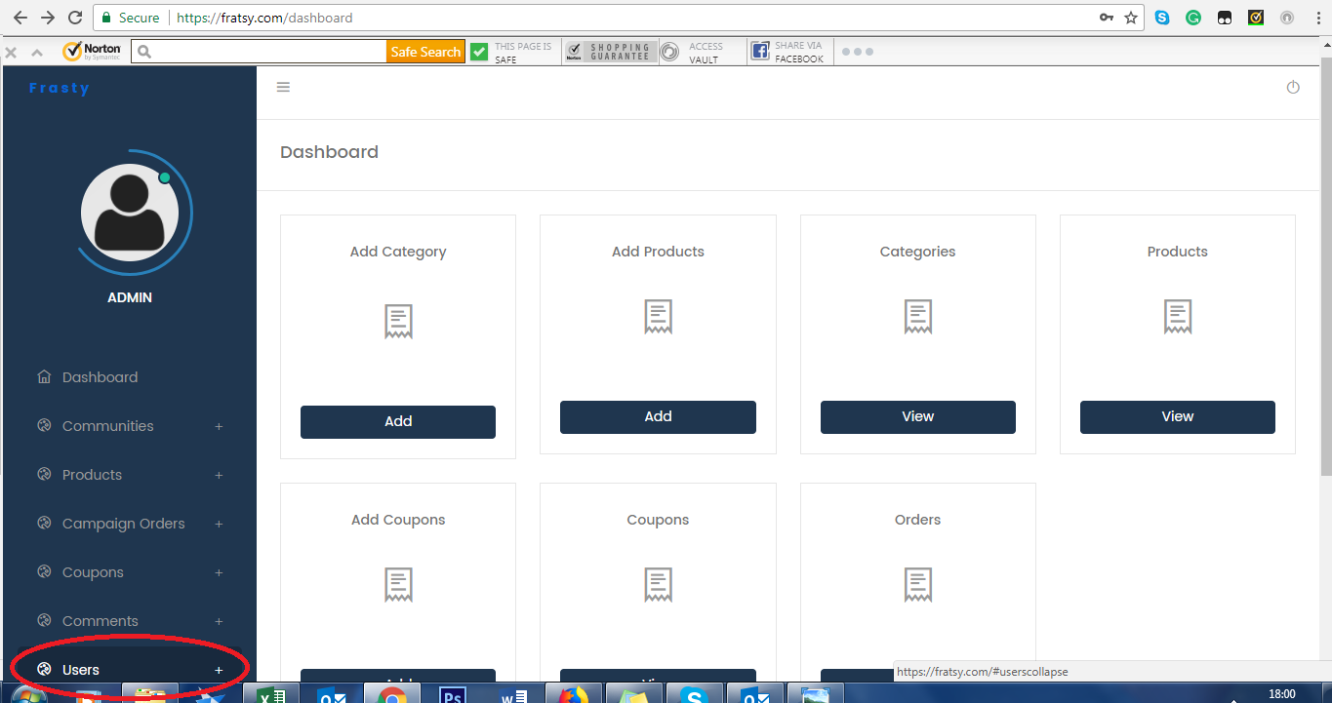

Front end:

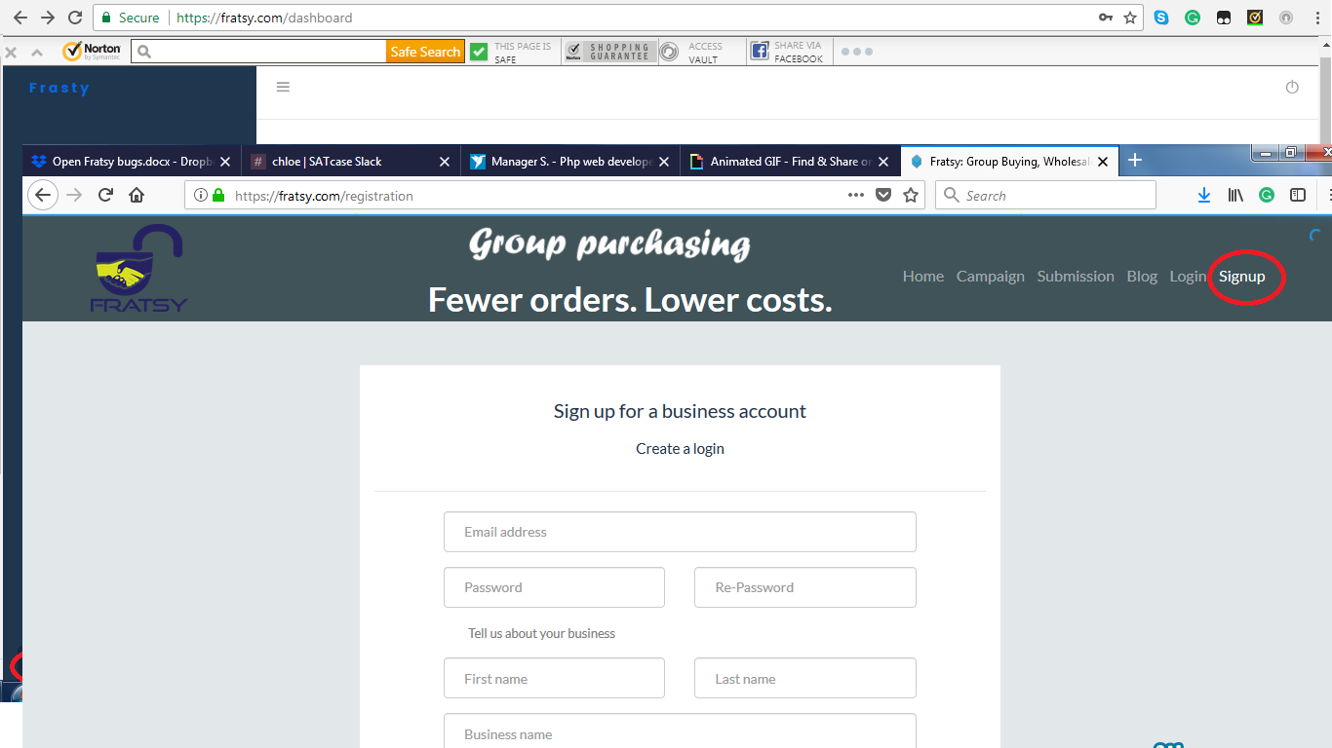

Manish20171201: OK, we will check and fix this bug, To check this bug in more details we need code files and database of current website, so that we can setup project on our local server and check it.

I have given you the code login details. The route files are found here: /var/www/html/dropsource

**Scope(2017-12-06): OK we will fix above issue and show all user details in admin panel.**

2.

Popup checkout isn't dynamic to each product pricing. The current calculation is locked to 1-10, 11-500, 501-1900, 2000-5000. But as you can see below all products unit brackets are different.

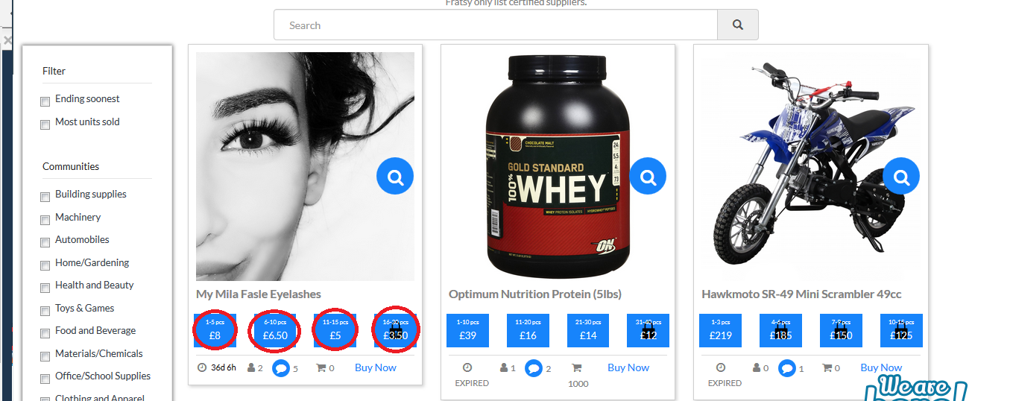

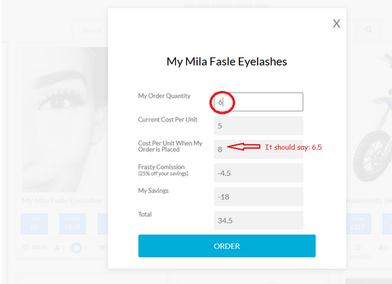

Manish20171201: OK.

**Scope(2017-12-06): Under this point we will show cost per unit according the quantiry assigned from admin panel.**

3.

When orders are refunded via the back end, as show below: (full refund for both buyers)

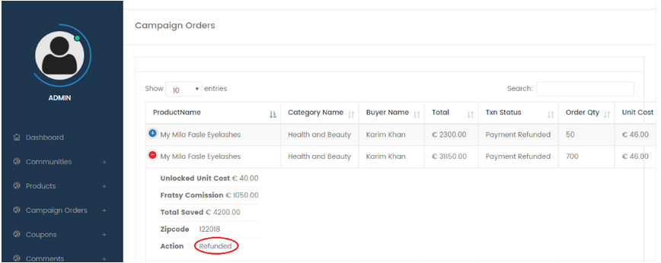

Manish20171201: What do you mean by Full Refund to Both Buyers?

Also please explain what process is currently implementated for refund functionality? Also how admin refund amount to buyer (Manually or through payment gateway)?

Answer to question 3: when I say ‘full refund for both buyers’ I am referring to the already refunded buyer on this product.

The process is done by pressing ‘refund on the back end’ – this will refund all the payment

There needs to be a new button added called ‘part refund’- this will refund as much as I select to refund.

Both of these processes are to be linked with the payment gateway.

**Scope(2017-12-06): OK, we will add new button part refund, so when admin click on this button they redirect to new page where they can enter part amount and confirm.**

The front end should remove the '2' next to the user icon and the padlocks should revert back to the 2nd box, as show incorrectly below:



Manish20171201: OK, we will remove count 2, next to user icon. Should we need to remove user icon as well?

In which case and why paidlock revert back to second box? please explain paidlock functionality in details.

The count 2 needs removing, but only because the full refund has been made (for a part refund the number next to the icon is to stay)

The number is relating to the number of buyers that have joined the purchase.

The icon itself must always show

The padlocks shout revert back to correct position after a full refund has been made. This will represent how many units are now sold and what the prices are locked and unlocked

**Scope(2017-12-06): OK, we will remove count if full payment is refunded and show count in the case of part refund. Also ser padlocks position after full refund.**

* There should also be a part refund option. This will refund an amount of the users payment (usually once the campaign is over). This should not change the front end. This is because users only have to pay the unit price that is reached at the end of the campaign. i.e if the 1st user pays £6.50 when buying 9 units at the start of the campaign, and a 2nd user buys 4 more units, making the unit price drop to £5. The 1st user will be partly refunded the difference between £6.5 and £5 per unit.

Manish20171201: We are not getting why 2nd user pay £5 only beccuase if they buy 4 units than they need to pay buys £8 as per above screen shot. As you define £8 for buying 1-5 units.

Please explain it in more details.

Our concept is to make everyone’s price go down the more products are bought. So at the end of the listing, everyone benefits from paying the same price per unit.

**Scope(2017-12-06): OK, under this point we will provide option to refund part payment to buyer at the end to listing and admin need to refund difference amount to each buyer one by one.**

4.

The checkout page is not showing on the front end of the website. There is some code on the back end but some coding needs to be finished off here.

Please add the checkout page and integrate it with the:

* promo code

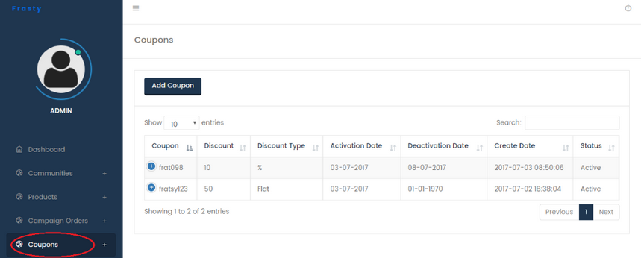

Manish20171201: OK, we will provide promo code management in admin panel but first we need to check why checkout page not working? To check this checkout functionality we need to setup on our local server. So please provide code files and database file.

* Stripe (there is code on the back end also) – each order needs to be documented here.

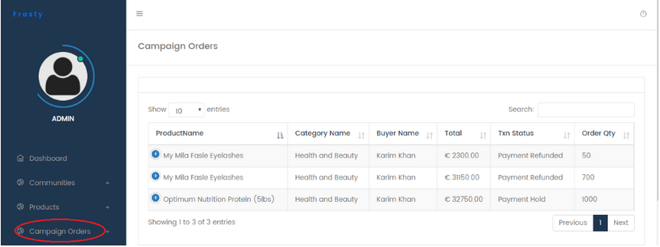

Manish20171201: What do you mean by each order documented here here? Also what type of code in backend?

Answer to question 4: every purchase needs to be listed on the back end under the campaign orders tab (as it currently does). The backend code is PHP  
**Scope(2017-12-06): OK, we will check payment issue in front and fix them and show all order listing under campaign tab. Also we will integrate promo code functionality on checkout page.**

* Popup checkout page

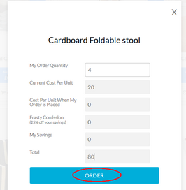

Manish20171201: OK, we will propvide checkout page in popup.

* shipping price

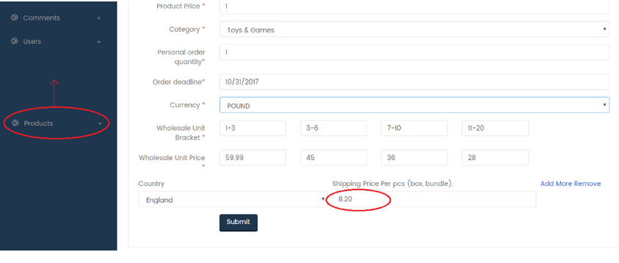

5.

The shipping price feature

* Another box needs to be added which states how many units can fit in a box. (if 10pcs can fit in a box and 9 units are ordered, the price will be the cost of 1 box)

Manish20171201: OK, we will add new field where admin can define how many units fit in a box. Please explain price(8.20) added in above screen shot is per box? Right.

Answer to question 5: correct the example of £8.20 is the price per box

**Scope(2017-12-06): we will add new field where admin can define how many units fit in a box.**

* The country will need to be selected at the checkout, calculating the shipping charge correctly. (There will need to be a ‘global shipping’ option added to the country selection on the back end).

Manish20171201: OK, we will provide option in checkout page to select country and calculate price according to the selected country. Also we will provide option to add in country section so that if user select different from added countries on checkout page, we will calculate shipping charges according to the global shipping price. Right?

**Scope(2017-12-06): Under this point we will provide option to select country on checkout page and calculate shipping price accordingly.**