**Live Server Report of Additional Features**

**Frontend URL:** [**https://gigminute.com/**](https://gigminute.com/)

**Admin URL:** [**https://gigminute.com/admin**](https://gigminute.com/admin)

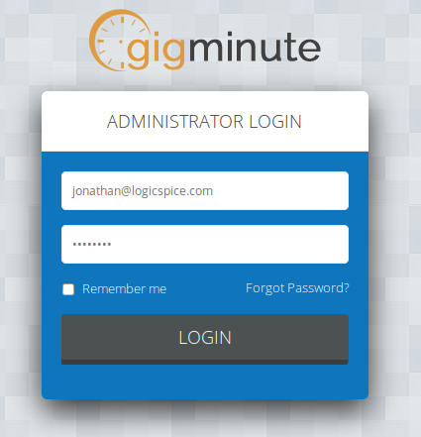

**Username: Thewinners**

**Password:**

**Date: 26 December 2018**

**We have uploaded CR20 additional features on live server please check it.**

**Mangopay is still in sandbox mode. We don't have admin access so we are unable to check CR20 points in admin area.**

# **Deposit and cancellation policy**

## **Artist area – Policy configuration (NEW view)**

**Comments**

1. Deposit

**Done (20181226):- See attached below screen-shot:-**

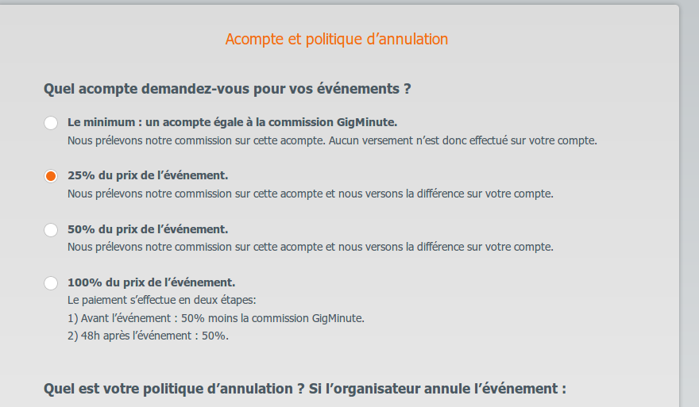

1. Cancellation policy

**Done (20181226):- See attached below screen-shot:-**

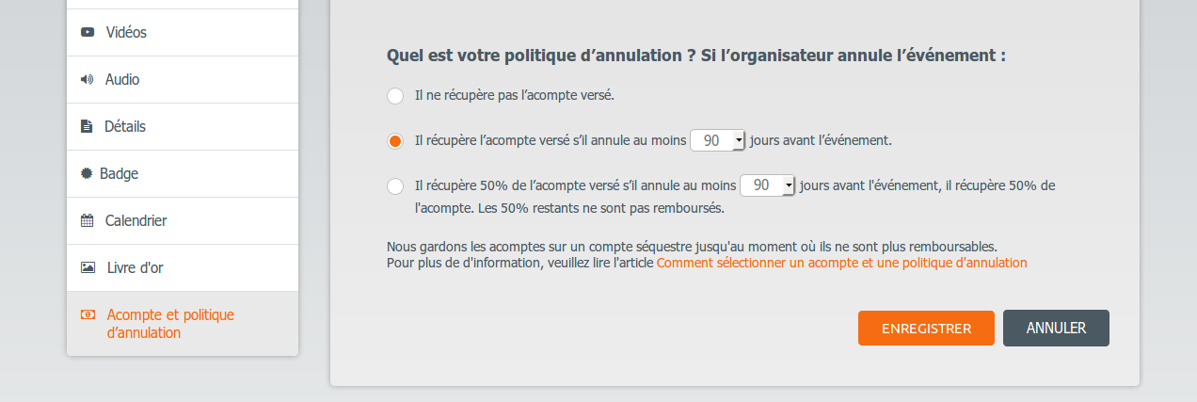

## B. **Artist Area – “Send a quote” option (“gig” view to be updated)**

## **Done (20181226):- See attached below screen-shot:-**

**Pop-up “Cancellation policy”:**

**Done (20181226):- See attached below screen-shot:-**

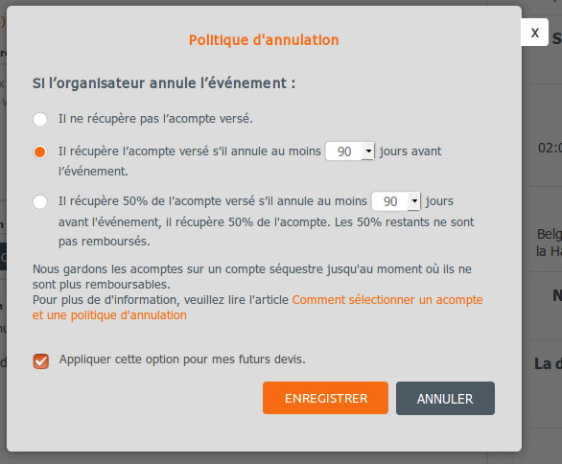

**Pop-up “Deposit”:**

**Done (20181226):- See attached below screen-shot:-**

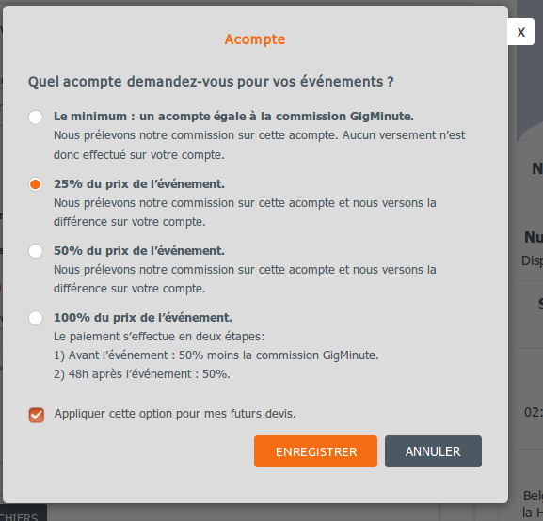

## C. **Event Planner area AND Artist area – Quote Sent (“gig” view to be updated)**

**Done (20181226):- See attached below screen-shot:-**

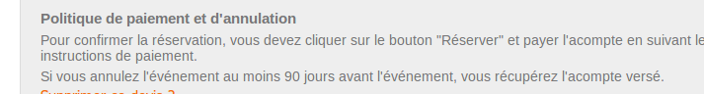

## D. **Artist area – Quote template (“edit quote” view to be updated)**

**Done (20181226):- See attached below screen-shot:-**

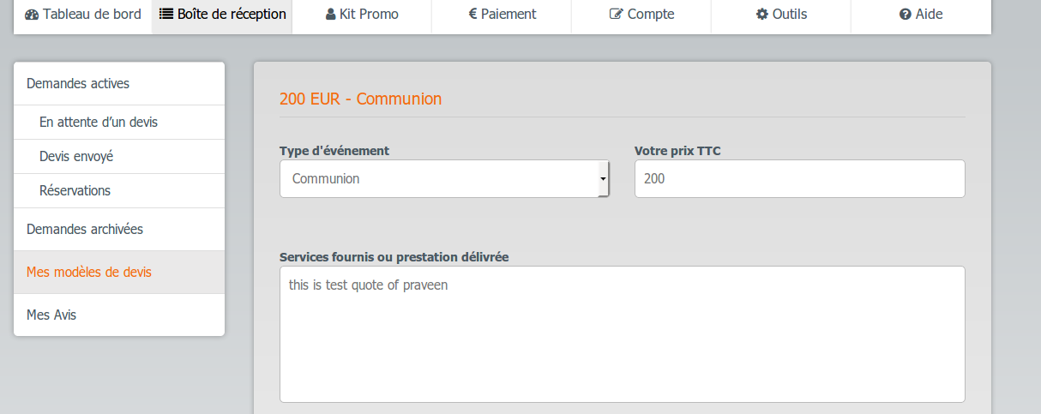

# **2. Mangopay Integration**

## **Event Planner Area – Booking process**

**STEP1 - Collect Natural user data**

**Done (20181102):- See attached below screen-shot:-**

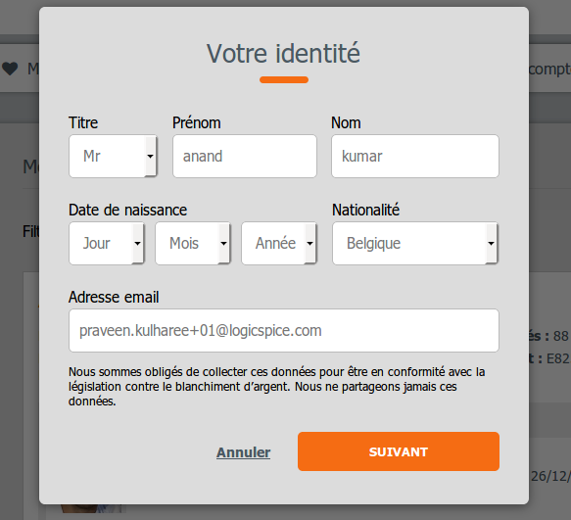

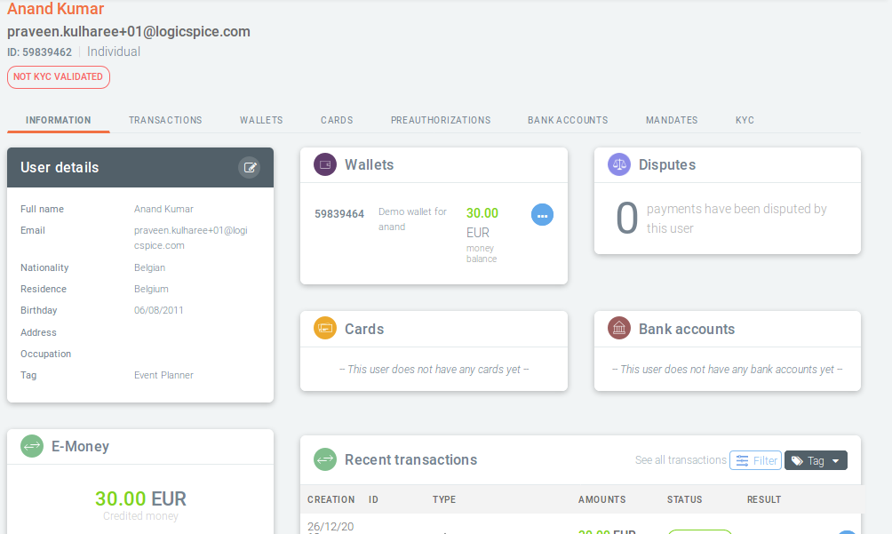

**Step 2: Payment method selection**

**Done (20181226):- See attached below screen-shot:-**

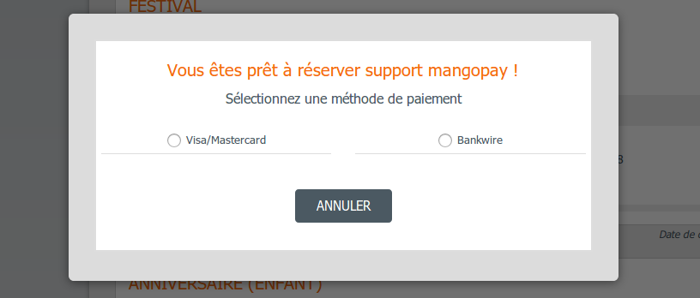

## **Artist area – Create/update user in Mangopay**

## **Done (20181226):- We are creating and update user in mangopay before transfer amount.**

## **Admin area – Mangopay API** Authentication **fields**

**Done (20181226):**

# **3. Payments Management**

## **Admin area – New “Payments” view**

**Done (20181226):**

## **Artist area – New “Payments” view**

**Done (20181226):- See attached below screen-shot:-**

