|  |  |
| --- | --- |
| Staffinghat  Date: 29th July, 2020 | |
| Front End URL | <https://demo73.logicspice.com/staffinghat/> |
| Back End URL | <https://demo73.logicspice.com/staffinghat/admin> |
|  | **Username**: staffinghat  **Password**: staffinghat_admin |
|  | |
| **Testing Status (Developer)** | |
| Browser | Firefox,Chrome |
| Simulator (for mobile testing) | Yes(Firefox,Chrome) |
| Testing in Mobile Device | NO |
|  | |
| **Testing Status (QA)** | |
| Browser | Firefox,Chrome |
| Simulator (for mobile testing) | No |
| Testing in Mobile Device | Yes |
|  |  |

**1. Home page Design and HTML Slicing**

**Done(2020-07-29): Please refer to the below screenshot. Currently we have added only the login sign up link for the CCBO. We will add other links in further milestones.**

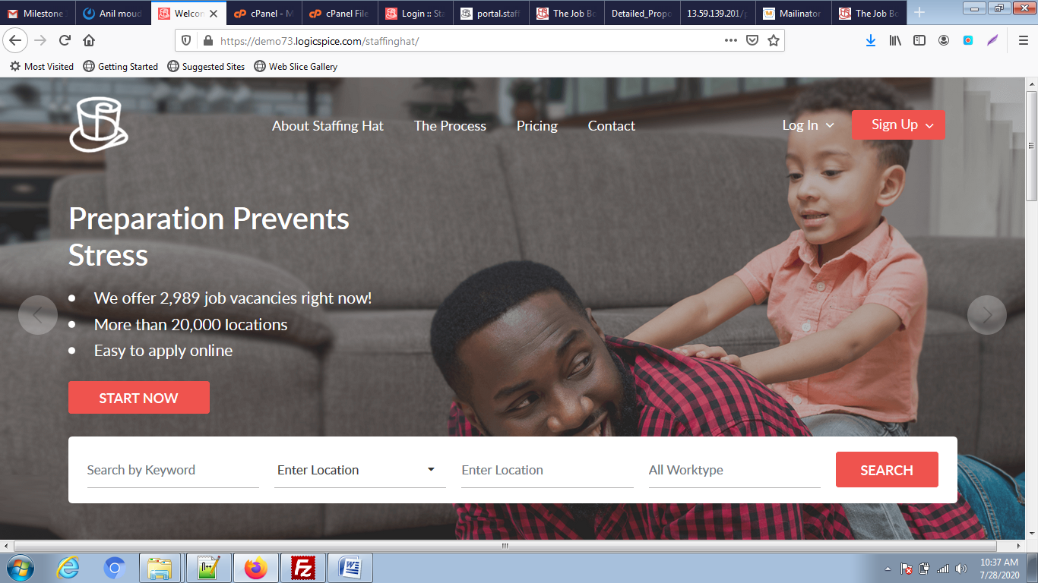

**CCBO**

**2. User Registration**

**Done(2020-07-29): Please check and refer to the below screenshot:**

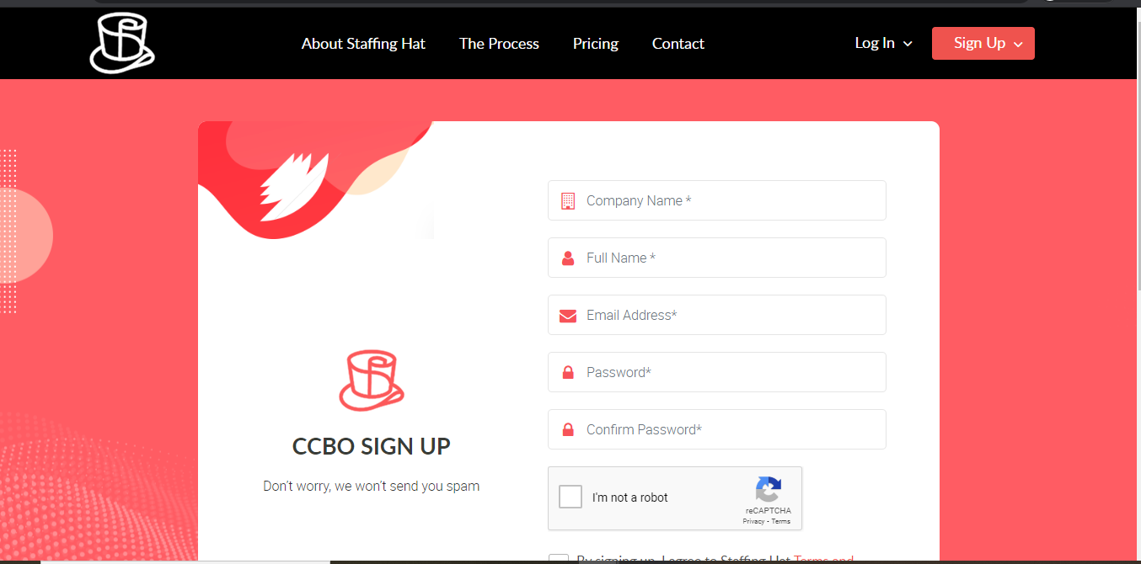

**3. User Login**

**Done(2020-07-29): Please check and refer to the below screenshot:**

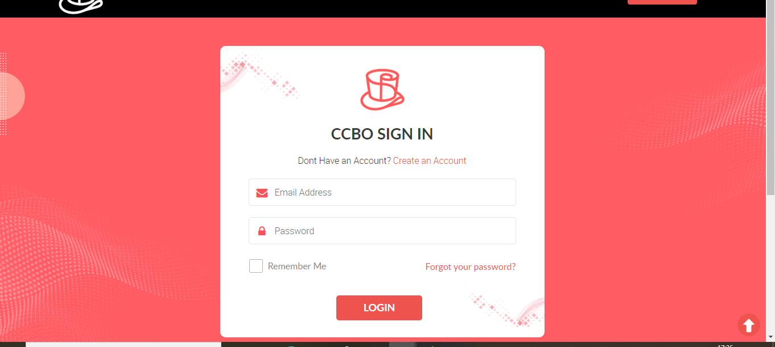

**4. User Forgot Password**

**Done(2020-07-29): Please check and refer to the below screenshot:**

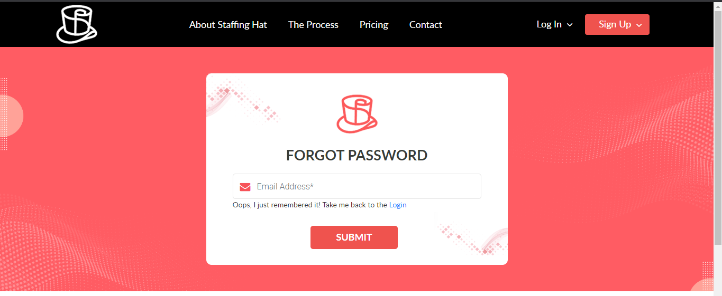

**5. CCBO Profile**

**Done(2020-07-29): Please check and refer to the below screenshot:**

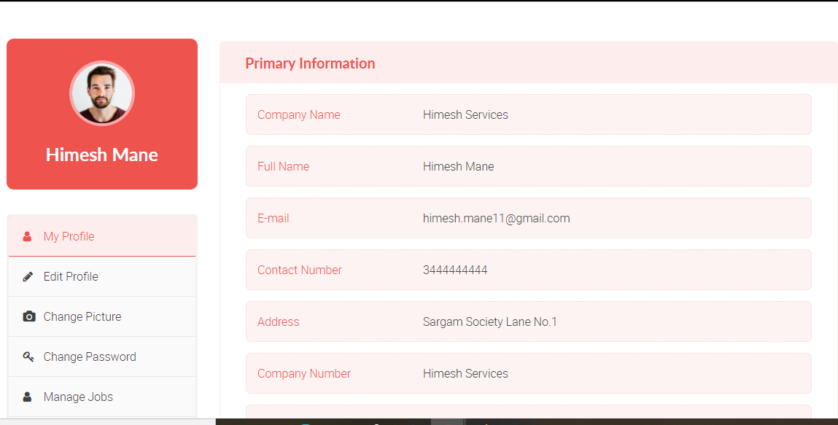

**Edit Profile:**

**Done(2020-07-29): Please check and refer to the below screenshot:**

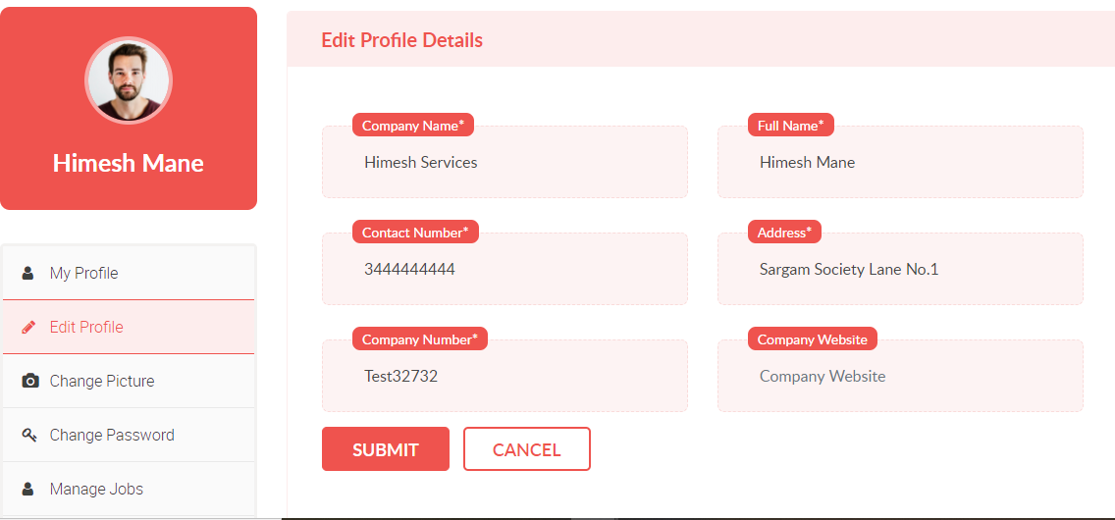

**Change Picture:**

**Done(2020-07-29): Please check and refer to the below screenshot:**

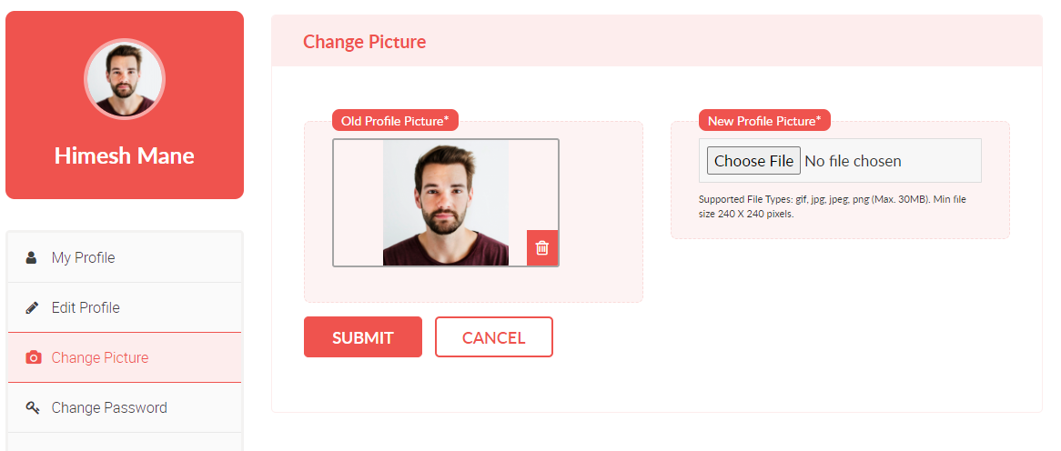

**Admin**

**6. Admin Login**

**Done(2020-07-29): Please check and refer to the below screenshot:**

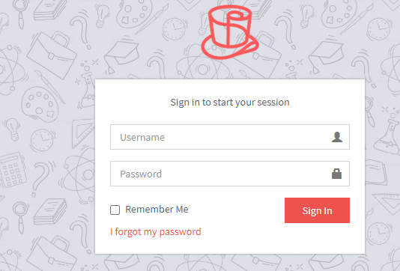

**7. Admin Dashboard**

**Done(2020-07-29): Please check and refer to the below screenshot:**

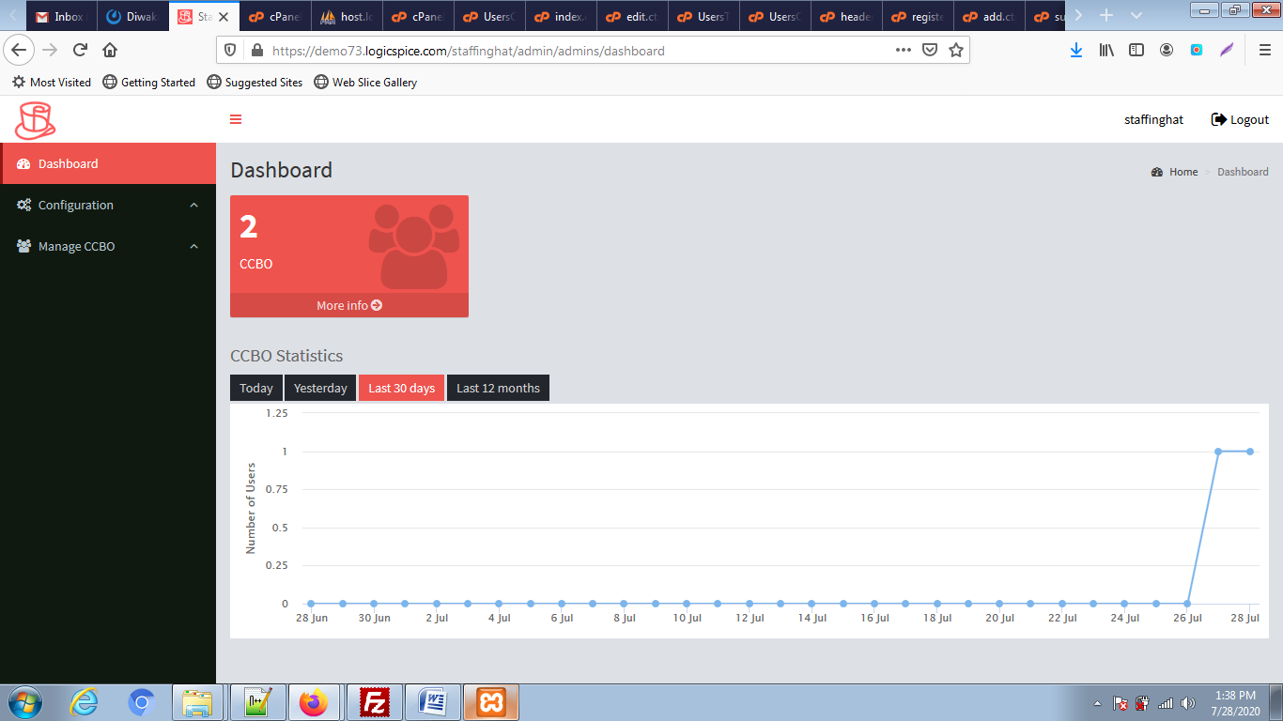

**8. Admin Configuration**

**Done(2020-07-29): Please check and refer to the below screenshot:**

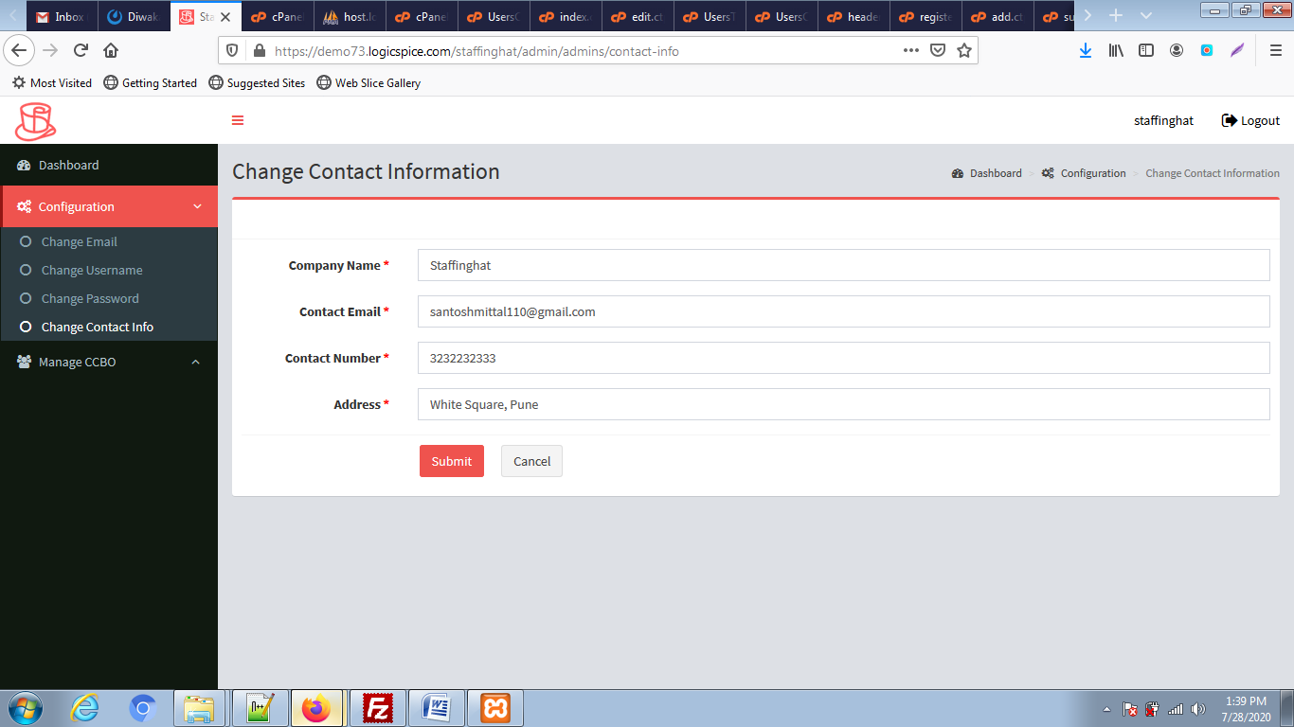

**9. CCBO Management**

**Done(2020-07-29): Please check and refer to the below screenshot:**

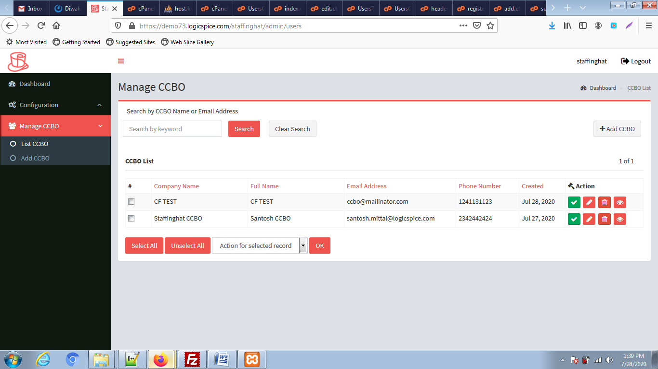

**Add CCBO:**

**Done(2020-07-29): Please check and refer to the below screenshot:**

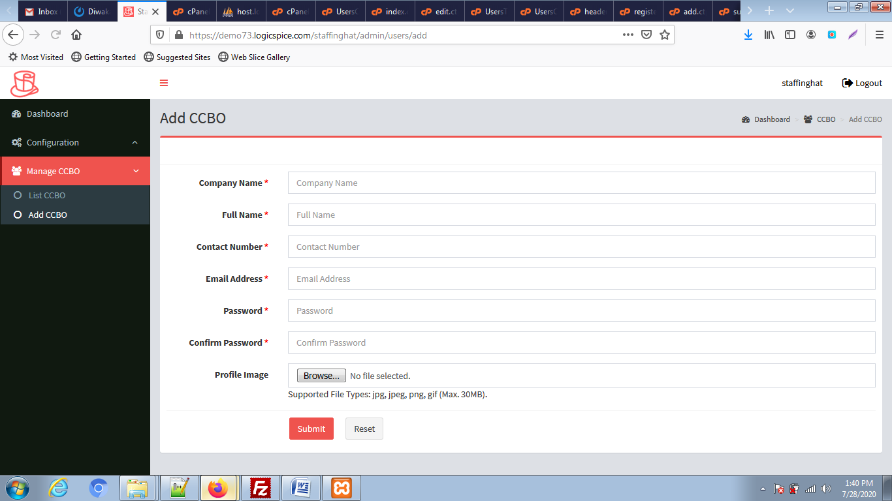

**Add Banner:**

**Done(2020-07-29): Please check and refer to the below screenshot:**

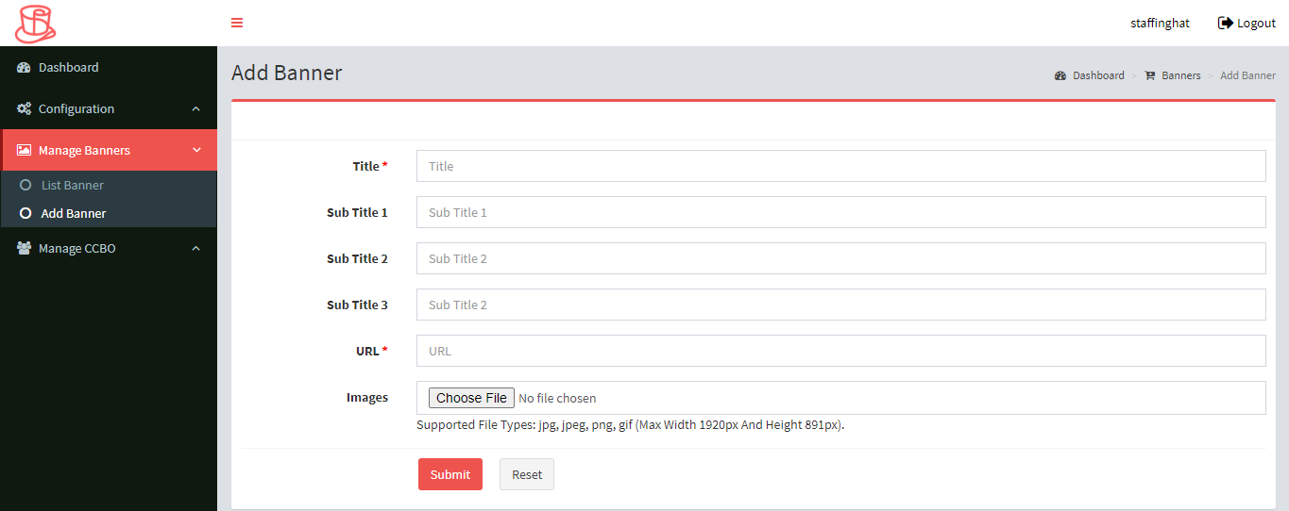

**Banner List:**

**Done(2020-07-29): Please check and refer to the below screenshot:**

