**Localgenii Android Milestone 2 Issues (b)**

1. Cannot maximise profile picture by clicking on profile image thumbnail at Profile menu
2. Is it possible to add feature to ‘Go Back’ by using gesture ‘Slide Left’ from left of screen to right as in iOS?
3. The cropping on uploaded images is incorrect. I asked for the *thumbnails* of the images to be cropped to the aspect ratio of the thumbnail, not for the images themselves to be cropped. Only the thumbnail preview should be cropped so that the image thumbnail does not display completely squashed, as it was in previous version. When user clicks on the thumbnail, the image should load to its full resolution. See screenshot of cropped image preview:

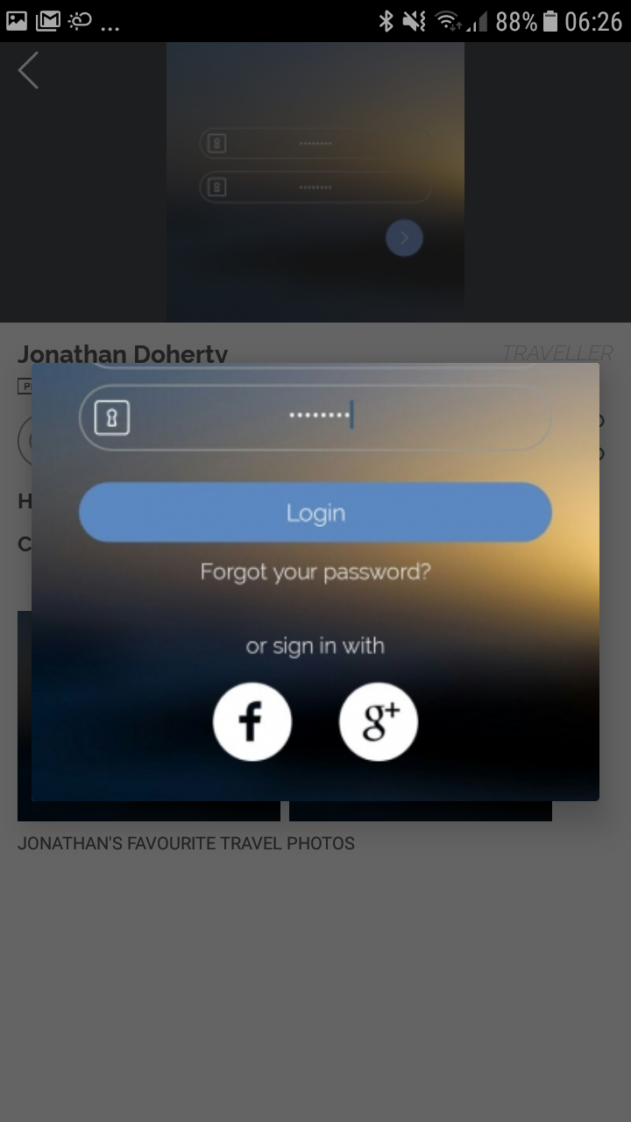

1. When you set Current Place under Profile Menu to e.g. Paris, France, the application thinks that the user has created a local profile in Paris, and the user’s traveller profile appears on Localboard when searching under city name Paris. This is a bug because only local profiles should appear under Localboard.
2. The Services section of local profile should match design of iOS version. Please ensure the Android app features the same basic size ratios as iOS version of texts and icon in Services section.

**IOS VERSION SCREENSHOT**

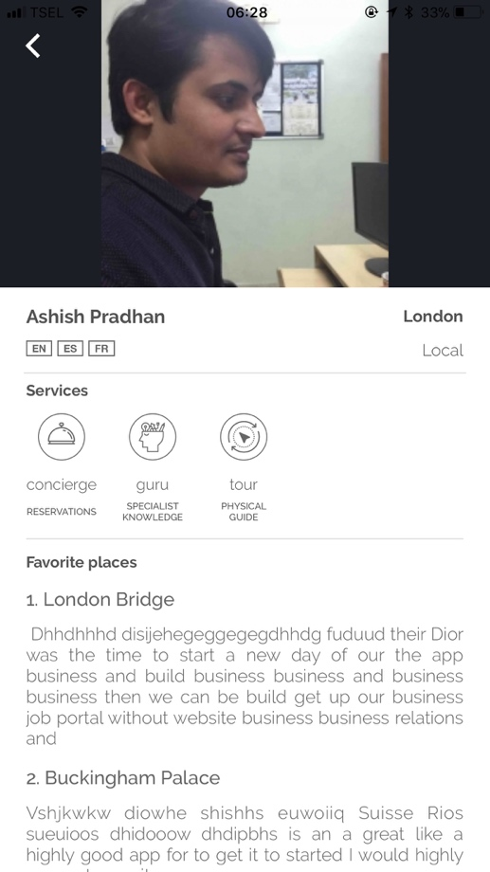

1. When View Profile from Profile Menu, the profile picture becomes stretched and covers the back arrow. Have to quit program and restart to return to main menu of app.

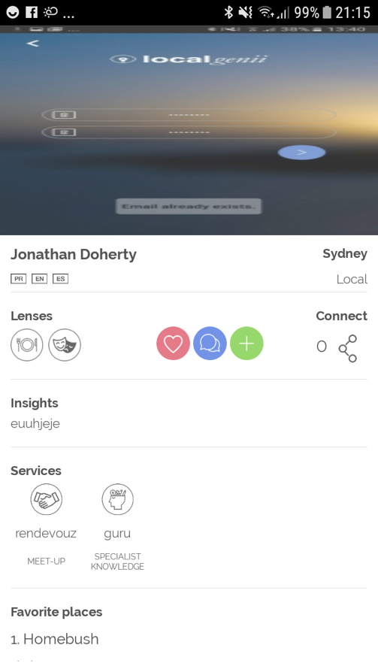

1. Google Places Suggestions still slightly crops the suggestion text box. See Screenshot below:

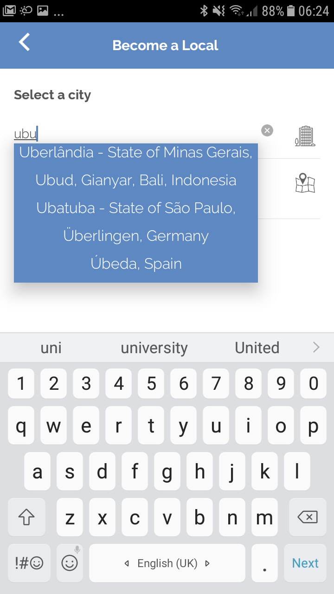

In my last comments I suggested that you match the style of Google Place Suggestions from when the user enters a city under Hometown or Current Place of Profile menu. Please check for yourself how the app shows the city names when entering a city under Hometown or Current Place. It is a lot clearer than the way it is set up now for Localboard and when choosing a city under Become a Local creation process. See screenshot below of the way Google Places Suggestions appear under Hometown/Current Place:

