Scope and Clarification Report of Traders Connect

**Frond End URL:** <http://demo.imagetowebpage.com/traders_connect/>

**Admin URL:** [http://demo.imagetowebpage.com/](http://demo.imagetowebpage.com/magazina_phase2/)traders_connect/admin/

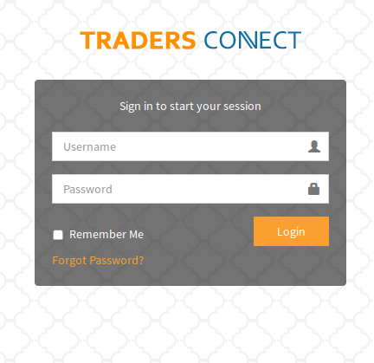

**Username :** logicspice

**Password :** traders_admin

**Date :** 24 June, 2018

|  |  |  |  |  |
| --- | --- | --- | --- | --- |
| **Sr. No.** | **Particular** | **iPhone** | **Android** | **Website** |
| 1. | RFQ, quotation & Advertise approval | - | - | Yes |
| 2. | Deactivate the payment process | - | - | Yes |
| 3. | Add slide banner | Yes | Yes | Yes |
| 4. | Mobile number verification | Yes | Yes | Yes |
| 5. | Views count on the advertises | Yes | Yes | Yes |
| 6. | NEXT Page designing | - | - | - |
|  | | | | |

1. We need to add slide banner in the home page in the apps to put some premium ads , same as in <https://www.jssor.com/demos/banner-slider.slider>

**Scope (20180419):-** We will provide a slider management in admin area where admin can upload slider Images and uploaded slider images will be shown in app homepage for both iPhone and Android.

Fine, kindly add a URL that will be open when tab/click the specific image

**Scope (20180419):- Ok, We will provide URL with image upload in admin panel.**

**Done (20180724)**

1. Adding mobile number verification when user signup and when updating his account details, OTP to be send to his mobile number.

**Clarification (20180419):-** We would like to inform you that please purchase valid SMS API first after that we will implement this API in our website. Without API we can't send OTP on mobile number.

Which SMS API you preferred?

**Scope (20180419):- We preferred following SMS API:-**

**I).****Twilio**

**II).Clickatell**

**Please check it these API should be working in your locality.**

**Done (20180724)**

1. We need to add the views count on the advertises ,

**Query (20180419):-** What type of view count on advertises you want?. Count on slide advertisement or some other places advertisement needs to show?

In the product details page, add a column for how many times this product viewed by users

**Scope (20180419):- Ok, We will provide view count on product details page.**

**Done (20180724)**

1. In the below page in the app ,

We need to increase the page height to show the NEXT button, because its not appearing unless user scroll down.

**Clarification (20180419):-** Please provide us direction of page so we can increase the page height. It would be great if you provide us screen-shot of the page.

**Page already attached below in the next page**

**Scope (20180419):- Ok, We will increase the page height.**

b-Change the button label to be DEAL COMPLETED WITH THIS TRADER,

Because NEXT is meaningless here.

**Clarification (20180419):-** Please provide us that current label text and new replace label text with page direction. It would be great if you provide us screen-shot of the page.

The current label is ‘NEXT’ and the Arabic currently is ‘التالي’’

**Scope (20180419):- Ok, We will change the label.**

**Clarification (20180724): Please provide the flow of this page, how we will reach over the page.**

**Clarification (26-07-2018):- 1- Quotations list -> select one of the open quotations received from traders-> in the details page there is a button/link in the bottom of the page labeled (NEXT) , this label we need to change it to be“Deal Completed with this trader”, that’s it .**

1. The Arabic translation will be ‘تم اكمال الشراء مع هذا المورد’

**Clarification (20180419):-** Please provide us which text you want to replace with this text on which page. It would be great if you provide us screen-shot of that particular on that page as we are not aware about Arabic language.

this is replacing the lable on the button ‘التالي’ in this page only.

**Clarification (20180724): Please provide the flow of this page, how we will reach over the page.**

**Clarification (26-07-2018):-same page mentioned above**