Job At Home

Front-End Side URL: - https://jobathome.fr
Back-End Side URL: - https://jobathome.fr/admin?secureKey=JobAtHome

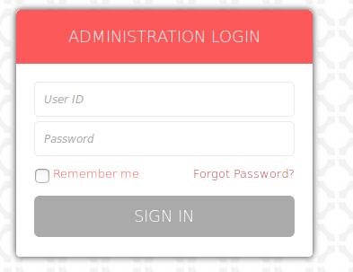

Username: - logicspice
Password: - jobsite_admin
Date: - 13th September, 2018

- Add possibility to add a file or several files in mail sent to a candidate as shown below
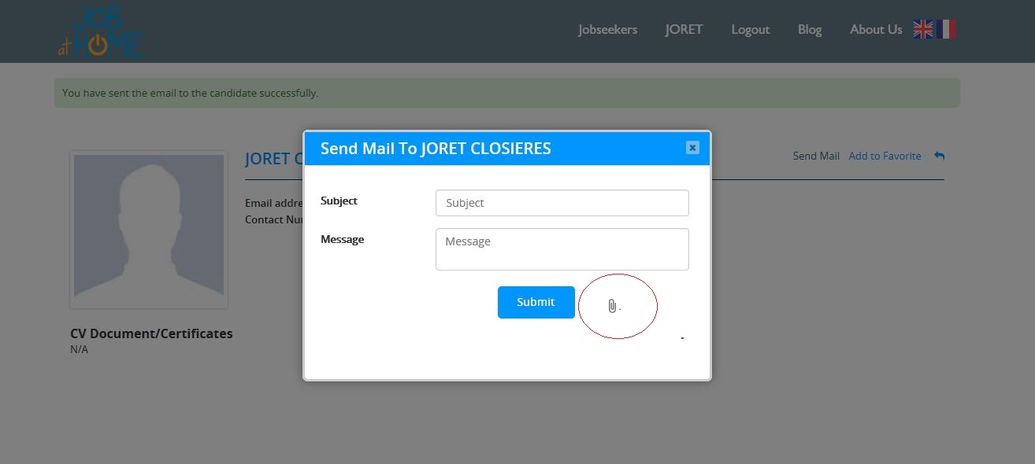

- Add possibility to a candidat add the possibility for a candidate to reply to the email that was sent to him and to add a file or several files in his mail.

