Live Server Report of Gigminute Additional Features CR18

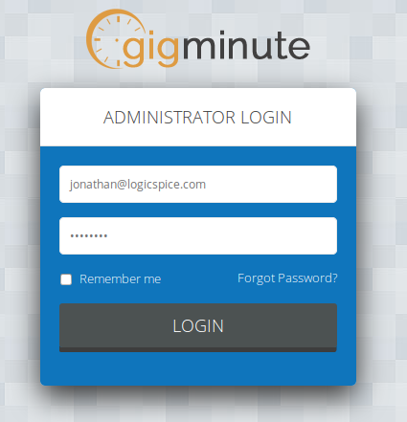

Front-End URL: - https://gigminute.com
Back-End Side URL: - https://gigminute.com/admin

Username: Thewinners
Password:
Date: 04 June 2018

Artist account – Menu missing on mobile version:
As you explained in the below picture, the left menu is not displayed on the mobile version. Could you please add it asap ? It is really important that the Artist can click on the submenu item “Réservations” on a mobile. Most of them use a mobile to find back the information the day of Event. Many thanks.

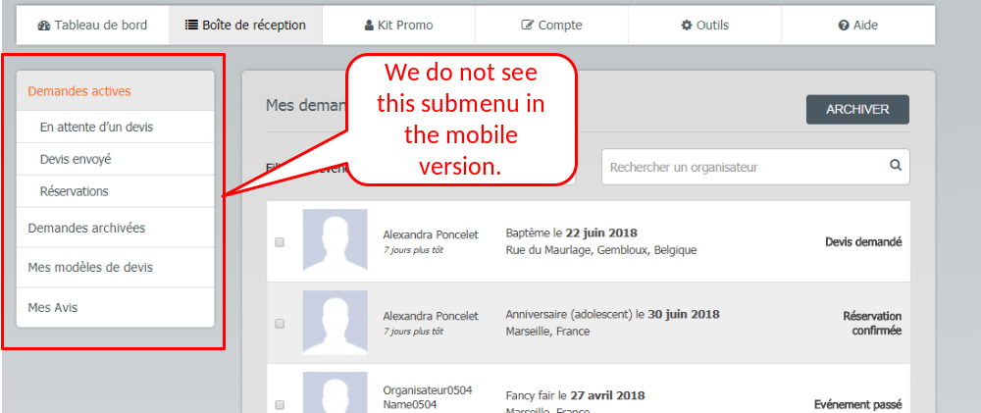

Done (20180604):- See attached below screen-shot:-
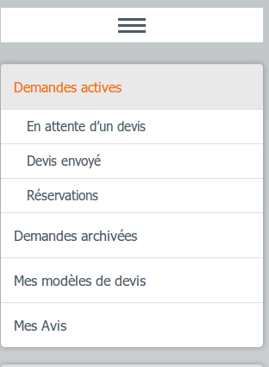

Olivier (20180604): I do not see this change on iphone (and I have empty the cache). On the mobile version, we should display this menu with a second menu icon like we do in the other tabs (see an example below).

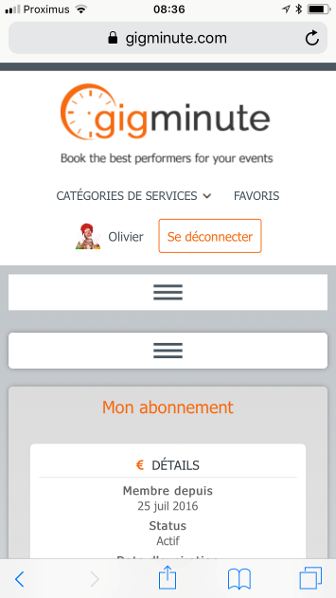.
Done (20180604):- You can see below attached screen-shot of iPhone.

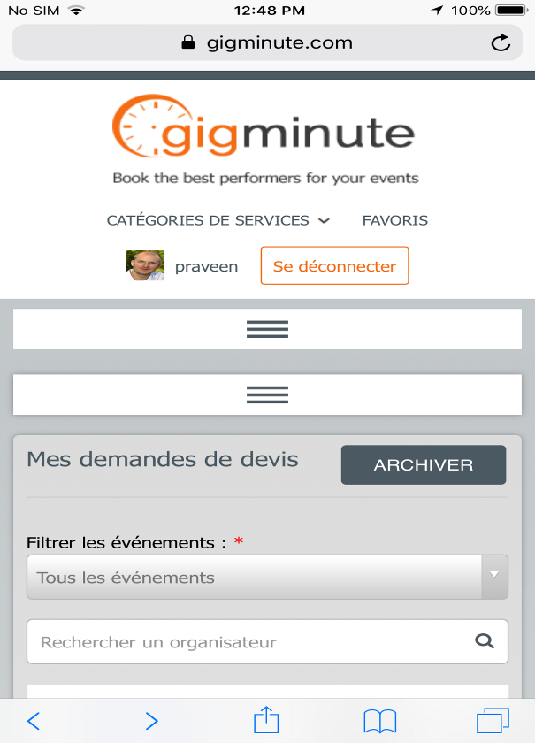

Olivier (20180604) : new button does not work. Nothing happens when I click on it.
Done(20180604):- Please check it now. See attached below screen-shot:-
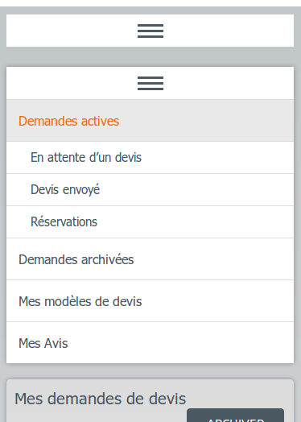

Artist and Event Planner Account, Gig details on Mobile version

Could you please improve the usability on the mobile version (do not change the desktop version) of the Gig detail view. As you can see below, it is really difficult to write a message or read a message as the picture column takes too much place. The best solution would be to strongly reduce left and right margins + space between the picture and the box. Many Thanks

Done (20180604):- See attached below screen-shot:-

Olivier (20180604): I do not see this change on iphone (and I have empty the cache). Thanks.
Done (20180604):- You can see below attached screen-shot of iPhone.

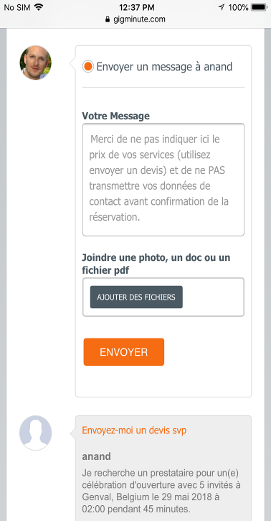

Olivier (20180604) : You can still reduce left and right margin (only a few pixels are necessary, you should apply the same margin than in the gigs list) + reduce space between the picture and the text box.
Done(20180604):- Please check it now. We have apply the same margin than in the gig list page.

