Job At Home

Front-End Side URL: - https://jobathome.fr
Back-End Side URL: - https://jobathome.fr/admin?secureKey=JobAtHome

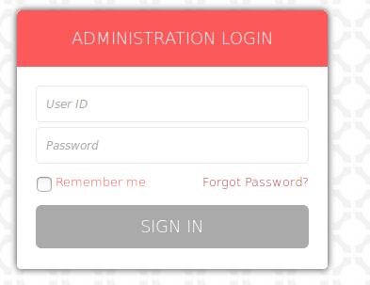

Username: - logicspice
Password: - jobsite_admin
Date: - 14th September, 2018

- Can you please add possibility to add a file or several files in mail sent to a candidate as shown below
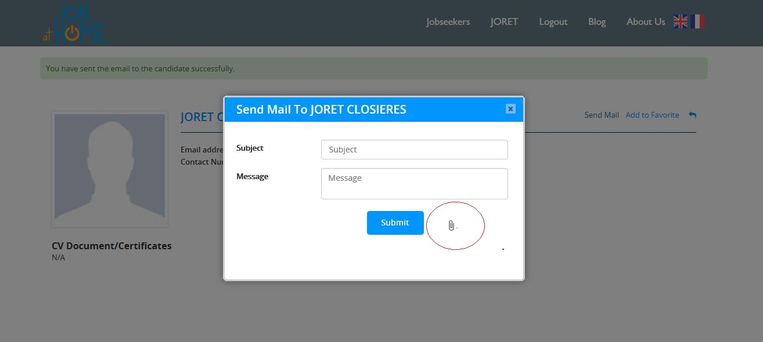
Done (20180914):- See attached below screen-shot:-

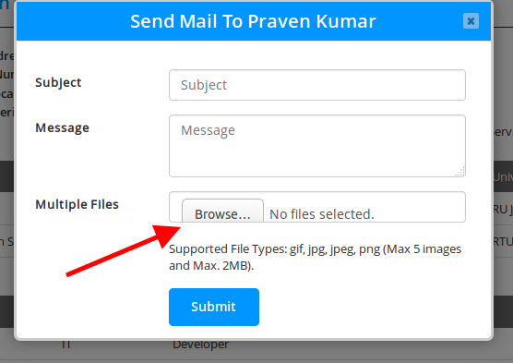

- Is it please possible to add possibility to upload a .PDF or *.docx files ? I think the candidate and recruiter most will want to send documents like CV or employment contract.
- I can send a file but it is not possible to add and send multiple files. Would it be possible to allow a user to add and send multiple files ? I think some users(Recruiter/Candidate) will sometimes want to send multiple files with an email.

- Download File sending

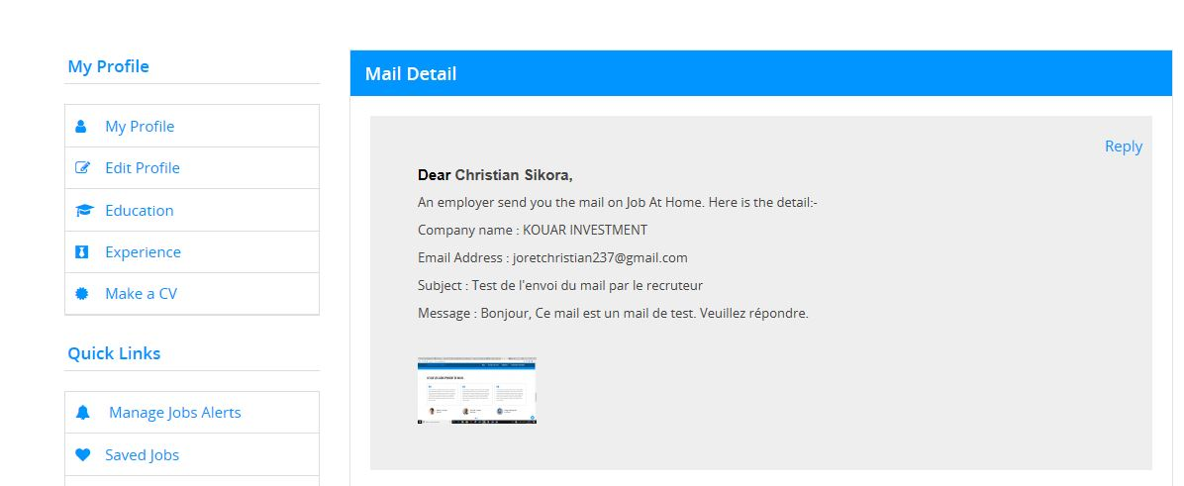

As shown above, the file sent is received but i don’t see where i can download it.

- Email address

Can you please tell me where i can change this email address ? I would like to use another email address.

