ASSIGNMENT 7.4

ADAM DONNER

WEB 425

October 23, 2019

TWIN LAB WORKS

Bob’s Computer Repair Shop Plan

TECHNICAL DESIGN DOCUMENT

TWIN LAB WORKS

|  |  |
| --- | --- |
| **Author** | Adam Donner |
| **Last Updated** | 10/23/19 |
| **Version Number** | 1.0 |

**Version History**

|  |  |  |  |
| --- | --- | --- | --- |
| **Name** | **Date** | **Reason for Change** | **Version** |
| Donner, Adam | 10/23/19 | Initial Release | 1.0 |
|  |  |  |  |
|  |  |  |  |
|  |  |  |  |
|  |  |  |  |
|  |  |  |  |
|  |  |  |  |
|  |  |  |  |
|  |  |  |  |
|  |  |  |  |

**Table of Contents**

SECTION 1: INTRODUCTION 4

Purpose 4

Terminology 5

Related Documents 5

Reviewers 7

Required Skills 7

SECTION 2: Architecture 8

Physical Architecture 8

tWIN LAB WORKS

Logical Architecture 9

SECTION 3: PROCESS DESIGN 11

Object Relational Diagram(s) 11

NoSQL Data Structure 12

Wireframes 13

SECTION 4: REFERENCES 18

# **SECTION 1: INTRODUCTION**

## Purpose

Bob’s Computer Repair Shop is an online retailer for computer repair parts and services. Bob’s Computer Repair Shop has the need for a new online booking system for their clients. Their clients will have the ability to book services such as keyboard cleaning, etc and a date in which they will bring in their computer for service. Additionally their clients want the ability to view previous invoices and the ability to print those invoices.

TWIN LAB WORKS

TWIN LAB WORKS

tWIN LAB WORKS

Employees need the ability to add the parts cost and the hourly rate of $50.00 per hour to the invoice as it moves through the service process. Due to the need to add additional services, there will need to be an employee facing login to the website as well.

Twin Lab Works is excited to work with you on this project, this document will assist us in the creation of your platform from conception through deployment.

## Terminology

## 

|  |  |
| --- | --- |
| **Name** | **Comments** |
| MEAN Stack | MongoDB, Express, Angular, and Node.js |
| Visual Studio Code | Development IDE |
| SoapUI | API testing tool |
| MongoDB | https://www.mongodb.com |
| Angular Material | https://material.angular.io/ |
| Flex-layout | https://github.com/angular/flex-layout |
| *Node.JS* |  |
| *Express* | https://expressjs.com/ |

## Related Documents

Image 1.1 is the logo which will be used for your website. The colors will be knocked out, in other words the black will be changed to white so that it will show up properly with the color scheme chosen for your website.

tWIN LAB WORKS

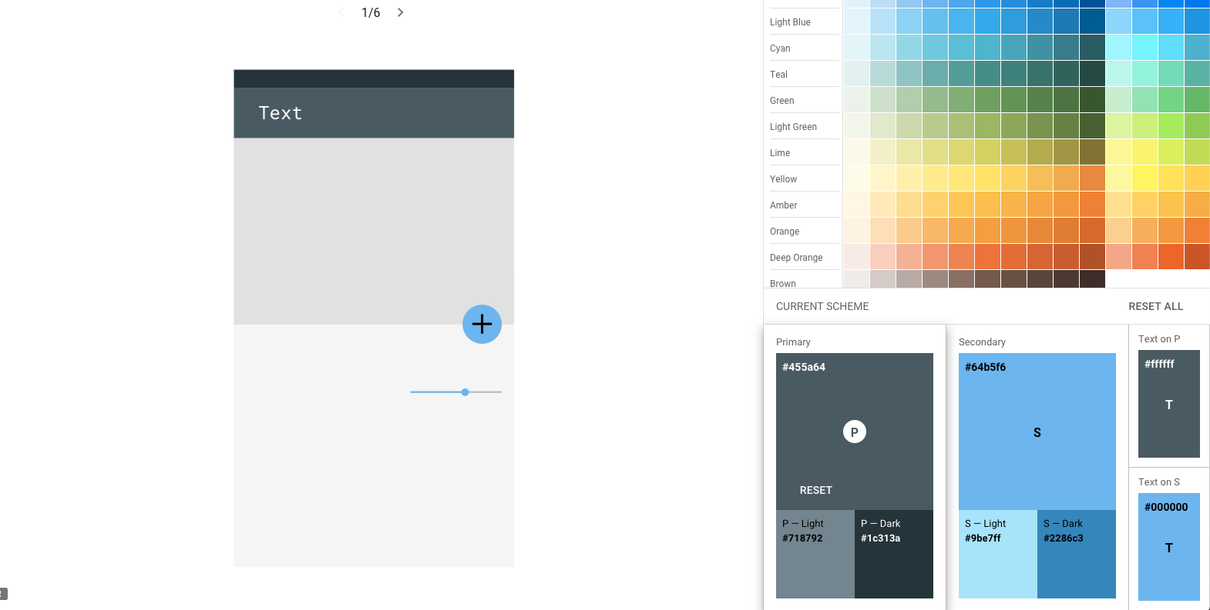

Image 1.2 is the color scheme that we have developed for your project. This mimics your current branding and uses Material Design color schemes so that your colors are modern and represent your brand.

## Reviewers

|  |  |  |
| --- | --- | --- |
| **Approvers** | **Name** | **Date** |
| **Approved By (**Client Acceptors, can be more than one) | Bob Jones, Bob’s Computer Repair | 10/23/2019 |
| **Approved By** (Solution Architect) | Adam Donner, Twin Lab Works | 10/23/2019 |
| **Approved By (**Development Team) | Alan Wegner, Twin Lab Works | 10/23/2019 |

## Required Skills

All of this will be built using an framework called Angular. Angular allows us the flexibility of creating exciting and dynamic customer facing websites with powerful functionality that will work across all platforms. Your customers will have all of the functionality you have requested and Angular will give us the ability to add functionality as required. Everything will be stored using MongoDB so that you can updated customer tickets and move them through the work process. This will also allow the customer to have access to previous tickets for invoicing purposes. MongoDB is a powerful NoSQL database which is a perfect fit for your application requirements. MongoDB is a general purpose, document-based, distributed database built for modern application developers and for the cloud era. Express will be the web framework for Node.js. Express is a minimal and flexible Node.js web application framework that provides a robust set of features for web and mobile applications. Node.js is an asynchronous event-driven JavaScript runtime that is designed to build scalable network applications.This all makes up the MEAN stack, MongoDB, Express, Angular, and Node.js.

The development team will develop your application using Visual Studio Code. Part of Angular is Angular Material. Angular Material will allow us the ability to construct attractive, consistent, and functional webpages while adhering to modern web design principals. Angular Material allows us the flexibility to create beautiful web applications that will be usable via any device whether a computer or mobile device.

Layout for your website will be done using a Flex-Layout. Flex-Layout will give us the ability to move portions of your website in rows and columns and is designed to mimic a printer layout as much as possible.

There will be a team of three programers that will be assigned to your project. The team will consist of myself, Alan Wegner, and Larry Dent. All of the developers on the team are well versed in the MEAN stack. The development team assigned to your project has a combined tenure of 20 years of experience working with the MEAN stack and developing applications just like yours.

# **SECTION 2: Architecture**

## Physical Architecture

The diagram below is a representation of the physical architecture of your application.

INTERNET

USER

BOB’S COMPUTER REPAIR SHOP

WEBSITE

DATABASE

EMPLOYEES

## Logical Architecture

The diagram depicts the logical architecture of the flow of usage of your application

Architecture from a customer perspective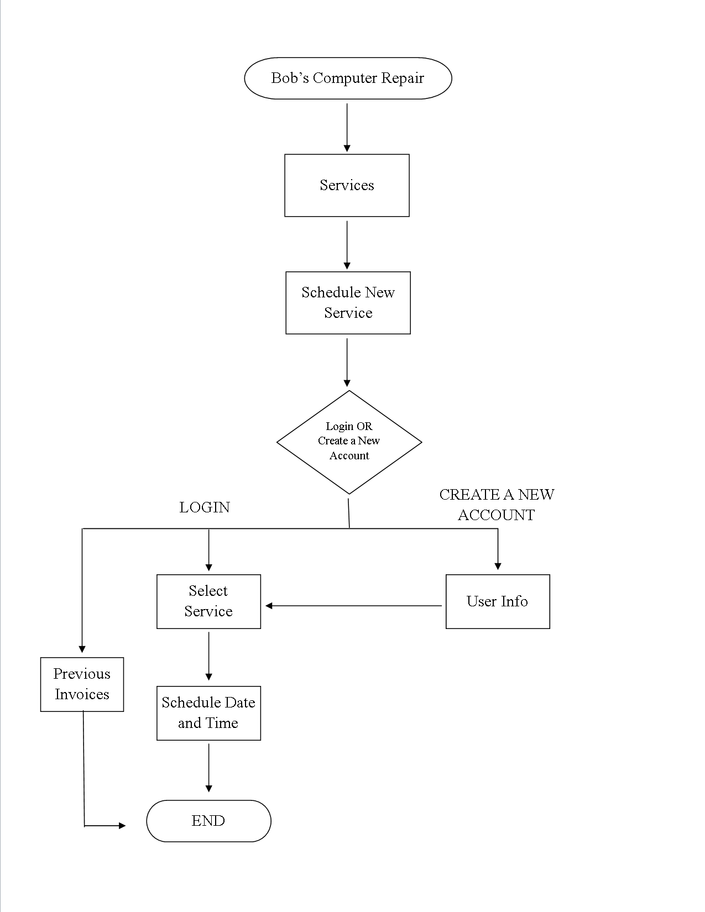

Architecture from a employee perspective

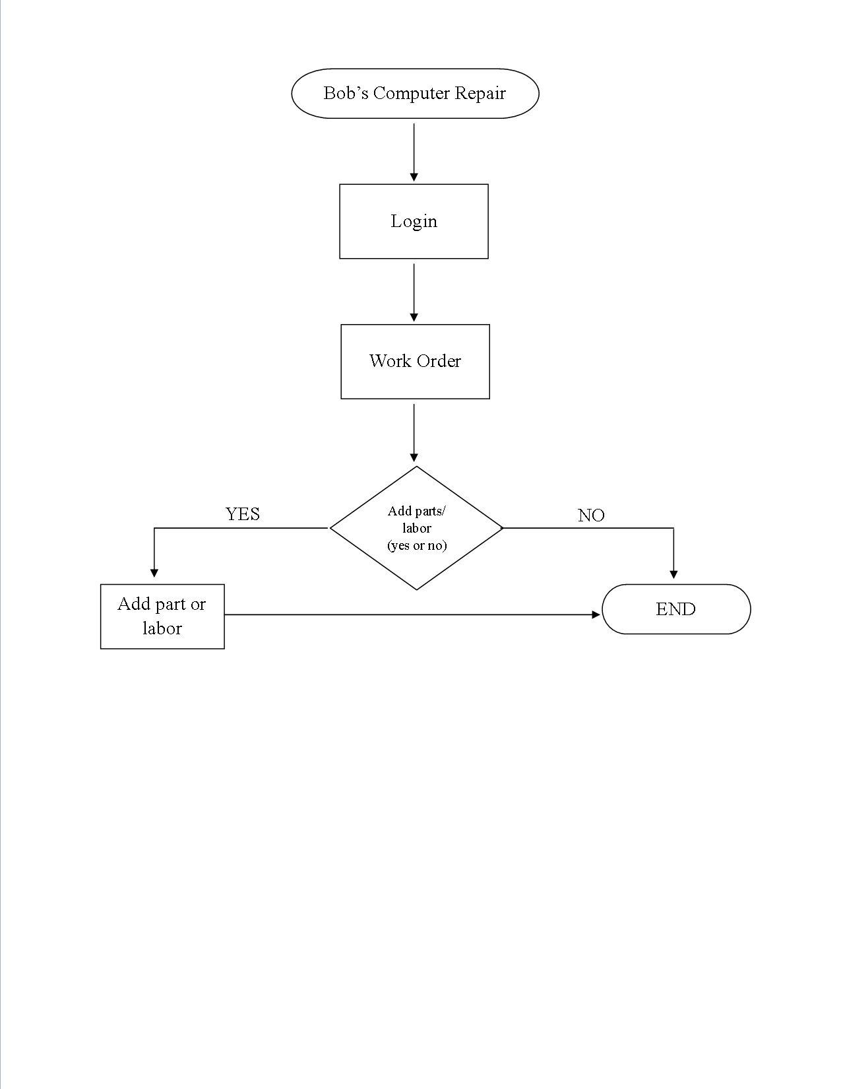

# **SECTION 3: PROCESS DESIGN**

## Object Relational Diagram(s)

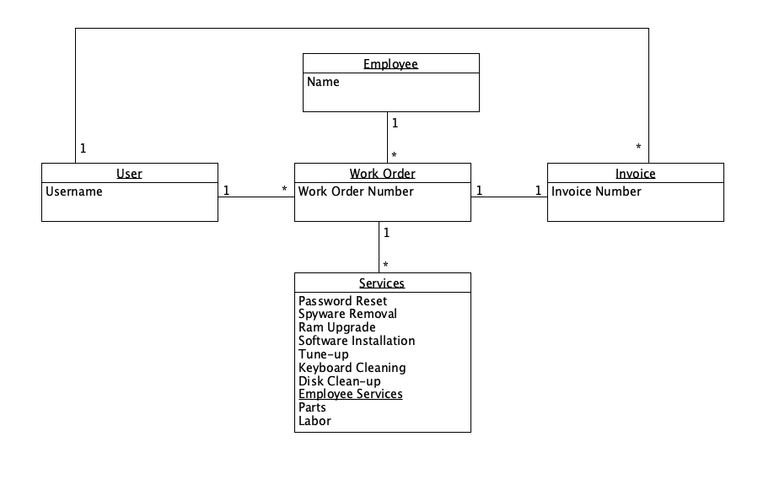This is a diagram depicting how your objects are related inside of your MongoDB.

## NoSQL Data Structure

This is the JSON structure depicting the layout of your MongoDB.

{

"user_name": "Steve Jobs",

"work_order":[{

"number": "1234",

// customer selectable services binary selected, yes or no

"services":[{

"passwordReset": 1,

"spywareRemoval": 0,

"ramUpgrade": 1,

"softwareInstall": 0,

"tuneUp": 0,

"keyboardCleaning": 0,

"diskCleanup": 0,

// services added via employee

"empParts": 80.00,

"empLabor": 2,

// employee information

"employee": {

// employee assigned to the account

"name": "Adam",

}

}],

"invoice": "1234"

}

## Wireframes

Below are prototype wireframes for your website.

**Landing page*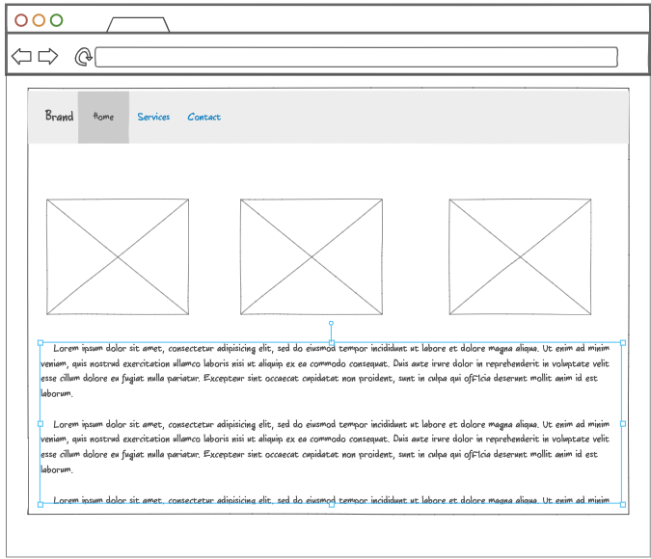***

**Services page, this details the services available and allows customers to login or create a new account to schedule a new service*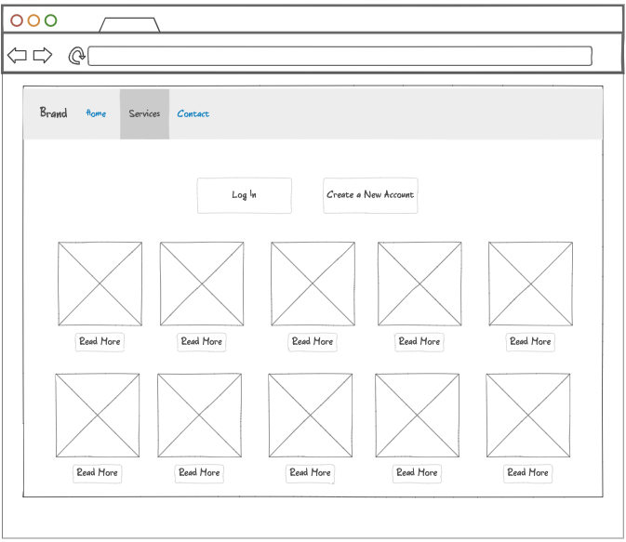***

**Customer logged in and schedule a new service or view previous invoices**

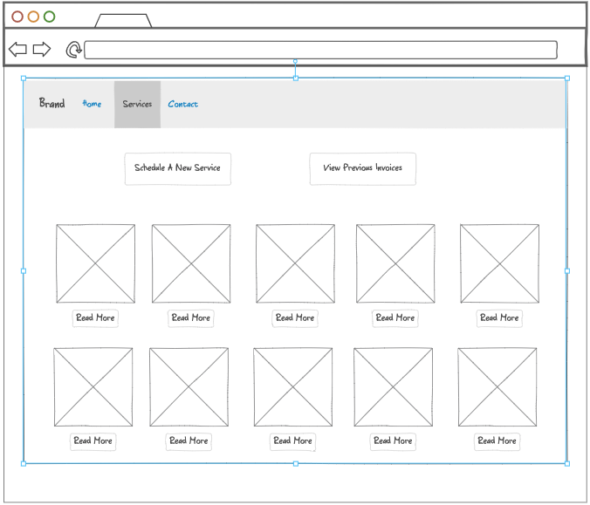

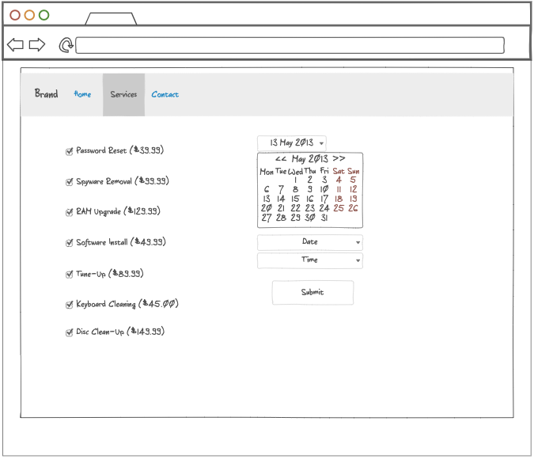**Customer schedule new service with date and time for drop off**

**Employee facing site for work o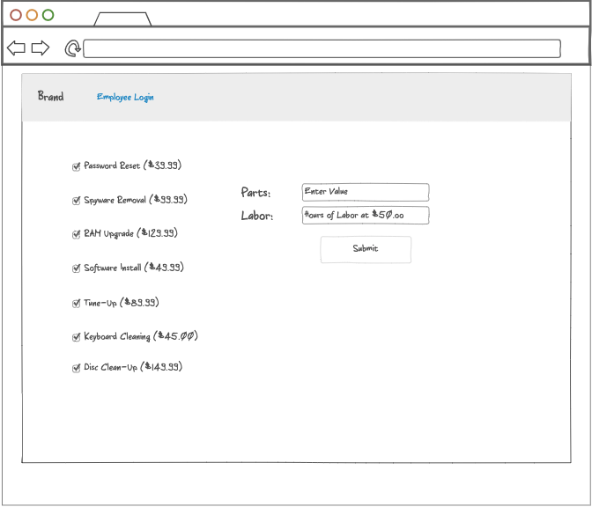rders to enter parts and labor**

# **SECTION 4: REFERENCES**

Angular. (n.d.). Retrieved October 22, 2019, from <https://angular.io/>.

Express. (n.d.). Retrieved October 22, 2019, from <https://expressjs.com/>

MongoDB. (n.d.). Retrieved October 22, 2019, from <https://www.mongodb.com/>

Node.js. (n.d.). Retrieved October 22, 2019, from <https://nodejs.org/en/about/>