MIROFISH SWARM AUDIT V2 · FULL-STACK BUG & UX GAP DOSSIER
Audit v2: Broken Use Cases, Security Defects & UX Gaps
(Customer POV & Merchant/Cashier User POV)
This comprehensive Audit v2 report consolidates two complementary verification tracks executed against the Saber F&B Direct Commerce Staging deployment (staging-fnbsupport.31.97.66.234.sslip.io, branch staging, commit f7ecd81) following the Bahasa Indonesia landing refresh, authentication rollout, and setup-toko protections. Track 1 ran the standard MiroFish OASIS happy-path API swarm against demo tenant warungmakan, whereas Track 2 unleashed an adversarial multi-tenant Playwright browser (Desktop 1280x850 and Mobile 390x844) and God's-Eye chaos swarm across newly onboarded restaurant accounts (kedai-mf-088490 and chaos-mf-359657-v2) to uncover functional bugs, security exploits, state-machine bypasses, and end-user friction points.
STAGING TARGET & BUILD  staging-fnbsupport.31.97.66.234.sslip.io  Branch: staging @ f7ecd81 | AUDIT METHODOLOGY  API Swarm (45 calls) +  Browser & Chaos Swarm v2 | FINDINGS SCORECARD  10 Confirmed Bugs (7 Cust / 3 Merch)  10 UX Gaps (5 Cust / 5 Merch) | AUDIT DATE & AUTHOR  Nov 12, 2026  Saber QA Engineering

SECTION 01 // EXECUTIVE VERDICT
Why Happy-Path Green Checks Missed 20 Real-World Failures
Running the baseline automated runner (mirofish_swarm_test.py: 6 personas across 2 rounds) returned 45/45 HTTP successes (100.0% pass rate, p50 latency 296.88 ms, p95 713.32 ms in 5.17 seconds). However, inspecting Staging as real diners on 390px smartphones and newly registered merchants revealed a critical blind spot: demo API smoke checks exercise clean happy paths against warungmakan, leaving negative security boundaries, disabled-feature enforcement, cancelled order transitions, bilingual modal leakage, and mobile Kanban ergonomics untested.
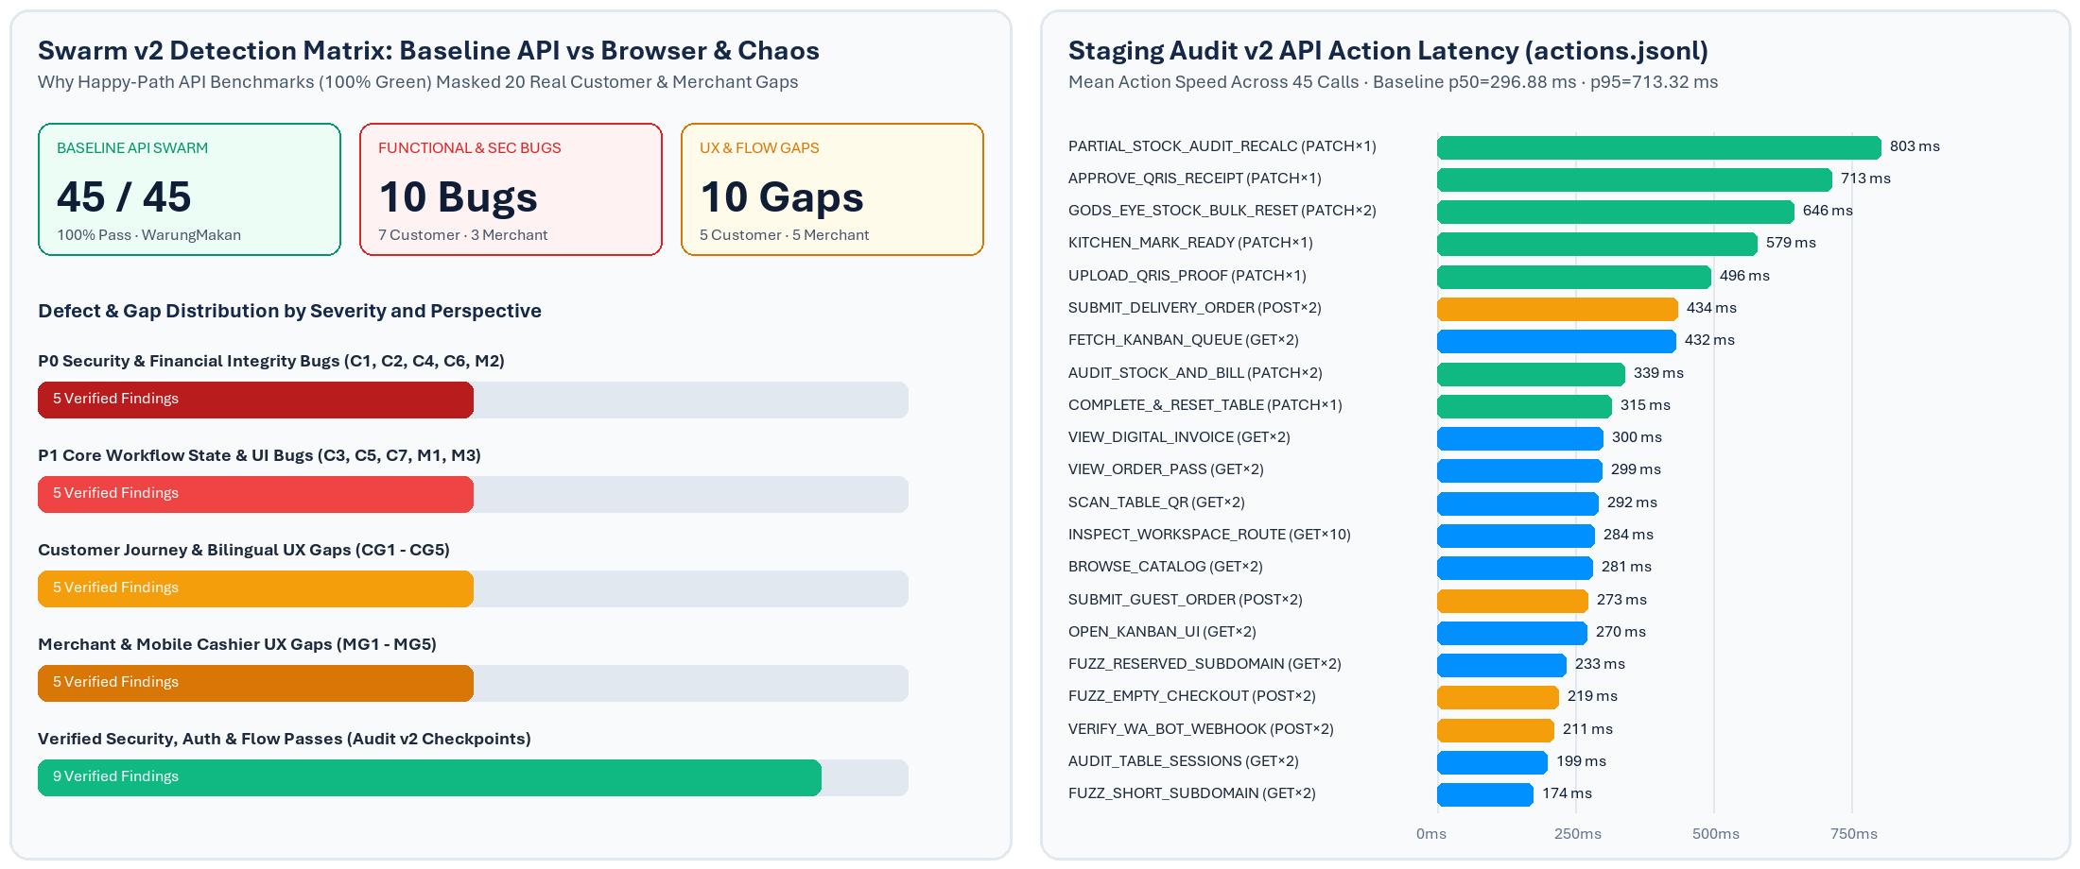
Audit Track | Execution Scope & Personas | Observed Latency | Outcome & Defect Yield
Track 1: Baseline API Swarm  (mirofish_swarm_test.py) | 6 OASIS personas x 2 rounds on Demo storefront 'warungmakan' via HTTP REST calls | p50: 296.88 ms  p95: 713.32 ms  Elapsed: 5.17 s | 45 / 45 PASS (0 bugs detected because single-tenant happy-path payloads omitted chaos edge cases)
Track 2A: Playwright Multi-Tenant Flow  (mirofish_full_ux_audit.mjs) | New merchant kedai-mf-088490 (Self-Delivery disabled); desktop 1280x850 & mobile 390x844 diner + cashier | Interactive page loads verified across 6 routes | Identified C3, C5, C7, M1, CG1, CG3, CG4, MG1, MG2, MG3, MG5 + verified Batal modal & magic-link auth
Track 2B: Chaos & Security Swarm  (mirofish_ux_audit_part2.mjs) | Tenant chaos-mf-359657-v2: invalid UUID checkout, sold-out race, receipt resurrection, negative price, slug edit sync | Guest Checkout: 282 ms  Invalid Item API: 41 ms | Proved C1 (IDR 0 free order), C2, C4, C6, M2 (-Rp 5.000), CG2, CG5, plus Auth Guards & Slug Sync PASS

Release Gate Advisory: HOLD Production Promotion Pending P0/P1 Remediation
While baseline authentication isolation (403/404 blocks on unauthenticated mutations), Bahasa Indonesia portal copy, and post-slug-edit session synchronization passed Staging checks, Staging MUST NOT be promoted to main until the P0 order/price integrity holes (C1 IDR 0 Menu Spesial exploit, C2 sold-out race condition, C4 receipt resurrection of CANCELLED orders, M2 negative menu price) and broken Customer/Cashier cancelled-state UIs (C3, M1, MG1) are resolved.

FIGURE 01 // BASELINE CONTEXT: BAHASA INDONESIA PORTAL LANDING (staging-fnbsupport.31.97.66.234.sslip.io)
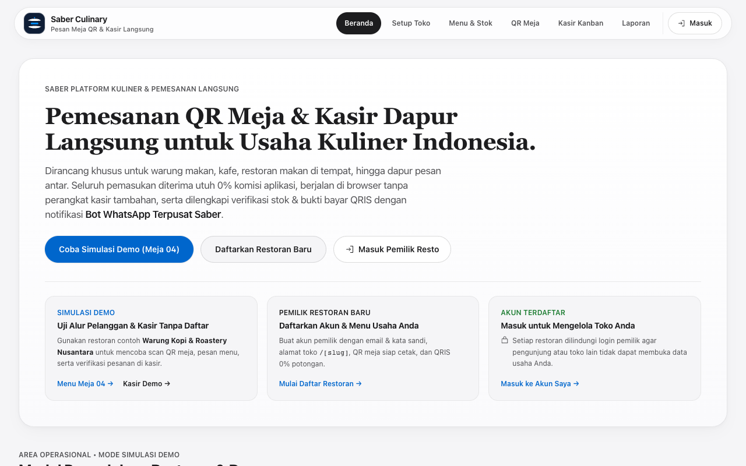
Verified Passing Baseline: Unauthenticated visitors arriving at the Staging root URL see clean Bahasa Indonesia copy, Saber Culinary branding without AI status pills or demo sandbox clutter, and isolated workspace CTAs before signing into a dedicated merchant tenant.

SECTION 02 // CUSTOMER POV AUDIT (DINER, PRE-ORDER & DELIVERY)
End-Customer Bugs (C1-C7) & Functional UX Gaps (CG1-CG5)
Customer testing covered every entry path across /[slug]?table=..., /[slug] without table parameter, Pre-Order Pick-Up, Self-Delivery, Checkout Modal confirmation, Live Order Tracking (/order/[orderId]), and Digital Web Receipt (/order/[orderId]/receipt). Seven concrete bugs and five high-friction UX gaps were reproduced directly on Staging:
2.1 Customer Functional & Security Bugs (C1 - C7)
ID | Defect & Technical Root Cause | Empirical Proof on Staging | Code Location
C1  [P0] | Non-existent or cross-tenant menuItemId creates IDR 0 'Menu Spesial' order. Lookup reads unfiltered global store.menuItems and falls back to unitPriceIdr = 0 if item is missing. | POST guest-checkout with menuItemId '00000000-...-999999999999' qty=5 returned HTTP 200 (order 634cba5c-c53f-4f8d-b6d0-0ea637009b60, totalAmountIdr: 0). | guest-checkout/route.ts  #L75-L89
C2  [P0] | Sold-out item race condition succeeds on backend. Server omits item.isSoldOut validation during checkout submission when diner holds stale cart. | Marked dish isSoldOut=true, then submitted guest-checkout with item ID -> HTTP 200 created order #ORD-1052. | guest-checkout/route.ts  #L75-L89
C3  [P1] | Cancelled order falsely displays Step 1 'Order Received • ACTIVE'. getStepIndex() maps unfound CANCELLED status (-1) to index 0 instead of a terminated Cancelled UI. | Cancelled #ORD-1048 (b7aeb84d-c40f-4dfb-bb59-e3ccd1e66859) still showed blue ACTIVE card + stale rejection warning box. | order/[orderId]/page.tsx  #L58-L61
C4  [P0] | Unauthenticated upload_receipt resurrects CANCELLED / COMPLETED orders back into PAYMENT_PENDING_APPROVAL due to missing terminal state guard. | PATCH /api/v1/orders { action: 'upload_receipt' } against cancelled order returned HTTP 200 and reverted orderStatus to PAYMENT_PENDING_APPROVAL. | orders/route.ts  #L195-L225
C5  [P1] | Self-Delivery tab remains visible & clickable even when merchant disabled Self-Delivery during onboarding (isSelfDeliveryEnabled: false). | On kedai-mf-088490 (isSelfDeliveryEnabled=false), mobile tabs rendered all 3 tabs including 'Antar Kurir Toko'. | CustomerStorefrontClient.tsx  #L507-L558
C6  [P0] | Backend accepts SELF_DELIVERY orders with blank deliveryAddress even when store disabled Self-Delivery. | POST guest-checkout { orderType: 'SELF_DELIVERY' } without address to chaos-mf-359657 returned HTTP 200 (#ORD-1053). | guest-checkout/route.ts  #L53-L109
C7  [P1] | PRE_ORDER_PICKUP submits cleanly with empty pickup time. UI renders inline warning hint, but handlePlaceOrder() never blocks submission. | Selected 'Pre-Order Ambil' with empty #pickupTime on kedai-mf-088490 and clicked Submit -> created #ORD-1048. | CustomerStorefrontClient.tsx  #L236-L354

2.2 Customer UX & Use-Case Gaps (CG1 - CG5)
ID | Use-Case Gap Description | Customer Friction & Impact | Code Reference
CG1 | Onboarding operationalHours neither rendered on storefront nor checked at checkout. | Diners cannot verify opening/closing hours from the store header and can submit orders outside scheduled shift windows. | CustomerStorefrontClient.tsx  merchants/onboard/route.ts
CG2 | Paused/closed store (isStoreOpen = false) lets customers build an entire cart before hitting native window.alert(). | Dishes remain clickable ('+ Tambah') below the pause banner; rejection only occurs at final Checkout tap using an abrupt browser alert. | CustomerStorefrontClient.tsx  #L228-L234
CG3 | Stale localStorage cart drops sold-out items silently upon page reload. | When kitchen toggles an item Sold Out while diner pauses, reload removes items with zero toast or notice explaining why the basket shrank/vanished. | CustomerStorefrontClient.tsx  (cart hydration filter)
CG4 | Broken bilingual parity across Storefront EN mode and Live Order Pass. | EN checkout modal still mixes Indonesian copy ('Ringkasan Pesanan', 'Total Tagihan', 'Bayar di Kasir (Cash)') while /order/[orderId] locks headers to English ('Live Order Pass', 'Sync Pass', 'View Invoice'). | CustomerStorefrontClient.tsx  order/[orderId]/page.tsx
CG5 | Digital Receipt displays raw database enum identifiers and omits Cancelled badge. | /order/[orderId]/receipt prints internal enums ('PROOF_UPLOADED', 'BANK_TRANSFER_QRIS', 'PRE_ORDER_PICKUP') and displays full Rupiah total even on cancelled orders. | order/[orderId]/receipt/page.tsx  #L70-L87

2.3 Visual Evidence — Customer Storefront & Checkout Defects
FIGURE 02 // BUG C5 & GAP CG1 (Mobile 390px)  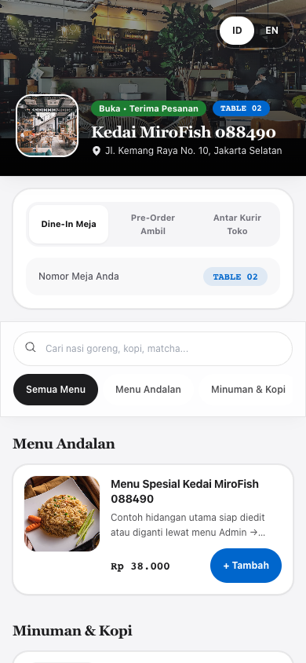  Kedai MiroFish 088490 was configured with Self-Delivery disabled (isSelfDeliveryEnabled: false), yet the channel switcher still renders and permits clicking 'Antar Kurir Toko'. Operational hours saved during merchant onboarding are also absent from the header. | FIGURE 03 // BUG C7 & GAP CG4 (Mobile 390px)  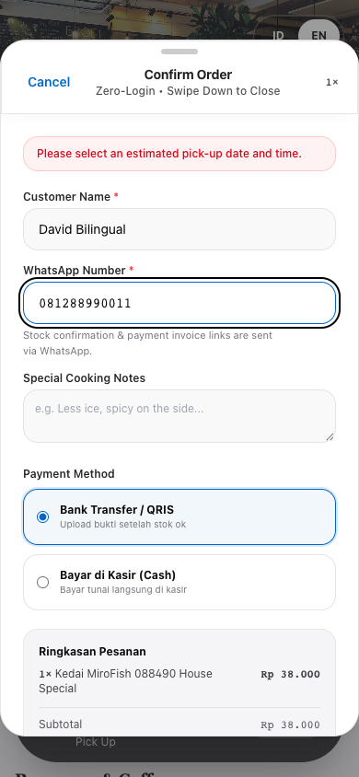  Storefront toggled to EN mode on Pre-Order Ambil: submit remains active despite empty pickup time (allowing C7 submission), while 'Ringkasan Pesanan', 'Total Tagihan', 'Bayar di Kasir (Cash)', and 'Upload bukti setelah stok ok' leak in Indonesian inside EN mode.

FIGURE 04 // GAP CG2 (Paused Store Cart Friction)  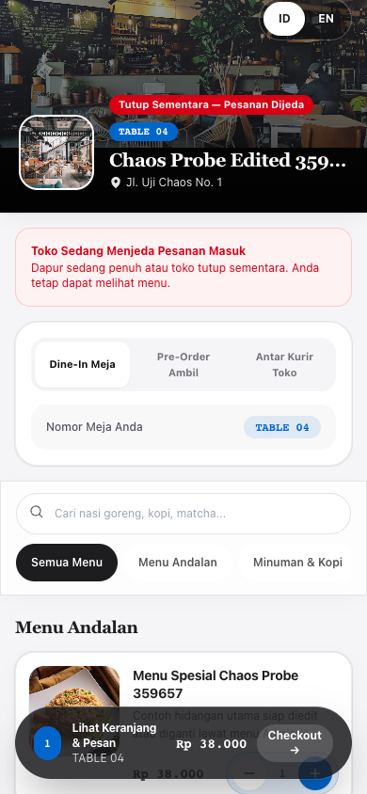  With isStoreOpen set to false on chaos-mf-359657-v2, the red banner 'Toko Sedang Menjeda Pesanan Masuk' renders at the top, yet every menu item's '+ Tambah' button stays active and allows assembling the floating 'Lihat Keranjang' basket before blocking via native window.alert(). | FIGURE 05 // BUG C3 (Cancelled Order False Active Pass)  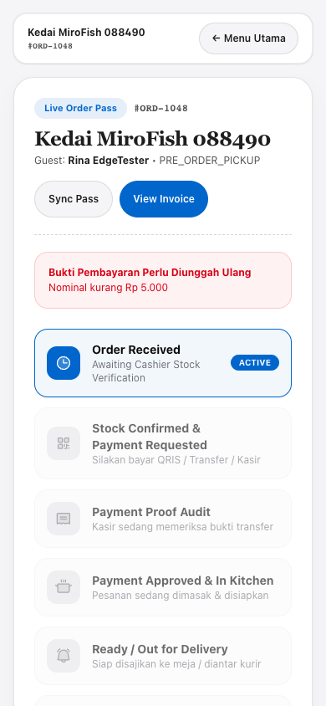  After cashier set #ORD-1048 to CANCELLED, the Live Order Pass mapped getStepIndex() to index 0, presenting Step 1 'Order Received • ACTIVE' in bright blue alongside a contradictory red 'Bukti Pembayaran Perlu Diunggah Ulang' card and untranslated English CTA buttons.

2.4 Visual Evidence — Digital Web Receipt Defect (Gap CG5)
FIGURE 06 // GAP CG5: DIGITAL RECEIPT EXPOSING RAW INTERNAL ENUMS & OMITTING CANCELLED BADGE (Mobile 390px)
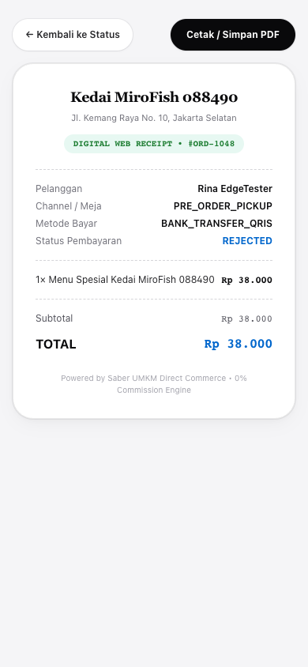
Rendered live on /order/b7aeb84d-c40f-4dfb-bb59-e3ccd1e66859/receipt: diners see raw code enums ('PRE_ORDER_PICKUP', 'BANK_TRANSFER_QRIS', 'REJECTED') instead of localized Indonesian/English labels, no 'Dibatalkan' stamp is rendered for cancelled tickets, and no 'Pesan Lagi' return-to-menu shortcut is provided.

SECTION 03 // MERCHANT OWNER & CASHIER POV AUDIT
Operator Bugs (M1-M3) & Operational UX Gaps (MG1-MG5)
Merchant and cashier simulations evaluated restaurant onboarding (/onboarding), email/password login & magic-link recovery (/login, /cashier/orders?magicToken=...), catalog curation (/admin/menu), QR standee printing (/admin/tables), shift revenue analytics (/admin/analytics), and peak-hour Kanban order execution.
3.1 Merchant & Cashier Functional Bugs (M1 - M3)
ID | Defect & Technical Root Cause | Empirical Proof on Staging | Code Location
M1  [P1] | Cashier Kanban displays green 'Bukti Transfer Diterima • Siap Diperiksa' badge even AFTER cashier rejects payment proof. hasProof checks order.receipts.length > 0 without verifying paymentStatus !== 'REJECTED'. | Rejected proof on both #ORD-1048 and #ORD-1054 (reason: 'Nominal kurang Rp 5.000'); Awaiting Payment column still highlighted green received badge. | cashier/orders/page.tsx  #L503-L593
M2  [P0] | Admin Menu API accepts negative item prices (priceIdr < 0), corrupting customer totals and shift financial telemetry. | POST /api/v1/menu-items with priceIdr: -5000 returned HTTP 200 and persisted 'Gratis Bug' at -Rp 5.000 in live catalog. | api/v1/menu-items/route.ts  #L121-L148
M3  [P1] | Cancelling a Walk-In dine-in order fails to release physical Table QR occupancy (isOccupied stays true). | Table release logic (tbl.isOccupied = false) only executes when nextStatus === COMPLETED; transitioning to CANCELLED leaves table locked. | api/v1/orders/route.ts  #L417-L427

3.2 Merchant & Cashier Operational UX Gaps (MG1 - MG5)
ID | Operational Gap | Impact on Store Staff & Owners | Affected Surfaces
MG1 | Missing 'Batalkan Pesanan' (Cancel Order) button across Cashier Kanban & Stock Audit modal. | When all items ordered are sold out (editableItems.length === 0) or walk-in guests leave before paying, cashiers are trapped with zero UI cancellation action. | cashier/orders/page.tsx  #L851-L858
MG2 | Mobile (390px) vertical Kanban column bloat & sub-44pt touch controls across operator tools. | Five min-h-[520px] Kanban columns force 2,000+ px scrolling over empty stages with no order search bar. Multiple controls fall below Apple HIG 44px minimum (28px, 22px, 17px). | cashier/orders, /onboarding,  /admin/menu, /admin/tables
MG3 | Missing category edit/delete on Menu Editor & silent Demo fallback on unauthenticated /admin/*. | DELETE /api/v1/menu-items deletes items only (categories cannot be edited or removed). Unauthenticated admins loading /admin/* see warungmakan demo with no explicit Demo Mode warning. | admin/menu/page.tsx  admin/tables, admin/analytics
MG4 | Renaming store slug in Edit Toko gives no warning about breaking already-printed Table QR standees. | Physical acrylic/paper QRs printed with old slug immediately 404 after slug update because zero confirmation warning or legacy redirect prompt is displayed. | onboarding/page.tsx  #L602-L614
MG5 | Mixed English & Bahasa Indonesia operator interface across back-office routes. | While /, /onboarding, and /login use cohesive Bahasa Indonesia, back-office screens still mix 'Pending Stock', 'Chime On', 'Store Status: OPEN', 'Gross Sales', and 'Completed Only'. | cashier/orders, admin/menu,  admin/analytics

3.3 Visual Evidence — Desktop Cashier Kanban & Stock Audit Modal
FIGURE 07 // BUG M1, C6 & GAP MG5: REJECTED PAYMENT TICKET STILL FLAGGED GREEN & DISABLED SELF-DELIVERY BYPASS IN KANBAN (Desktop 1280x860)
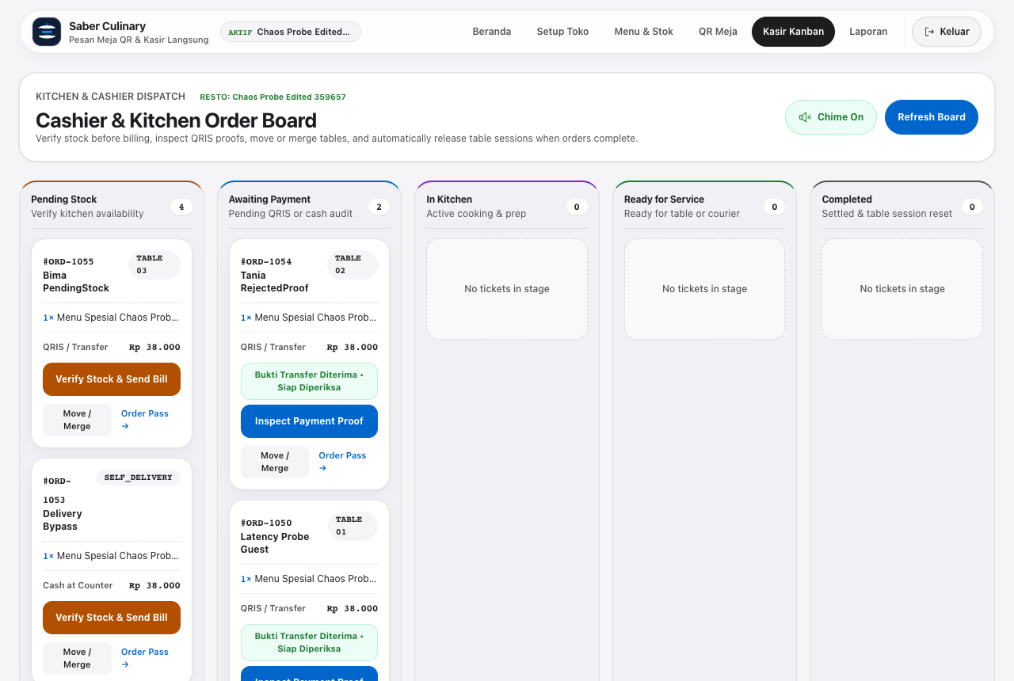
Captured on /cashier/orders for tenant chaos-mf-359657-v2: after the cashier explicitly rejected #ORD-1054 (Tania RejectedProof, reason 'Nominal kurang Rp 5.000'), the card under Awaiting Payment still displays the misleading green 'Bukti Transfer Diterima • Siap Diperiksa' badge because the UI checks receipts.length > 0 instead of excluding REJECTED state (Bug M1). Simultaneously, #ORD-1053 ('Delivery Bypass', SELF_DELIVERY) appears inside Pending Stock despite disabled self-delivery (Bug C6), alongside mixed English column headings ('Pending Stock', 'Awaiting Payment', 'In Kitchen', 'Ready for Service').

FIGURE 08 // GAP MG1: STOCK AUDIT MODAL (#ORD-1055) OFFERS NO 'BATALKAN PESANAN' OPTION IF DISHES SELL OUT
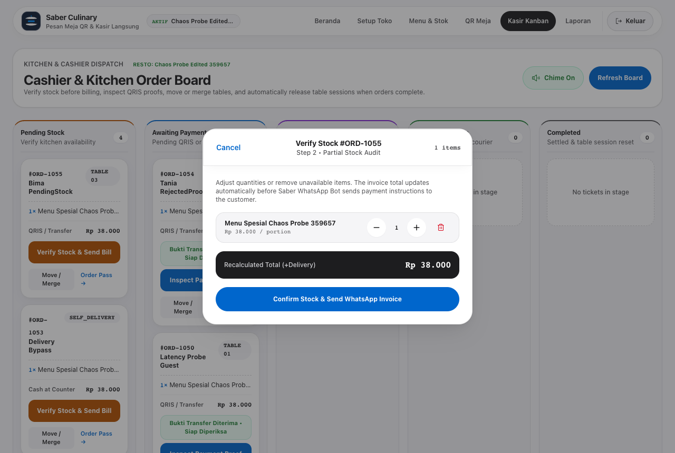
Inspecting 'Verify Stock #ORD-1055' (Bima PendingStock): cashiers can decrement quantities or delete line items, yet the 'Cancel' link at top-left only closes the modal overlay and neither the modal footer nor the Kanban card exposes a 'Batalkan Pesanan / Cancel Order' action to abort unfulfillable tickets.

3.4 Visual Evidence — Mobile Operator Ergonomics (390x844 Viewport)
FIGURE 09 // GAP MG2 & MG5 (Mobile Cashier 390px)  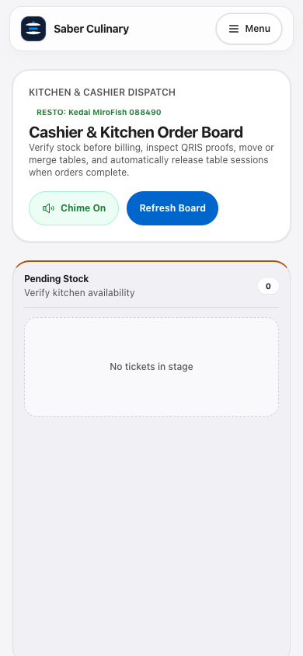  Empty Kanban columns preserve desktop min-h-[520px] height when stacked vertically on mobile, forcing cashiers to scroll past 2,000+ px of blank dropzones (without search or stage tabs) to reach In Kitchen or Ready orders. | FIGURE 10 // GAP MG2 (Mobile Admin Tables 390px)  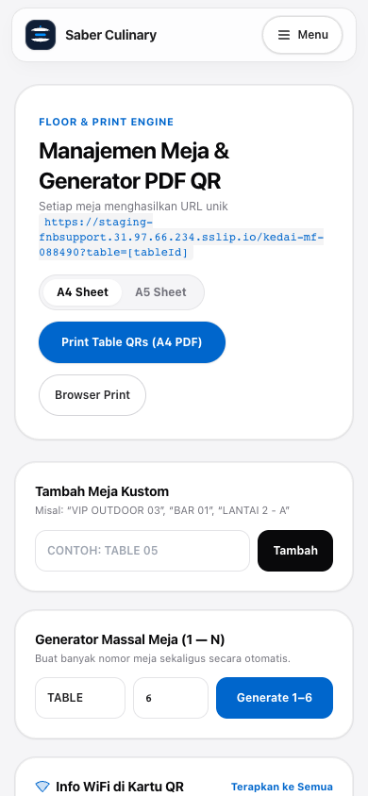  Automated viewport telemetry caught interactive targets beneath Apple HIG's 44pt minimum: 'A4 Sheet' segmented toggle (28px height) and inline link 'Terapkan ke Semua' (17px height), reducing thumb accuracy on mobile devices.

3.5 Visual Evidence — Admin Menu & Analytics Integrity / Language Gaps
FIGURE 11 // BUG M2 & GAP MG3: NEGATIVE PRICE ITEM '-Rp 5.000' PERSISTED & CATEGORY CONTROLS ABSENT
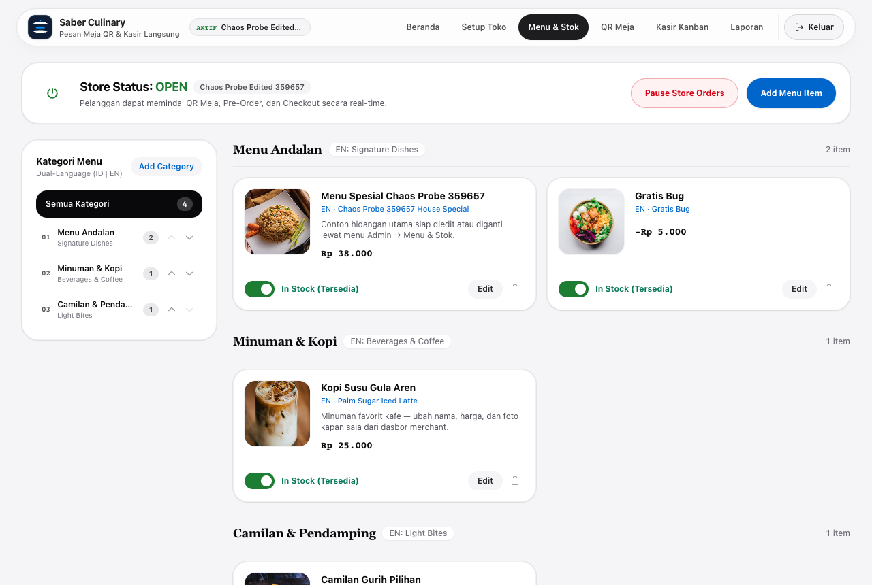
Captured on /admin/menu for chaos-mf-359657-v2: 'Gratis Bug' created with priceIdr: -5000 (HTTP 200) renders cleanly in the store menu editor, confirming lack of server/UI validation (> 0 IDR). Categories ('Menu Andalan', 'Minuman') show small 22px reorder arrows and lack any Edit or Delete Category button.

FIGURE 12 // GAP MG3 & MG5: UNAUTHENTICATED DEMO SILENT LOAD & MIXED EN/ID ANALYTICS COPY
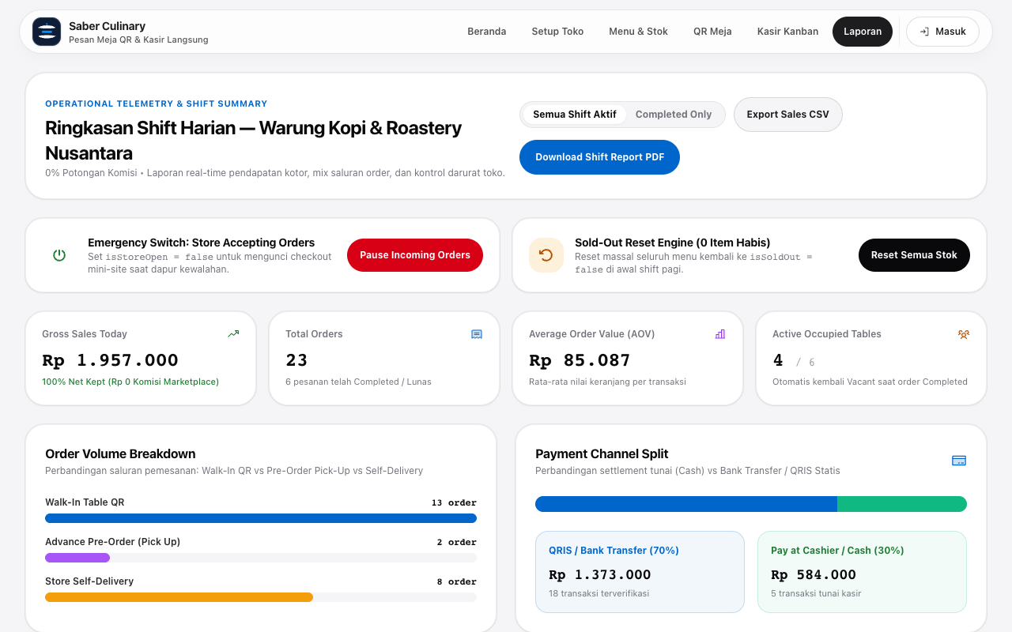
Captured without session cookies on /admin/analytics: back-office route silently opens demo tenant warungmakan without a prominent 'Mode Simulasi Demo' banner urging merchants to sign in, while KPI cards mix English ('Gross Sales Today', 'Average Order Value', 'Completed Only', 'Export Sales CSV') with Indonesian copy ('Ringkasan Shift Harian', 'Semua Shift Aktif' 24px filter pills).

SECTION 04 // VERIFIED CONTROLS & PERSONA INTERVIEWS
Passing Security Boundaries (Stage 3/4) & Post-Audit Persona Feedback (Stage 5)
Despite the 20 uncovered defects and gaps, core platform isolation, authentication walls, WhatsApp synchronous latency, and workspace slug-edit session updates performed reliably under live Staging pressure:
Verification Checkpoint | Verified Staging Evidence | Status
Cross-Tenant / Unauth Stock & Order Auth Guard | Unauthenticated toggle-stock returned 404; unauth PATCH /api/v1/orders confirm_stock returned 403 | PASS
Registered Tenant Onboarding & Cookie Auto-Login | kedai-mf-088490 & chaos-mf-359657 onboarded with seeded catalog, 4 tables & active session | PASS
Slug Edit -> Session & Workspace Cookie Sync | Renaming chaos-mf-359657 -> chaos-mf-359657-v2 updated auth/session & /api/v1/tables cleanly | PASS
Checkout Modal Batal / Cancel Button | Native <dialog> closed immediately (modalStillOpen: false) on mobile viewport | PASS
WhatsApp Magic Link Unauthenticated Redirect | Fresh browser opening ?magicToken=... redirected cleanly to /login preserving token | PASS
Unknown Restaurant Slug 404 Isolation | /toko-fiktif-404 displayed 'Menu Restoran Tidak Ditemukan' without exposing merchant bars | PASS
Guest Checkout + WhatsApp Dispatch Latency | End-to-end guest-checkout HTTP round-trip measured 282 ms on Staging | PASS
Reserved & Short Slug Validation | 'admin' blocked (400/available:false) and 'ab' rejected (<3 chars) | PASS
Baseline API Swarm Smoke Suite (warungmakan) | 45 / 45 concurrent calls passed across 2 rounds (p50 296.88 ms, p95 713.32 ms in 5.17 s) | PASS

Stage 5 — Post-Audit 1-on-1 Synthetic Persona Interviews
Persona (Entity / Role) | Evaluated Staging Journey | 1-on-1 Verbatim Audit Observation
Rina Kusuma  (WalkInDiner · Mobile) | Table 02/03 QR Scan, Checkout Sheet & Live Tracking | Adding dishes and closing the Checkout dialog via 'Batal' responded fast. However, switching accidentally to Pre-Order Pickup with an empty pickup time still submitted #ORD-1048, and after the cashier cancelled it, my Order Pass still read 'Order Received • ACTIVE'.
David Miller  (DeliveryCustomer · EN) | Bilingual Toggle, Delivery Availability & Digital Receipt | When the merchant turned off Self-Delivery, the 'Antar Kurir Toko' tab stayed visible on mobile. Switching to EN left checkout payment labels in Indonesian, and the receipt exposed raw system strings like PROOF_UPLOADED and BANK_TRANSFER_QRIS.
Siti Rahma  (CashierOperator) | Cashier Kanban (/cashier/orders) & Mobile Dispatch | Magic Links protected unauthenticated access by redirecting to Login, but on my phone I had to scroll over 2,000 px past huge empty columns, rejected QRIS proofs still showed a green 'Bukti Transfer Diterima' banner, and I had no button to cancel dead orders.
Pak Budi  (StoreOwner) | Onboarding Wizard, Menu Editor, Table QRs & Analytics | 3-step registration seeded dishes and tables smoothly. Yet opening hours I entered never appeared on the customer storefront, Menu API didn't stop a negative -Rp 5.000 price, and renaming the store slug gave zero warning that printed table QRs would break.
Zed Bot  (Adversarial & Chaos) | Security Fuzzing & State-Transition Exploits | Auth guards blocked unauthenticated merchant mutations (403/404), but guest-checkout allowed invalid menuItemIds at IDR 0, accepted Sold-Out items, bypassed disabled Self-Delivery rules, and unauthenticated upload_receipt resurrected Cancelled tickets.

SECTION 05 // REMEDIATION ROADMAP & SIGN-OFF DECISIONS
Recommended Fix Sequence & Open Product Decisions
To resolve every identified vulnerability and UX gap efficiently while preserving Saber's 3-stage deployment governance (fix/* branch -> staging -> human verification -> main), engineering remediation should execute in three focused batches:
Fix Batch | Included Scope IDs | Specific Implementation Changes
Batch 1 (P0)  Security & Order Integrity | C1, C2, C4, C6,  M2, M3 | Scope guest-checkout menu lookup strictly to target merchantId and reject missing/foreign/isSoldOut items (HTTP 400); block SELF_DELIVERY when !merchant.isSelfDeliveryEnabled or empty address; forbid upload_receipt on CANCELLED/COMPLETED orders; reject priceIdr <= 0 in menu-items API; release table occupancy on CANCELLED transitions.
Batch 2 (P1)  Cancelled Flows & UI Bugs | C3, C5, C7,  M1, MG1 | Hide Self-Delivery tab when disabled; enforce pickup time validation before Pre-Order submission; render dedicated 'Pesanan Dibatalkan' card & hide rejection prompts in /order/[orderId]; clear 'Bukti Transfer Diterima' green badge when paymentStatus === REJECTED; add 'Batalkan Pesanan' button on Cashier Kanban & Stock Audit modal.
Batch 3 (P2)  UX Polish, Mobile & i18n | CG1-CG5,  MG2-MG5 | Disable '+ Tambah' with sleek inline notice when store closed; show stale-cart Sold-Out toast; complete ID/EN parity across Checkout, Order Pass, Cashier, and Analytics + humanize Receipt enum labels; compact mobile Kanban columns + stage tabs & >= 44px touch targets; add Category edit/delete, unauth Demo banner, and QR break warning on slug edit.

Open Product Decisions Required from Stakeholder Before Implementation
Decision Topic | Gap ID | Option A (Recommended) vs Option B
Operational Hours Enforcement | CG1 | Option A: Display daily opening hours prominently on storefront header AND gently warn/block checkouts outside open hours (matching merchant schedule).  Option B: Display schedule as informational badge only and rely solely on manual 'Tutup Toko' toggle.
Back-Office Language Consistency | MG5 / CG4 | Option A: Convert all Cashier Kanban, Admin Menu, Tables, and Analytics labels to cohesive Bahasa Indonesia (matching /, /onboarding, /login) while preserving full ID | EN toggle on Customer Storefront, Order Pass, and Digital Receipt.
Post-Onboarding Store Slug Edits | MG4 | Option A: Keep slug editable but trigger an explicit confirmation modal warning that existing printed table QRs will require reprinting.  Option B: Lock slug permanently after onboarding.
Staging Test Tenant Cleanup | Ops | Option A: Retain only warungmakan demo cleanly on Staging and remove synthetic audit merchants (kedai-mf-088490, chaos-mf-359657-v2) after verification.

