MIROFISH SWARM INTELLIGENCE AUDIT V3 · POST-REMEDIATION VERIFICATION
Saber Culinary Direct Commerce — Full User Journey, Delivery & Order-for-Later Audit
Target: https://staging-fnbsupport.31.97.66.234.sslip.io (Commit 68dd636) · Executed: 12 November 2026 · 6 OASIS Agent Archetypes · 65 Baseline API Actions + 17 Playwright Checkout & Fulfillment Checks

API SWARM PASS  65/65 (100%)  p50=143.98ms / p95=270.55ms | FUNCTIONAL BUGS  8 Confirmed  Checkout, Delivery & Cashier | PROCESS & UX GAPS  5 Identified  Maps Pinpoint, Radius & Tap | AUDIT V2 SECURITY  100% Holding  403 Isolation & Hours Guard

STAGE 4 SYNTHESIS · EXECUTIVE OVERVIEW
1. Executive Summary & Audit v2 Regression Status
Following the deployment of all Audit v2 fixes to Staging (commit 68dd636), a fresh 5-Stage MiroFish Swarm Simulation (Audit v3) was executed against https://staging-fnbsupport.31.97.66.234.sslip.io. The baseline 6-persona API swarm completed all 65 HTTP actions cleanly (100% pass rate, median latency 143.98 ms, p95 latency 270.55 ms). Unauthenticated cross-tenant mutations (PATCH /api/v1/orders, POST /api/v1/menu-items), closed-hours ordering, sold-out item tampering, and cancelled-order receipt uploads remain firmly blocked with HTTP 400/403/409.
However, our targeted Playwright Customer + Merchant POV exploration uncovered why Self-Delivery and Order-for-Later (Pre-Order) appear broken or incomplete during real-world Checkout, along with 13 active findings (8 functional/validation bugs and 5 process & UX gaps) spanning modal channel switching, geolocation/maps pinpointing, datetime validation, downstream Cashier/Order-Pass visibility, WhatsApp alerts, and concurrent table session overwrites.
WHY DELIVERY & ORDER-FOR-LATER APPEARED MISSING IN CHECKOUT (USER SUSPICION CONFIRMED)
1) Locked Channel Inside Checkout Popup: Once a customer scrolls down the menu (or enters via a Table QR URL) and clicks 'Lihat Keranjang & Pesan', the Checkout <dialog> contains NO channel selector ('Dine-In Meja | Pre-Order Ambil | Antar Kurir Toko'). It silently locks to 'WALK_IN_TABLE', showing only 'Nomor Meja' and hiding both Delivery Address and Pick-Up Date/Time.
2) Zero Geolocation / Maps Pinpoint & Cosmetic Delivery Radius: Even when Delivery is chosen at the top of the page, only a plain textarea is shown — there is zero browser Geolocation ('Gunakan Lokasi Saya'), zero latitude/longitude map pinpoint picker, and zero restaurant coordinates in Onboarding Step 2, making 'Maks 5 km' purely decorative (an address 800 km away in Surabaya passed HTTP 200).
3) Broken Downstream Fulfillment: Delivery does not support scheduled date/time ('Order for Later'); Pre-Order accepts past dates like '2020-01-01' and malformed strings; and worst of all, Cashier Kanban, Live Order Pass, Digital Receipt, and Merchant WhatsApp Alerts ALL OMIT both 'deliveryAddress' and 'scheduledPickupTime'!

Figure 1 — Audit v3 Swarm Detection Matrix & Live Staging API Latency Profile
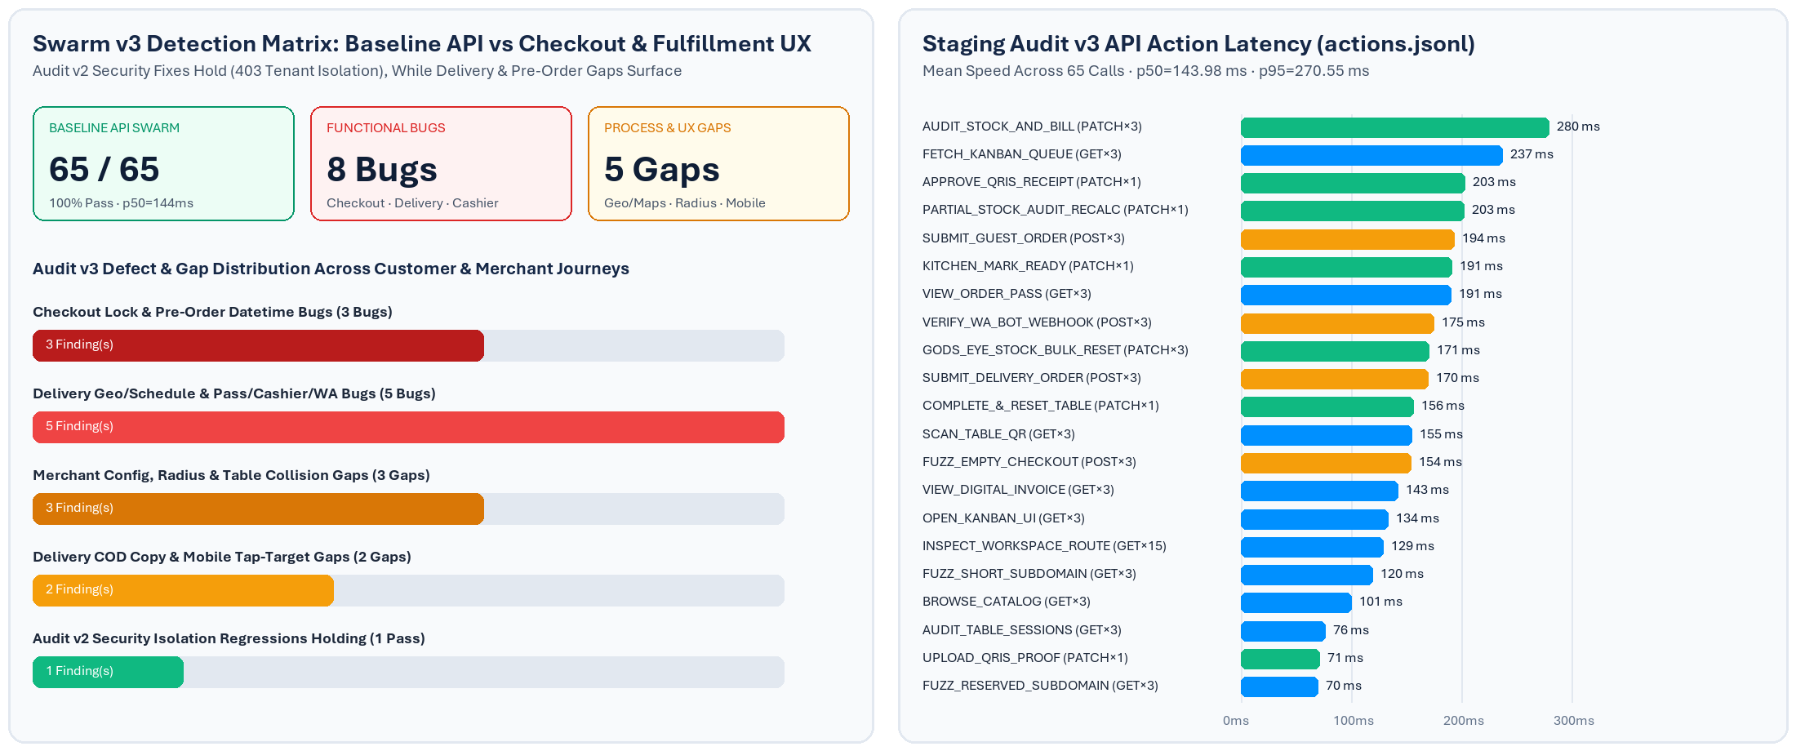
Left: Comparison between happy-path API swarm coverage (65/65 green) and Audit v3 deep UX/Chaos probes (8 bugs + 5 process gaps across Checkout, Delivery, Pre-Order, and Cashier). Right: Mean API latency by endpoint action from actions.jsonl.

STAGES 1 & 2 · GRAPHRAG & OASIS SYNTHESIS
2. Domain Ontology & Swarm Personas Executed
Per the MiroFish protocol, the simulation synthesized a 10-entity ontology and 9 domain interaction edges, driven by 6 distinct OASIS persona archetypes interacting concurrently across Desktop (1280×860) and Mobile (390×844) browser contexts plus adversarial HTTP fuzzers:
Persona / ID | Archetype & Entity Type | Primary Verification Focus in Audit v3 | Key Verdict
Rina (101)  Mobile 390px | Hurried Mobile User  (WalkInDiner) | Scanned ?table=TABLE 01, scrolled menu, opened Checkout modal, checked in-modal channel switcher & tap targets >=44px. | Blocked from switching to Delivery inside modal; ID/EN pills 36px high.
Budi (102)  Desktop | Delivery & Order-for-Later  (DeliveryCustomer) | Tested Antar Kurir Toko address, Geolocation/Maps pin, Scheduled Delivery, COD wording, and Live Pass/Receipt visibility. | Missing GPS pinpoint, missing delivery schedule, hidden address on Pass/Receipt.
Rafi (105)  Desktop | Pre-Order Customer  (PreOrderCustomer) | Tested Pre-Order Ambil min datetime guard, past-date rejection (2020-01-01), malformed strings, and Pass/Kanban time visibility. | Server returned HTTP 200 for year 2020 & garbage text; time hidden on Pass.
Siti (103)  Cashier | Peak-Hour Operator  (CashierOperator) | Audited /cashier/orders Kanban tickets for Self-Delivery address, Pre-Order time, Maps links, and enum formatting. | Both deliveryAddress & scheduledPickupTime invisible; raw enum strings leaked.
Pak Hendra (104)  Owner | Merchant Owner  (StoreOwner) | Audited /onboarding Step 2 restaurant GPS pinpoint setup, Forgot Password OTP delivery, WhatsApp logs, and Analytics. | No store GPS setup despite radius km setting; step transition scroll overlap.
Zed (106)  Chaos Bot | Adversarial Fuzzer  (AdversarialBot) | Injected 800 km out-of-radius address, double-scanned occupied TABLE 01, tested unauthenticated PATCH/POST IDOR. | Auth isolation holds (403); out-of-radius accepted (200); TABLE 01 overwritten.

STAGE 3B · CHECKOUT & DELIVERY BREAKDOWN
3. Deep Dive: Checkout, Self-Delivery & Order-for-Later Gaps
Below are the live Staging screenshots captured during the Audit v3 run on temporary sandbox tenant kedai-mf-v3-667802 (purged cleanly after test completion) demonstrating every broken UX link between Storefront Checkout, Order Pass, Receipt, Cashier Kanban, and Merchant Onboarding.
Fig 2A · GAP_CHECKOUT_LOCKED_CHANNEL (Mobile 390px)  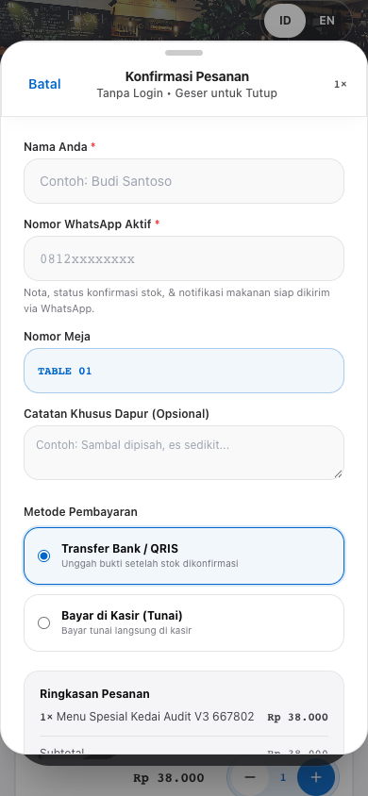  Customer tapped 'Lihat Keranjang & Pesan' after browsing menu. Checkout modal locks to 'Nomor Meja' with NO channel switcher to choose Self-Delivery or Pre-Order Pick-Up, hiding Delivery Address & Date/Time. | Fig 2B · UX_MOBILE_TAP_TARGETS & Top Storefront  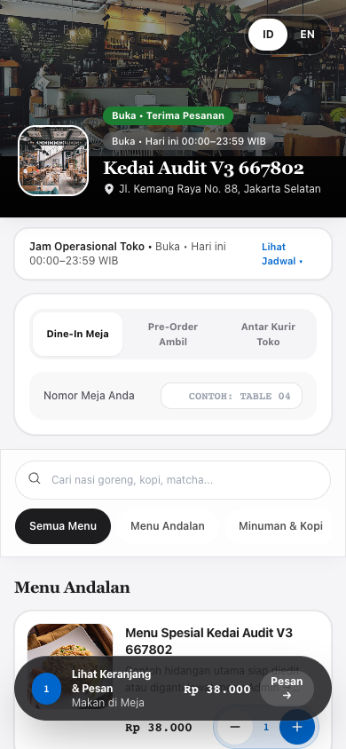  Storefront channel tabs live ONLY at the very top of the page. Once scrolled down to pick menu items, users forget or cannot access channel options inside Checkout. Top ID/EN toggle pills measure 36px (<44px).

Fig 3 · GAP_DELIVERY_NO_GEOLOCATION_PINPOINT & GAP_DELIVERY_NO_SCHEDULED_TIME (Desktop Delivery Modal)
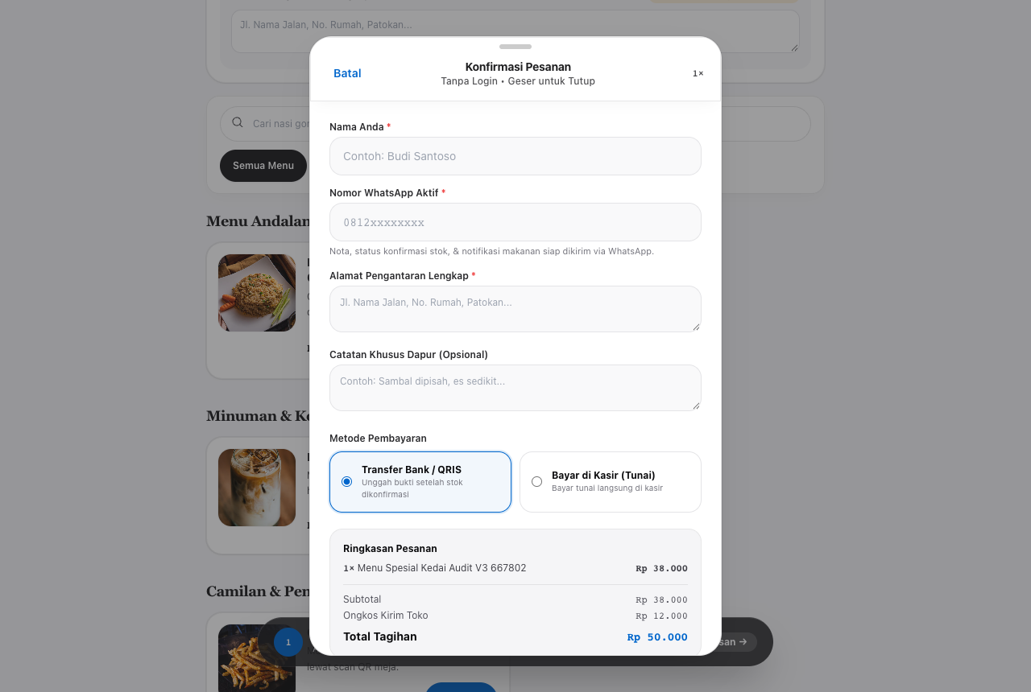
When Self-Delivery IS selected at the top of the storefront, the Checkout modal offers only a plain 'Alamat Pengantaran Lengkap' textarea. There is NO Geolocation ('Gunakan Lokasi Saya'), NO Maps Pinpoint picker, NO delivery Date/Time selector, and the Cash option confusingly says 'Bayar di Kasir (Tunai)' instead of Cash on Delivery (COD).

Fig 4 · BUG_DELIVERY_ADDRESS_HIDDEN_ON_PASS_RECEIPT & BUG_PREORDER_TIME_HIDDEN_ON_PASS
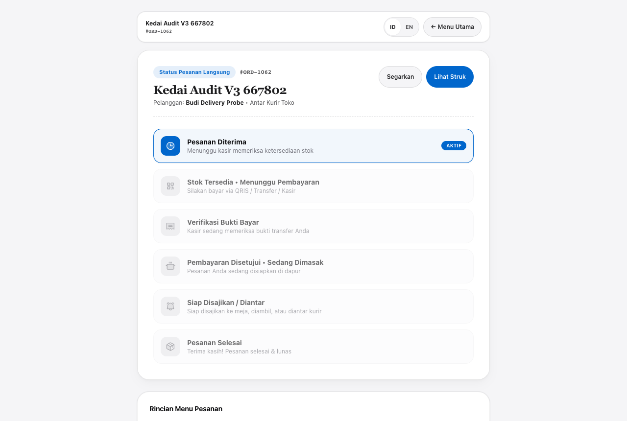
Confirmed Delivery order #ORD-1062 rendered on /order/[orderId]. Although Ongkir (Rp 12.000) was billed, the Live Order Pass (and /receipt page) completely omits the customer's delivery address ('Jl. Senopati No. 45...') and omits scheduledPickupTime for Pre-Orders.

Fig 5 · BUG_CASHIER_CANNOT_SEE_DELIVERY_ADDRESS_OR_PICKUP_TIME (Cashier Kanban)
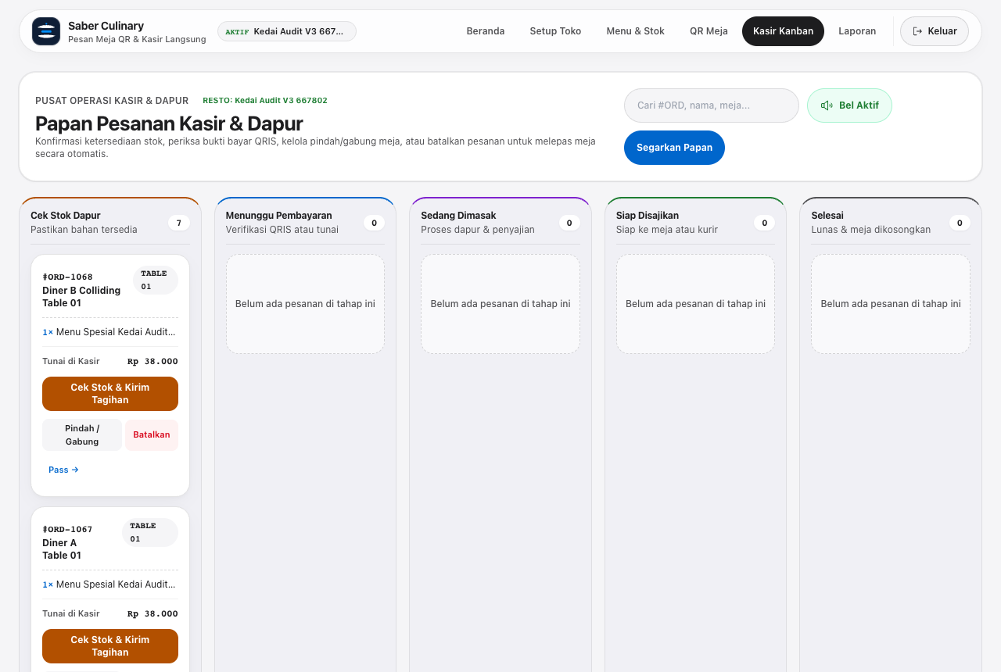
Merchant Cashier Kanban (/cashier/orders): Delivery and Pre-Order cards omit deliveryAddress, omit scheduledPickupTime, provide no Google Maps pin link for couriers, and still display raw badge labels ('SELF_DELIVERY', 'PRE_ORDER'). Also shown: #ORD-1068 silently overwrote #ORD-1067 on TABLE 01 (GAP_CONCURRENT_TABLE_OVERWRITE).

Fig 6 · GAP_ONBOARDING_NO_BRANCH_COORDINATES & UX_ONBOARDING_STEP_SCROLL_HEADER_OVERLAP
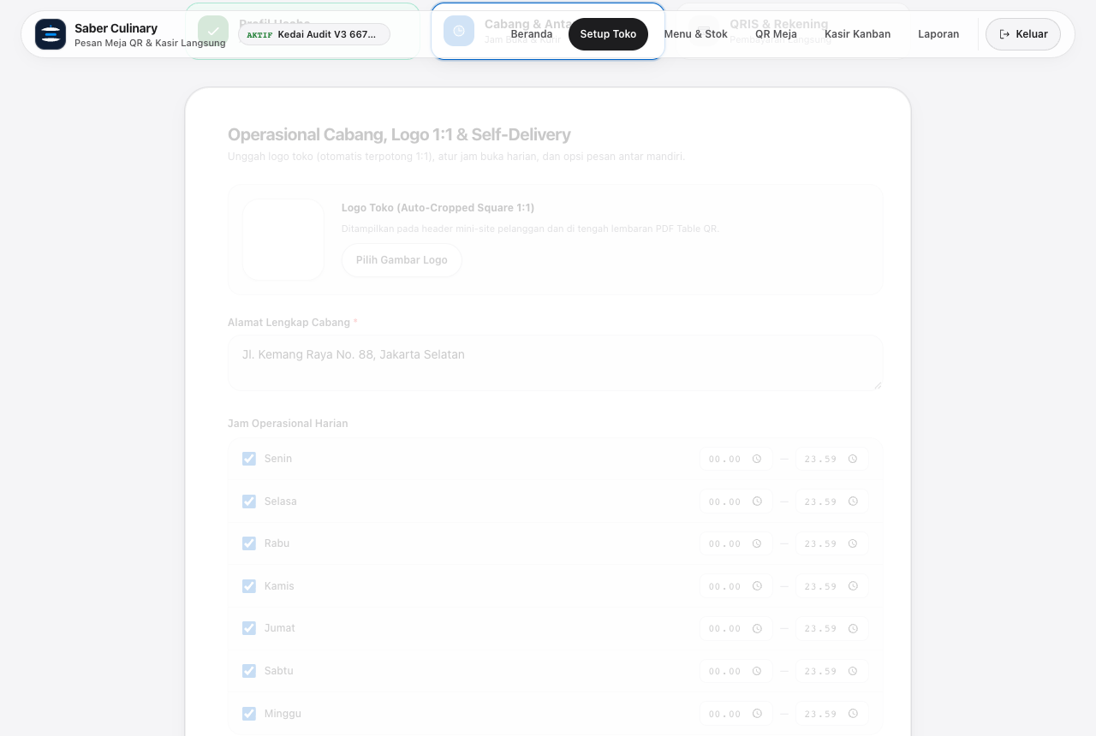
Merchant Onboarding Step 2 lets store owners enter a delivery radius in kilometers without pinning restaurant GPS coordinates. Visual inspection also caught a navigation polish bug: clicking 'Langkah Berikutnya' preserves scroll position down the page and lets the floating top bar overlap the Stepper.

COMPLETE FINDINGS REGISTRY
4. Prioritized Defect, Process Gap & Security Catalogue
All 13 active defects and gaps discovered in Audit v3 (8 functional bugs + 5 process/UX gaps, plus 1 verified Audit v2 security regression check) are prioritized below by Customer/Merchant business impact:
ID & Severity | POV / Area | Verified Defect / Process Gap | Exact Evidence & Affected Code
P0 BUG  GAP_CHECKOUT_LOCKED_CHANNEL | Customer  Checkout | No channel selector inside Checkout modal; users who scroll down or enter via QR cannot switch to Delivery or Pre-Order or see address/time fields. | CustomerStorefrontClient.tsx (<dialog> lines 1089-1280). Fig 2A.
P0 BUG  BUG_CASHIER_CANNOT_SEE_DELIVERY_ADDRESS_OR_PICKUP_TIME | Merchant  Cashier | Cashier Kanban cards never display customer deliveryAddress or scheduledPickupTime, provide no Maps link, and show raw SELF_DELIVERY / PRE_ORDER enums. | cashier/orders/page.tsx (line 606). Fig 5: showsDeliveryAddress=false.
P0 BUG  GAP_DELIVERY_NO_GEOLOCATION_PINPOINT | Customer & Merchant  Delivery | Zero Geolocation / Interactive Maps Pinpoint (lat/lng) in Delivery Checkout and zero branch coordinates in Onboarding Step 2; 'Maks 5 km' never validated. | schema.ts Branch/Order lack lat/lng; Surabaya (800km) passed HTTP 200.
P0 BUG  BUG_PREORDER_ACCEPTS_PAST_AND_INVALID_DATETIME | Customer / Sec  Pre-Order | datetime-local input has min=null in UI, and guest-checkout API accepts year 2020 ('2020-01-01T10:00') and non-date strings ('besok jam terserah') with HTTP 200. | CustomerStorefrontClient.tsx (#modalPickupTime); guest-checkout/route.ts.
P1 BUG  BUG_DELIVERY_ADDRESS_HIDDEN_ON_PASS_RECEIPT | Customer  Tracking | Live Order Pass and Digital Receipt hide the submitted deliveryAddress so buyers cannot verify their destination. | order/[orderId]/page.tsx & receipt/page.tsx. Fig 4.
P1 BUG  BUG_PREORDER_TIME_HIDDEN_ON_PASS | Customer  Tracking | Live Order Pass and Receipt hide scheduledPickupTime after submitting a Pre-Order Pick-Up order. | order/[orderId]/page.tsx & receipt/page.tsx. scheduledPickupTime omitted.
P1 BUG  GAP_WA_ALERT_OMITS_DELIVERY_AND_PICKUP_DETAILS | Merchant  WhatsApp | Merchant NEW_ORDER_MAGIC_LINK WhatsApp message omits deliveryAddress / scheduledPickupTime and prints raw orderType enum. | guest-checkout/route.ts (line 231).
P1 GAP  GAP_DELIVERY_NO_SCHEDULED_TIME | Customer  Delivery | Self-Delivery supports ASAP only — no 'Kirim Sekarang vs Jadwalkan Pengantaran' date/time option ('Order for Later'). | CustomerStorefrontClient.tsx (SELF_DELIVERY block lines 1224-1260).
P1 GAP  GAP_CONCURRENT_TABLE_OVERWRITE | Merchant / Guest  Dine-In | Concurrent order on occupied TABLE 01 silently overwrites table.activeOrderId, orphaning Customer A's active ticket upon table release. | guest-checkout/route.ts (lines 202-209). #ORD-1068 replaced #ORD-1067.
P2 GAP  UX_DELIVERY_CASH_COPY_MISMATCH | Customer  Delivery | Cash payment radio option shows 'Bayar di Kasir (Tunai)' during Self-Delivery instead of Cash on Delivery (COD). | CustomerStorefrontClient.tsx (lines 1330-1336).
P2 GAP  UX_ONBOARDING_STEP_SCROLL_HEADER_OVERLAP | Merchant  Onboarding | Clicking 'Langkah Berikutnya' does not scroll to top; floating workspace navbar overlaps Stepper; modal fade caused transient ghost frame. | onboarding/page.tsx (handleNextStep) & globals.css dialog entry.
P2 GAP  UX_MOBILE_TAP_TARGETS | Customer  Mobile | ID | EN header language switcher buttons measure 36px height on 390px viewport (below 44px Apple HIG tap target). | CustomerStorefrontClient.tsx header toggle (h=36px).
PASS  SEC_TENANT_ISOLATION_RECHECK | Security  Audit v2 Hold | Unauthenticated PATCH /orders, GET /orders?slug=..., and POST /menu-items strictly rejected with HTTP 403. | Verified on Staging across all merchant-protected routes.

REACT RECOMMENDATIONS & STAGE 5
5. Concrete Fix Blueprint & Simulated Agent Interviews
5.1 Prioritized Remediation Blueprint (For Next Engineering Sprint)
1. Unified In-Modal Channel Switcher: Embed the 3-way channel pill ('Dine-In Meja | Pre-Order Ambil | Antar Kurir Toko') directly at the top of the Checkout <dialog> modal so customers never lose Delivery Address or Date/Time controls after scrolling or QR entry. Update Cash label dynamically to 'Bayar Tunai saat Diantar (COD)' when Self-Delivery is active.
2. Geolocation, Interactive Map Pinpoint & Haversine Radius Guard: Add branchLat / branchLng to Branch (captured in Onboarding Step 2 via browser Geolocation + clickable Leaflet/OpenStreetMap pin + Google Maps link) and deliveryLat / deliveryLng + scheduledDeliveryTime to Order. Inside Delivery Checkout, add a 'Gunakan Lokasi Saya (GPS)' pinpoint button + draggable map preview + real-time Haversine distance check against maxDeliveryRadiusKm (rejecting out-of-radius requests on both UI and server HTTP 400).
3. Order-for-Later Scheduling & Server Time Validation: Support both 'Ambil Sekarang / Jadwalkan Waktu' (PRE_ORDER_PICKUP) and 'Kirim Sekarang / Jadwalkan Pengantaran' (SELF_DELIVERY). Add HTML min={nowLocalIso} and validate on guest-checkout/route.ts that scheduled timestamps parse cleanly, are >= now - 5 mins, and fall inside the merchant's configured operationalHours.
4. Full Downstream Visibility (Pass, Receipt, Cashier Kanban & WhatsApp): Display formatted deliveryAddress, clickable Google Maps Pin ('Buka di Google Maps'), and scheduledPickupTime / scheduledDeliveryTime cards on /cashier/orders, /order/[orderId], /order/[orderId]/receipt, and inside Merchant WhatsApp NEW_ORDER_MAGIC_LINK templates. Replace raw badges on Cashier Kanban with human Indonesian labels.
5. Concurrent Table Session Safety & UI Polish: Track multiple activeOrderIds (or preserve first unpaid activeOrderId / warn guest 'Meja sedang digunakan — gabung tagihan?') instead of overwriting table.activeOrderId silently. Scroll window.scrollTo({ top: 0, behavior: 'smooth' }) between Onboarding steps, enlarge ID|EN buttons to min-h-[44px], and ensure Checkout dialog surface is solid opaque white.
5.2 Stage 5: Post-Simulation 1-on-1 OASIS Agent Interviews
Rina Kusuma (WalkInDiner · Mobile 390px)
Adding food to the cart and dragging down the Checkout sheet felt fast and native. However, once I scrolled down to browse drinks and tapped Checkout, I wanted to switch to Delivery for home — and the Checkout popup had no Delivery tab or address field at all! I had to close Checkout and hunt back up to the top of the page.

Budi Santoso (DeliveryCustomer · Desktop)
I saw 'Maks 5 km • Ongkir Rp 12.000', so I expected a 'Pinpoint / Gunakan Lokasi Saya' map button and a choice to schedule delivery for 18:00 tonight. Instead I only got a blank textarea, a radio button saying 'Bayar di Kasir (Tunai)' for a delivery order, and on my Live Order Pass after submitting, my street address vanished completely.

Siti Rahma (CashierOperator · Kanban Board)
Thank goodness the Batalkan button and the red 'Bukti Ditolak' warning are working nicely now! My biggest operational blocker today is Delivery and Pre-Order tickets: a Delivery card shows Rp 50.000 and Customer Name, yet zero street address, zero Google Maps pin for our driver, and zero scheduled pickup clock time!

Zed (AdversarialBot · Chaos Fuzzer)
Security guards from Audit v2 are noticeably tighter — cross-tenant items returned 400, closed hours returned 403, cancelled receipt upload returned 409, and unauthenticated merchant PATCHes returned 403. My only easy bypasses were submitting '2020-01-01T10:00' for Pre-Order Pickup (200 OK), ordering from 800 km away on a 5 km radius store (200 OK), and silently clobbering Table 01's previous active order.

