SOFTWARE PROCESS MODELS AND REQUIREMENTS ENGINEERING
Building an Online Food Delivery System Like Swiggy — Which Development Approach Actually Works?
Course Name: Introduction to Software Engineering
Course Code: IS1103-1
Assignment Number & Title: Assignment 1 - Software Process Models and Requirements Engineering
Student Name: Avani S. Rao
USN: NNM24IS047
Semester & Section: 4th semester & ‘A’ section
Department: ISE
Institution Name: NMAM Institute of Technology
Academic Year: 2025-26
Instructor Name: Dr.Jason Elroy Martis

ABSTRACT
When you open a food delivery app it looks easy. You just tap on it look at the options and then place your order. If you think about it there is a lot going on behind the scenes. The people who work at the restaurant start getting your food ready. A delivery person picks up your food. Navigates through the traffic using a map, on their phone. Your payment is processed securely too. The food delivery app has to deal with a lot of orders at the time all over the city. The food delivery app is handling thousands of orders all at the time in the same city. I want to compare three ways to build software: Waterfall, Incremental and Spiral. I am looking at how they work for a company like Swiggy that moves fast. I looked into how Waterfall, Incremental and Spiral handle changes in what the software needs to do. I also checked how Waterfall, Incremental and Spiral keep things working correctly.
I saw how Waterfall, Incremental and Spiral deal, with problems that might come up. I saw how Waterfall, Incremental and Spiral control how much money is spent. I even made a list of what the software needs to do and a plan to test Waterfall, Incremental and Spiral to make sure everything works as it should. Hands down, Spiral comes out on top for me; in the wild world of food delivery, where customer tastes flip overnight, restaurant demands evolve, and logistics get messy with traffic or weather, you need that flexibility to iterate without starting from scratch.
GITHUB REPOSITORY LINK
GitHub URL:
INTRODUCTION
Software engineering means building software in an organized way rather than just jumping in and hoping it works [1]. Every project follows a Software Development Lifecycle — a path from initial idea to a finished product real people use. The method you choose affects whether it finishes on time, stays within budget, and ends up good [2].
The system I chose is an Online Food Delivery System, modeled on Swiggy and Zomato. Nowadays, people use the internet to get things they need. This has changed the way we get food and other things we need every day. These platforms connect three very different groups — customers who want food, restaurants that cook it, and delivery partners who bring it — all coordinated in real time [3]. A good food delivery system has to do a lot of things at the time. It has to let people order food in time. It has to work with restaurants to get the food ready. It has to process payments. It has to figure out the way to get the food to people. It has to help customers when they have problems. The food delivery system has to do all these things for a lot of people at the time. The food delivery system has to support millions of users at once.
These big platforms are really driven by software. They are always changing. So it is very important to choose the right Software Development Life Cycle model to manage all the requirements, risks, system upgrades and to keep the Software Development Life Cycle running and the whole system stable. The Software Development Life Cycle model is key, to making sure everything works well.
This report is, about looking at three Software Development Life Cycle models to see how they compare to each other. The Software Development Life Cycle models are the focus of this report.
• Waterfall Model
• Incremental Development Model
• Spiral Model
PROBLEM STATEMENT
This piece is about comparing Waterfall and Incremental and Spiral models when we build an Online Food Delivery System. We will look at how Waterfall models and Incremental models and Spiral models work with requirements and risks and how they handle time and cost.
I will make a good requirements document, for the Online Food Delivery System. I will make a plan to check that the Online Food Delivery System works as it should.
Assumptions here include a three-way marketplace linking customers, restaurants, and delivery riders; a team of 25-35 engineers; a 12-18 month rollout; funding from a backed food-tech startup; and a cross-platform build for Android/iOS tied to a cloud backend.
CASE STUDY: ONLINE FOOD DELIVERY SYSTEM (SWIGGY)
What This System Actually Is:
An online food delivery system connects hungry customers with restaurants and manages the delivery in between. Swiggy, started in Bangalore in 2014, grew across hundreds of Indian cities by solving this coordination at scale [5]. The customer sees menus and reviews, the restaurant sees incoming orders, the delivery partner sees pickup and drop points — and behind all three views is one complicated system that has to get everything right simultaneously.
Customers can see what food is available and what other people think of the restaurant on their phones. Restaurants can see when someone places an order and send it out to be delivered. The people who deliver the food can find the restaurants and the houses where they need to deliver the food. All of this happens because of the food delivery setup that Swiggy has. The online food delivery setup is, like the brain that makes everything work together. The online food delivery setup has to work else the food will not get delivered on time.
These platforms need to be really strong all the time. People want to be able to log in when they are getting ready for dinner or during big festivals. They also want to be able to pay and get their food on the table in 30 minutes. The platforms have to deal with a lot of traffic at these times. Sometimes it is 10 times more, than usual. They have to be able to handle this without any problems or slowing down. The food platforms have to keep working so people can get their food on time. The platforms have to be strong so they do not fail when people need them to work.
On security, it's non-negotiable: think full encryption from start to finish, extra login checks for payments, smart fraud-spotting tech, and tight APIs connecting eateries, riders, and banks. Real-time GPS tracking weaves in too, all while slamming the door on hackers.
Main Things the System Does
•Customers look at the menus of restaurants. They see photos of the food the prices, what other people think of the restaurant and how long it will take for the food to be delivered to them. They like to know the estimated delivery time of the restaurant.
•Live search filters by cuisine type, distance, price range, and dietary preferences.
• You can manage your cart apply a promo code to get a discount and place your order when you are ready to buy the things you want. Managing your cart and applying a promo code is easy. Then you can place your order. Cart management, promo code application and order placement are all things you can do when you shop online.
•Real-time order tracking from restaurant acceptance to delivery partner pickup to doorstep.
•Multiple payment options: UPI, net banking, cards, wallets, and cash on delivery.
•Restaurant partners get a special dashboard to manage orders. This dashboard helps them do a things with the orders they get. They can accept orders prepare orders and then mark the orders as ready when they are done with them. This is, about the orders that the restaurant partners get.
•Delivery partners get directions to the restaurant. Then they get directions to the customer so the delivery partners know where the restaurant is and where the customer is and the delivery partners can find their way, to the customer after they pick up the food from the restaurant.
•Ratings and reviews for both restaurants and delivery partners after each order.
•Swiggy One subscription for reduced delivery fees and priority service.
•Customer support chat for wrong orders, late deliveries, and refund requests.
•Admin dashboard for monitoring city-wide operations, partner performance, and revenues.
Waterfall Method
Waterfall means you complete each phase entirely before starting the next one [6]. You gather all requirements, then design the whole system, then build it, then test it, and then launch. No going back.
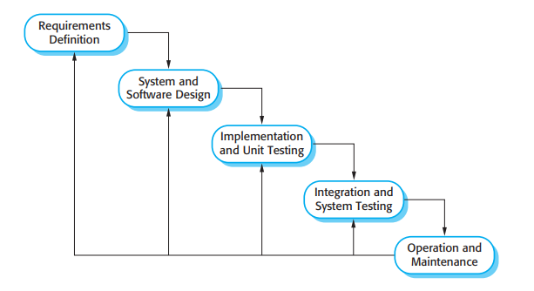 [1]
The Waterfall method can be useful in some situations. For example it helps you make all the documents at the beginning, which is important for legal agreements, with restaurants and delivery partners. It also helps you set goals, which makes it easier to manage a big team. The Waterfall method works well for things that do not change often like the part of the system where users register or where they can see the menu.
The problem with this approach is that Food delivery is always changing. The menus are different every day new restaurants are. Old ones are leaving and other companies are coming up with new features that Food delivery needs to have too. The Waterfall method does not work well for Food delivery because it makes a plan at the beginning and does not let you make any changes, on. This means that you do not find out about problems until you are testing everything and by that time you have already spent most of your money on Food delivery.
Why I would not pick it: A food delivery platform is never truly "finished" — it evolves constantly based on feedback from all three sides. A single-pass method is simply not built for that reality [7].
Incremental Development Method
Instead of delivering everything at once, Incremental breaks the system into meaningful pieces and ships each one as it is ready [8]. Users get a working product early, and each release adds more capability.
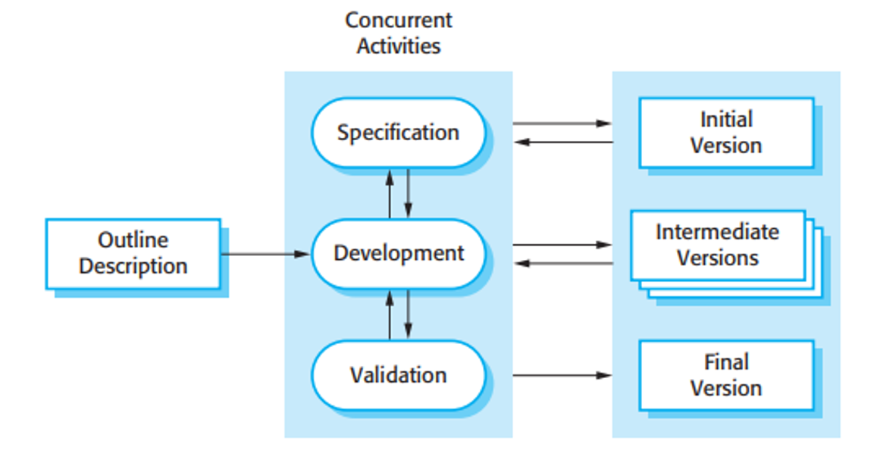 [1]
Where it works: A basic live version means real feedback from real users early. You see which features actually get used. Revenue starts from early orders. First-release bugs get fixed before they affect the full system.
Stages: Stage 1 (Months 1-4): registration, restaurant listing, basic cart, cash on delivery, order status. Stage 2 (Months 5-8): GPS tracking, digital payments, ratings, restaurant dashboard, notifications. Stage 3 (Months 9-12): promo codes, subscription, support chat, earnings dashboard. Stage 4 (Months 13-16): advanced filters, scheduled orders, group ordering, loyalty, analytics.
Where it struggles: All three sides — customer, restaurant, delivery — must work together from Stage 1. If the restaurant or delivery app is weak, the whole system breaks even if the customer side looks fine. Payment security cannot wait until Stage 2.
My take: Incremental is a genuinely strong candidate. MVP-first-then-iterate is how many food-tech startups succeed. The risk is poor early architecture making later stages feel like rebuilding from scratch [9].
Spiral Method
The Spiral method is organized around one idea that the other two methods treat as secondary: before you build anything in a given cycle, you sit down and think hard about what could go wrong [10]. Every loop of the spiral starts with planning, moves to risk analysis, then to building, then to evaluation — and the size of each loop grows as the project matures.

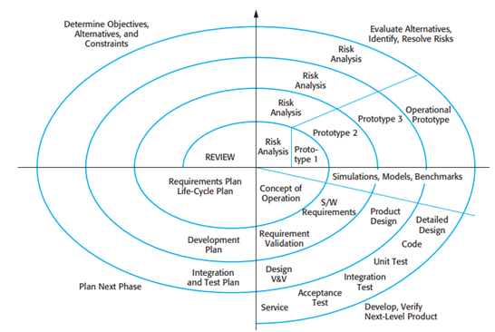
[1]
Where Spiral works well is with food delivery. This is because food delivery has a lot of things that can go wrong and cause problems for the business. Spiral is the way that always asks "what is the biggest risk right now?" before starting to build something new. Problems like getting restaurants, on board, payment issues people trying to cheat the system and the website crashing when it is really busy are much cheaper to fix if you catch them early. Spiral helps with food delivery by finding these problems before they become issues.
Key risks for food delivery are really problems. For example food delivery companies have to deal with orders reaching customers, which can really hurt the trust people have in them. Then there are payment failures that happen in the middle of checkout. Sometimes delivery partners just do not pick up the orders they are supposed to. The system can even crash on a Saturday when lots of people are trying to order dinner. Some partners might also mark orders as delivered when they really are not.. To make things worse rules, about GST or labor for gig workers can change.
Each Spiral loop is designed to fix the pressing of these food delivery problems before the company keeps building on their system.
Doing a risk analysis every time we make a change is slower and it costs more money. The thing is, not every single feature we work on is a high risk thing. For example loyalty rewards do not need to be checked carefully as payments do. Sometimes the people we are working with want things done quickly. They get frustrated with our loop structure.
My take: Spiral is right here because the damage from getting food delivery wrong is visible and public. A restaurant getting wrong orders for a week stops trusting the platform. A customer charged for a delivery that never came posts about it online. Spiral forces you to prevent those situations rather than discover them after the damage is done [11].
Comparative Analysis:
Aspect | Waterfall | Incremental | Spiral
Functional Requirements | Fixed at start; hard to add new services later | Features added step-by-step in releases | Requirements reviewed and improved each cycle
Non-Functional Requirements | Planned early; hard to improve later | Performance improves with each release | Performance & security checked every cycle
Risk Management | Risks identified late | Some risks handled during updates | Strong risk analysis in every cycle
Change Handling | Changes costly and difficult | Changes easier between increments | Changes expected and managed continuously
Time Constraints | Full system delivered late | Useful features delivered faster | Moderate speed due to repeated cycles
Cost Constraints | Predictable initially but costly to change | Cost spread across stages | Higher cost due to risk analysis
Suitability for Swiggy | Less suitable for evolving platform | Highly suitable for gradual growth | Suitable for complex, high-risk upgrades

Functional & Non-Functional Requirements Impact
How Requirements Were Gathered:
Requirements were gathered by [12]: using Swiggy and Zomato and reading restaurant and delivery partner forums, studying one-star app reviews for common frustrations, reviewing food safety and gig economy regulations, mapping every step of an order from tap to doorstep, and identifying failure points at each stage.
Functional Requirements:
- Customer Accounts: Quick sign-up via phone OTP, stash addresses, link payments, revisit past orders anytime.
- Restaurant Discovery: Sort spots by distance, stars, wait time—listings packed with menu pics, costs, tweaks like extra spice, and stock status.
- Ordering: Cart it up, punch in promos, pick drop spot and pay style, confirm—system double-checks stock and quotes arrival before lock-in.
- Live Tracking: Timeline unfolds for you: confirmed, cooking, rider tapped, grabbed, en route, dropped. Map pings rider spot every 5 seconds.
- Payments: UPI, cards, banks, wallets, cash at door. Cancellations trigger refunds in 5-7 days; receipts hit email and text.
- Restaurant Dashboard: Orders ping live, accept and tweak status, flag pickup-ready, hit pause if kitchen chaos hits.
- Delivery Partner App: Grab pickup alerts, GPS to eatery, verify grab, reroute to door, snap optional proof on drop.
- Ratings: Split scores for food joint and rider—low ones auto-flag for a look.
- Customer Support: Chat bubbles for mix-ups, delays, pay glitches—sort refunds or redos right there, bump to human if stuck.
- Admin Dashboard: City-wide order radar, jump-in powers, coverage checks, cash tracking, compliance printouts on demand.

Non-Functional Requirements:
- Speed: They can tap in under 60 seconds after they place an order. The position of the rider gets updated every 5 seconds. The pages on the app open quickly it takes just 2 seconds and this is true even, for basic phones that are not very powerful. Speed of the app is very good.
- Scale: Chew through 100,000 orders at once, 50,000 payments hourly—no hiccups on IPL finals or New Year's madness.
- Reliability: The website is really reliable. It is up. Running almost all the time with a Rock-steady 99.95% uptime. They make any changes during the quiet hours of 3-5am. When it comes to payments they get it 99.97% of the time on the first try. This means that reliability of the website is very good. The reliability of the website is something that they take seriously.
- Security: We keep your payments safe, with encryption so they are never stored on your device. We only show the riders locations to the customer who booked them. Our logins are protected from brute-force hacks. We do not share any of your information with the kitchens. Our customer information is kept private and secure and payments are always locked in encryption to keep you safe.
- Usability: The software is really easy to use. You can start using it away no need to read a big manual. It works with languages like Hindi, Kannada, Tamil and English. It is also very helpful for people who cannot see well because it has a special screen reader. If you make a mistake it will tell you what is wrong and how to fix it which is really helpful. The error messages, for the software are actually useful. Explain what you did wrong.
- Compliance: GST nailed on every bill, PCI-DSS for cash flow, gig worker rights and privacy per Indian law, plus food safety logs where rules demand.
MAKING SURE THE REQUIREMENTS ARE CORRECT:
Getting requirements written down is only half the job — confirming they are right is the other half [13]. I would do this through: review sessions with customers, restaurant owners, and delivery partners flagging anything that does not match reality; clickable prototypes of the ordering flow, tracking screen, and restaurant dashboard tested with real users before coding; a concrete test case for every functional requirement (if one cannot be written, the requirement needs rewriting); data flow and sequence diagrams showing how information moves across all three sides; and four sign-off sessions — Week 1 users, Week 2 engineers, Week 3 legal and finance, Week 4 management.
PROBLEMS TO EXPECT WHILE CHECKING:
There are three groups that want things. Customers want to pay prices get their food fast and not have to pay extra fees. This is not what restaurants want. Restaurants want people to buy food so they make more money and they want more time to get the food ready. Then there are the riders they want to drive distances and get paid well. My solution is to make a list of what each group wants and then write down all the things they have to give up to get what they want. This way everything is clear and easy to see.
When it comes to delivery promises things do not always go as planned. Traffic jams can cause delays. Slow kitchens can also make things take longer. Downpours can really mess up the schedule.
To make things more realistic we should look at what happened in the past in markets. We can use this information to set targets that make sense. For example we can have different time windows, like gold, silver and bronze delivery windows. This way delivery promises for gold windows are the fastest silver windows and bronze windows are the slowest.
Using promo codes seems simple. It can get really complicated with all the different rules like stacks and cut-offs and limits on how many users can use them. To avoid this mess you should make a list of every combination in your requirements checklist. Do not just guess or make assumptions. Promo codes can be tricky so be thorough when you are listing all the requirements, for promo codes.
Regs shift overnight—GST tweaks, gig labour tags, safety logs. Bake quarterly audits into the roadmap from day one.
WHAT I RECOMMEND AND WHY:
After looking at all three methods, Spiral is my choice for a food delivery platform, and here is why. Food delivery platforms fail publicly — a restaurant getting wrong orders leaves the platform, an underpaid delivery partner stops showing up, a customer charged for a missing delivery posts about it online. Spiral is designed to eliminate those risks before they hurt the business, not after [14]. The three-sided marketplace also makes Spiral particularly fitting — the evaluation phase after each loop is a natural checkpoint to confirm all three groups are still being served well.
My Spiral plan: Loop 1 (Months 1-3) — prototype with basic ordering, tested with 5 restaurants and 20 real customers, validating order assignment logic. Loop 2 (Months 4-7) — payments, live tracking, delivery partner app, city-block load tests. Loop 3 (Months 8-12) — subscriptions, support, promotions, admin tools, full city pilot. Loop 4 (Months 13-18) — public launch, group ordering, scheduled delivery, compliance certifications.
CONCLUSION:
Spiral is my clear recommendation — but Incremental is not a bad answer if speed to market is the top priority.
Waterfall does not fit a fast-changing consumer product. It gives you no way to adapt when restaurants ask for features you missed, or when a competitor launches something your users suddenly want.
Incremental is genuinely solid for food-tech. Getting a working app to real users in four months and iterating is a proven approach. The risk is that poor architecture decisions early make later stages increasingly difficult.
Spiral wins because food delivery involves real money, real food, and real people waiting at their door. Payment fraud, delivery partner reliability, and peak-hour crashes need to be dealt with from day one — and Spiral is the only method that formally builds that into every cycle [14].
Key lessons: A system's risk profile should drive method selection. Real-time multi-group coordination requirements are the hardest to get right. Validate with all three user groups, not just the loudest one. A prototype before production code almost always saves time.
Final recommendation: Spiral method, four loops anchored to risk review, real-world restaurant-and-partner pilot at the end of Loop 2.

REFERENCES:
[1] I. Sommerville, "Software Engineering," 10th ed., Pearson Education, 2015.
[2] R. S. Pressman and B. R. Maxim, "Software Engineering: A Practitioner's Approach," 8th ed., McGraw-Hill Education, 2014.
[3] G. G. Parker, M. W. Van Alstyne, and S. P. Choudary, "Platform Revolution: How Networked Markets Are Transforming the Economy," W. W. Norton and Company, 2016.
[4] The Standish Group, "CHAOS Report 2020: Beyond Infinity," The Standish Group International, 2020.
[5] S. Sood and A. Pande, "Growth of Food Delivery Platforms in India: A Case Study of Swiggy," Journal of Business Strategy and Execution, vol. 12, no. 1, pp. 45-60, 2021.
[6] W. W. Royce, "Managing the Development of Large Software Systems," Proceedings of IEEE WESCON, vol. 26, no. 8, pp. 1-9, 1970.
[7] B. W. Boehm, "A Spiral Model of Software Development and Enhancement," IEEE Computer, vol. 21, no. 5, pp. 61-72, May 1988.
[8] C. Larman and V. R. Basili, "Iterative and Incremental Development: A Brief History," IEEE Computer, vol. 36, no. 6, pp. 47-56, June 2003.
[9] K. Beck et al., "Manifesto for Agile Software Development," Agile Alliance, 2001.
[10] B. W. Boehm, "Software Risk Management: Principles and Practices," IEEE Software, vol. 8, no. 1, pp. 32-41, Jan. 1991.
[11] P. Kruchten, "The Rational Unified Process: An Introduction," 3rd ed., Addison-Wesley Professional, 2003.
[12] K. Pohl, "Requirements Engineering: Fundamentals, Principles, and Techniques," Springer Publishing Company, 2010.
[13] IEEE Computer Society, "IEEE Recommended Practice for Software Requirements Specifications," IEEE Std 830-1998, 1998.
[14] A. van Lamsweerde, "Requirements Engineering: From System Goals to UML Models to Software Specifications," John Wiley & Sons, 2009.

DECLARATION OF ACADEMIC INTEGRITY
I hereby declare that this assignment is my original work and has not been copied or plagiarized from any source. All references and resources used have been properly cited. I understand that any form of academic dishonesty will result in severe consequences including but not limited to forfeiting my marks for this assignment.
Student Name: Avani S. Rao
USN: NNM24IS047
Date: 14-02-2026
Signature:
