SOFTWARE PROCESS MODELS AND REQUIREMENTS ENGINEERING
Building an Online Food Delivery System Like Swiggy — Which Development Approach Actually Works?

Course Name: Introduction to Software Engineering
Course Code: IS1103-1
Assignment Number & Title: Assignment 1 - Software Process Models and Requirements Engineering
Student Name: Avani S. Rao
USN: NNM24IS047
Semester & Section: 4th semester & ‘A’ section
Department: ISE
Institution Name: NMAM Institute of Technology
Academic Year: 2025-26
Instructor Name: Dr.Jason Elroy Martis

ABSTRACT
When you open a food delivery app, it seems simple. You just tap on it, look at the options, and place your order. But if you think about it, there's a lot happening behind the scenes. The people at the restaurant start preparing your food. A delivery person picks it up and uses their phone's map to navigate through traffic. Your payment is also processed securely. The food delivery app has to handle many orders at the same time across the city. It's dealing with thousands of orders all at once in the same city. I want to compare three software development methods: Waterfall, Incremental, and Spiral. I want to see how each of these methods would work for a company like Swiggy, which is a food delivery service and needs to be fast. I want to know how each method handles changes in what the software needs to do. I also want to know how each method ensures everything works properly. I want to know how each method deals with possible problems that might come up. I want to know how each method handles the cost of development. I also want to know what needs to be done by the software and a plan for testing Waterfall, Incremental, and Spiral so that everything works as it should. For me, Spiral is the best choice. In the real world of food delivery, customer tastes can change overnight, restaurant needs can shift, and logistics can be really tough because of traffic or bad weather.

GITHUB REPOSITORY LINK
GitHub URL: https://github.com/adooravani22-cyber/Food-Delivery-SDLC-Case-Study

INTRODUCTION
Software engineering means building software in an organized way rather than just jumping in and hoping it works [1]. Every project follows a Software Development Lifecycle — a path from initial idea to a finished product real people use. The method you choose affects whether it finishes on time, stays within budget, and ends up good [2].
The system I chose is an Online Food Delivery System, modeled on Swiggy and Zomato. Nowadays, people use the internet to get things they need. This has changed the way we get food and other things we need every day. These platforms connect three very different groups customers who want food, restaurants that cook it, and delivery partners who bring it all coordinated in real time [3]. A good food delivery system has to do a lot of things at the time. It has to let people order food in time. It has to work with restaurants to get the food ready. It has to process payments. It has to figure out the way to get the food to people. It has to help customers when they have problems. The food delivery system has to do all these things for a lot of people at the time. The food delivery system has to support millions of users at once.
These big platforms are really driven by software. They are always changing. So it is very important to choose the right Software Development Life Cycle model to manage all the requirements, risks, system upgrades and to keep the Software Development Life Cycle running and the whole system stable. The Software Development Life Cycle model is key, to making sure everything works well.
This report is, about looking at three Software Development Life Cycle models to see how they compare to each other. The Software Development Life Cycle models are the focus of this report.
• Waterfall Model
• Incremental Development Model
• Spiral Model
PROBLEM STATEMENT
This piece of writing is all about how we can compare the Waterfall and Incremental and Spiral models when we are creating the Online Food Delivery System. Here, we are going to discuss how Waterfall models and Incremental models and Spiral models deal with requirements and risks, and how they deal with time and cost.
I will write a good requirements document for the Online Food Delivery System. I will write a plan to ensure the Online Food Delivery System works as it should.
Assumptions:
- It’s a three-way marketplace.
- There are 25-35 engineers.
- It’s going to take 12-18 months.
- It’s funded by a backed food tech startup.
- It’s going to be cross-platform, Android and iOS, and cloud-based.
CASE STUDY: ONLINE FOOD DELIVERY SYSTEM (SWIGGY)
Swiggy, started in Bangalore in 2014, grew across hundreds of Indian cities by solving this coordination at scale [5]. The customer will be able to see what food is available and what others say about the food, while the restaurant will be able to see when a customer is ordering food, and send it out so it can be delivered, and the person who delivers it will be able to locate the restaurant and the house where he needs to deliver, all of this happening through the food delivery system provided by Swiggy. The online food delivery system is, in a sense, like the brain, coordinating everything so that everything works together. The online food delivery system needs to work so that food can be delivered in time. These platforms need to be really strong all the time. People want to be able to log in when they are getting ready for dinner or during big festivals. They also want to be able to pay and get their food on the table in 30 minutes. The platforms have to deal with a lot of traffic at these times. Sometimes it is 10 times more, than usual. They have to be able to handle this without any problems or slowing down. The food platforms have to keep working so people can get their food on time. The platforms have to be strong so they do not fail when people need them to work.
On security, it's non-negotiable: think full encryption from start to finish, extra login checks for payments, smart fraud-spotting tech, and tight APIs connecting eateries, riders, and banks. Real-time GPS tracking weaves in too, all while slamming the door on hackers.
Main Things the System Does
•Customers look at the menus of restaurants. They see photos of the food the prices, what other people think of the restaurant and how long it will take for the food to be delivered to them. They like to know the estimated delivery time of the restaurant.
•Live search filters by cuisine type, distance, price range, and dietary preferences.
• You can manage your cart apply a promo code to get a discount and place your order when you are ready to buy the things you want. Managing your cart and applying a promo code is easy. Then you can place your order. Cart management, promo code application and order placement are all things you can do when you shop online.
•Real-time order tracking from restaurant acceptance to delivery partner pickup to doorstep.
•Multiple payment options: UPI, net banking, cards, wallets, and cash on delivery.
•Restaurant partners get a special dashboard to manage orders. This dashboard helps them do a things with the orders they get. They can accept orders prepare orders and then mark the orders as ready when they are done with them. This is, about the orders that the restaurant partners get.
•Delivery partners get directions to the restaurant. Then they get directions to the customer so the delivery partners know where the restaurant is and where the customer is and the delivery partners can find their way, to the customer after they pick up the food from the restaurant.
•Ratings and reviews for both restaurants and delivery partners after each order.
•Swiggy One subscription for reduced delivery fees and priority service.
•Customer support chat for wrong orders, late deliveries, and refund requests.
•Admin dashboard for monitoring city-wide operations, partner performance, and revenues.

Waterfall Method
Waterfall means you complete each phase entirely before starting the next one [6]. You gather all requirements, then design the whole system, then build it, then test it, and then launch. No going back.
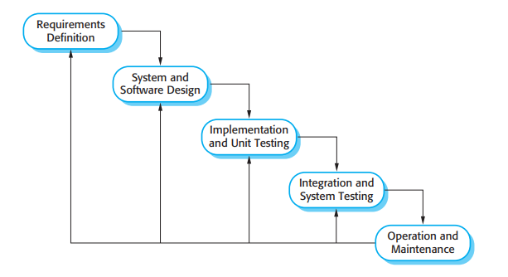 [1]
The Waterfall method can be useful in some situations. For example it helps you make all the documents at the beginning, which is important for legal agreements, with restaurants and delivery partners. It also helps you set goals, which makes it easier to manage a big team. The Waterfall method works well for things that do not change often like the part of the system where users register or where they can see the menu.
The problem with this approach is that Food delivery is always changing. The menus are different every day because new restaurants are opening, and old ones are closing, and other companies are coming up with new features that Food delivery needs too. The Waterfall method is not good for Food delivery because it helps you make a plan at the beginning and then does not allow you to make any changes, on. That means you do not know about the problems until you are testing everything, and by then, you have already spent most of your money on Food delivery.
Why I would not pick it: Food delivery is something that is always changing, and it changes based on the feedback of all three sides. A single-pass method is simply not built for that reality [7].
Incremental Development Method
Instead of delivering everything at once, Incremental breaks the system into meaningful pieces and ships each one as it is ready [8]. Users get a working product early, and each release adds more capability.
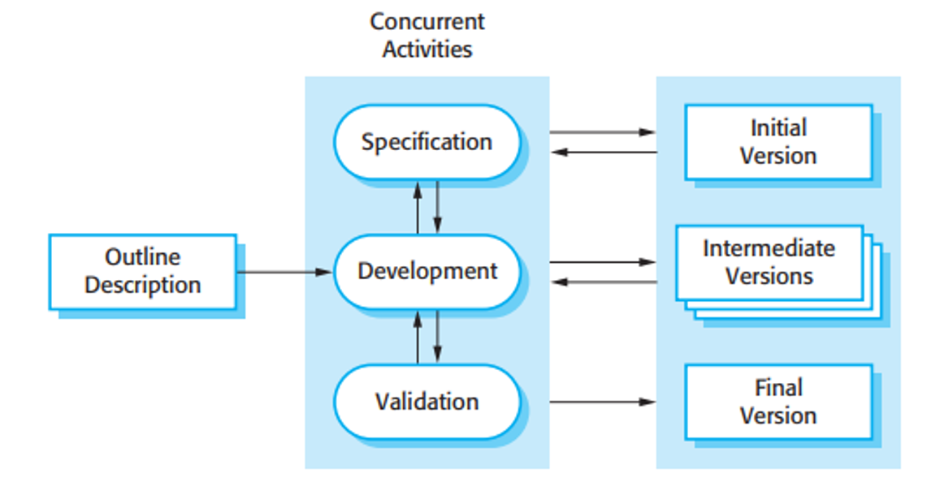 [1]
Where it works: A basic live version means real feedback from real users early. You see which features actually get used. Revenue starts from early orders. First-release bugs get fixed before they affect the full system.
Stages: Stage 1 (Months 1-4): registration, restaurant listing, basic cart, cash on delivery, order status. Stage 2 (Months 5-8): GPS tracking, digital payments, ratings, restaurant dashboard, notifications. Stage 3 (Months 9-12): promo codes, subscription, support chat, earnings dashboard. Stage 4 (Months 13-16): advanced filters, scheduled orders, group ordering, loyalty, analytics.
Where it struggles: The system requires all three sides, i.e., the customer, the restaurant, and the delivery, to work in tandem from the first stage. If the restaurant or the delivery app side is weak, the whole system collapses, even if the customer side looks good. Payment security cannot wait until Stage 2.
My take: Incremental is a genuinely strong candidate. MVP-first-then-iterate is how many food-tech startups succeed. The risk is poor early architecture making later stages feel like rebuilding from scratch [9].
Spiral Method
The Spiral method is organized around one idea that the other two methods treat as secondary: before you build anything in a given cycle, you sit down and think hard about what could go wrong [10]. Every loop of the spiral starts with planning, moves to risk analysis, then to building, then to evaluation — and the size of each loop grows as the project matures.

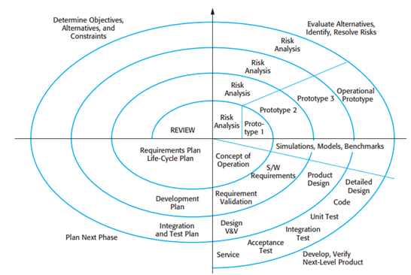
[1]
Where Spiral works well is with food delivery. This is because food delivery has a lot of things that can go wrong and cause problems for the business. Spiral is the way that always asks "what is the biggest risk right now?" before starting to build something new. Problems like getting restaurants, on board, payment issues people trying to cheat the system and the website crashing when it is really busy are much cheaper to fix if you catch them early. In this way, Spiral helps with food delivery by identifying these issues before they become a problem.
The key issues for food delivery are, in reality, problems. For example, food delivery companies need to address issues with orders reaching customers, which can really affect people's trust in them. Then there are issues with payments not being processed in the middle of a checkout. Sometimes, the food delivery people just do not pick up orders they are supposed to. Sometimes, the system crashes on a Saturday, for example, because many people want to order dinner. Sometimes, some food delivery people mark orders as delivered even if they are not. And to top it all off, there are rules about GST and labor for gig workers.
Each loop of Spiral is meant to address the pressing of food delivery's key issues before a food delivery company continues to work on their system.
It would be slower and would cost us a lot of money to do a risk analysis every time we want to make a change. The thing is, not all of the features we are working on are key issues. For example, loyalty rewards are not as key as making sure our payments are okay. Sometimes, our business partners want us to work quickly. They get frustrated with our loop structure.
My opinion on this is that Spiral is right here because, for example, if a restaurant gets wrong orders for a week, they stop trusting food delivery. A customer charged for a delivery that never came posts about it online. Spiral forces you to prevent those situations rather than discover them after the damage is done [11].
Comparative Analysis:
Aspect | Waterfall | Incremental | Spiral
Functional Requirements | Fixed at start; hard to add new services later | Features added step-by-step in releases | Requirements reviewed and improved each cycle
Non-Functional Requirements | Planned early; hard to improve later | Performance improves with each release | Performance & security checked every cycle
Risk Management | Risks identified late | Some risks handled during updates | Strong risk analysis in every cycle
Change Handling | Changes costly and difficult | Changes easier between increments | Changes expected and managed continuously
Time Constraints | Full system delivered late | Useful features delivered faster | Moderate speed due to repeated cycles
Cost Constraints | Predictable initially but costly to change | Cost spread across stages | Higher cost due to risk analysis
Suitability for Swiggy | Less suitable for evolving platform | Highly suitable for gradual growth | Suitable for complex, high-risk upgrades

Functional & Non-Functional Requirements Impact
How Requirements Were Gathered:
Requirements were gathered by [12]: using Swiggy and Zomato and reading restaurant and delivery partner forums, studying one-star app reviews for common frustrations, reviewing food safety and gig economy regulations, mapping every step of an order from tap to doorstep, and identifying failure points at each stage.
Functional Requirements:
- Customer Accounts: Quick sign-up via phone OTP, stash addresses, link payments, revisit past orders anytime.
- Restaurant Discovery: Sort spots by distance, stars, wait time—listings packed with menu pics, costs, tweaks like extra spice, and stock status.
- Ordering: Cart it up, punch in promos, pick drop spot and pay style, confirm—system double-checks stock and quotes arrival before lock-in.
- Live Tracking: Timeline unfolds for you: confirmed, cooking, rider tapped, grabbed, en route, dropped. Map pings rider spot every 5 seconds.
- Payments: UPI, cards, banks, wallets, cash at door. Cancellations trigger refunds in 5-7 days; receipts hit email and text.
- Restaurant Dashboard: Orders ping live, accept and tweak status, flag pickup-ready, hit pause if kitchen chaos hits.
- Delivery Partner App: Grab pickup alerts, GPS to eatery, verify grab, reroute to door, snap optional proof on drop.
- Ratings: Split scores for food joint and rider—low ones auto-flag for a look.
- Customer Support: Chat bubbles for mix-ups, delays, pay glitches—sort refunds or redos right there, bump to human if stuck.
- Admin Dashboard: City-wide order radar, jump-in powers, coverage checks, cash tracking, compliance printouts on demand.

Non-Functional Requirements:
- Speed: They can tap in under 60 seconds after they place an order. The position of the rider gets updated every 5 seconds. The pages on the app open quickly it takes just 2 seconds and this is true even, for basic phones that are not very powerful. Speed of the app is very good.
- Scale: Chew through 100,000 orders at once, 50,000 payments hourly—no hiccups on IPL finals or New Year's madness.
- Reliability: The website is really reliable. It is up. Running almost all the time with a Rock-steady 99.95% uptime. They make any changes during the quiet hours of 3-5am. When it comes to payments they get it 99.97% of the time on the first try. This means that reliability of the website is very good. The reliability of the website is something that they take seriously.
- Security: We keep your payments safe, with encryption so they are never stored on your device. We only show the riders locations to the customer who booked them. Our logins are protected from brute-force hacks. We do not share any of your information with the kitchens. Our customer information is kept private and secure and payments are always locked in encryption to keep you safe.
- Usability: The software is really easy to use. You can start using it away no need to read a big manual. It works with languages like Hindi, Kannada, Tamil and English. It is also very helpful for people who cannot see well because it has a special screen reader. If you make a mistake it will tell you what is wrong and how to fix it which is really helpful. The error messages, for the software are actually useful. Explain what you did wrong.
- Compliance: GST nailed on every bill, PCI-DSS for cash flow, gig worker rights and privacy per Indian law, plus food safety logs where rules demand.
MAKING SURE THE REQUIREMENTS ARE CORRECT:
Getting requirements written down is only half the job — confirming they are right is the other half [13]. I would do this through: review sessions with customers, restaurant owners, and delivery partners flagging anything that does not match reality; clickable prototypes of the ordering flow, tracking screen, and restaurant dashboard tested with real users before coding; a concrete test case for every functional requirement (if one cannot be written, the requirement needs rewriting); data flow and sequence diagrams showing how information moves across all three sides; and four sign-off sessions — Week 1 users, Week 2 engineers, Week 3 legal and finance, Week 4 management.
PROBLEMS TO EXPECT WHILE CHECKING:
There are three groups that want things. Customers want to pay prices get their food fast and not have to pay extra fees. This is not what restaurants want. Restaurants want people to buy food so they make more money and they want more time to get the food ready. Then there are the riders they want to drive distances and get paid well. My solution is to make a list of what each group wants and then write down all the things they have to give up to get what they want. This way everything is clear and easy to see.
When it comes to delivery promises things do not always go as planned. Traffic jams can cause delays. Slow kitchens can also make things take longer. Downpours can really mess up the schedule.
To make things more realistic we should look at what happened in the past in markets. We can use this information to set targets that make sense. For example we can have different time windows, like gold, silver and bronze delivery windows. This way delivery promises for gold windows are the fastest silver windows and bronze windows are the slowest.
Using promo codes seems simple. It can get really complicated with all the different rules like stacks and cut-offs and limits on how many users can use them. To avoid this mess you should make a list of every combination in your requirements checklist. Do not just guess or make assumptions. Promo codes can be tricky so be thorough when you are listing all the requirements, for promo codes.
Regs shift overnight—GST tweaks, gig labour tags, safety logs. Bake quarterly audits into the roadmap from day one.
WHAT I RECOMMEND AND WHY:
After looking at all three methods, Spiral is my choice for a food delivery platform, and here is why. Food delivery platforms fail publicly — a restaurant getting wrong orders leaves the platform, an underpaid delivery partner stops showing up, a customer charged for a missing delivery posts about it online. Spiral is designed to eliminate those risks before they hurt the business, not after [14]. The three-part marketplace also makes the Spiral model very appropriate, as the evaluation phase at the end of each loop is a natural time to ensure that all three groups are being well-served.
My proposed Spiral Model:
Loop 1 (Months 1-3): Prototype with basic ordering functionality, tested with 5 restaurants and 20 real customers to validate the logic of the order assignment process.
Loop 2 (Months 4-7): Payments, live tracking, app for delivery partners, and city block load tests.
Loop 3 (Months 8-12): Subscriptions, support, promotions, admin tools, and a full-city pilot.
Loop 4 (Months 13-18): Public launch, group ordering, scheduled delivery, and compliance certifications.
CONCLUSION:
In conclusion, the Spiral Model is the recommended approach. The Incremental Model is a very acceptable answer if the only thing that mattered was speed to market.
The Waterfall Model is completely inappropriate for a rapidly changing consumer product. There is no way to react to the restaurant requests for features that were not included or to the competitor's introduction of a feature that your users suddenly want.
The Incremental Model is a very good model for the food tech space. Getting the app working and into the hands of users in four months is a proven approach. The only drawback is that bad architecture decisions early on will only get progressively worse as the project goes on.
The reason the Spiral Model is the winner is that it is the only model that accounts for the fact that this is a food delivery app with real money, real food, and real people waiting at the door. The issues with payment fraud, delivery partner reliability, and peak hour crashes all need to be addressed from day one – and the only model that allows that is the Spiral Model [14].
Key Lessons Learned:
The risk profile of the system should dictate the appropriate model to use. The most difficult part to get correct is the ability to coordinate all three user groups in real time. The loudest user is not necessarily the most important user to validate with. A prototype before writing production code almost always saves time in the long run.
Final Recommendation:
The recommended approach is the Spiral Model with four loops based on risk reviews and a restaurant and partner pilot at the end of Loop 2.
REFERENCES:
- Sommerville, I. Software Engineering. Pearson Education.
- Pressman, R. S. Software Engineering: A Practitioner’s Approach. McGraw-Hill.
- Parker, G. G., Van Alstyne, M. W., & Choudary, S. P. – Platform Revolution: How Networked Markets Are Transforming the Economy, 2016.
- The Standish Group – CHAOS Report 2020: Beyond Infinity, 2020.
- Sood, S., & Pande, A. – Growth of Food Delivery Platforms in India: A Case Study of Swiggy, 2021.
- Royce, W. W. – Managing the Development of Large Software Systems, 1970.
- Boehm, B. W. – A Spiral Model of Software Development and Enhancement, 1988.
- Larman, C., & Basili, V. R. – Iterative and Incremental Development: A Brief History, 2003.
- Beck, K., et al. – Manifesto for Agile Software Development, 2001.
- Boehm, B. W. – Software Risk Management: Principles and Practices, 1991.
- Kruchten, P. – The Rational Unified Process: An Introduction, 2003.
- Pohl, K. – Requirements Engineering: Fundamentals, Principles, and Techniques, 2010.
- IEEE Computer Society – IEEE Recommended Practice for Software Requirements Specifications, 1998.
- van Lamsweerde, A. – Requirements Engineering: From System Goals to UML Models to Software Specifications, 2009.

DECLARATION OF ACADEMIC INTEGRITY
I hereby declare that this assignment is my original work and has not been copied or plagiarized from any source. All references and resources used have been properly cited. I understand that any form of academic dishonesty will result in severe consequences including but not limited to forfeiting my marks for this assignment.
Student Name: Avani S. Rao
USN: NNM24IS047
Date: 14-02-2026
Signature:
