PersonaSwitcher

# What is it?

PersonaSwitcher is a UI addon for Sitecore Preview mode which allows content editors to view and edit the current OMS profile. The main benefit of this is that it allows content editors to preview conditional rendering changes.

Content editors can either enter the profile values manually or predefine a set of values that act as a Persona definition. These allow you to define visitor archetypes such as a female professional photographer interested in macro lenses; you can then switch between these personas to test what they would see.

Finally you can view the active conditional rendering rules and the entire profile can be reset back to zero.

# How do I install it?

Simply download and install the package hosted at **** using the package manager, more details on how to use the package manager can be found on the SDN: <http://sdn.sitecore.net/SDN5/End%20User/Package%20Designer/Installation%20Wizard.aspx>

You shouldn’t need to reboot the app pool afterwards but I’d recommend doing it as a first step if anything goes wrong.

# Help! It doesn’t work!

Well in that case feel free to get in touch with me, Steve Green: [sgr@sitecore.net](mailto:sgr@sitecore.net)

Send through as much information as reasonably possible, preferably instructions on how to repeat the issue.

# How does it work?

Once installed you’ll see a new Change Persona button in the Preview mode ribbon as well as a Personas folder in the Marketing Centre, the former allows you to edit the profile in preview mode, the later allows you to create personas definitions.

Persona Definitions

You’ll find the package creates a persona folder item at /sitecore/system/Marketing Center/Personas under which you can create the individual persona definition items:

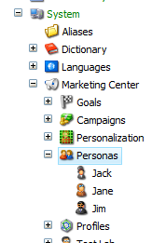

Persona definitions are predefined sets of scores that represent a visitor archetype. There are only 3 fields in the persona definition, a name, description and the scores themselves. The only important thing to note about the scores is that since the profile values field can only go to 10 I’ve had to multiple the values by 10 to make it useful. This means that in the example shown below the Persona Jack would have a Male score of 10 and a Beginner score of 100.

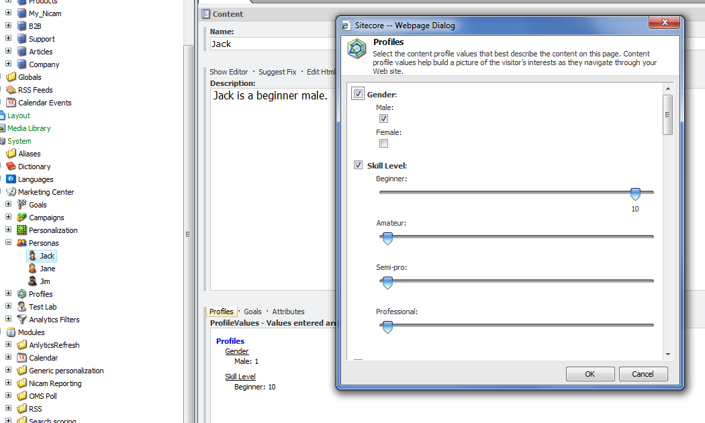

Profile Scores

The first is profile scores, this will list all your profiles and the keys, clicking on any key will allow you to change the set the value and refresh. 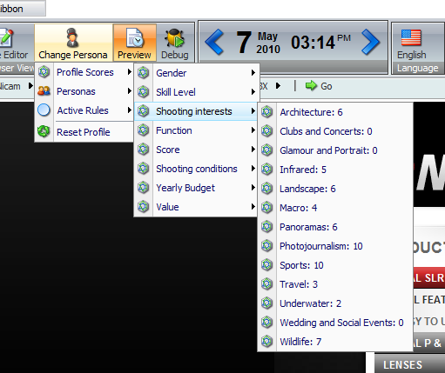

Personas

The second option is the Personas, these are predefined profile scores. Clikcing one of these will reset all other scores back to zero, and set all other keys to the values defined on the profile. In this example Jane has 100 in professional and 50 in female, she is also listed as the currently active Persona:

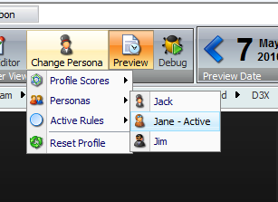

Active Rules

As the various profile scores increase various conditional rendering rules will be activated that change how the site appears. Active rules are highlighted by blue stars; inactive stars a listed with the rules icon. Beneath each rule heading is the definition of the rule conditions the same as would be shown in the rule editor interface.

