**Introduction of „Network Adapter Configuration Information“ Tool**

The tool „Network Adapter Configuration Information“ is developed using following technique and environment:

* Programming language: C#
* WPF
* Visual Studio 2022
* .NET Framework 4.7.2

The user interface is quite simple, in the Combobox next to label „**Adapter Name:**“, the indication text „Please select“ informs the user to select an adapter from the Combobox.

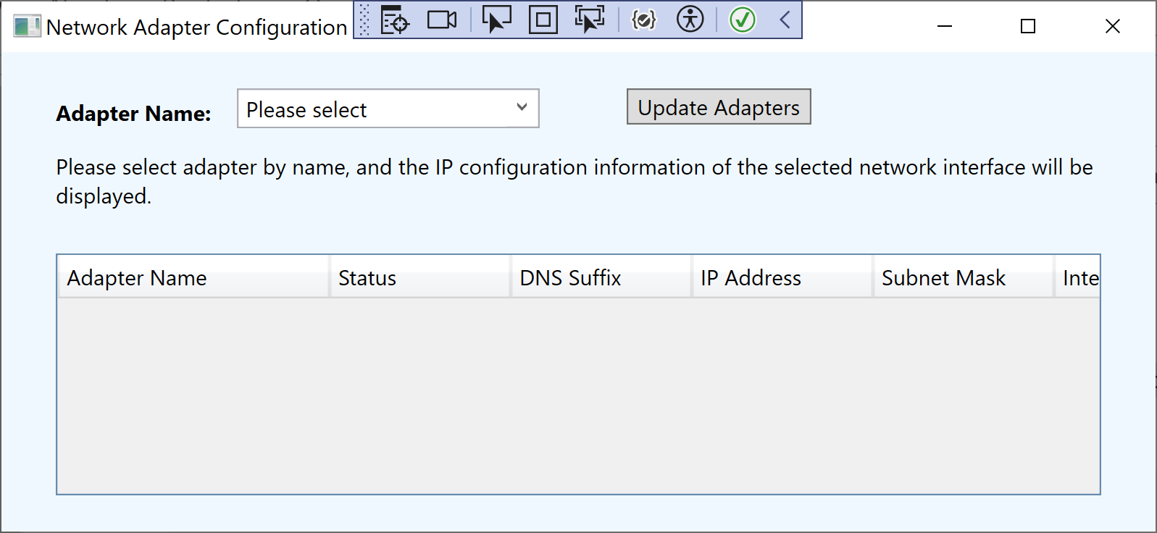

When the dropdown list is clicked, all the network adapters will be displayed. The user can select either a single adapter by name, or select all adapters by clicking „Select all adapters“.

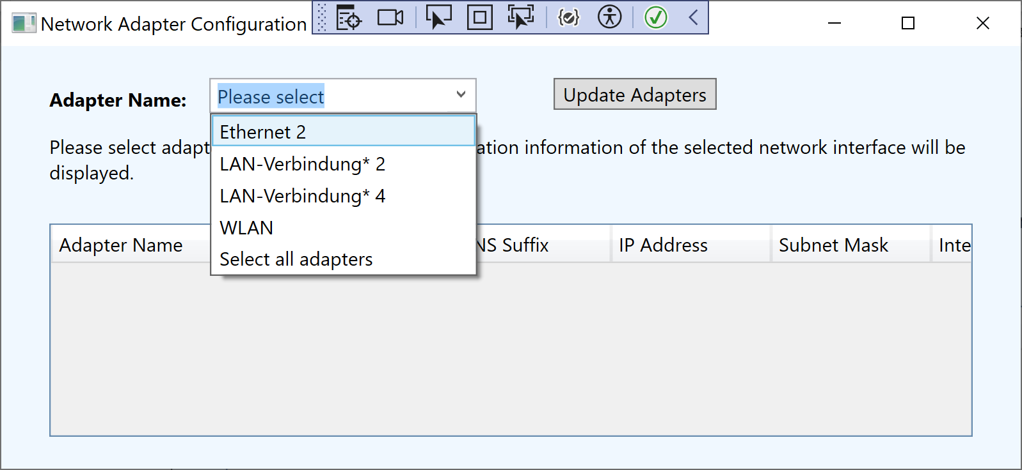

When one of them is selected, some related information of the selected adapter will be displayed in the Datagrid below:

* Adapter name
* Status
* DNS Suffix
* IP Address
* Subnet Mask
* Interface Type
* MAC-Address

The related information will be displayed based on the status of the adapter, some information is only meaningful when the adapter is connected, otherwise „N/A“ will be displayed when the adapter is disabled or disconnected.



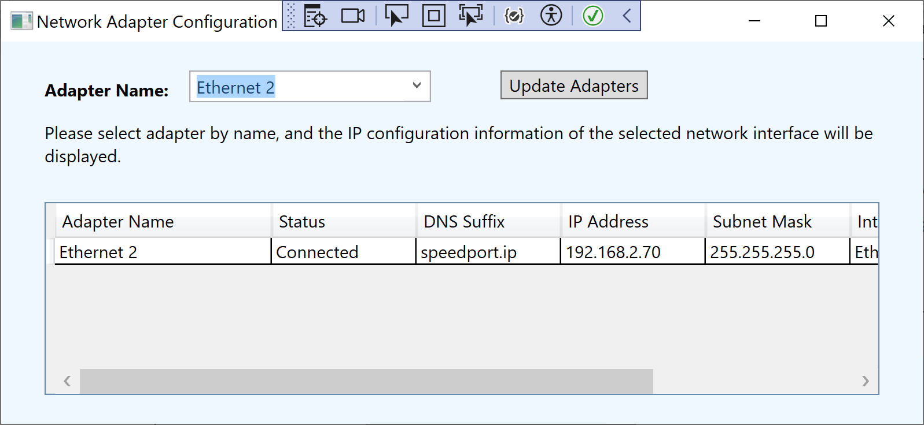

When selecting other adapter in the Combobox, the displayed information will be updated accordingly.

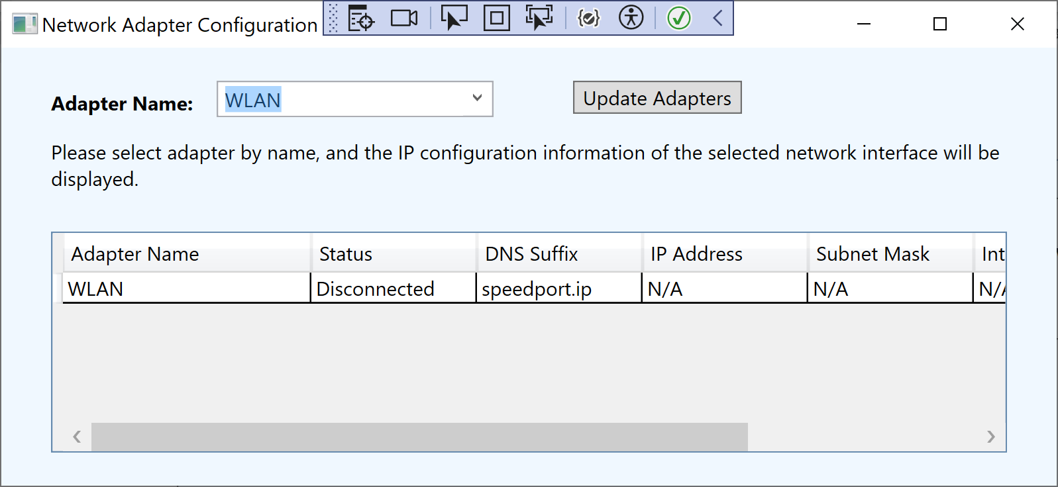

By selecting the option „Select all adapters“ the information of all different adapters will be listed as below.

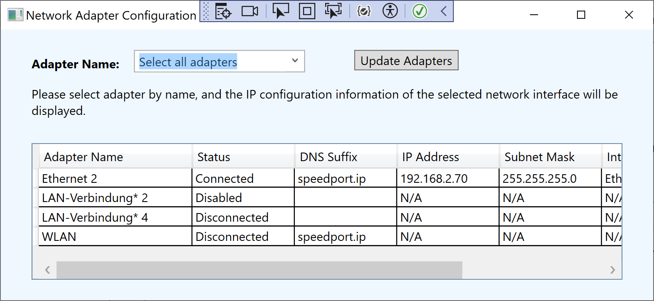

When the application is running, if some changes happens, e.g. an adapter is disconnected or disabled manually, click the „Update Adapters“ Button the adapter list and the related information will be updated accordingly.

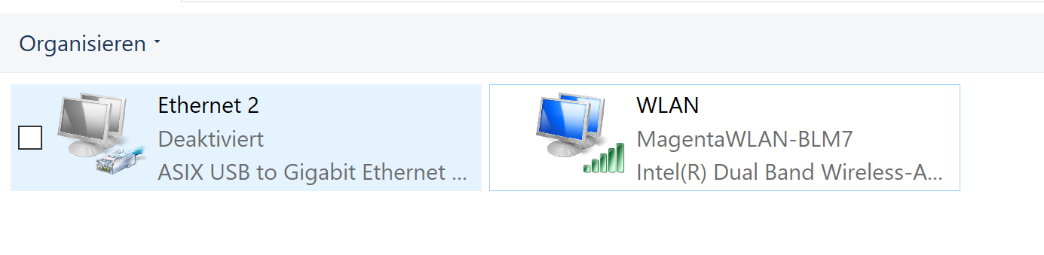

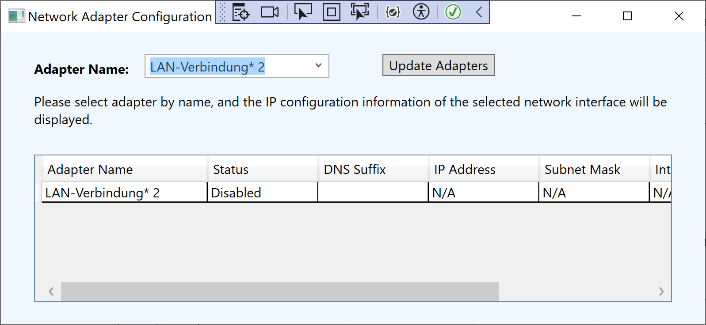

Some assumptions and decisions I have made during the development are listed below:

1. If only Ethernet adapters should be listed, another filter could be set. In this tool I set the filter to list any adapter whose Network Interface Type is not Loopback.
2. At the first glance I thought when selecting adapter by name, it means single selection, but when I reviewed the assignment I noticed a possible scenario is to select multiple adapters, in this case, maybe it is better to use some other control e.g. ListBox other than Combobox.
3. I have also considered if GetAllNetworkInterfaces() should be used here to get all adapters, or maybe in some other way e.g. using System.Management namespace and ObjectQuery to get all network adapters. The issue is if a disabled adapter can be returned when using GetAllNetworkInterfaces(). I tried on my own laptop and it seems to work, that‘s why I used GetAllNetworkInterfaces() for this tool.