Compilers Project #1

Qiao Zhang

To run the project, simply run make in your command line environment:
make
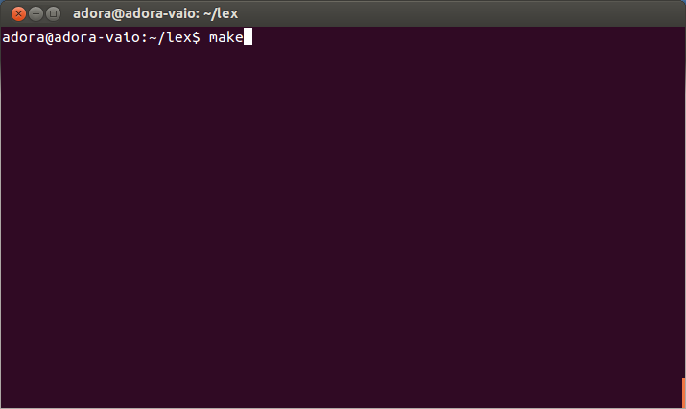

Screenshot of the output of the first program:
//Sorry I wasn't able to make the output look aligned... But the values are correct.

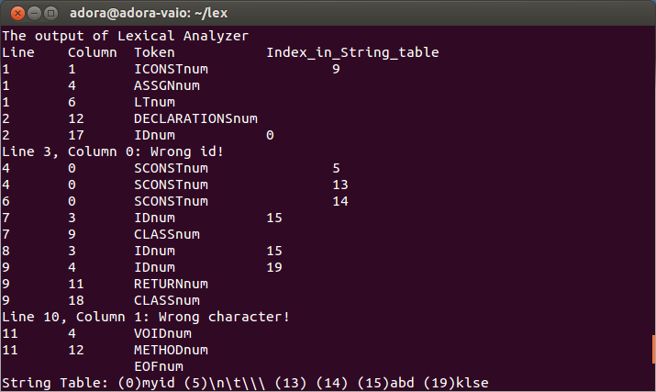

The output of the first text program (test1.mjava):

The output of Lexical Analyzer

Line Column Token Index_in_String_table

1 1 ICONSTnum 9

1 4 ASSGNnum

1 6 LTnum

2 12 DECLARATIONSnum

2 17 IDnum 0

Line 3, Column 0: Wrong id!

4 0 SCONSTnum 5

4 0 SCONSTnum 13

6 0 SCONSTnum 14

7 3 IDnum 15

7 9 CLASSnum

8 3 IDnum 15

9 4 IDnum 19

9 11 RETURNnum

9 18 CLASSnum

Line 10, Column 1: Wrong character!

11 4 VOIDnum

11 12 METHODnum

EOFnum

String Table: (0)myid (5)\n\t\\\ (13) (14) (15)abd (19)klse

Screenshot of the output of the second program:
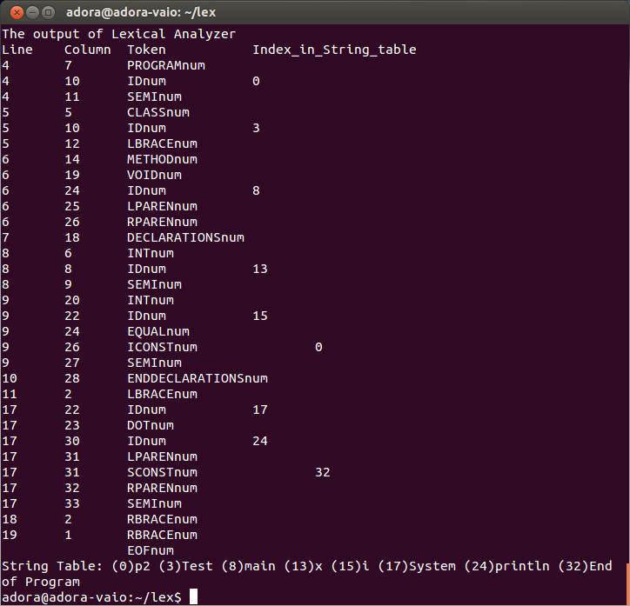

The output of the second text program (test2.mjava):

The output of Lexical Analyzer

Line Column Token Index_in_String_table

4 7 PROGRAMnum

4 10 IDnum 0

4 11 SEMInum

5 5 CLASSnum

5 10 IDnum 3

5 12 LBRACEnum

6 14 METHODnum

6 19 VOIDnum

6 24 IDnum 8

6 25 LPARENnum

6 26 RPARENnum

7 18 DECLARATIONSnum

8 6 INTnum

8 8 IDnum 13

8 9 SEMInum

9 20 INTnum

9 22 IDnum 15

9 24 EQUALnum

9 26 ICONSTnum 0

9 27 SEMInum

10 28 ENDDECLARATIONSnum

11 2 LBRACEnum

17 22 IDnum 17

17 23 DOTnum

17 30 IDnum 24

17 31 LPARENnum

17 31 SCONSTnum 32

17 32 RPARENnum

17 33 SEMInum

18 2 RBRACEnum

19 1 RBRACEnum

EOFnum

String Table: (0)p2 (3)Test (8)main (13)x (15)i (17)System (24)println (32)End of Program

