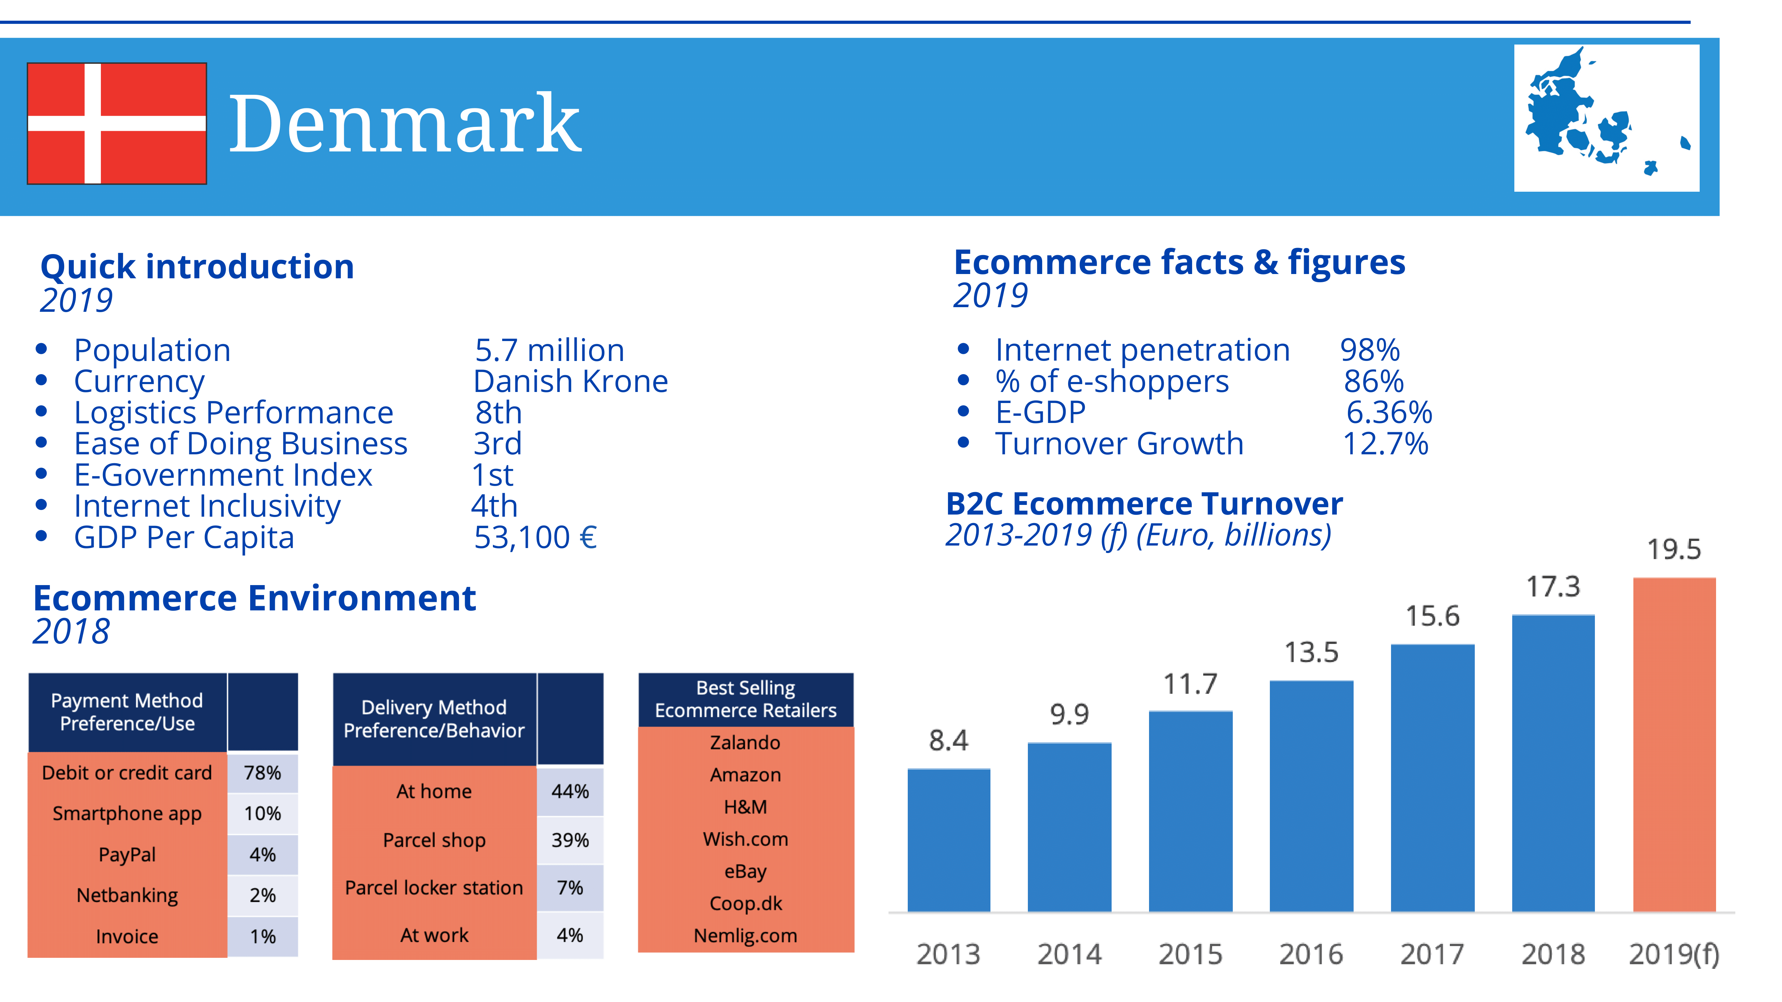

Image source: ecommerce-europe.eu.

Imagine a world where the walls of every home and office in Denmark tell a unique story through vibrant, personalized art. This isn't just a dream—it's a burgeoning reality driven by the growing demand for online poster sales. As e-commerce continues to thrive, the Danish market presents a golden opportunity for startups to tap into this creative and lucrative niche. But what makes Denmark such fertile ground for this industry? And how can new ventures navigate the complexities of consumer preferences and market dynamics to carve out a successful business? Let's delve into the strategic insights that can turn this vision into a thriving enterprise.

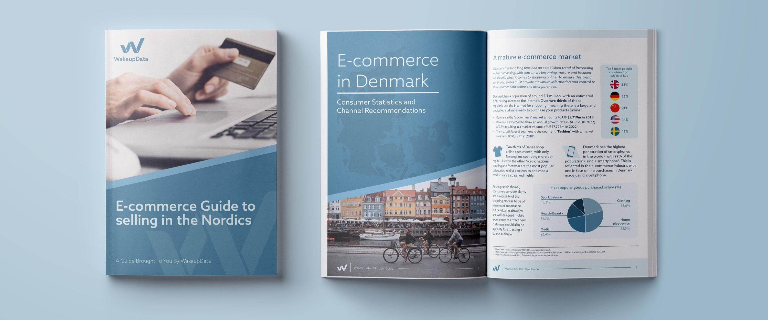

Image source: wakeupdata.com.

### Overview of the Online Poster Industry

The online poster industry has seen remarkable growth in recent years, driven by advancements in digital printing technology and the increasing popularity of e-commerce. Consumers are now able to access a vast array of designs and customization options, allowing them to express their personal tastes and preferences more easily than ever before. This industry caters to a wide range of demographics, from art enthusiasts and interior designers to businesses looking to enhance their office spaces. The convenience of online shopping, combined with the ability to preview and personalize posters, has made this market particularly appealing. Additionally, the rise of social media platforms has provided a powerful marketing tool for artists and retailers to reach a broader audience, further fueling the industry's expansion. As a result, the online poster market is not only thriving but also evolving rapidly, presenting numerous opportunities for innovative startups.

### Purpose of Market Evaluation for Startups

Understanding the market potential is crucial for startups aiming to enter the online poster industry in Denmark. Market evaluation helps identify the size and growth prospects of the market, ensuring that the business idea is viable and sustainable. It also provides insights into consumer preferences, enabling startups to tailor their products and marketing strategies effectively. By analyzing competitors, startups can identify gaps in the market and develop unique selling propositions to stand out. Additionally, a thorough market evaluation helps in forecasting financial performance and securing investment by demonstrating a clear understanding of the market dynamics. Ultimately, this process equips startups with the knowledge needed to make informed decisions, mitigate risks, and strategically position themselves for success in the competitive landscape.

To successfully penetrate the Danish market, it's essential to grasp the unique characteristics that define it. Denmark boasts a high internet penetration rate, with a significant portion of the population engaging in online shopping regularly. This tech-savvy demographic is accustomed to the convenience and variety offered by e-commerce platforms. Additionally, Danish consumers have a strong appreciation for art and design, often seeking out unique and personalized items to enhance their living and working spaces.

E-commerce trends in Denmark reveal a preference for seamless shopping experiences, with mobile commerce gaining traction. Social media platforms, particularly Facebook, play a crucial role in influencing purchasing decisions, making them vital channels for marketing and customer engagement. By understanding these market dynamics, startups can better tailor their offerings and strategies to meet the expectations of Danish consumers, positioning themselves for success in this vibrant and competitive landscape.

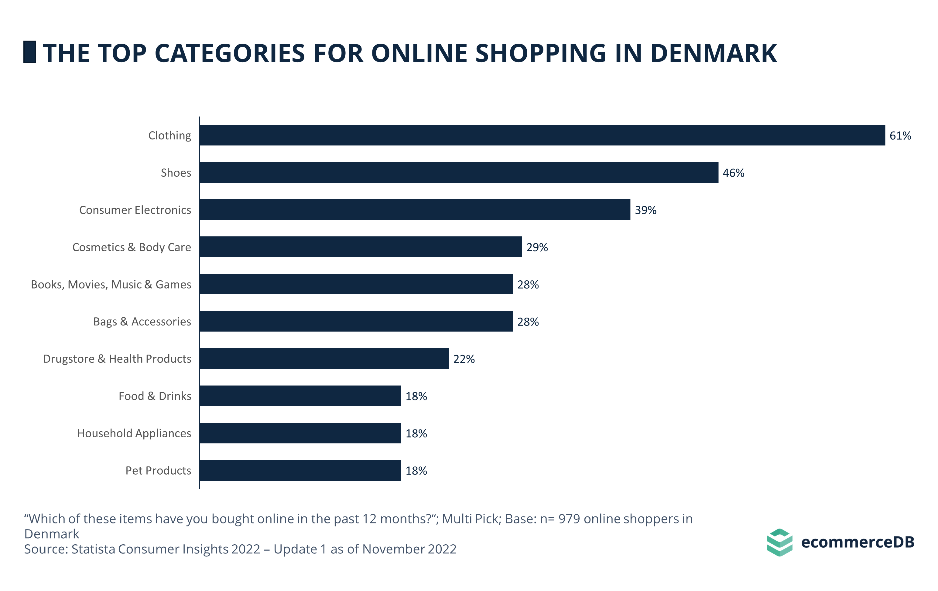

Image source: ecommercedb.com.

### Demographics and Consumer Behavior

Denmark's population is characterized by a high level of digital literacy and a strong inclination towards online shopping. The majority of Danish consumers are well-educated, with a significant portion falling within the 25-54 age range, which is a prime demographic for online purchases. This group values convenience, quality, and the ability to customize products to reflect their personal style.

Danish consumers also exhibit a strong preference for sustainable and ethically produced goods. They are willing to pay a premium for products that align with their values, such as eco-friendly materials and fair-trade practices. Additionally, the Danish market shows a high level of trust in online transactions, supported by robust consumer protection laws and efficient delivery services.

Understanding these demographic trends and consumer behaviors is crucial for startups aiming to capture the Danish market. Tailoring products and marketing strategies to meet these preferences can significantly enhance market penetration and customer loyalty.

### E-Commerce Trends in Denmark

E-commerce in Denmark is thriving, with a market size of EUR 20.7 billion, supported by a high number of citizens who have integrated online shopping into their daily lives. Mobile commerce is gaining significant traction, reflecting the tech-savvy nature of Danish consumers who prefer seamless shopping experiences. Social media platforms, particularly Facebook, dominate the social commerce landscape, with 62.7% market share, making them essential for marketing and customer engagement.

Cross-border shopping is also prevalent, with nearly 25% of total e-commerce transactions involving international purchases. Danish consumers have high expectations for quick and reliable delivery, often influenced by their experiences with efficient local logistics. This trend underscores the importance of strong communication and dependable delivery services for startups aiming to enter the market. By leveraging these e-commerce trends, startups can effectively position themselves to meet the demands of Danish consumers and capitalize on the growing online poster market.

### Cultural Appreciation for Art and Design

Denmark has a rich cultural heritage that deeply values art and design. This appreciation is evident in the country's architecture, public spaces, and even everyday objects. Danish consumers often seek out unique and aesthetically pleasing items to enhance their living and working environments. This cultural inclination towards design excellence provides a fertile ground for online poster sales, as consumers are likely to invest in high-quality, visually appealing artwork.

Moreover, the Danish concept of "hygge," which emphasizes coziness and comfort, often involves creating a visually pleasing and personalized home environment. Posters and art prints play a significant role in achieving this ambiance. Danish consumers are also known for their support of local artists and designers, making it advantageous for startups to collaborate with local talent. By tapping into this cultural appreciation, startups can offer products that resonate deeply with Danish values and aesthetics, thereby enhancing their market appeal.

Analyzing the market potential for online poster sales in Denmark involves understanding several key factors. The current market size is substantial, with projections indicating continued growth driven by increasing consumer interest in personalized and unique home decor. This growth is supported by advancements in digital printing technology, which allow for high-quality, customizable posters at competitive prices.

The competitive landscape is diverse, with both local and international players vying for market share. Startups can differentiate themselves by focusing on niche markets, such as eco-friendly posters or collaborations with local artists, which align with Danish consumer values.

Consumer preferences in Denmark lean towards high-quality, aesthetically pleasing designs that reflect personal style and cultural appreciation for art. Understanding these preferences and integrating them into product offerings can significantly enhance market penetration. Additionally, leveraging social media and e-commerce platforms effectively can help startups reach a broader audience and build a loyal customer base.

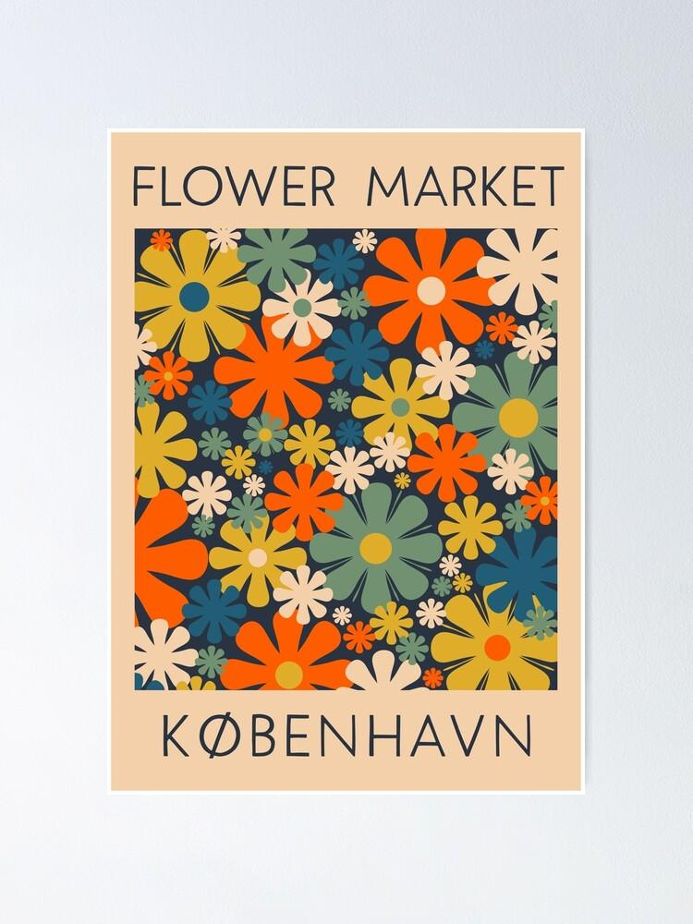

Image source: redbubble.com.

### Current Market Size and Growth Projections

The online poster market in Denmark is experiencing robust growth, driven by a combination of high internet penetration and a strong e-commerce infrastructure. As of 2024, the market size for online poster sales is estimated to be part of the broader EUR 20.7 billion e-commerce sector. This segment is expected to grow steadily, fueled by increasing consumer demand for personalized and unique home decor items.

Advancements in digital printing technology have made it easier and more cost-effective to produce high-quality, customizable posters. This technological progress, coupled with the Danish consumers' appreciation for art and design, suggests a positive growth trajectory for the market. Projections indicate that the market will continue to expand as more consumers turn to online platforms for their art and decor needs. Startups entering this space can capitalize on these trends by offering innovative and personalized products that cater to the evolving tastes of Danish consumers.

### Competitive Landscape

The competitive landscape for online poster sales in Denmark is diverse, featuring both local and international players. Key local competitors include specialized art retailers and independent artists who leverage e-commerce platforms to reach a broader audience. International giants like Amazon and Etsy also have a significant presence, offering a wide range of posters and art prints.

To stand out in this competitive market, startups can focus on niche segments that resonate with Danish consumer values. For instance, eco-friendly posters made from sustainable materials or exclusive collaborations with local artists can attract environmentally conscious and culturally inclined buyers. Additionally, providing exceptional customer service and leveraging social media for targeted marketing can help build a loyal customer base.

Understanding the strengths and weaknesses of competitors allows startups to identify market gaps and develop unique selling propositions. By strategically positioning themselves, new ventures can effectively navigate the competitive landscape and capture a significant share of the market.

### Consumer Preferences and Buying Patterns

Danish consumers exhibit a strong preference for high-quality, aesthetically pleasing designs that reflect their personal style and cultural appreciation for art. They value the ability to customize products, which allows them to create unique and personalized home decor. This trend is particularly evident in the growing demand for posters that can be tailored to individual tastes.

Sustainability is also a significant factor in purchasing decisions. While consumers are willing to pay a premium for eco-friendly products, they still prioritize value for money. Therefore, offering affordable sustainable options can enhance market appeal.

Online shopping is deeply ingrained in Danish consumer behavior, with a notable shift towards mobile commerce. Social media platforms, especially Facebook, play a crucial role in influencing purchasing decisions. Startups can leverage these platforms for targeted marketing and customer engagement, ensuring they meet the evolving preferences and buying patterns of Danish consumers.

Navigating the legal and regulatory framework is crucial for startups entering the online poster market in Denmark. E-commerce regulations in Denmark are stringent, ensuring consumer protection and fair trading practices. Startups must comply with laws related to online transactions, data protection, and consumer rights. The General Data Protection Regulation (GDPR) is particularly important, as it governs how businesses handle personal data.

Intellectual property laws are another critical aspect. Startups need to ensure that their designs do not infringe on existing copyrights and should consider registering their own designs to protect their intellectual property. This can prevent legal disputes and safeguard the originality of their products.

Business registration and compliance are also essential. Startups must register with the Danish Business Authority and adhere to local tax regulations. Understanding these legal requirements can help startups avoid potential pitfalls and establish a solid foundation for their business operations.

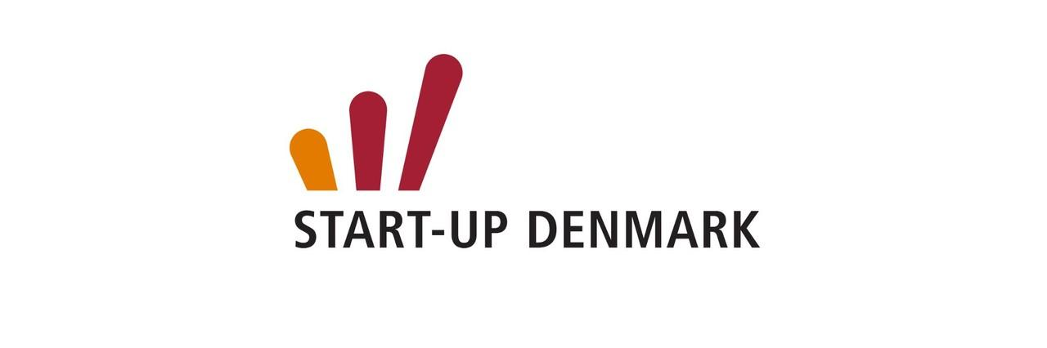

Image source: linkedin.com.

### E-Commerce Regulations

E-commerce regulations in Denmark are designed to ensure a fair and secure online shopping environment. Startups must adhere to the Danish E-commerce Act, which mandates transparency in business operations, including clear information about products, pricing, and terms of sale. Compliance with the General Data Protection Regulation (GDPR) is also essential, as it governs the handling of personal data, requiring businesses to implement robust data protection measures.

Consumer protection laws are stringent, emphasizing the right to return goods and receive refunds. Startups must provide clear return policies and ensure that customers can easily exercise their rights. Additionally, electronic payment systems must comply with the Payment Services Directive (PSD2), which enhances security and consumer protection in online transactions.

By understanding and adhering to these regulations, startups can build trust with consumers and create a reliable and legally compliant e-commerce platform, essential for long-term success in the Danish market.

### Intellectual Property Laws

Intellectual property laws are vital for startups in the online poster market to protect their creative assets. In Denmark, these laws ensure that original designs and artworks are safeguarded against unauthorized use. Startups must be vigilant about copyright issues, ensuring that their products do not infringe on existing copyrights. Registering original designs can provide legal protection and prevent potential disputes.

Additionally, understanding the nuances of trademark laws is crucial. Trademarks protect brand names, logos, and other identifiers that distinguish a startup's products from competitors. This can help in building a strong brand identity and maintaining market exclusivity.

Compliance with these laws not only protects the startup's intellectual property but also builds consumer trust. By respecting intellectual property rights, startups can foster a reputation for integrity and creativity, which is essential for long-term success in the competitive Danish market.

### Business Registration and Compliance

Business registration and compliance are fundamental steps for startups entering the Danish market. Startups must register with the Danish Business Authority (Erhvervsstyrelsen), which involves providing detailed information about the business structure, ownership, and financials. This registration process ensures that the business is legally recognized and can operate within Denmark.

Compliance with local tax regulations is also crucial. Startups need to understand the Danish tax system, including VAT registration and reporting requirements. Failure to comply with tax obligations can result in penalties and legal issues.

Additionally, startups must adhere to employment laws, which cover aspects such as contracts, working conditions, and employee rights. Ensuring compliance with these regulations helps in building a reputable and sustainable business.

By thoroughly understanding and adhering to these requirements, startups can establish a solid legal foundation, enabling them to focus on growth and innovation in the competitive Danish market.

Entering the Danish market for online poster sales requires a well-thought-out strategy. Identifying target segments is crucial; focus on demographics that value art and design, such as young professionals and interior design enthusiasts. Understanding their preferences can help tailor your offerings to meet their specific needs.

Brand positioning and differentiation are key to standing out. Highlight unique selling points, such as eco-friendly materials or exclusive collaborations with local artists. This not only appeals to Danish values but also builds a strong brand identity.

Effective marketing and promotional strategies are essential. Utilize social media platforms like Facebook and Instagram to reach your audience. Engage with potential customers through visually appealing content and targeted ads.

Lastly, logistics and distribution channels must be efficient. Partner with reliable local delivery services to ensure quick and hassle-free shipping. This enhances customer satisfaction and fosters loyalty, crucial for long-term success in the competitive Danish market.

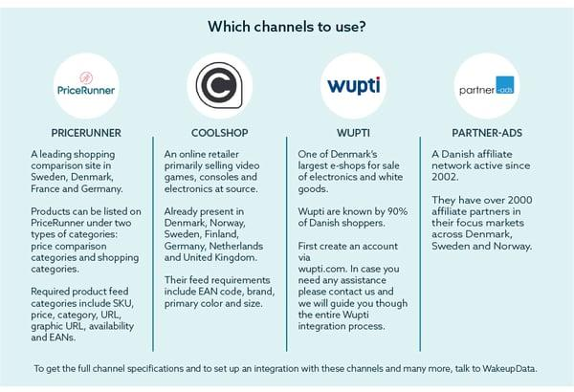

Image source: wakeupdata.com.

### Identifying Target Segments

Identifying target segments is a critical step for startups entering the Danish online poster market. Focus on demographics that have a strong appreciation for art and design, such as young professionals, interior design enthusiasts, and tech-savvy millennials. These groups are more likely to seek personalized and aesthetically pleasing decor for their living and working spaces.

Additionally, consider targeting eco-conscious consumers who prioritize sustainability. Offering posters made from eco-friendly materials can attract this segment, which values products that align with their environmental ethics.

Another promising segment includes businesses looking to enhance their office environments. Corporate clients often seek high-quality, customizable art to create inspiring workspaces. Tailoring marketing efforts to these specific segments can help startups effectively reach and engage their ideal customers, ensuring a higher conversion rate and stronger market presence.

### Brand Positioning and Differentiation

Brand positioning and differentiation are essential for standing out in the competitive Danish market. Startups should emphasize unique selling points that resonate with Danish values, such as sustainability and local artistry. Highlighting the use of eco-friendly materials can attract environmentally conscious consumers who prioritize ethical products.

Collaborations with local artists can also set your brand apart, offering exclusive designs that reflect Danish culture and aesthetics. This not only supports local talent but also appeals to consumers seeking unique and culturally relevant art.

Additionally, creating a strong brand narrative that communicates your commitment to quality and personalization can enhance your market position. Utilize storytelling in your marketing efforts to build an emotional connection with your audience. By clearly defining what makes your brand unique, you can effectively differentiate yourself from competitors and build a loyal customer base.

### Marketing and Promotional Strategies

Effective marketing and promotional strategies are crucial for capturing the Danish market. Utilize social media platforms like Facebook and Instagram to reach your audience, as these channels are highly influential in Denmark. Create visually appealing content that showcases your posters in various settings, highlighting their unique features and customization options.

Leverage influencer partnerships to expand your reach. Collaborating with local influencers who resonate with your target demographics can provide authentic endorsements and increase brand visibility.

Additionally, consider hosting virtual events or webinars to engage with potential customers. These events can showcase your expertise in art and design, offering valuable insights and fostering a sense of community around your brand.

Investing in search engine optimization (SEO) can also enhance your online presence. Optimize your website and content with relevant keywords to improve search engine rankings and attract organic traffic. By implementing these strategies, startups can effectively promote their products and build a strong market presence in Denmark.

### Logistics and Distribution Channels

Efficient logistics and distribution channels are vital for ensuring customer satisfaction and operational success in the Danish market. Partnering with reliable local delivery services can help ensure quick and hassle-free shipping, which is crucial given Danish consumers' high expectations for prompt delivery.

Consider implementing a robust inventory management system to keep track of stock levels and streamline order fulfillment. This can help prevent delays and ensure that popular items are always available.

Additionally, offering multiple delivery options, such as standard and express shipping, can cater to different customer needs and preferences. Providing clear communication about delivery times and tracking information can further enhance the customer experience.

Exploring partnerships with local retailers for click-and-collect services can also be beneficial. This not only provides convenience for customers but also reduces shipping costs and environmental impact. By optimizing logistics and distribution channels, startups can build a strong reputation for reliability and efficiency in the Danish market.

The Danish market for online poster sales presents numerous opportunities for startups. The growing appreciation for personalized and unique home decor items offers a fertile ground for innovative products. Collaborations with local artists can provide exclusive designs that resonate with Danish cultural values, enhancing market appeal.

However, startups must also navigate several challenges. The competitive landscape is crowded with both local and international players, making differentiation crucial. Additionally, Danish consumers have high expectations for quality and sustainability, requiring startups to invest in eco-friendly materials and ethical production practices.

Logistical challenges, such as ensuring prompt delivery and managing inventory, are also significant. Partnering with reliable local delivery services and implementing robust inventory management systems can mitigate these issues. By understanding and addressing these opportunities and challenges, startups can strategically position themselves for success in the Danish online poster market.

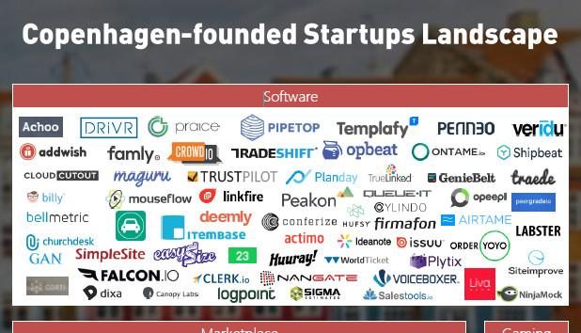

Image source: linkedin.com.

### Emerging Trends and Innovations

The online poster market in Denmark is witnessing several emerging trends and innovations that startups can leverage. One significant trend is the increasing demand for sustainable and eco-friendly products. Consumers are becoming more environmentally conscious, seeking posters made from recycled materials and produced using sustainable practices.

Another innovation is the use of augmented reality (AR) technology, allowing customers to visualize how posters will look in their spaces before making a purchase. This enhances the shopping experience and reduces the likelihood of returns.

Personalization is also gaining traction, with consumers preferring posters that reflect their individual tastes and styles. Startups can offer customizable options, enabling customers to choose designs, colors, and sizes that suit their preferences.

Additionally, the integration of social commerce is transforming how consumers discover and purchase art. Leveraging platforms like Instagram and Facebook for direct sales and marketing can significantly boost visibility and engagement. By staying attuned to these trends, startups can position themselves at the forefront of the market.

### Potential Barriers to Entry

Entering the Danish online poster market comes with its set of challenges. One significant barrier is the high level of competition from both local and international players. Established brands and platforms like Amazon and Etsy dominate the market, making it difficult for new entrants to gain visibility.

Another barrier is the stringent regulatory environment. Compliance with e-commerce regulations, data protection laws like GDPR, and consumer protection standards requires substantial effort and resources. Startups must ensure they meet these legal requirements to avoid penalties and build consumer trust.

Additionally, Danish consumers have high expectations for quality and sustainability. Meeting these standards often involves higher production costs and sourcing eco-friendly materials, which can be a financial strain for new businesses.

Logistical challenges, such as ensuring efficient delivery and managing returns, also pose significant hurdles. Partnering with reliable local logistics providers and implementing robust inventory management systems can help mitigate these issues. Understanding and addressing these barriers is crucial for successful market entry.

### Risk Mitigation Strategies

To navigate the complexities of the Danish online poster market, startups must implement effective risk mitigation strategies. One key approach is conducting thorough market research to understand consumer preferences and competitive dynamics. This helps in identifying market gaps and tailoring products to meet specific demands.

Building strong relationships with local suppliers and logistics providers can ensure a reliable supply chain and efficient delivery services. This is crucial for maintaining customer satisfaction and managing operational risks.

Compliance with local regulations, including e-commerce laws and data protection standards, is essential. Startups should invest in legal expertise to navigate these requirements and avoid potential legal pitfalls.

Additionally, diversifying marketing channels can reduce dependency on any single platform. Utilizing social media, search engine optimization (SEO), and influencer partnerships can create a robust marketing strategy that reaches a wider audience.

By proactively addressing these risks, startups can establish a solid foundation for sustainable growth in the Danish market.

### What are the key factors driving the growth of the online poster market in Denmark?

Several key factors are driving the growth of the online poster market in Denmark. Firstly, the high internet penetration rate and the tech-savvy nature of Danish consumers make online shopping a preferred choice. The convenience and variety offered by e-commerce platforms attract a significant portion of the population.

Secondly, there is a strong cultural appreciation for art and design in Denmark. Consumers often seek unique and personalized items to enhance their living and working spaces, which aligns perfectly with the offerings of the online poster market.

Additionally, advancements in digital printing technology have made it easier and more cost-effective to produce high-quality, customizable posters. This technological progress, combined with the rise of social media as a powerful marketing tool, has further fueled the market's expansion.

Lastly, the increasing demand for sustainable and eco-friendly products has led to a growing interest in posters made from recycled materials and produced using ethical practices, appealing to environmentally conscious consumers.

### How can startups effectively differentiate themselves in the competitive Danish market?

Startups can effectively differentiate themselves in the competitive Danish market by focusing on several key strategies. Firstly, emphasizing sustainability can attract eco-conscious consumers. Offering posters made from recycled materials and using environmentally friendly production processes can set a startup apart.

Collaborating with local artists to create exclusive designs that reflect Danish culture and aesthetics is another powerful differentiator. This not only supports local talent but also appeals to consumers seeking unique and culturally relevant art.

Building a strong brand narrative that highlights quality and personalization can also enhance market position. Utilizing storytelling in marketing efforts helps create an emotional connection with the audience, making the brand more memorable.

Leveraging social media and influencer partnerships can expand reach and build credibility. Engaging content and authentic endorsements from local influencers can significantly boost visibility and customer trust.

Lastly, providing exceptional customer service and a seamless shopping experience, including efficient delivery and easy returns, can foster customer loyalty and positive word-of-mouth, further distinguishing the startup in the market.

### What are the essential legal and regulatory requirements for starting an online poster business in Denmark?

Starting an online poster business in Denmark requires adherence to several essential legal and regulatory requirements. First, compliance with the Danish E-commerce Act is crucial. This includes providing transparent information about products, pricing, and terms of sale. Additionally, businesses must comply with the General Data Protection Regulation (GDPR), which governs the handling of personal data and mandates robust data protection measures.

Consumer protection laws in Denmark are stringent, emphasizing the right to return goods and receive refunds. Startups must ensure clear return policies and facilitate easy returns to comply with these regulations. Electronic payment systems must also adhere to the Payment Services Directive (PSD2), enhancing security and consumer protection in online transactions.

intellectual property laws are another critical aspect. Startups need to ensure their designs do not infringe on existing copyrights and should consider registering their own designs to protect their intellectual property. This helps prevent legal disputes and safeguards the originality of their products.

Finally, business registration with the Danish Business Authority (Erhvervsstyrelsen) is mandatory. This process involves providing detailed information about the business structure, ownership, and financials. Compliance with local tax regulations, including VAT registration and reporting, is also essential to avoid penalties and legal issues. By understanding and adhering to these requirements, startups can establish a solid legal foundation for their operations.

### How important is sustainability to Danish consumers when purchasing online posters?

Sustainability is increasingly important to Danish consumers when purchasing online posters. Danish shoppers exhibit a strong preference for products that align with their environmental values. They are willing to pay a premium for sustainable options, although price remains a critical factor in their purchasing decisions. Consumers prioritize eco-friendly materials and ethical production practices, reflecting a broader trend towards sustainability in their shopping behavior.

Moreover, Danish consumers' focus on sustainability extends beyond just the product itself. They also consider factors such as recyclable packaging and the overall environmental impact of their purchases. This growing emphasis on sustainability is not just a passing trend but a significant criterion that influences their buying patterns. Startups that offer eco-friendly posters and communicate their commitment to sustainability effectively can resonate deeply with this market segment, enhancing their appeal and competitive edge in the Danish market.

### What are the best marketing strategies for reaching Danish consumers in the online poster market?

To reach Danish consumers in the online poster market, leveraging social media platforms is essential. Facebook, with its 62.7 percent market share, stands out as the most effective platform for social commerce. Utilizing Facebook's shoppable features and targeted advertising can significantly enhance visibility and engagement. Instagram, despite its smaller market share, can also be valuable for visually-driven marketing campaigns, showcasing the aesthetic appeal of posters.

Influencer partnerships are another powerful strategy. Collaborating with local influencers who resonate with the target demographics can provide authentic endorsements and expand reach. These influencers can help create buzz and drive traffic to the online store through their established follower base.

Investing in search engine optimization (SEO) is crucial for improving online visibility. Optimizing the website and content with relevant keywords can enhance search engine rankings, attracting organic traffic. Additionally, running targeted ads on search engines can capture the attention of consumers actively looking for home decor solutions.

Engaging content marketing, such as blog posts and videos that highlight design trends, customization options, and the stories behind the artwork, can also attract and retain customers. This approach not only educates consumers but also builds a connection with the brand.

Lastly, offering exceptional customer service and a seamless shopping experience, including efficient delivery and easy returns, can foster customer loyalty and positive word-of-mouth, further boosting the brand's reputation in the Danish market.

Entering the Danish market for online poster sales presents a promising opportunity for startups, given the country's high internet penetration and strong appreciation for art and design. By understanding the unique consumer preferences and leveraging effective marketing strategies, startups can carve out a niche in this competitive landscape. Emphasizing sustainability and collaborating with local artists can further enhance market appeal, aligning with Danish values. Additionally, navigating the legal and regulatory framework with diligence ensures a solid foundation for business operations. As the market continues to grow, startups that stay attuned to emerging trends and consumer behaviors will be well-positioned to thrive. By strategically positioning themselves and addressing potential challenges, new ventures can successfully tap into the vibrant Danish market and build a loyal customer base.

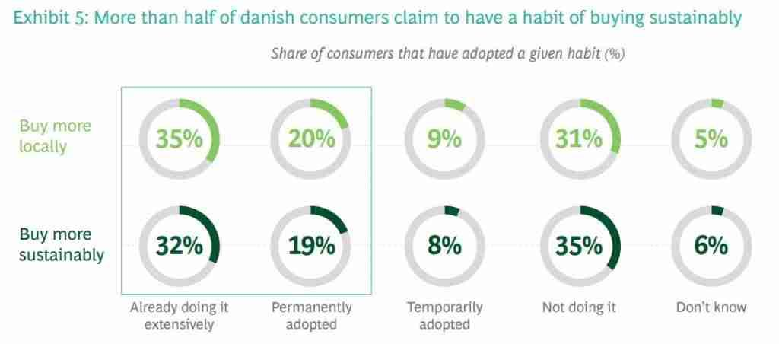

Image source: gaasly.com.

### Summary of Key Insights

The Danish market for online poster sales is ripe with potential, driven by high internet penetration and a strong cultural appreciation for art and design. Danish consumers value personalized and unique home decor items, making customization a key selling point. Sustainability is a significant factor, with consumers willing to pay a premium for eco-friendly products. Effective marketing strategies, such as leveraging social media platforms and influencer partnerships, are crucial for reaching the target audience. Additionally, understanding and complying with local e-commerce regulations and intellectual property laws is essential for building a trustworthy brand. Collaborations with local artists can provide exclusive designs that resonate with Danish cultural values, further enhancing market appeal. By focusing on these insights, startups can strategically position themselves to succeed in the competitive Danish market.

### Recommendations for Startup Ventures

For startups venturing into the Danish online poster market, focusing on sustainability is crucial. Offering eco-friendly products can attract environmentally conscious consumers. Collaborating with local artists to create exclusive designs can also set your brand apart, appealing to the Danish appreciation for unique and culturally relevant art.

Investing in robust digital marketing strategies is essential. Utilize social media platforms like Facebook and Instagram for targeted advertising and influencer partnerships to expand your reach. Additionally, optimizing your website for search engines can enhance visibility and attract organic traffic.

Ensuring compliance with local e-commerce regulations and intellectual property laws is vital for building consumer trust and avoiding legal pitfalls. Efficient logistics and reliable delivery services are also key to meeting the high expectations of Danish consumers.

By focusing on these strategies, startups can effectively navigate the competitive landscape and establish a strong presence in the Danish market.