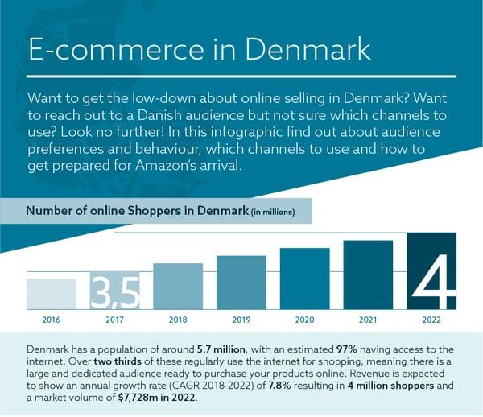

Image source: wakeupdata.com.

Imagine a world where art and commerce seamlessly blend, where the vibrant hues of creativity meet the dynamic pulse of online shopping. In Denmark, a country renowned for its rich cultural heritage and innovative spirit, this fusion is not just a possibility but a burgeoning reality. As the digital marketplace continues to expand, the potential for online poster sales is capturing the attention of entrepreneurs and art enthusiasts alike.

Denmark's e-commerce landscape is thriving, with consumers increasingly turning to online platforms for their shopping needs. This shift presents a golden opportunity for startups to tap into the market for posters, a product that combines aesthetic appeal with personal expression. But what makes Denmark particularly ripe for this venture? The answer lies in a unique blend of economic stability, a tech-savvy population, and a deep-seated appreciation for art and design.

In this blog post, we will delve into the strategic insights necessary for launching a successful online poster business in Denmark. From understanding the economic indicators and consumer spending habits to identifying the target audience and cultural trends, we will provide a comprehensive analysis to help you navigate this promising market. Whether you're an artist looking to monetize your creations or an entrepreneur seeking a new venture, the Danish market offers a fertile ground for growth and innovation.

Join us as we explore the intricacies of the Danish e-commerce landscape and uncover the potential that lies within the realm of online poster sales. This journey promises to equip you with the knowledge and strategies needed to turn your creative vision into a thriving business.

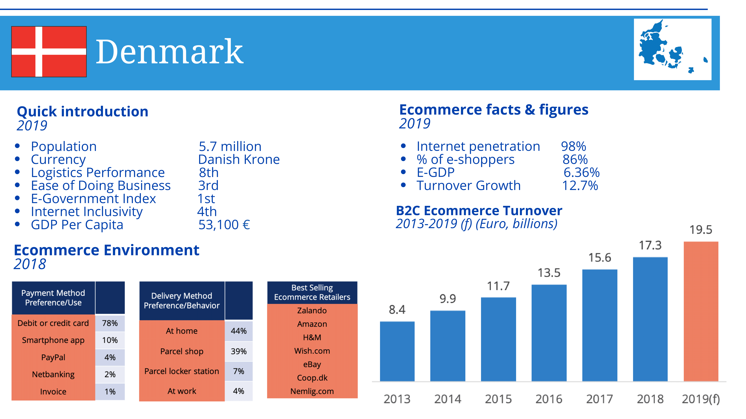

Image source: ecommerce-europe.eu.

### Purpose and Scope of the Analysis

The primary aim of this analysis is to provide a detailed examination of the market potential for online poster sales in Denmark. By dissecting various economic, cultural, and consumer behavior factors, this analysis seeks to offer strategic insights that can guide startup ventures in making informed decisions. This comprehensive approach ensures that entrepreneurs can identify opportunities, mitigate risks, and develop effective strategies tailored to the Danish market.

To achieve this, the analysis will cover several key areas. First, it will explore the economic indicators and consumer spending patterns that influence the purchasing power and behavior of Danish consumers. Understanding these factors is crucial for determining the market's capacity to support new ventures and for identifying potential growth areas.

Next, the analysis will delve into the demographics and target audience for online poster sales. By examining age groups, income levels, and lifestyle preferences, we can pinpoint the most promising customer segments. This demographic insight will help startups tailor their marketing and product offerings to meet the specific needs and desires of their audience.

Additionally, the cultural appreciation for art and design in Denmark will be a focal point. Denmark's rich artistic heritage and contemporary design sensibilities create a unique environment for poster sales. By understanding these cultural nuances, startups can better align their products with local tastes and trends, enhancing their appeal to Danish consumers.

The scope of this analysis also includes an overview of the current state of the online poster market in Denmark, global trends, and growth projections. This will provide a contextual backdrop against which startups can benchmark their performance and set realistic goals.

By integrating these diverse elements, the analysis aims to equip entrepreneurs with a holistic understanding of the Danish market, enabling them to craft strategies that are both innovative and grounded in market realities. This approach ensures that startups are well-prepared to navigate the complexities of the online poster sales landscape in Denmark.

### Overview of the Danish E-commerce Landscape

Denmark's e-commerce landscape is characterized by a robust infrastructure and a tech-savvy population, making it one of the most advanced digital markets in Europe. With a business-to-consumer e-commerce market valued at EUR 20.7 billion, the country showcases a high penetration of online shopping in everyday life. This thriving environment is supported by excellent logistics and a high level of internet penetration, ensuring that consumers have seamless access to online retail platforms.

The Danish market is dominated by a few key players, with the top five online stores accounting for 28% of net sales among the top 100 online stores. Notable names include ando, elgiganten.dk, bilka.dk, Apple, and H&M. These platforms have set high standards for user experience, delivery efficiency, and customer service, which new entrants must strive to match or exceed.

Social commerce also plays a significant role in Denmark's e-commerce ecosystem. Facebook leads the pack with a 62.7% market share among social media users, followed by Pinterest at 16.8%, and Instagram at 3.6%. This indicates a strong potential for startups to leverage social media platforms for marketing and sales, tapping into the extensive reach and engagement these channels offer.

Cross-border shopping is another notable trend, with nearly 25% of total e-commerce transactions in Denmark involving international merchants. Over half of Danish online shoppers have made purchases from other countries, primarily from China, the UK, and Germany. This openness to international products suggests that Danish consumers are not only tech-savvy but also open to diverse offerings, providing a fertile ground for innovative and unique poster designs.

In summary, Denmark's e-commerce landscape is a dynamic and well-established market with significant opportunities for growth. Startups entering this space must be prepared to meet high consumer expectations and leverage the strengths of digital and social commerce to succeed.

Denmark's market offers a unique blend of economic stability, high consumer spending, and a deep appreciation for art and design, making it an attractive destination for online poster sales. The country's economic indicators reveal a strong and resilient economy, with a high GDP per capita and low unemployment rates. This economic stability translates into significant disposable income, allowing consumers to spend on non-essential items such as art and decor.

The demographics of Denmark further enhance its market potential. The population is well-educated, with a high percentage of individuals holding tertiary degrees. This educated populace tends to value cultural and artistic expressions, making them more likely to invest in aesthetically pleasing products like posters. Additionally, Denmark's urbanization rate is high, with a significant portion of the population residing in cities where modern design and home decor trends are prevalent.

Consumer spending patterns in Denmark indicate a strong inclination towards online shopping. The tech-savvy nature of Danish consumers, coupled with high internet penetration rates, ensures that a large segment of the population is comfortable making purchases online. This is further supported by the country's efficient logistics and delivery infrastructure, which guarantees timely and reliable delivery of online orders.

Culturally, Denmark has a rich heritage of art and design, deeply embedded in its societal fabric. The Danish design philosophy, known for its minimalism and functionality, resonates well with both local and international audiences. This cultural appreciation for design extends to various forms of art, including posters, which are often used to enhance interior spaces.

Understanding these facets of the Danish market is crucial for startups aiming to enter the online poster sales industry. By aligning their offerings with the economic conditions, demographic preferences, and cultural values of Danish consumers, startups can effectively tap into this promising market.

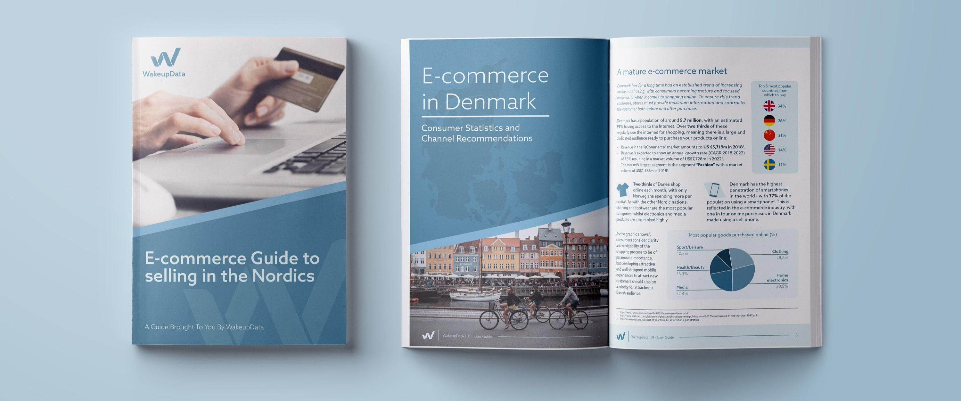

Image source: wakeupdata.com.

### Economic Indicators and Consumer Spending

Denmark's economic landscape is marked by stability and prosperity, making it an ideal environment for new business ventures. The country's GDP per capita is among the highest in the world, reflecting a robust economy that supports consumer spending. Low unemployment rates further contribute to this economic stability, ensuring that a significant portion of the population has disposable income to spend on non-essential items, including art and decor.

Consumer spending in Denmark is characterized by a high level of discretionary income, which bodes well for the online poster market. Danish consumers are known for their willingness to invest in quality products that enhance their living spaces. This trend is supported by the country's strong economic indicators, which show consistent growth in consumer spending over the years. The high standard of living in Denmark means that consumers have both the means and the inclination to purchase items that reflect their personal tastes and cultural values.

The tech-savvy nature of Danish consumers also plays a crucial role in shaping their spending habits. With one of the highest internet penetration rates in Europe, Denmark's population is well-versed in online shopping. This familiarity with digital platforms makes it easier for startups to reach potential customers through e-commerce channels. The convenience of online shopping, combined with efficient logistics and delivery systems, ensures that consumers can easily access and purchase posters from the comfort of their homes.

Moreover, Denmark's economic policies are conducive to business growth. The country offers a favorable business environment with low barriers to entry, making it easier for startups to establish and scale their operations. This supportive economic framework, coupled with strong consumer spending, creates a fertile ground for the online poster market to thrive.

By understanding these economic indicators and consumer spending patterns, startups can better position themselves to capture the market potential in Denmark. This knowledge allows for strategic planning and targeted marketing efforts that align with the financial capabilities and purchasing behaviors of Danish consumers.

### Demographics and Target Audience

Denmark's population is characterized by a high level of education and urbanization, which significantly influences consumer behavior and preferences. A substantial portion of the population holds tertiary degrees, indicating a well-educated society that values cultural and intellectual pursuits. This demographic is more likely to appreciate and invest in art and design, making them an ideal target audience for online poster sales.

The urbanization rate in Denmark is notably high, with a significant number of people living in cities such as Copenhagen, Aarhus, and Odense. Urban dwellers often have a keen interest in modern design and home decor trends, seeking to personalize their living spaces with unique and aesthetically pleasing items. Posters, as a form of affordable art, fit well into this lifestyle, offering a versatile way to enhance interior environments.

Age demographics also play a crucial role in shaping the target audience for online poster sales. Younger consumers, particularly those in the 18-34 age bracket, are more inclined towards online shopping and digital engagement. This tech-savvy group is comfortable navigating e-commerce platforms and is often influenced by social media trends. They are likely to seek out contemporary and trendy designs that reflect their personal style and interests.

In addition to younger consumers, middle-aged individuals (35-54 years) also represent a valuable market segment. This group typically has higher disposable income and a greater focus on home improvement and decor. They may prefer classic and sophisticated designs that align with their established tastes and lifestyle.

Income levels further define the target audience. Higher-income households have more discretionary spending power, allowing them to invest in quality art pieces. However, the affordability of posters makes them accessible to a broader audience, including those with moderate incomes who still wish to enhance their living spaces with artistic elements.

By understanding these demographic factors, startups can tailor their marketing strategies and product offerings to meet the specific needs and preferences of Danish consumers, ensuring a successful entry into the online poster market.

### Cultural Appreciation for Art and Design

Denmark boasts a rich cultural heritage that deeply values art and design, making it a fertile ground for the online poster market. The Danish design philosophy, known for its minimalism, functionality, and elegance, has garnered international acclaim. This appreciation for well-crafted, aesthetically pleasing items extends to various forms of art, including posters.

The influence of renowned Danish artists such as Asger Jorn and Bjørn Winblad highlights the country's longstanding tradition of artistic excellence. Jorn's diverse body of work, ranging from oils to watercolors and drawings, and Winblad's iconic posters depicting characters from Tivoli Gardens in Copenhagen, underscore the nation's deep-seated love for visual art. These cultural icons have set a high standard for artistic quality, which resonates with Danish consumers' expectations.

In contemporary Denmark, art and design are integral to everyday life. The country's museums and galleries, such as the Hirschsprung Collection in Copenhagen, showcase both historical and modern art, reflecting a continuous engagement with artistic expression. This cultural backdrop creates a receptive audience for new and innovative poster designs that align with Danish tastes.

Moreover, the Danish lifestyle places a strong emphasis on creating harmonious and visually appealing living spaces. This is evident in the popularity of home decor items that blend functionality with beauty. Posters, as an affordable and versatile form of art, fit seamlessly into this cultural context, offering consumers a way to personalize their homes with pieces that reflect their individual style and cultural heritage.

The Danish market's openness to international influences also plays a role in shaping consumer preferences. Danish consumers are not only appreciative of local art but are also keen on exploring global trends. This cosmopolitan outlook provides startups with the opportunity to introduce diverse and eclectic poster designs that cater to a wide range of tastes.

Understanding this cultural appreciation for art and design is crucial for startups aiming to succeed in the Danish market. By aligning their products with the aesthetic values and cultural sensibilities of Danish consumers, businesses can effectively tap into this vibrant and discerning market.

The online poster industry has seen significant growth globally, driven by advancements in digital printing technology and the increasing popularity of e-commerce. This trend is particularly evident in markets with a strong appreciation for art and design, such as Denmark. The global market for online poster sales is characterized by a diverse range of styles and themes, catering to various consumer preferences and interior design trends.

One of the key drivers of this market is the rise of print-on-demand services. These platforms allow artists and designers to create and sell their work without the need for large upfront investments in inventory. This model not only reduces financial risk but also enables a wider variety of designs to be available to consumers. Print-on-demand services have democratized the art market, allowing independent artists to reach a global audience with ease.

In Denmark, the current state of the online poster market reflects these global trends. Danish consumers, known for their tech-savvy nature and high internet penetration rates, are increasingly turning to online platforms for their art purchases. The convenience of browsing and buying art from the comfort of their homes, combined with efficient delivery services, makes online shopping an attractive option.

growth projections for the online poster market in Denmark are promising. The country's strong economic indicators, coupled with a cultural appreciation for art and design, suggest a steady increase in demand for unique and high-quality posters. Startups entering this market can capitalize on these trends by offering innovative designs that resonate with Danish consumers' tastes.

Furthermore, the integration of social media and e-commerce has opened new avenues for marketing and sales. Platforms like Instagram and Pinterest, which are popular among Danish users, provide an ideal space for showcasing poster designs and engaging with potential customers. By leveraging these digital tools, startups can effectively reach and attract their target audience.

Overall, the online poster industry presents a dynamic and lucrative opportunity for startups in Denmark. By understanding and aligning with market trends, businesses can position themselves for success in this vibrant sector.

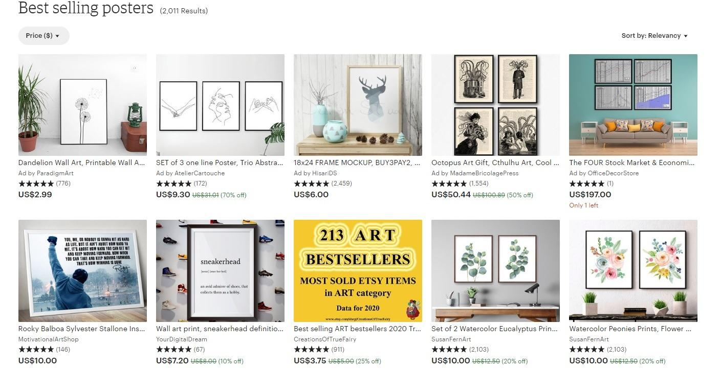

Image source: blog.storeya.com.

### Global Trends in Online Poster Sales

The online poster market has experienced a surge in popularity worldwide, driven by several key trends that are shaping consumer behavior and industry practices. One of the most significant trends is the rise of print-on-demand services. These platforms have revolutionized the way artists and designers bring their creations to market, eliminating the need for large upfront investments in inventory. This model not only reduces financial risk but also allows for a broader range of designs to be available to consumers, catering to diverse tastes and preferences.

Another notable trend is the increasing use of digital platforms for art sales. E-commerce giants and specialized online marketplaces have made it easier than ever for consumers to discover and purchase posters from the comfort of their homes. This shift towards online shopping is supported by advancements in digital printing technology, which ensures high-quality reproductions of original artworks. The convenience and accessibility of online shopping have made it a preferred method for many art enthusiasts.

Social media has also played a crucial role in the growth of the online poster market. Platforms like Instagram, Pinterest, and Facebook have become essential tools for artists and businesses to showcase their work, engage with potential customers, and drive sales. The visual nature of these platforms makes them ideal for promoting art, allowing for direct interaction with a global audience. Influencer collaborations and targeted advertising on social media further amplify the reach and impact of marketing efforts.

Sustainability is another emerging trend in the online poster industry. Consumers are increasingly conscious of the environmental impact of their purchases and are seeking out eco-friendly options. This has led to a rise in the use of sustainable materials and printing practices, as well as the promotion of posters that support environmental causes.

These global trends highlight the dynamic and evolving nature of the online poster market. By staying attuned to these developments, startups can better position themselves to meet the demands of modern consumers and capitalize on the growing opportunities in this vibrant industry.

### Current State of the Market in Denmark

Denmark's online poster market is thriving, reflecting broader global trends while also showcasing unique local characteristics. Danish consumers, known for their tech-savvy nature and high internet penetration rates, are increasingly turning to online platforms for their art purchases. This shift is supported by the country's robust e-commerce infrastructure, which ensures seamless transactions and efficient delivery services.

The market is characterized by a diverse range of styles and themes, catering to various consumer preferences. Danish consumers have a strong appreciation for minimalistic and functional designs, which align with the country's renowned design philosophy. This cultural inclination towards simplicity and elegance is evident in the types of posters that are popular among Danish buyers.

Key players in Denmark's e-commerce landscape, such as ando, elgiganten.dk, bilka.dk, Apple, and H&M, dominate the market, accounting for a significant portion of online sales. These platforms have set high standards for user experience, delivery efficiency, and customer service, which new entrants must strive to match or exceed. The presence of these established players indicates a competitive market environment, but also highlights the potential for startups to carve out a niche by offering unique and high-quality poster designs.

Social commerce is another critical aspect of the Danish market. Platforms like Facebook, Pinterest, and Instagram play a significant role in influencing consumer behavior and driving sales. With Facebook leading the pack in market share among social media users, startups can leverage these platforms to reach a broader audience and engage with potential customers through targeted advertising and influencer collaborations.

Cross-border shopping is also prevalent, with a substantial portion of Danish consumers making purchases from international merchants. This openness to global products suggests that Danish consumers are not only tech-savvy but also open to diverse offerings, providing a fertile ground for innovative and unique poster designs.

Overall, the current state of the online poster market in Denmark presents a dynamic and promising landscape for startups. By understanding and aligning with local consumer preferences and leveraging the strengths of digital and social commerce, businesses can effectively tap into this vibrant market.

### Growth Projections and Potential

Denmark's online poster market is poised for significant growth, driven by a combination of economic stability, cultural appreciation for art, and increasing digital engagement. The country's strong GDP per capita and low unemployment rates provide a solid foundation for consumer spending on non-essential items, including art and decor. This economic backdrop, coupled with a high standard of living, ensures that Danish consumers have both the means and the inclination to invest in quality posters.

The tech-savvy nature of the Danish population further amplifies the market potential. With one of the highest internet penetration rates in Europe, Denmark's consumers are well-versed in online shopping. This familiarity with digital platforms, combined with efficient logistics and delivery systems, makes the online purchase of posters a convenient and attractive option. The integration of social media and e-commerce also plays a crucial role, as platforms like Instagram and Pinterest provide ideal spaces for showcasing and selling art.

Market forecasts indicate a steady increase in demand for online posters in Denmark. The country's appreciation for minimalistic and functional design aligns well with current global trends, suggesting that Danish consumers will continue to seek out unique and aesthetically pleasing posters. Additionally, the rise of print-on-demand services allows for a diverse range of designs to be available, catering to various tastes and preferences.

Sustainability is another factor contributing to the market's growth potential. Danish consumers are increasingly conscious of the environmental impact of their purchases and are likely to support eco-friendly options. This trend towards sustainability can be leveraged by startups to differentiate their offerings and appeal to environmentally conscious buyers.

Overall, the combination of economic stability, digital engagement, and cultural appreciation for art positions Denmark as a promising market for online poster sales. Startups entering this space can capitalize on these growth projections by offering innovative and high-quality designs that resonate with Danish consumers' tastes and values.

Denmark's online poster market is characterized by a competitive landscape with several key players dominating the space. Major e-commerce platforms such as ando, elgiganten.dk, bilka.dk, Apple, and H&M hold a significant share of the market, setting high standards for user experience, delivery efficiency, and customer service. These established players have built strong brand recognition and customer loyalty, making it essential for new entrants to differentiate themselves through unique value propositions.

Analyzing competitor strategies reveals a focus on seamless online shopping experiences, fast and reliable delivery, and robust customer support. These elements are crucial for gaining consumer trust and ensuring repeat business. Additionally, many of these platforms leverage advanced data analytics to personalize marketing efforts and optimize inventory management, further enhancing their competitive edge.

Market gaps and opportunities exist for startups willing to innovate and cater to niche segments. While the major players cover a broad range of products, there is room for specialized offerings that target specific consumer preferences. For instance, startups can focus on eco-friendly posters, limited edition prints, or customizable designs that allow customers to create personalized art pieces. By addressing these niche markets, new ventures can attract a dedicated customer base and build a strong brand identity.

Social commerce also presents a significant opportunity for startups. Platforms like Facebook, Pinterest, and Instagram are popular among Danish consumers and offer powerful tools for targeted advertising and influencer collaborations. By effectively utilizing these channels, startups can reach a wider audience and drive engagement through visually appealing content and interactive campaigns.

Furthermore, cross-border shopping trends indicate that Danish consumers are open to international products, providing an opportunity for startups to introduce unique and diverse designs from global artists. This openness to international offerings can be leveraged to create a distinctive product portfolio that stands out in the competitive landscape.

In summary, while the Danish online poster market is competitive, there are ample opportunities for startups to carve out a niche by focusing on innovation, personalization, and effective use of digital marketing channels.

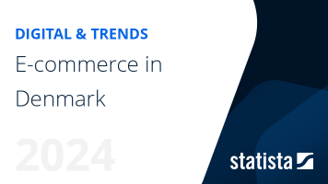

Image source: proxy.parisjc.edu:8293.

### Key Competitors and Market Share

Denmark's online poster market is dominated by a few key players who have established themselves as leaders in the e-commerce space. Among these, ando stands out as the top site by net sales, followed closely by elgiganten.dk, bilka.dk, Apple, and H&M. Together, these five platforms account for 28% of the net sales among the top 100 online stores in Denmark, highlighting their significant market influence.

These major competitors have built their market share through a combination of extensive product offerings, competitive pricing, and exceptional customer service. For instance, ando has leveraged its strong brand presence and user-friendly interface to attract a large customer base. Similarly, elgiganten.dk and bilka.dk have capitalized on their broad product ranges and efficient delivery services to maintain a competitive edge.

Apple and H&M, while primarily known for their electronics and fashion products respectively, have also made significant inroads into the online poster market. Their established brand reputations and loyal customer bases provide them with a strong foundation to expand their offerings into new categories, including art and decor.

In addition to these dominant players, the market also features several niche platforms that cater to specific consumer preferences. These smaller competitors often focus on unique selling points such as eco-friendly materials, limited edition prints, or customizable designs. By targeting specific segments of the market, these niche players can carve out a dedicated customer base and compete effectively against larger, more established brands.

The competitive landscape in Denmark is further shaped by the presence of international e-commerce giants like Amazon and Alibaba. These global players bring extensive product ranges and competitive pricing to the market, challenging local businesses to continuously innovate and improve their offerings.

Overall, the key competitors in Denmark's online poster market have established strong positions through a combination of strategic initiatives and market responsiveness. Startups entering this space must carefully analyze these competitors and identify opportunities to differentiate themselves and capture market share.

### Analysis of Competitor Strategies

The leading players in Denmark's online poster market have adopted a range of strategies to secure their positions and drive growth. A key element of their success lies in providing a seamless online shopping experience. This includes intuitive website design, easy navigation, and efficient checkout processes. By prioritizing user experience, these companies ensure that customers can find and purchase products with minimal friction.

Delivery efficiency is another critical factor. Companies like elgiganten.dk and bilka.dk have invested heavily in logistics to offer fast and reliable delivery services. This not only meets consumer expectations but also builds trust and encourages repeat purchases. In a market where timely delivery is a significant competitive advantage, these investments are crucial.

Customer service excellence is also a hallmark of successful competitors. Platforms such as ando and H&M have established robust customer support systems, including live chat, comprehensive FAQs, and responsive email support. By addressing customer inquiries and issues promptly, these companies enhance customer satisfaction and loyalty.

Personalization through advanced data analytics is a strategy that many top players employ. By analyzing customer data, companies can tailor their marketing efforts and product recommendations to individual preferences. This targeted approach increases the likelihood of conversions and boosts overall sales. For instance, Apple uses its extensive data capabilities to offer personalized product suggestions, enhancing the shopping experience.

Social media engagement is another vital strategy. Leading platforms leverage social media channels to reach and interact with their audience. Facebook, Instagram, and Pinterest are particularly effective for visual products like posters. By using targeted ads, influencer partnerships, and engaging content, companies can drive traffic to their online stores and increase brand visibility.

Sustainability initiatives are increasingly important in differentiating brands. Companies that offer eco-friendly products or use sustainable practices can attract environmentally conscious consumers. This not only aligns with global trends but also resonates with the values of many Danish consumers.

By adopting these strategies, leading competitors in Denmark's online poster market have successfully navigated the competitive landscape, setting high standards for new entrants.

### Market Gaps and Opportunities

While the Danish online poster market is competitive, there are several market gaps and opportunities that startups can exploit to establish a strong presence. One significant gap lies in the niche segments that are underserved by the major players. For instance, eco-friendly posters made from sustainable materials are gaining traction among environmentally conscious consumers. Startups focusing on sustainability can differentiate themselves by offering products that align with these values, thereby attracting a dedicated customer base.

Another opportunity exists in the realm of customizable designs. Personalized posters that allow customers to add their own text, images, or other elements can cater to the growing demand for unique and individualized home decor. This customization can be extended to various themes, such as family portraits, travel memories, or motivational quotes, providing a wide range of options for consumers to choose from.

Limited edition prints and collaborations with local artists also present a promising avenue. By partnering with Danish artists, startups can offer exclusive designs that resonate with the local culture and artistic heritage. These limited edition prints can create a sense of exclusivity and urgency, encouraging consumers to make a purchase before the designs are sold out.

Additionally, there is potential in leveraging advanced technology to enhance the shopping experience. Augmented reality (AR) features that allow customers to visualize how a poster would look in their space before making a purchase can significantly improve customer satisfaction and reduce return rates. This technology-driven approach can set startups apart from competitors who may not yet offer such innovative solutions.

Social commerce remains a powerful tool for reaching and engaging with potential customers. By effectively utilizing platforms like Facebook, Pinterest, and Instagram, startups can tap into the extensive reach and engagement these channels offer. Targeted advertising, influencer partnerships, and interactive content can drive traffic to online stores and boost sales.

By identifying and capitalizing on these market gaps and opportunities, startups can carve out a niche in the Danish online poster market and build a loyal customer base.

Understanding consumer behavior and preferences is crucial for startups aiming to succeed in the Danish online poster market. Danish consumers exhibit distinct online shopping habits that reflect their tech-savvy nature and high internet penetration rates. They value convenience and efficiency, often opting for platforms that offer seamless browsing and purchasing experiences. This preference for user-friendly interfaces means that startups must prioritize website design and functionality to attract and retain customers.

Popular styles and trends in posters are heavily influenced by Denmark's cultural appreciation for minimalism and functionality. Danish consumers tend to favor designs that are clean, simple, and aesthetically pleasing. This aligns with the broader Scandinavian design ethos, which emphasizes minimalistic beauty and practical elegance. Startups can capitalize on this trend by offering posters that feature minimalist art, geometric patterns, and nature-inspired themes.

Price sensitivity is another important factor to consider. While Danish consumers are willing to invest in quality products, they also seek value for money. Competitive pricing strategies, combined with occasional discounts and promotions, can help attract price-conscious buyers. Additionally, offering a range of price points can cater to different segments of the market, from budget-conscious students to affluent professionals looking for premium art pieces.

Purchase drivers for Danish consumers often include the desire to personalize their living spaces and express their individual tastes. Posters that allow for customization, such as adding personal photos or text, can appeal to this need for personal expression. Moreover, limited edition prints and collaborations with local artists can create a sense of exclusivity and uniqueness, further driving consumer interest.

Social media plays a significant role in shaping consumer preferences and driving purchases. Platforms like Instagram and Pinterest are popular among Danish users and serve as key channels for discovering new art and decor trends. Startups can leverage these platforms for targeted advertising, influencer partnerships, and engaging content to reach and influence potential customers.

By aligning their offerings with these consumer behaviors and preferences, startups can effectively tap into the Danish online poster market and build a loyal customer base.

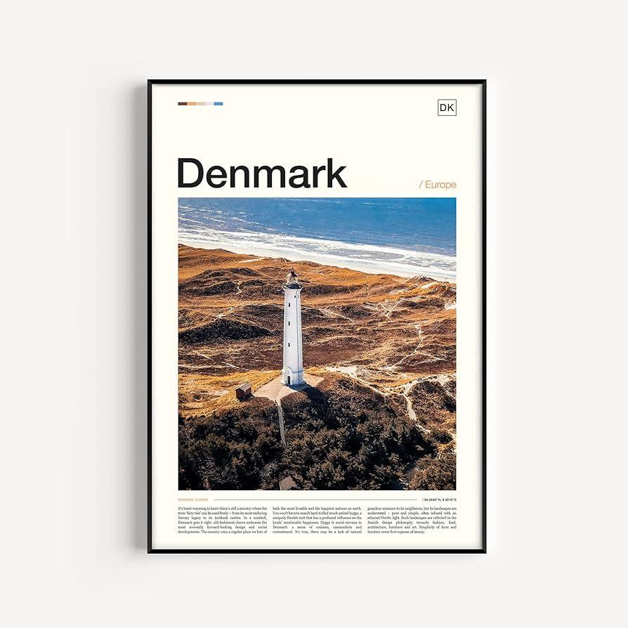

Image source: amazon.com.

### Online Shopping Habits in Denmark

Danish consumers are among the most tech-savvy in Europe, with a high internet penetration rate that facilitates widespread online shopping. This digital proficiency is reflected in their shopping habits, where convenience and efficiency are paramount. Danish shoppers prefer platforms that offer seamless navigation, quick load times, and easy checkout processes. These elements are crucial for startups to consider when designing their e-commerce websites.

Mobile shopping is particularly popular in Denmark, with many consumers using smartphones and tablets to browse and purchase products. This trend underscores the importance of having a mobile-optimized website or app that provides a smooth and intuitive user experience. Features such as mobile payment options, responsive design, and fast loading speeds can significantly enhance the shopping experience for mobile users.

Another notable aspect of Danish online shopping habits is the preference for secure and reliable payment methods. Consumers in Denmark often use digital wallets like MobilePay and Apple Pay, which have become more popular than traditional credit and debit cards. Startups should ensure that their payment gateways support these options to cater to local preferences and build trust with their customers.

Click-and-collect services are also gaining traction in Denmark. This option allows consumers to purchase products online and pick them up at a physical location, combining the convenience of online shopping with the immediacy of in-store pickup. Offering click-and-collect can be a strategic advantage for startups, especially those with a physical presence or partnerships with local stores.

Social commerce is another significant trend, with platforms like Facebook, Pinterest, and Instagram playing a crucial role in influencing purchasing decisions. Danish consumers frequently discover new products through social media, making it essential for startups to maintain an active and engaging presence on these platforms. Utilizing targeted ads, influencer collaborations, and interactive content can drive traffic to online stores and boost sales.

By understanding and adapting to these online shopping habits, startups can effectively meet the needs of Danish consumers and position themselves for success in the competitive e-commerce landscape.

### Popular Styles and Trends in Posters

Danish consumers have a distinct taste for minimalistic and functional designs, which is deeply rooted in the broader Scandinavian design ethos. This preference for simplicity and elegance is evident in the types of posters that are popular among Danish buyers. Minimalism, characterized by clean lines, neutral color palettes, and uncluttered compositions, resonates well with the Danish aesthetic. Posters that emphasize simplicity and reduce visual clutter to focus on the core message are highly favored.

Bold typography is another trend that has gained traction in Denmark. Posters featuring large, striking fonts can make a powerful visual statement and are often used to convey motivational quotes or impactful messages. This trend aligns with the Danish appreciation for design that is both aesthetically pleasing and functional.

Nature-inspired themes are also prevalent in the Danish poster market. Given Denmark's strong connection to nature and the environment, posters that depict natural landscapes, botanical illustrations, and wildlife are particularly appealing. These designs not only enhance the visual appeal of living spaces but also reflect the cultural value placed on nature and sustainability.

Geometric patterns and abstract art are other popular styles. These designs often feature bold shapes, vibrant colors, and dynamic compositions that add a modern touch to interior decor. The versatility of geometric and abstract posters allows them to complement various design styles, making them a popular choice for Danish consumers looking to personalize their homes.

In addition to these trends, there is a growing interest in posters that incorporate elements of Danish culture and heritage. Designs that feature iconic Danish landmarks, cultural symbols, or references to local traditions can evoke a sense of pride and nostalgia, making them highly desirable.

By staying abreast of these popular styles and trends, startups can create poster designs that resonate with Danish consumers, ensuring their offerings are both relevant and appealing in this discerning market.

### Price Sensitivity and Purchase Drivers

Understanding the price sensitivity of Danish consumers is crucial for startups entering the online poster market. Danish buyers are known for their discerning taste and willingness to invest in quality products, but they also seek value for money. This dual focus on quality and affordability means that startups must carefully balance their pricing strategies to attract and retain customers.

Competitive pricing is essential, especially in a market where consumers have access to a wide range of options. Offering a variety of price points can cater to different segments of the market, from budget-conscious students to affluent professionals looking for premium art pieces. Discounts, promotions, and bundle deals can also be effective in appealing to price-sensitive customers without compromising on perceived value.

Purchase drivers for Danish consumers often include the desire to personalize their living spaces and express their individual tastes. Posters that allow for customization, such as adding personal photos or text, can appeal to this need for personal expression. Moreover, limited edition prints and collaborations with local artists can create a sense of exclusivity and uniqueness, further driving consumer interest.

The cultural appreciation for art and design in Denmark also plays a significant role in purchase decisions. Consumers are more likely to invest in posters that reflect their aesthetic preferences and cultural values. This means that designs aligning with the minimalist and functional Scandinavian design ethos are particularly appealing.

Sustainability is another important purchase driver. Danish consumers are increasingly conscious of the environmental impact of their purchases and are willing to pay a premium for eco-friendly products. Startups that emphasize sustainable materials and ethical production practices can attract environmentally conscious buyers and differentiate themselves in the market.

By understanding these aspects of price sensitivity and purchase drivers, startups can develop pricing strategies and product offerings that resonate with Danish consumers, ensuring a successful entry into the online poster market.

Navigating the regulatory and legal landscape is essential for startups aiming to enter the Danish online poster market. Denmark has a well-defined set of e-commerce regulations that ensure consumer protection and fair trading practices. Startups must familiarize themselves with these regulations to operate legally and build trust with their customers.

One of the primary considerations is compliance with the General Data Protection Regulation (GDPR). This EU-wide regulation mandates strict guidelines on how businesses collect, store, and use personal data. Startups must implement robust data protection measures, including obtaining explicit consent from customers before collecting their data and ensuring secure storage practices. Non-compliance can result in hefty fines and damage to the business's reputation.

Taxation is another critical aspect. Denmark imposes a value-added tax (VAT) on goods sold within the country. Startups must register for VAT and ensure that they charge the correct rate on their products. Additionally, they need to file regular VAT returns and maintain accurate records of their transactions. Understanding the nuances of VAT compliance can help avoid legal issues and ensure smooth operations.

Intellectual property rights are also vital in the online poster market. Startups must ensure that their designs do not infringe on existing copyrights or trademarks. Using original artwork or obtaining proper licenses for any third-party content is crucial. This not only protects the business from legal disputes but also upholds the integrity of the brand.

Moreover, consumer protection laws in Denmark require businesses to provide clear information about their products, including pricing, delivery terms, and return policies. Startups must ensure that their websites are transparent and user-friendly, offering detailed product descriptions and easy access to customer service.

By adhering to these regulatory and legal considerations, startups can establish a solid foundation for their business, fostering trust and credibility with Danish consumers.

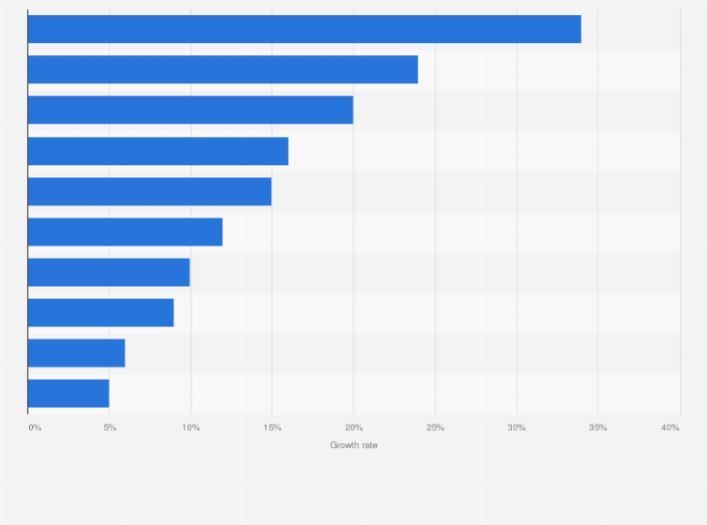

Image source: statista.com.

### E-commerce Regulations

Denmark's e-commerce regulations are designed to protect consumers and ensure fair trading practices, making it crucial for startups to understand and comply with these rules. One of the most significant regulations is the General Data Protection Regulation (GDPR), which governs how businesses collect, store, and use personal data. Startups must obtain explicit consent from customers before collecting their data and ensure that this data is stored securely. Failure to comply with GDPR can result in substantial fines and damage to the business's reputation.

In addition to GDPR, startups must adhere to the Danish Consumer Contracts Act, which outlines the rights and obligations of both consumers and businesses in online transactions. This act requires businesses to provide clear and comprehensive information about their products, including pricing, delivery terms, and return policies. Ensuring transparency in these areas helps build trust with customers and reduces the risk of disputes.

Another critical aspect of e-commerce regulations in Denmark is the requirement for secure payment methods. Danish consumers prefer using digital wallets like MobilePay and Apple Pay, which offer enhanced security compared to traditional credit and debit cards. Startups should integrate these payment options into their e-commerce platforms to meet consumer preferences and ensure secure transactions.

Moreover, the Danish Marketing Practices Act regulates advertising and marketing activities, prohibiting misleading or deceptive practices. Startups must ensure that their marketing materials are truthful and not exaggerated, providing accurate representations of their products. This regulation also covers the use of cookies and tracking technologies, requiring businesses to obtain consent from users before collecting data through these means.

Compliance with these e-commerce regulations not only helps startups avoid legal issues but also enhances their credibility and trustworthiness in the eyes of Danish consumers. By prioritizing transparency, data protection, and secure payment methods, startups can create a solid foundation for their online poster sales business in Denmark.

### Taxation and Compliance

Navigating the taxation landscape is a critical aspect for startups entering the Danish online poster market. Denmark imposes a value-added tax (VAT) on goods sold within the country, which is currently set at 25%. Startups must register for VAT with the Danish Tax Agency (SKAT) and ensure that they charge the correct rate on their products. This involves displaying VAT-inclusive prices on their websites, which is a legal requirement to maintain transparency with consumers.

Filing regular VAT returns is another essential compliance task. Startups need to submit these returns either monthly, quarterly, or annually, depending on their turnover. Accurate record-keeping of all transactions, including sales and purchases, is crucial to ensure that VAT returns are correct and submitted on time. Failure to comply with VAT regulations can result in penalties and interest charges, which can be detrimental to a startup's financial health.

In addition to VAT, startups must be aware of customs duties if they are importing posters or materials from outside the European Union. These duties vary depending on the country of origin and the type of goods being imported. Understanding the Harmonized System (HS) codes for their products can help startups determine the applicable duties and ensure compliance with customs regulations.

Moreover, Denmark has specific rules regarding the declaration of low-value consignments. As of October 2023, all goods bought by Danish customers from online marketplaces and shops abroad must be declared and checked for VAT, regardless of their value. This change aims to level the playing field between domestic and international sellers, ensuring that all businesses comply with VAT obligations.

Startups should also consider the potential impact of EU-wide regulations, such as the right to repair and green claims, which affect how products are marketed and sold. Staying informed about these regulations can help startups avoid legal pitfalls and align their business practices with current and future compliance requirements.

By understanding and adhering to these taxation and compliance requirements, startups can establish a solid foundation for their operations in Denmark, ensuring legal compliance and fostering consumer trust.

### Intellectual Property Rights

Protecting intellectual property (IP) is crucial for startups in the online poster market to safeguard their creative assets and maintain a competitive edge. In Denmark, IP rights are governed by a robust legal framework that includes copyright, trademarks, and design rights, each offering different forms of protection.

Copyright automatically protects original works of art, including posters, from the moment they are created. This protection grants the creator exclusive rights to reproduce, distribute, and display their work. Startups must ensure that all poster designs are original or properly licensed to avoid infringement issues. Using copyrighted material without permission can lead to legal disputes and financial penalties. Therefore, it is advisable to conduct thorough checks and, if necessary, consult a copyright lawyer to ensure compliance.

Trademarks protect brand names, logos, and slogans that distinguish a business's goods or services. Registering a trademark in Denmark provides legal protection against unauthorized use by competitors. For startups, securing trademarks for their brand and unique product names can prevent others from capitalizing on their reputation and ensure brand integrity. The registration process involves submitting an application to the Danish Patent and Trademark Office (DKPTO), which reviews and approves the trademark if it meets all legal requirements.

Design rights protect the visual appearance of a product, including its shape, patterns, and colors. Registering a design with the DKPTO provides exclusive rights to use the design and prevent others from copying it. This is particularly relevant for startups offering unique and innovative poster designs. The registration process is straightforward and can provide significant legal advantages in case of infringement.

Additionally, startups should be aware of international IP protection if they plan to sell posters outside Denmark. The World Intellectual Property Organization (WIPO) offers mechanisms like the Madrid System for trademarks and the Hague System for industrial designs, which facilitate international registration and protection.

By proactively managing intellectual property rights, startups can protect their creative assets, enhance their market position, and avoid costly legal disputes.

To successfully enter the Danish online poster market, startups need to adopt well-thought-out strategies that align with local consumer preferences and market dynamics. One of the first steps is to conduct thorough market research to understand the competitive landscape, consumer behavior, and current trends. This research will provide valuable insights into what types of posters are in demand and how to position your products effectively.

Leveraging digital marketing is crucial for reaching a tech-savvy Danish audience. Utilizing social media platforms like Facebook, Instagram, and Pinterest can help create brand awareness and drive traffic to your online store. Engaging content, influencer partnerships, and targeted ads can significantly boost visibility and sales. Additionally, consider using search engine optimization (SEO) techniques to improve your website's ranking on search engines, making it easier for potential customers to find you.

Offering a diverse range of products can cater to various consumer tastes and preferences. Consider including customizable options that allow customers to personalize their posters with their own photos or text. Limited edition prints and collaborations with local artists can also create a sense of exclusivity and appeal to Danish consumers' appreciation for unique and high-quality designs.

Ensuring a seamless and user-friendly online shopping experience is essential. This includes having a mobile-optimized website, easy navigation, and secure payment options. Danish consumers prefer digital wallets like MobilePay and Apple Pay, so integrating these payment methods can enhance customer satisfaction and trust.

Building strong customer relationships through excellent customer service is another key strategy. Prompt responses to inquiries, clear communication about delivery times, and hassle-free return policies can foster loyalty and encourage repeat purchases. Consider implementing a customer loyalty program to reward repeat buyers and incentivize referrals.

Finally, staying informed about regulatory and legal requirements, such as GDPR compliance and VAT regulations, is crucial for operating smoothly in the Danish market. By adhering to these guidelines, startups can build a reputable brand and avoid potential legal issues.

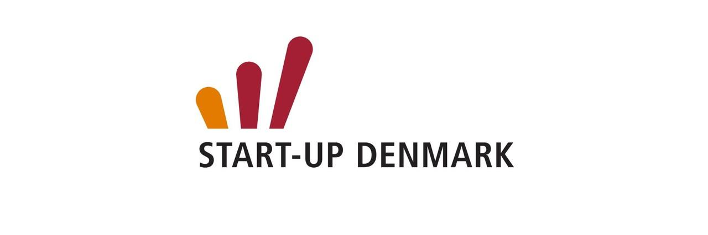

Image source: linkedin.com.

### Market Entry Strategies

Entering the Danish online poster market requires a strategic approach that leverages the unique characteristics of the local consumer base and competitive landscape. One effective strategy is to start with a soft launch, allowing you to test the market and gather valuable feedback before a full-scale rollout. This can involve launching a limited product range or targeting a specific geographic area within Denmark. By doing so, you can refine your offerings and marketing strategies based on real-world data and consumer responses.

Building a strong online presence is essential. Invest in a professional, mobile-optimized website that offers a seamless user experience. Ensure that your site is easy to navigate, with clear product categories and detailed descriptions. High-quality images and customer reviews can also enhance the shopping experience and build trust with potential buyers.

Leveraging local partnerships can provide a significant boost. Collaborate with Danish artists to create exclusive designs that resonate with local tastes. These partnerships can also help in marketing efforts, as local artists often have established followings that can be tapped into. Additionally, consider partnering with local influencers and bloggers who can promote your products to their audiences, providing authentic endorsements that can drive traffic and sales.

Utilizing social media effectively is another crucial component. Platforms like Facebook, Instagram, and Pinterest are popular in Denmark and offer powerful tools for targeted advertising. Create engaging content that showcases your posters in various settings, and use social media analytics to track performance and adjust your strategies accordingly.

Offering localized customer service can set you apart from international competitors. Provide support in Danish and ensure that your customer service team is well-versed in local customs and preferences. This can enhance customer satisfaction and foster loyalty.

Finally, consider the logistics of shipping and delivery. Partner with reliable local couriers to ensure timely and cost-effective delivery. Offering options like click-and-collect can also appeal to consumers who prefer to pick up their purchases at a convenient location.

By implementing these market entry strategies, startups can effectively navigate the Danish online poster market and build a strong foundation for growth.

### Marketing and Branding Approaches

Creating a strong marketing and branding strategy is essential for startups aiming to capture the Danish online poster market. The first step is to develop a compelling brand story that resonates with your target audience. This story should highlight your unique value proposition, such as the originality of your designs, the quality of your materials, or your commitment to sustainability. A well-crafted brand narrative can differentiate your business from competitors and create an emotional connection with consumers.

Utilizing social media platforms effectively is crucial for building brand awareness and driving sales. Facebook, Instagram, and Pinterest are particularly popular in Denmark and offer robust tools for targeted advertising. Create visually appealing content that showcases your posters in various settings, and use features like Instagram Stories and Pinterest Pins to engage with your audience. Collaborating with local influencers can also amplify your reach and lend credibility to your brand.

Content marketing is another powerful tool. Start a blog on your website where you can share insights about design trends, tips for decorating with posters, and behind-the-scenes looks at your creative process. This not only positions your brand as an authority in the art and design space but also improves your website's SEO, making it easier for potential customers to find you through search engines.

Email marketing should not be overlooked. Building an email list allows you to communicate directly with your audience, offering personalized recommendations, exclusive discounts, and updates on new releases. Segment your email list based on customer preferences and behaviors to ensure that your messages are relevant and engaging.

Participating in local events and art fairs can also enhance your brand visibility. These events provide an opportunity to showcase your posters in person, interact with potential customers, and gather valuable feedback. Additionally, consider offering limited edition prints or exclusive designs at these events to create a sense of urgency and exclusivity.

By integrating these marketing and branding approaches, startups can effectively build a strong presence in the Danish online poster market, attracting and retaining a loyal customer base.

### Partnerships and Collaborations

Forming strategic partnerships and collaborations can significantly enhance the market potential for online poster sales in Denmark. One effective approach is to collaborate with local artists and designers. By featuring exclusive designs from well-known or emerging Danish artists, startups can tap into existing fan bases and add a unique, local flavor to their product offerings. These collaborations not only diversify the product range but also create a sense of exclusivity and authenticity that resonates with Danish consumers.

Another valuable partnership opportunity lies with interior designers and home decor influencers. These professionals can provide expert insights into current design trends and consumer preferences, helping startups tailor their offerings to meet market demands. Additionally, featuring your posters in their projects or social media channels can provide powerful endorsements and increase brand visibility. Hosting joint events, such as pop-up shops or online webinars, can further strengthen these relationships and attract a broader audience.

Collaborating with local businesses, such as cafes, bookstores, and boutique shops, can also be beneficial. These establishments can serve as physical touchpoints where customers can view and purchase posters in person. This approach not only increases brand exposure but also provides a tangible experience that can drive online sales. Offering co-branded products or limited edition prints exclusive to these locations can create additional buzz and attract foot traffic.

Engaging with educational institutions and cultural organizations can open up new avenues for partnerships. Schools, universities, and museums often seek unique decor for their spaces and may be interested in bulk purchases or custom designs. Partnering with these institutions can lead to long-term contracts and steady revenue streams.

Finally, leveraging e-commerce platforms and marketplaces like Alibaba can expand reach and streamline operations. These platforms offer access to a broader audience and provide valuable tools for marketing, logistics, and customer service. By forming strategic partnerships and collaborations, startups can enhance their market presence, drive sales, and build a robust brand in the Danish online poster market.

When launching an online poster business in Denmark, several operational considerations are crucial for ensuring smooth and efficient operations. One of the primary aspects to focus on is supply chain and distribution logistics. Establishing reliable relationships with suppliers and print-on-demand services can help maintain a steady flow of inventory and reduce lead times. Efficient logistics are essential for meeting customer expectations regarding delivery times, which is a significant factor in customer satisfaction.

Technology and platform selection also play a vital role in the success of an online poster business. Choosing the right e-commerce platform can streamline various aspects of the business, from inventory management to customer service. Platforms like Shopify, WooCommerce, and Ecwid offer robust features that can be tailored to the specific needs of a poster business. These platforms provide tools for managing product listings, processing payments, and tracking orders, which can significantly enhance operational efficiency.

Customer service and retention are other critical components. Providing excellent customer service can differentiate your business from competitors and foster customer loyalty. Implementing a comprehensive customer service strategy that includes multiple touchpoints, such as live chat, email support, and social media engagement, can ensure that customer inquiries and issues are addressed promptly. Additionally, offering hassle-free return policies and guarantees can build trust and encourage repeat purchases.

Inventory management is another key operational consideration. Utilizing inventory management software can help track stock levels, manage reorders, and prevent stockouts or overstock situations. This ensures that popular designs are always available, and resources are not tied up in unsold inventory.

Finally, consider the importance of scalability. As your business grows, the operational processes should be able to scale accordingly. This includes having flexible logistics partners, scalable technology solutions, and a robust customer service framework that can handle increased demand. By focusing on these operational considerations, startups can build a solid foundation for their online poster business in Denmark, ensuring long-term success and growth.

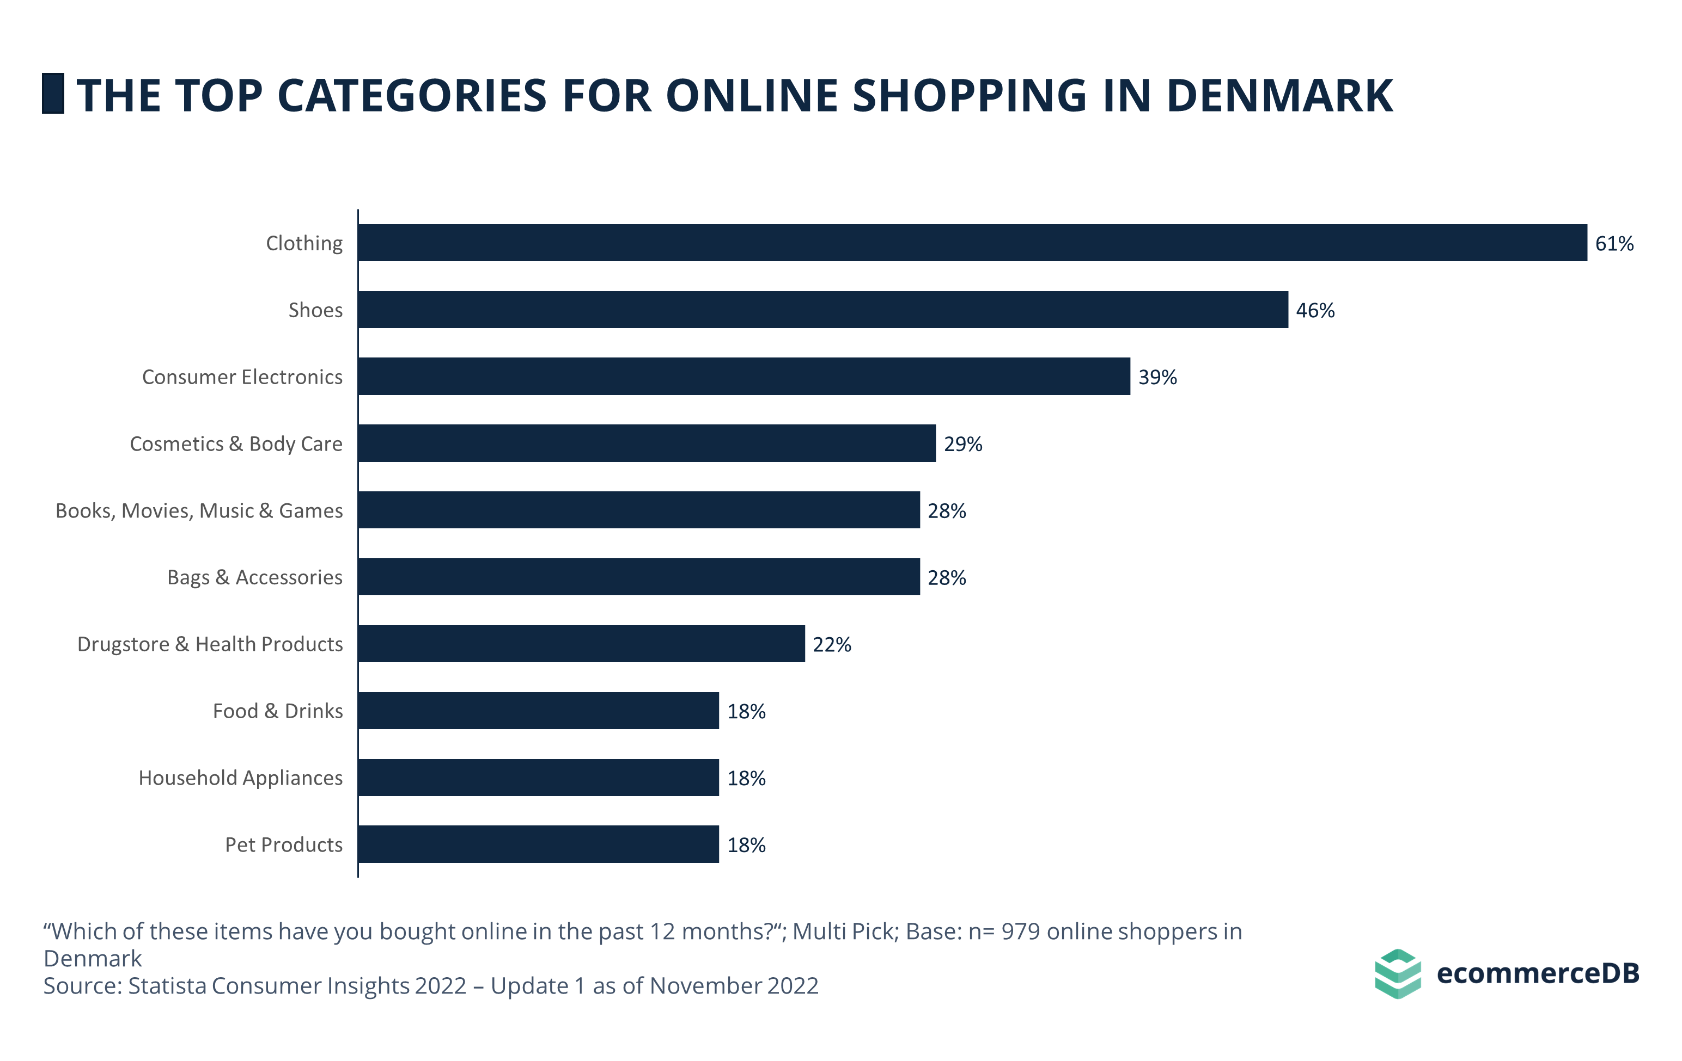

Image source: ecommercedb.com.

### Supply Chain and Distribution Logistics

Establishing a robust supply chain and efficient distribution logistics is paramount for the success of an online poster business in Denmark. The first step involves selecting reliable suppliers and print-on-demand services. These partners should be capable of delivering high-quality prints consistently and on time. Building strong relationships with these suppliers can help ensure a steady flow of inventory, reducing the risk of stockouts and delays.

Localizing your supply chain can significantly enhance efficiency. By partnering with local print shops and suppliers, you can minimize shipping times and costs. This not only improves delivery speed but also aligns with the growing consumer preference for supporting local businesses. Additionally, local suppliers are often more adaptable to custom orders and urgent requests, providing greater flexibility in meeting customer demands.

Efficient distribution logistics are equally critical. Collaborating with reputable courier services that offer reliable and timely delivery is essential. In Denmark, services like PostNord, GLS, and Bring are well-regarded for their efficiency and coverage. Offering multiple delivery options, including standard, express, and click-and-collect, can cater to different customer preferences and enhance the overall shopping experience.

Implementing advanced tracking systems can further improve logistics operations. Real-time tracking allows customers to monitor their orders, providing transparency and reducing anxiety about delivery times. This feature can also help your business manage logistics more effectively, identifying and addressing any potential delays promptly.

Sustainability in logistics is becoming increasingly important to Danish consumers. Utilizing eco-friendly packaging materials and optimizing delivery routes to reduce carbon emissions can appeal to environmentally conscious buyers. Partnering with logistics providers that prioritize green practices can also enhance your brand's reputation.

By focusing on these aspects of supply chain and distribution logistics, startups can ensure efficient operations, meet customer expectations, and build a strong foundation for growth in the Danish online poster market.

### Technology and Platform Selection

Choosing the right technology and e-commerce platform is crucial for the success of an online poster business in Denmark. The platform you select will serve as the backbone of your operations, influencing everything from inventory management to customer service.

Start by evaluating platforms like Shopify, WooCommerce, and Ecwid, which offer robust features tailored to the needs of an online poster business. These platforms provide comprehensive tools for managing product listings, processing payments, and tracking orders. Shopify, for instance, is known for its user-friendly interface and extensive app ecosystem, which can help automate various aspects of your business. WooCommerce, on the other hand, offers greater flexibility and customization options, making it ideal for businesses with specific needs. Ecwid is another excellent choice, particularly for those looking to integrate their online store with existing websites or social media channels.

Mobile optimization is a critical factor to consider. With a significant portion of Danish consumers shopping via smartphones and tablets, ensuring that your platform offers a seamless mobile experience is essential. Features like responsive design, mobile payment options, and fast loading speeds can significantly enhance the user experience and boost conversion rates.

Security is another paramount consideration. The platform you choose should support secure payment gateways, such as MobilePay and Apple Pay, which are popular among Danish consumers. Additionally, compliance with GDPR is non-negotiable, as it ensures the protection of customer data and builds trust.

Integration capabilities are also vital. Your e-commerce platform should easily integrate with other tools and services you use, such as email marketing software, CRM systems, and analytics tools. This integration can streamline operations and provide valuable insights into customer behavior and sales performance.

Lastly, consider scalability. As your business grows, your platform should be able to handle increased traffic and transaction volumes without compromising performance. Investing in a scalable solution from the outset can save you time and resources in the long run, ensuring that your business can adapt to changing market conditions and consumer demands.

### Customer Service and Retention

Providing exceptional customer service is a cornerstone for building a successful online poster business in Denmark. Danish consumers value prompt and efficient service, which can significantly influence their purchasing decisions and loyalty to your brand.

Implementing a comprehensive customer service strategy is essential. This includes offering multiple touchpoints for customer support, such as live chat, email, and social media. Live chat, in particular, can provide immediate assistance, addressing customer queries and concerns in real-time. Email support should be responsive, with clear and concise communication to resolve issues effectively. Engaging with customers on social media platforms like Facebook and Instagram can also enhance your brand's accessibility and responsiveness.

A well-structured FAQ section on your website can preemptively address common questions, reducing the volume of direct inquiries and providing customers with quick answers. This not only improves the user experience but also frees up your customer service team to handle more complex issues.

Offering hassle-free return policies is another critical aspect. Clear and fair return policies build trust and encourage customers to make purchases with confidence. Ensure that your return process is straightforward, with easy-to-follow instructions and minimal barriers. This can significantly enhance customer satisfaction and foster repeat business.

Personalization can also play a significant role in customer retention. Utilize customer data to offer personalized recommendations and targeted promotions. For instance, sending personalized emails with product suggestions based on previous purchases can make customers feel valued and understood. Loyalty programs that reward repeat purchases with discounts or exclusive offers can further incentivize customers to return.

Finally, gathering and acting on customer feedback is crucial. Regularly solicit feedback through surveys or reviews and use this information to improve your products and services. Demonstrating that you value and act on customer input can strengthen relationships and enhance brand loyalty.

By focusing on these elements, startups can create a robust customer service framework that not only meets but exceeds customer expectations, driving long-term retention and growth.

When planning to launch an online poster business in Denmark, understanding the financial landscape is crucial. Startups need to develop detailed financial projections to ensure they are prepared for the costs and potential revenue streams associated with their venture.

Startup Costs and Revenue Models

Initial costs for an online poster business can vary widely depending on factors such as the scale of operations, technology investments, and marketing strategies. Key expenses include website development, inventory procurement, marketing campaigns, and logistics setup. Utilizing print-on-demand services can help mitigate upfront inventory costs, allowing startups to focus their resources on marketing and customer acquisition.

Revenue models for online poster sales typically include direct sales through an e-commerce platform, subscription services for regular poster deliveries, and collaborations with artists for exclusive designs. Offering customizable posters can also create an additional revenue stream, catering to consumers seeking personalized art.

Investment and Funding Options

Securing funding is often a critical step for startups. Various funding options are available, including bootstrapping, angel investors, venture capital, and crowdfunding. Bootstrapping allows founders to retain full control of their business but may limit growth potential due to limited resources. Angel investors and venture capitalists can provide significant funding in exchange for equity, offering the financial support needed to scale operations quickly.

Crowdfunding platforms like Kickstarter and Indiegogo offer an alternative route, allowing startups to raise funds directly from consumers. This approach not only provides capital but also validates the business idea and builds an initial customer base.

Break-even Analysis and ROI

Conducting a break-even analysis helps determine the point at which the business will start generating profit. This involves calculating fixed and variable costs and estimating the sales volume required to cover these expenses. Understanding the break-even point is essential for setting realistic financial goals and timelines.

Return on investment (ROI) is another critical metric. By analyzing the ROI, startups can assess the efficiency of their investments and make informed decisions about future expenditures. Regularly reviewing financial performance against projections ensures that the business remains on track and can adapt to changing market conditions.

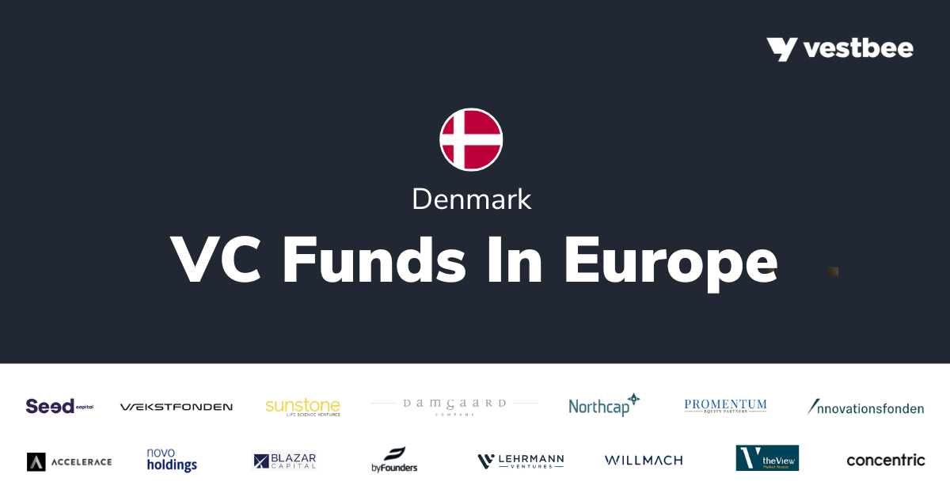

Image source: vestbee.com.

### Startup Costs and Revenue Models

Launching an online poster business in Denmark involves several initial costs that startups must carefully plan for. These costs can vary depending on the scale of operations, the technology used, and the marketing strategies employed. Key expenses include website development, inventory procurement, marketing campaigns, and logistics setup.

Website development is a critical investment, as a well-designed, user-friendly site can significantly enhance the customer experience. Costs here can range from basic template-based sites to fully customized platforms with advanced features. Additionally, integrating secure payment gateways like MobilePay and Apple Pay, which are popular in Denmark, is essential for building consumer trust.

Inventory procurement is another major expense. Utilizing print-on-demand services can help mitigate upfront costs by eliminating the need for large inventory purchases. This model allows startups to produce posters only when an order is placed, reducing financial risk and storage costs. However, it’s important to partner with reliable print-on-demand providers to ensure consistent quality and timely delivery.

Marketing campaigns are crucial for building brand awareness and driving traffic to the online store. Initial marketing efforts may include social media advertising, influencer partnerships, and search engine optimization (SEO). Allocating a budget for these activities can help attract a steady stream of potential customers and establish a strong market presence.

Logistics setup involves establishing relationships with reliable courier services to ensure efficient and timely delivery. Offering multiple delivery options, such as standard, express, and click-and-collect, can cater to different customer preferences and enhance the overall shopping experience.

Revenue models for online poster sales typically include direct sales through the e-commerce platform, subscription services for regular poster deliveries, and collaborations with artists for exclusive designs. Customizable posters can also create an additional revenue stream, appealing to consumers seeking personalized art. By diversifying revenue models, startups can tap into various market segments and maximize their earning potential.

### Investment and Funding Options

Securing funding is often a critical step for startups. Various funding options are available, each with its own set of advantages and considerations. Bootstrapping, for instance, allows founders to retain full control of their business but may limit growth potential due to limited resources. This self-funding approach is ideal for entrepreneurs who prefer to grow their business organically and avoid external debt or equity dilution.

Angel investors and venture capitalists can provide significant funding in exchange for equity, offering the financial support needed to scale operations quickly. Angel investors typically invest smaller amounts compared to venture capitalists but can offer valuable mentorship and industry connections. Venture capitalists, on the other hand, are more suitable for startups with high growth potential and scalable business models. They can provide substantial capital injections, often in multiple funding rounds, to support rapid expansion.

Crowdfunding platforms like Kickstarter and Indiegogo offer an alternative route, allowing startups to raise funds directly from consumers. This approach not only provides capital but also validates the business idea and builds an initial customer base. Successful crowdfunding campaigns can generate buzz and attract media attention, further boosting brand visibility. However, it requires a compelling pitch and effective marketing to stand out in a crowded space.

Government grants and subsidies are another viable option, particularly in Denmark, where various programs support innovation and entrepreneurship. These funds are typically non-dilutive, meaning they do not require giving up equity. Startups should explore local and national grant opportunities, which can provide financial support for research, development, and market entry activities.

Bank loans and lines of credit are traditional funding options that can provide the necessary capital without diluting ownership. However, they require a solid business plan and creditworthiness. Interest rates and repayment terms should be carefully considered to ensure they align with the startup's financial projections and cash flow.

By exploring these diverse funding options, startups can secure the necessary capital to launch and grow their online poster business in Denmark, ensuring they are well-positioned to capitalize on market opportunities.

### Break-even Analysis and ROI

Conducting a break-even analysis is essential for understanding when your online poster business will start generating profit. This involves calculating both fixed and variable costs and determining the sales volume required to cover these expenses. Fixed costs include expenses such as website development, marketing campaigns, and salaries, which remain constant regardless of sales volume. Variable costs, on the other hand, fluctuate with production levels and include costs like printing, packaging, and shipping.

To perform a break-even analysis, you need to identify the break-even point, which is the number of units that must be sold to cover all costs. The formula for this is:

$$Break−even Point (units) = \frac{Fixed Costs}{Selling Price per Unit − Variable Cost per Unit}$$

For example, if your fixed costs are $10,000, the selling price per poster is $50, and the variable cost per poster is $20, the break-even point would be:

$$\frac{10,000}{50 − 20} = 334 posters$$

This means you need to sell 334 posters to cover all your costs and start making a profit.

Return on investment (ROI) is another critical metric for assessing the efficiency of your investments. ROI measures the profitability of your investments relative to their cost and is calculated using the formula:

$$ROI = \frac{Net Profit}{Total Investment × 100}$$

For instance, if your total investment is $20,000 and your net profit after one year is $5,000, the ROI would be:

$$\frac{5,000}{20,000 × 100} = 25\backslash \%$$

A 25% ROI indicates that for every dollar invested, you earn 25 cents in profit. Regularly reviewing your ROI helps in making informed decisions about future investments and identifying areas for improvement.

By understanding these financial metrics, startups can set realistic financial goals, monitor their progress, and make data-driven decisions to ensure long-term success in the Danish online poster market.

### What are the key economic indicators that influence the market potential for online poster sales in Denmark?

Key economic indicators that influence the market potential for online poster sales in Denmark include GDP per capita, consumer spending per capita, and internet penetration rates. Denmark boasts one of the highest GDP per capita figures globally, reflecting a robust economy that supports discretionary spending on non-essential items like art and decor. This economic stability translates into significant disposable income, allowing consumers to invest in quality products that enhance their living spaces.

Consumer spending per capita is another crucial indicator. Danish consumers are known for their willingness to invest in high-quality, aesthetically pleasing products. This trend is supported by consistent growth in consumer spending, driven by a high standard of living and low unemployment rates. The tech-savvy nature of the Danish population, coupled with high internet penetration rates, ensures that a large segment of the population is comfortable making purchases online. This familiarity with digital platforms makes it easier for startups to reach potential customers through e-commerce channels.

Additionally, Denmark's efficient logistics and delivery infrastructure guarantee timely and reliable delivery of online orders, further enhancing the appeal of online shopping. By understanding these economic indicators, startups can better position themselves to capture the market potential in Denmark, aligning their strategies with the financial capabilities and purchasing behaviors of Danish consumers.

### How can startups identify and target the most promising customer segments in the Danish market?

Startups can identify and target the most promising customer segments in the Danish market by analyzing demographic data, consumer behavior, and cultural preferences. Denmark's population is well-educated, with a high percentage of individuals holding tertiary degrees, indicating a society that values cultural and intellectual pursuits. This demographic is more likely to appreciate and invest in art and design, making them an ideal target audience for online poster sales.

Urbanization is another key factor. A significant portion of the population resides in cities such as Copenhagen, Aarhus, and Odense, where modern design and home decor trends are prevalent. Urban dwellers often seek to personalize their living spaces with unique and aesthetically pleasing items, making posters a popular choice. Age demographics also play a crucial role, with younger consumers (18-34 years) being more inclined towards online shopping and digital engagement. This tech-savvy group is comfortable navigating e-commerce platforms and is often influenced by social media trends.

Income levels further define the target audience. Higher-income households have more discretionary spending power, allowing them to invest in quality art pieces. However, the affordability of posters makes them accessible to a broader audience, including those with moderate incomes who still wish to enhance their living spaces with artistic elements.

By leveraging data analytics and market research, startups can gain insights into these demographic factors and consumer preferences. This information can be used to tailor marketing strategies, product offerings, and pricing models to meet the specific needs and desires of Danish consumers, ensuring a successful entry into the online poster market.

### What are the current trends in the global and Danish online poster markets that startups should be aware of?

Current trends in the global and Danish online poster markets that startups should be aware of include the rise of print-on-demand services, the increasing use of digital platforms for art sales, and the significant role of social media in influencing consumer behavior. Print-on-demand services have revolutionized the market by allowing artists and designers to create and sell their work without large upfront investments in inventory. This model reduces financial risk and enables a wider variety of designs to be available to consumers, catering to diverse tastes and preferences.

The shift towards online shopping is supported by advancements in digital printing technology, ensuring high-quality reproductions of original artworks. E-commerce giants and specialized online marketplaces have made it easier for consumers to discover and purchase posters from the comfort of their homes. The convenience and accessibility of online shopping have made it a preferred method for many art enthusiasts.

Social media platforms like Instagram, Pinterest, and Facebook have become essential tools for artists and businesses to showcase their work, engage with potential customers, and drive sales. The visual nature of these platforms makes them ideal for promoting art, allowing for direct interaction with a global audience. Influencer collaborations and targeted advertising on social media further amplify the reach and impact of marketing efforts.

In Denmark, the market reflects these global trends while also showcasing unique local characteristics. Danish consumers have a strong appreciation for minimalistic and functional designs, which align with the country's renowned design philosophy. This cultural inclination towards simplicity and elegance is evident in the types of posters that are popular among Danish buyers. Additionally, the integration of social media and e-commerce has opened new avenues for marketing and sales, providing startups with the opportunity to leverage these digital tools to reach and attract their target audience.

Sustainability is another emerging trend in the online poster industry. Consumers are increasingly conscious of the environmental impact of their purchases and are seeking out eco-friendly options. This has led to a rise in the use of sustainable materials and printing practices, as well as the promotion of posters that support environmental causes. By staying attuned to these trends, startups can better position themselves to meet the demands of modern consumers and capitalize on the growing opportunities in this vibrant industry.

### What regulatory and legal considerations must be addressed when launching an online poster business in Denmark?

When launching an online poster business in Denmark, several regulatory and legal considerations must be addressed to ensure compliance and build consumer trust. One of the primary considerations is adherence to the General Data Protection Regulation (GDPR). This EU-wide regulation mandates strict guidelines on how businesses collect, store, and use personal data. Startups must implement robust data protection measures, including obtaining explicit consent from customers before collecting their data and ensuring secure storage practices. Non-compliance with GDPR can result in hefty fines and damage to the business's reputation.

Taxation is another critical aspect. Denmark imposes a value-added tax (VAT) on goods sold within the country. Startups must register for VAT and ensure that they charge the correct rate on their products. Additionally, they need to file regular VAT returns and maintain accurate records of their transactions. Understanding the nuances of VAT compliance can help avoid legal issues and ensure smooth operations.

Intellectual property rights are also vital in the online poster market. Startups must ensure that their designs do not infringe on existing copyrights or trademarks. Using original artwork or obtaining proper licenses for any third-party content is crucial. This not only protects the business from legal disputes but also upholds the integrity of the brand.

Moreover, consumer protection laws in Denmark require businesses to provide clear information about their products, including pricing, delivery terms, and return policies. Startups must ensure that their websites are transparent and user-friendly, offering detailed product descriptions and easy access to customer service.

By adhering to these regulatory and legal considerations, startups can establish a solid foundation for their business, fostering trust and credibility with Danish consumers.

### What are the most effective marketing and branding strategies for reaching Danish consumers in the online poster market?

To reach Danish consumers in the online poster market effectively, startups should focus on developing a compelling brand story that resonates with their target audience. This story should highlight unique value propositions, such as the originality of designs, the quality of materials, or a commitment to sustainability. A well-crafted brand narrative can differentiate the business from competitors and create an emotional connection with consumers.

Utilizing social media platforms is crucial for building brand awareness and driving sales. Facebook, Instagram, and Pinterest are particularly popular in Denmark and offer robust tools for targeted advertising. Creating visually appealing content that showcases posters in various settings and using features like Instagram Stories and Pinterest Pins can engage the audience effectively. Collaborating with local influencers can amplify reach and lend credibility to the brand.

Content marketing is another powerful tool. Starting a blog on the website to share insights about design trends, tips for decorating with posters, and behind-the-scenes looks at the creative process can position the brand as an authority in the art and design space. This not only improves the website's SEO but also makes it easier for potential customers to find the business through search engines.

Email marketing should not be overlooked. Building an email list allows direct communication with the audience, offering personalized recommendations, exclusive discounts, and updates on new releases. Segmenting the email list based on customer preferences and behaviors ensures that messages are relevant and engaging.

Participating in local events and art fairs can also enhance brand visibility. These events provide an opportunity to showcase posters in person, interact with potential customers, and gather valuable feedback. Offering limited edition prints or exclusive designs at these events can create a sense of urgency and exclusivity.

By integrating these marketing and branding strategies, startups can effectively build a strong presence in the Danish online poster market, attracting and retaining a loyal customer base.

As we navigate the dynamic landscape of online poster sales in Denmark, it becomes evident that this market holds significant potential for startups. The blend of economic stability, cultural appreciation for art, and a tech-savvy population creates a fertile ground for innovative ventures. By understanding the unique characteristics of Danish consumers and aligning business strategies accordingly, startups can carve out a niche in this vibrant market.

One of the key takeaways is the importance of leveraging digital platforms to reach and engage with potential customers. Social media channels like Facebook, Instagram, and Pinterest are not just tools for visibility but powerful engines for driving sales and building brand loyalty. Crafting visually appealing content and collaborating with local influencers can amplify your reach and resonate with the Danish audience.

Moreover, the emphasis on sustainability cannot be overstated. Danish consumers are increasingly conscious of the environmental impact of their purchases. Startups that prioritize eco-friendly materials and ethical production practices can differentiate themselves and attract a dedicated customer base. This commitment to sustainability should be woven into the brand narrative, reinforcing the values that resonate with Danish consumers.

Another critical aspect is the seamless integration of technology in business operations. From mobile-optimized websites to secure payment gateways, ensuring a smooth and secure shopping experience is paramount. The use of advanced analytics can also provide valuable insights into consumer behavior, enabling startups to tailor their offerings and marketing strategies more effectively.

Finally, building strong customer relationships through excellent service and personalized experiences can foster loyalty and encourage repeat business. Implementing a comprehensive customer service strategy, offering hassle-free returns, and engaging with customers through multiple touchpoints can significantly enhance satisfaction and retention.

By focusing on these strategic insights, startups can navigate the complexities of the Danish online poster market and position themselves for long-term success. The journey may be challenging, but with the right approach, the rewards can be substantial.

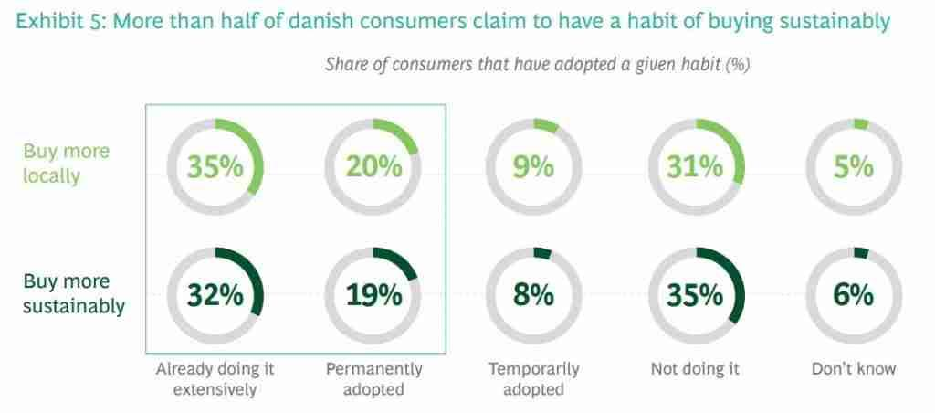

Image source: gaasly.com.

### Summary of Key Insights

Denmark presents a promising market for online poster sales, driven by a combination of economic stability, cultural appreciation for art, and a tech-savvy population. The high GDP per capita and low unemployment rates translate into significant disposable income, allowing consumers to invest in quality products that enhance their living spaces. This economic backdrop, coupled with a high standard of living, ensures that Danish consumers have both the means and the inclination to purchase aesthetically pleasing posters.

Understanding the demographics is crucial. The well-educated and urbanized population values cultural and intellectual pursuits, making them more likely to invest in art and design. Younger consumers, particularly those in the 18-34 age bracket, are more inclined towards online shopping and digital engagement, often influenced by social media trends. This tech-savvy group is comfortable navigating e-commerce platforms, making it easier for startups to reach potential customers through digital channels.

Cultural appreciation for minimalistic and functional designs aligns well with the broader Scandinavian design ethos. Danish consumers favor clean, simple, and aesthetically pleasing designs, which should be reflected in the poster offerings. Nature-inspired themes, bold typography, and geometric patterns are particularly popular, catering to the local taste for simplicity and elegance.

Leveraging digital platforms is essential for reaching and engaging with potential customers. Social media channels like Facebook, Instagram, and Pinterest are powerful tools for building brand awareness and driving sales. Collaborating with local influencers and creating visually appealing content can amplify reach and resonate with the Danish audience.

Sustainability is a significant purchase driver. Danish consumers are increasingly conscious of the environmental impact of their purchases. Startups that prioritize eco-friendly materials and ethical production practices can differentiate themselves and attract a dedicated customer base.

By focusing on these key insights, startups can effectively navigate the Danish online poster market, aligning their strategies with local consumer preferences and market dynamics to achieve long-term success.

### Final Thoughts and Next Steps

As we look ahead, it's clear that the Danish market offers a fertile ground for online poster sales. Startups should focus on a few critical areas to ensure their success. First, continuous market research is essential. Staying updated on consumer preferences, emerging trends, and competitive dynamics will help businesses adapt and innovate. Tools like Google Trends and social media analytics can provide valuable insights into what resonates with Danish consumers.

Building a strong brand presence is another crucial step. This involves not only creating visually appealing and high-quality products but also crafting a compelling brand story that connects with the audience. Emphasizing unique selling points such as sustainability, local artistry, or customizable options can set a brand apart in a crowded market.

Investing in technology is also vital. A seamless, mobile-optimized e-commerce platform with secure payment options will enhance the shopping experience and build consumer trust. Integrating advanced analytics can help track customer behavior, optimize marketing strategies, and improve inventory management.

Collaboration and partnerships can provide significant advantages. Working with local artists, influencers, and other businesses can expand reach and add credibility. These partnerships can also lead to exclusive product offerings that attract a dedicated customer base.

Customer engagement should be a continuous effort. Implementing loyalty programs, personalized marketing, and excellent customer service can foster long-term relationships and encourage repeat purchases. Engaging with customers through social media, email newsletters, and events can keep the brand top-of-mind and build a community around it.

Finally, staying compliant with local regulations and understanding the legal landscape is crucial. This includes adhering to GDPR, VAT regulations, and intellectual property laws. Ensuring compliance not only avoids legal issues but also builds a trustworthy brand image.

By focusing on these strategic areas, startups can navigate the Danish online poster market effectively, positioning themselves for sustainable growth and success.