Linux Commands 2
Date: 19/04/26
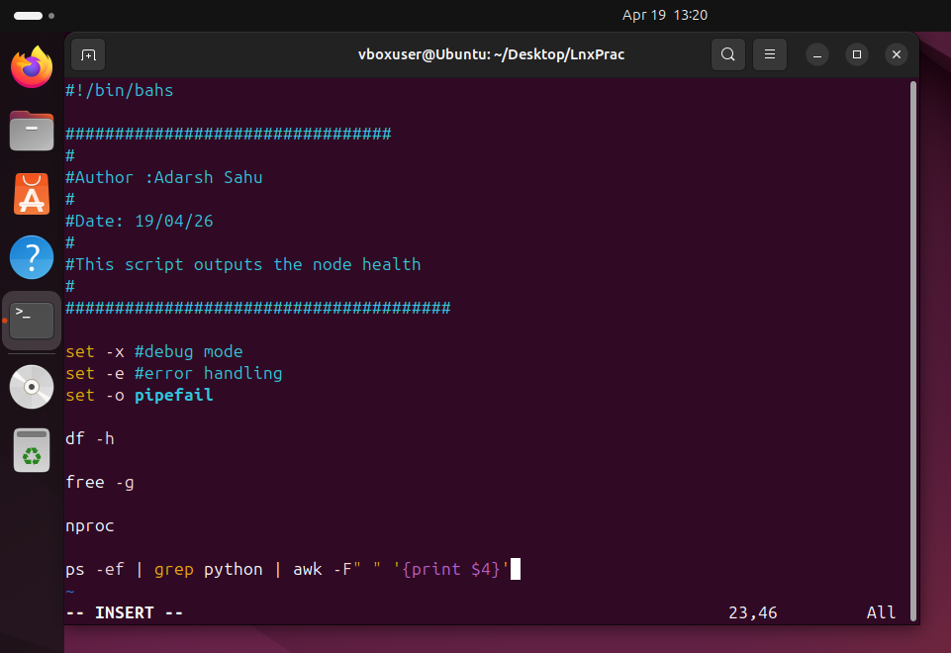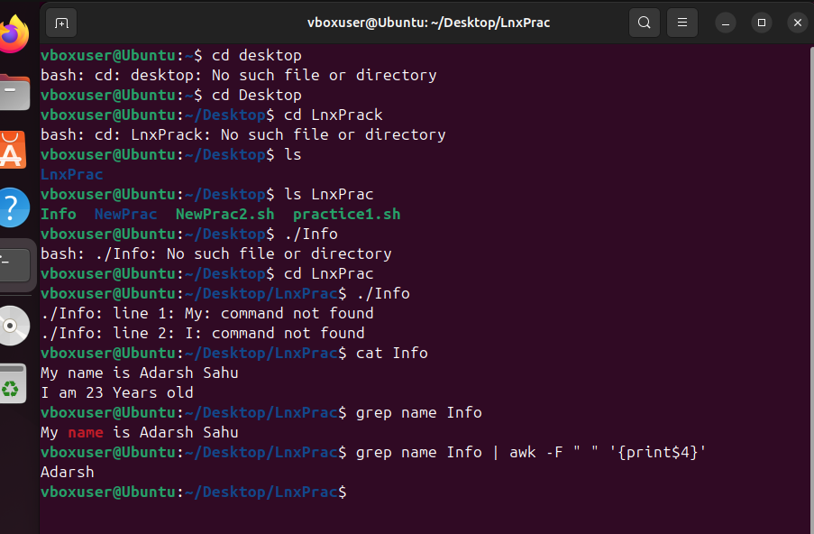
AWK is a powerful data-driven programming language and command-line utility used in Linux for text processing and data extraction.

Curl Command : (Client URL) is a versatile command-line tool used to transfer data between a client and a server using various network protocols, including HTTP, HTTPS, FTP, and SFTP. It is widely used by developers for testing APIs, downloading files, and automating web tasks.

the pipe (represented by the vertical bar symbol |) is a shell operator that connects the standard output (stdout) of one command directly to the standard input (stdin) of another.

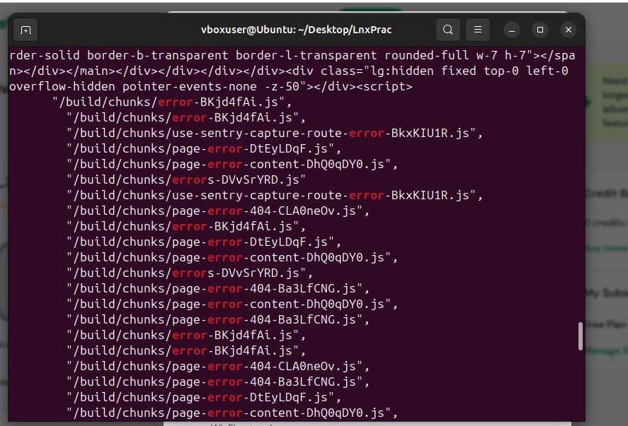

In Linux, the set command is a built-in shell utility used to change the values of shell options and positional parameters. The flags -x, -e, and -o are frequently used together in scripts to improve reliability and debugging.

Find Command : The find command in Linux is a powerful utility used to search for files and directories in a filesystem hierarchy. Unlike the locate command which uses a database, find searches in real-time.
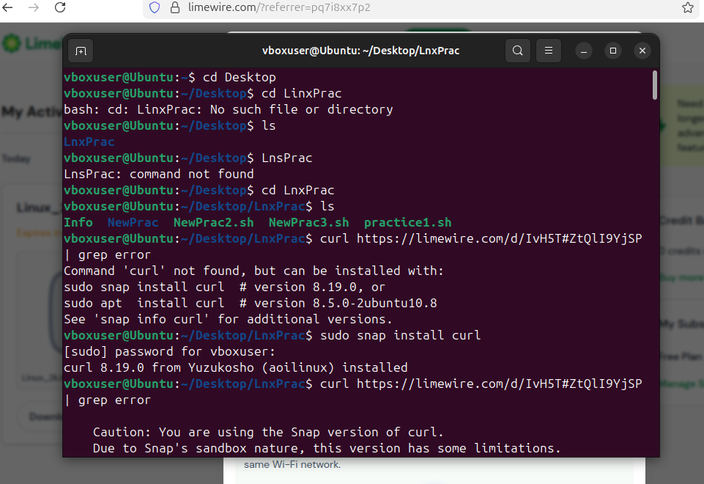

Summary for Today
Today I learedn various distribution of linux and their demands and uses.
How Linux is unknowingly working behind the processes.
The History of Linux, Unix and other distributions.
Learned about the permissions given to the file.
Got hands on Practice on shell scripting.
Implemented new commands and took one step forward to strengthen my Linux skill in order to get into administrator role.

