**Wonders of Yoga for Children**

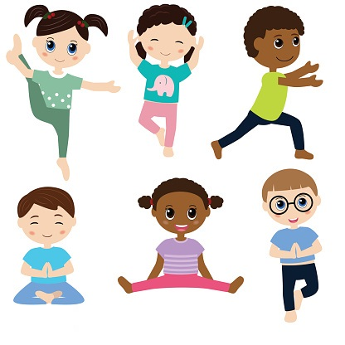

**Seema Tekchandani**

**Diploma Course No. 22**

**Group No. 3 Roll no. 41**

**2016-2017**

**Ghantali Mitra Mandal**

**Yog Department**

**Wonders of Yoga for Children**

**Seema Tekchandani**

**Diploma Course No. 22**

**Group No. 3 Roll no. 41**

**2016-2017**

**Table of Contents**

1. Introduction
2. Preface
3. Growth & Development
4. Lifestyle Disorders
5. Prevention of Lifestyle Disorders
6. Diet Management
7. Om Mantra
8. Daily Yogsadhana
9. Benefits of Yoga
10. Yoga Classroom
11. Conclusion
12. References
13. Acknowledgement
14. Personal Details

**Introduction**

For a parent, nothing is more important in the world besides the wellbeing and happiness of one’s child. Children are the futures of tomorrow. Having practiced Yoga for so many years, it occurred that if the same practice is inculcated in a child from the early years how it could be beneficial in the long run.

With the practice of Yoga for so many years, one acquires physical and mental stability, empowering one to live a happy and stress free life. The earlier a child is introduced to this empowerment, better are the chances for him/her to lead a blissful life.

**Preface**

Yoga is not a form of physical exercise, but has more of physical, mental & spiritual core. The origins of yoga have been speculated to date back to pre-Vedic Indian traditions. The Yoga Sutras of Patañjali are 196 Indian sutras (aphorisms). The Yoga Sutras were compiled prior to 400 CE by Sage Patanjali, taking materials about yoga from older traditions. Yoga gurus from India later introduced yoga to the west, following the success of Swami Vivekananda in the late 19th and early 20th century. In the 1980s, yoga became popular as a system of physical exercise across the Western world. But according to Indian tradition Yoga has more of a meditative & spiritual core.

The word "yoga" comes from the Sanskrit root yuj, which means "to join" or "to yoke”. Yoga is a practical aid, not a religion. Yoga is an ancient art based on a harmonizing system of development for the body, mind, and spirit. The continued practice of yoga will lead you to a sense of peace and well-being, and also a feeling of being at one with their environment.

Our children live in a hurry-up world of busy parents, school pressures, incessant lessons, video games, malls, and competitive sports. We usually don’t think of these influences as stressful for our kids, but often they are.

It is found that yoga can help counter these pressures. When children learn techniques for self-health, relaxation, and inner fulfilment, they can navigate life’s challenges with a little more ease. Yoga at an early age encourages self-esteem and body awareness with a physical activity that’s non-competitive. Fostering cooperation and compassion—instead of opposition—is a great gift to give our children.

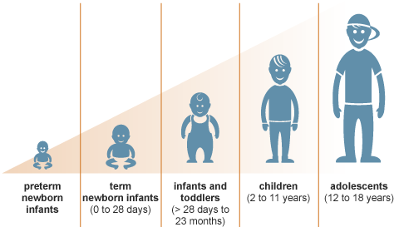

**Growth & Development**

It is common knowledge that yoga is great for adults. And millions around the world pursue this practice regularly. Yoga practice should ideally begin at an early age, so kids can grow into a well-rounded individual and not come to yoga to fix issues with their body and mind later in life.

Yoga is a gift to humanity, and should be started early in life so the practitioner can reap the lifelong benefits of this ancient practice. There are some very important advantages to starting yoga when you are young. The magical age is 8.

It is common knowledge that adults combat stress in many forms every day. But today’s children are as stressed as adults. They have to keep up with the growing competition in schools and colleges, deal with peer pressure and the difficult stage of puberty, stay involved in extracurricular activities and meet their parents and teachers’ expectations. For a kid, this is a lot to handle.

Where and what pressures are the children facing?

1. Pressure in school for studies
2. Pressure at home for competency with peers
3. Pressure at the playground to perform
4. Pressure at other extra-curricular activities

Why are they facing these pressures?

1. Peer pressure
2. Comparison between other individuals
3. Wanting to be always the best
4. Wanting always to have the best.

How can they cope with it?

Yoga comes to rescue, especially if inculcated within a child from the adolescent years. We should all know about the benefits of yoga for children. The practice has a huge effect on the body and the systems that support it, like the nervous, respiratory and digestive systems. Yoga influences children’s emotions and behaviour; it has a positive effect on the mental state and aids creativity.

Just like you prep the soil before you sow the seeds, one needs to prepare the mind. The mind assumes many stages. While many believe that kids can be difficult to influence, some are actually very receptive. Yoga can help transform the ‘quality of consciousness.’ The quality of consciousness is good when one is aware and receptive and not so good if you find yourself lost in your own thoughts, unable to focus, absorb or retain information or have a poor memory.

At what age should kids start yoga? In India, children traditionally have their thread ceremony (upanayanam) — their initiation into religious practices — at age 8. At this age, children are introduced to sun salutations, nadi shodhana pranayama and the gayatri mantra. This age represents the end of childhood. Even modern scientists recognize that this is a crucial milestone for physiological and psychological development of children transitioning into adult life. Some of the evidence that supports this is:

The number of air sacs in the lungs stabilize at age 8. After age 8, they only grow in size and not in number. This is considered to be the ideal time to introduce pranayama into a child’s daily routine. This will help the cardiovascular and respiratory systems maintain high levels of resistance and endurance.

Psychologists believe that kids’ ability to understand concepts and ideas which form the basis of ongoing technical and moral education begins at age 8. Before this, fantasy and play are dominant in the child’s life.

Spiritual development begins at this age. This is a great time to initiate children into karma yoga – where they begin to help with small household tasks, earn some responsibility, learn morals and are held accountable. This will help them develop their own spiritual journey. Children can definitely grow and flourish with yoga.



**Lifestyle Disorders**

Lifestyle diseases have become a major health challenge and yoga can help prevent these.

Gorging on junk food, addiction to television and aversion to outdoor activities are the three major reasons why kids are developing these diseases, say doctors. City schools are on the alert now and after having done a preliminary assessment of children's health, have found out that at least 20% kids are obese, have hypertension and have the potential to develop heart ailments, if they haven't already.

On an average, at least 20% children in most schools are obese and hypertensive. They get tired easily, are lazy and out of breath at the slightest sign of physical movement. This is a cause of concern because these kids are potential heart patients.

**Prevention of Lifestyle Disorders**

Now that we know about the Lifestyle Disorders, let us look at some ways in which these may be prevented. Children are meant to be playing outside and not becoming couch potatoes. Making them more active is the responsibility of parents. Lifestyle diseases are preventable for children if parents set them on the correct path, as our early life decisions and influences can impact us later on in life.

The good thing about lifestyle diseases is that if we do something about them, it is possible to reverse the condition. Listed below are some things that you can do to prevent lifestyle diseases.

* Start with a diet based on fruits, vegetables, nuts, and wholegrain, and seafood, fat-free or low-fat dairy products.
* Avoid trans fats, found in many foods including fried stuffs.
* Avoid sugar-added beverages, which are the most fattening aspect of modern diet.
* Drink lots of water to flush out toxins from the body as well as to keep the body hydrated.
* Never skip meal.
* Exercise regularly – at least 150 minutes of moderate exercise a week. Even a 15 minutes of daily brisk walk will do a lot for you.
* Get adequate sleep of about 6-8 hours daily.
* Maintain a correct posture while sitting in an office chair or when working at home.

While our lifestyles have become more convenient, there certainly is nothing classy about lifestyle diseases. We pay a high price for our press-of-a-button lifestyles. Eventually, we may need to take a step back and relearn how to lead physically active lives, and, in turn, disease-free lives.

**Diet Management**

To help your child maintain a healthy weight, balance the calories your child consumes from foods and beverages with the calories your child uses through physical activity and normal growth.

#### Balancing Calories: Help Kids Develop Healthy Eating Habits

One part of balancing calories is to eat foods that provide adequate nutrition and an appropriate number of calories. You can help children learn to be aware of what they eat by developing healthy eating habits, looking for ways to make favourite dishes healthier, and reducing calorie-rich temptations.  
  
**Encourage healthy eating habits.**

There's no great secret to healthy eating. To help your children and family develop healthy eating habits:

* Provide plenty of vegetables, fruits, and whole-grain products.
* Include low-fat or non-fat milk or dairy products.
* Choose lean meats, poultry, fish, lentils, and beans for protein.
* Serve reasonably-sized portions.
* Encourage your family to drink lots of water.
* Limit sugar-sweetened beverages.
* Limit consumption of sugar and saturated fat.  
  **Remove calorie-rich temptations!**Although everything can be enjoyed in moderation, reducing the calorie-rich temptations of high-fat and high-sugar, or salty snacks can also help your children develop healthy eating habits. Instead only allow your children to eat them sometimes, so that they truly will be treats! Here are examples of easy-to-prepare, low-fat and low-sugar treats that are 100 calories or less:
* A medium-size apple
* A medium-size banana
* 1 cup blueberries
* 1 cup grapes
* 1 cup carrots, broccoli, or bell peppers with 2 tbsp. hummus

#### Balancing Calories: Help Kids Stay Active

Another part of balancing calories is to engage in an appropriate amount of physical activity and avoid too much sedentary time. In addition to being fun for children and teens, regular physical activity has many health benefits, including:

* Strengthening bones
* Decreasing blood pressure
* Reducing stress and anxiety
* Increasing self-esteem
* Helping with weight management

**Help kids stay active.**  
Children and teens should participate in at least 60 minutes of moderate intensity physical activity most days of the week, preferably daily. Remember that children imitate adults. Start adding physical activity to your own daily routine and encourage your child to join you. Some examples of moderate intensity physical activity include:

* Brisk walking
* Playing tag
* Jumping rope
* Playing soccer
* Swimming
* Dancing
* **Reduce sedentary time.**  
  In addition to encouraging physical activity, help children avoid too much sedentary time. Although quiet time for reading and homework is fine, limit the time your children watch television, play video games, or surf the web to no more than 2 hours per day. Additionally, the American Academy of Paediatrics (AAP) does not recommend television viewing for children age 2 or younger.12 Instead, encourage your children to find fun activities to do with family members or on their own that simply involve more activity.
* **Adapt the Food Pyramid**
* **WHAT COUNTS AS ONE SERVING?**
* BREAD, CEREALS & POTATOES GROUP
* 1 slice of bread
* 1 /2 cup of cooked rice or pasta
* 1 /2 cup of cooked cereal
* 1 ounce of ready-to-eat cereal
* VEGETABLE GROUP
* 1 /2 cup of chopped raw or cooked vegetables
* 1 cup of raw leafy vegetables
* FRUIT GROUP
* 1 piece of fruit or melon wedge
* 3/4 cup of juice
* 1 /2 cup of canned fruit
* 1 /4 cup of dried fruit

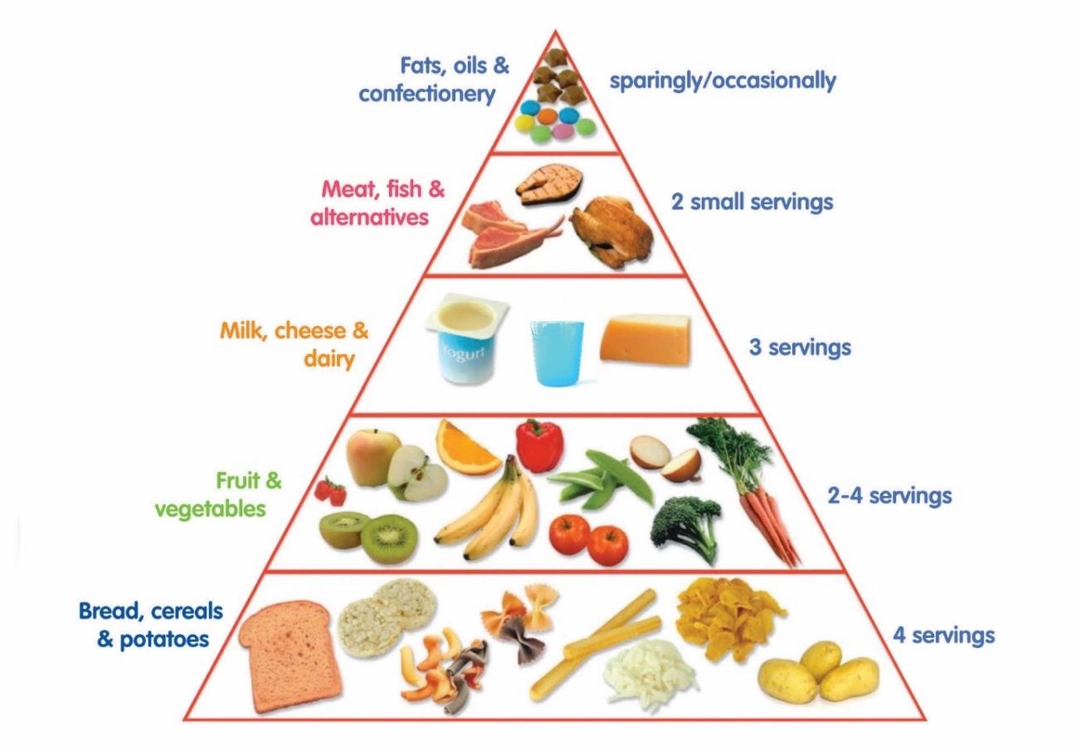

MILK, CHEESE & DIARY GROUP

1 cup of milk or yogurt

2 ounces of cheese

MEAT, FISH & ALTERNATIVES GROUP

2 to 3 ounces of cooked lean meat, poultry, or fish.

1 /2 cup of cooked dry beans, or 1 egg counts as 1 ounce of lean meat.

2 tablespoons of peanut butter count as 1 ounce of meat.

FATS AND SWEETS

Limit calories from these.

Four- to 6-year-olds can eat these serving sizes. Offer 2- to 3-year-olds less, except for milk. Two- to 6-year-old children need a total of 2 servings from the milk group each day

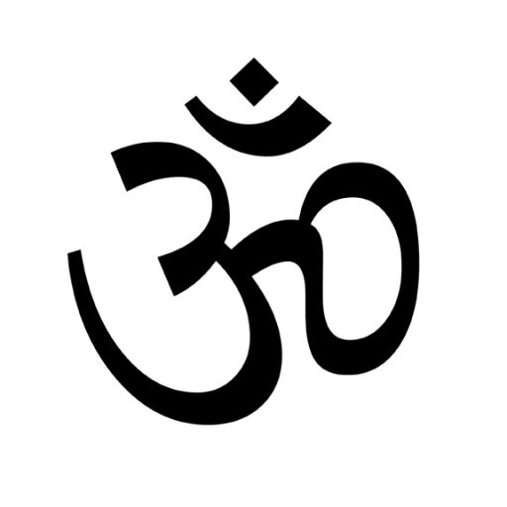

**Om Mantra**

Before the beginning, the Brahman (absolute reality) was one and non-dual. It thought, "I am only one -- may I become many." This caused a vibration which eventually became sound, and this sound was Om. Creation itself was set in motion by the vibration of Om. The closest approach to Brahman is that first sound, Om. Thus, this sacred symbol has become emblematic of Brahman just as images are emblematic of material objects.

### The Power of Chanting Om

1. The chanting of Om drives away all worldly thoughts and removes distraction and infuses new vigour in the body.
2. When you feel depressed, chant Om fifty times and you will be filled with new vigour and strength. The chanting of Om is a powerful tonic. When you chant Om, you feel you are the pure, all pervading light and consciousness.
3. Those who chant Om will have a powerful, sweet voice. Whenever you take a stroll, you can chant Om. You can also sing Om in a beautiful way. The rhythmic pronunciation of Om makes the mind serene and pointed, and infuses the spiritual qualifications which ensure self-realization.
4. Those who do meditation of Om daily will get tremendous power. They will have lustre in their eyes and faces.

### Meditation on Om

Retire to a quiet place, sit down, close your eyes and completely relax your muscles and nerves. Concentrate on the space between your eyebrows and quieten and silence the conscious mind. Begin to repeat "Om" mentally while associating the ideas of infinity, eternity, immortality, etc. You must repeat Om with the feeling that you are the infinite and all-pervading. Mere repetition of Om will not bring the desired result. Keep the meaning of Om always at heart. Feel Om. Feel that you are the pure, perfect, all-knowing, eternal, free, Brahman. Feel that you are absolute consciousness and the infinite, unchanging existence. Every part of your body should powerfully vibrate with these ideas. This feeling should be kept up all day long. Practice regularly and steadily with sincerity, faith, perseverance and enthusiasm in the morning, midday and evening.

## **Benefits of the OM Mantra**

* Chanting of the Om Mantra purifies the environment around you and creates positive vibrations.
* The Om not only benefits the person who is chanting it but also to the people around them wherever its vibrations flow.
* It cleanses your aura.
* It can place you in a meditational state which gives you [deep relaxation.](http://www.idealmantra.com/om-shanti-mantra)
* Your concentration increases when you chant this universal hymn.
* [The **ॐ** chanting](http://www.idealmantra.com/Om-Chanting) removes toxin from your body. It is said to give you better immunity and self-healing power.
* It improves your concentration and helps you focus on whatever your goals may be.
* The**ॐ** chanting actually improves your voice by giving strength to your vocal cords and the muscles around it. This is very helpful during old age.
* The **ॐ**chanting produces a vibration and sound which is felt through your vocal cords and sinuses. The vibrations open up the sinuses to clear the airways.
* The Om Mantra has cardiovascular benefits – by relaxing our mind and body, our blood pressure will decrease and our heart will beat with regular rhythm.
* Through chanting and meditation, you can have better control over your emotions, thus allowing you to see situations with a clear and rational mind.
* Regular chanting of this Mantra will take you on a spiritual journey to greater happiness and positivity, but only if it is done daily for a longer period of time. Mantras are not and overnight fix to your problems – you must have patience and learn the correct techniques.
* When the OM Mantra is chanted in a group, the effects are amplified and this will produce immense positive vibrations which charge up the entire vicinity.
* Some people have also claimed to lose weight through **ॐ**chanting as it puts your entire body in a heightened state of sensitivity – its vibrations are thought to stimulate your metabolism which would lead to weight loss.
* It has been our experience that Om can even help cleanse your skin. The massive levels of internal positive energy and a cleansed aura that come from chanting the Om Mantra regularly will be reflected externally with a sunny glow on your face and body.
* Your spinal cord is strengthened through the vibrations caused by sound of Aaaa. As this sound is generated from abdomen, it helps to strengthen the supporting muscles of the spinal cord.
* The sound uuu is created by vocal cords which benefit the thyroid glands and the throat.
* It is said that rubbing your hands together while **ॐ**chanting and putting those charged hands on different parts of body heals or activates those body parts.
* If those energy charged hands are put on your eyes, your eye sight will start improving.

**Daily Yogsadhana**

Yoga if performed on a daily benefits has enormous benefits as mentioned earlier. In yoga, asana refers both to the place in which a practitioner sits and the posture in which he or she sits. Patanjali "asana" as "to be seated in a position that is firm, but relaxed".

Asanas are also performed as physical exercise where they are sometimes referred to as "yoga postures" or "yoga positions".Some asanas are arguably performed by many practitioners just for health purposes. Asanas do promote good health, although in different ways compared to physical exercises, "placing the physical body in positions that cultivate also awareness, relaxation and concentration".

Given below are some of the asanas that are helpful not only for children but also for adults to improve concentration, boost confidence and reduce stress levels.



### Viparita Virabhadrasana

### **(Reverse Warrior Pose)**

### ****Benefits**:**

### This posture helps to open the ribs and makes the body more flexible. It also gives a boost to self-confidence.

### Steps:

1. Stand erect and breathe in.
2. Slide your right leg outwards, but both your legs should be in the same line.
3. You can slightly bend your right knee while the left knee should be straight and locked.
4. Keep your right hand upwards.
5. Bend your right hand towards your left side. Keep in mind that your palm should be towards the ceiling.
6. Keep your left hand downwards and straight.
7. Place your left palm on your left knee.
8. Bend your body a little towards your right side.
9. Look upwards and keep your breathing normal.
10. Stay in this position for 30 seconds.
11. Return to the original position by putting your right hand down, straightening your left leg and standing erect. Repeat the same with the other side.

### 

### Navasana

### **(Partner Boat Pose/Double Boat Pose)**

### ****Benefits**:**

### It improves the digestion system, strengthens your back bone and helps you to learn teamwork. It is a great stress-buster pose.

### Steps:

1. Sit down facing your partner.
2. Both of you raise your legs slightly upwards. Join your toes with the partner’s toes.
3. Now, raise your hands and hold each other’s hands.
4. Use some pressure and push your partner’s soles.
5. Breathe normally and return to the original state by first putting your feet down slowly and then, releasing your hands.
6. Finally, sit in a relaxed position.

### 

### Urdhva Mukha Svanasana

### **(Upward Facing Dog Pose)**

### ****Benefits**:**

### It makes the spinal cord strong. This posture not only opens your chest but stretches it too. It decreases the stress level and helps in asthma.

### Steps:

1. Lie on the floor with your face down.
2. Place your palms on the ground.
3. Raise your hands up by your shoulders, keeping your elbows locked.
4. Now, use a little strength and push your body from head to waist, upwards.
5. Breathe normally.
6. Keep your legs straightened, and knees should be straight and locked.
7. Stay in this posture for 25-30 seconds.

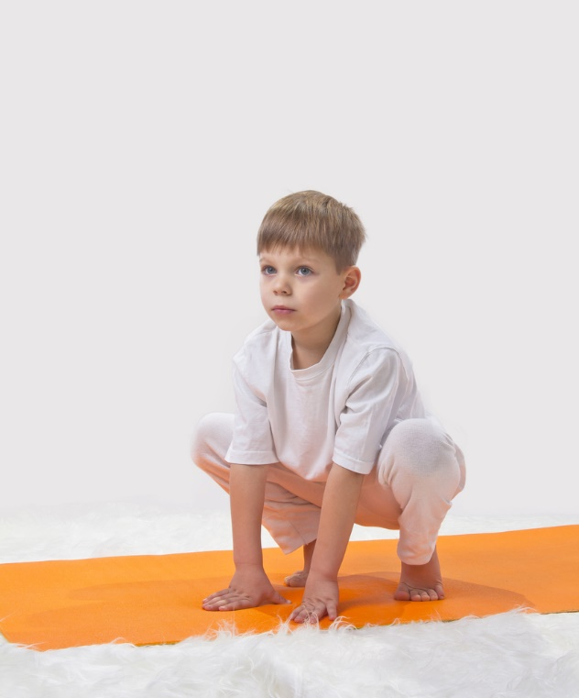

### Ardha Bhekasana

### **(Frog Pose)**

**Benefits:**

This yoga posture maintains your health by improving the functioning of your heart. It also helps to tone your legs.

**Steps**:

1. Bend your knees and sit down.
2. Place your palms on the ground, but make sure your knees don’t touch the floor.
3. Breathe normally and shift your body weight on your hands by leaning forward.
4. Slowly and gently raise your soles upwards and put a little pressure on your toes.
5. Slowly, put your soles on the floor and stand up.



### Setu Bandha Sarvangasana

### **(Bridge Pose)**

**Benefits:**

 It helps to stretch your back and neck. It is a great yoga posture to remove stress and depression along with strengthening the legs and improving the digestion.

**Steps**:

1. Breathe in and lie down supine on the floor.
2. Put your hands on the floor with your palms facing downwards.
3. Bend your knees. From knees to toes, your legs should be straight.
4. Breathe out, use some strength and push your body upwards. From chest to knees, the body should be upwards.
5. Stay in this pose for 5-10 seconds.
6. Breathe out and lower down your body.

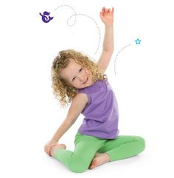

### ****Mermaid Pose****

**Benefits:**

It helps to make your body more flexible, especially the backbone and the lower abdomen.

**Steps**:

1. Bend your knees and sit down.
2. Bend your left leg backwards and slide your right leg inside your left leg.
3. The sole of your right foot should touch your right knee. Inhale and exhale normally.
4. Place your left palm on your left toe.
5. Raise your right hand upwards. Your right palm should be towards your face.
6. Look at your palm, keeping your face upwards.
7. Keep your body in this position for a few breaths.
8. Lower down your hand and return to the original posture.

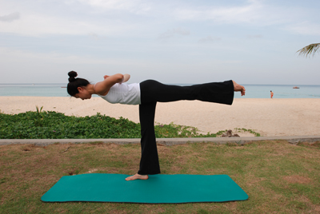

### Dekasana

### ****(Airplane Pose)****

**Benefits:**

This yoga posture helps to increase the concentration level. It teaches kids to maintain balance and helps to strengthen the legs, the chest and hands.

**Steps:**

1. Breathe in and stand straight.
2. Put your right leg forward. Both your knees should be straight and locked.
3. Lean your body a little forward.
4. Raise your arms upwards on either side to maintain your balance. Your body pose should be like a flying aeroplane.
5. Stay in this posture for a few seconds.
6. Put your arms down and stand straight.

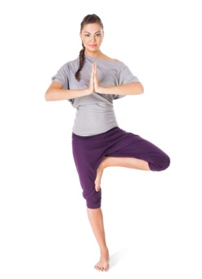

### Vriksasana

### ****(Tree Pose)****

**Benefits:**

It helps to balance your body and stretches the chest. It also assists in strengthening your legs and hands.

**Steps**:

1. Inhale and stand erect.
2. Put your left sole a little bit upwards, but keep your toe on the floor.
3. Your left sole should be on the floor and touch your right toe.
4. To balance yourself, extend your hands upwards.
5. Your right leg should be straight and right knee should be locked.
6. Look upwards and breathe normally.
7. Stay in this position for 5-7 seconds.
8. Repeat this pose with the other leg.



### Anjali Mudra

### ****(Salutation Seal)****

**Benefits:**

This yoga pose works as a great stress-buster, which ultimately relaxes your body and provides you peace of mind.

**Steps**:

1. Breathe in and sit down, crossing your legs.
2. Join both your palms together while inhaling. Place your hands in such a manner as if you are doing a prayer. Your back should be straight.
3. Stay in this position for 1 minute or so and breathe normally, then deeply.

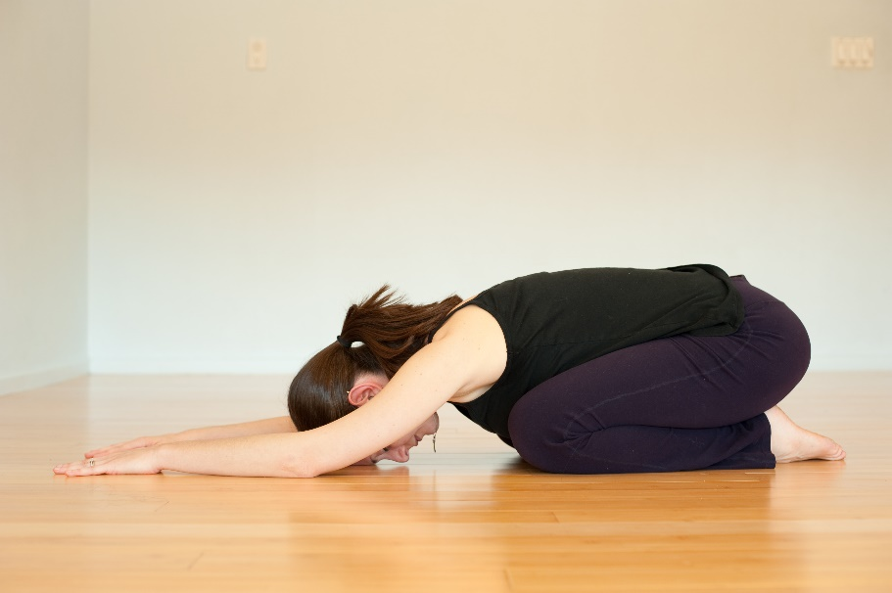

### Balasana

### ****(Flower Pose)****

**Benefits:**

Flower pose helps to build strength, as well as helps to improve balance.

**Steps**:

1. Sit on the floor and keep your spinal cord straight.
2. Bend your legs and both your knees should be pointed in the opposite direction.
3. Hold your legs with your hands.
4. Now, slowly lift your legs upwards.
5. Stay in this position for a few seconds.
6. Lower down your legs, gently.



### Tadasana

### ****(Mountain Pose)****

**Benefits:**

Mountain pose helps to improve your body posture and helps to strengthen your legs and muscles.

**Steps:**

1. Stand straight.
2. Take a deep breath and keep your spinal cord straight.
3. Your legs should be straight and knees should be locked.
4. Your toes should touch each other.
5. Your hands should be downwards and straight.
6. Inhale and exhale deeply and stay in this pose for 30 seconds or so.



### Adho Mukha Svanasana

### ****(Downward Facing Dog Pose)****

**Benefits:**

This yoga posture helps to calm your mind and provides energy to your body. It stretches the upper body area, which helps to relieve headaches and back pain.

**Steps**:

1. Take a deep breath and stand erect.
2. Now, bend your body from waist to head, downwards.
3. Place your palms on the floor.
4. Push your butt upwards. Your elbows shouldn’t be bent.
5. Pull your soles upwards.
6. Breathe normally and stay in this pose for a few seconds.
7. Return to the original posture while exhaling.

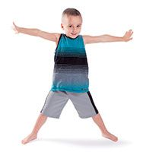

### ****Star Pose****

**Benefits:**

Star pose helps to improve your balance and also helps in stretching the chest and shoulders. This pose also helps to build-up the strength.

**Steps**:

1. Take a deep breath and stand erect.
2. Slide your legs apart from each other.
3. Raise your hands upwards on either side. Your elbows should not be bent.
4. Your body posture should be in a star shape. Breathe normally.
5. Stay in this posture for a few seconds.
6. Lower down your hands and stand straight.

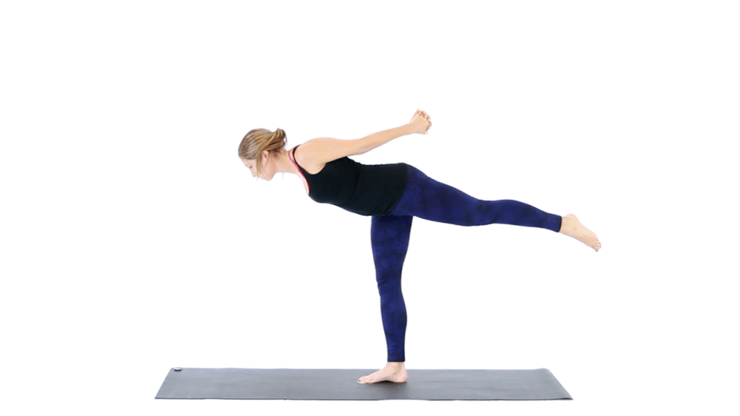

### ****Kite Pose****

### ****(Falling Star)****

**Benefits:**

This pose helps to strengthen the legs, stretches the arms and improves the balance.

**Steps**:

1. Start with the star pose.
2. Slide your right leg backwards and raise it a little bit upwards from the floor.
3. Shift your body weight on your left leg.
4. Lean towards your left leg.
5. Stay in this position for 5-10 seconds.
6. Lower your hands down and stand straight.

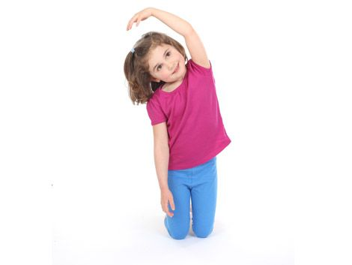

### ****Rainbow Pose****

**Benefits:**

This posture helps in stretching the arm, the abdominal and chest along with the spinal cord. It also helps to calm down the stressed mind.

**Steps**:

1. Begin with kneeling down on the ground.
2. Keep your backbone straight. From head to tailbone, your body should be straight.
3. Raise your left hand upwards and bend it on your right side.
4. Keep your right hand downwards and don’t bend your right elbow.
5. Stay in this position for several seconds.
6. Repeat this pose with the other hand.

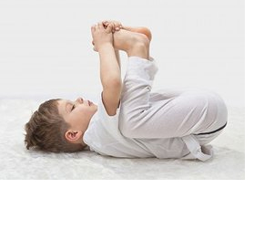

### Ananda Balasana

### ****(Happy Baby Pose)****

**Benefits:**

Happy baby pose helps to pacify the mind and body, and decreases the level of stress. It also stretches the spinal cord.

**Steps**:

1. Inhale and lay down supine on the floor.
2. Breathe out and bend your knees towards your belly.
3. Hold your feet with your palms.
4. Stay in this position for 5 to 7 seconds.
5. Gently, lower down your legs.

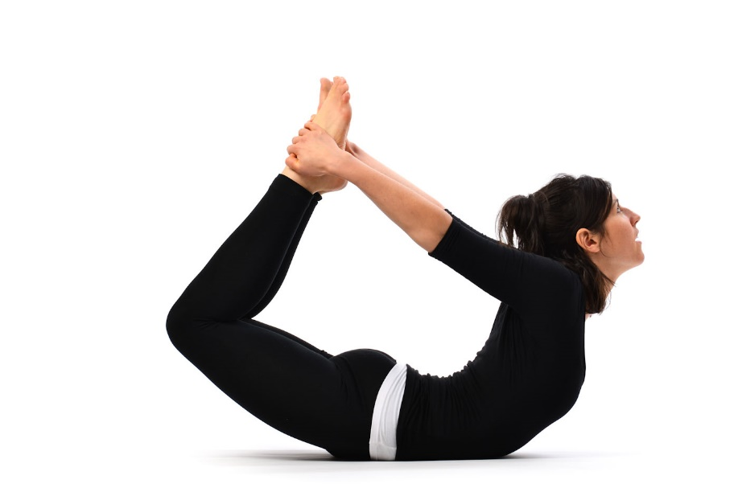

### Dhanurasana

### ****(Floor Bow Pose)****

**Benefits:**

This yoga posture helps the kids in improving their body posture, stretching out their whole body and helps in strengthening the back muscles.

**Steps**:

1. Inhale, bend your knees backwards and sit down.
2. Now, breathe normally and bend your body forward.
3. Put your hands backwards and keep your knuckles on the floor.
4. Put your head down and keep your forehead on the ground
5. Make sure that your bent body touches your thighs.
6. Stay in this position for a few relaxing breaths.
7. Put your hands forward and sit down.

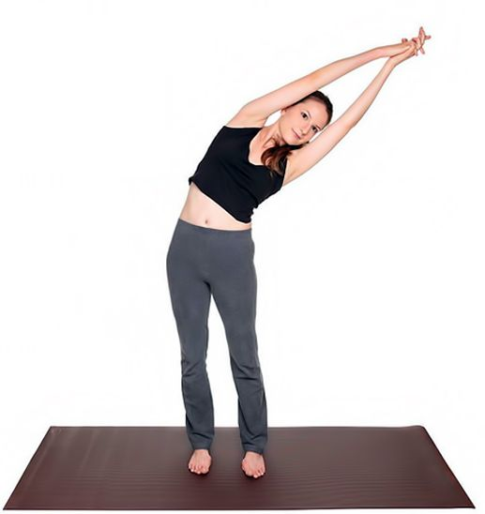

### ****Crescent Moon Pose****

**Benefits:**

Crescent moon pose helps in relieving the stress. It stretches your abdomen, hands and spinal cord.

**Steps**:

1. Breathe in and stand erect.
2. Raise your hands upwards while inhaling. Your fingers should be towards the ceiling.
3. Join your palms.
4. Exhale and bend your body a little towards your right side.
5. Stay in this position for a few seconds.
6. Then, inhale and stand erect. Bring your arms down while exhaling.
7. Repeat this pose on the left side.



### Marjaryasana Bitilasana

### ****(Cat Cow Pose)****

**Benefits:**

Cat cow pose massages the organs and spinal cord gently, and helps in stretching the neck and the torso.

**Steps**:

1. Kneel down. Remember, your knees should be underneath your hips and hands should be underneath your shoulders.
2. Your hands should be straight and elbows shouldn’t be bent.
3. Let your tummy slightly sink towards the floor while inhaling. Look towards the ceiling. (Cow pose)
4. Now, exhale slightly raise your tummy towards the ceiling. Look towards your belly. (Cat pose)
5. Repeat this pose 2-3 times.



### Savasana

### ****(Corpse Pose)****

**Benefits:**

Corpse pose is really helpful in relaxing the mind, vanishing the stress, and alleviating insomnia, headaches and fatigue.

**Steps**:

1. Lie supine on the floor.
2. Keep your legs and hands straight.
3. Place your palms on the ground.
4. Close your eyes and try to focus for 10 minutes.



### ****Dolphin Pose/Shark Pose****

**Benefits:**

Dolphin pose or shark pose provide many benefits, like stretching the hips and upper body, fights with depression, relieves the headaches and backaches, provides energy to the body, and strengthens the legs and hands.

**Steps**:

1. Kneel down. Put your hands below your shoulders and knees below your hips.
2. Your palms should be on the floor and fingers should be spaced out from each other. Your back should be straight.
3. Breathe out and lift your hips while straightening your knees.
4. Raise your soles. Only your toes should be on the floor.
5. From elbows to palms, your hands should be on the floor. Keep your breathing normal. Clasp the knuckles of both palms.
6. Your body should be in “/\” shape.
7. Stay in this position for a few seconds.
8. Straighten your body and return to the original pose.

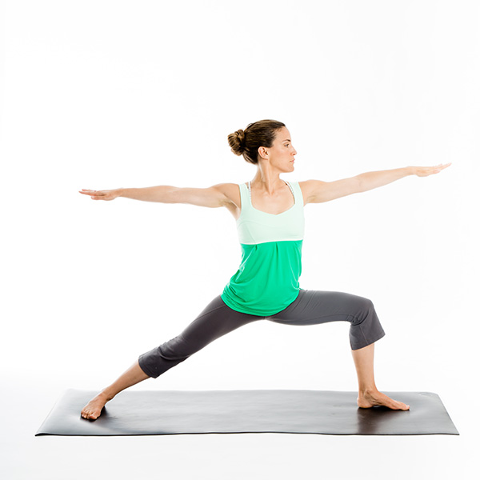

### Virabhradhrasana II

### ****(Warrior II Pose)****

**Benefits:**

Warrior pose II helps in stretching the body, especially the spinal cord and the hands. It also helps to get rid of backaches.

**Steps**:

1. Inhale and stand erect. Your feet should be apart from each other.
2. Breathe out and bend your right knee.
3. Slide your left leg backwards and lock your left knee.
4. Keep your spinal cord straight.
5. Stretch your hands and raise them up to your shoulders.
6. From right palm to the left palm, your hands should form a perfect 180° angle. Your elbows should be straight.
7. Look towards the fingertips of the right hand.
8. Stay in this position for a few seconds. Then, lower your hands and straighten your legs while inhaling.
9. Repeat this pose on the other side.



### ****Table Pose****

**Benefits:**

This posture helps in strengthening your bones and increasing the balance.

**Steps**:

1. Breathe in and kneel down.
2. Put your arms beneath your shoulders and palms on the floor.
3. Keep your elbows locked and breathe normally.  Your backbone should be straight.
4. Look straight.
5. Stay in this posture for 1 minute and then, return to the original posture.

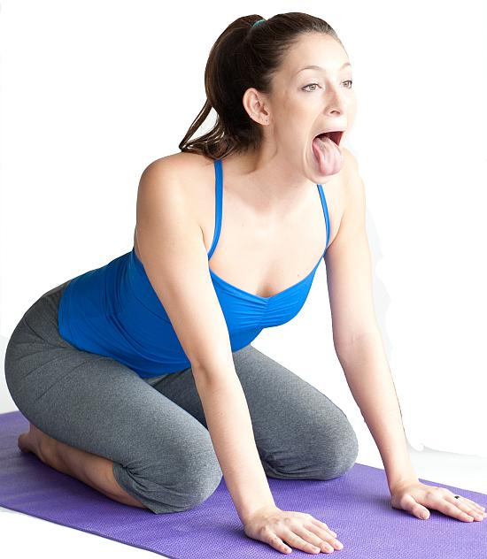

### Simhasana

### ****(Lion Pose)****

**Benefits:**

Lion pose helps in stretching the lower body, relieving stress and calming the mind.

**Steps**:

1. Inhale, bend your knees backwards and sit down.
2. Put your palms on your knees. Spread out your fingers.
3. Exhale and bend your body a little forward.
4. Inhale deep through nose.
5. Open your mouth and take out your tongue.
6. Exhale out through your mouth making a loud ‘Roar’.
7. Repeat this pose many times.

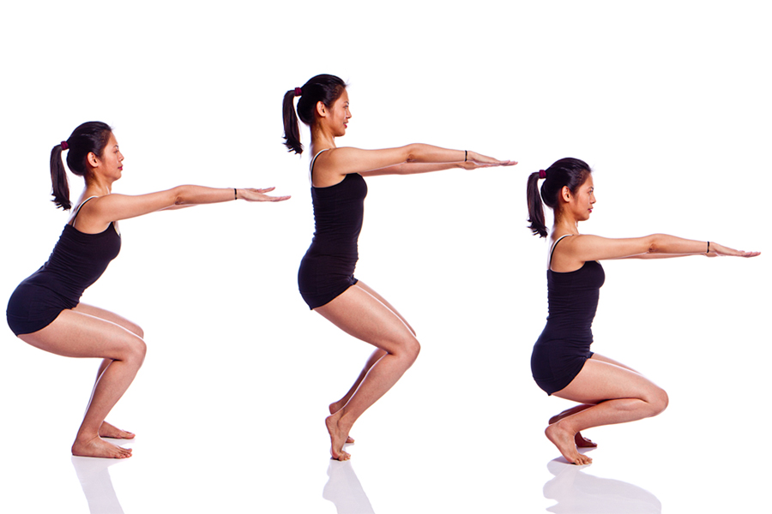

### Utkatasana

### ****(Chair Pose)****

**Benefits:**

This posture helps in strengthening the legs, as well as, stretches the shoulders.

**Steps**:

1. Stand straight.
2. Inhale, raise your hands upwards and stretch your body a little.
3. Bend your knees enough to stand properly.
4. Breathe normally and hold this pose for a few seconds.
5. Straighten your legs while breathing in and bring down your hands while exhaling.



### Uttanasana

### ****(Ragdoll Pose)****

**Benefits:**

Ragdoll pose relaxes the mind and stretches your back, neck and legs.

**Steps**:

1. Breathe in and stand erect.
2. Put your hands towards the ceiling.
3. Bend your body from waist to head forward.
4. Try to touch your toes with your palms.
5. Take a deep breath. First, nod your head yes, and then, shake it no.
6. Stay in this position for a few seconds.
7. Slowly, straighten your back and stand straight.

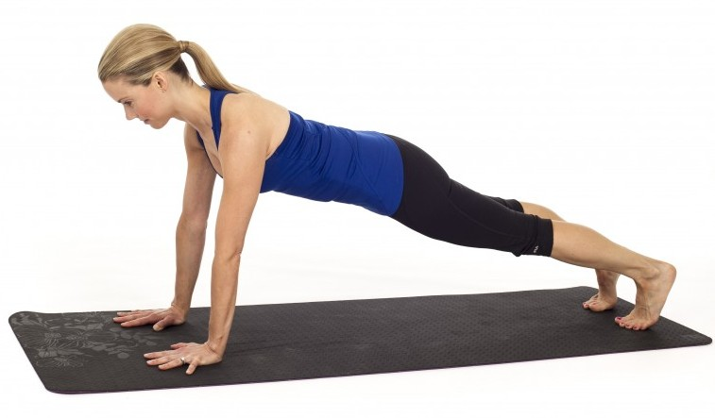

### ****Plank Pose****

**Benefits:**

Plank pose helps in strengthening and energizing the whole body.

**Steps**:

1. Start with downward facing dog. (Explained above in pose no. 12)
2. Lower down your torso while inhaling till it becomes parallel to the ground. Keep your arms perpendicular to the ground.
3. Only your palms and toe fingers should be on the floor.
4. Stay in this posture for a few seconds.
5. Lower down your body and lie down to relax.



### Trikonasana

### ****(Triangle Pose)****

**Benefits:**

Triangle pose helps in stretching, as well as, strengthening the hands, spinal cord and chest. It also aids in improving the digestion system.

**Steps:**

1. Stand erect and inhale.
2. Apart your feet while exhaling. Both your knees should be locked.
3. Raise your hands towards the ceiling and stretch your body upwards.
4. Bend your body on your right side.
5. Lower down your right hand and put it on your ankle.
6. Lock your elbows and look towards your raised left palm.
7. Stay in this position for several seconds.
8. Then, stand straight and repeat this pose with your left leg.

**Benefits of Yoga**

Children deal with many distractions, temptations, overstimulation and peer pressure. Schools are challenged to do more with less and be creative in how they reach even the most isolated child.

Yoga is a low-cost, helpful tool that can have a positive impact on children.

Benefits of Yoga Asanas in Children

* Increases concentration and focus
* Helps stay calm
* Relieves stress
* Makes healthy
* Develop team skills
* Overcome feelings of jealousy, revenge and other negative feelings
* Builds self-esteem and confidence
* Develops creativity and imagination
* Makes them sharp and improves awareness
* **Enhances Physical Flexibility**
* **Refines Balance and Coordination**
* **Develops Focus and Concentration**
* **Boosts Self-Esteem and Confidence**

**Yoga Classroom**

Incorporating anything new in a child’s life, especially beneficial practices, isn’t a child’s play. One needs to come up with creative ideas for the concept of Yoga to be openly accepted by a child. Children these days are being sent to various tutors and classes to enhance their knowledge in every field, yet yoga is something that can be done at home as a parent-child activity. Some of the things that can be taken into consideration before starting with this practice are:

* Create a special time of the day for yoga. Take some time in the morning or evening, and follow it with a deep relaxation
* Make it a fun session with them, start with just few minutes every day, get colourful yoga mats, you can even match your yoga outfits…anything to make it interesting for them.
* Practice yoga barefoot and wear easy comfortable clothing
* Put on some soothing music to set in the relaxed mood
* Make sure the child has not eaten anything right before doing the yoga asana
* Show your child the pose and do it with them
* Let your child do as much as he can, do not push it too much

There isn’t only one approach to incorporate yoga into a child’s life, it could also be something that a group of children can do as team. Whichever way works, is best.

**Conclusion**

It is never easy to incorporate healthy habits not only in children but also adults. Yoga is a gift of our Indian heritage, which focuses on prevention rather than cure. Throughout the duration of this document, one could only get a glimpse of all the benefits of this technique.

The earlier one starts to do something, the more of an impact it leaves in the long term. As it is has been reiterated in this document that Yoga is something that needs to be injected into a child’s life at an early age to see the results last through a lifetime.

Yoga science does not tell you what to do and what not to do, but teaches you how to be. Yoga science is a science of life that helps you to know the known and unknown parts of life, and that helps you to liberate yourself from pains and miseries.

**“Don’t wait till tomorrow, do it now!”**

Let us not put off this beautiful gift of Indian tradition, rather start incorporating it into our and our children’s daily lives immediately. We all know the benefits and are aware of how this will help every child to overcome all the hassles that come along with growing up. Not only does it help us cope up with difficulties but also makes one a stronger human being inside out.

**References**

* https://en.wikipedia.org/wiki/Yoga
* https://en.wikipedia.org/wiki/Yoga_Sutras_of_Patanjali
* http://yoga.org.nz/what-is-yoga/yoga_definition.htm
* http://seattleyoganews.com/yoga-for-kids-right-age/
* http://timesofindia.indiatimes.com/city/kolkata/Lifestyle-diseases-now-target-kids/articleshow/6165170.cms
* http://www.home-remedies-for-you.com/articles/1782/wellness/nothing-classy-about-lifestyle-diseases.html
* http://zeenews.india.com/news/health/tips/useful-tips-to-prevent-lifestyle-diseases_1853464.html
* https://www.cdc.gov/healthyweight/children/
* https://www.cnpp.usda.gov/sites/default/files/archived_projects/FGP4KidsTipsBook.pdf
* http://www.omsakthi.org/worship/mantra.html
* http://www.idealmantra.com/om-mantra/
* https://en.wikipedia.org/wiki/Asana
* http://www.indiaparenting.com/alternative-healing/12_3709/top-10-yoga-asanas-for-children.html
* https://homeremedyshop.com/30-easy-to-do-yoga-poses-for-kids/

**Acknowledgement**

I am very thankful to our esteemed Yoga centre of Ghantali Mitra Mandal, Thane, for giving me the opportunity to learn Yoga and work on this project. I feel extremely proud to be associated with this Institution.

I take this opportunity to pay my gratitude and deepest respect to Anna Vyawahare Guruji and the most dedicated team of teachers and the other faculties of the Yoga Department of Ghantali Mitra Mandal.

I am thankful to our group teacher Jaya Mam, Smt. Sandhya Mam, Pankaj Sir, Neela Mam and all the other teachers for their continuous guidance.

I also take the opportunity to acknowledge the great support and co-operation of all fellow students and my group for making this course enjoyable and interactive.

Finally I wish to also acknowledge my family for their extreme support and continuous help during the duration of this project.

**Personal Details**

**Name:**

Seema Tekchandani

**Education Qualification:**

Bachelors of Science

**Profession:**

Homemaker

**Family:**

Husband: Ramesh Tekchandani (Proprietor of Ekdant Enterprise)

Son: Prachet Tekchandani (Proprietor of Krishna Impex)

Daughter-in-law: Naisha Tekchandani (IT Manager)

**Address:**

Neelkanth Valley, Vindhyachal Bldg. 307/8, 7th Road, Ghatkopar (E)

**Mobile:**

9819191987

**E-mail:**

[seematek15@gmail.com](mailto:seematek15@gmail.com)