# VA Systems Inventory SOP

VASI Standard Operating Procedures

**Decommissions or Designating Not a System**

To decommission any system or designate a system as “not a system” it must first come through the VTWG. The PPO (Program Planning Oversight) group will send the VASI Team a report if there is funding still tied to this system. Once a decision has been made in the VTWG, proceed with decommissioning or marking as not a system.

*Standard Decommissions or Designations*

1. Navigate to the System in SA
2. Edit the Name Field to include “[INACTIVE]” or “[NOT A SYSTEM]” at the end of the name. Do the same for the Full Name field on the Identity Tab.  
   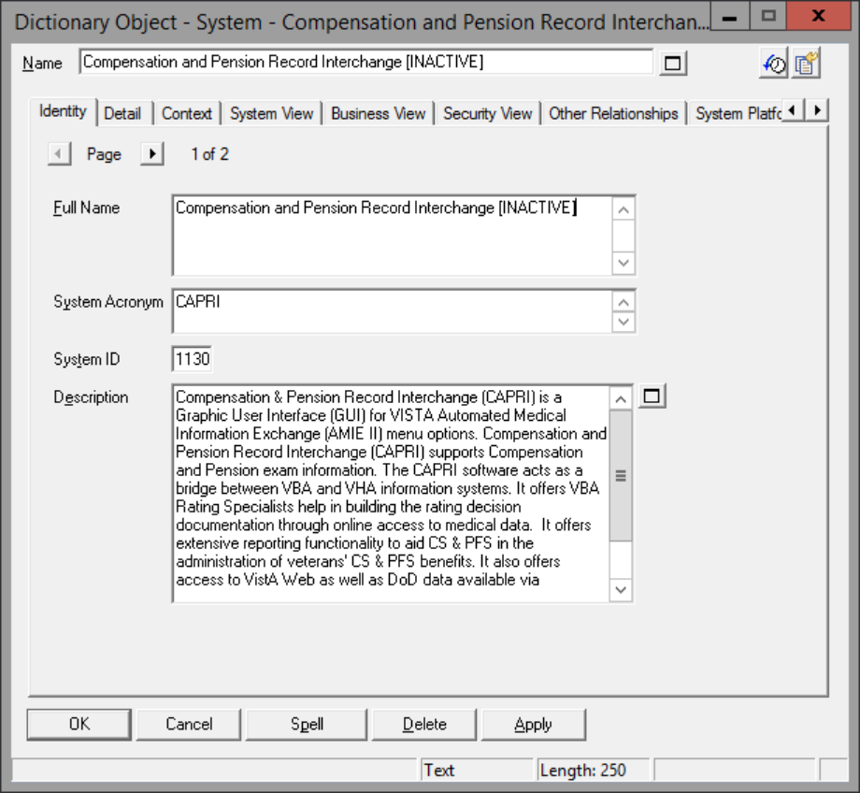
3. On the Identity Tab, please include verbiage at the beginning of the description stating why the system has been marked not a system or inactive and the date (including year) of the VTWG.  
     
   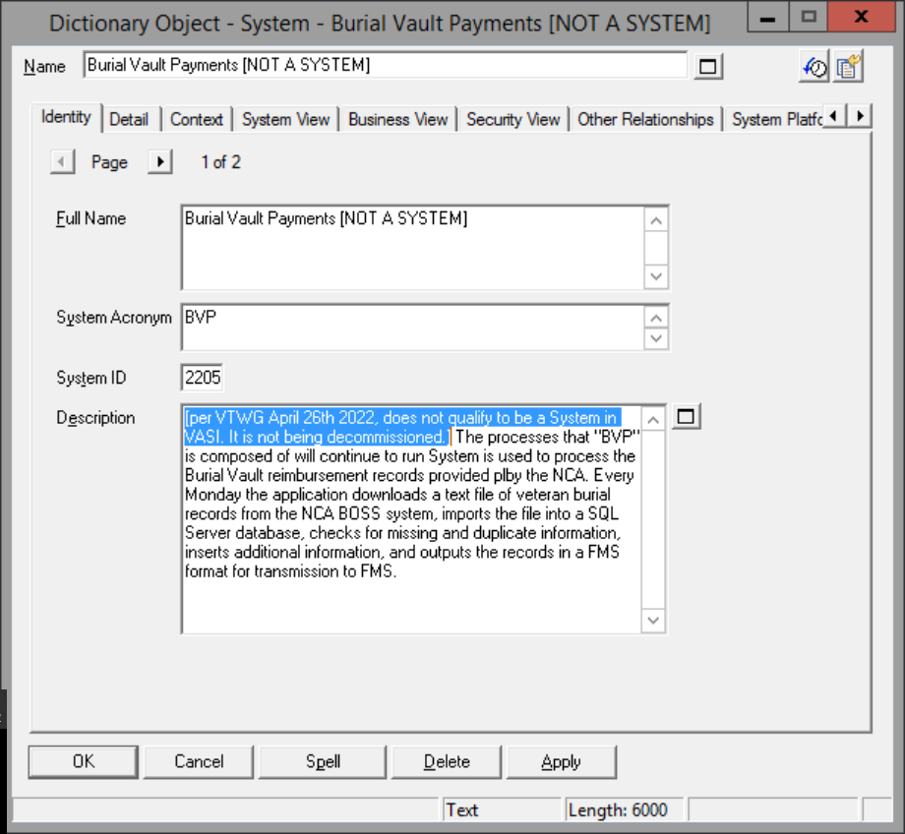

On the Detail tab of the System Object, change the System Status to the appropriate selection. Inactive is chosen for decommissions. Not a system is chosen for Not a System.  
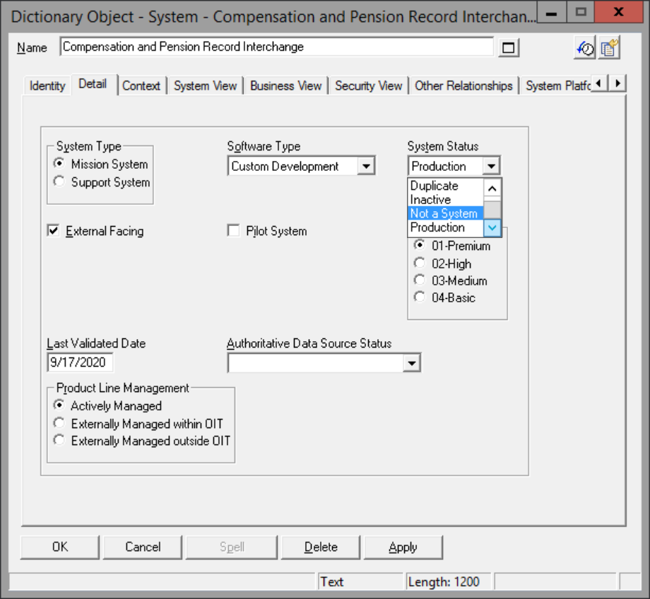

Edit the Name Field to include “[INACTIVE]” or “[NOT A SYSTEM]” at the end of the name. Do the same for the Full Name field on the Identity Tab.

Click OK to Save.

If the system was marked Inactive, open the Technical Detail object from the references panel and input the decommission date as the date of the VTWG where this was agreed upon.  
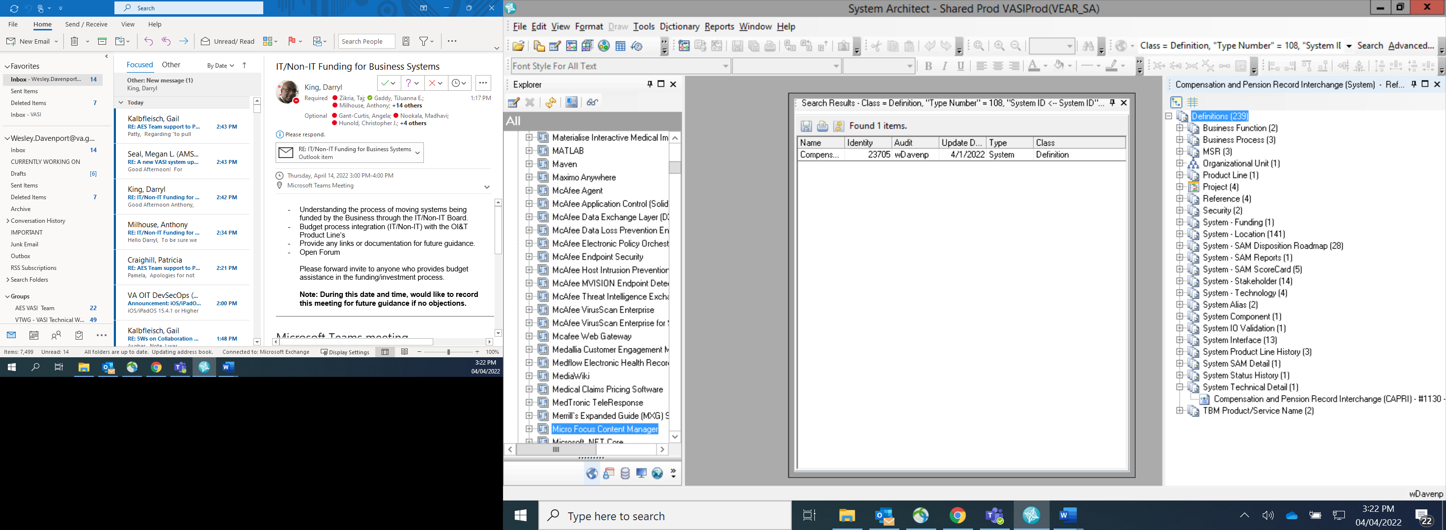  
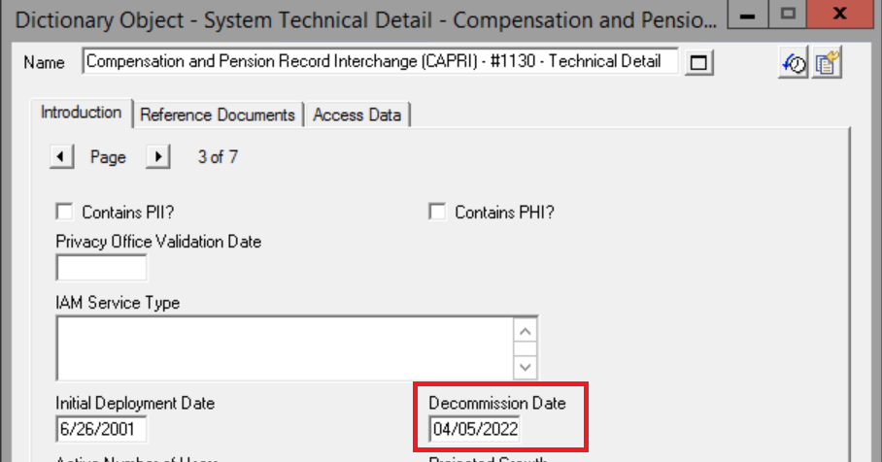  
If the system was marked as “Not a System”, the Decommission Date is not required. For not a system – in description explain why it’s not a system - component of another system etc.

Verify if any system interfaces or security objects are associated with the system in the References Panel

* 1. If a system interface is an information exchange, follow up with the VASI IO to ensure the information exchange has been transferred or taken care of. Once confirmation is received, delete the interface
  2. If a system interface is not an information exchange it can be deleted

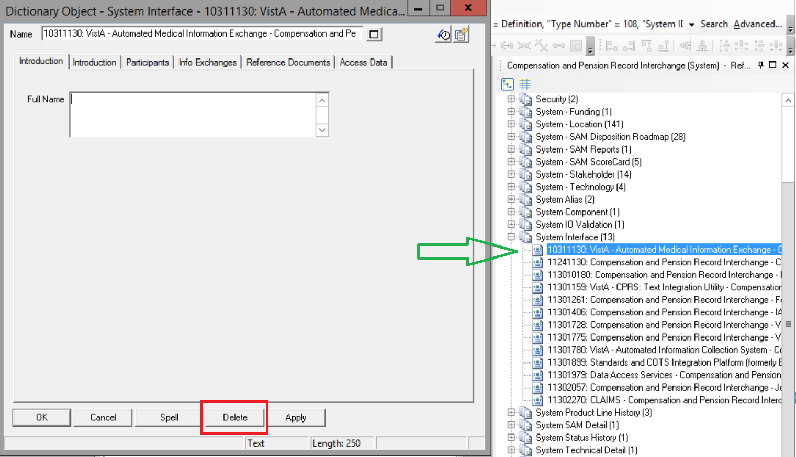

Remove the association with all Security items.

* 1. All Security items must be verified with the VASI IO that the appropriate steps have been taken before they are deleted.
  2. **DO NOT DELETE THE SECURITY ITEM IN THE REFERENCES PANEL.** Unlike Stakeholders, Technologies, and Interfaces, when you delete a security item it deletes that item for all systems that may have that security item.
  3. Double click the main dictionary object for the system and go to the Security tab.
  4. Remove the system association to the security item. Contact the ECSO Group if there is cloud/VAEC alignment with this system to have them remove the alignment.
  5. Per leadership guidance, do not remove the Product Line Alignment when decommissioning a system.

*Designating Not a System where the system becomes a component*

When a system’s processes are absorbed by another system, the VASI Team will designate the absorbed system as “Not A System” and proceed to make that system a component of the one which absorbed it.

1. Navigate to the system in SA.
2. Designate the system as “Not A System” by updating the name, description, and status of the system.
3. Remove any security alignments to the system.   
   Note: Do not delete the security item. Only remove the alignment.
4. Add a new component to the system absorbing the functionality
   1. Component Name should be the same as the system now marked “Not a System.”
   2. Copy/Paste the description from the system into the component description  
      Note: Do not copy over the VTWG note
5. Return to the system now marked “Not A System.”
6. Update any components or interfaces that the system has and align them with the system which absorbed the functionality (or the new component if an interface)
7. If the system is a platform, move the systems beneath it to the system absorbing the functionality as well.