**Optimizing Engine Operating Conditions for Fuel economy and Emission Benefits in a Hybrid Electric Drive**

*Submitted by*

**Alphin Davis Pomy**

ME19B076

*Under the guidance of*

**Dr A Ramesh**



**Department of Mechanical Engineering**

Indian Institute of Technology, Madras

Chennai – 600036

**INTRODUCTION**

**Overview:**

As the world is moving towards green energy, electric vehicles are predicted to be the mode of future transportation. Governments all over the world have been taking initiatives to smoothen this transition. Still, transitioning from ICE vehicles to EVs have proven to be challenging due to issues such as a lack of charging infrastructure, lengthy charging times, and concerns about limited driving range, causing potential anxiety among users.

One potential option to mitigate this problem is by introducing hybrids especially in the most common commutation segments (2 wheelers). Hybrids act as the bridge between ICEs and EVs combining the best of both worlds. This study aims to develop and implement efficient control strategy for a hybrid two wheeler to extract the most out of the vehicle.

Some of the existing control strategies include Rule-based control, Pontryagin’s Principle, Dynamic Programming and Neural Network based control. But the controls that are implementable in real-time are sub-optimal while controls that are optimal are either non-implementable or too complicated to make a physical meaning out of it.

To mitigate these problems, a machine learning based approach which extracts a simple, implementable control from optimal control strategy is proposed.

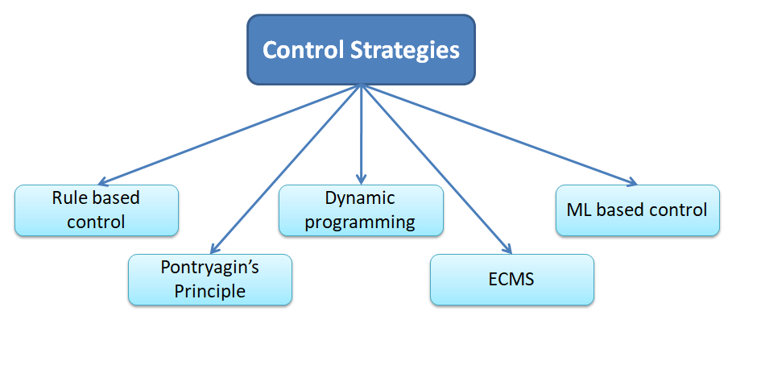

Fig 1: Existing strategies to control a hybrid electric vehicle

**Objective:**

To develop and implement a control strategy that optimize the engine operating conditions and thus improve mileage and reduce emissions in a hybrid electric vehicle

**LITERATURE SURVEY**