Partial Differential Equation Modeling with FEniCS and Potential Applications in Chemistry

Andrew Pendergast

Dr. Ming Lin

Comp 50H-Everyday Computing

9 May 2017

PDE Modeling and Introduction/Motivation

**I. Motivation and Background of PDE systems**

Within the field of chemistry, the modeling of reactions, diffusion interactions, and kinetic equilibria ultimately fall to the utilization of dynamical systems and the application of partial differential equations as a method for state prediction. Dynamical systems modeling allows for the determination of complex mathematical behaviors for a given function through a vector field or area, thereby allowing for direct application for chemistry and other physical sciences wherein the focus of quantitation efforts centralizes around analyzing the effects of individual components compared to that of the whole system. As chemical systems permit the analysis of multiple controlled factors with predictable desired results, reaction-diffusion systems and other extrapolations of chemical laws allow for a logical first experience in applying Partial Differential Equation (PDE) systems through computer science. Specifically, chemical reactions permit the analysis of both Ordinary Differential Equation (ODE) systems and PDE systems due to the different levels of formula complexity based on the chemical principle analyzed. Through PDE system modeling[1], the original set of equations for a function defined by its interaction with a vector field or another function can be determined corresponding to the behavior of the partial derivatives of the system. The most direct means through which PDE modeling can be applied to chemical phenomena is through the analysis of diffusion systems and diffusion-reaction systems as these are representative of simple one or two dimensional PDE systems.

**II. Methodology for PDE systems solutions with FEniCS**

One method to solve PDE systems is through the use of the FEniCS Project python library wherein sets of functions and vector fields defining a set of physical and mathematical phenomena are described as the partial derivative behavior of the unknown parent function. From these initial inputs combined with the inclusion of known constants and other input conditions, it is possible to generate an entire set of functions corresponding to the general solution of the different equation model to predict the ultimate behavior of the system. The simplest application of this FEniCS library is through the solution of a Poisson system for the solution of a boundary value problem such that .[2] As presented within the code below representing a modified version of the tutorial code for the FEniCS library, an arbitrary function definition of $f\left(x,y\right)= 1 x^{3}+2y^{2}$ acts as an example of the strengths of PDE solvers and the extent to which they can be used to solve full functions.

**Modified Sample Code Representing Poisson System[3] (see. PoissonSample.py)**

from fenics import *

*# Creates unit mesh and define function space*

mesh = UnitSquareMesh(10, 10)

V = FunctionSpace(mesh, 'P', 1)

*# Boundary Conditions of Function*

u_D = Expression('1 + x[0]*x[0]*x[0] + 2*x[1]*x[1]', degree=3)

def boundary(x, on_boundary):

return on_boundary

bc = DirichletBC(V, u_D, boundary)

*# Define variations of function within problem*

u = TrialFunction(V)

v = TestFunction(V)

f = Constant(-6.0)

a = dot(grad(u), grad(v))*dx

L = f*v*dx

*# Compute solution*

u = Function(V)

solve(a == L, u, bc)

*# Plot solution and mesh*

plot(u)

plot(mesh)

*# VTK format of Solution for use in paraview*

vtkfile = File('poisson/solution2.pvd')

vtkfile << u

*# Hold plot*

interactive()

From this code, the following visual representation (Figure A) can be rendered in a program called Paraview in which three dimensional vectors and functions can be graphed together.

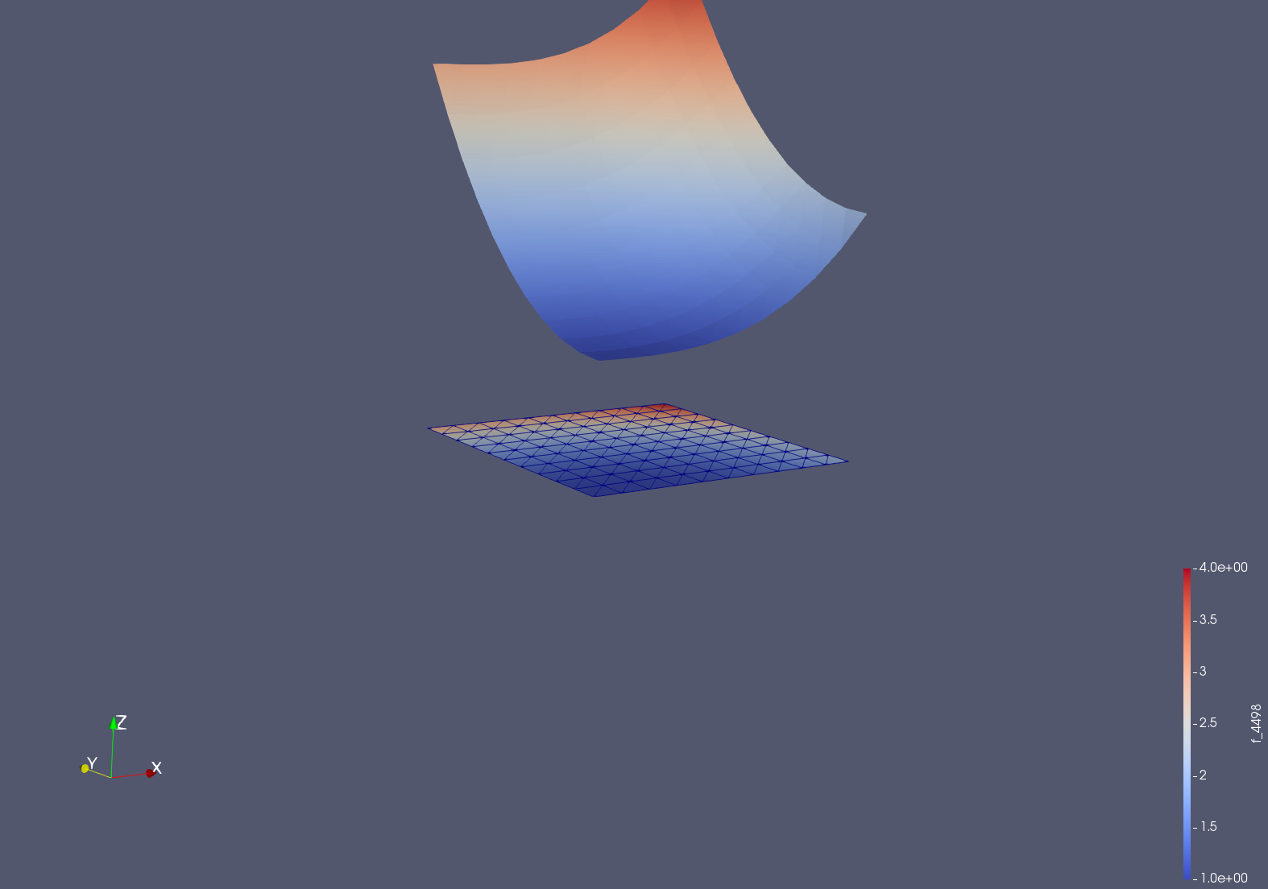

Figure A. Graphical Representation of Poisson System Sample Code

Within Figure A, the vector field graphed above the domain given by the mesh defined for the functional model is representative of the surface corresponding to the set of all real solutions. From this surface generated by the set of solutions, the gradient can be visualized in terms of the color associated therein, allowing for optimization with more advanced systems. While this particular system exhibits clear advantages towards increased values of X and Y due to the direct relational nature of the arbitrary function selected as a solution for the problem. Although this fundamentally represents a simple example of the use of a PDE solving library, the basics of mesh field definition, function definition, expected value assumption, and vector gradient determination can be extrapolated to higher order functions such as those present within chemical and physical systems.

**III. Applications of PDE systems within Chemistry: Gaussian Example**

The prediction of system equilibrium through diffusion in chemistry is founded in the fundamental behavior of a density function under the forces of a vector field.[4] By allowing the function *u(x,t)* to define a surface in R3 and a vector force *J(x,t)* defined in R3 to correspond to the flow of the system over time, a specific solution for the reaction can be determined such that the change in density of *u(x,y)* is the flux of *J* through the tested volume.[5] Therefore, $\frac{d}{dt}\int{u\left(x,t\right)dV= -\int{J\left(x,t\right)dS }}$ can be rewritten such that $\int{\left(\frac{d}{dt}u+div J\right)dV=0}$ simplifying to $\frac{d}{dt}u+div J=0$ and $u_{t}=D∆u$ where D corresponds to the diffusion coefficient of the system. This mathematical relationship therefore allows for a simple application of PDE analysis in a system wherein the diffusion of an analyte is considered to be constant throughout the domain in R2 wherein *u(x,y)* is defined with continuous first and second order partial derivatives.

Within the diffusion of particles, specifically within constant value systems, a Gaussian distribution for diffusion can be used such that $u\left(x,y\right)= e^{∝(x^{2}-y^{2})}$ where alpha is defined by the diffusion coefficient and x and y vary along the domain of the region. Diffusion reactions in chemistry represent a situation in which simple Gaussian relationships can be applied due to the fundamental averaging of diffusion over time within a system and the reaching of a known equilibrium. By evaluating this function over a mesh constituting a rectangular domain to represent a cross section of some diffusion membrane, the following image can be produced as an example of the function at a given time interval. (See GaussianExample.py)

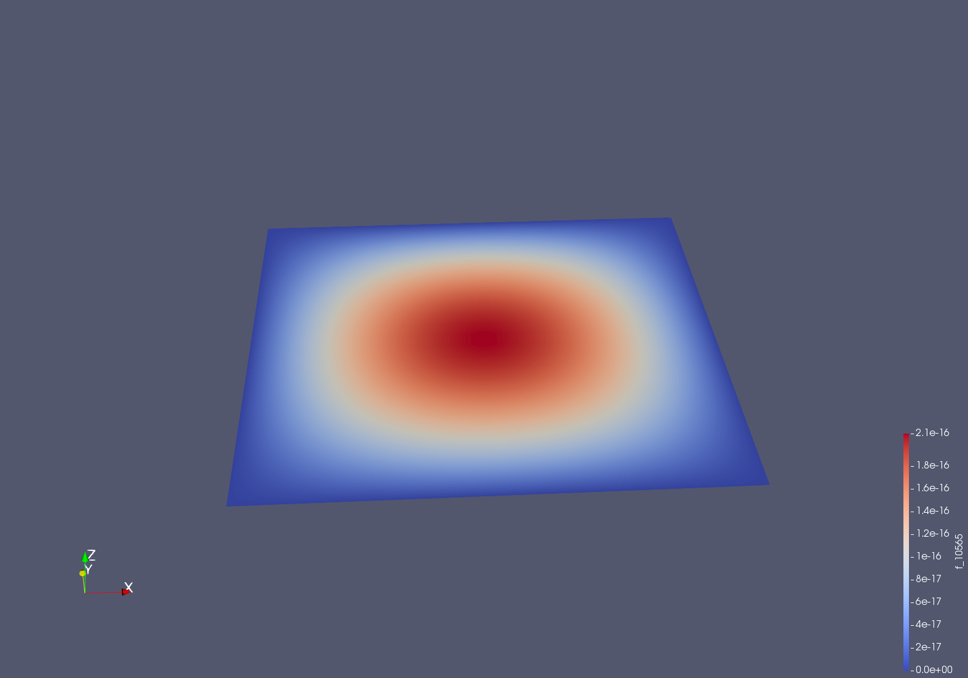

At this particular time interval (t = 66 subunits), the Gaussian distribution favors solutions towards the center of the given domain, however, at different times, this solution changes based on the functional relationship between time and location.

**IV. Future Applications with Direct Chemical Modeling**

While the modeling of known behavior PDE systems is the simplest method to learn the underlying value of solution systems and applied PDE solving code, the most practical applications of PDE systems emerge with the modeling of observed behavior. One direct application of PDE systems would be through the van Deemter equation used within Chromatography to reduce the noise of chemical separation readouts. The van Deemter equation is defined such that the noise $H=2λdp+\frac{2γDm}{u}+\frac{w{\left(dp\right)}^{2}u}{Dm}+\frac{Rd^{2}f\left(u\right)}{Ds}$ where lamba, gamma, w, and R are defined as chemical constants, Dm corresponds to the diffusion coefficient of the mobile phase, dp corresponds to the particle packing diameter, and Ds corresponds to the diffusion coefficient of the stationary phase. While a full PDE system could be developed from this equation, by analyzing a Capillary Electrophoretic system such that $H=\frac{2γDm}{u}$, the fundamental value of PDE solution programs can be elucidated as a foundation unto which the additional components of the van Deemter equation can be formulated[6].

The equation $H=\frac{2γDm}{u}$ is an example of the potential application of the relationship between the time partial derivative of the function *u*  and the conservative vector field J used to describe the flux of the system. Given a constant domain for u(x,y,t) or the mesh of the field, wherein the domain corresponds to the rectangular representation of the cross section area of the column linear velocity and the diffusion constant of the mobile phase, the behavior of this function can be equated into a vector field wherein an approximation of H can be derived. Specifically, for this future application, u(x,y,t) is defined over the domain of the cylinder produced with an inner diameter of 0.0025 and a length of 100 with a time component of 10 in order to represent a capillary column as an example mesh for the rectangular region. From this definition of the mesh of the domain, the vector space V could be defined as a finite element P function space onto which the unknown parent function of the vector function can be analyzed.

One key limitation preventing the analysis of a van Deemter system within this project is the lack of data collection. While a partial differential equation for a system, once presented, can be solved by analyzing the known solutions and predicting a backwards model, the best way to apply this to the physical or chemical worlds would be through the analysis of gathered data. For example, within the example outlined for the van Deemter equation, the most logical future step would be to gather data related to the total noise gathered by a capillary electrophoresis detection system with varying diffusion coefficients and linear velocity of the column from which true partial derivatives could be calculated. From these behavioral observations, the extent to which the predicted model followed the real observed model could be analyzed through the calculation of the surface representing the gradient of the parent function.

**V. Shortcomings and Conclusions**

With the onset of this project, my end goal was to model some type of chemical reaction or behavior according to the partial differential equations produced from the ideal chemical equations. However, over the course of conducting this project, I realized that the best way to actually form some type of model would be to use the PDE solving system FEniCS with sets of data that could be gathered from future experimentation. Specifically, with known equations, the partial differential models would produce perfectly linear relationships as seen below with an attempt to apply the van Deemter equation partial derivatives (see NoiseExample.py) and the following image.

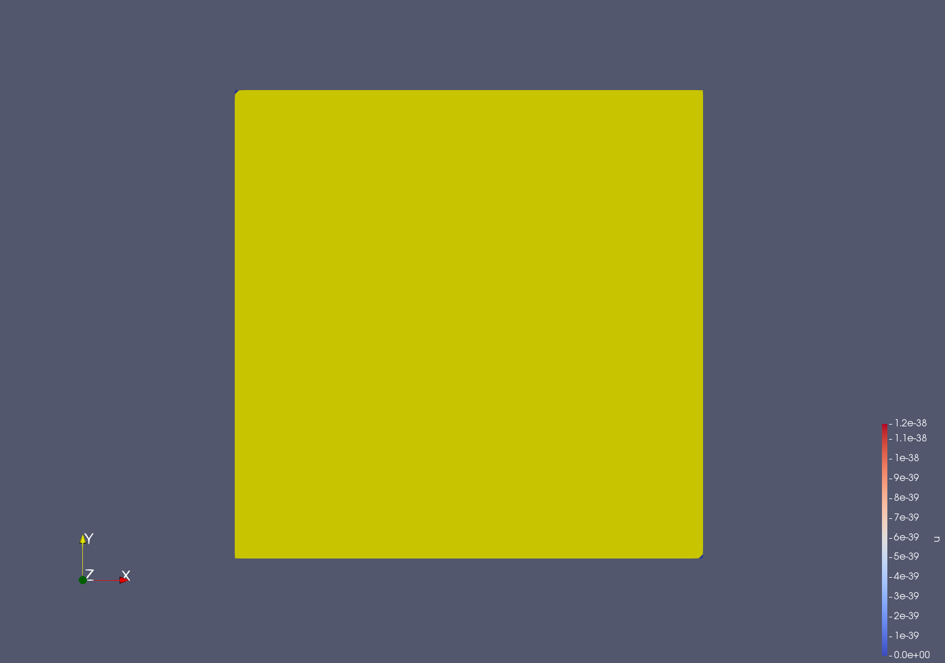

Within the associated image, the solutions for the equation are viewed as a plane such that z = 0 for all z in R3, thereby suggesting that the applications of this method of modeling is particularly applicable for more complex functions than that which is given by the van Deemter simplification. Specifically, by having a vector field that is fully conservative with a divergence of 0, the representation of the vector field would be a constant vector field of <0,0,0>, represented by a plane such that z = 0.

Furthermore, this project would greatly have been helped by experience in Math 383 or another similar course in differential equations. Therefore, in time, I would like to revisit this project with data obtained through lab work and an increased knowledge of the applications of differential equations from a formalized class. While this project therefore did not ultimately fulfill my goals at the beginning, I believe that the experience has allowed me to appreciate the underlying intricacies of PDE systems and the inherent complexity of modeling chemical or physical behaviors through computer science due to the inherent limitations of discretized calculation. Overall, this project represents a proof of principle in that with a full data set and a more complete understanding in the theory behind differential equations, the modeling of chemical reactions, diffusions, or other phenomena could be determined through a PDE solving system such as FEniCS through simple coding.

References:

Harris, D. C. (2003). Quantitative chemical analysis. New York: W.H. Freeman and Co.

Kuttler, Christina. Reaction-Diffusion equations with applications. 2011.

Langtangen HP and A. Logg. Solving PDEs in Minutes-The FEniCS Tutorial Volume 1. Sep.

19, 2016. Springer.

1. Langtangen 11.
2. Kettler 5; Langtangen 11.
3. Langtangen 17.
4. Kuttler. 5-8
5. Kuttler. 9
6. Harris.