**Part 1**

**D)** Graph of actual and desired robot trajectory with using error in end effector as input

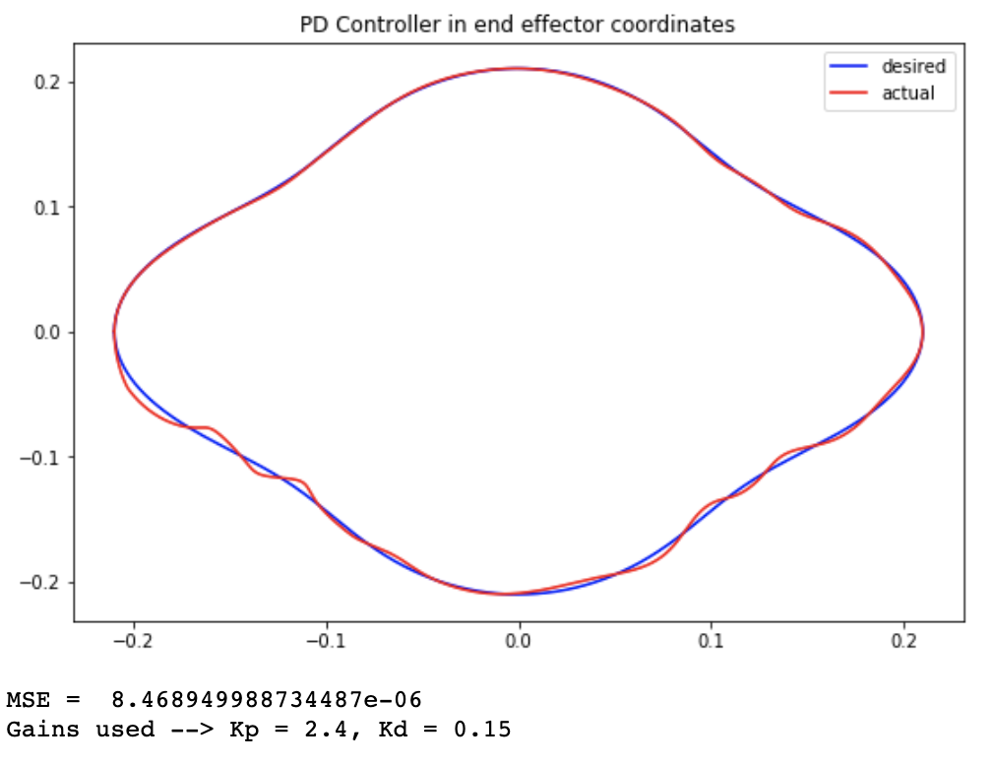

**Gains used:** Kp = 2.4, Kd = 0.15

**MSE: $8.47 ×{10}^{-6}$**

**E)** Graph of actual and desired robot trajectory with using error in joint angles as input

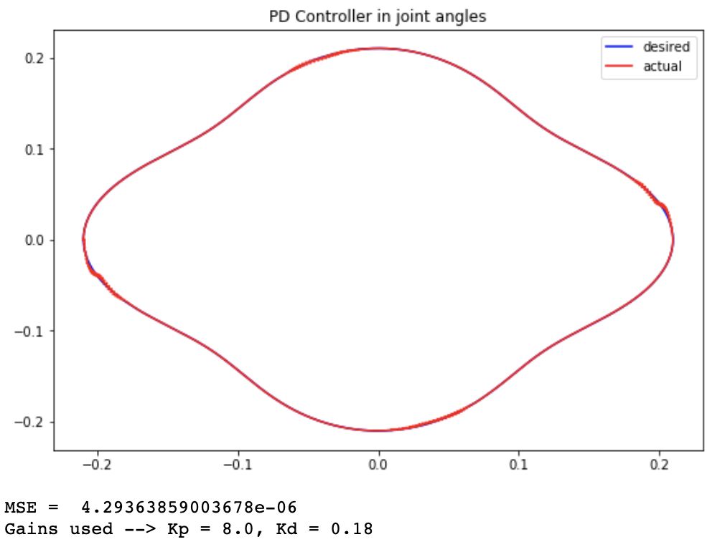

**Gains used:** Kp = 8.0, Kd = 0.18

**MSE: $4.29 ×{10}^{-6}$**

**Part 2**

1. Controller

A PD controller similar to part 1 was used to control the thrust. No controller was used to control the wheel angle given by $γ$. That is calculated definitively and fed in as an input.

$Thrust=\left[K_{p}×\sqrt{\left({∆x}^{2}+{∆y}^{2}\right)}\right]+ \left[K_{d}×\left(v_{desired}-v_{current}\right)\right]$, where

$v_{current}= \sqrt{\left({v_{x}}^{2}+{v_{y}}^{2}\right)}$ $v_{desired}=\sqrt{\frac{\left({∆x}^{2}+{∆y}^{2}\right)}{\cos^{2}{γ}}}$ $γ=\tan^{-1}\left(\frac{∆y}{∆x}\right)-θ$

$∆y=y_{desired}-y_{current}$ $∆x=x_{desired}-x_{current}$

$K_{p}=Proportional gain, K_{d}=Differential gain$

$x_{desired}, y_{desired}, x_{current}, y_{current}, v_{x}, v_{y}, θ$ are read from the observation.

1. Results

For gain of $K_{p}=1.05, K_{d}=0.33$, the plots are:

1. Linear Track

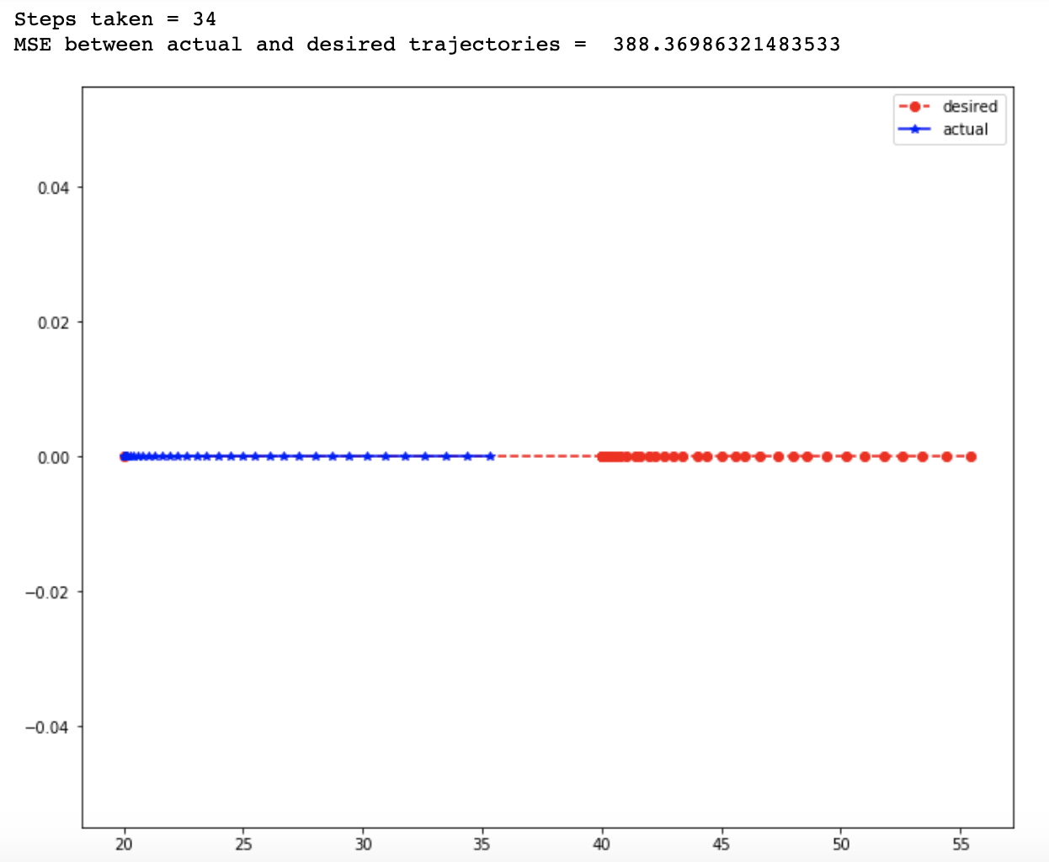

Steps taken = 34, MSE = 388.369

1. Circle Track

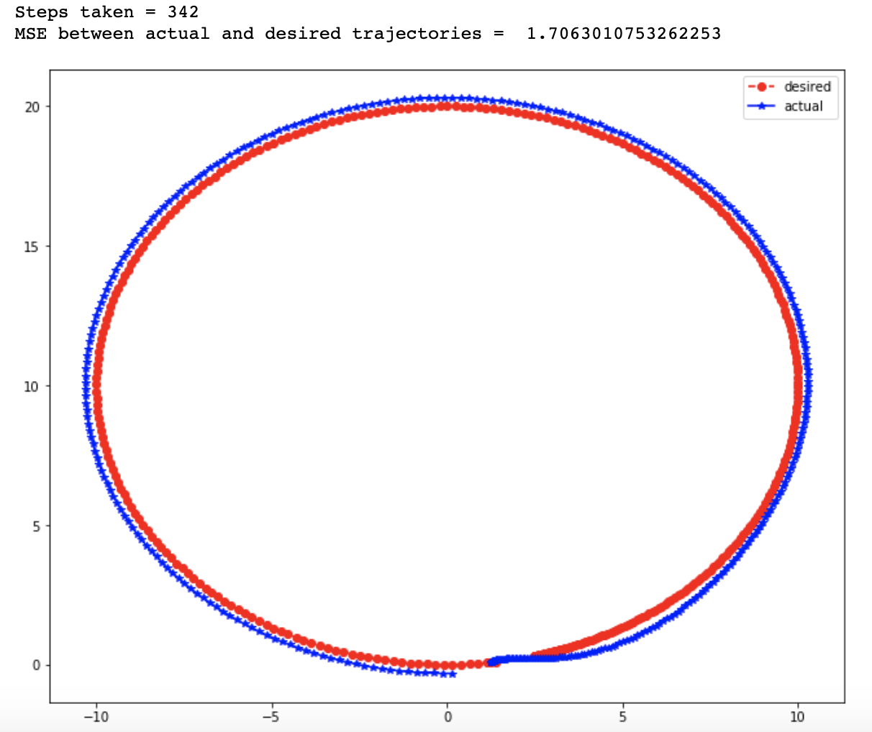

Steps taken = 342, MSE = 1.70

1. FigureEight Track

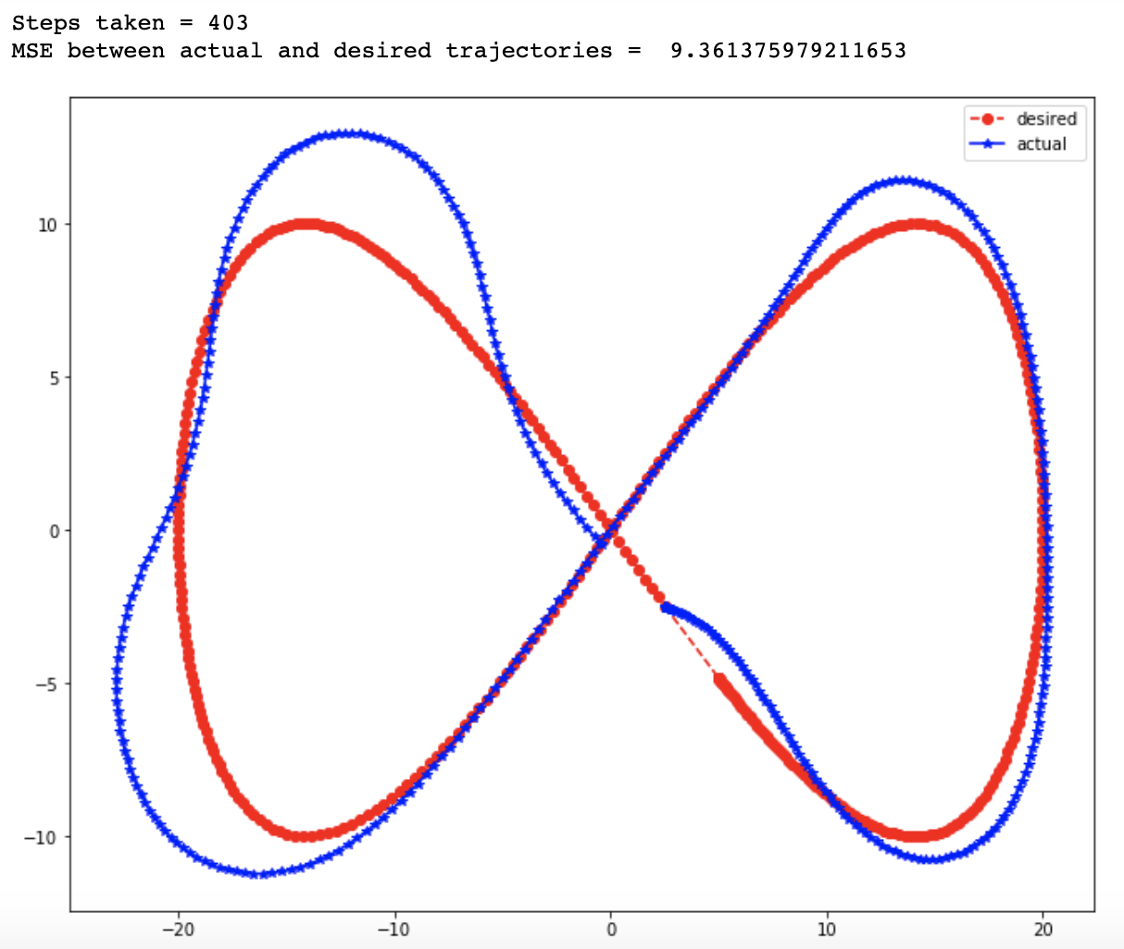

Steps taken = 403, MSE = 9.36

Although the controller is able to make the car stay almost on track, the error can be completely eliminated by using an integral controller too. This is reserved for future work.