Healthcare capstone #2

Descriptive Documentation

Business questions
- Which patient encounters are at risk of generating unusually high treatment costs compared to similar cases?
This issue needs to use patient encounter characteristics to define which one could have more chances of generating high costs. This model is intended for analytical insight and predictive modeling practice and binary classification. This means the target variable will be binary 0 / 1 called “encounters_high_treatment_costs”. The unit of analysis that will be used to solve this issue will be encountered. The model category would be supervised learning since there is an evident Y variable.
- Which patients are most likely to be readmitted within 30 days after discharge?
This issue needs to look at the characteristics of patients to determine which one would be readmitted in the hospital 30 days after discharge and which one not, we could establish this as binary classification problem with a target variable or binary output 0 or 1 called “readmissions_between _30 _days”. The unit of analysis will be patient and would be a supervised learning model with a defined Y or target variable.
- Can we predict the probability of an adverse clinical outcome for an encounter based on patient and encounter characteristics?
This question aims to find out what clinical encounters would have an adverse outcome or not. So would be a binary classification type of problem. The target variable will be 1 or 0 and will be called “adverse_encounters_outcome”. We will be using a supervised model category since there is a well-defined Y variable.
- Can we use information contained in clinical notes, beyond structured data, to predict elevated patient risk?
The question’s issue is trying to determine if clinical notes can be used to predict elevated patient risk. This is an NLP classification type of problem. NLP will be converted to output binary data 0 or 1. Y variable will be called “Patient_risk_by_notes”. The unit of analysis will be clinical notes, and we will be using a supervised learning model since Y is defined.

- Can we predict whether a patient will experience a longer-than-expected hospital stay based on demographics, clinical history, and treatment patterns?

We are trying to see if yes or no longer_than_expected hospital stay based on demographics, clinical history, and treatment patterns. So, this is a binary classification problem. Target variable would be defined as 0 or 1 and Y will be called “Hospital_stay_based_on_patterns”. The unit of analysis will be the hospital stay and this will be a supervised learning model since Y is defined.

- Can we build a risk-adjusted model of patient outcomes to identify facilities whose performance deviates from expected predictions?

This question tries to find facilities performance deviated from expected predictions based on patients’ outcomes. This is also a binary classification problem with a 0 or 1 output where Y will be called “Facilities_p_by_outcomes”. We are trying to analyze the facilities, so that should be the unit of analysis. This will be a learning supervised modeling since Y is defined.

Program used for this project:
AWS platform
- S3
- AWS Glue
- Athena
- Amazon SageMaker
Structure.
The original dataset was provided in Excel format consisting of six sheets, each representing a different dataset. Each sheet was converted into a separate CSV file, resulting in six CSV files. These files were then uploaded to AWS S3, each stored in its corresponding folder.
Each dataset will be cleaned and filtered independently using AWS Glue with PySpark. The exploratory data analysis (EDA) process will also be performed separately for each table.
AWS Glue will be used for data transformation and cleaning, leveraging the PySpark library, while Amazon Athena will be used for querying and analysis using SQL.

EDA
Table: hc_clinical_notes/
A structural overview of the dataset was conducted through Athena to confirm integrity.
Structure overview
- The dataset contains 3 columns and 5001 rows.
- The three columns contain string values.
Summary statistics
Purpose: The objective is to understand category or non-numeric field’s diversity, detect dominant or repeat values and confirm consistency. There are no missing or null values nor duplicates. The note_type column contains multiple unique categories, reflecting moderate diversity, where is possible to appreciate the dominance of Progress Note with 2217 rows over the other two categories, Discharge Summary with 1508 rows and ED Note with 1275 rows. Clinical notes exhibit a relatively consistent length distribution, with an average of approximately 187 characters and a narrow range between 124 and 306 characters. This indicates low variability and suggests the dataset is well-structured with no extreme outliers or missing text entries. No irregular or unexpected categories were identified, and all values aligned with expected domain-specific classifications.
Relation analysis
Each encounter is associated with exactly one clinical note, indicating a one-to-one relationship and confirming that the dataset is structured at the encounter level. A relationship analysis was conducted between note type and text length to evaluate whether different clinical documentation categories exhibit distinct text characteristics. The results show that the average, minimum, and maximum note lengths, as well as the total number of notes, are relatively consistent across categories, suggesting a balanced distribution with no significant variability between note types. Aggregation analysis revealed variability in documentation patterns across encounters, with some encounters containing multiple note types and varying note lengths. Certain note types were consistently longer and more frequent, indicating structured differences in clinical documentation.

Sampling
A random sample of 100 rows was inspected to validate data quality and structure. The sampled records showed no irregular formats or unexpected values. The note_text field is readable, with no broken entries or unusual characters. Additionally, each encounter is associated with a single note, and categorical values appear consistently across observations. The observed text lengths align with previously computed summary statistics, confirming the reliability of the dataset.
Basic NLP Exploration
Basic NLP exploration was conducted using the keyword “pain” to identify its presence within clinical notes. A total of 426 notes were found to contain the term, suggesting that it may represent a relevant clinical signal within the dataset. Further analysis by note type showed that “Progress Note” contains the highest frequency of the keyword, with 180 occurrences. This is consistent with its higher overall representation in the dataset and indicates that this note category is more likely to document symptoms such as pain.

Table: Encounters/
A structural overview of the dataset was conducted through Athena to confirm integrity.
Structure overview:
- The table contains 15 columns and 5000 rows.
- Data type: The table contains 8 string columns, 6 int columns and 1 float column.
encounter_id string
patient_id string
facility_id string
encounter_date string
admission_type string
department string
primary_diagnosis_group string
encounter_severity bigint
length_of_stay_days bigint
total_cost_usd double
discharge_disposition string
adverse_outcome_flag bigint
readmitted_30_days_flag bigint
polypharmacy_flag bigint
opioid_prescribed_flag bigint

Summary statistics
The table has cero nulls, after finding the table unique identifier “encounter_id” we could verify that there are not duplicates.
Distribution:
- There is 1 value per encounter, which makes sense and proves the data is clean. Patients have multiple encounters, with some patients having up to 11 visits, while most have fewer. This indicates that patient_id is not unique and patients can have repeated interactions with the healthcare system. Encounters are evenly distributed across facilities, with counts ranging from 599 to 673 encounters per facility, indicating a balanced workload among facilities. Also is possible to observe that the range of encounters per day between 2024 to 2025 is between 10 to 17 per day. There is a balanced distribution of encounters between elective and urgent admissions; however, emergency admissions appear as an outlier, with counts approximately double those of the other admission types. The encounters per department are really balanced between a range of 600 to 650 per department. The distribution for diagnosis is extended, with a range from approximately 280 to 590 encounters per diagnosis, and there is an outlier of around 1250 in the “Other” category, almost double the highest encounter count among the remaining diagnoses. Last we can observe that discharge range is also extended with values between 275 to 896 with “home” category having an outlier that double the other categories around 1930.
Numeric summary
- The severity by encounters has a min value of 1 and a max value of 5 with an avg of 3.217 of severity by encounter. The data is concentrated between 3 and 4, with a median of 3, indicating low variability and a tight distribution. The data shows a slight right skew, with values concentrated at the lower end and a gradual spread toward higher values. Which means most cases are not highly severe. The stay days per encounter has a range between 1 to 17 days with an avg of 4 days per encounter. There is a low 25 percentile of three stay days per encounter, a median of 4 days stays per encounter and a 75 percentile of 6 stay days per encounter, that means there isa slice skew to the right toward the high values. The total cost per encounter has a very extended range of value, where values could go from $2200 to $20500 with an average per encounter of around 8400. While the lower 25 % pay around $6621 and the other 75% pay more than $9800 the median is $8137 that means this peace of data is not skew to either side, in fact is well balanced and the mean and median are around the same values. The adverse outcome per encounter variable has a binary representation, which means 0 are the non-adverse outcomes while 1’s represents the adverse outcomes. By default, it is just 1 by encounter for an average of 57 % of patients having an adverse outcome per encounter, in the case the variable has a binary classification the percentiles classification is not giving valuable information. Therefore, the mean (proportion) and distribution of values are more informative for analysis. The readmission variable between the first 30 days is a similar situation, is also represented with a binary classification where 0 means not readmission while 1 represents the readmissions between the first 30 days. The average number of readmissions per encounter between the first 30 days is around 49%. The percentile information in this case is not very informative neither. The polypharmacy_flag and the opioid_prescribed_flag are similar cases where binary classification is used. In the polypharmacy case 0 represents patients that use just one medication while 1 represents patients consuming multiple medications, we found that 40 percent of patients that are having encounters use polypharmacy. In the opioid case, 0 represents patients not consuming opioids and 1 represents patients consuming opioids and it was possible to observe that 8.50% have opioid prescribed. In these two cases, percentile information is not very informative either. There was some aggregation patterns analyzed

Relationship Analysis

- The dataset has one identifier, encounter_id, which is unique for each row. This means each encounter_id appears only once in the dataset, indicating that the data is structured at the encounter level. Some aggregation measures were applied to identify different data behaviors that could be used in later feature stages of the project. Admission_type and encounter_severity were aggregated, and it was found that severity ranges from 1 to 5, with averages between 2.70 and 3.45 per admission type. The highest average belongs to emergency (3.46), which also has the highest number of encounters (2713). This means the aggregation is slightly influenced by emergency cases, as they have nearly double the number of encounters compared to urgent and elective admissions, along with the highest average severity. The next aggregation for interpretation was between department and length_of_stay_days. The range of stay by department is between 1 and 17 days, with Surgery having the lowest maximum stay (13) and Neurology the highest (17). The average length of stay for each department is around 4 days, and the number of records per department is around 600. Since there are 8 departments, we can say that the length of stay is balanced across departments. The last aggregation was between primary_diagnosis_group and total_cost_usd. The average cost by diagnosis ranges from approximately $7,650 to $10,240, depending on the diagnosis. The minimum cost is around $2,300, while the maximum cost can reach up to $20,500. Additionally, the number of records per diagnosis ranges from 279 to 590, with Stroke having the least cases and Diabetes the most. There is also an outlier category labeled “Other,” which groups multiple diagnoses and has a significantly higher number of records (1,252) compared to the rest.

Outcome vs numerical relationship

- Outcome vs numerical relationship analysis was not performed during the EDA phase because the dataset does not contain a predefined outcome variable. This analysis will be conducted during the feature engineering stage once an appropriate target variable is created.

Aggregation Patterns Across Variables
- A couple aggregation patterns across variables were conducted during this analysis. First found was the average price by admission and department. The highest average is seen in the cardiology department and admissions in Urgent care with an average of $ 8600, while the lowest appears in electives admissions and internal medicine with $7300. This suggests that emergency surgeries influences have the highest costs on the center. In the second aggregation pattern, the aggregated variables were primary diagnosis group and discharge disposition, and the numeric variable used was encounter severity. The highest average severity is found in Sepsis diagnoses with expired discharges, with an average severity of 4.60, while the lowest average appears in the “Other” classification for remaining diagnoses with patients discharged home, with an average severity of 2.60. This suggests that Sepsis diagnoses with expired dispositions are associated with higher risk.
Sampling
- Sample rows were inspected to validate data quality and consistency. Values appear correct and consistent with expected formats. No unusual or unexpected values were identified. Date formats are standardized, and categorical variables such as admission type, department, and diagnosis group are consistent and meaningful. No missing or broken records were observed in the sampled data. Each encounter appears to be unique, and the data aligns with previous summary statistics.

Table: medications
Structure overview
- The table contains 12134 rows and two string columns.
- encounter_id string
- medication_class string

Summary statistics:
The table as no Nulls values. There are duplicate values, distinct_encounter_ids has 5000 values while there is a total of 12134 rows which means there is more than one medication class per ID, which make sense since one patient may have multiple medications.
Distributions
As we said before each medication_class has multiple cunts since every identifier may have multiple medications.

medication_class | count
Antibiotic | 1773
Antihypertensive | 1734
Insulin | 1726
Analgesic | 1446
Antidepressant | 1423
Anticoagulant | 1370
Bronchodilator | 1333
Steroid | 1329

Data consistency
Data has a pretty consistent format, there are no variations, nor broken ids. There are not patterns that could need modifications and since there is just one column it is not necessary or possible to find consistency between columns.
Relationship analysis.
Data is more detailed and one ID is linked to multiple rows. Total rows 12134 while there are 5000 distinct_encounters, this means there is more than one count for each ID. Medication class is the only column exist besides the identifier. There is a range of frequency per medication class of 1 to 6 with an average of 2 frequencies per medication class. EDA was conducted independently on each dataset to ensure data quality and understanding prior to performing cross-table relationship analysis.
Sampling
Values look correct, there are not weird formats to fix on the table nor unexpected values. Categories look correct. The only column on the table “medication_class” hs 8 different classifications:
medication_class | total_count
Steroid | 1329
Antibiotic | 1773
Insulin | 1726
Anticoagulant | 1370
Antihypertensive | 1734
Analgesic | 1446
Bronchodilator | 1333
Antidepressant | 1423
The range is well balanced min values 1329 on steroids and max values 1773 on Antibiotics. So is secure to say that antibiotics are the most consumed medication while Steroids are the less consumed medication.

Table: Facilities
Structure overview
The table contains 8 rows and 6 string columns. Three of them string, two are bigint and one is classified as double.
facility_id string
facility_name string
region string
bed_count bigint
teaching_hospital bigint
avg_patients_per_nurse double

Summary statistics:
Table has no nulls; the table has not duplicated values.

Distributions
There are three category columns that were distributed. The facility_id column has 1 count per facility Id which means data is well distributed since facility_ID is the only identifier. Facility _name has also just one count per facility, it is important to keep in mind this is a small table. The region column is different, while Midwest and west has just one count, Northeast and Southeast had each one 3 counts. That means that Northeast and Southeast regions are the ones with more facilities.
Basic summary
The table has three numerical columns, “bed_count”, “teaching_hospital” and “avg_patients_per_nurse”. The “bed_count” column has min values as 228 and max value as 539 which means each facility has between 228 and 539 beds with an average per facility if 372.25. When we look at percentile rates, around 25 % of facilities have 293 beds while the higher 75 % have around 525 beds for a median of 379 beds per facility. The distribution shows a very slight right skew; however, since the mean and median are close in value, the skewness is minimal and the data can be considered balanced. The teaching_hospital column is a binary column where 0 (min_value) represents non-teaching hospitals and 1 (max_value) represents teaching hospital. The proportion of facilities that are teaching hospitals is 0.62, this means that around 62 % of medical centers are teaching_hospitals. Since this is a binary classification, percentiles and median are not really very informative data. The avg_patients_per_nurse has min values of 3.6 and max values of 6.39 that means that there is a minimum of about 3 to 4 patients per nurse and a maximum of about 6 to 7 patients per nurse, with an approximate average of 4 to 5 patients per nurse. Percentile calculations show that 25% of those facilities count with around 4 patients while the higher 75% have around 6 patients per nurse, for a median of 4 to 5 patients per nurse per nurse per facility. Since median and average looks the same, we can deduce that data is well balanced and distributed.
Data consistency
Data consistency was evaluated through column-to-column comparisons. A logical consistency check was performed to determine whether the number of beds (bed_count) is less than the average number of patients per nurse (avg_patients_per_nurse). No records were found that violated this condition, indicating that the data follows expected logical relationships and is consistent.
Additionally, a length consistency check was applied to the facility_id column. The results showed consistent lengths across all values, confirming that the identifiers follow a uniform structure.
Relation analysis
Frequency by entity
The relationship between identifiers and attributes was examined by comparing the total number of rows with the count of non-null values in the region and facility_name column. The results show that both counts are equal (8), indicating that there are no missing values in the region column nor on the facility_name column and that each record contains a valid region entry. Another important finding is that there is an avg of one identifier per entity which is consistent with previous findings and confirms the expected logical relationships and is consistent with other variables.
Aggregations for numerical variables
- Categorical vs Target Relationships: To continue this analysis several aggregations for numerical variables were made. Checking how many beds per facility there are we could find first that there is a value per count and that the facility with less beds is Southeast Medical Center 6 with 228 beds and Midest Medical Center 3 is the one with the most beds with 539. Also, we can deduce that it’s a very expanded range of beds between one facility and the other between the 8 existent facilities. Another finding was how many patients per nurse there are per region. The total_records show that between the four regions Midwest and West have each one, just one count while Northeast and Southeast each have 3 counts, that means that Northeast and Southeast each have 3 facilities while the other two regions have just 1 each one. The avg of patients per nurse per facility is extended and has a lot of variances depending on the region. Even though the Southeast region has 3 facilities and the West region has just 1 both regions maintain an average of between 3.6 and 3.9 patients per nurse, Northeast has an avg of 5.31 patients per nurse and Midwest even when has just one facility has an avg of 6.3 patients per nurse. From all facilities Midwest Medical Center 3 is the one with most bed_count per facility and the highest avg_patients_per_nurse per facility.
- Aggregation Patterns Across Variables: Subgroup comparisons were performed by calculating summary statistics for numerical variables across categorical groups. This process was done twice. In this case we used the category variable, region, and the identifier facilitie_name to find the patterns, and the two numeric columns used every time the process was applied were bed_count and avg_patients_per_nurse. In the first case, bed_count, the highest avg_value is seen in the Midwest Medical Center 3 in the Midwest region with an avg of and 539 beds, while the lowest appears in Southeast Medical Center 6 with 228 beds. This highlights a significant variation in facility capacity. In the second case, avg_patients_per_nurse, the highest avg_value is seen also in the Midwest Medical Center 3 with an average of 6.39 patients per nurse and the lowest average is seen in the West Medical Center 8 with 3.6 patients per nurse. This indicates variability in workload across facilities. This suggests that regions influence the number of beds per facility and number of patients per nurse.

Sampling
- All values on the table look correct, there are not weird formats nor unexpected values. There are not strange characters, all categories look correct.

Table: Patients/
Structure overview
Patient’s table has a total of 8 columns, and 1500 rows/ Six of the columns are string and two of them are bigint.
patient_id string
age bigint
gender string
ethnicity string
insurance_type string
socioeconomic_risk_level string
chronic_condition_count bigint
smoker_status string

Summary statistics or missing values.
The table does not have any Null values. After finding how many identifiers were present, only one was found “patient_id, since there are 1500 rows and each one has it own patient_id. Using the identifier was possible to verify the number of duplicates, finding that the table has no duplicates.

Distributions
Category distribution
- Gender: the gender column has three values Females with 757 counts, Male with 714 counts and Other with 29 counts. This mean that females and males are fairly balance on the amount of people from each gender with a slight majority in females, while the “others” classification may be seen as an imbalance due the small number of patients that have been treat without a gender identification.
- Ethnicity: This column has 5 classifications: Asian with 153 counts, Black/African American with 291 counts, Hispanic/Latino with 490 counts, White with 494 counts, and Other/Unknown with 72 counts. In this column, there is a largely extended distribution, and the data is unbalanced across ethnicity classifications.
- Insurance_type: This column contains 4 types of classifications: Medicaid with 272 counts, Medicare with 305 counts, Private with 839 counts, and Self-Pay with 84 counts. This is also an extended distribution with large variations and imbalance between classifications, where Private insurance has the most counts and every other classification is well below, with 272 for Medicaid and 305 for Medicare as the nearest classifications.
- Socioeconomic_risk_level: This column has three classifications: High with 335 counts, Low with 629 counts, and Medium with 536 counts. The data is extended and unbalanced, with Low risk as the classification with the most counts and High with the least count, confirming that there is some clear distinction in the variation between classifications easy to appreciate.
- Smoker_status: This column also has three classifications: Smoker with 220 counts, Former with 350 counts, and Never with 930 counts. There is a clear imbalance, with the number of people who never smoke at 930 counts, while the other two classifications have relatively low counts of 220 and 350. The data has a large distribution, ranging from 220 to 930 counts.
Basic Summary Statistics
- Age: This column has 18 as minimum value and 90 as the maximum value with an average age value of 51.87. Approximately 25% of patients are below 40, while 75% are below 64. The median value is 52. This suggests that there is a wide range between the age columns, but data is still generally well balanced since the avg of age is 51.87 and median per patient is 52.
- Chronic_condition_count: This is a numerical column with multilevel classification and discrete values from 0 to 6, where the average number of chronic conditions per patient is 1.54. Approximately 25% of values are below 1, while 75% are below 2. The median value is 1. This suggests that the range is relatively short, from 1 to 6, and the data is relatively balanced since the median and average have similar values.
Data consistency
- Data consistency checks were performed twice to compare ranges and values consistencies. One check was conducted on the chronic_condition_count column to identify any values greater than ten, and another on the age column to identify any values greater than 90. In both cases, no results were returned, which is consistent with previous results and outputs.
- Length Consistency: The length consistency of the identifier column “patient_id” was checked, and the output also matched previous findings, confirming that there is one unique ID for each row.
Relation analysis
- Frequency by entity: Based on the analysis, there are 1,500 rows, and there is one ID per row, resulting in an average frequency of 1 ID per patient.
- Categorical vs Target Relationships: Basic aggregations were performed to compare different groups. In the first case, gender was used as the categorical column and age as the numerical column to calculate the average age per gender. It was found that the average age range per gender is relatively small, with females having an average age of approximately 51.45, males 52.13, and the “Other” category 56.48. This indicates a range between 51 and 56. The minimum age is 18 across all groups, while the maximum age is 82 for the “Other” category and 90 for both males and females.
In the second case, ethnicity was used as the categorical column and chronic_condition_count as the numerical column to calculate the average number of chronic conditions per ethnicity. It was found that the average chronic condition count per ethnicity ranges between 1.43 and 1.66, with Black/African American having the lowest average and the Other/Unknown classification the highest average value, while the other classifications fall in between. In this case, the range of average chronic conditions per ethnicity is also relatively short. The minimum value is 0, while the maximum value is 6.
- Aggregation Patterns Across Variables. Aggregations across two dimensions were processed to compare subgroups. In the first case the categorical variables used were insurance _type and smoker_status, the numerical variable use was age. Trying to find the relation between the type of insurance per the type of smokers and their age. The highest average age is 55.64 and it is seen in those patients that never smoke and have the self-pay classification, while the lowest avg is 49.07 and appears in the Private classification that are current smokers. Different combinations of insurance type and smoking status are associated with different average ages.
- In the second case, the categorical variables used were socioeconomic_risk_level and ethnicity, and the numerical variable used was chronic_condition_count. The goal was to identify the relationship between socioeconomic level, patient ethnicity, and the number of chronic conditions. The highest average number of chronic conditions is 2.05 for the Other/Unknown classification with High socioeconomic_risk_level, while the lowest average is 1.34 for the Other/Unknown classification with Medium socioeconomic_risk_level. This suggests that different combinations of socioeconomic levels and ethnicity are associated with variations in the average number of chronic conditions.
Sampling
- Sampling: Through the EDA process, we were able to confirm that all values appear correct. There were no unusual formats, unexpected values, or irregular characters, and all categories appear consistent and valid.

Table: vital_labs
Structure overview
The table has 6 columns, one categorical column (string) and five numerical columns (four float and one int)
Summary statistics
The table do not have Nulls nor Duplicates. There is just one Identifier and there is just one identifier per each of the 5000 rows on the table.
Distributions
Category distribution: Since the table’s only categorical column is an identifier a categorical distribution analysis is not necessary.
Basic Summary Statistics
- avg_heart_rate_bpm: Patients min avg heart rate bpm is 54 while the max value is 144.7 for an average of 98.80. Approximately 25% of values are below 89.72, while 75% are below 107.98. The median value is 98.72. This suggests that while there is a large range between avg_heart_rate_bpm, mean and median have approximately the same values there is a right skew toward higher values.

- avg_systolic_bp: Patients min avg_systolic_bp is 80.4 while max is 209.4 for an average of 138.11. Approximately 25% of values are below 125.21, while 75% are below 150.83. The median value is 138.11. This suggests that there is a wide range between avg_systolic_bp but there is symmetry on the data since avg and median have the same value. However, the high maximum value suggests the presence of elevated blood pressure readings, which may indicate cases of hypertension.

- glucose_mg_dl: Patients min glucose_mg_dl values are 65 while max is 245.9. The avg is 135.97. Approximately 25% of values are below 114.93, while 75% are below 156.14. The median value is 135.68. This suggests that there is a wide range between glucose_mg_dl values, but data has symmetry since avg, and median values are approximately the same. However, the high maximum value suggests the presence of elevated glucose levels in some observations.”
- bmi: Patient’s bmi min values are 16 while max values are 50. The avg value is 27.89. Approximately 25% of values are below 23.79, while 75% are below 31.80. The median value is 27.89. These values suggest that this data has a wide range of values and there is symmetry between it since avg and median have the same values. However, the high maximum value suggests an elevated Body Mass Index in patients.

- abnormal_lab_count: Patients’ abnormal_lab_count min values are 0, max value is 12 and avg value is 4.34. Approximately 25% of values are below 3, while 75% are below 6. The median value is 4. This suggests that data has a decent range between 0 to 12 and since avg and median are approximately the same but have a slight difference we could say it slightly skewed to the right. The max value of 12 suggests that there is a high elevated values of abnormal results between patients.

Data consistency checks
- Comparing values in the same row from different columns: Two data consistency experiments were done to check consistency of previous outputs. In the first case the abnormal_lab_count numerical column was used to try to find values below zero, the outcome was “no results” which means is proportional with previous outputs. In the second case the numerical column avg_systolic_bp was used to find if there was any value over the max of 210, output was also” no result” which is also proportional to previous outputs.
- Length consistency: A length consistency check was performed on the identifier column ‘encounter_id’. The output was consistent, with all IDs having a length of 7 characters.
Relation analysis
- Frequency by entity: A frequency check was performed on the identifier column ‘encounter_id’. The results confirmed that each record contains a valid value and that all identifiers are unique, indicating no missing or duplicate entries.

- Aggregations for numerical variables: Numerical aggregation was performed in the summary statistics section. Additional aggregation by category was not possible due to the absence of categorical variables in the dataset.
Sampling
- Sampling: Through the EDA process, we were able to confirm that all values appear correct. There were no unusual formats, unexpected values, or irregular characters, and all categories appear consistent and valid.

KPI
Metric # 1
Which patient encounters are at risk of generating unusually high treatment costs compared to similar cases?
- This issue needs to use patient encounter characteristics to define which one could have more chances of generating high costs. This model is intended for analytical insight and predictive modeling practice and binary classification. This means the target variable will be binary 0 / 1 called “encounters_high_treatment_costs”. The unit of analysis that will be used to solve this issue will be encountered. The model category would be supervised learning since there is an evident Y variable.
Independent Variables (X): (Blue low variability / Red high variability)
- admission_type: Cost Avg variability 8091 - 8790
- department: Cost Avg variability 7938 - 9400
- primary_diagnosis_group: Cost Avg variability 7844 – 10351
- encounter_severity: Cost Avg variability 5957 – 10770
- length_of_stay_days: Cost Avg variability 5114 – 18080
- insurance_type: Cost Avg variability 8290 - 8615
- region: Cost Avg variability 8520 - 8696
- teaching_hospital: Cost Avg variability 8538 - 8574
- medication_class: Cost Avg variability 8427 - 8677
- smoker_status: Cost Avg variability 8536 - 8696
- chronic_condition_count: Cost Avg variability 7504 – 11034
- socioeconomic_risk_level: Cost Avg variability 8484 - 8721
- bmi: Cost Avg variability 8834 -15775
- abnormal_lab_count: Cost Avg variability 6871 – 10997
Dependent V (Y): encounters_high_treatment_costs: (avg in total_cost_usd column 8560)
After identifying the five X variables to be used as descriptive variables for feature creation, five aggregation tables were created. In each table, an X variable was used as the aggregation level, and the target variable (Y) was calculated through the aggregation process.
Encounter_severity aggregation table:
At the time the table was created, encounter_severity became the aggregation level, and other aggregated variables were created, including min_cost, max_cost, n, and encounters_high_treatment_costs (Y target). The target variable was created through an average aggregation process. All aggregated columns in the table are numerical, where encounter_severity and n are integers, while encounter_high_treatment_costs, min_cost, and max_cost are floating-point values. This is not a time-based aggregated table. The aggregation level (X variable) has values from 1 to 5, and the target variable ranges from 0.089 to 0.86. The n values range from 145 to 1,012. The lowest minimum cost is 2,227 and the highest maximum cost is 20,502.9. The table has no NULLs, zero values, or excluded values. The graph below shows that the cost per encounter depends on the severity of the encounter, with severity level 5 reaching values above 0.8 (80%). This shows a clear increasing trend, where higher encounter severity is associated with a higher probability of high treatment cost.
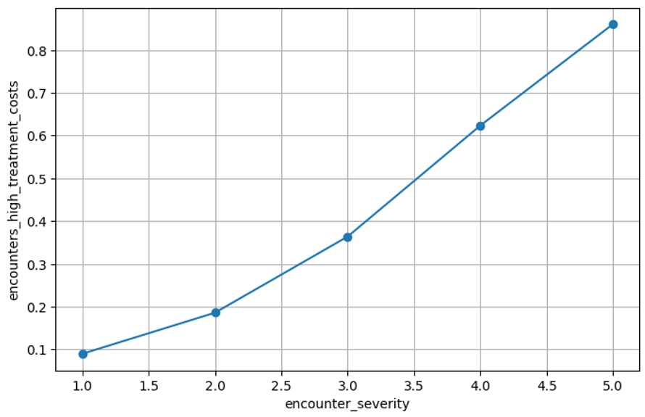

abnormal_lab_count table:
At the time the table was created, the X variable became the aggregation level. Other aggregated variables were created, including min_cost, max_cost, n, and encounters_high_treatment_costs (Y target). The target variable was created through an average aggregation process. All aggregated columns in the table are numerical, where abnormal_lab_count and n are integers, while encounters_high_treatment_cost, min_cost, and max_cost are floating-point values. This is not a time-based aggregated table. The aggregation level abnormal_lab_count has 13 levels starting from 0. The target variable encounters_high_treatment_costs range from 0.21 to 0.87. The minimum cost has the lowest value of 2,227.05, and the maximum cost has a highest value of 13,680.57. The n values range from 54 to 2,238. The table has no NULLs, zero values, or excluded values. The graph shows that treatment cost is linked to the number of abnormal_lab_count, with higher counts (between 10 and 12) increasing the probability of high treatment cost to between 80% and 90%. This shows a clear increasing trend, suggesting that abnormal_lab_count is a strong predictor of high-cost encounters and should be considered an important feature in predictive modeling.
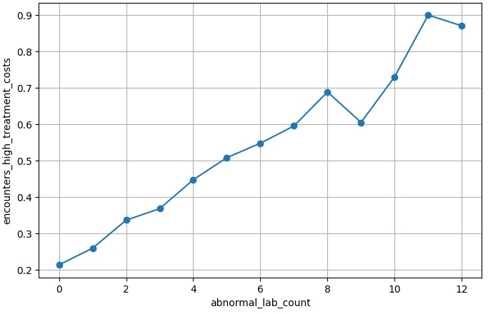

chronic_condition_count table:
At the time the table was created, the X variable became the aggregation level. Other aggregated variables were created, including min_cost, max_cost, n, and encounters_high_treatment_costs (Y target). The target variable was created through an average aggregation process. All aggregated columns in the table are numerical, where chronic_condition_count and n are integers, while encounters_high_treatment_costs (Y), min_cost, and max_cost are floating-point values. This is not a time-based aggregated table. The aggregation level chronic_condition_count has 6 levels, and the target variable encounters_high_treatment_costs ranges from 0.2764 to 0.8817. The minimum cost has a lowest value of 2,227.05, and the maximum cost has a highest value of 20,502.9. The n values range from 55 to 3,442. The table has no NULLs, zero values, or excluded values. The chart below shows that between levels 5 and 6 of chronic conditions, the probability of high treatment cost increases to between 80% and 90%. This shows a clear increasing trend, suggesting that chronic_condition_count is a strong predictor of high-cost encounters and should be considered an important feature in predictive modeling.

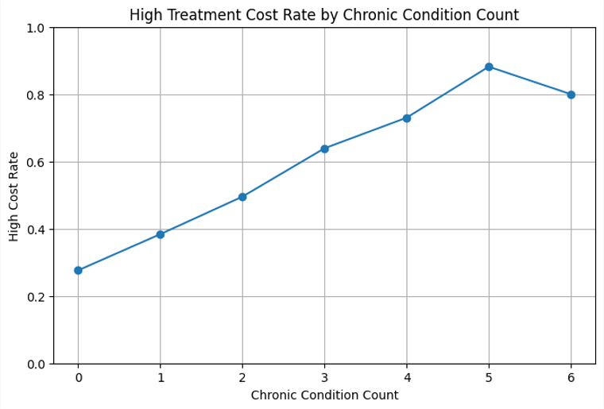

Bmi table:
At the time the table was created, the X variable became the aggregation level. Other aggregated variables were created, including min_cost, max_cost, n, and encounters_high_treatment_costs (Y target). The target variable was created through an average aggregation process. All aggregated columns in the table are numerical, where n is the only integer, and the rest of the variables—bmi, encounters_high_treatment_costs (target), min_cost, and max_cost—are floating-point values. This is not a time-based aggregated table. The aggregation level bmi has values ranging from 16.2 to 48.3, while the target variable encounters_high_treatment_costs ranges from 0.52 to 1.0. The minimum cost has a lowest value of 2,227.05, and the maximum cost has a highest value of 20,502.9. The n values range from 1 to 116. The chart below shows that BMI levels between 40 and 50 are associated with a higher probability of high treatment costs, reaching up to 100%. This suggests a general increasing trend, indicating that bmi may be a strong predictor of high-cost encounters and should be considered an important feature in predictive modeling.

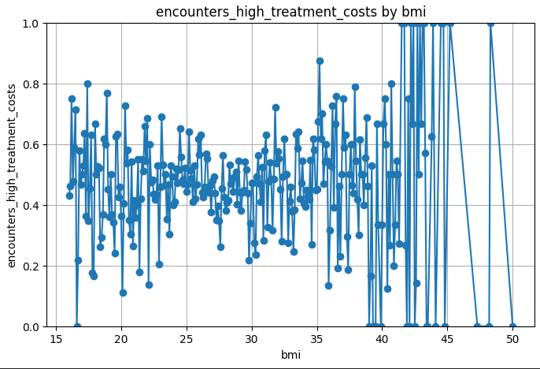
length_of_stay_days table:
At the time the table was created, the X variable became the aggregation level. Other aggregated variables were created, including min_cost, max_cost, n, and encounters_high_treatment_costs (Y target). The target variable was created through an average aggregation process. All aggregated columns in the table are numerical, length_of_stay_days the aggregated level or x variable and n are intg, encounters_high_treatment_costs (target), min cost and max cost are float values. This is not a time-based aggregated table. The aggregation level length_of_stay_days has values from 1 to 17, encounters_high_treatment_costs has a range of values from 0 to 1, min cost lowest value is 2582.29 and max cost higher value is 20502.9, n values range from 2 to 2397. The chart below shows that patients that stay longer than 8 days could pay 100% of the treatment costs. This suggests a general increasing trend, indicating that longer stay may be a strong predictor of high-cost encounters and should be considered an important feature in predictive modeling.

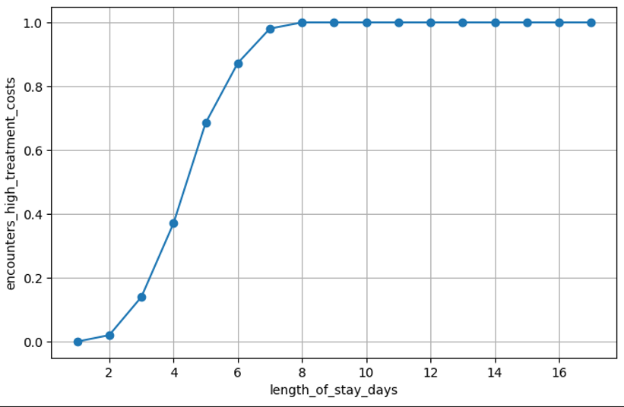
Metric#2:
Which patients are most likely to be readmitted within 30 days after discharge?
This issue needs to look at the characteristics of patients to determine which one would be readmitted in the hospital 30 days after discharge and which one not, we could establish this as binary classification problem with a target variable or binary output 0 or 1 called “readmissions_between _30 _days”. The unit of analysis will be patient and would be a supervised learning model with a defined Y or target variable.
Independent Variables (X): (Blue low variability / Red high variability)
discharge_disposition min 0 – max 0.65
admission_type min 0.44 – max 0.52
department min 0.48 – max 0.52
primary_diagnosis_group min 0.41 – max 0.59
encounter_severity 0=3.14 – 1=3.53
length_of_stay_days 0=4.31 – 1=4.64
age: 0=51.11 – 1= 52.82
insurance_type min 0.50 – max 0.53
socioeconomic_risk_level min 0.42 – max 0.62
chronic_condition_count 0=1.45 – 1= 1.89
smoker_status min=0.49 – max=0.51
avg_heart_rate_bpm 0=98.50 – 1=100.95
avg_systolic_bp 0=137.30 – 1=140.56
glucose_mg_dl 0=133.80 – 1=141.25
bmi 0=27.91 – 1=27.84
abnormal_lab_count min 0.40 – max 0.79

Dependent V (Y): readmissions_between _30 _days (readmitted_30_days_flag 0-1 classification)

Since the target variable is a binary classification, the independent variables (X) were selected through the GROUP COMPARISON method and using average for those X variables that are categorical. The variation of each variable was identified. In the case of numerical variables, the mean per 0 and 1 classification was calculated to verify whether there is wide or low variability between the two groups. In the case of categorical variables, average was used to find the range between minimum and maximum values. In both cases, the wider the range, the more variability. Finally, the four X variables with the highest variability were selected: two numerical variables, chronic_condition_count (0 = 1.45 – 1 = 1.89) and length_of_stay_days (0 = 4.31 – 1 = 4.64), and two categorical variables, discharge_disposition (min = 0 – max = 0.65) and abnormal_lab_count (min = 0.40 – max = 0.79). Two aggregation tables will be created to generate descriptive insights that will be used as a reference for feature engineering processes.

Agregation table #1
X variables :
discharge_disposition
abnormal_lab_count
Y variable
readmissions_between_30_days

This process was conducted to create descriptive variables for the feature engineering phase in order to generate insights. The independent variables used are discharge_disposition and abnormal_lab_count, while the dependent variable is readmissions_between_30_days, all derived from the healthcare_new_merged_table. This aggregation supports the second KPI of the capstone, which aims to identify which patients are most likely to be readmitted within 30 days after discharge. The abnormal_lab_count variable ranges from 0 to 12, and discharge_disposition represents discharge outcome categories, while readmissions_between_30_days ranges from 0 to 1 as a proportion of readmissions; min_cost and max_cost are binary indicators, and n represents the number of observations per group. The results suggest that higher abnormal lab counts—especially values between 11 and 12—combined with certain discharge dispositions, are associated with readmission rates approaching 100%, indicating a meaningful relationship between abnormal lab results, discharge outcomes, and likelihood of 30-day readmission. This suggests that an increase in admissions between 30 days has a relation with the number of abnormal labs count.
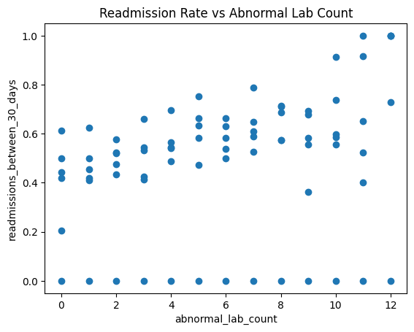
Aggregation table #2
X variables:
chronic_condition_count,
length_of_stay_days
Y variable
readmissions_between_30_days

This process was conducted to create descriptive variables for the feature engineering phase to generate insights. The independent variables used are chronic_condition_count and length_of_stay_days, while the dependent variable is readmissions_between_30_days, all derived from the healthcare_new_merged_table. This aggregation supports the second KPI of the capstone, which aims to identify which patients are most likely to be readmitted within 30 days after discharge. The variable chronic_condition_count ranges from 1 to 6, and length_of_stay_days ranges from 1 to 17, while the dependent variable ranges from 0 to 1 and includes decimal values representing the proportion of readmissions; min_cost and max_cost are binary indicators (0 and 1), and n ranges from 1 to 748. The chart suggests that higher numbers of chronic conditions are associated with readmission rates approaching 100%, indicating a strong relationship between chronic conditions and the likelihood of 30-day readmission.

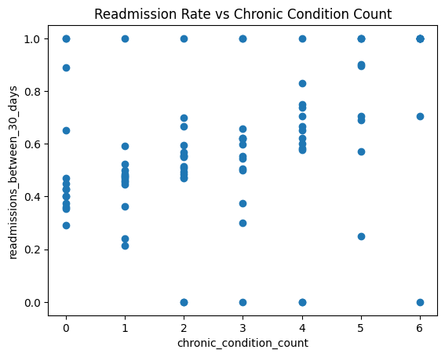
Metric #3
Can we predict the probability of an adverse clinical outcome for an encounter based on patient and encounter characteristics?
This question aims to find out what clinical encounters would have an adverse outcome or not. So would be a binary classification type of problem. The target variable will be 1 or 0 and will be called “adverse_encounters_outcome”. We will be using a supervised model category since there is a well-defined Y variable.
Independent Variables (X): (Blue low variability / Red high variability)
admission_type min = 0.52 – max = 0.63
primary_diagnosis_group min = 0.50– max = 0.84
Discharge_disposition min = 0.53 – max = 1.0
Région min = 0.58– max = 0.61
medication_class min = 0.59 - max = 0.60
insurance_type min = 0.56 - max = 0.62
socioeconomic_risk_level min = 0.59- max = 0.60
gender min = 0.58 – max = 0.61
smoker_status min = 0.58 – max = 0.60
abnormal_lab_count 0= 3.75 – 1= 5.00
readmitted_30_days_flag 0= 0.47– 1= 0.52
teaching_hospital 0= 0.622– 1= 0.616
avg_patients_per_nurse 0= 4.72– 1= 4.755
age 0= 48.84 – 1= 54.06
bmi 0= 27.97 – 1= 27.81
chronic_condition_count 0= 1.53 – 1= 1.77
avg_heart_rate_bpm 0= 96.86 – 1= 101.65
avg_systolic_bp 0= 136.94 – 1= 140.29
glucose_mg_dl 0= 136.55– 1= 138.25
length_of_stay_days 0= 4.21 – 1= 4.66
encounter_severity 0= 2.95 – 1= 3.60
total_cost_usd 0= 8006.01 – 1= 8929.71
bed_count 0= 375.0– 1= 374.9

Numerical variables were evaluated based on their variability in relation to the target variable. Variables with significantly larger scales, such as total_cost_usd and bed_count, were excluded from this comparison to avoid scale-driven bias. Instead, variables such as age and avg_heart_rate_bpm were selected due to their clinical relevance and meaningful variability.

Dependent V (Y): adverse_encounters_outcome (adverse_outcome_flag binary 0/1)
Aggregation table #1
X variables:
encounter_severity
length_of_stay_days

Y variable
adverse_encounters_outcome

. This process was conducted to create descriptive variables for the feature engineering phase to generate insights. The independent variables used are encounter_severity and length_of_stay_days, while the dependent variable is adverse_encounters_outcome, all derived from the healthcare_new_merged_table. This aggregation supports the third KPI of the capstone, which predicts the probability of an adverse clinical outcome for an encounter based on patient and encounter characteristics. The variable encounter_severity count ranges from 1 to 5, and length_of_stay_days ranges from 1 to 17, while the dependent variable ranges from 0 to 1 and includes decimal values representing the proportion adverse_encounters_outcome; min_cost and max_cost are binary indicators (0 and 1), and n ranges from 1 to 1111. The chart below shows that level 1 of encounter severity has a low adverse outcome just above 0.2 while level 5 of severity has a high 0.8 avg of adverse outcome. The higher the level of severity the stronger the chances of an adverse outcome.

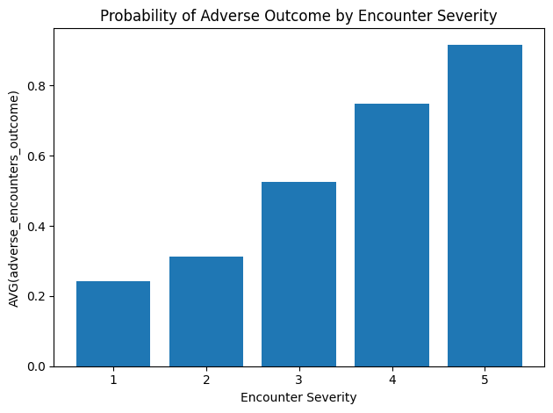

Aggregation table #2
X variables:
abnormal_lab_count
readmitted_30_days_flag

Y variable
adverse_encounters_outcome

This process was conducted to create descriptive variables for the feature engineering phase to generate insights. The independent variables used are abnormal_lab_count and readmitted_30_days_flag, while the dependent variable is adverse_encounters_outcome, all derived from the healthcare_new_merged_table. This aggregation supports the third KPI of the capstone, which predicts the probability of an adverse clinical outcome for an encounter based on patient and encounter characteristics. The variable abnormal_lab_count count ranges from 0 to 12, and readmitted_30_days_flag has a 0/1 binary classification, while the dependent variable ranges from 0 to 1 and includes decimal values representing the proportion adverse_encounters_outcome; min_cost and max_cost are binary indicators (0 and 1), and n ranges from 11 to 1119. The chart below shows that when there are no abnormal labs the chances of adverse outcomes fall below 40% while 11 abnormal labs count or increase chances of adverse outcomes by more than 80%. The higher the level abnormal labs count the stronger the chances of an adverse outcome.
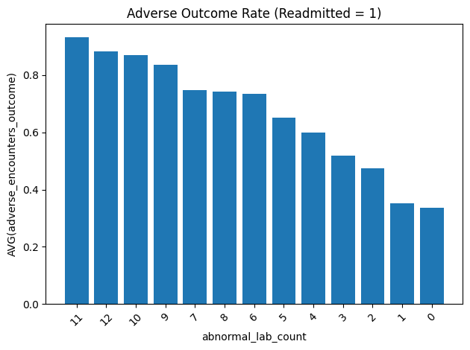
Metric #4
Can we use information contained in clinical notes, beyond structured data, to predict elevated patient risk?
The question’s issue is trying to determine if clinical notes can be used to predict elevated patient risk. This is an NLP classification type of problem. NLP will be converted to output binary data 0 or 1. Y variable will be called “Patient_risk_by_notes”. The unit of analysis will be clinical notes, and we will be using a supervised learning model since Y is defined.
Clinical Words used:
- deterioration
- overload
- distress
Y source: encounter_severity
Y variable (Target): Patient_risk_by_notes
Aggregation table #1
This process was conducted to create descriptive variables for the feature engineering phase to generate insights. This is an NLP case where words that could modify the Y source were used. The words used in this table were deterioration with 5313 counts and overload with 1315 counts. The words are from the column note_text, derived from the healthcare_new_merged_table. This aggregation supports the fourth KPI of the capstone, which intends to use information contained in clinical notes, beyond structured data, to predict elevated patient risk. In the aggregation table, both words became binary variables (0/1). N has a range between 498 and 6342, and Patient_risk_by_notes has a range between 0 and 0.02. One chart per word was created. The chart for deterioration shows that 0.25% of patients encountering risks have word deterioration in the note. While on the overload chart, this percentage increases to around 0.55%.

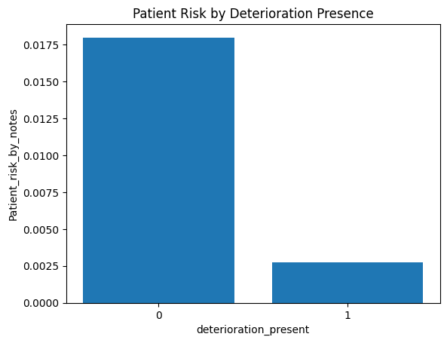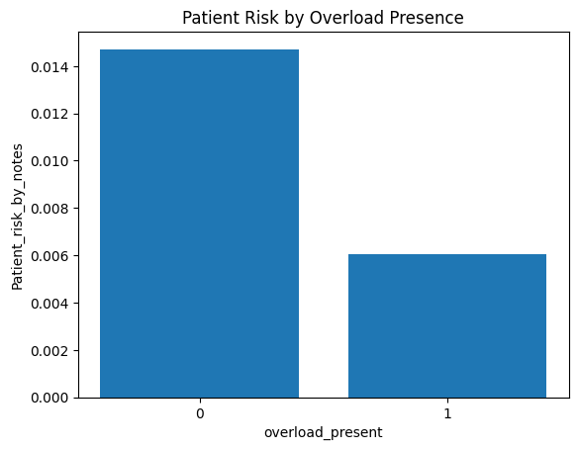
Aggregation table #2
This process was conducted to create descriptive variables for the feature engineering phase to generate insights. This is an NLP case where words that could modify the Y source were used. The word used in this table was “distress” with 1348 counts. The words are from the column note_text, derived from the healthcare_new_merged_table. This aggregation supports the fourth KPI of the capstone, which intends to use information contained in clinical notes, beyond structured data, to predict elevated patient risk. In the aggregation table, distress became binary variables (0/1). N has a range between 1493 and 10641, and Patient_risk_by_notes has a range between 0.007 and 0.012. The chart for overload shows that between 60% and 80%of patients encountering risks have word deterioration in the note.
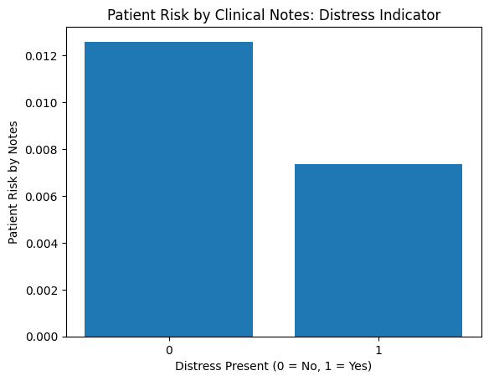

Metric#5
Can we predict whether a patient will experience a longer-than-expected hospital stay based on demographics, clinical history, and treatment patterns?
We are trying to see if yes or no longer_than_expected hospital stay based on demographics, clinical history, and treatment patterns. So, this is a binary classification problem. Target variable would be defined as 0 or 1 and Y will be called “Hospital_stay_based_on_patterns”. The unit of analysis will be the hospital stay and this will be a supervised learning model since Y is defined.
Independent Variables (X): (data_types) (Blue low variability / Red high variability)
Admission_type string 4.30 – 4.59
Department string 4.36- 4.64
Primary_diagnosis_group string 4.03- 5.80
Encounter_severity bigint 3.37 – 5.64
Polypharmacy_flag bigint 4.09-4.95
Opioid_prescribed_flag bigint 4.43-4.49
Region string 4.43-4.60
Bed_count bigint 4.41-4.63
Teaching hospital bigint 4.45-4.50
Avg_patients_per_nurse double 4.41-4.63
Medication_class string 4.34-4.58
Age bigint 3.76- 5.48
Gender string 4.11 – 4.53
Insurance_type string 4.18 – 4.53
Socioeconomic_risk_level string 4.42 – 4.64
Chronic_conditio_count bigint 3.88 – 5.85
Smoker_status string 4.43 – 4.58
avg_heart_rate_bpm float 5.66 – 12
avg_systolic_bp float 6 -12
glucose_mg_dl float 6.63-12
bmi float 4.72 – 10
abnormal_lab_count int 3.91- 5.51

Numerical variables were evaluated based on their variability in relation to the target variable. Variables avg_heart_rate_bpm, avg_systolic_bp , glucose_mg_dl, bmi were selected due to their clinical relevance and meaningful variability.

Dependent target V (Y): (Hospital_stay_based_on_patterns binary 0/1)
Source variable used to derive Y: length_of_stay_days

Aggregation table # 1
X variables:
avg_heart_rate_bpm
avg_systolic_bp
Y variable: Hospital_stay_based_on_patterns
This process was conducted to create descriptive variables for the feature engineering phase in order to generate insights. The independent variables used are avg_heart_rate_bpm and avg_systolic_bp, while the dependent variable is Hospital_stay_based_on_patterns, all derived from the healthcare_new_merged_table. This aggregation supports the fifth KPI of the capstone, which intends to predict the probability of hospital stays based on patient demographics, clinical history, and treatment patterns. The variable avg_heart_rate_bpm is a continuous variable with a large range of values. Because of the clinical nature of the variable, and so that it could be used more precisely, it was grouped into the following categories: less than 70 (Low), between 70 and 90 (Normal), between 90 and 110 (Elevated), and above 110 (High). The variable avg_systolic_bp also has a large range of values and therefore needs to be grouped in order to be used. It was grouped using clinical classifications: less than 90 (Low), between 90 and 120 (Normal), between 120 and 130 (Elevated), between 130 and 140 (Hypertension_1), and anything above 140 (High). One chart per X variable was created. The Heart Rate Range chart shows that while patients in the low heart rate range stay in the hospital less than 6 days on average, the other three classifications may experience average stays longer than 10 days, depending on other medical conditions. In summary, higher heart rate ranges are associated with longer stays in the hospital. The chart for Systolic Blood Pressure Range shows that low pressure has a lower association with longer stays. On average, low-pressure patients stay below 6 days, while the other classifications show average stays above 10 days, depending on other patients’ conditions. In conclusion, high blood pressure ranges are strongly associated with longer stays.
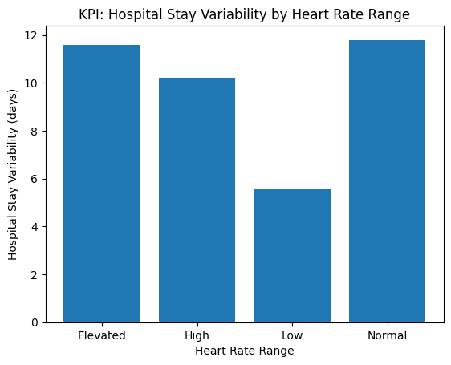
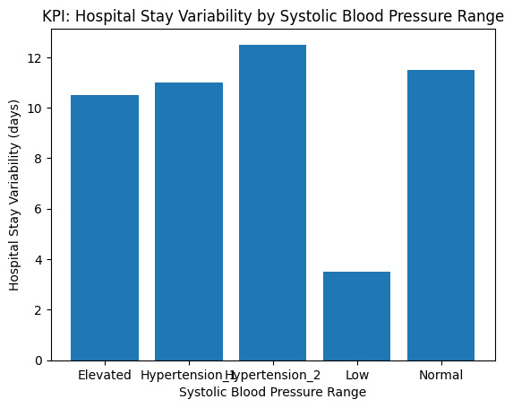

Aggregation table # 2
X variables:
glucose_mg_dl
bmi
Y variable: Hospital_stay_based_on_patterns
This process was conducted to create descriptive variables for the feature engineering phase in order to generate insights. The independent variables used are glucose_mg_dl and bmi, while the dependent variable is Hospital_stay_based_on_patterns, all derived from the healthcare_new_merged_table. This aggregation supports the fifth KPI of the capstone, which intends to predict the probability of hospital stays based on patient demographics, clinical history, and treatment patterns. The variable glucose_mg_dl is a continuous variable with a large range of values. Because of the clinical nature of the variable, and so that it could be used more precisely, it was grouped into the following categories: less than 70 (Low), between 70 and 99 (Normal), between 100 and 125 (Prediabetes / Elevated), and above 125 (High). The variable bmi also has a large range of values and therefore needs to be grouped in order to be used. It was grouped using clinical classifications: less than 18.5 (Low), between 18.5 and 24.9 (Normal weight), between 25 and 29.9 (Overweight), and anything above 29.9 (Obese). One chart per X variable was created. The BMI chart shows that this variable is related to longer stays since all BMI classifications have an average stay of longer than 10 days, depending on other patient conditions, with the obese classification being the one most associated with longer stays. The glucose chart shows a more evident pattern. Patients with high glucose levels have a stronger relationship with longer stays, with an average of 14 days, while those with the lowest glucose levels have an average stay below 6 days. In summary, for the glucose chart, besides the low classification, the other three classifications show a higher relationship with longer hospital stays, with averages above 10 days.

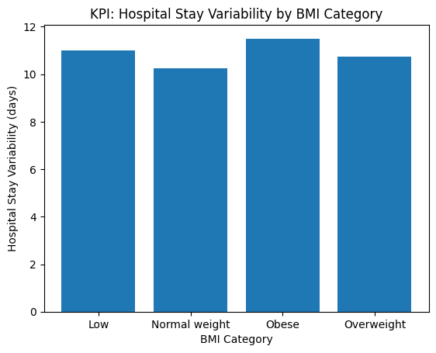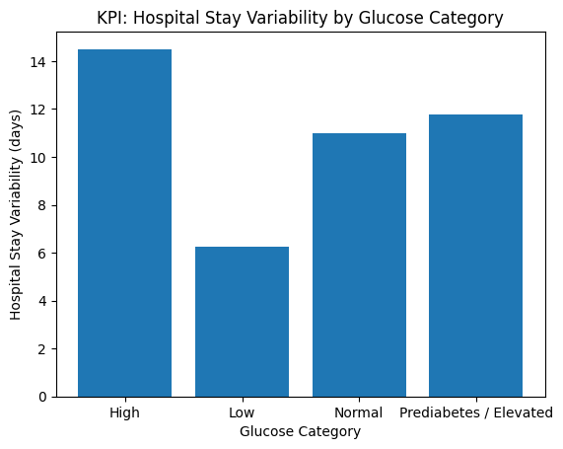

Metric # 6
- Can we build a risk-adjusted model of patient outcomes to identify facilities whose performance deviates from expected predictions?

This question tries to find facilities performance deviated from expected predictions based on patients’ outcomes. This is also a binary classification problem with a 0 or 1 output where Y will be called “Facilities_p_by_outcomes”. We are trying to analyze the facilities, so that should be the unit of analysis. This will be a learning supervised modeling since Y is defined.
Independent Variables (X): (Blue low variability / Red high variability)
Department min = 0.58 – max 0.51
admission_type min = 0.52 – max = 0.63
primary_diagnosis_group min = 0.50– max = 0.84
encounter_severity 0= 2.95 – 1= 3.60
polypharmacy_flag 0=0.37- 1=0.53
opioid_prescribed_flag 0=0.08 – 1 = 0.08
medication_class min = 0.59 - max = 0.60
age 0= 48.84 – 1= 54.06
gender min = 0.58 – max = 0.61
insurance_type min = 0.56 - max = 0.62
socioeconomic_risk_level min = 0.59- max = 0.60
chronic_condition_count 0= 1.53 – 1= 1.77
smoker_status min = 0.58 – max = 0.60
avg_heart_rate_bpm 0= 96.86 – 1= 101.65
avg_systolic_bp 0= 136.94 – 1= 140.29
glucose_mg_dl 0= 136.55– 1= 138.25
bmi 0= 27.97 – 1= 27.81
abnormal_lab_count 0= 3.75 – 1= 5.00
Région min = 0.58– max = 0.61
bed_count 0= 375.0– 1= 374.9
teaching_hospital 0= 0.622– 1= 0.616
avg_patients_per_nurse 0= 4.72– 1= 4.755

source variable used to derive Y: adverse_outcome_flag.
Target variable (Y): Facilities_p_by_outcomes.

Aggregation table #1

X variables:
encounter_severity
avg_heart_rate_bpm
Y variable: Facilities_p_by_outcomes.
This process was conducted to create descriptive variables for the feature engineering phase in order to generate insights. The independent variables used are encounter_severity and avg_heart_rate_bpm, while the dependent variable is Facilities_p_by_outcomes, all derived from the healthcare_new_merged_table. This aggregation supports the sixth KPI of the capstone, which intends to build a risk-adjusted model of patient outcomes to identify facilities whose performance deviates from expected predictions. The variable encounter_severity is a discrete variable with five values ranging from 1 to 5. The second variable, avg_heart_rate_bpm, is a continuous clinical variable with several values and needed to be grouped by clinical ranges in order to be used. In this case, the clinical ranges are below 70 (Low), between 70 and 90 (Normal), between 90 and 110 (Elevated), and above 110 (High). One chart per X variable was created. The chart for encounter_severity shows that severity levels 4 and 5, the highest levels, have 80% or more facility performance by outcome, while the other three levels 1, 2, and 3 show a lower relationship with facility performance by outcome, below 50%. The heart rate range chart shows higher heart rate ranges tend to show higher outcome probabilities

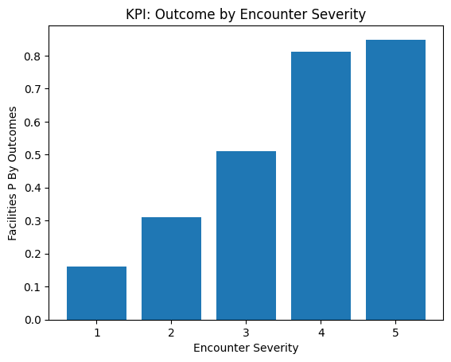
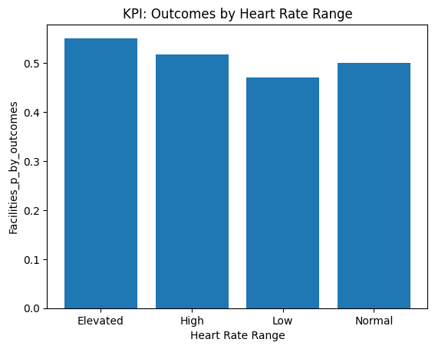

Aggregation table #2

X variables:
Primary_diagnosis_group
age
Y variable: Facilities_p_by_outcomes.
This process was conducted to create descriptive variables for the feature engineering phase to generate insights. The independent variables used are primary_diagnosis_group and age, while the dependent variable is Facilities_p_by_outcomes, all derived from the healthcare_new_merged_table. This aggregation supports the sixth KPI of the capstone, which intends to build a risk-adjusted model of patient outcomes to identify facilities whose performance deviates from expected predictions. The variable primary_diagnosis_group is a discrete variable with 10 categories representing CHF, COPD, Cancer, Diabetes, Fracture, Kidney Disease, Other, Pneumonia, Sepsis, and Stroke. The second variable, age, is a continuous clinical variable with several values and needs to be grouped into clinical ranges in order to be used. In this case, the clinical ranges are 0–17 (Pediatric), 18–44 (Young Adult), 45–64 (Middle-aged), 65–74 (Older Adult), and 75+ (Elderly). One chart per X variable was created. The chart for primary_diagnosis_group shows that the Sepsis and Stroke groups have the highest relationship with facility performance by outcome, with more than 80%, while the other categories range between 50% and 80%. The age chart shows that the Older Adult and Elderly categories have the highest facility performance by outcome, with over 70%, while Middle-aged and Young Adult groups range between 50% and 70%.