ColorForth 2.0a TUTORIAL

Revision 1.0

02/08/08

This tutorial is designed for users with little or no experience with ColorForth and very limited experience with Forth. It describes how to launch and use some of the tools available by walking through examples. It may be helpful to learn some basic editor commands before beginning the tutorial (refer to section 3 of Users’ Guide for ColorForth2 colorForth Human Interface). In the following examples, commands and editor control panel keys are shown in bold while qwerty keys are shown in bold underline.
Warning: While referring to the examples while in the editor command mode, if a single character is in bold it will sometimes represent a control panel command and typing the qwerty character will not produce the expected result. For example the editor command l (left ) is mapped to the qwerty key j. This may sound a little confusing but will become clear after doing a few examples.
Below is a copy of the editor command mode key mapping taken from the Users’ Guide for ColorForth2. The commands appear in the lower right corner of the screen while in editor command mode.
Q | W  S | E  C | R  t |  | U  y | I  r | O  g | P  *
A | S  d | D  f | F  j |  | J  l | K  u | L  d | ;  r
Z | X | C | V | N  x | M  - | ,  m | .  c | /  +
 |  |  |  | space  . |  | alt  i

ColorForth configuration
The following examples show how to use the interpreter, editor, and some configuration utilities. The colorForth editor is a modal edtitor consisting of a command mode and text entry modes for several colors of text.

First ColorForth function
In Forth, functions are referred to as words. For the first example, the word “2 3 +” will be entered. If a typing mistake is made while in the editor, backspace will remove the text currently being typed. To remove text that has already been entered into a block the editor command, x (mapped to n), is used. For more editor commands refer to section 3 of the Users’ Guide for ColorForth2. While in the interpreter, backspace will remove the current text and c can be used to clear the stack if too much debris collects at the bottom of the screen.
Enter the editor.
e
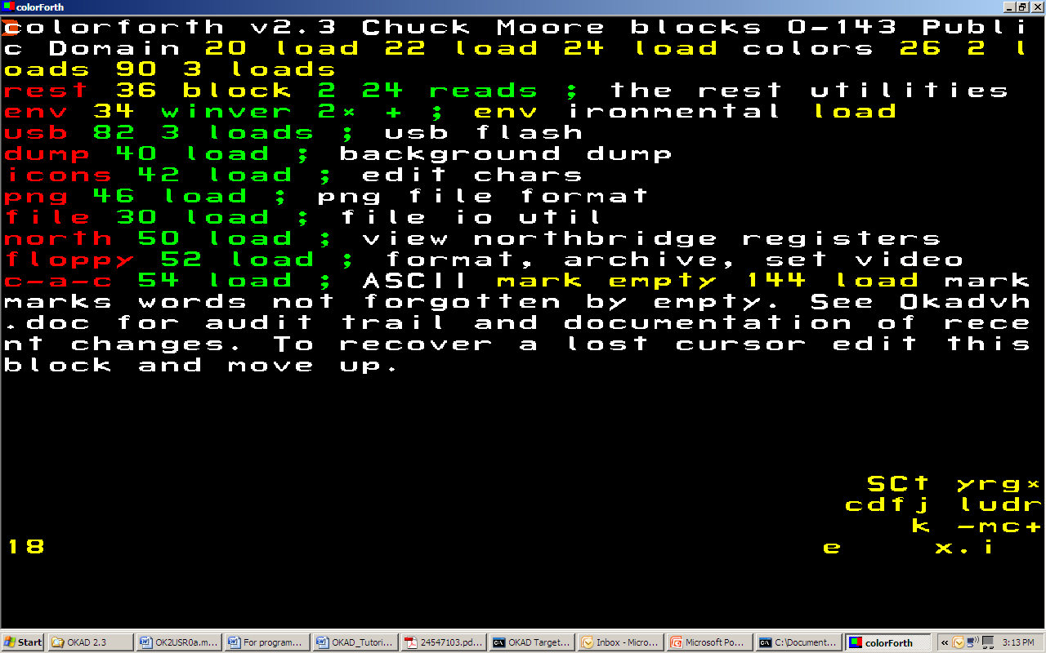
Block 18 is the first block loaded when OKAD is launched. It is also the block that comes up in the editor when no block number is specified. The 18 in the lower left hand corner of the display indicates that the editor is in block 18. The editor control panel map is in the lower right corner and the last word typed, e, is displayed just to the left of the control panel map. The last text entered in interpretive mode will be displayed in the same location.
To search for an empty block, use the forward block command +( mapped to ?). This command is the first character from the right in the third line of the control panel map.
After an empty block is located, select the r (mapped to the i )on the top of the editor control panel to enter a red word. Red is the color used for word names in colorForth. Enter the name of the word.
add
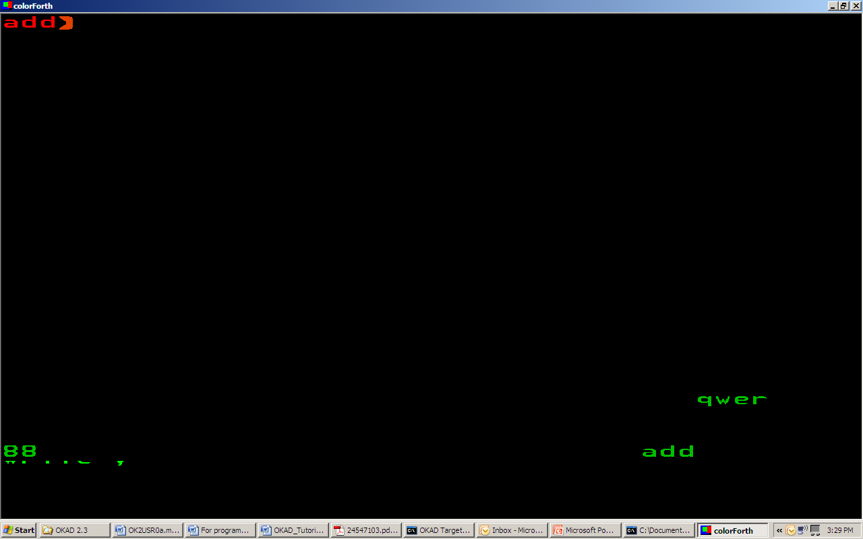
Notice that after the red word is entered the font changes to green. Green is used to call colorForth words and macros.
Enter the equation to be executed when the word is called.
2 3 + ;
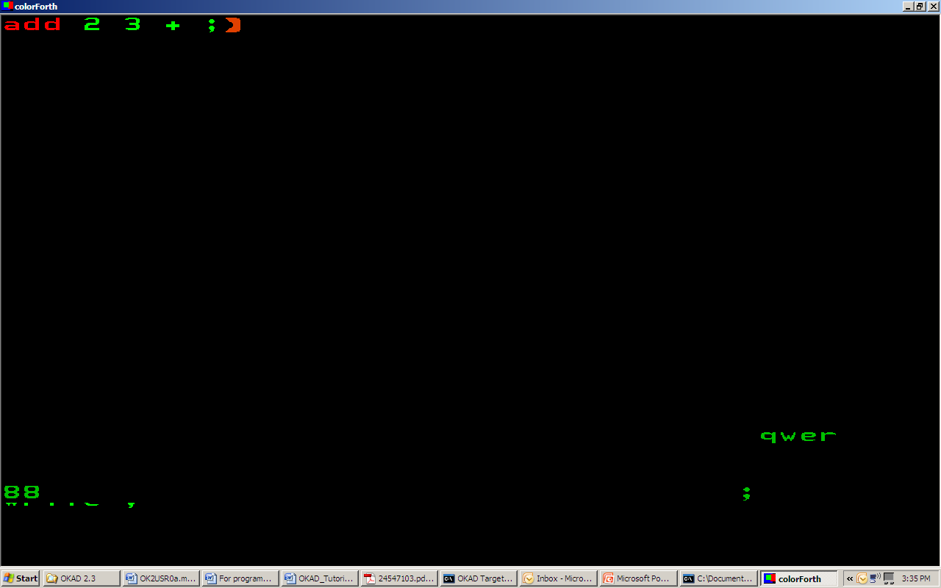
The semicolon is used to end a word. If one is not placed at the end of a word and code exists below, the word will continue to run until a semicolon is reached. If a word has no semicolon at all it will not run. Exit green text entry and return to the editor controls by hitting the escape key.
esc
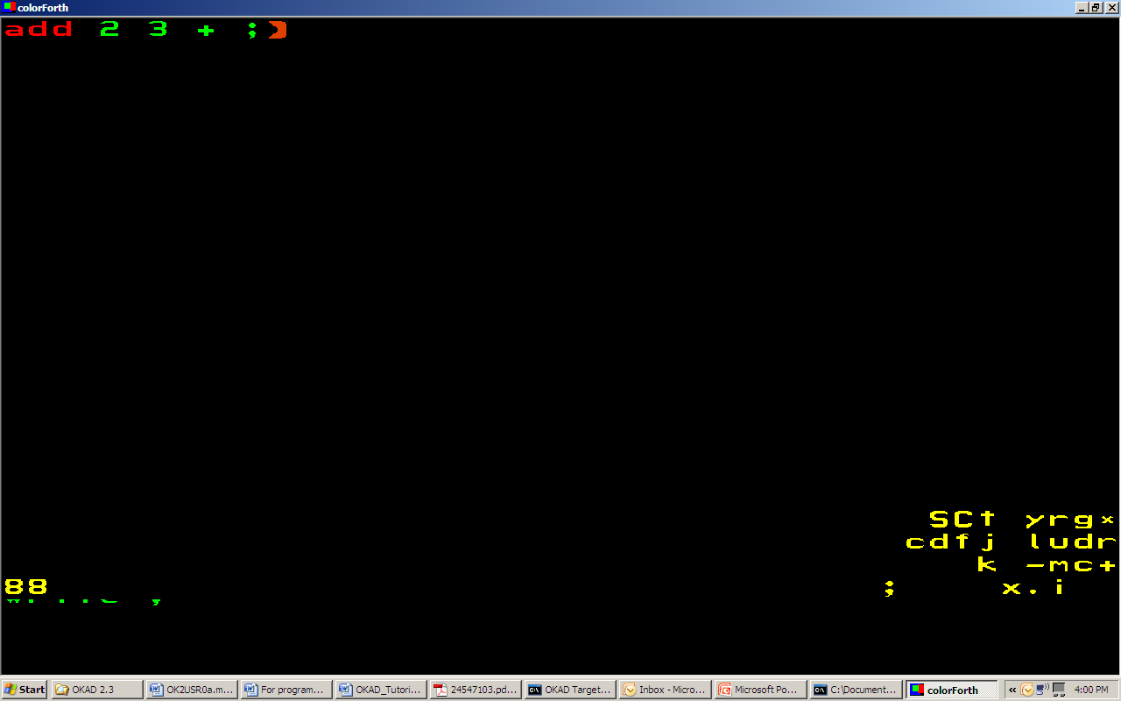
In order to run this word the block that contains the definition must be loaded. Only Forth words from blocks that have been loaded can be run. In this example the word was placed in block 88. Exit the editor and load the block that contains add.
.
88 load
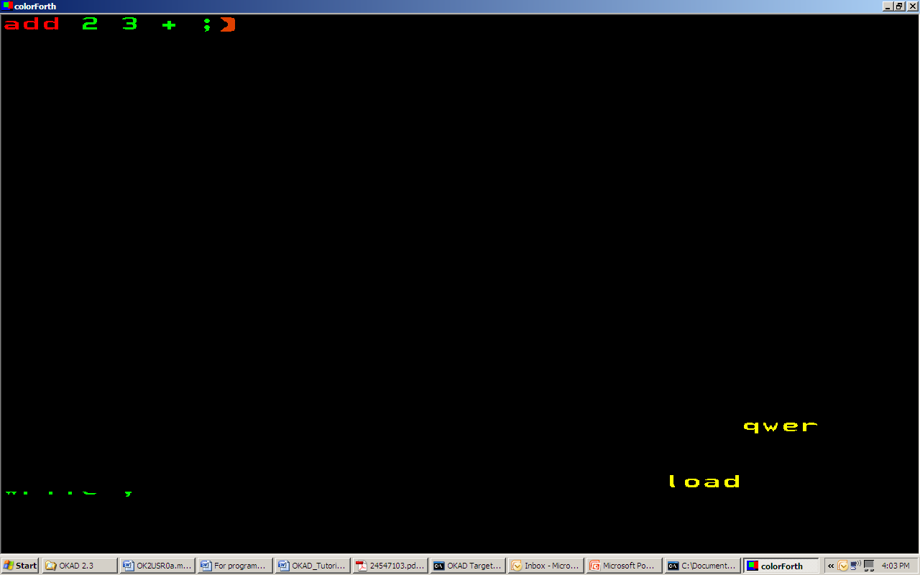
Execute the word.
add
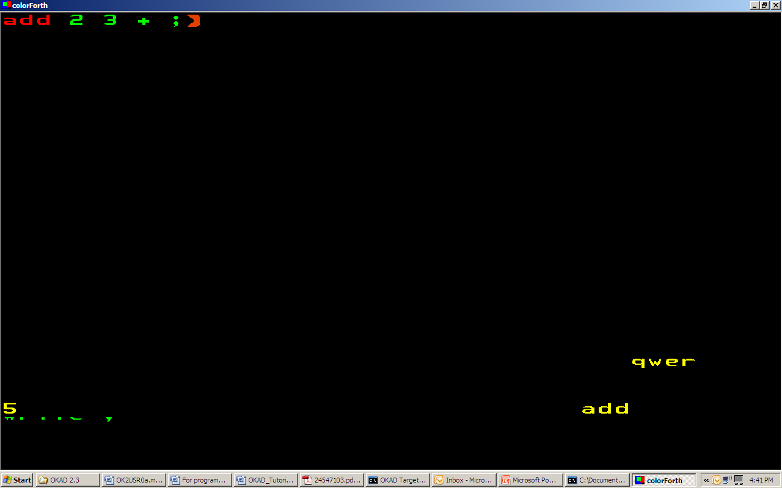
Five appears on the top of the stack in the lower left hand corner.

Accessing memory.
This example shows how to store and retrieve data from memory. In colorForth memory can be accessed by numeric addresses or variable names. ColorForth commands are available to convert blocks and words into cell addresses. A cell is 32 bits long. Variables are displayed as cell addresses as soon as their names are entered on the stack. Magenta is the color used for variable names in colorForth.
An empty block is needed for this example. Use the block from example 1.1 or enter the editor and use + to search for another empty block.
e
+ (until empty block is located.)
Once a block is located select text “t” (mapped to e) from the editor control map. The editor command t will place the editor in white text entry mode. In colorForth white words are comments.
t
vtest
esc
Select magenta and enter 2 variables, var1 and var2.
m
var1
var2
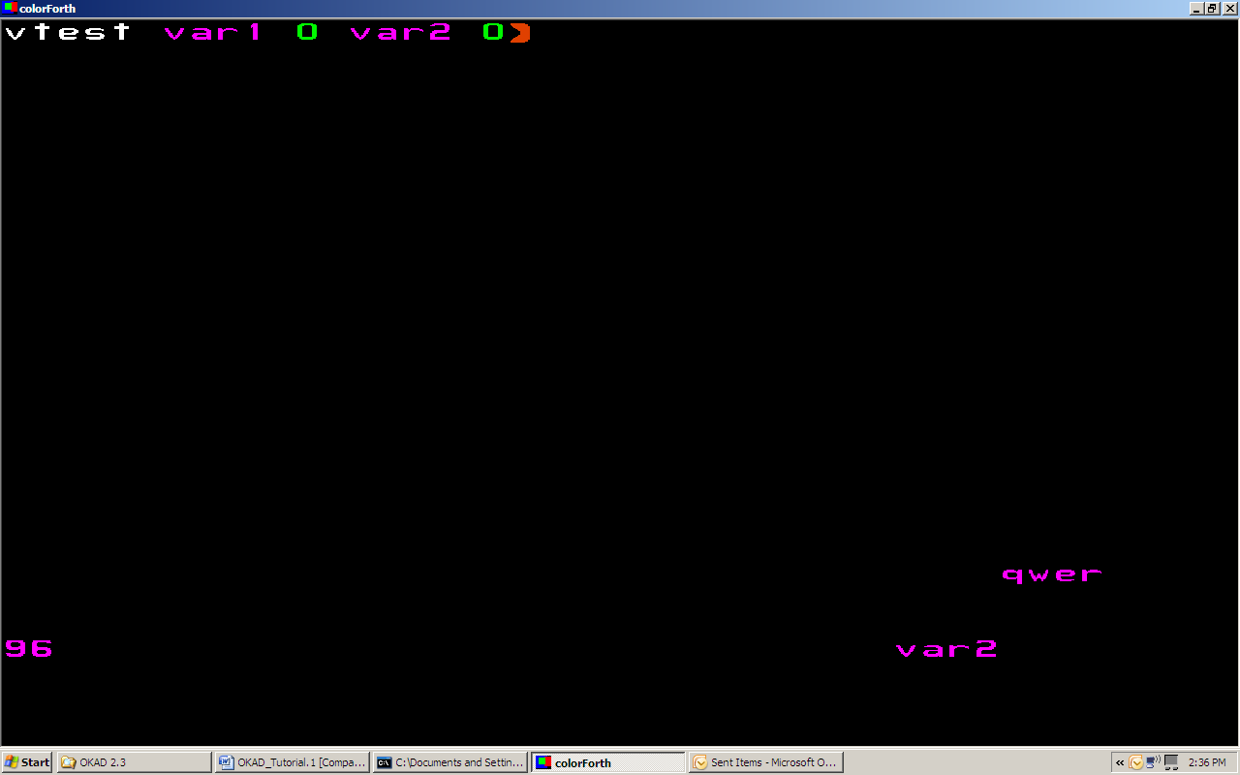
As mentioned in the previous example, the block containing a command or variable must be loaded before the command or variable can be used. If we try to access var1 or var2 without loading the block in which it resides, the variable will not be available. Exit the editor and try to store 28 in var1.
esc
.
28 var1 !
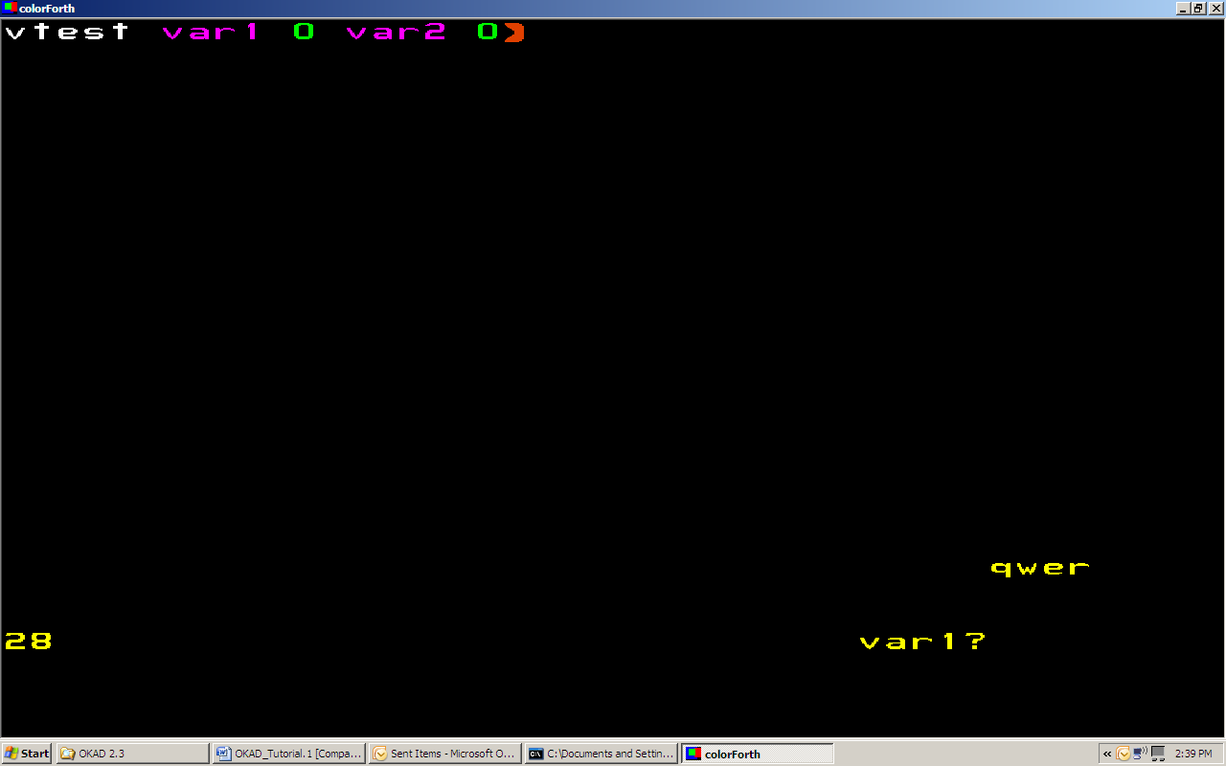
The interpreter will only push valid data onto the stack. “28” is pushed on the stack but “var”1 is not. The question mark following “var1” indicates that it has not been found by the interpreter. This is because block 96 has not been loaded. When “!” is entered a question mark will appear next to it because there is no place to store “28”.
Load the block that contains var1 and var2 and try again. When the name var1 is pushed on the stack, it is converted to a cell address.
96 load
28 var1 !
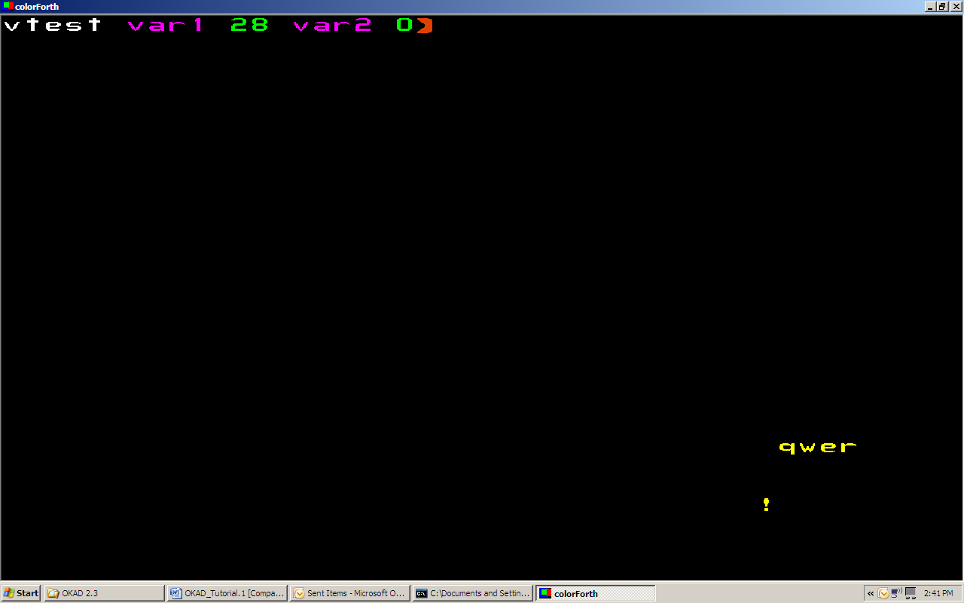
As can be seen on the display var1 now contains the value 28.
The address can be fetched from var1 by accessing the variable directly or using cell offsets.
var1 @
or
96 block 2 + @
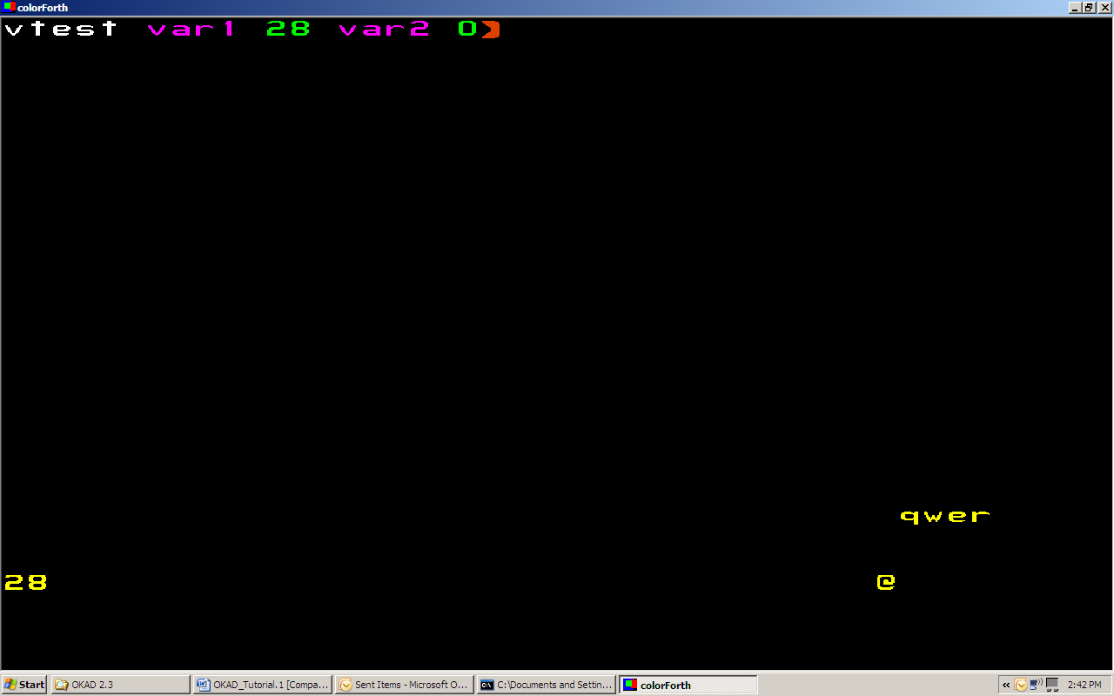
“28” is displayed on the stack in the lower left of the display.
The colorForth command, block converts the block number to a cell address. Two is then added to this memory location and @ fetches the contents of this address. This shows that the value of var1 is stored in the second cell address from the start of the block.
To verify that “96 block 2 +” is var1, both numbers can be displayed on the stack.
96 block 2 + var1
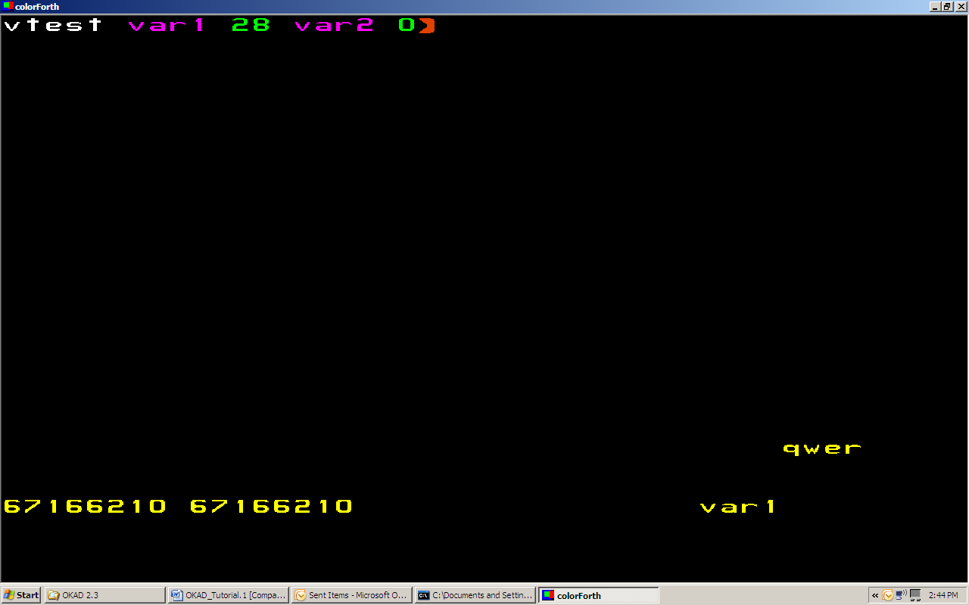
The stack representation in the lower left shows that these locations are identical. You can use similar commands to verify that var2 is two cells past var1.

Loop example (WIP)
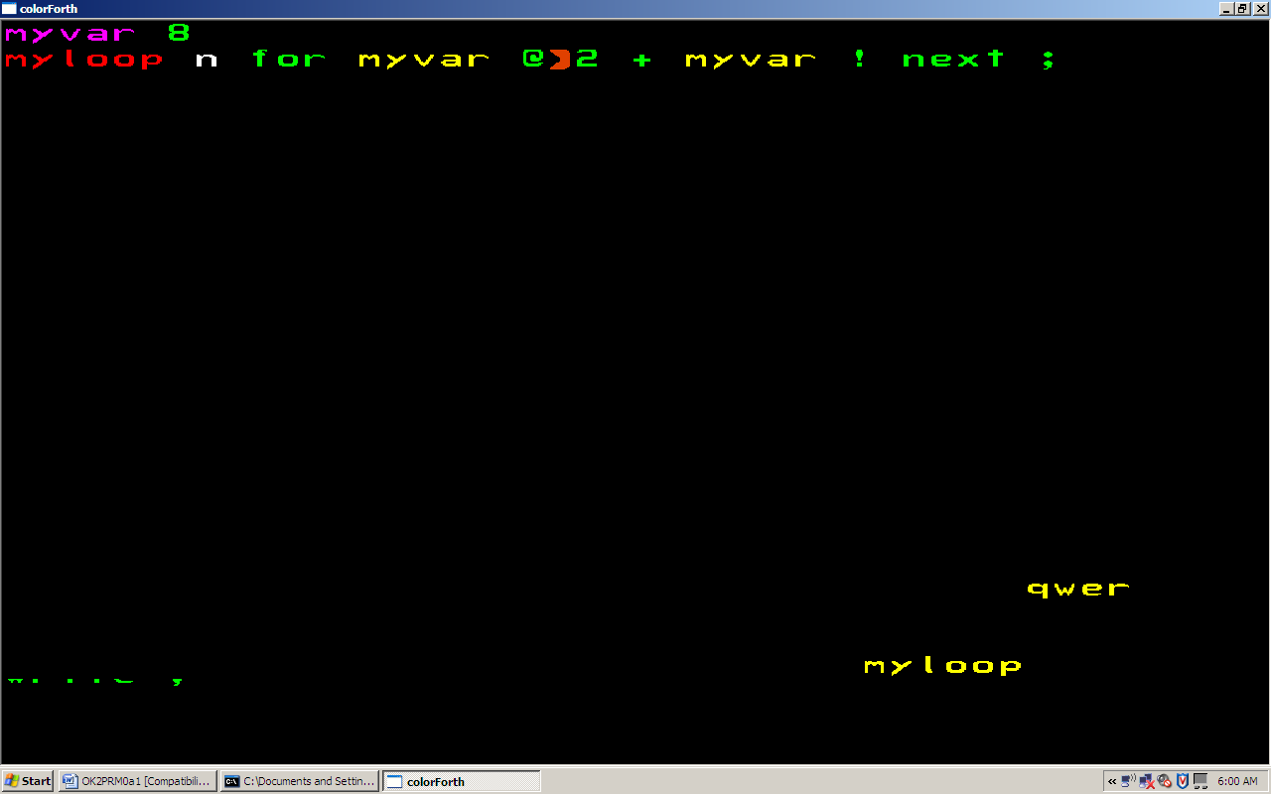
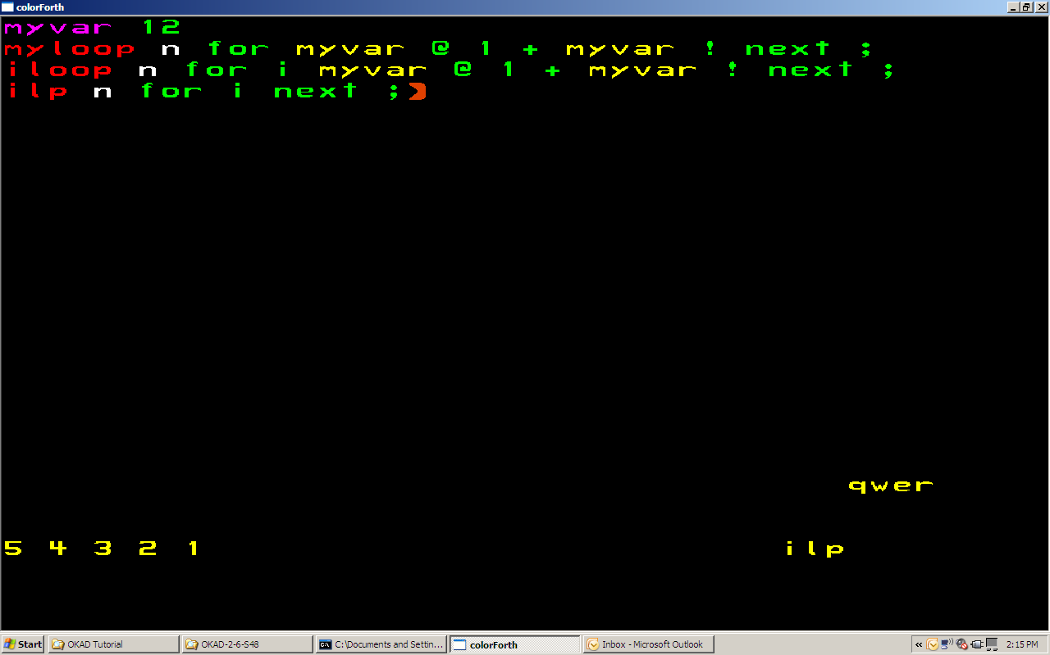

How to modify ColorForth and save the result.
In this example a subtraction word will be written and saved in ColorForth. A load instruction will be placed in block 18 so that the word can be executed whenever ColorForth is launched.
Search for an empty block and enter the following subtraction equation.
sub - 1 + + ;
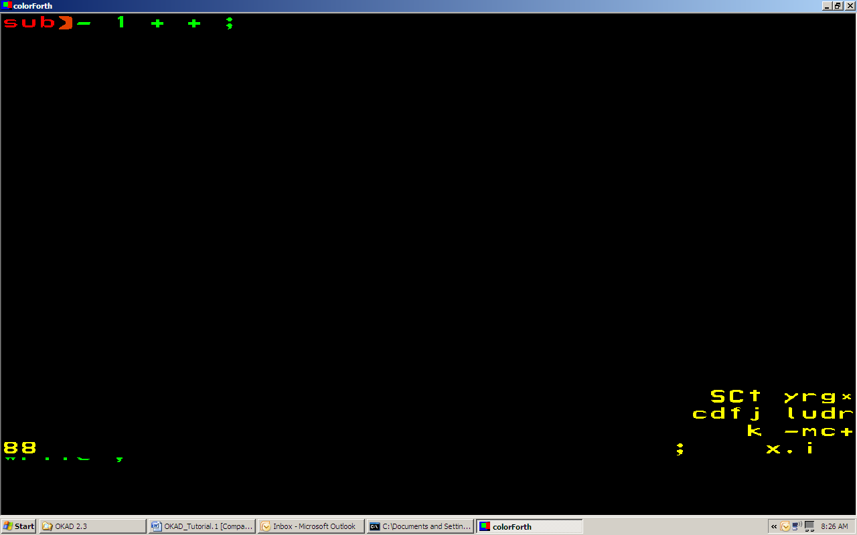
Load the block and test the function.
88 load
4 3 sub
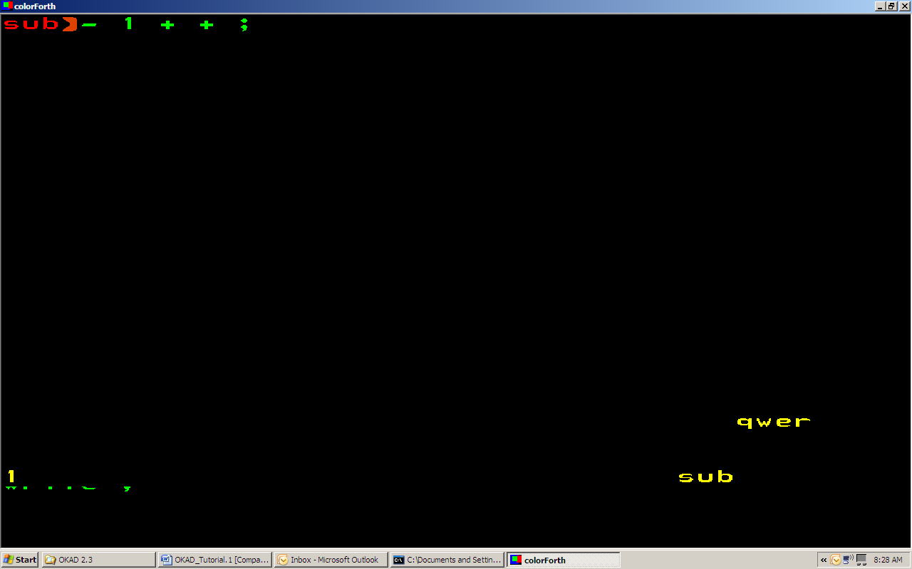
Once you are convinced that the function works save it. If the save command is not executed before closing a ColorForth session, all changes will be lost.
save
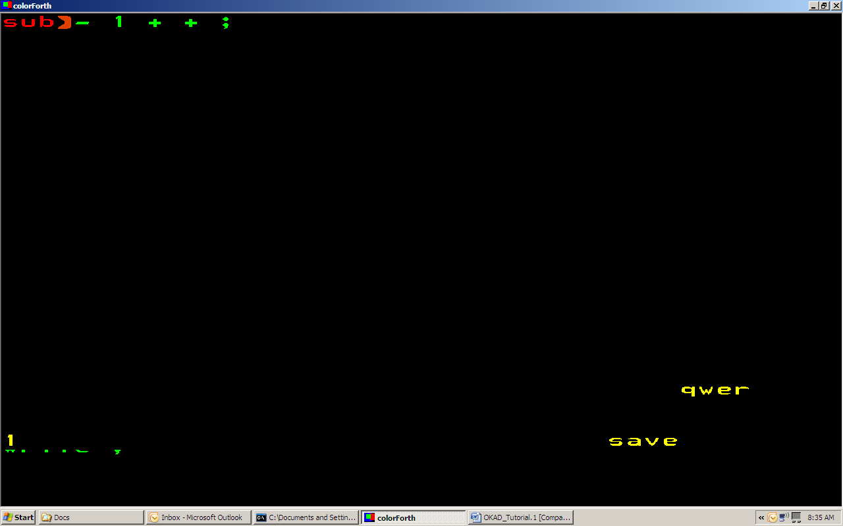
As mentioned in example 1.1, block 18 is the first block that is loaded when ColorForth is launched. To make sub available the next time ColorForth is launched, a load command will be placed in block 18.
Use d and r from the second row of the editor control panel to position the cursor at the end of the block.
18 edit
d (until bottom is reached)
r (until end of line is reached)
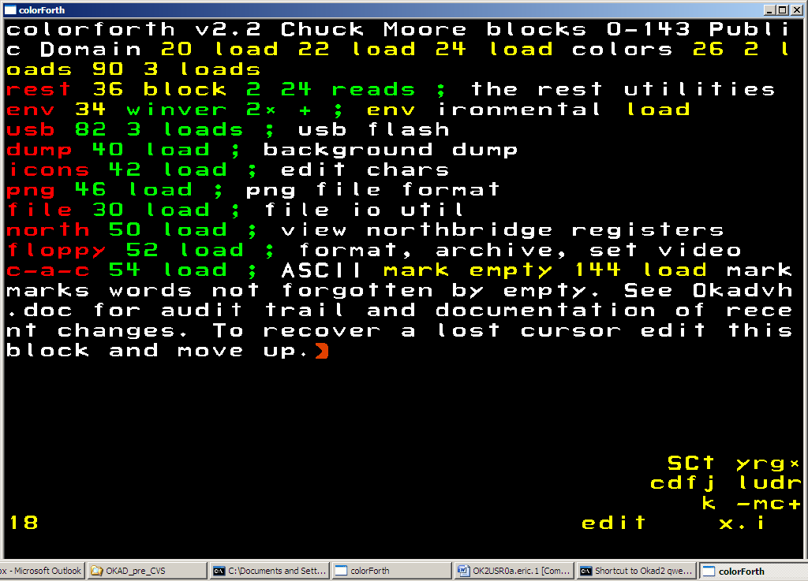
Select y, yellow, from the editor control panel and load the block containing sub.
88 load
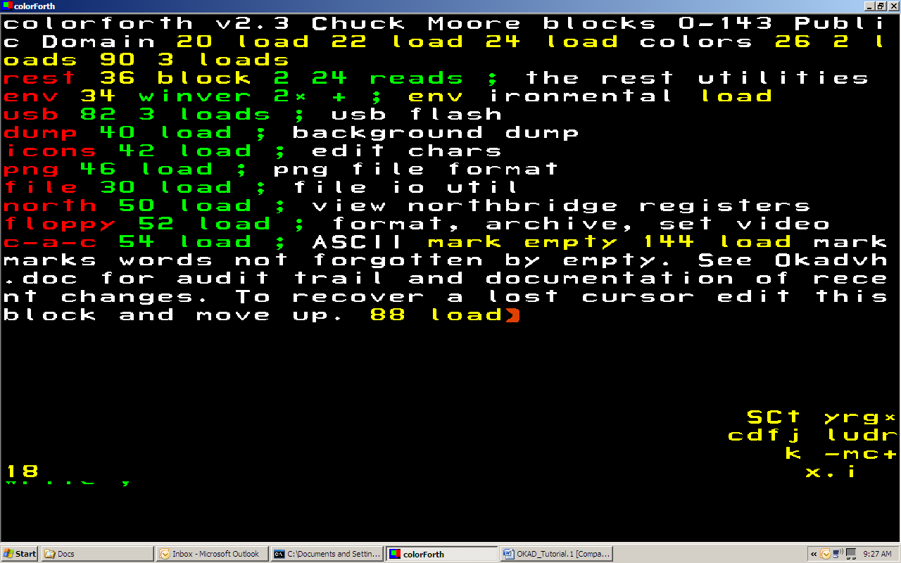
Exit the editor and type save. Exit ColorForth by executing bye. When ColorForth is restarted the sub word will be available.

Verifying changes in source code.
Changes in source code can be verified before they are saved to OkadWork.cf. This is done by comparing code in the current ColorForth session to OkadBack.cf. For this example, begin by backing up the current source.
0 !back
Add comments to three blocks of your choice. 22, 24, and 26 will be used in the example.
edit 22
d and l (until end of block)
C
change1
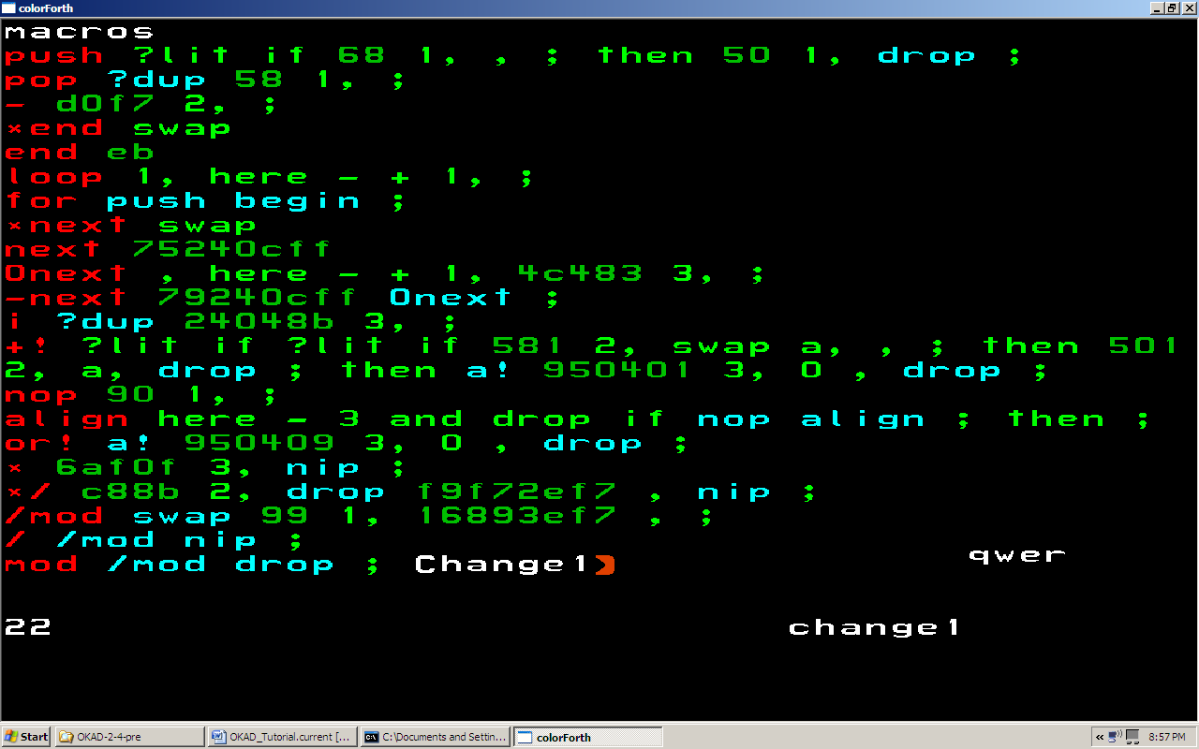
esc
Continue to make similar changes to the next two blocks.
+
d and l (until end of block)
C
change2
esc
+
d and l (until end of block)
C
Change3
esc
. (exit the editor)
The changes made to ColorForth can now be compared to the backup. Load the disking utility at block 120 and use the check function to find changes.
120 load
check
all
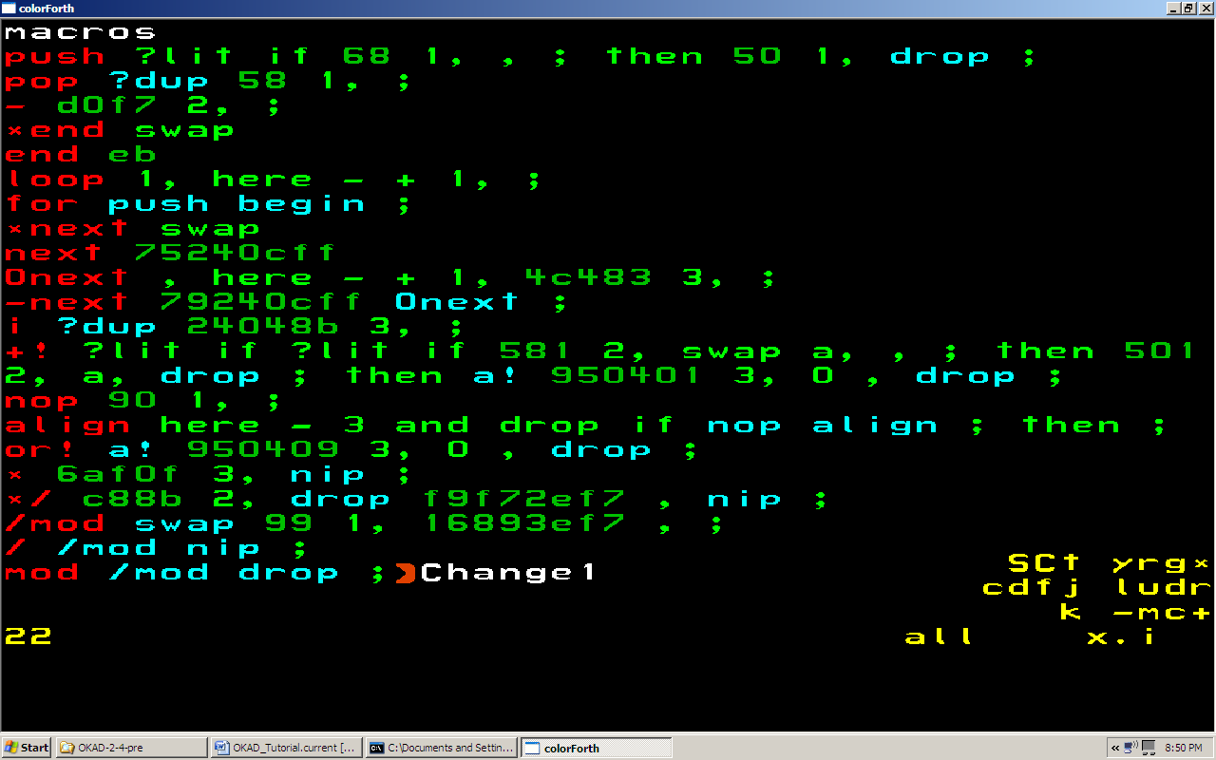
To compare differences, select j from the control panel. This will toggle between the current block and the current block + 3000 where the backed up version of the current block is stored. Exit the editor and proceed to the next change by using the g command. This command will bring up the editor again. To view the change, select j from the editor control panel. When the last change is reached the g command will not advance or enter the editor.
j
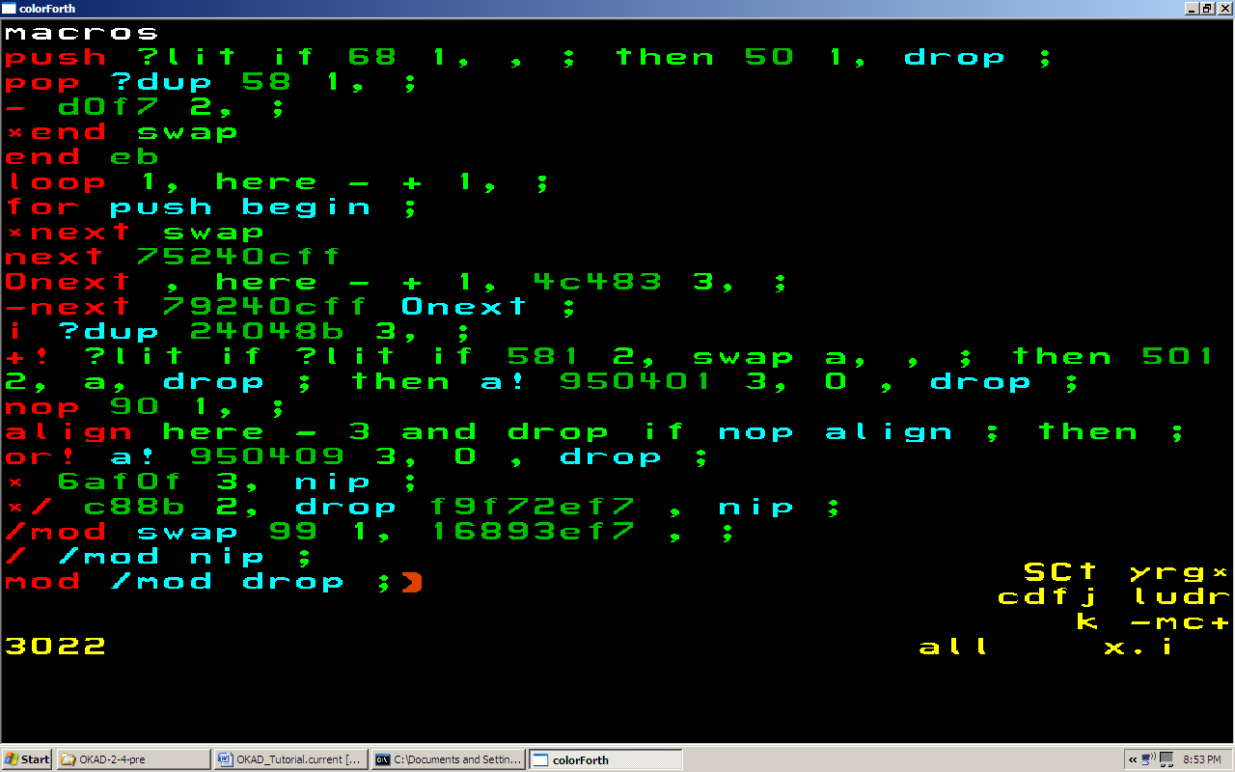
.
g
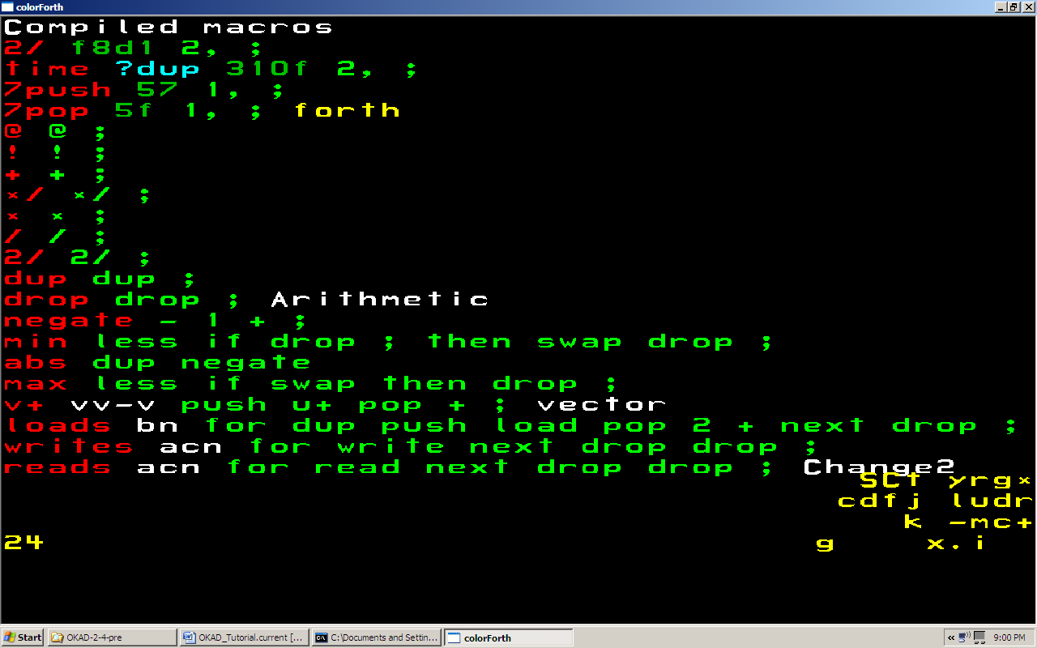
j
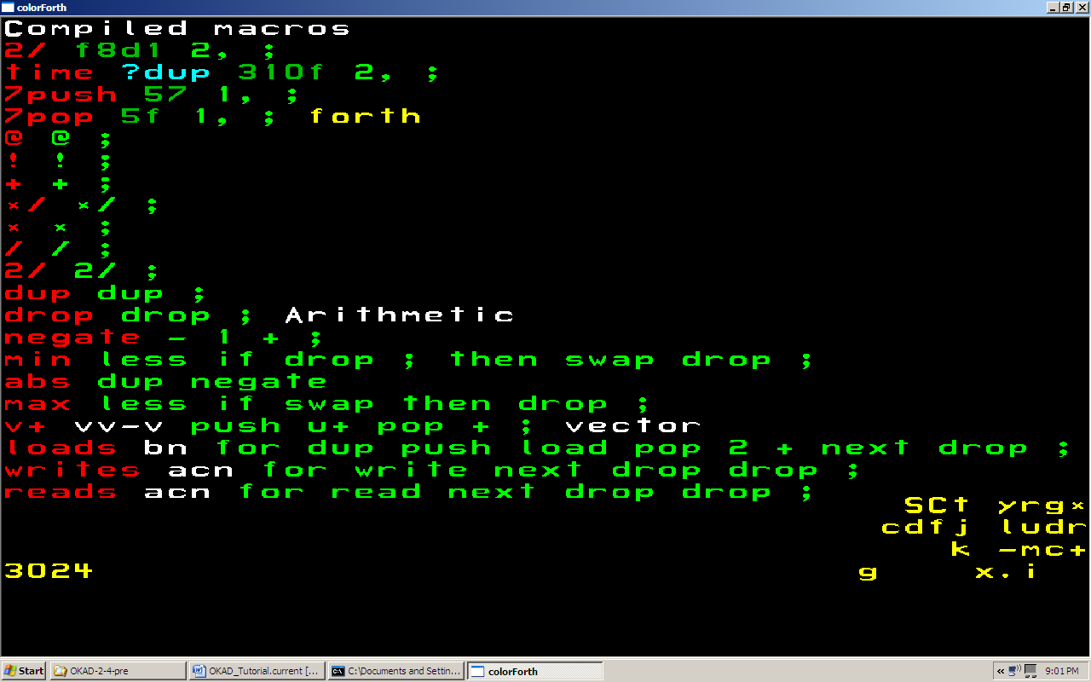
.
g
j
.
g
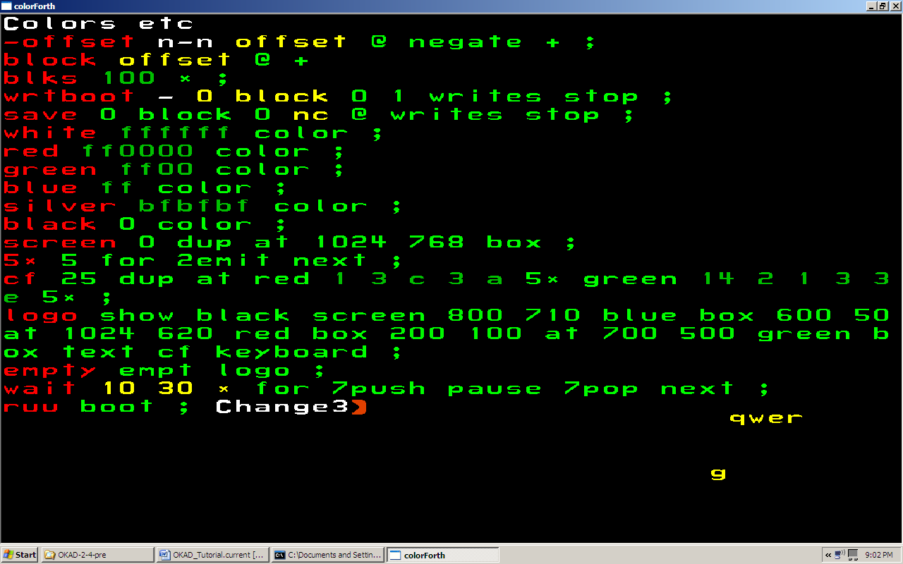
The changes have all been verified.

