**Test Results**

**I. Test Summary:**

The testing was as follows. I first created good graphs and then followed up with created graphs with errors and seeing how they handled the errors. What follows are first the successful runs with the console output and any and all graphic output. The GUI output results if multiple windows would overlap one another. So make sure to drag the resultant window of the run away so you can see the initial graph. One other thing I think it has something to do with the GUI Framework I used but it was difficult to not have the Edge labels in the center of the Edge so it is alittle un-readable.

**II. Test Run dijkstra_graph.xml (Successful run):**

Running “java test.Driver dijkstra_graph.xml” output to console:

Vertices:D,E,F,A,B,C

Edges:(D) ---- 6 ----> (E)

[D,E] (E) ---- 2 ----> (F)

[E,F] (C) ---- 3 ----> (D)

[C,D] (B) ---- 8 ----> (C)

[B,C] (B) ---- 6 ----> (D)

[B,D] (A) ---- 5 ----> (D)

[A,D] (A) ---- 6 ----> (F)

[A,F] (A) ---- 2 ----> (B)

[A,B] (D) ---- 7 ----> (F)

[D,F]

The shortest unweighted path from s = A to t = E is:

[(A) ---- 5 ----> (D), (D) ---- 6 ----> (E) ]

The shortest weighted path from s = A to t = E is:

[(A) ---- 5 ----> (D), (D) ---- 6 ----> (E) ]

The length of the path is: 11.0

Initial Dijkstra's Graph:

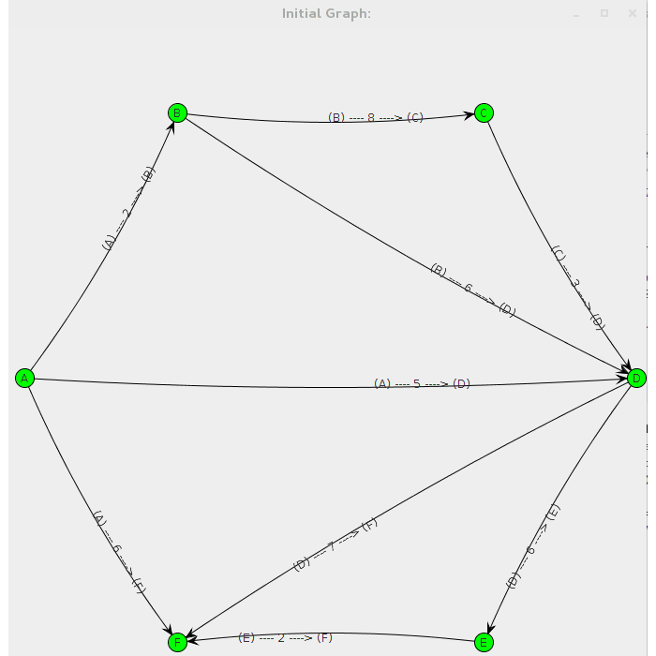

Result of Dijkstra's Graph is:

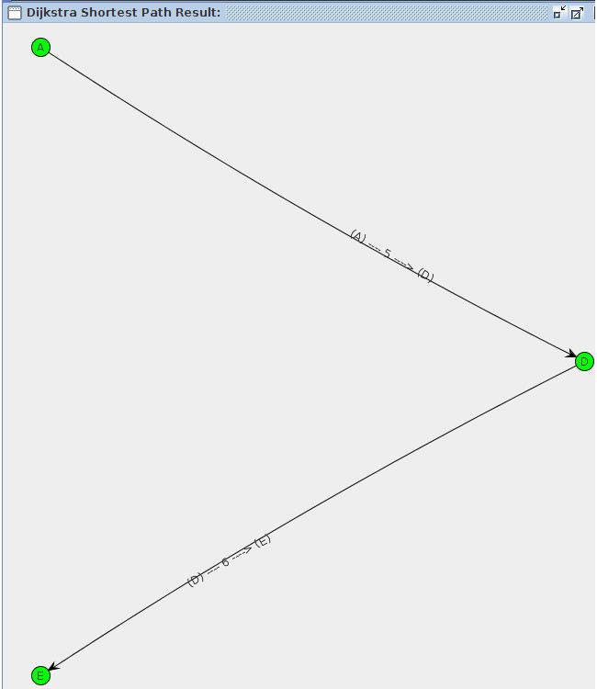

**III. Test Run edmondKarp_graph.xml (Somewhat Successful run):**

The problem faced with the Edmonds-Karp test was that on the result it would not calculate the maximum flow correctly. It would yeild the correct max_flow, however the graph result is not fully correct. The result I should have got was a max flow of 2000, either picking A → B → D for a total of 2000, or A → C → D for 2000 being 1000. The graph resulting in the maximum flow isn't correct. It shows null values for return, which I don't know if it was from the residual capacity creating a return edge which wasn't initialized therefore being (null) → (null) for all return edges.

Running “java test.Driver edmondKarp_graph.xml” console output:

Vertices:D,A,B,C

Edges:(B) ---- 1000 ----> (D)

[B,D] (C) ---- 1000 ----> (D)

[C,D] (A) ---- 1000 ----> (C)

[A,C] (B) ---- 1 ----> (C)

[B,C] (A) ---- 1000 ----> (B)

[A,B]

The max flow is: 2000

The max flow graph is: Vertices:D,A,B,C

Edges:(null) ---- 0 ----> (null)

[B,A] (null) ---- 0 ----> (null)

[C,B] (null) ---- 0 ----> (null)

[D,C] (B) ---- 1000 ----> (D)

[B,D] (C) ---- 1000 ----> (D)

[C,D] (A) ---- 1000 ----> (C)

[A,C] (null) ---- 0 ----> (null)

[C,A] (A) ---- 1000 ----> (B)

[A,B] (B) ---- 1 ----> (C)

[B,C] (null) ---- 0 ----> (null)

[D,B]

The min cut is: [(A) ---- 1000 ----> (C),

(A) ---- 1000 ----> (B)]

In the source partition: [A]

In the sink partition: [D, B, C]

Initial Edmonds-Karp Graph:

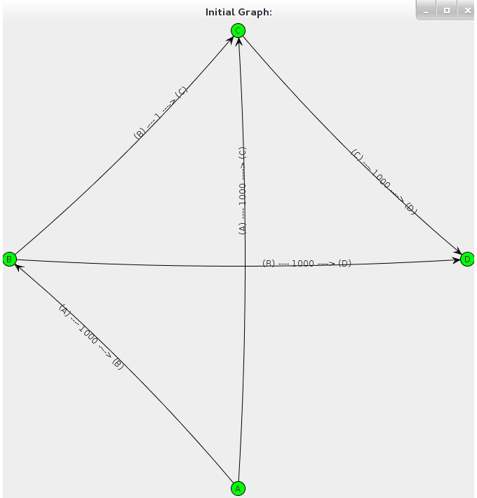

Result Edmonds-Karp Graph:

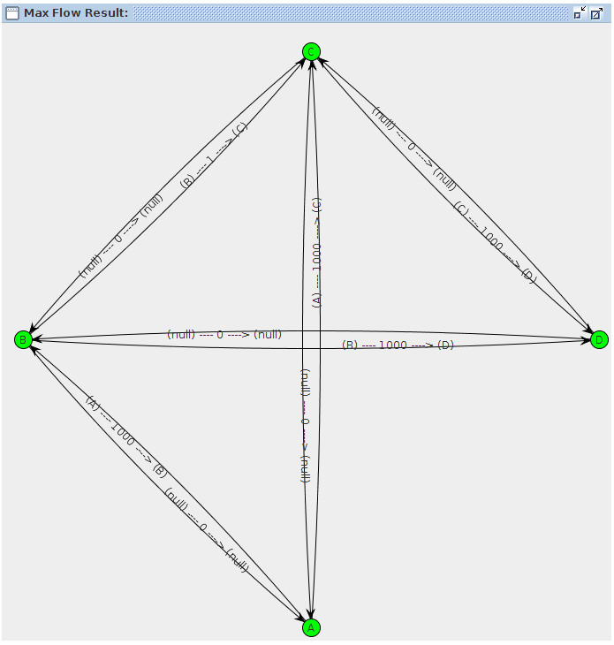

**IV. Unsuccessful Runs**

A. Unsuccessful run with no workspace tag in XML input file.

line 6:2 mismatched input 'graph' expecting 'workspace'

B. Unsuccessful run with random text in XML input file.

line 5:0 mismatched input 'Shortest' expecting '<'

line 15:4 mismatched input 'vertices' expecting 'workspace'

Exception in thread "main" java.lang.NullPointerException

at parser.GrapherExtendBaseListener.exitGraph(GrapherExtendBaseListener.java:108)

at parser.GrapherParser$GraphContext.exitRule(GrapherParser.java:124)

at org.antlr.v4.runtime.tree.ParseTreeWalker.exitRule(ParseTreeWalker.java:71)

at org.antlr.v4.runtime.tree.ParseTreeWalker.walk(ParseTreeWalker.java:54)

at org.antlr.v4.runtime.tree.ParseTreeWalker.walk(ParseTreeWalker.java:52)

at test.Driver.main(Driver.java:35)

C. Unsuccessful run with no s_node but with a t_node in XML input file:

line 74:3 mismatched input 't_node' expecting 's_node'

Exception in thread "main" java.lang.NullPointerException

at parser.GrapherExtendBaseListener.enterT_node(GrapherExtendBaseListener.java:104)

at parser.GrapherParser$T_nodeContext.enterRule(GrapherParser.java:650)

at org.antlr.v4.runtime.tree.ParseTreeWalker.enterRule(ParseTreeWalker.java:66)

at org.antlr.v4.runtime.tree.ParseTreeWalker.walk(ParseTreeWalker.java:49)

at org.antlr.v4.runtime.tree.ParseTreeWalker.walk(ParseTreeWalker.java:52)

at org.antlr.v4.runtime.tree.ParseTreeWalker.walk(ParseTreeWalker.java:52)

at test.Driver.main(Driver.java:35)

D. Unsuccessful Run with random tag in XML input file.

line 72:3 mismatched input 'hello' expecting 's_node'

line 72:12 mismatched input 'hello' expecting 'graph'

line 76:3 mismatched input 'graph' expecting 'workspace'

Exception in thread "main" java.lang.NullPointerException

at parser.GrapherExtendBaseListener.enterT_node(GrapherExtendBaseListener.java:104)

at parser.GrapherParser$T_nodeContext.enterRule(GrapherParser.java:650)

at org.antlr.v4.runtime.tree.ParseTreeWalker.enterRule(ParseTreeWalker.java:66)

at org.antlr.v4.runtime.tree.ParseTreeWalker.walk(ParseTreeWalker.java:49)

at org.antlr.v4.runtime.tree.ParseTreeWalker.walk(ParseTreeWalker.java:52)

at org.antlr.v4.runtime.tree.ParseTreeWalker.walk(ParseTreeWalker.java:52)

at test.Driver.main(Driver.java:35)