**DIT’s Data Base Documentation:**

**Schema:**

This database has been created with 9 tables:

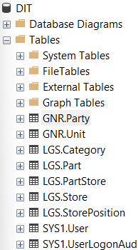

1. GNR. Party
2. GNR.Unit
3. LGS.Category
4. LGS.Part
5. LGS.Partstore
6. LGS.Store
7. LGS.StorePosition
8. SYS1.User
9. SYS1.UserLogonAudit

Use schema_name to specifies our tables

GNR: General

SYS1: System

* I use “SYS1” instead of “SYS” because SQL Server uses “SYS”.

LGS: Logistic

I use these “schema_name” base on my previous knowledge. On this way we can specifies our modules in the future (if this project become complete in the future) such as Logistics, Human Capital Management/Human resources (HCM), Supplementary logistics services (SLS), Procurement (PRC), Finance (FIN) and etc.

*Default of schema name is “dbo.”

**Tables:**

Each table has a Primary_key and Foreign_key.

*Primary_key:

A primary key is a designated attribute (column) that can reliably identify and distinguish between each individual record in a table.

* Foreign_key:

A foreign key is a column or group of columns in a relational database table that provides a link between data in two tables.

With the help of these to keys we can connect tables.

**GNR. Party:**

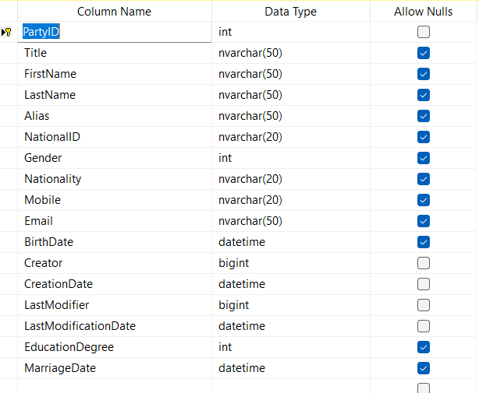We use this table to create

persons/companies.

we define persons/companies once and

use them in other modules and tables such

as SYS1.User, Human resource modules

as Employee, Purchasing modules as

Vendors, or Sales Modules as Customers

Title:

Mr/Mrs/Miss

**GNR.Unit**

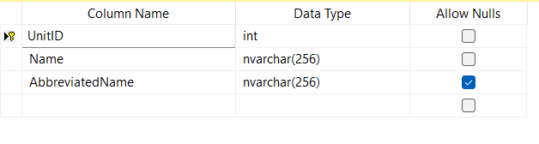We use this table to define Unit of measurement.

I separate this table because we can define

Units once and use them in different Modules

such as logistics Part table, purchasing for define services.

Name:

Kg, gr, Liter, Hours, person-hour, and etc.

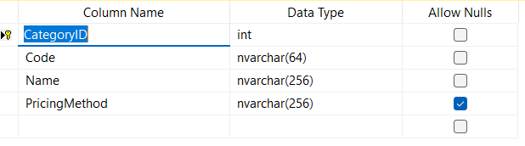**LGS.Category**

We use this table to categorize our goods

(in our data base named LGS.Part).

Such as Mechanical, Electrical, Assets,

Raw Material, and etc.

Purpose of defining category is to use

it for Pricing goods in the warehouse.

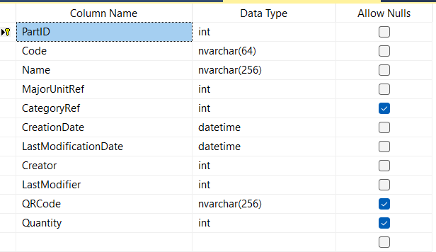**LGS.Part**

We use table to define different kinds of stuff

Such as Cables, Electronic circuit, and etc.

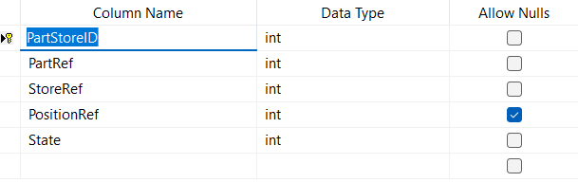**LGS.Partstore**

We use this table to connect Part,

stores and StorePosition together.

**LGS.Store**

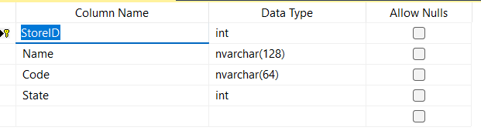we use this table to define names of our inventory

for example:

Labor1, Labor2, Labor3, and etc.

**LGS.StorePosition**

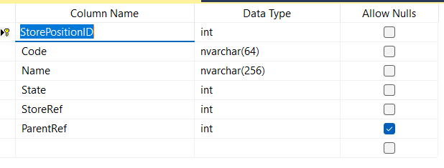We use this table to define the precise position of items.

For example, Cables are placed in

Labor 6, Cabinet 2, second floor

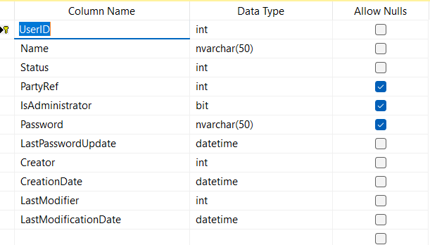**SYS1.User**

We use this table to define the Users who

want to work with the software.

Admin, User1, User2, and etc.

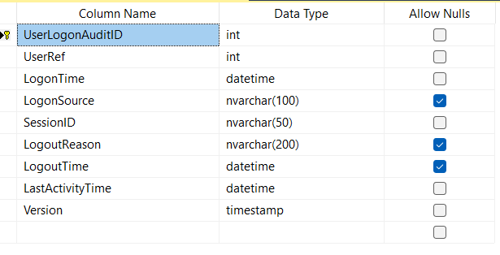**SYS1.UserLogonAudit**

With the help of this table and

SYS1. UserLogonAudit we

can control user access.