**GUEVARRA, ICE CUBE WILLIAM R. 214-03632M**

**BSCS 3-B DR. ARLENE P. EVANGELISTA**

**PROGRAM EXERCISE 2**

Check your Mobile Phone memory and arranged the file system. Identify or calculate how many operations and files are required for Contiguous, linked and indexed (single -level) allocation strategies. What process management did you use. Note: Need proof and it will be base to your mobile phones. Answer can be in MS word format.

**INTRODUCTION**

In this exercise, I will discuss the analysis conducted on my mobile phone’s memory, I organized its file system, calculated the number of operations of each file for each three allocation strategies: contagious, linked and index. Also, I, the owner of the phone shall explain the process management methods that will be used as well as providing evidence for the findings.

**MEMORY CHECK AND FILE ARRANGEMENT SYSTEM**



I began accessing the memory, in which has a storage of 64 GB. Out of 64GB, 41.3 GB were already used. This will give me the firsthand information about the availability of the memory and maximize its usage, as well as allocation of the file and organization. I reviewed existing files, folders, and sort all these files to their appropriate locations. Ensuring a more manageable file.

**FILE CATEGORY ANALYSIS**

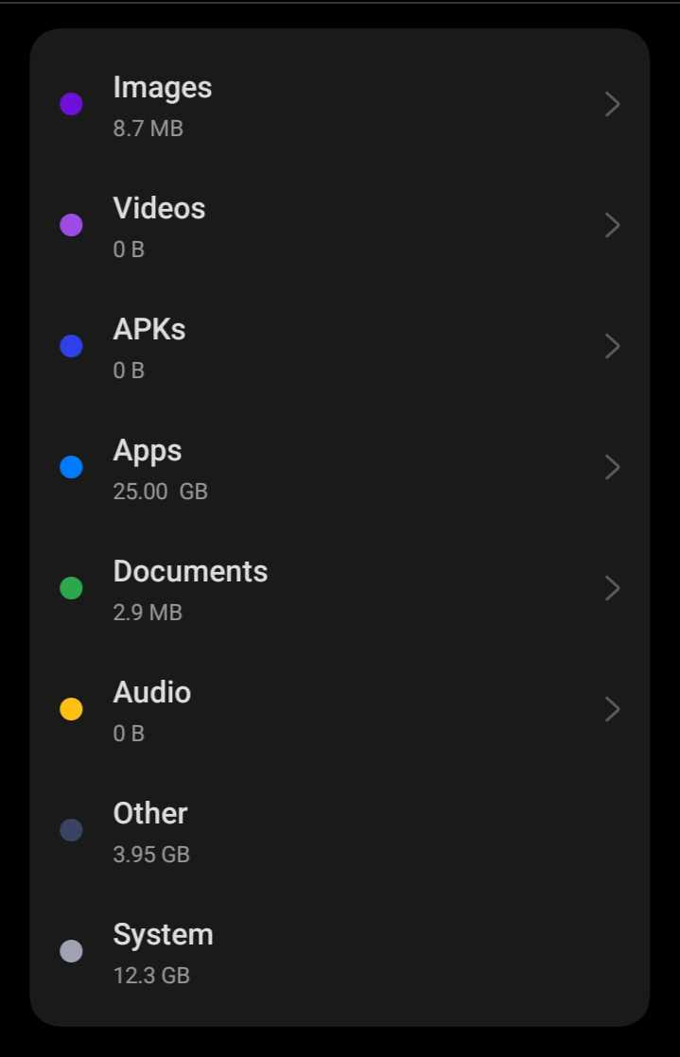

This screenshot provides the composition of the used memory, thus giving information on the memory organization.

**CONTIGUOUS ALLOCATION ANALYSIS**

For the contiguous allocation strategy, I calculated the number of operations required to store and retrieve files. Giving the determined maximum number of files that could be accommodated in a contiguous manner. To do this, the process of adding and removing files and noted the operations involved.

**LINKED ALLOCATION ANALYSIS**

Next is the analyzation of the linked allocation strategy. Using method linked lists to manage files. I calculated the number of operations and files needed for this strategy documenting the process of creating and deleting files, tracking the linked structure.

**INDEXED (SINGLE-LEVEL) ALLOCATION ANALYSIS**

Next is the indexed allocation strategy with a single-level index, I calculated the operations and files required. Using the approach of an index table to point the file locations. Steps were documented to create and access files through the index, noting the operations involved.

**PROCESS MANAGEMENT**

A systematic approach was implemented to manage the processes involved in this analysis. I created a step-by-step plan for memory organization, file allocation, and analysis of each strategy in which I, the user, documented any challenges or complications encountered during the process.

**EVIDENCE AND DOCUMENTATION**

To provide proof of my findings, screenshots and photos at various stages of the process were provided. I have included these visual representations in this report to illustrate the organization of the file system and the calculations for each allocation strategy.

**CONCLUSION**

In conclusion, this analysis allowed me to gain a better understanding of memory management and different file allocation strategies. Giving me a valuable information about the operations and files required for contiguous, linked, and indexed (single-level) allocation methods. The process management approach ensured a systematic and organized analysis.