The flag shall be properly illuminated at night.

**SECTION 7.** The flag shall also be displayed in private buildings and residences or raised in the open flag-staffs in front of said buildings every April 9 (Araw ngKagitingan); May 1 (Labor Day); May 28 (National Flag Day) to June 12 (Independence Day); last Sunday of August (National Heroes Day); November 30 (Bonifacio Day); and December 30 (Rizal Day); and on such other days as may be declared by the President and/or local chief executives. The flag may also be displayed throughout the year in private buildings or offices or raised in the open on flag-staffs in front of private buildings: Provided, that they observe flag-raising ceremonies in accordance with the rules and regulations to be issued by the Office of the President.

**SECTION 8**. All government agencies and instrumentalities, and local government offices, government-owned corporations and local government units are enjoined to observe flag day with appropriate ceremonies. Socio-civic groups, non-government organizations and the private sector are exhorted to cooperate in making the celebrations a success.

**SECTION 9.** The flag shall be flown on merchant ships of Philippine registry of more than one thousand (1000) gross tons and on all naval vessels. On board naval vessels, the flag shall be displayed on the flagstaff at the stern when the ship is at anchor. The Flag shall be hoisted to the gaff at the aftermast when the ship is at sea.

**SECTION 10.** The flag, if flown from a flagpole, shall have its blue field on top in time of peace and the red field on top in time of war; if in a hanging position, the blue field shall be to the right (left of the observer) in time of peace, and the red field to the right (left of the observer) in time of war. The flagpole staff must be straight and slightly tapering at the top.

**SECTION 11.** If planted on the ground, the flagpole shall be at a prominent place and shall be of such height as would give the flag commanding position in relation to the buildings in the vicinity. If attached to a building, the flagpole shall be on top of its roof or anchored on a sill projecting at an angle upward. If on stage or platform or government office, the flag shall be at the left (facing the stage) or the left of the office upon entering.

**SECTION 12**. When the Philippine flag is flown with another flag, the flags, if both are national flags, must be flown on separate staffs of the same height and shall be of equal size. The Philippine flag shall be hoisted first and lowered last. If the other flag is not a national flag, it may be flown in the same lineyard as the Philippine flag but below the latter and it cannot be of greater size than the Philippine flag.

**SECTION 13.** When displayed with another flag, the Philippine flag shall be on the right of the other flag. If there is a line of other flags, the Philippine flag shall be in the middle of the line. When carried in a parade with flags, which are not national flags, the Philippine flag shall be in front of the center of the line.

**SECTION 14.** A flag worn out through wear and tear shall not be thrown away. It shall be solemnly burned to avoid misuse or desecration. The flag shall be replaced immediately when it begins to show signs of wear and tear.

**SECTION 15**. The flag shall be raised at sunrise and lowered at sunset. It shall be on the mast at the start of official’office hours, shall remain flying throughout the day.

**SECTION 16.** The flag may be displayed:

1. Inside or outside-a building or on a stationary flagpoles. If the flag is displayed indoors on a flagpole, it shall be placed at the left of the observer as one enters the room;
2. b. From the top of a flagpole, which shall be at a prominent place or a commanding position in relation to the surrounding buildings;

c. From a staff projecting upward from the window sill, canopy, balcony or facade of a building.

d. In a suspended position from a rope extending from a building to pole erected away from the building;

e. Flat against the wall vertically with the sun and stars on top; and

f. Hanging in a vertical position across a street, with the blue field pointing east, if the road is heading south or north, or pointing north if the road is heading east or west.

The flag shall not be raised when the weather is inclement. If already raised, the flag shall not be lowered.

**SECTION 17.** The flag shall be hoisted to the top briskly and lowered ceremoniously.

The flag shall never touch anything beneath it, such as the ground, flood, water or other objects. After being lowered, the flag shall be handled and folded solemnly as part of the ceremony.

C. Conduct of Flag Raising Ceremony

**SECTION 18.** All government offices and educational institutions shall henceforth observe the flag-raising ceremony every Monday morning and the flag lowering ceremony every Friday afternoon. The ceremony shall be simple and dignified and shall include the playing or singing of the Philippine National Anthem.

**SECTION 19.** The office of the President upon the recommendation of the Institute shall issue rules and regulations for the proper conduct of the flag ceremony.

**SECTION 20**. The observance of the flag ceremony in official or civic gatherings shall be simple and dignified and shall include the playing or singing of the anthem in its original Filipino lyrics and march tempo.

**SECTION 21.** During the flag-raising ceremony, the assembly shall stand in formation racing the flag. At the moment the first note of the anthem is heard, everyone in the premises shall come to attention; moving vehicles shall stop. All persons present shall :.ace their right palms over their chests, those with hats shall uncover, while those in military, scouting, security guard, and citizens military training uniforms shall give :.-.£ salute prescribed by their regulations, which salute shall be completed upon the last note of the anthem.

The assembly shall sing the Philippine national anthem, accompanied by a band, r available, and at the first note, the flag shall be raised briskly. The same procedure shall be observed when the flag is passing in review or in parade.

**SECTION 22**. During the flag lowering, the flag shall be lowered solemnly and slowly so that the flag shall be down the mast at the sound of the last note of the anthem. Those in the assembly shall observe the same deportment or shall observe the same behavior as for the flag-raising ceremony.

D. Half-Mast

**SECTION 23.** The flag shall be flown at half-mast as a sign of mourning on all buildings and places where it is displayed, as provided for in this Act, on the day of official announcement of the death of any of the following officials:

a. The President or a former President, for ten (10) days;

b. The Vice-President, the Chief Justice, the President of the Senate, and the Speaker of the House of Representatives, for seven (7) days; and

c. Other persons to be determined by the Institute, for any period less than seven (7) days.

The flag shall be flown at half-mast on all the buildings and places where the decedent was holding office, on the day of death until the day of interment of an incumbent member of the Supreme Court, the Cabinet, the Senate or the House of Representatives, and such other persons as may be determined by the Institute.

The flag when flown at half-mast shall be first hoisted to the peak for a moment then lowered to the half-mast position. The flag shall again be raised briskly to the peak before it is lowered for the day.

E. Casket

**SECTION 24.** The flag may be used to cover the caskets of the honored dead of the military, veterans of previous wars, national artists, and of civilians who have rendered distinguished service to the nation, as maybe determined by the local government unit concerned. In such cases, the flag shall be placed such that the white triangle shall be at the head and the blue portion shall cover the right side of the caskets. The flag shall not be lowered to the grave or allowed to touch the ground, but shall be folded solemnly and handed over to the heirs of the deceased.

and even ectasy.

**Ecstacy**- etymologically which mean **ex- estasis**, is not just physical but psychological and spiritual experience.

**Human sexuality**- serves both psychologically and spiritually.

**Secondary Sex Characteristics**

Girls usually begin to show physical changes at puberty between the ages of 9-13 which is a little earlier than boys. The female sex hormone and **estrogen** and other hormones causes the physical changes. Many girls are fully develop through age 16, others continue to develop through 18. The following are the stages that female undergoes.

**Stage 1: From ages 8-12**

• No noticeable sign of physical development although the ovaries are enlarging and

hormone production is starting.

**Stage 2: May begin anywhere from ages 8-14.**

• Height and weight increase rapidly. Fine hair growth begins close to the public area and underarm

Sweat and oil glands ( sebaceous and apocrine) become active which may result to acne.

**Stage 3: May start anywhere from ages 9-15.**

• Breasts may become rounder and fuller.

• Hips may start to widen in relation to breast.

• Vagina begins secreting a clear and whitish fluid.

• Public hair become fuller, thicker and curlier.

• Height and weight continue to increase.

• For some girls ovulation and menstruation may begin but may be irregular.

**Stage 4: May begin anywhere from ages 10-16.**

• Underarm hair becomes darker

• Public hair starts to form triangular patch in front and side of the genital area.

The nipple and the dark area around the breast called areola may stick out from the rest of the breast.

• For the girls ovulation and menstruation period begins but may be irregular.

**Stage 5: May start anywhere from ages 12-19.**

• Adult height is already reached.

• Breast development is complete.

• Public hair forms a thick, curly, triangular patch.

• Ovulation and menstrual period occur regularly.

• Overall look is that of a young adult woman.

**Ovulation**

Is the release of eggs from the ovaries.In women, this event occurs when the ovarian follicles rupture and release the secondary oocyte ovarian cells

**Menstraution**

Is the regular discharge of blood and mucosal tissue from the inner lining of the uterus through the vagina.

**Boys** usually begin to show the physical changes at puberty between the ages 11-14, which is slightly later than the girls. The male hormone **testosterone** and other hormones cause the puberty changes. The following are the stages that happen.

**Testosterone**

Male hormone

**Stage 1: Between ages 8-12 .**

• No visible sign of physical development, but hormone production is starting

**Stage 2: May begin anywhere from ages 11-13.**

•Height and weight increase rapidly.

• Testicles become larger and scrotum hangs lower.

• Scrotum becomes darker in color.

• Fine hair growth starts at the base of the penis.

• Hair growth may begin on the legs and underarms.

**Stage 3: May start anywhere from ages 12-14.**

• The penis, scrotum and testicle grow

• Public hair becomes darker, thicker and curlier.

• Muscles become larger and shoulder becomes broader.

• Sweat and oil glands ( sebaceous and apocrine) become more active which may result in acne.

• Sperm production may begin.

• Temporary swelling and tenderness may occur around the nipples.

• Height and weight continue to increase

• Hair growth on the legs and underarms continue.

**Stage 4: May begin anywhere from ages 13-16.**

• Sperm production has begun.

• The larynx or Adam’s apple increases in size. Vocal chords become longer and thicker, and the voice begins to crack or break, then becomes low.

• Height and weight continue to increase.

• Penis and testicles continue to grow.

• Public hair increases in amount and becomes darker, coarser and curlier.

**Stage 5: May begin anywhere from ages 14-18.**

• Growth of facial hair begins

• Chest hair growth begins ( not all males get much chest hair)

• Adult height is reached.

• Penis and testicles have reached adult size

• Pubic, underarm, and legs hair are adult color, texture and distribution.

• Overall look is that of a young adult man ( Rathus, 2014)

When the secondary sex characteristics appear sexual maturation begins.

• **Puberty** – process of physical maturation where an adolescent reaches sexual maturity and becomes capable of reproduction.

• **Pituitary Gland** – secrets growth hormones and the signal adrenal gland to release androgens.

• **Androgens** – are crucial for male sexual and reproductive function. Responsible for development of secondary sexual characteristics in men including facial and body hair growth and voice change.

**Human Reproduction**- any for of sexual reproduction resulting in human fertilization.

• **Gonads**- Human reproduction cells.it composed of testes of the male and ovary of the female.

• **Testes**- contains spermatozoa.

• **Ovary**- contains ova.

• **Fallopian tube**- passage of the ripe egg cell from the uterus during ovulation.

•**Ovulation**- expulsion of one ripe egg cell from the ovary to the fallopian tube during menstrual cycle.

• **Spermatozoa and ova**- contains 23 chromosomes

•**Chromosomes**- hereditary material, each genes consist of single molecule of deoxyrebunucleic acid (DNA).

• **DNA**- is a biochemical basis code of hereditary. Female has 23 pairs of X chromosomes, and Male has 23 chromosomes but the first 22 chromosome called antosomes and the unpaired is called sex or Y chromosome.

- During Fertilization when the Y chromosome of the female the combination is an XY hence the produced offspring is a boy, but when the combination is an XX the resulting offspring is a girl.

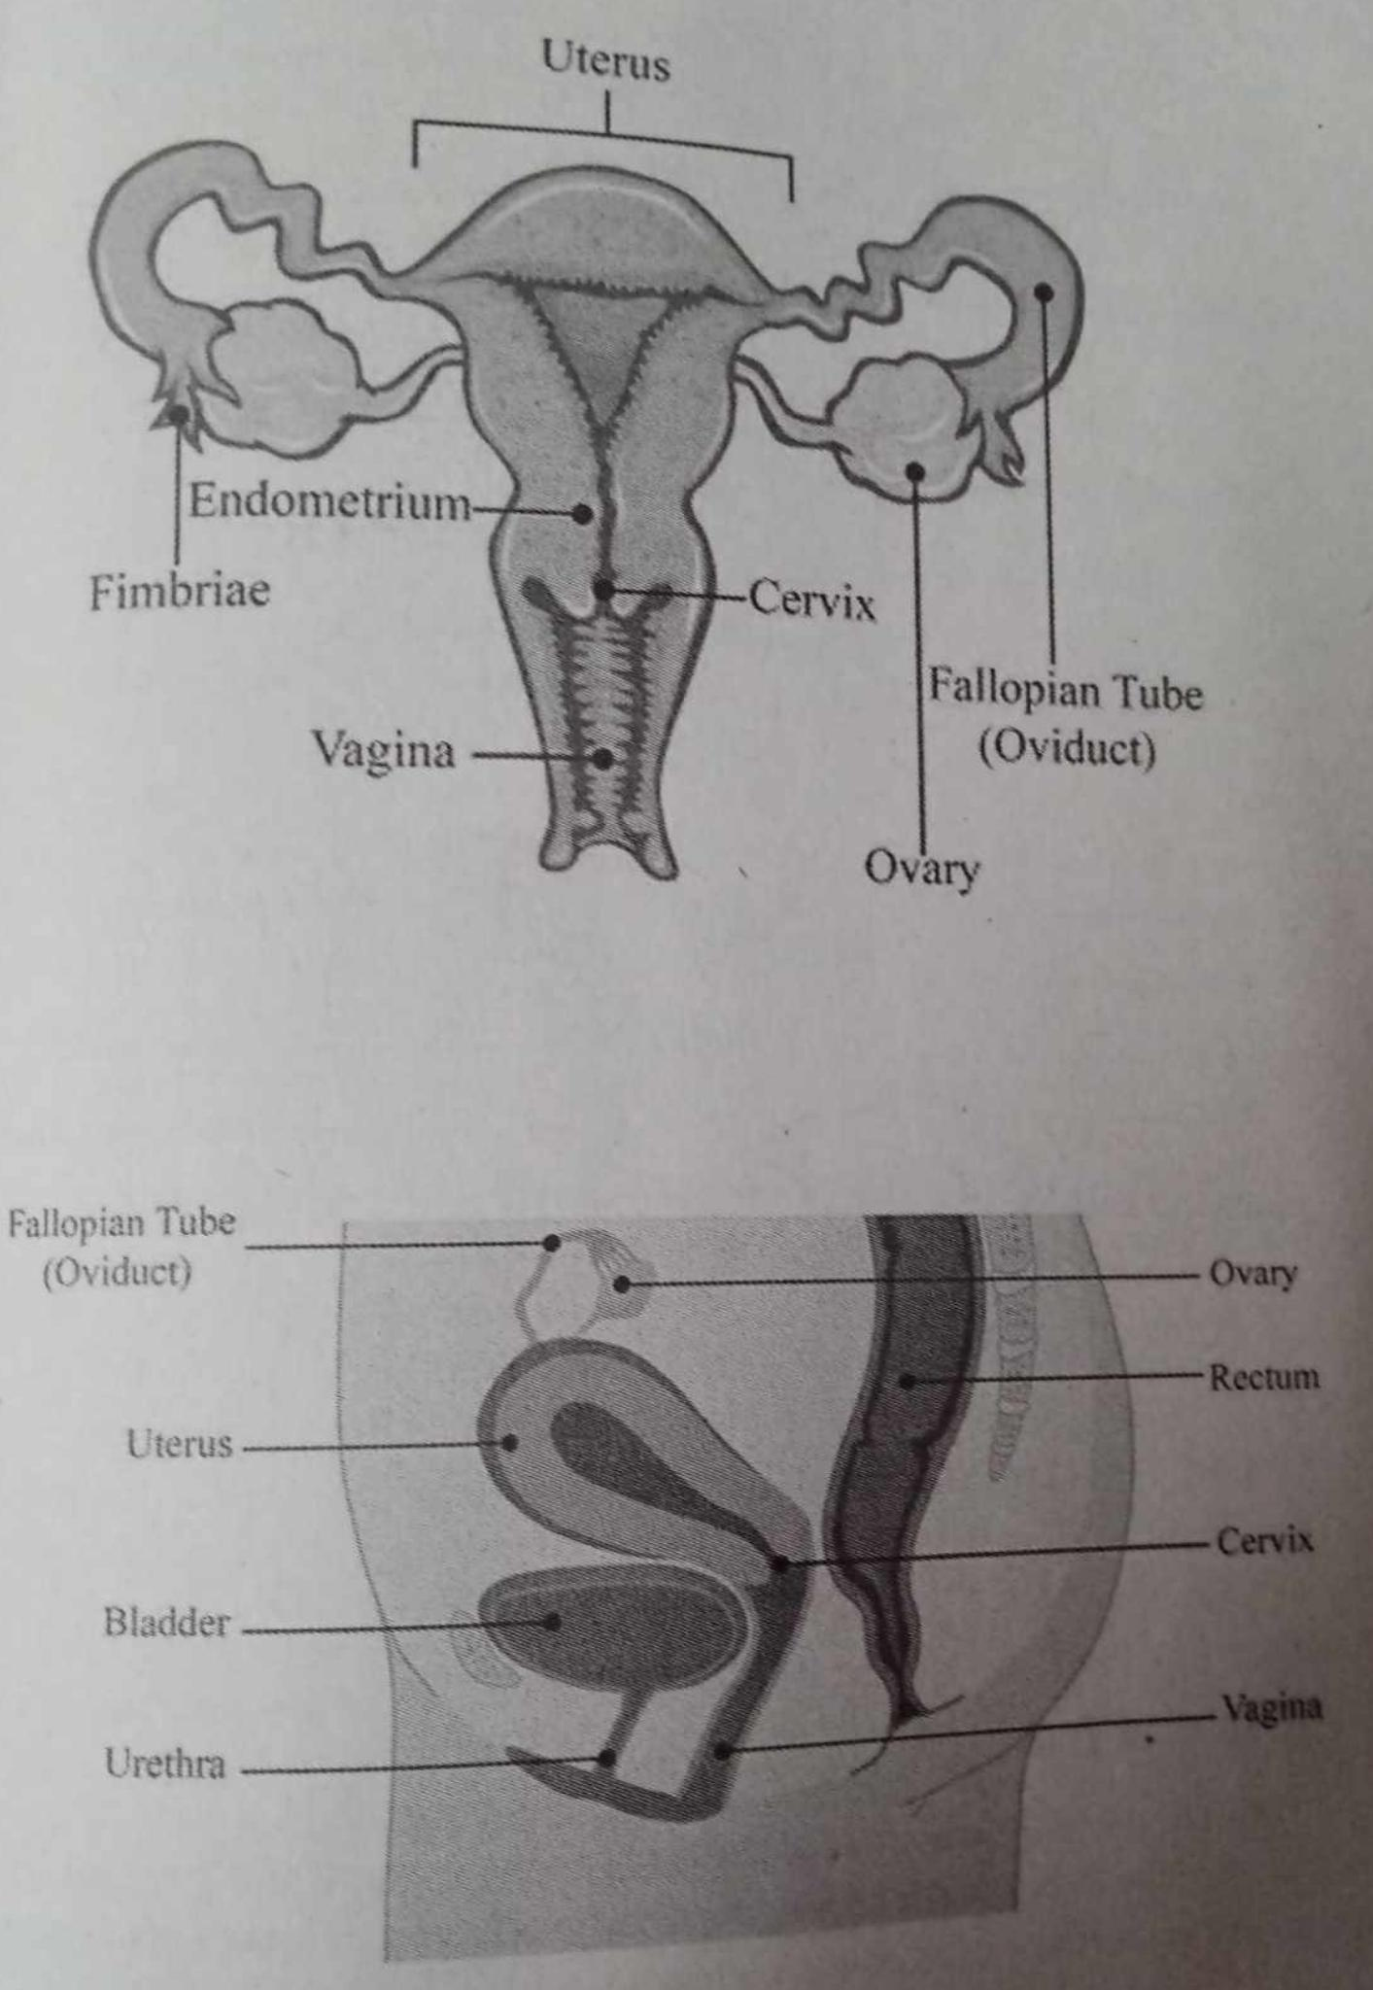

**Parts of Reproductive System**

**UTERUS**

uterus is an organ that is about the shape and size of a pear. It is also known as the womb. It consists of muscular walls and a lining (endometrium) that grows and diminishes with each menstrual cycle.

**FALLOPIAN TUBE**

fallopian tubes are passageways that carry eggs toward the uterus.

**OVARY**

are small, oval-shaped glands that are located on either side of your uterus. Your ovaries produce eggs and hormones

**CERVIX**

This is the passage of the baby of during birth and mentruation

**Endometrium**

The inner layer or lining of your uterus (uterine lining). This layer of your uterus is shed during your menstrual cycle.

**FIMBRIAE**

Fimbriae are finger-like projections on the ends of your fallopian tubes closest to your ovaries. Each month, your fimbriae catch the egg that one of your ovaries releases during ovulation. Your fimbriae then sweep the egg (ovum) into the fallopian tube where the egg can be fertilized.

**BLADDER**

The urinary bladder is a hollow, stretchy organ in the lower part of your abdomen that stores urine before it leaves your body through your urethra.

**URETHRA**

This tube allows urine to pass outside the body. The brain signals the bladder muscles to tighten, which squeezes urine out of the bladder.

**VAGINA**

provides a passageway for blood and mucosal tissue from the uterus during a woman’s monthly period. Receives the penis during sexual intercourse and holds the sperm until they pass into the uterus. Provides a passageway for childbirth.

**Parts of Reproductive System ( Boys )**

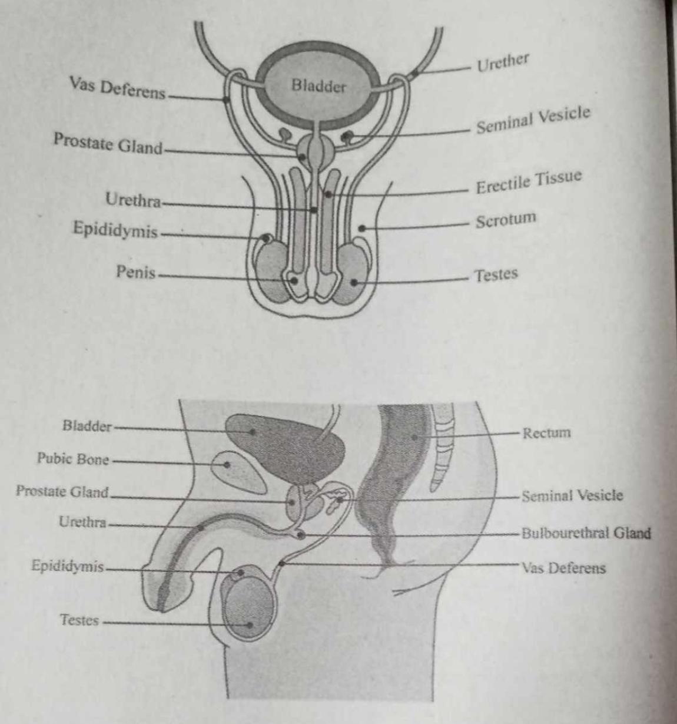

**Vas deferens**

is a long, muscular tube that travels from the epididymis into the pelvic cavity, just behind the urinary bladder. The vas deferens transports mature sperm to the urethra in preparation for ejaculation.

**URETHER**

ureters are bilateral thin (3 to 4 mm) tubular structures that connect the kidneys to the urinary bladder, transporting urine from the renal pelvis into the bladder. The muscular layers are responsible for the peristaltic activity that the ureter uses to move the urine from the kidneys to the bladder.

**The Prostate gland**

is located just below the bladder in men and surrounds the top portion of the tube that drains urine from the bladder (urethra). The prostate’s primary function is to produce the fluid that nourishes and transports sperm (seminal fluid).

**seminal vesicles**

(also known as the vesicular or seminal glands) are a pair of glands found in the male pelvis, which function to produce many of the constituent ingredients of semen.

**erectile tissue**

contains thousands of spaces. During sexual arousal, the spaces fill with blood, and your penis becomes hard and rigid (erection). An erection allows you to have penetrative sex

**URETHRA**

This tube allows urine to pass outside the body. The brain signals the bladder muscles to tighten, which squeezes urine out of the bladder.

**Epididymis**

is to transport sperm from the rete testes to the vas deferens. Total transit time through the epididymis is generally between 10–15 days.

**Testes**

are 2 small organs that are found inside the scrotum. The testes are responsible for making sperm and are also involved in producing a hormone called testosterone.

**Penis**

is the male organ used for urination and sexual intercourse. The penis is located above the scrotum. It is made of spongy tissue and blood vessels. The shaft of the penis surrounds the urethra and is connected to the pubic bone.

**Erogenous Zones**– this are the physical part of the body that is sensitive that is responsive for arousal. are areas of the body that are particularly responsive to tactile pleasurable parts.

.  **Erogenous zones maybe**!

• **Primary erogenous zones** – pertains that contain thick concentration of nerve ending. Here is a list of primary erogenous zones– genitals, buttocks, anus, nipples, inner, surface of the thighs, armpits, navel, neck, ears, lips, tongue, and entire oral cavities.

. • **Secondary erogenous zones** – include all other regions of the body. For instance, if one’s lover tenderly kissed and stroked the upper back of his partner during sexual interplay the area can be transformed to an erogenous zone because they are touched in a context of sexual intimacies.

**Human Sexuality** – defined as the ways in which people experience and expressed themselves a sexual being as expected by specific society.

Sex and sex related behavior are influenced by social, expectation, attitude, beliefs, and biological knowledge

**Basic Sexual Behavior**

**Masturbation or solitary** – is a sexual satisfaction, more often engaged in only by those who do not have sexual outlet, an idea that has no relation to reality.

It started at the age of 5-21 years with a highest peak of at 9-13 years for male and 12-16 years for female ( Feldman 2014 )  
  
- Male masturbation is common in the early teens and then slowly down.  
- Female masturbation begin to maximum early with a maximum frequency .  
- It is reported that masturbated 24 times a year, and married women at the same age had it 10 times a year ( Feldman 2016 )  
- **Heterosexuality** – attraction and behavior towards the other sex , is far more than male and female sexual act .  
 Example: kissing, caressing, necking, massaging, petting, cuddling, and other forms of sex.  
- **Premarital Sex** – is penetrative vaginal intercourse performed between couples before formal marriage.  
- The idea that premarital sex is allowed for the male but not permitted for the female is termed double standard.

However in the 1960’s there was a dramatic change in the view premarital sex. Permissiveness with affection – as quoted by Feldman (2014) premarital sex is permissable to both Males and Females who have long term commitment or long relationship.

-**Marital sex**- sex in marriage, is the most standard and acceptable sexual behavior and generally the gauge of wedded bliss .

- **Extramarital sex** – practice between married person and someone who is not his/her spouse .

**Marital**

Is a term for sexual intercourse between married partners

**Homosexuality and Bisexuality** – is biological in nature.

**Homosexual** – are individuals who are sexually attracted to members of their own sex.

**Gays** – those are male homosexual.

**Lesbian** – those are female homosexual.

**Bisexual** – those who are attracted to the same sex or other sex. - **Transsexual** – people who believes that they were born with a body of another gender. -

**Transsexualism** – part of wider category known as trangendeism. - **Transgenderism** – pertains not only transsexual but also to people who see themselves as the third gender.

**Transvestites** – those who wear clothes of the other gender or some of them believe that traditional male-female classification who wrongly characterized themselves .

**Asexuality** – is another type of sexual orientation where an asexual lacks attraction to both men and women.

**Androgyny** – this literally means man-woman which refers to having both masculine and feminine traits

Human sexual development and behavior are influenced by hormones, and differs between Male and Female. Male testes start to secret androgens, a male sex hormone which produces secondary sex characteristics. Like growth of hair, change of voice widening of shoulder for the boys and enlargement of the breast, widening of the hips for girls.The production of androgens by the testes is constant making men capable of sexual activities with no reference to the biological cycle. Woman have different patterns. When they reach puberty the ovaries start to produce estrogen and progesterone the two female hormones.

**The Phases of Sexual Responses**

According to Johnson’s research, sexual responses generally follow four phases; excitement, plateau, orgasm, and resolution.

**The Excitement Phase** – phase can last for a few minutes to an hour. Here, there is an exciting stimulus that starts a sequence that prepares the genital for sexual activity

**The Plateau Phase** – This is the body’s preparation for orgasm. At this phase the maximum level of sexual arousal is attained as the penis and clitoris swell with blood.

**Orgasm** is the peak of sexual excitement and the pleasurable characterized by feelings of pleasure centered in the genitals and (in men) experienced as an accompaniment to ejaculation.

**The Resolution Phase** – Here the body returns to the resting phase where there is a reversal brought about by arousal.comeback to the same structure of private parts

**Sexual problems** have historically been kept hidden due to societal moral values, which highly prioritize desirable sexual conduct. Sexual activities across various dimensions, such as solitary, marital, heterosexual, homosexual, bisexual, or transsexual, are all driven by the goal of satisfaction and fulfillment.

**Erectile dysfunction** - refers to the inability of a male to achieve or maintain an erection. This issue is not limited to older men; a significant percentage of men under 50 also experience erectile dysfunction, often due to factors like alcohol, drug use, performance anxiety, and anxiety.

Modern treatments, such as the drug Viagra, have provided a & for erectile dysfunction. Viagra works by increasing blood flow to the male's penis, facilitating a quick erection

**Premature ejaculation** - is a condition where a male cannot control or delay his orgasm as long as he desires, often influenced by his partner's preferences. •

**Inhibited ejaculation** - is a condition where a man struggles to ejaculate when desired, often remedied by general relaxation. For women, anorgasmia denotes a lack of orgasm, with two types: primary orgasmic dysfunction (never experiencing orgasm) and secondary orgasmic dysfunction (previously experiencing orgasm but no longer able to, or only in specific situations like masturbation

**Inhibited sexual desire** - is characterized by a lack of motivation or interest in sexual activity. Individuals experiencing this condition may feel sexually disconnected and eventually begin to avoid sexual situations, leading to a decline in sexual intimacy with others. This can be likened to a form of "sexual amnesia" where the desire for sexual engagement diminishes over time.

**Sexually Transmitted Infections (STIs)** have become more prevalent with changing sexual norms and practices in modern times. These infections are often the result of sexual encounters, leading to physical discomfort and psychological distress for those affected. Here are the major Sexually Transmitted Infections (STIs)

**Chlamydia** **(occurs if there are multiple partner)**is a widespread sexually transmitted infection (STI) that often doesn't exhibit symptoms in women but can cause a burning sensation and discharge in men. If left untreated in women, it can lead to complications like pelvic inflammation, arthritis, and potential sterility. Regular testing for sexually active women under 26 is advisable, and if diagnosed, Chlamydia can be effectively treated with antibiotics

**Genital herpes** they can still able to spread the virus. Other people have pain, itching, and sores around the genitals, anus or mouth.

**Gonorrhea** is a sexually transmitted disease (STD) caused by infection with the Neisseria gonorrhoeae infects the mucous membranes of the reproductive tract, including the cervix, uterus, and fallopian tubes in women, and the urethra in women and men.it often presents with symptoms like burning during urination and discharge but can also be asymptomatic.

**Syphilis** begins with a small wound at the site of sexual contact, followed by rashes in the second stage. Left untreated, it can affect the brain, heart, and even a growing fetus. Early diagnosis allows for effective treatment with antibiotics.

**Aids** These past decades there is no sexually transmitted infectious disease that has most severe impact on sexual behavior and the whole society than this Acquired Immune Deficiency Syndrome. This AIDS are caused by a virus, the human immuno deficiency virus (HIV) which destroy body' immune system Semen and blood are the vehicles of transmission (Santrock, 2014). AIDS in the US was found among gay men then it spread to other populations through intravenous drug users and to various sexual activities. People become conscious to engage in "casual sex with new found acquaintance and the use of condom has increased.

**Human immunodeficiency virus (HIV)** is the virus that causes acquire immunodeficiency syndrome (AIDS) when a person becomes infected with HIV, the cirus attacks and weakens the immune system weakens, the person is at risk for getting life-threatening infections and cancers.

**Methods of Contraceptives** The use of contraceptives is an important aspect of responsible sexual behavior. While sexual fulfillment and ecstasy are natural, they should be channeled toward ethical sexual behavior rather than sexual liberation.

**Natural Methods** Fertility awareness, a natural method for family planning, involves observing signs and symptoms of fertility to identify safe and fertile periods within the menstrual cycle. • **Rhythm or Calendar Method,** a part of fertility awareness, relies on tracking the evolution period and menstrual cycle to determine safe days for sexual contact.

**The Cervical Mucus Method** relies on observing changes in vaginal discharge to determine fertility. •

**The Basal Body Temperature method** involves using a special thermometer to track temperature change

**The Sympto-Thermal Method** combines the Basal Body Temperature and Cervical Mucus methods and includes additional indicators like breast tenderness and mid- cycle pains to predict ovulation. •

**Abstinence** prevents pregnancy by avoiding all sexual activities involving semen coming into contact with the vulva. It is 100% effective in preventing pregnancy.

**Douche** is done by washing the sperm and semen deposited in the vagina with medical solution just after the sexual contact. • **Withdrawal** is the practice of removing the penis from the vagina before ejaculation, but it can be unreliable due to the difficulty in timing, potentially leading to pregnancy.

**Prolong Lactation or Lactational Amenorrhea (LAM).** LAM is considered natural contraceptive that protect the woman from pregnancy particularly during the first 6 months after giving birth. It is because breast feeding is the prime factor in delaying menstruation. While the baby suck, the nipples become stimulated causing the woman to manufacture prolactine or oxytocin a hormone that induces the flow of milk. Mother's milk is the best milk due to its natural nutrient content and the colostrum.

**Artificial Methods**

**Oral contraceptives**, known as "the Pill, " contain synthetic hormones (estrogen and progesterone) that mimic those in a woman's body.

**Two types:** Combined Oral Contraceptives (COC) and Progesterone-Only Pills (POP). - Estrogen prevents egg maturation and release from the ovary, while progesterone alters uterine lining and cervical mucus.

**The morning-after pill** is an emergency contraceptive that prevents pregnancy after unprotected sex. It contains a high dose of hormones. This pill, such as Postinor, works by preventing egg cell ovulation and disrupting the uterine lining to inhibit the implantation of a fertilized egg (zygote). In some regions, like the Philippines, using this pill is considered abortion by pro-life groups because it may terminate a fertilized egg with a life of its own. •

**Implants** are matchstick-size rubber silicon, rods, capsules or tubes containing progesterone

**Surgical Method or Sterilization:** This procedure involves cutting or tying the fallopian tubes to prevent the meeting of sperm and egg, usually done in a hospital or clinic operation

**Vasectomy:** A male sterilization procedure that severs the vas deferens, preventing sperm from mixing with seminal fluid. It's a permanent or irreversible surgical method, taking 15-20 minutes, typically performed by cutting slit in the scrotum. •

**Male Condom or** **Prophylactic Latex:** A synthetic sheath worn over the penis during sexual activity to block sperm from entering the uterus. It has a sealed tip to catch semen during ejaculation and should be removed promptly after intercourse. ••

**Diaphragm or Cervical Cap:** These devices are thin rubber bowl-shaped disks with a flexible rim that fit over the vagina to cover the cervix, preventing sperm from entering. •

**Sponge:** A soft doughnut-shaped device made of spongy material with spermicide

**Love and Attachment**

Love is a complex and multifaceted emotion that is challenging to define. Researchers often measure aspects of attachment, intimacy, companionship, and infatuation as indicators of love. Some scientific studies have explored the role of oxytocin and serotonin in romantic relationships. Love is often described as patient, kind, unenvious, respectful, selfless, forgiving, truthful, trusting, hopeful, and enduring, as mentioned in Corinthians 13:4. • Function Of Dating

**Dating** has evolved beyond its traditional role of mate selection and now serves various functions in the lives of adolescents. It can be a source of recreation, a way to attain social status and achievement, a means of socialization, and an opportunity for learning about intimacy and forming meaningful relationships. Additionally, dating can provide a platform for sexual exploration, contribute to identity development, and help with mate sorting and selection.

**Types Of Love**

**Love** takes varied forms. There is love between friends called philia, an ancient Greek word. Love is a feeling that is complex than liking making it difficult to measure. Love is what people longed for, live for and even die for. Although love has varied and complex meaning, yet it can be simplified in two types. Passionate love and Companionate love (Meyer, 1993).

**Passionate love**, also known as **romantic love**, is characterized by an intense longing for union with another person. It involves ecstasy, tenderness, and elation when in the presence of the loved one, as well as feelings of sadness when separated. Love shows generalized physiological arousal like increased heartbeat, blushing, perspiration and feeling of intense excitement.

**Companionate love** is characterized by **friendly affection**, deep caring attachment, tolerance for shortcomings, and a commitment and nurturing the partnership. It is enduring and involves thoughtful appreciation of one's partner. In companionate love, sex reflects familiarity and security, leading to improved communication and a stronger bond. While not as exciting as passionate love, it is richer, more meaningful, and deeply satisfying.

According to **Robert Sternberg**, love can be understood through a triarchic dimension comprising three elements: •

**Passion:** This is the motivational component that ignites romantic feelings, physical attraction, and a strong desire for sexual interaction.

**Intimacy:** Intimacy is the emotional component of love that involves a sense of bonding with the person. •

**Commitment:** is the cognitive component of love and involves a conscious decision to love and stay in a relationship despite challenges.