**Assignment #3 – Immigration Statistics of United States**

Devendar Reddy Adulla

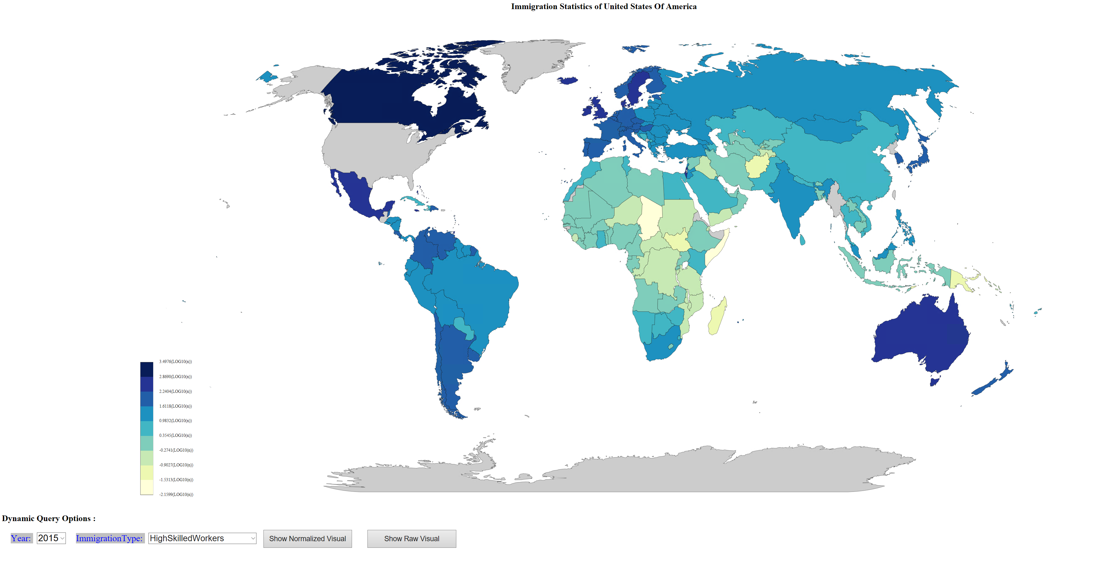

**Process and Story**:

I have looked into the USCIS data base and got official data from their repository for immigration statistics for the year 2015 and 2016 (they have not published data for 2017 or beyond yet). This data contains information like the number of immigrants from each country and category of immigration ( High skilled, agricultural, athletes, investments or amnesty etc) USCIS has lot more data than what I need to show visualization and was missing some data like ( total population of the country, which is useful for density matrix). SO, refined the data to get what exactly I wanted to show this visualization. From the start, I was concentrated on making this visualization interactive using dynamic queries and I also wanted to show data on geomap rather than bar - charts with country names on it. So, I used some libraries that help me draw geomap. Data population, alignments, styles and filtering is completely done by me. This visualization has following filters to see filtered data.

1. Immigration statistics for the Year
2. Immigration statistics for the category
3. Normalized view.
4. Calculated metrics ( like density etc)

**Data Source**:

2015 year: <https://www.dhs.gov/immigration-statistics/yearbook/2015/table32>

2016 year: <https://www.dhs.gov/immigration-statistics/yearbook/2016/table32>

Population stats: <https://data.worldbank.org/indicator/SP.POP.TOTL>

**Implementation changes:**

Immigration statistics were not uniform across the countries. More populated countries were contributing more immigration to USA than others and it was hard to choose color hue on raw numbers. Also, looking at the raw numbers does not give a clear picture due to the size and population of that country. It would have to be normalized based on other properties. One such calculated property in my dynamic query is “Density” which tells the density of immigration from a particular country. I also used logarithmic values to make color hue more appealing and differentiable.