# **Frequently Asked Questions – Supervisors and Appraisers of Wings2**

➢ **What is Elevate**

Elevate, is a merit based, democratized, transparent talent framework designed to establish a tighter linkage between Learning, Career and Reward.

It has been designed in collaboration with Business Groups and Units to marshal premium Learning Resources in guided paths, based on experience levels.

➢ **What is Wings2**

Wings2 is aimed at transforming mid-talent to futuristic ‘Specialists’ through a subscription-based, future role driven curriculum.

Key Tenets for Wings2 are:

• Future-Role Based

▪ Associates learn to get ready to perform next(future) elevated role

▪ The role assigned are futuristic for Organization’s Growth and Transformation

• Structured Career path for Role Movement

▪ Associates have flexibility to subscribe to a Role and Job Area with Appraiser’s consent based on their aspiration and business requirement

▪ Associates have the opportunity to move continuously in their career journey and transform to ‘Specialists’

• Democratic and Multi-Dimensional Performance-based

▪ Associate can demonstrate early readiness towards the elevated role and be deployed.

▪ Associates have equal opportunity for rewards and compensations by being consistent performers

➢ **What are the key steps in Wings2 Program?**

• Future Role and Job Area must be assigned to the associates for the purpose of getting future ready for deployment

• Template of learning called ‘learning spec’ to be tagged to the associate based on future role job area assignment

• Associates to perform learning as per the learning spec.

• Experiential Learning through mentoring to be enabled halfway through the associates learning journey

➢ **Who is eligible for Wings 2?**

• Associates in the grades C2 and C3A

➢ **Who and where can I assign the Future Role and Job Area to the eligible associates?**

The Future Role and Job Area can be assigned in the following ways:

A) By SPEED Appriaser based on combination of associate’s aspiration and business requirement. This can be done in Xcelerate application. The navigation is Ultimatix > HR, Talent and Diversity > Talent Management > Xcelerate or

B) By Won/SWon Supervisor if speed supervisor is not available. This can be done in Xcelerate or iTalent applications

***Key to Note: In first option, system approval needs to done in GESS > Role Management by Won / SWon Supervisor

➢ **Where can I see the list of Future Roles and Job Area applicable in Wings2 that I can assign to my team?**

Comprehensive list of Role and Job area for future assignment will be available in the Xcelerate screen as the list of values under each screen.

***Key to Note: To refer to sp. list of Future Wings2 Roles and Job Area, please refer to Learning Spec on the following link: <https://knowmax3.ultimatix.net/sites/learning-corpfn/TalentDevelopment/Learning%20Spec%20%20Elevate%20Wings2/Forms/AllItems.aspx>

➢ **What are the benefits for the associates?**

• Structured Career Growth and Movement

• Career Boost - Will be deployed in the future Role-Job Area

• Specialist/Superior Brand Identity

• Compensation Revision

• Premium Learning Programs

➢ **How long will it take to complete Wings2?**

• Wings2 certification will have one overall Program Certificate with three Intermediate

Milestones (IM1, IM2 and IM3). Every milestone refers to one or more Future Role-Job Area which will have the components (competencies/certificates/T-Factor and the Learning Credits/Hours) configured and courses defined under learning paths.

▪ Associate needs to perform in the defined (future) role for a minimum of 6 months before moving to the next (defined future) role

➢ **Checkpoints for the Supervisor and Appraiser during assignment of Future Role-Job Area and Learning**

**(S)WON Supervisor**

• Current Role-Job Area of associates to be captured accurately in the system (iTalent)

▪ Currently, in Role Management System (iTalent), assignment of Job Area is not mandatory while assigning the current Role of an associate.

▪ However, for Wings2 both Role and Job Area have to be updated by the (S)WON supervisor in iTalent before nominating the associate for Wings2 program

▪ An iTalent User Manual is hosted in GESS at the navigation - GESS>> Responsibilities >My Profile Responsibilities > Role Management https://hrms.ultimatix.net/Ess/Responsibility_Management

**SPEED Appraiser**

• Future Role-Job Area of the nominated associates to be identified and assigned in the system

(Xcelerate) by the SPEED supervisor along with relevant Competencies, Certificates and T-Factor ▪ In both competencies and certificates, there would be:

 Pre-requisites and Fixed Learning section – Mandatorily required to be assigned for Role and Job Area, these will directly get assigned in iEvolve after the assignment of Future Role Job Area

 Specialization Electives - Options from which the supervisor can choose to assign as required Competency cluster, Certificate based on the BG/Unit/Project need

▪ T-Factor (mandatory) will be assigned based on the Future Role-Job Area assigned ▪ The navigation is Ultimatix > HR, Talent and Diversity > Talent Management > Xcelerate

**(S)WON Supervisor**

• The selected future Role-Job Area and the related Competencies, Certificates, T-Factor by SPEED supervisor will be shared with the (S)WON supervisor for approval

▪ If approved, the data flows into iEvolve

▪ In case of conflict, the information flows back to Xcelerate for the SPEED supervisor to change the future Role-Job Area accordingly

• 48 hours after WON Supervisor approval, the Wings2 nominated associates will be able to view the supervisor assigned competency (along with proficiency level), certificate and T-Factor against his/her assigned Future Role-Job Area in iEvolve Learner Dashboard. It shows current status and pending items they need to complete in Wings2 learning. It only reflects for associates in C2 and C3A Grade.

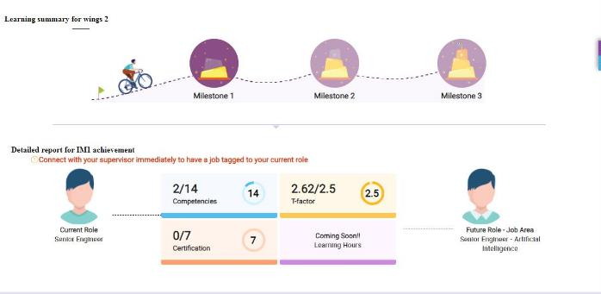

On Clicking Competencies / Certifications, the extended dashboard with the details of assigned Competencies and Certifications will be displayed.

Pre-requisites will be displayed with yellow tick mark and pop-up when mouse is hovered on it.

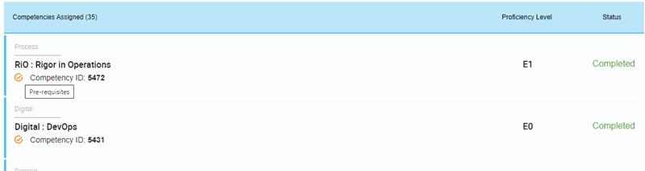

➢ **What is Core Learning and Non-Core Learning?**

Core Learning refers to Learning Objects directly mapped to the Future Job Areas while Non-Core Learning is recommended to enhance the effectiveness of the Future Role. It is recommended that both are taken with equal focus.

➢ **I want to assign Learning outside the Future Role-Job Area mapping. Is it possible?**

You can assign Learning outside Wings2 Learning Bundle, but it will not contribute to Wings2 completion. You can do so through iEvolve Supervisor Home Page, it will reflect for associates under Supervisor assigned Learning.

➢ **Experiential Learning through Mentoring**

In iConnect, mentors will be mapped to Wings2 associates upon completing 50% of learning under the Future Role-Job Area and activities related to Future Role-Job Area Internship will be assigned and tracked in Prime.

➢ **Stages of Wings2 Program Certificate**

Wings2 will have one overall Program Certificate with three Intermediate Milestones (IM1, IM2 and IM3). Every milestone refers to one or more Future Role-Job Area which will have the components (competencies/certificates/T-Factor and the Learning Credits/Hours) configured and courses defined under learning paths.